Appendix: Business networks and the persistence of entrepreneurship: Evidence from China

Appendix Figures

Figure A1: Number of chamber memberships at the provincial level, 1912-1920
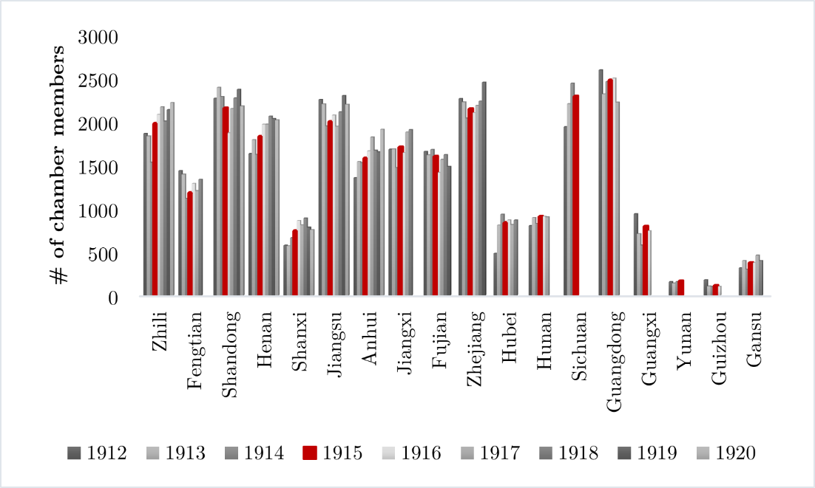

Figure A2: Correlations between chamber’s membership and it other characteristics
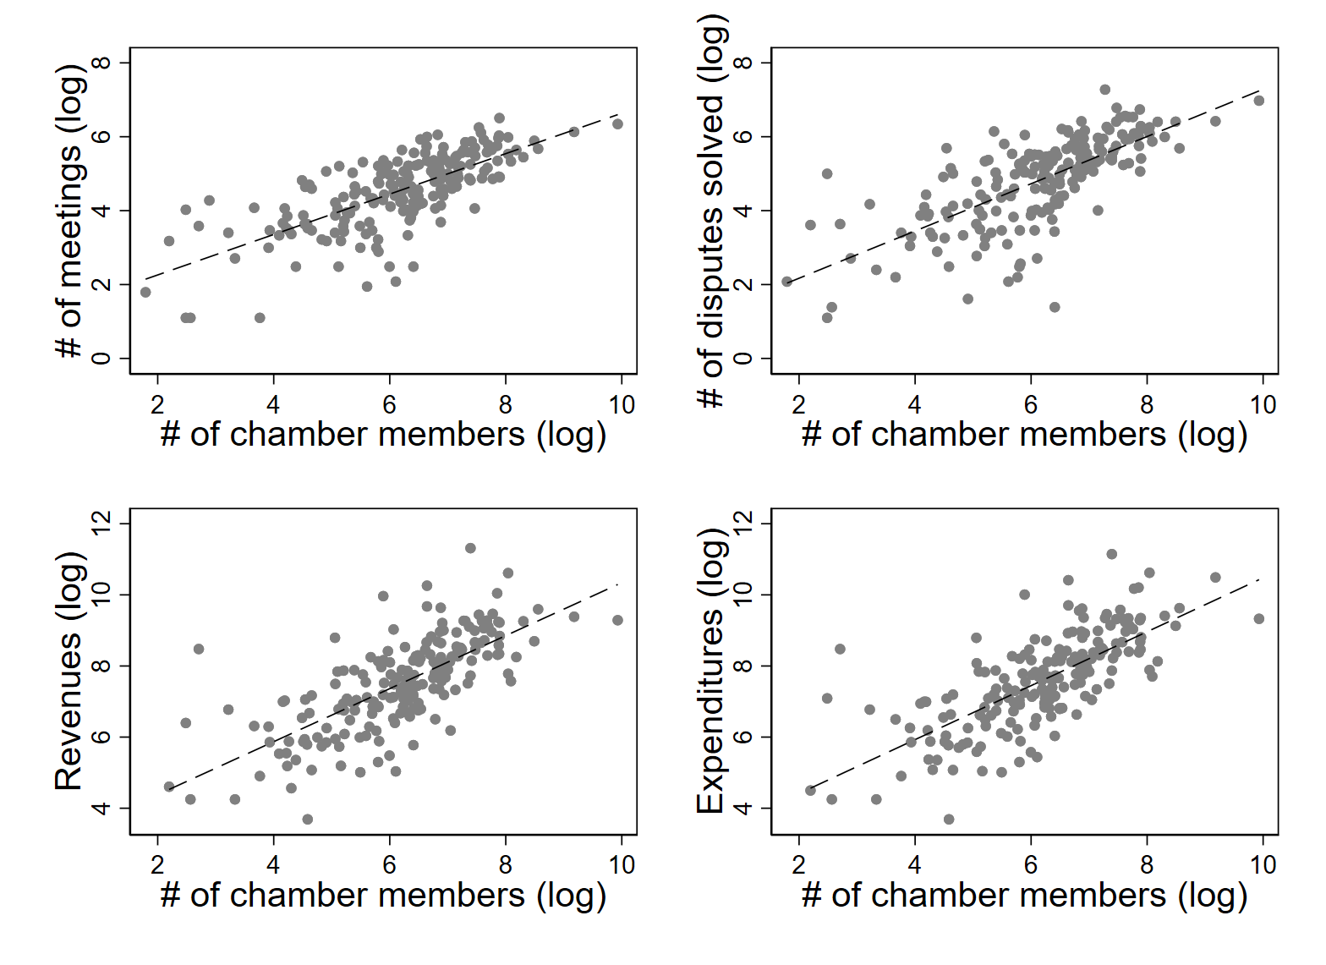

Figure A3: Dynamic effect of historical chamber system on number of SOE created
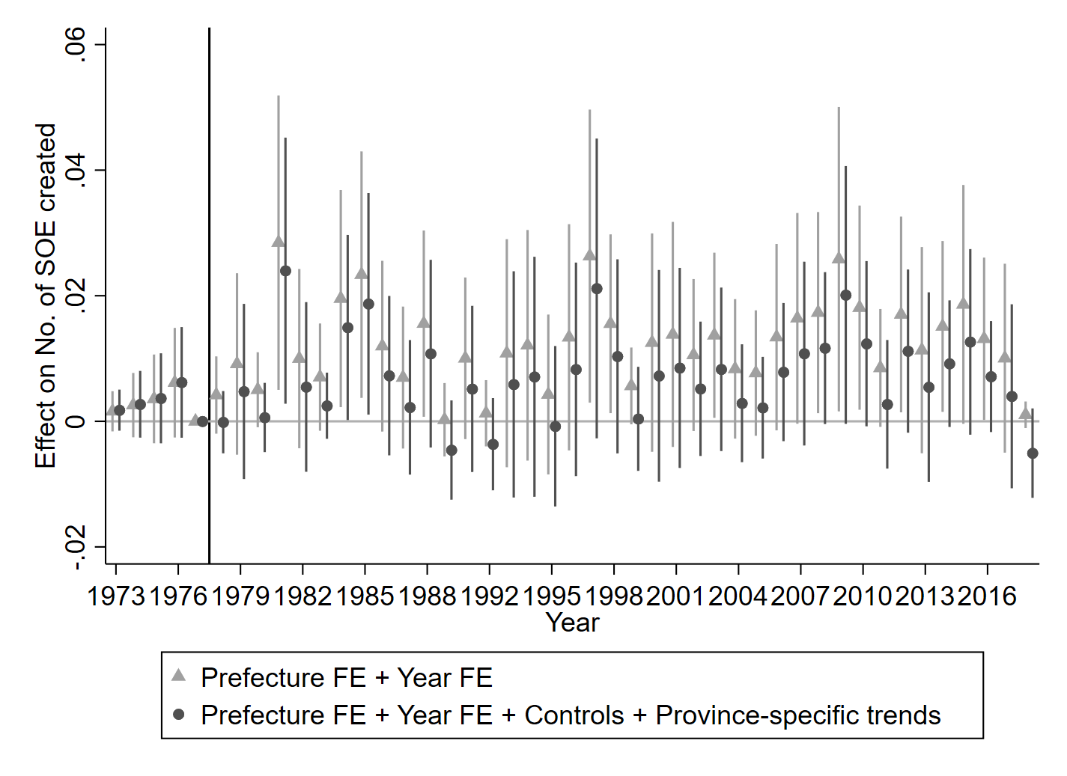
Notes: Reporting 95% confidence intervals. Standard errors clustered at the prefecture level.

Figure A4: Dynamic effect of historical chamber system on number of non-SOE created
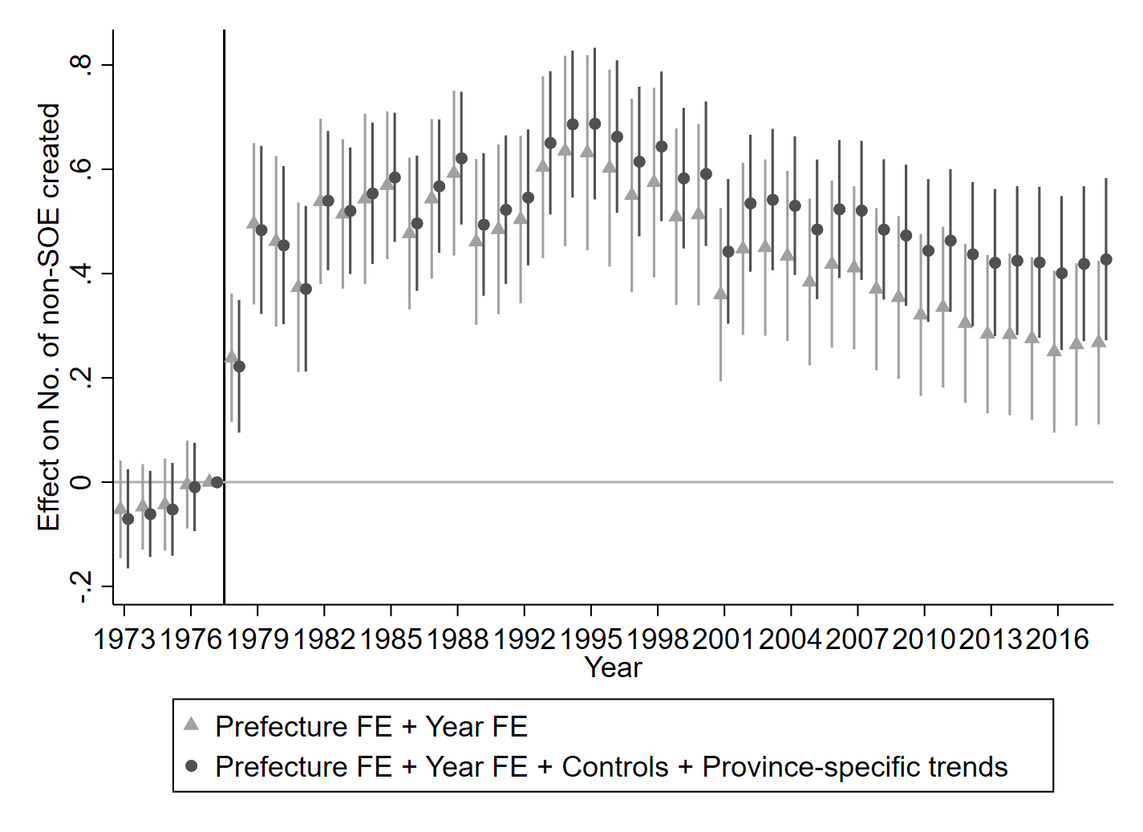
Notes: Reporting 95% confidence intervals. Standard errors clustered at the prefecture level.

Figure A5: Hypothesized linear trend of the event-study result
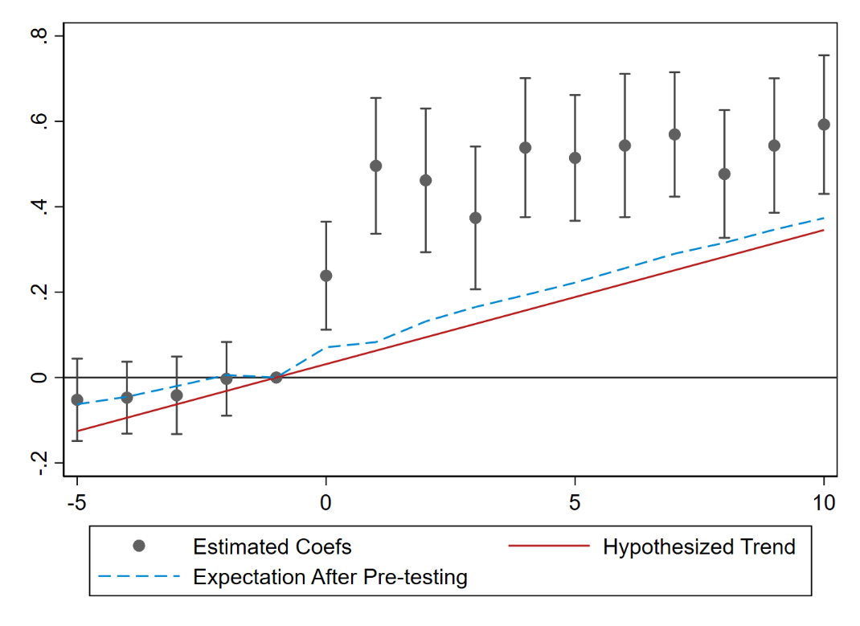
Notes: The figures show the hypothesized linear trend of the event study results using Roth (2022)’s pretrends package. The solid line is the hypothesized linear trend with 50% power. The slope of the hypothesized linear pre-trend is chosen so that the probability that a pre-trend test would detect a linear vilation of parallel trends in 50% of the time. The dashed line is the expected value of the coefficients conditional on passing the pre-trend test under the hypothesized trend.

Figure A6: Sensitivity analysis for parallel trends
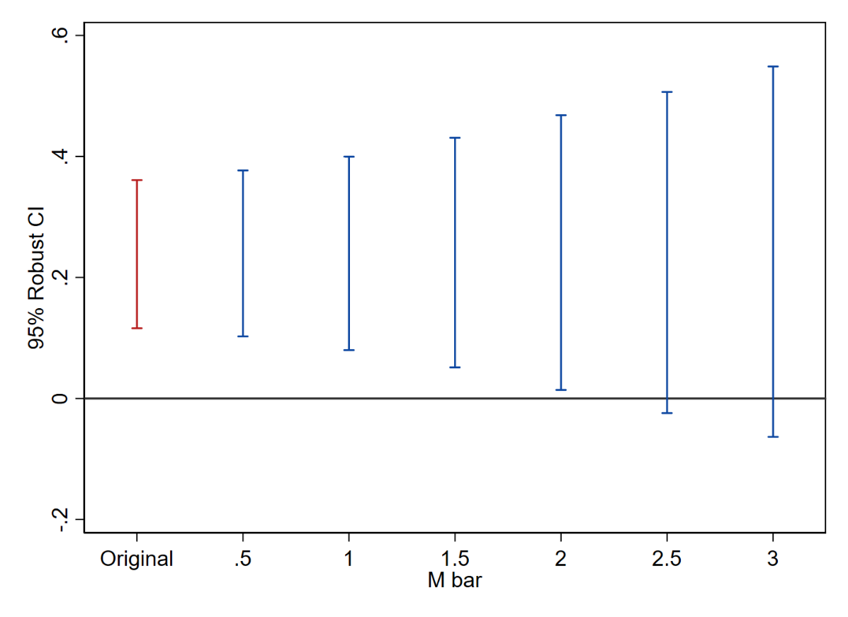
Notes: To evaluate the robustness of our event study estimates to potential violations of the parallel trends assumption, we implement the sensitivity analysis proposed by Rambachan and Roth (2023). Confidence intervals are calculated under the assumption that deviations from parallel trends in the post-period are scaled versions of the maximum pre-trend deviation, multiplied by a factor $\overline{M}=2$. This implies that our estimates remain robust to violations comparable in magnitude to the largest deviation observed in the pre-treatment period.

Figure A7: Dynamic effect of historical chamber system on firm creations, adopting chamber meeting density as indicator
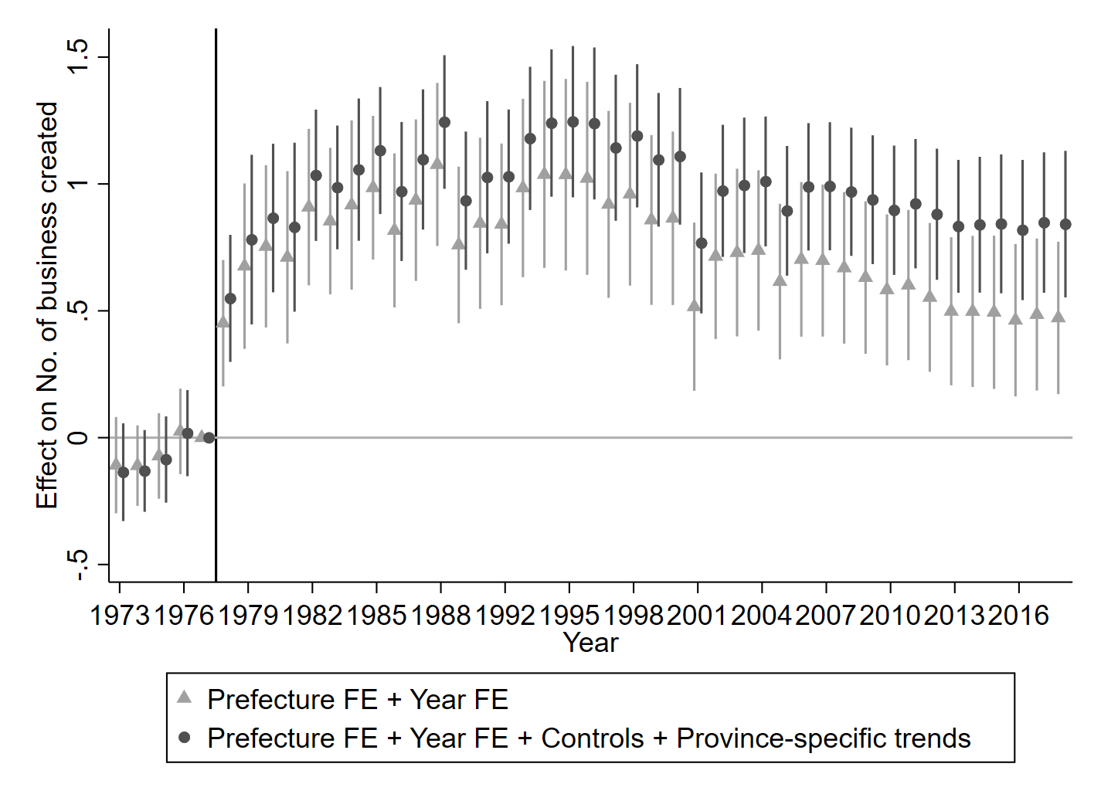
Notes: Reporting 95% confidence intervals. Standard errors clustered at the prefecture level.

Figure A8: Dynamic effect of historical chamber system on firm creations, adopting chamber disputes solved density as indicator
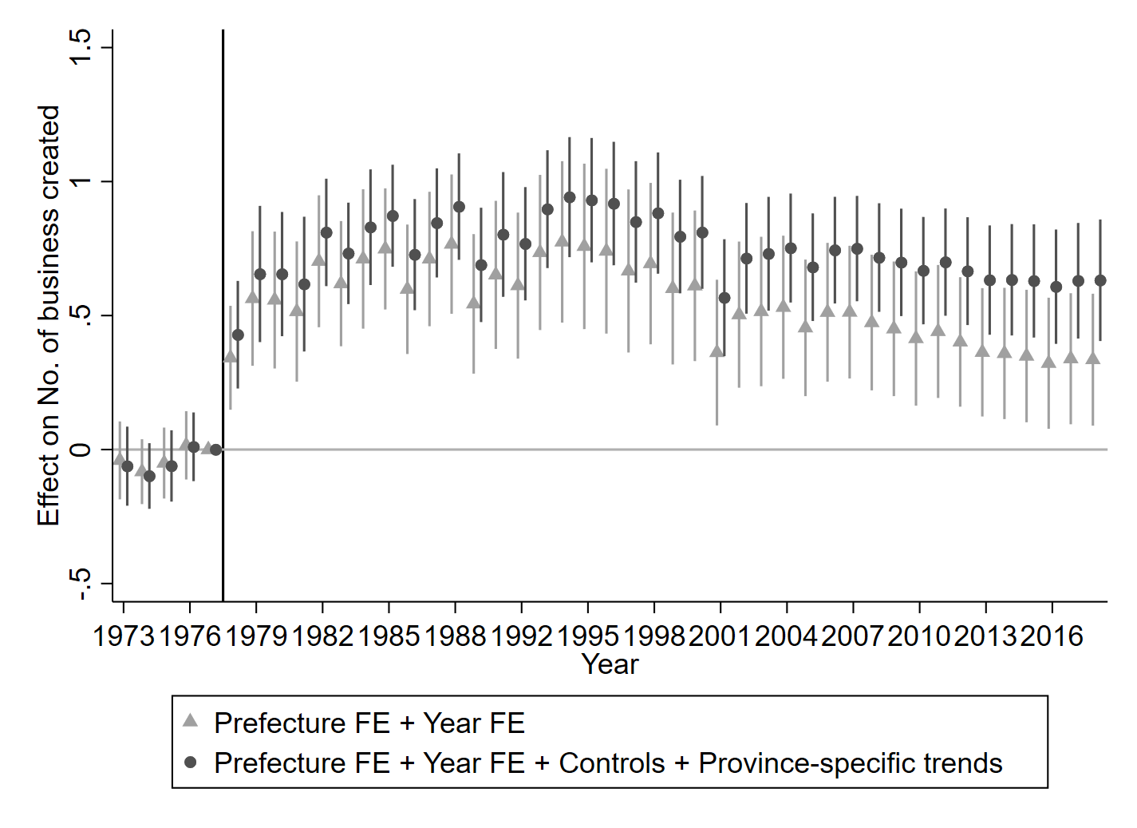
Notes: Reporting 95% confidence intervals. Standard errors clustered at the prefecture level.

Figure A9: Dynamic effect of historical chamber system on firm creations, adopting chamber revenue density as indicator
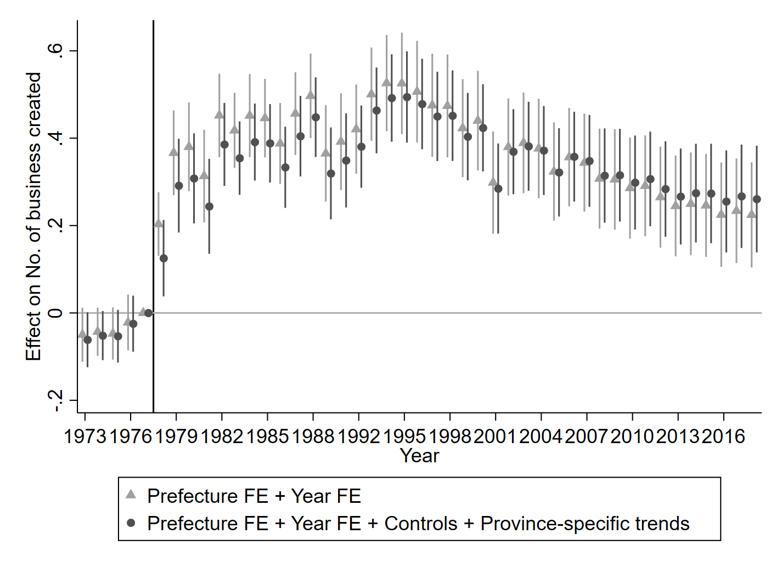
Notes: Reporting 95% confidence intervals. Standard errors clustered at the prefecture level.

Figure A10: Dynamic effect of historical chamber system on firm creations, adopting chamber expenditure density as indicator
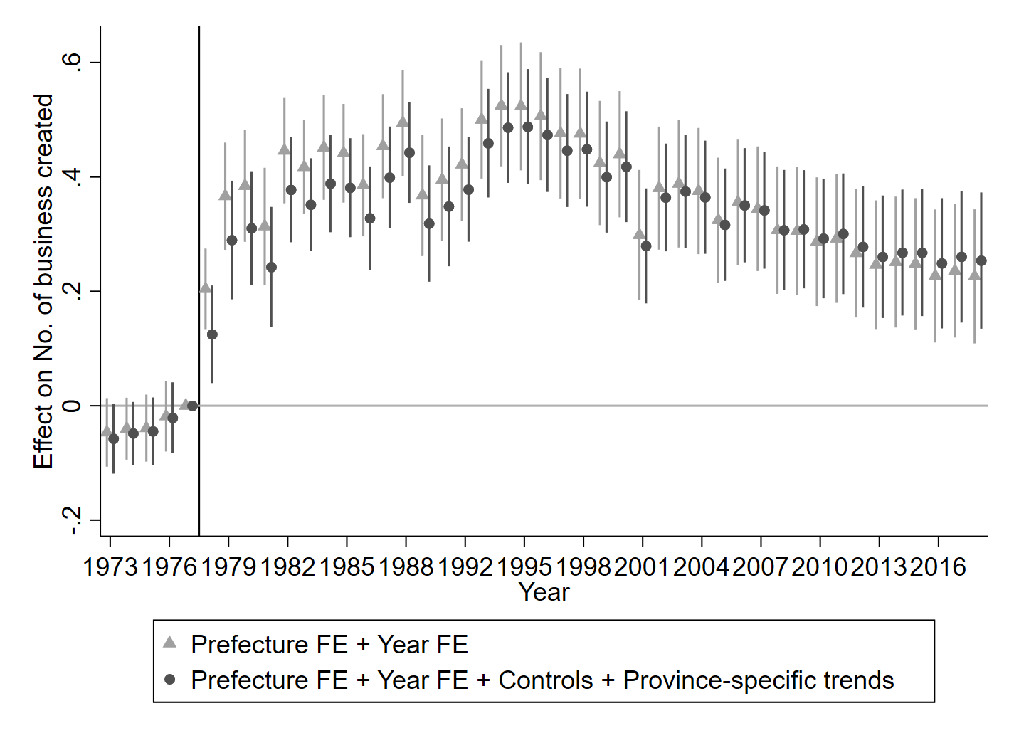
Notes: Reporting 95% confidence intervals. Standard errors clustered at the prefecture level.

Figure A11: Distribution of placebo estimates (t-statistics)
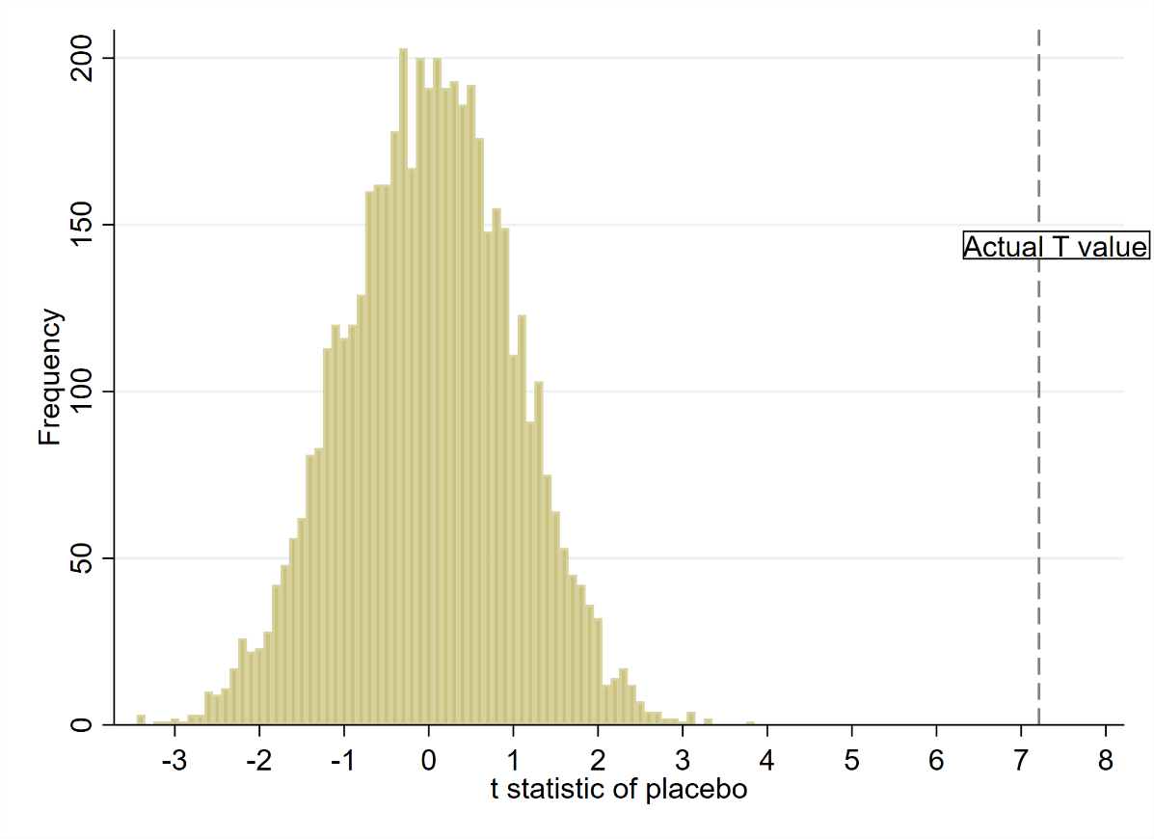

Figure A12: Dynamic effect of the historical chamber system on firm creations: IV estimates using distance to telegraph lines and excluding prefectures with treaty port, excluding treaty-port prefectures
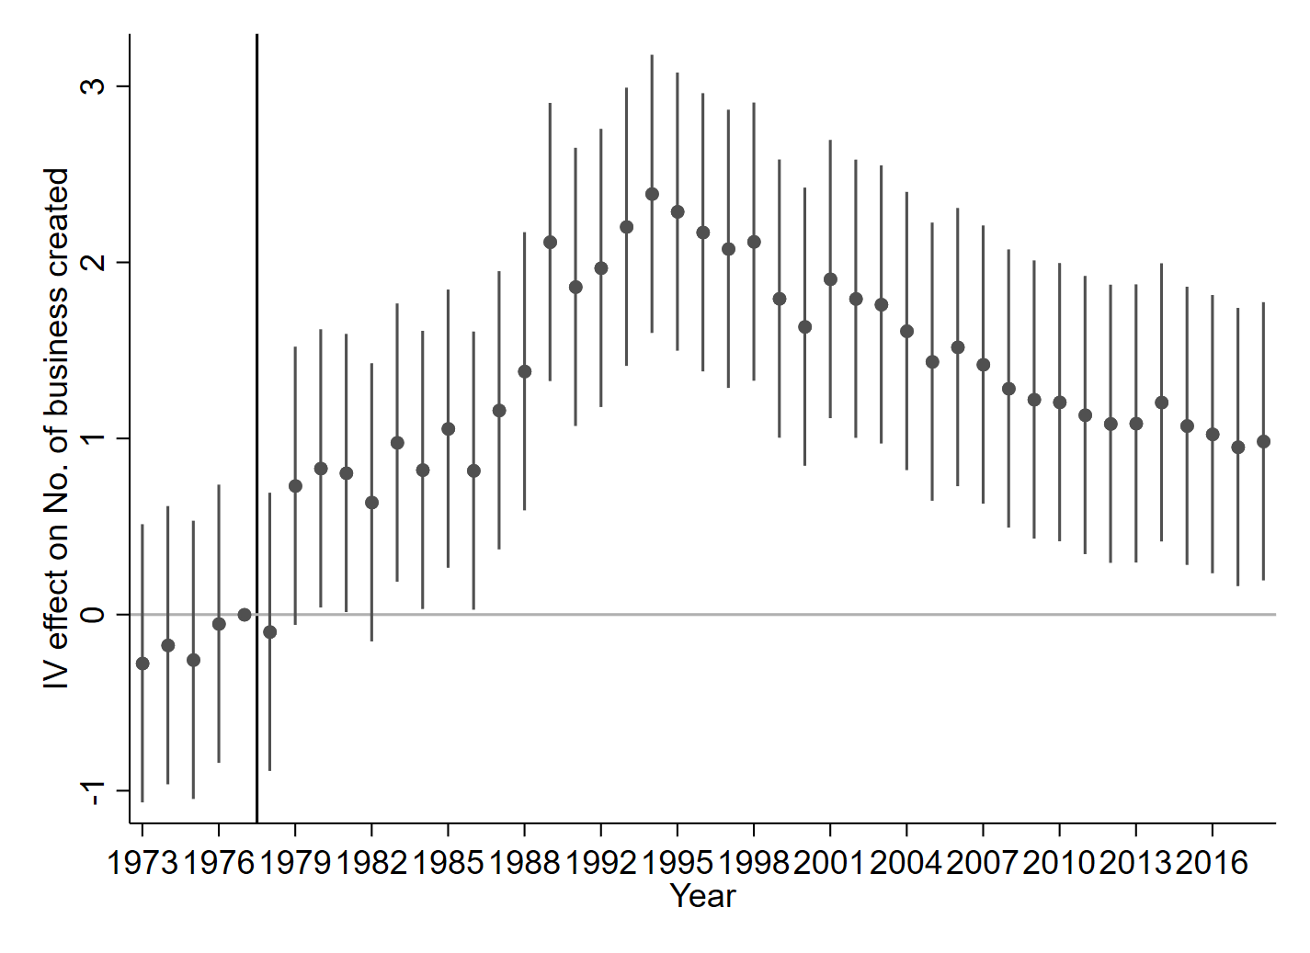
Notes: Reporting 95% confidence intervals. Standard errors clustered at the prefecture level.

Figure A13: Dynamic effect of the historical chamber system on firm creations, by telegraph terminal status: IV estimates using distance to telegraph lines
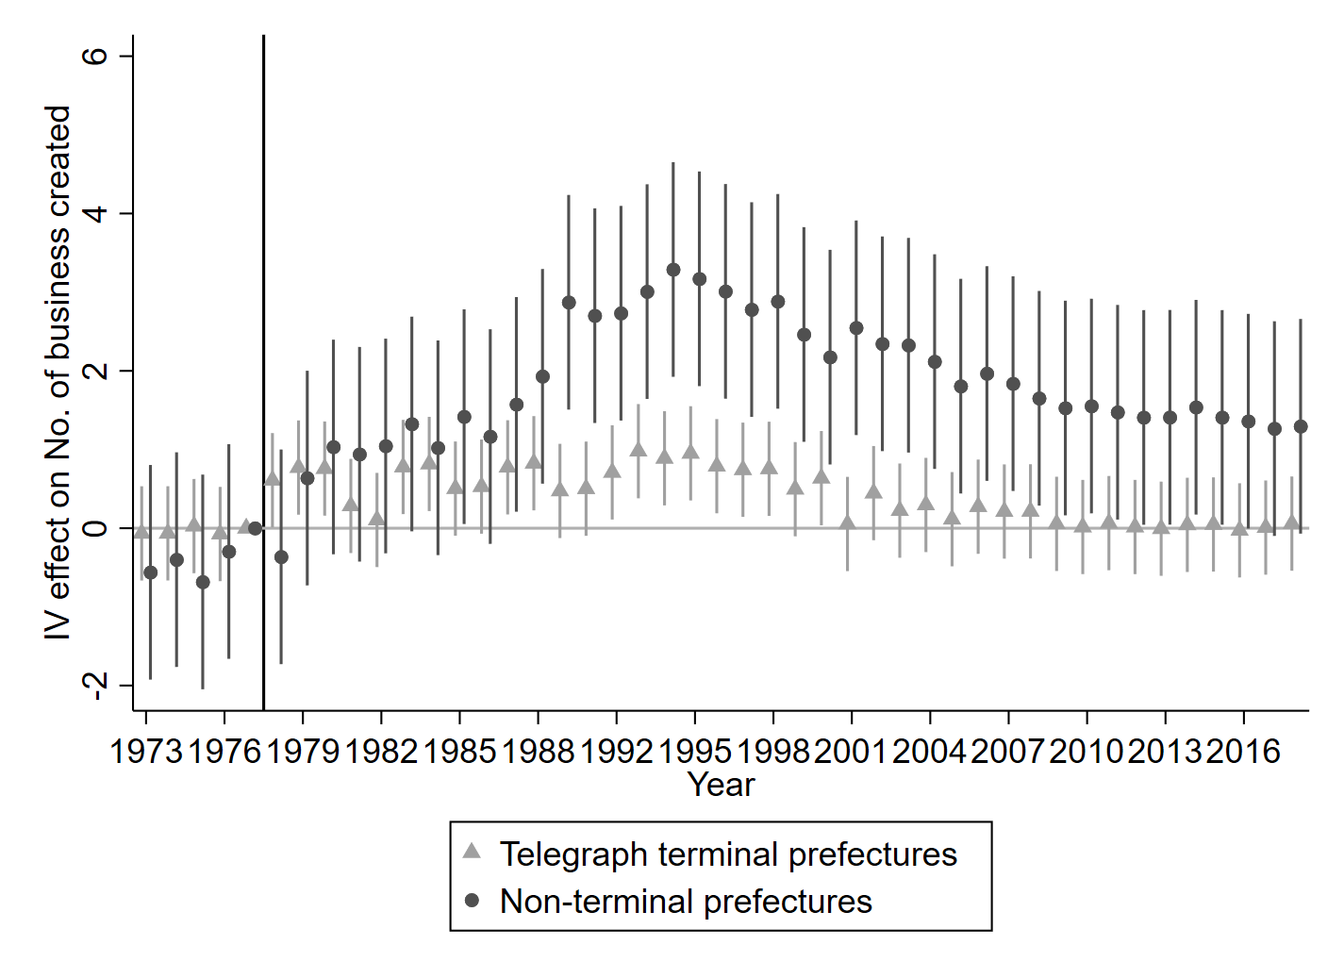
Notes: Reporting 95% confidence intervals. Standard errors clustered at the prefecture level.

Figure A14: Dynamic effect of the historical chamber system on firm creations, by telegraph node status: IV estimates using distance to telegraph lines
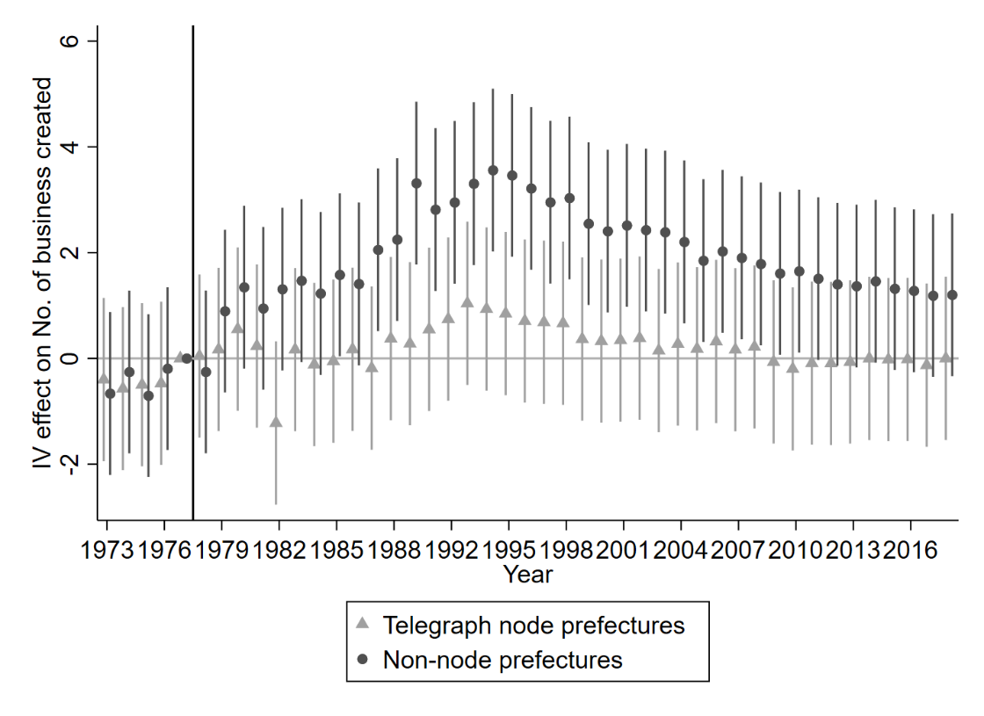
Notes: Reporting 95% confidence intervals. Standard errors clustered at the prefecture level.

Figure A15: Dynamic effect of the historical chamber system on firm creations, by population size: IV estimates using distance to telegraph lines
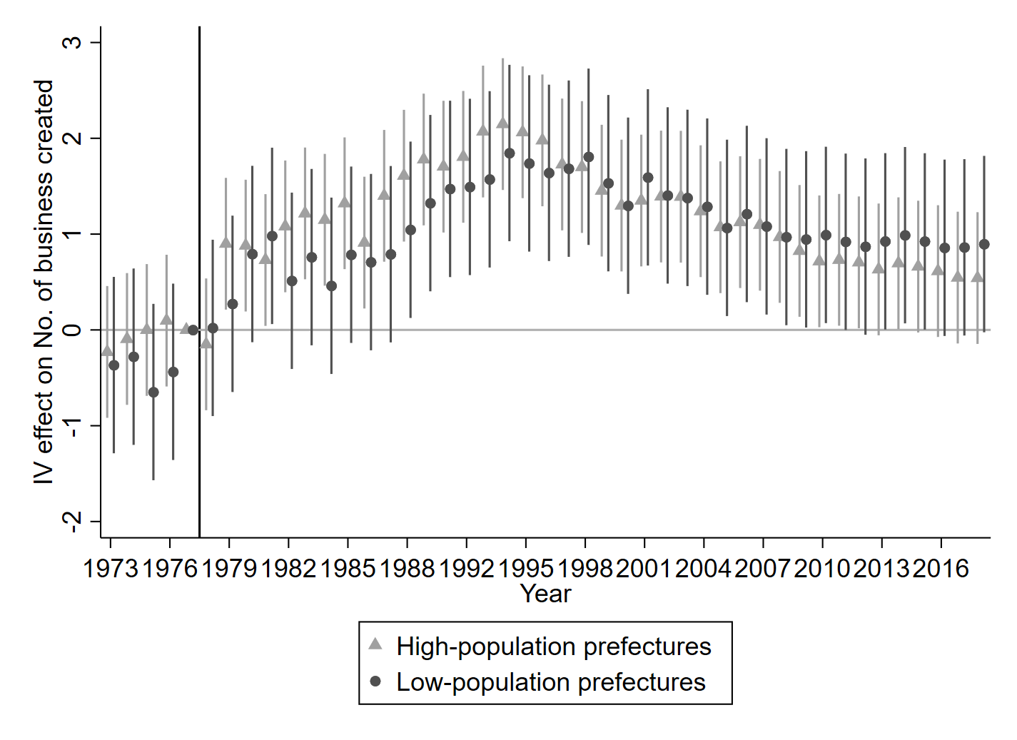
Notes: Reporting 95% confidence intervals. Standard errors clustered at the prefecture level.

Figure A16: Dynamic effect of the historical chamber system on firm creations, by guild presence: IV estimates using distance to telegraph lines
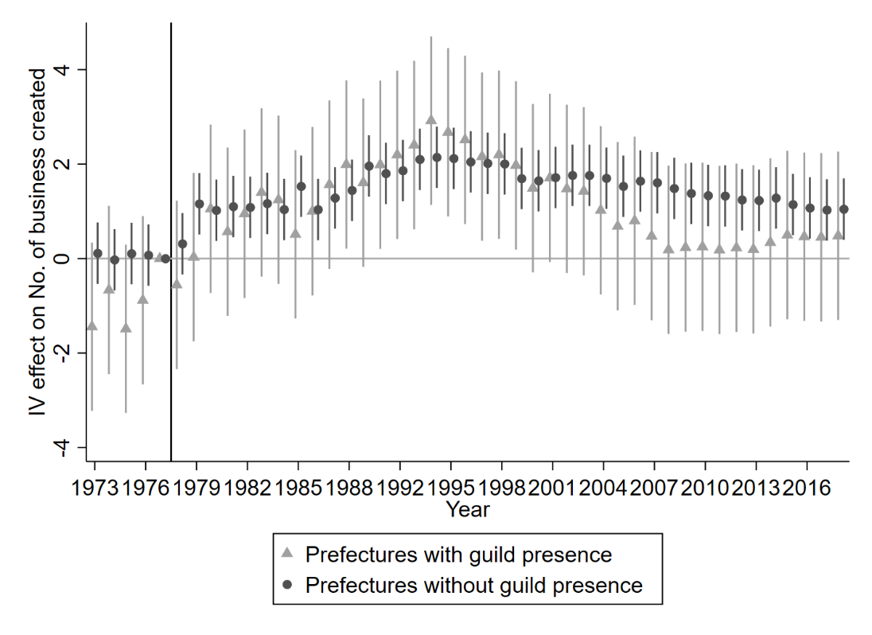
Notes: Reporting 95% confidence intervals. Standard errors clustered at the prefecture level.

Figure A17: Dynamic effect of the historical chamber system on firm creations, by official importance of prefectures: IV estimates using distance to telegraph lines
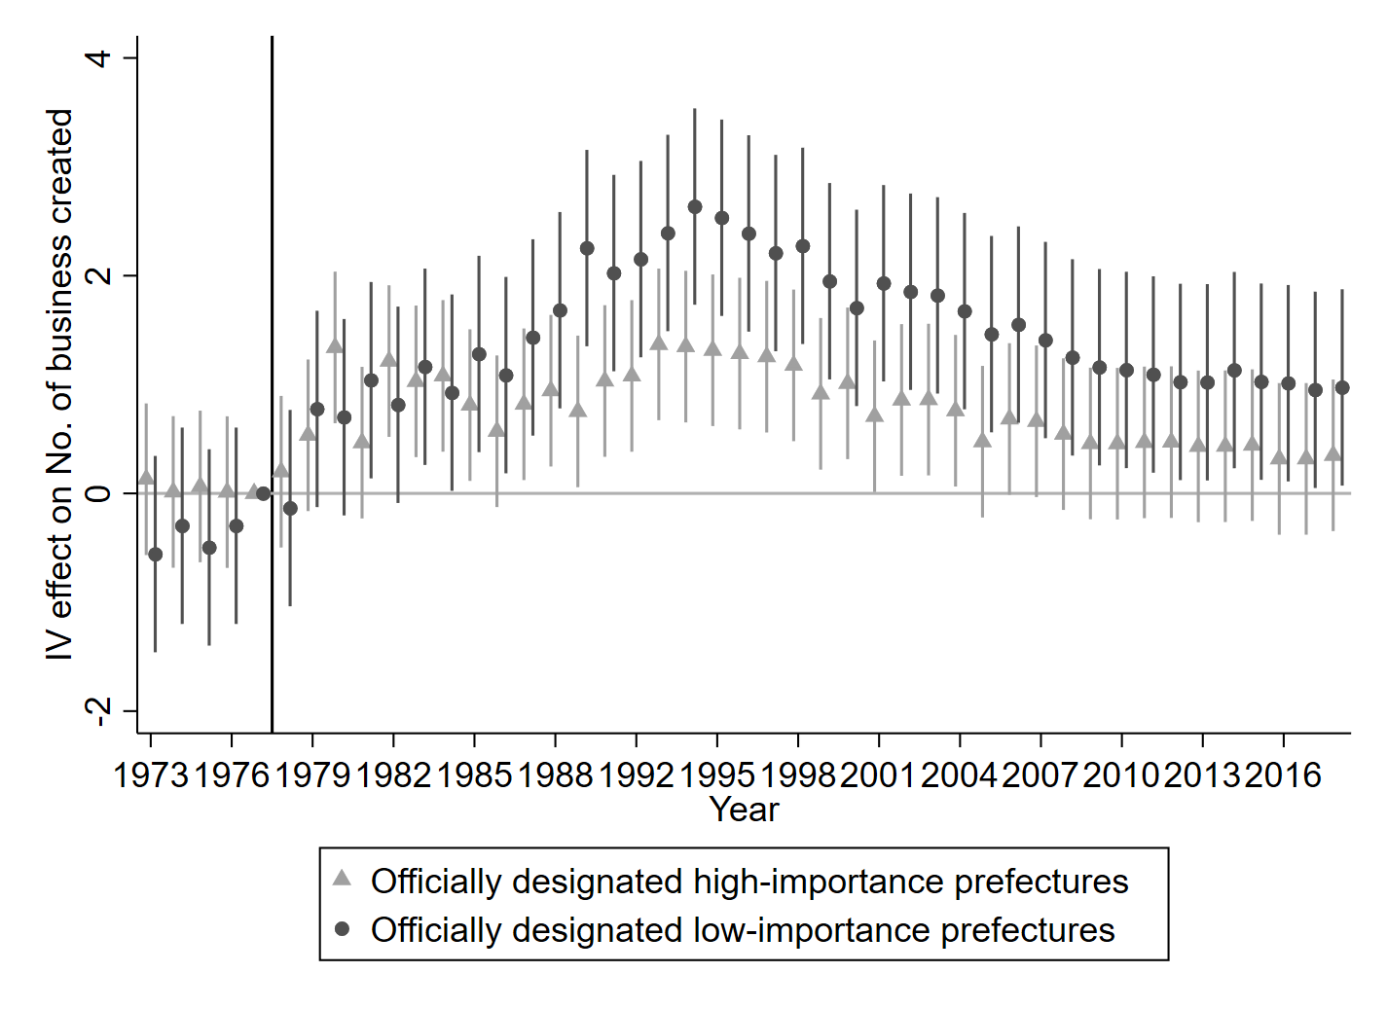
Notes: Reporting 95% confidence intervals. Standard errors clustered at the prefecture level.

Figure A18: Dynamic effect of the historical chamber system on firm creations, by 1911 railway connection: IV estimates using distance to telegraph lines
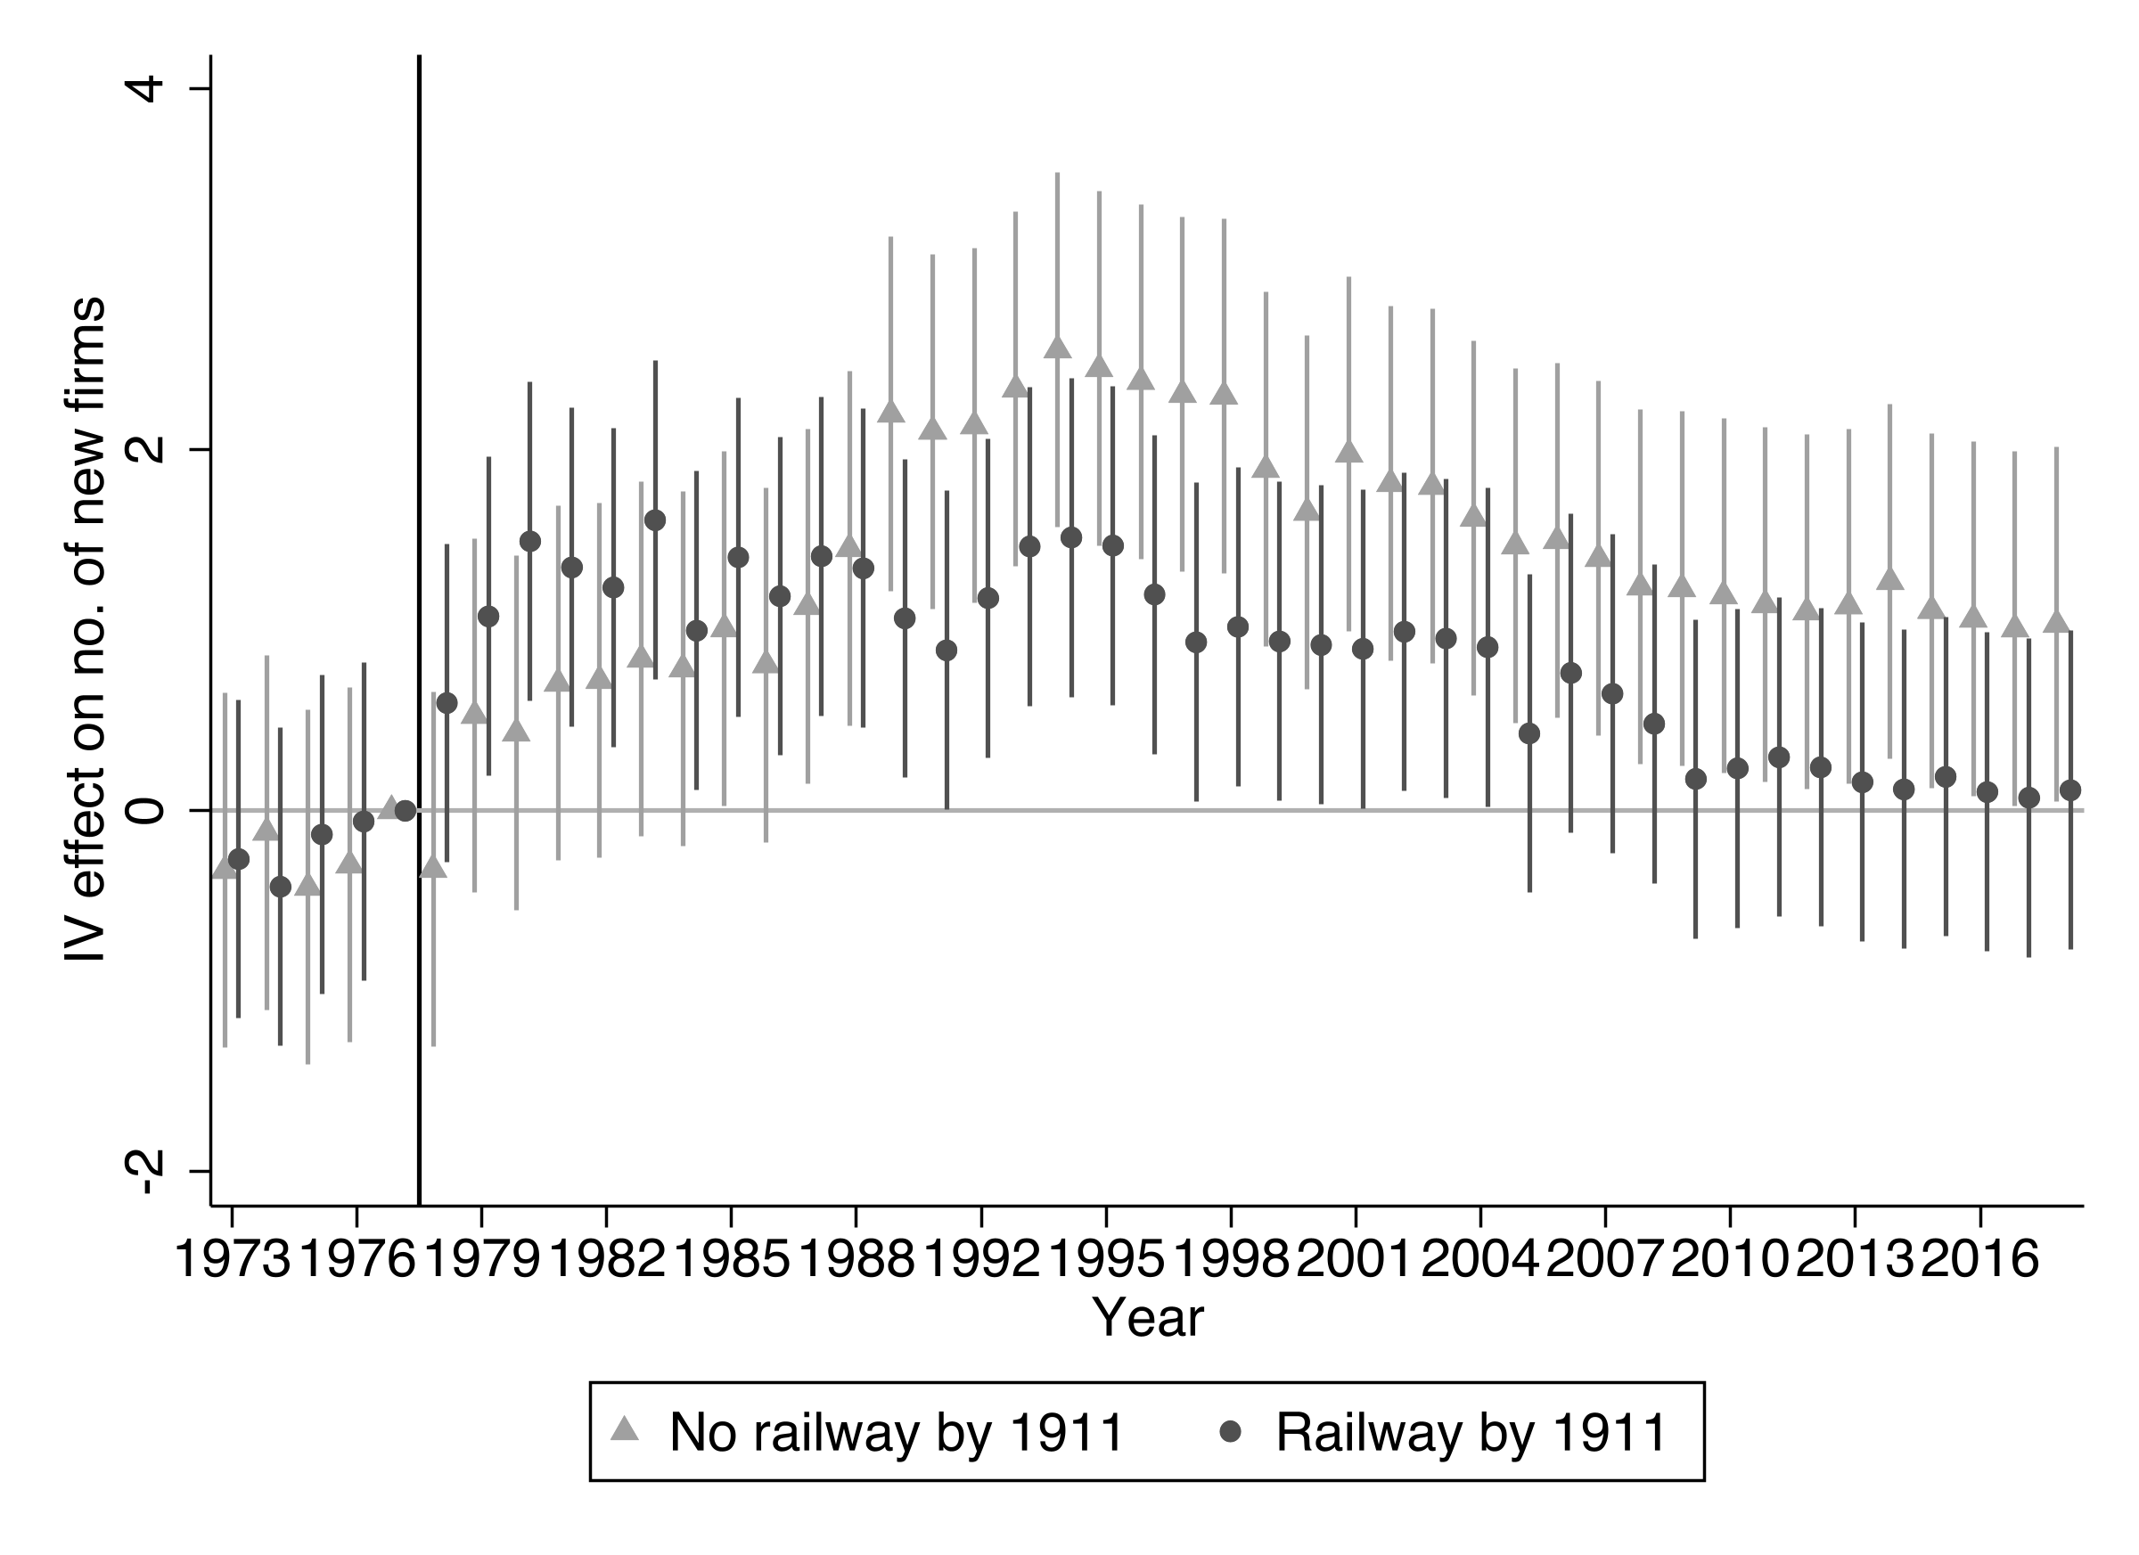
Notes: Reporting 95% confidence intervals. Standard errors clustered at the prefecture level.

Figure A19: Dynamic effect of the historical chamber system on firm creations: IV estimates using using chamber establishment time
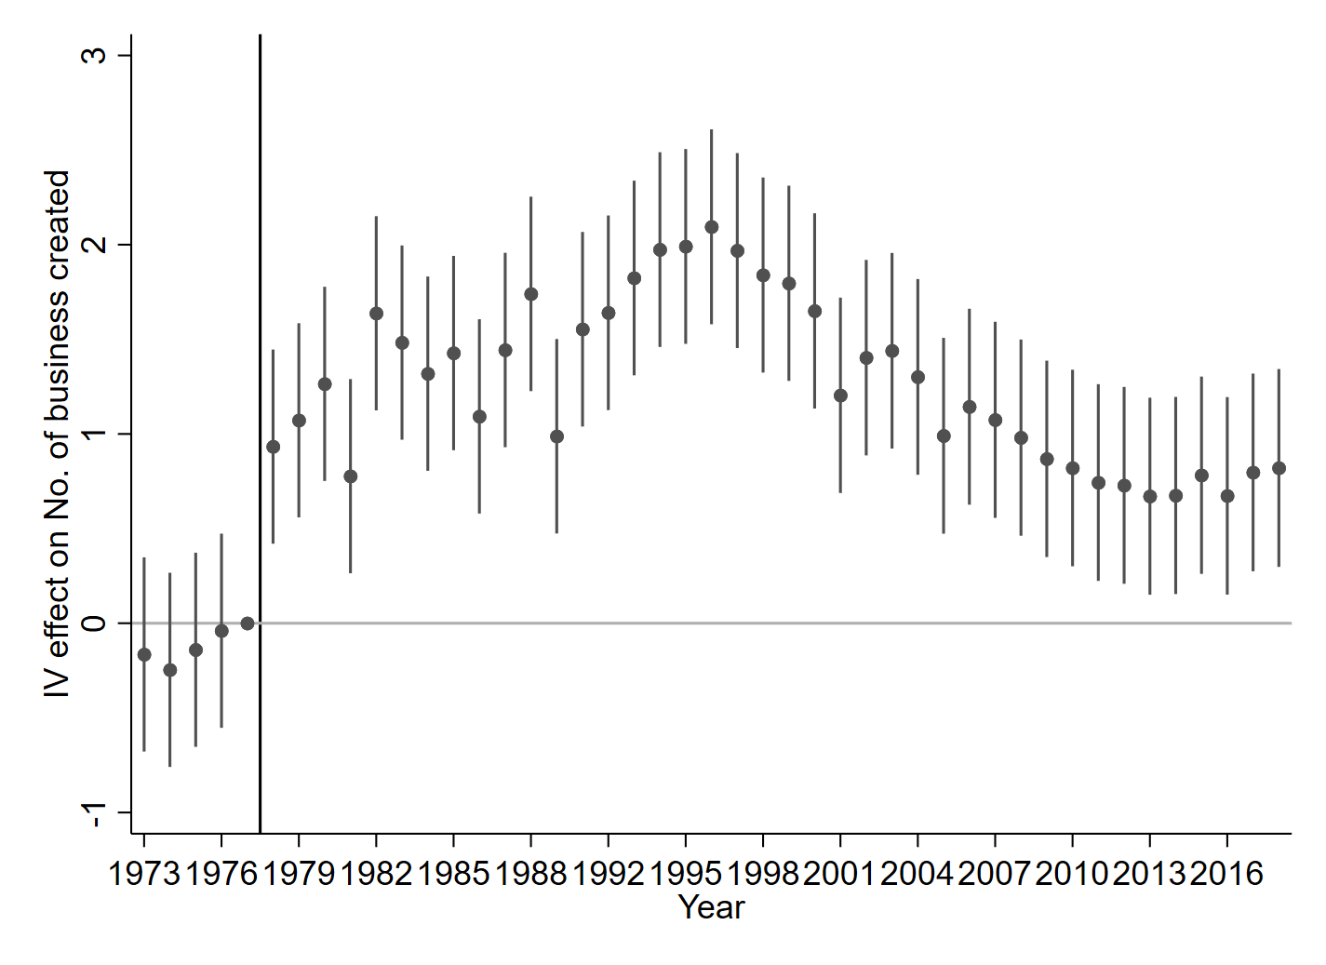
Notes: Reporting 95% confidence intervals. Standard errors clustered at the prefecture level.

Figure A20: Dynamic effect of the historical chamber system on employment of newly registered firms: IV estimates using distance to telegraph lines
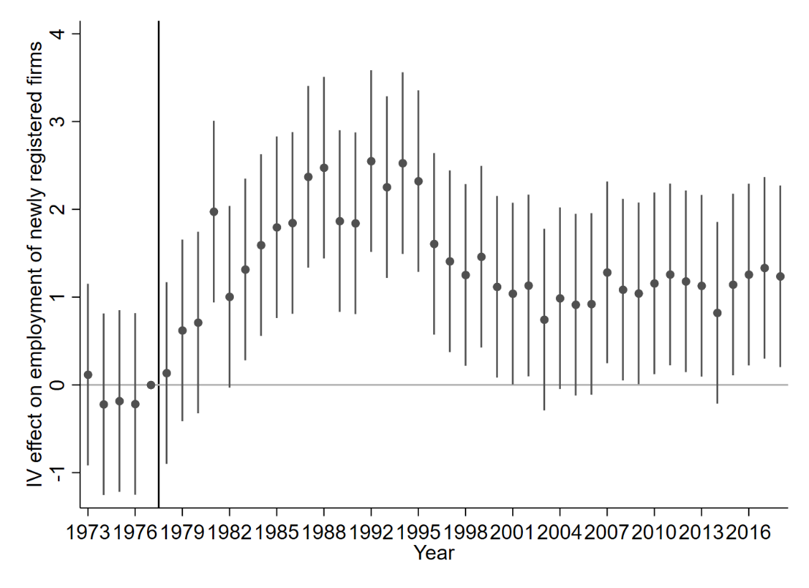
Notes: Reporting 95% confidence intervals. Standard errors clustered at the prefecture level.

Figure A21: Dynamic effect of the historical chamber system on asset of newly registered firms: IV estimates using distance to telegraph lines
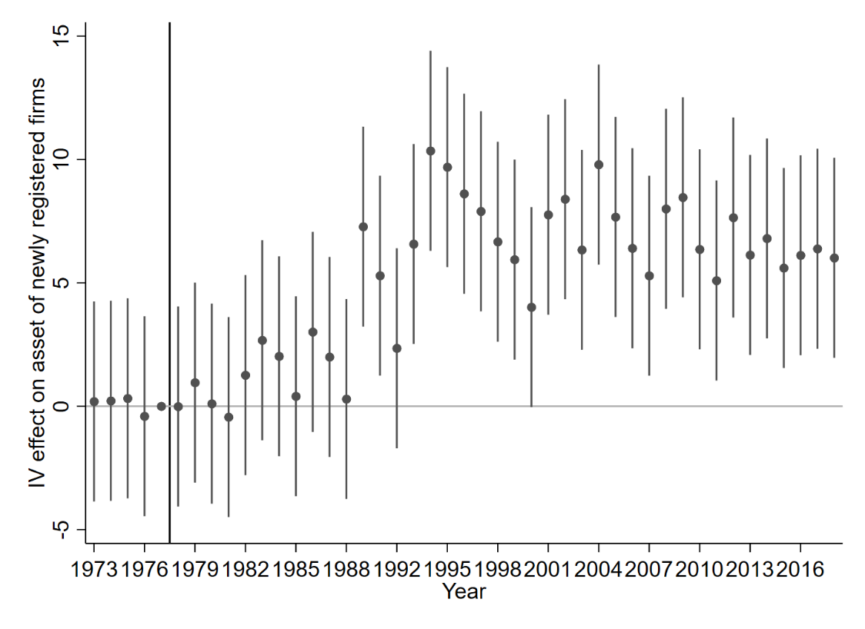
Notes: Reporting 95% confidence intervals. Standard errors clustered at the prefecture level.

Appendix Tables

Table A1: Non-native rate of elites of non-elites in Shanghai and Shengze chambers
 | Shanghai Chamber |  |  |  | Shengze Chamber
Year | elites | non-elites | total | elites | non-elites | total
1906 | 76.19% | 68.97% | 70.89% | 44.44% | 40.00% | 41.18%
1907 |  |  |  | 54.55% | 51.61% | 52.38%
1908 | 66.67% | 67.14% | 67.03% | 54.55% | 51.61% | 52.38%
1909 | 57.14% | 62.12% | 60.92% | 63.64% | 58.06% | 59.52%
1910 | 57.14% | 68.12% | 65.56%
1911 | 57.14% | 74.00% | 69.01%
Notes: This table shows that non-native rates in Shanghai and Shengze chambers respectively. The data is collected from Chen (2011). It proves that, even in the early stage of establishment, chamber system was not restricted their memberships by the clans and birthplaces. Both elite and non-elite groups have a very high percentage of non-natives across years.

Table A2: Summary Statistics
 | Sources | Obs. | Mean | S.D.
(a) Outcome variables
No. of business created | 1 | 11,430 | 5.75 | 3.32
Avg. employee of new firms | 1 | 11,430 | 5.17 | 3.78
Avg. asset of new firms | 1 | 11,430 | 15.30 | 10.86
(b) Variable of interest
Chamber density | 2, 3 | 11,430 | 1.25 | 1.12
(c) Instrument variables
Distance to telegraph | 4 | 11,430 | 8.16 | 5.13
Chamber establishment time | 2 | 11,430 | 1908.12 | 2.65
(d) Geographic controls
Wheat suitability | 5 | 11,430 | 8.46 | 0.49
Rice suitability | 5 | 11,430 | 7.50 | 1.79
Sweet potato suitability | 5 | 11,430 | 4.59 | 4.08
Fox millet suitability | 5 | 11,430 | 7.87 | 1.44
Maize suitability | 5 | 11,430 | 8.26 | 1.01
Elevation | 6 | 11,430 | 5.84 | 1.51
Longitude | 6 | 11,430 | 30.97 | 5.16
Latitude | 6 | 11,430 | 111.79 | 5.85
(e) Socio-economic controls
Population | 3 | 11,430 | 4.61 | 1.05
Guild | 7 | 11,430 | 0.35 | 0.48
Treaty port | 8 | 11,430 | 0.07 | 0.25
Political importance | 9 | 11,430 | 0.66 | 0.47
Distance to coast | 6 | 11,430 | 12.64 | 1.24
Distance to canal | 6 | 11,430 | 13.13 | 1.14

Sources:
1. Business Registry Data
2. Agriculture and Commercial Statistical Tables of the Republic of China
3. Ge (2000), China Population History
4. Complete Official Map of the Great Qing Empire (1905), compiled and printed by the Commercial Press
5. FAO GAEZ v5, https://data.apps.fao.org/gaez/?lang=en
6. China Historical GIS, http://chgis.fas.harvard.edu/.
7. Liu et al. (2021), Long-term Economic Consequences of Traditional Business Culture: Evidence from Ming-Qing Guilds
8. Jia (2014), The Legacies of Forced Freedom: China’s Treaty Ports
9. Veritable Records of the Qing Dynasty

Table A3: Impact of historical chamber system on firm creations post-1978 economic reform, replacing the outcome variable with the inverse hyperbolic sine transformation
 | No. of business created (IHS)
 | (1) | (2) | (3) | (4)
Chamber density × Post | 0.431*** | 0.331*** | 0.424*** | 0.533***
 | (0.0705) | (0.0618) | (0.0581) | (0.0611)
Prefecture FE | Yes | Yes | Yes | Yes
Year FE | Yes | Yes | Yes | Yes
Geographic controls | No | Yes | Yes | Yes
Socio-economic controls | No | No | Yes | Yes
Province year trend | No | No | No | Yes
Observations | 11,430 | 11,430 | 11,430 | 11,430
R-squared | 0.949 | 0.952 | 0.953 | 0.957
Notes: The sample consists of 254 prefectures from 1973 to 2017. Standard errors clustered at the prefecture level are in parentheses. ***, **, and * indicate significant at the 1, 5, and 10 percent levels, respectively.

Table A4: Impact of historical chamber system on firm creations post-1978 economic reform, replacing the denominator with land size
 | No. of business created (logged)
 | (1) | (2) | (3) | (4)
Chamber density × Post | 0.244*** | 0.193*** | 0.180*** | 0.235***
 | (0.0255) | (0.0288) | (0.0284) | (0.0306)
Prefecture FE | Yes | Yes | Yes | Yes
Year FE | Yes | Yes | Yes | Yes
Geographic controls | No | Yes | Yes | Yes
Socio-economic controls | No | No | Yes | Yes
Province year trend | No | No | No | Yes
Observations | 11,430 | 11,430 | 11,430 | 11,430
R-squared | 0.952 | 0.954 | 0.954 | 0.958
Notes: The sample consists of 254 prefectures from 1973 to 2017. Standard errors clustered at the prefecture level are in parentheses. ***, **, and * indicate significant at the 1, 5, and 10 percent levels, respectively.

Table A5: Impact of historical chamber system on firm creations post-1978 economic reform, standard errors are clustered at the province level
 | No. of business created (logged)
 | (1) | (2) | (3) | (4)
Chamber density × Post | 0.470*** | 0.366*** | 0.456*** | 0.557***
 | (0.0804) | (0.0611) | (0.0487) | (0.0530)
Prefecture FE | Yes | Yes | Yes | Yes
Year FE | Yes | Yes | Yes | Yes
Geographic controls | No | Yes | Yes | Yes
Socio-economic controls | No | No | Yes | Yes
Province year trend | No | No | No | Yes
Observations | 11,430 | 11,430 | 11,430 | 11,430
R-squared | 0.950 | 0.953 | 0.953 | 0.956
Notes: The sample consists of 254 prefectures from 1973 to 2017. Standard errors clustered at the province level are in parentheses. ***, **, and * indicate significant at the 1, 5, and 10 percent levels, respectively.

Table A6: Balance tests on distance to telegraph lines
 | Distance to telegraph lines
 | (1) | (2) | (3)
 | Geographic characteristics characteristics | Socio-economic characteristics | Geographic characteristics + Socio-economic characteristics
Wheat suitability | -0.658 |  | -0.917
 | (1.032) |  | (1.060)
Rice suitability | 0.0820 |  | 0.0410
 | (0.234) |  | (0.217)
Sweet potato suitability | 0.214 |  | 0.141
 | (0.126) |  | (0.165)
Fox millet suitability | -0.256 |  | -0.246
 | (0.181) |  | (0.276)
Maize suitability | 0.358 |  | 0.415
 | (0.372) |  | (0.385)
Elevation | 0.00119 |  | 0.00101
 | (0.000749) |  | (0.000759)
Longitude | -0.0486 |  | 0.0398
 | (0.231) |  | (0.283)
Latitude | 0.0860 |  | 0.0312
 | (0.195) |  | (0.177)
Population |  | -0.141 | 0.0492
 |  | (0.222) | (0.293)
Guild |  | 1.133 | 0.610
 |  | (1.640) | (1.502)
Treaty port |  | -3.496 | -3.116
 |  | (2.271) | (2.322)
Political importance |  | -1.411* | -1.401*
 |  | (0.770) | (0.793)
Distance to coast |  | 0.307 | 0.273
 |  | (0.305) | (0.460)
Distance to canal |  | 0.536 | 0.269
 |  | (0.580) | (0.430)
Province FE | Yes | Yes | Yes
Observations | 254 | 254 | 254
R-squared | 0.416 | 0.422 | 0.431
Notes: Standard errors clustered at the prefecture level are in parentheses. ***, **, and * indicate significant at the 1, 5, and 10 percent levels, respectively.

Table A7: Balance tests on chamber establishment time
 | Chamber establishment time
 | (1) | (2) | (3)
 | Geographic characteristics characteristics | Socio-economic characteristics | Geographic characteristics + Socio-economic characteristics
Wheat suitability | 0.815 |  | 0.672
 | (1.203) |  | (1.057)
Rice suitability | 0.00256 |  | -0.0378
 | (0.122) |  | (0.149)
Sweet potato suitability | -0.0236 |  | -0.0714
 | (0.105) |  | (0.111)
Fox millet suitability | -0.273** |  | -0.241
 | (0.121) |  | (0.142)
Maize suitability | -0.0459 |  | 0.0100
 | (0.565) |  | (0.536)
Elevation | 0.00141*** |  | 0.00121**
 | (0.000462) |  | (0.000555)
Longitude | -0.0590 |  | -0.0521
 | (0.131) |  | (0.146)
Latitude | 0.0764 |  | 0.0712
 | (0.162) |  | (0.171)
Population |  | -0.162 | 0.0603
 |  | (0.124) | (0.149)
Guild |  | -0.171 | 0.130
 |  | (0.938) | (1.030)
Treaty port |  | -2.296** | -2.030**
 |  | (1.028) | (0.959)
Political importance |  | 0.0641 | 0.00140
 |  | (0.166) | (0.173)
Distance to coast |  | 0.525* | 0.382
 |  | (0.302) | (0.274)
Distance to canal |  | -0.496* | -0.484*
 |  | (0.241) | (0.249)
Province FE | Yes | Yes | Yes
Observations | 254 | 254 | 254
R-squared | 0.432 | 0.407 | 0.451
Notes: Standard errors clustered at the prefecture level are in parentheses. ***, **, and * indicate significant at the 1, 5, and 10 percent levels, respectively.

Table A8: Impact of historical chamber system on firm creations post-1978 economic reform: IV estimates using chamber establishment time
Panel A | No. of business created (logged) |  |  | Avg. employee of new firms (logged) | Avg. asset of new firms (logged)
 | (1) | (2) | (3) | (4) | (5)
Chamber density × Post | 1.364*** | 0.787*** | 1.038*** | 1.380*** | 2.738***
 | (0.335) | (0.115) | (0.127) | (0.169) | (0.462)
Panel B | First stage
Chamber establishment time × Post | -0.119*** | -0.125*** | -0.120*** | -0.120*** | -0.120***
 | (0.00994) | (0.00922) | (0.00903) | (0.00903) | (0.00903)
Prefecture FE | Yes | Yes | Yes | Yes | Yes
Year FE | Yes | Yes | Yes | Yes | Yes
Geographic controls | No | Yes | Yes | Yes | Yes
Socio-economic controls | No | Yes | Yes | Yes | Yes
Province year trend | No | No | Yes | Yes | Yes
Observations | 11,430 | 11,430 | 11,430 | 11,430 | 11,430
R-squared | 0.921 | 0.959 | 0.960 | 0.960 | 0.960
Kleibergen-Paap rk Wald F statistic | 17.992 | 143.432 | 143.867 | 143.867 | 143.867
Notes: The sample consists of 254 prefectures from 1973 to 2017. Standard errors clustered at the prefecture level are in parentheses. ***, **, and * indicate significant at the 1, 5, and 10 percent levels, respectively.

Table A9: Impact of historical chamber system on bridging social capital, proxied by social organisations
 | Bridging social capital
 | (1) | (2) | (3) | (4)
 | No. of social organisations (1950-1977) |  | No. of social organisations (1978-2017)
 | OLS | IV | OLS | IV
Chamber density | 0.478*** | 1.487*** | 0.499*** | 1.536***
 | (0.0691) | (0.383) | (0.0845) | (0.424)
Province FE | Yes | Yes | Yes | Yes
Geographic controls | Yes | Yes | Yes | Yes
Socio-economic controls | Yes | Yes | Yes | Yes
Observations | 254 | 254 | 254 | 254
Notes: The sample consists of 254 prefectures. Standard errors clustered at the prefecture level are in parentheses. ***, **, and * indicate significant at the 1, 5, and 10 percent levels, respectively.

Table A10: Impact of historical chamber system on bonding social capital, proxied by genealogies
 | Bonding social capital
 | (1) | (2) | (3) | (4)
 | No. of genealogies (1950-1977) |  | No. of genealogies (1978-2017)
 | OLS | IV | OLS | IV
Chamber density | 0.205*** | 0.701*** | 0.299*** | 0.839***
 | (0.0568) | (0.251) | (0.0594) | (0.299)
Province FE | Yes | Yes | Yes | Yes
Geographic controls | Yes | Yes | Yes | Yes
Socio-economic controls | Yes | Yes | Yes | Yes
Observations | 254 | 254 | 254 | 254
Notes: The sample consists of 254 prefectures. Standard errors clustered at the prefecture level are in parentheses. ***, **, and * indicate significant at the 1, 5, and 10 percent levels, respectively.

Appendix B. Construction of historical and contemporary data
This appendix expands on the data sources described in Section 4.1 of the main text, providing additional detail on the construction of the historical chamber data, the matching of historical and contemporary boundaries, the firm registry data, the ACFIC gazetteer data, and the telegraph network used as our instrument.
B.1 Historical chamber data
Our chamber data are drawn from the Statistics of Agriculture and Commerce, the statistical yearbook compiled by the Ministry of Agriculture and Commerce of the Republic of China and published in the 1910s. We manually digitised the 1915 volume from scanned originals and cross-checked each entry against the source. The 1915 volume was chosen because it provides the most comprehensive coverage of chambers across China Proper. In the source, each chamber is recorded as a separate entry, with the chamber name, type, establishment year, location, number of board members, number of registered members, frequency of meetings, number of disputes settled, and revenues and spendings each entered as separate fields. Chambers were registered in cities and towns within each prefecture-level unit (fu, zhou or ting) of the late Qing administration, and we aggregate all chambers within a prefecture to the prefecture level.
Two coding decisions warrant explanation. First, within a province that the source surveys, a prefecture for which no chamber entry appears, while other prefectures in the same province are recorded, is coded as zero; we cross-check the adjacent-year volumes of the same source to confirm that the prefecture genuinely had no registered chamber rather than that the entry was simply omitted. Second, the source provides no systematic chamber statistics for seven outer and frontier provinces (Outer Mongolia, Inner Mongolia, Jilin, Heilongjiang, Xinjiang, Qinghai, and Tibet), which reflects the limited administrative reach of the Ministry of Agriculture and Commerce in these regions at the time rather than a genuine absence of commercial organisation. Coding the prefectures of these unsurveyed provinces as zero would introduce systematic measurement bias, so we exclude these provinces entirely. Our analysis therefore covers the prefectures of the eighteen provinces of China Proper together with Fengtian.
B.2 Historical and contemporary prefecture boundaries
For the historical boundaries we use the prefecture-level administrative layer of the CHGIS v6 1911 dataset (China Historical GIS, Harvard University), which represents the first-order sub-provincial units of the late Qing and comprises fu, zhou and ting. We treat these uniformly as prefectures. This is both administratively appropriate, since these units occupied the same tier of the late-Qing hierarchy directly below the province, and consistent with the prefecture-level approach to late-Qing China adopted in the economic-history literature (Jia, 2014; Wang, Rodríguez-Pose and Lee, 2021). The matching to contemporary administrative units differs by outcome variable.
For the firm-creation outcome that drives our principal analysis (Sections 5.1 to 5.3, Tables 1 to 3), the firm-level registry data record the geographic coordinates of each firm at its registered address. We therefore perform a point-in-polygon spatial join of each firm against the CHGIS v6 1911 prefecture polygons, which assigns every firm directly to the historical prefecture whose territory contains its registered location. This requires no boundary crosswalk and no within-prefecture distribution assumption.
For the cross-sectional GDP outcome (Section 5.4, Table 4), GDP per capita is observed only at modern prefecture boundaries. Following the procedure described in Section 5.4, we estimate GDP per capita at the modern prefecture boundaries, divide it using the historical CHGIS v6 1911 boundaries, assume that economic output is evenly distributed within each modern prefecture to obtain the GDP per capita of each boundary segment, and aggregate the segments to the historical prefecture level. Because the even-distribution assumption is a simplification, we validate the GDP results against the pixel-level VIIRS nighttime luminosity outcome (Table 4 columns (3)–(4)), which does not require any disaggregation assumption, as discussed in the caveat in Section 5.4.
B.3 Business registry data (NECIPS)
Our firm-level data are drawn from the National Enterprise Credit Information Publicity System (NECIPS), the public business registry maintained by the State Administration for Market Regulation and its predecessor, the State Administration for Industry and Commerce. We access these records through Tianyancha, a commercial business-information platform that aggregates and indexes the registry alongside historical registration archives. We cross-validated a random sub-sample of records against the official NECIPS portal and found no systematic discrepancies.
The registry is a database that was assembled from the late 2000s onward, with comprehensive quality achieved by the early 2010s (Bai et al., 2020). Each firm record carries the firm’s original registration date, which for many firms extends back to the 1970s. Historical coverage is therefore necessarily retrospective and subject to survivorship: firms that were still registered, or whose records were retained, at the time the database was compiled are captured with their original registration date, whereas firms that registered and were deregistered well before compilation are progressively under-represented the earlier the period. This attenuation is smooth over time rather than a discrete break, and is most pronounced in the pre-reform years, consistent with the smaller but non-zero pre-1978 variation noted in Section 4.1. Two implications for identification follow. First, our DID specification (Equation 1) absorbs any time-invariant prefecture-level differences in reporting completeness through the prefecture fixed effects, so geographic differences in historical coverage do not bias the post-1978 differential. Second, because the pre-1978 baseline serves as our reference period and lower coverage there attenuates rather than amplifies cross-prefecture variation, any residual bias from retrospective compilation is conservative for our estimates.
B.4 ACFIC incorporation data
The ACFIC incorporation variable used in Section 6.2 measures the number of entrepreneurs incorporated into the All-China Federation of Industry and Commerce in the early 1950s. The data were compiled manually from local gazetteers (difangzhi) catalogued in the Wanfang Data digital archive. For each county, we located the Federation of Industry and Commerce chapter in the local gazetteer and extracted the reported aggregate count of entrepreneurs incorporated into ACFIC around 1952. The procedure yielded county-level observations, which we then aggregate to the historical prefectures via the CHGIS v6 1911 polygon overlay. Counties for which no gazetteer is digitally available in Wanfang Data, or for which the digitised gazetteer does not include a Federation chapter, are coded as zero. This is a known limitation of the new dataset: such zeros may reflect either genuinely limited ACFIC incorporation or simply incomplete gazetteer digitisation. As with the registry coverage issue discussed in Appendix B.3, the prefecture fixed effects absorb time-invariant differences in gazetteer availability across regions.
B.5 Telegraph network and instrumental variable construction
Our instrumental variable is the Euclidean distance from each historical prefecture centroid to the nearest telegraph line on the 1903 imperial telegraph network. The underlying network is digitised from the Postal Working Map of China, drafted on 13 May 1903 by the Postal Secretary’s Office of the Inspectorate General of Customs and Post in Beijing, and printed by the Oriental Press in Shanghai on 15 May 1903 (a copy of the map is held by the Royal Geographical Society in London, shelf-mark mr Chins G31). The map depicts the post and telegraph network of the Qing Empire as of 1903. We georeferenced this map against the CHGIS v6 1911 prefecture shapefile and digitised the visible telegraph lines as vector geometry. The network is consistent with the broader history of Qing telegraph expansion documented by Baark (1997) and with the 1870 to 1904 telegraph network used by Gao and Lei (2021).
We use the 1903 cross-section of the network because it predates the introduction of the chamber system in 1904 by one year, which satisfies the exogeneity requirement of the instrument: by construction, telegraph placement could not have been determined by chamber-level variables that did not yet exist. For each historical prefecture, we compute the Euclidean distance from the centroid of the CHGIS 1911 polygon to the nearest digitised telegraph line and take its natural logarithm. This is the variable used as our excluded instrument in the DID-IV specifications of Section 5.3 and Table 3.

