Pre-intervention interview protocol
Participants were posed the following questions. In addition, they were also posed clarification questions (e.g., what do you mean when you say "theory"?) or requests to elaborate (e.g., can you say more about this?). The questions were selected predominantly to elicit the students' initial NOS considerations, but also their initial views of what statistics and science are.
- In your opinion, what is science? In what ways is science different than other things?
- In your opinion, what is valued scientific knowledge?
- What do you think are the purposes or goals, in general, of scientific research?
- Is research that does not show immediate practical implications worth conducting?
- Is modern scientific knowledge better able to explain natural phenomena than knowledge from previous years?
- Do you agree that scientific knowledge is accurate and does not change over time?
- If two scientists disagree, does that necessarily mean that one of them is wrong? If so, how can one know who is right? If not, what other reasons can there be for disagreements on scientific issues?
- In your opinion, can there be instances where scientists conduct an experiment and its results do not meet their expectations? If not – please explain why. If yes – what can they do in these situations?
- In your opinion, what is statistics?
- In your opinion, what is data analysis?

Introduction activity
The designed learning sequence included multiple experiences with exploratory data analysis (Tukey, 1977), informal statistical inference (Makkar, Bakker, & Ben-Zvi, 2011), and statistical modeling (Dvir & Ben-Zvi, 2018), adapted to the purposes of the Radon scientists and the scientific knowledge about Radon that students will need to discover (i.e., its temporal variation). The activity sequence was also infused with prompts to elicit explicit expressions of the students’ NOS understandings.
Having completed their pre-test interviews, the students engaged in an introduction activity, intended to provide them with the basic necessary background (e.g., they did not learn about the Radon's temporal variation as they were intended to discover it through the data they will begin to examine after the introduction activity). The introduction activity consisted of two main parts, each implemented with the students in two separate sessions.
Part 1: This part of the introduction activity was guided by a worksheet with written information and questions. The pair of students were instructed to read the information, and then asked to respond together, outload, to the questions at the end of each of its sub-sections. R posed follow-up questions when necessary to either elicit more detailed responses or clarification of the students' intended meaning. The sub-sections were:
- Let's meet the Radon Gas – the sub-section provided basic information about the Radon gas, its properties and dangers. Figure 13 summarized the written information that the students were instructed to read.
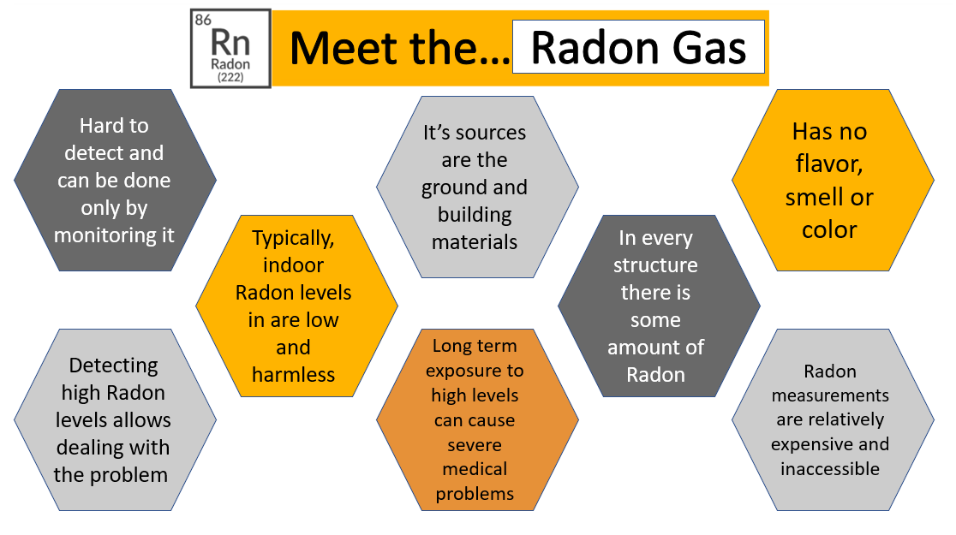
Figure 13: Summary of the basic information about the Radon gas, covered by the written materials of the introduction activity
- What is Citizen Science? – the sub-section provided basic information about Citizen Science, examples of Citizen Science projects, and the dual benefit of Citizen Science (to science and to the participating citizens, in this case – the students).
- Welcome to the Citizen Science Radon project! – the sub-section provided basic information about the project, its scientists, and its goals. The goals that were introduced to the students were:
- Raise awareness of the issue of Radon gas, its dangers, and ways of measuring it.
- Provide general and important information to the public about the "Radon problem" and the effects and consequences of radon gas.
- Use an innovative measurement device to measure Radon concentration levels in as many homes as possible, to create a national Radon map and notify the public and the appropriate authorities of locations with dangerous Radon concentration levels.
- The measurement instruments we will use – the sub-section provided basic information about the two measurement devices that will be used to generate the data that the students will engage with throughout the project:
- A long-term, stationary measurement device that provides hourly Radon readings in the Radon scientists' laboratory;
- A short-term, portable measurement device developed by the Radon scientists that the students will use to measure Radon levels in their own bedrooms. The device provides a summative reading of the average Radon levels during the three-four days it is intended to be used.
Part 2: This part consisted of a visit to the Radon scientists' laboratory. Guided by the Radon scientists, the students were introduced to the stationary measurement tool, were explained its importance in constant monitoring of the Radon levels in the laboratory, saw where it was placed and how it operated. They also saw the setting of the lab (e.g., that the lab had no windows) and learned how the conditions in the laboratory were kept relatively stable. They then were introduced to the portable measurement tool, explained how to operate it and saw the set-up in a separate office that the scientists used to interpret its Radon readings.

