The Hidden Lessons of Scientific Writing: How Language Can Shape What Students Learn About the Nature of Science

Annelies Pieterman-Bos, Cathelijne M. Reincke, Rens van de Schoot, Marc H.W. van Mil

Science & Education

Online Resource 1 – Interview Guide English Translation

Introduction
Before we start, I will start the recorders. As you can see, I have two recorders, just to be sure. Both only record sound and I will remove the audio files after I have transcribed them.
Then on with the interview. To summarize why we do this interview: I am interested to know how you and other students think about scientific research and about the research you have performed yourself for your thesis. Feel free, during the interview, to ask me questions or to tell me if you do not really know how to answer to a question.

Thesis experience and guidance
- First, I am curious to know how you, now, look back at your internship and the writing of your thesis. Can you tell me something about that?
  - How hard did you feel it was in comparison with other courses?
  - Are there things you would do differently now?
- Can you tell me something about the guidance you received from your thesis supervisor?
  - What kind of guidance did you receive with the research design?
during the execution?
with the interpretation of the data?
with drawing conclusions?
  - Did you receive guidance of other people during your internship or during writing? If so, what type of guidance?
  - Did you receive feedback on the text? What type of feedback? Did it help you?
- In a moment we will discuss your thesis more substantively, but are there things you would like to add now about your experience with the Research project or with the guidance?

Thesis content
Then, I would like to ask you some more general questions about scientific research and writing a research article. Those questions are sometimes a bit more about knowledge, but they are not meant to quiz you. For me, it is about getting an idea of what we can improve in the bachelor program. Besides, they are often questions about which scientists have different viewpoints. So, there is no right or wrong or specific answers that I would like to hear. It is about how you think about these things. It is also okay if you take some time to think before you answer.
- What, for you, is the aim of doing biomedical research?
  - What is the aim of doing scientific research in general?
- What is the aim of writing up a study in the form of a research article?
  - Was that also how you wrote up the practical work? Or did you have another aim in mind then?
- What type of customs or rules do you adhere to when writing a research article?
  - When useful: If you would explain what a research article looks like to a new student, what would you say?
  - For example, structure
    - What goes in which section? (results vs discussion)
  - For example, language use
    - Writing down materials and methods
    - Why do you think that researchers write as little as possible from the first person? But for example, write “the data are analyzed with SPSS”? Or “the figure shows there is an association”?
  - Are there customs or rules of which you think it could or should be done differently?
- If you describe this figure in a results section, what do you write about it?
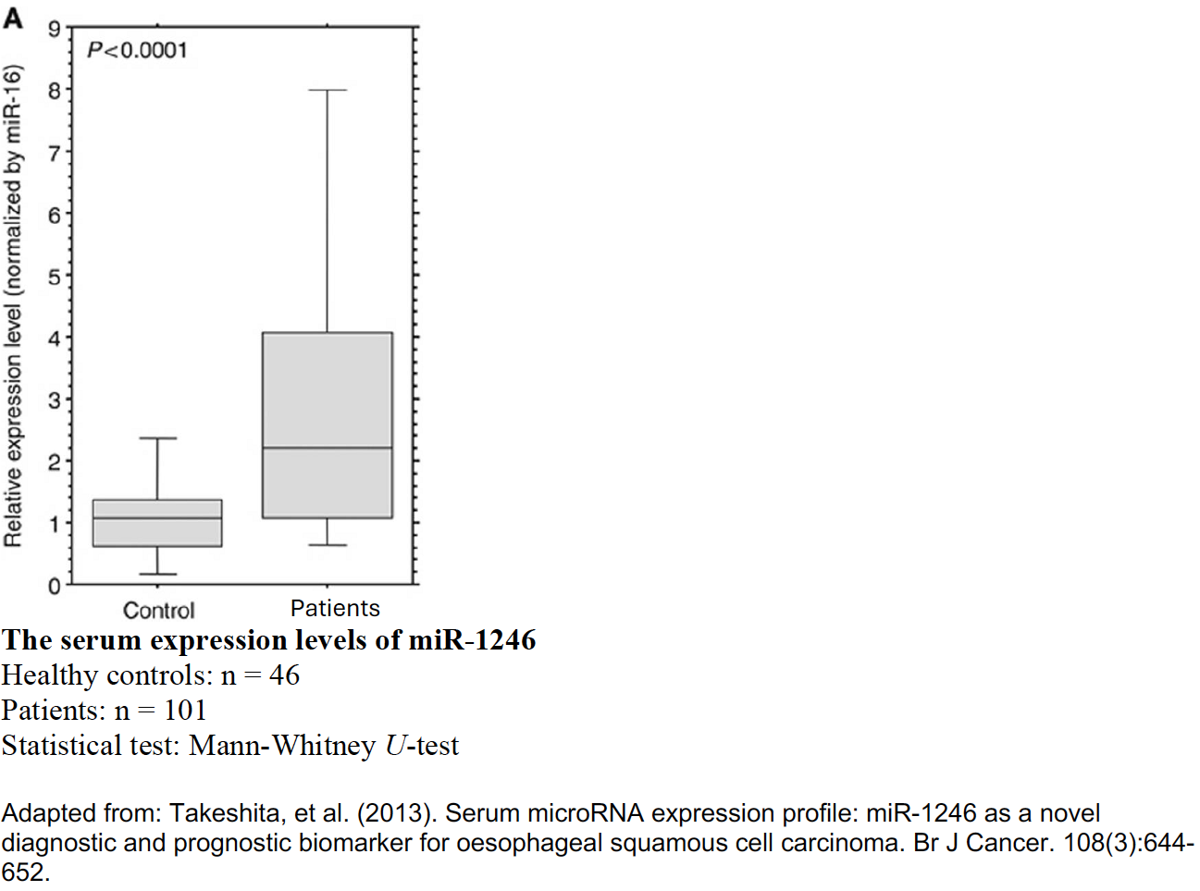
There are different ideas in science about how scientific theories are born from data. I have two statements about that. I am curious what you think about those statements.
‘Explanations and theories are logical consequences of observations. The researcher needs to present the data well, so that other researchers can draw the same conclusions.’
Or ‘Explanations and theories are devised by researchers. Only presenting data is not enough, the researcher should also argue how those data support an explanation or theory.’
With which do you agree more? You can also indicate it on the scale below.
- What should you, according to you, take into account when you are going to draw conclusions about your data?
  - Explication: You look at to what extent the data support a conclusion, but are there other things that affect the extent to which a conclusion is supported or under which circumstances?
    - Examples: Research question, method, sample, theory/lens
  - What do you write when the result is unclear or not exactly as you expected?
- If the result of a statistical test is significant, what do you write about it?
- What do you do with results that are not statistically significant?
- What is a scientific way of doing research?
  - Follow-up question: on the one hand there are scientists who say: ‘For each research question there are multiple correct ways to study that.’
On the other hand, there are scientists who say: ‘For each research question there is one correct way to study that.’ With which do you agree more?
  - We sometimes talk about “the scientific method”, what does that mean according to you?
  - What is the added value of that?
- What does well-executed scientific research yield?
- In this case, we assume that the researcher has all the necessary test subjects, materials, time, and money to execute the study.
  - Can you show me on the scale what well-executed scientific research then yields?
- Scale from: facts that are very certain to uncertain knowledge that continually changes
  - Does that differ between disciplines? For example, biomedical sciences or sociology or math or administrative science?
  - Examples to indicate on the scale:
    - DNA has a double helix structure
    - “Using serial samples from a mouse model of AML to generate time-series miRNA sequencing data, we are the first to show that the miRNA transcriptome undergoes state-transition during AML initiation and progression.”
Frankhouser, David E., et al. "Dynamic patterns of microRNA expression during acute myeloid leukemia state-transition." Science advances 8.16 (2022): eabj1664.
    - “Using serial samples from a mouse model of AML, we can confirm that the miRNA transcriptome undergoes state-transition during AML initiation and progression.”
    - Main claim in student’s own thesis
  - If you write about this in the introduction of your own research, what do you write about it?
- How objective or subjective are results of scientific research?
  - Scale from subjective to objective
  - Can we make observations and measurements neutral?
  - Should research be objective according to you?
  - Have you heard of aiming for intersubjectivity instead of objectivity? What does that mean according to you? What do you think about it?
- Does it matter who executes the research for the results that come out of it?
  - Yes: Can you explain how?
    - Society in which the scientist lives
    - Scientists as product of culture
    - Power structures
    - Politics
    - Socio-economic factors
    - Philosophy, norms and values
    - Religion
  - No: There are scientists who say that the society and culture in which the researcher lives form the person and because of that also affect what the researcher does or does not see and the theories that they form based on data. There are also scientists who say that that does not matter at all. What do you think about this?
  - Do you feel that we should prevent the influence of culture and society?
- What makes a scientific study valuable or good, to you?
  - Does the size of the effect matter? Example figures:
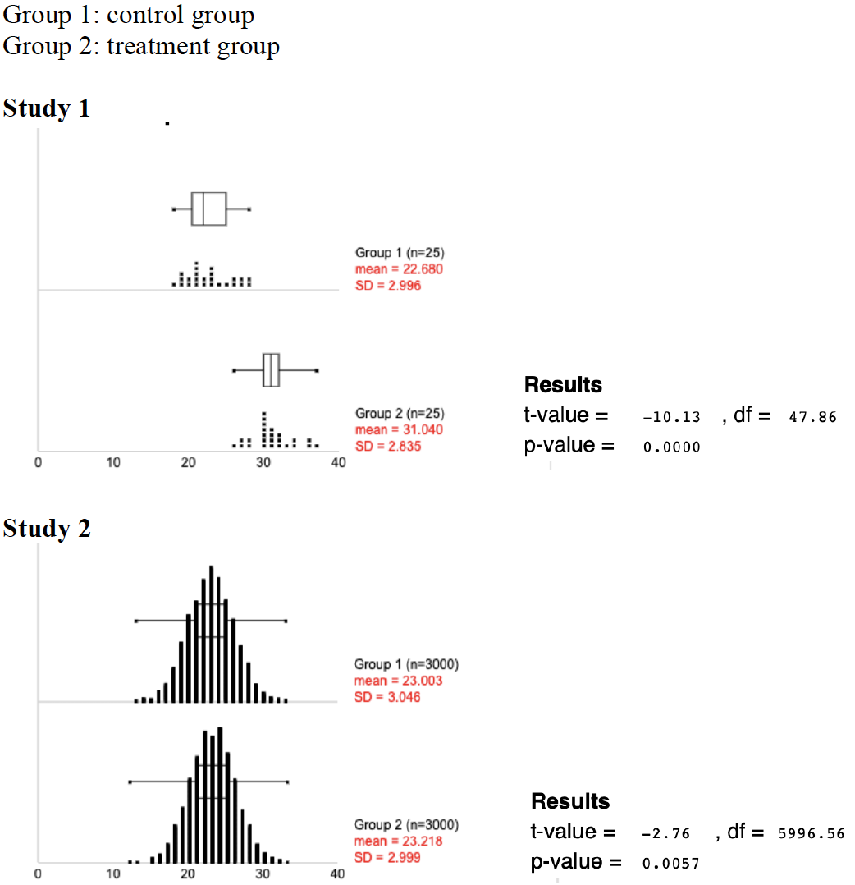
  - Example sentences from an article in which the effect has been made bigger (inflation of the effect)
    - Why do researchers do this, do you think?
    - Can you imagine you would do this yourself?
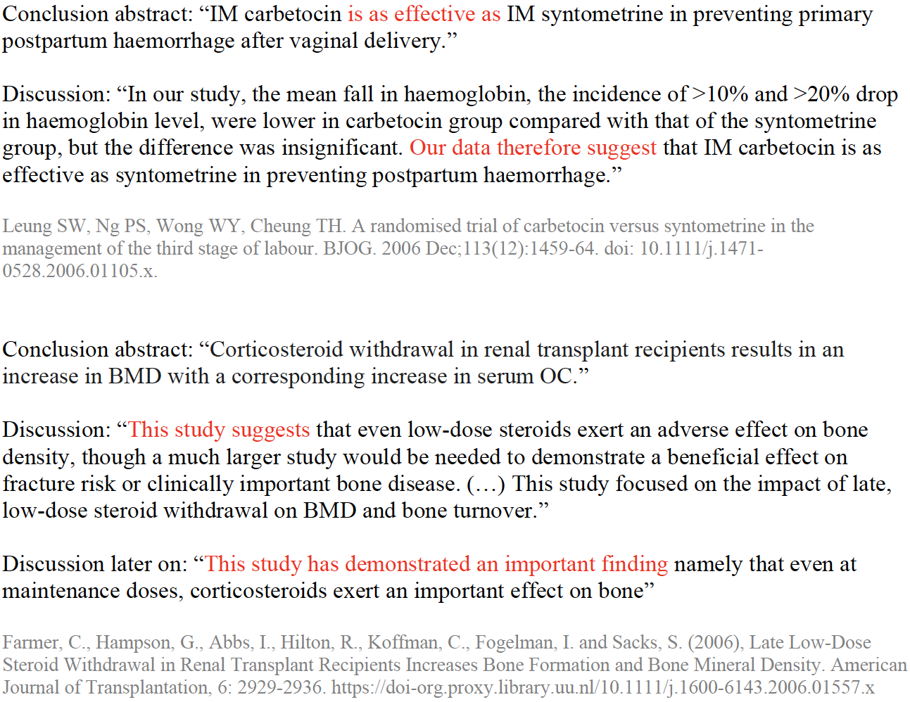
  - If it is statistically significant, does it, according to you, matter whether the size of the effect is big enough to be relevant in practice?
    - Do you feel that we should publish results that are statistically significant but not relevant? How would you handle this yourself in a research article?
- Do you view yourself as a researcher?
  - When helpful: scale from 0-10, from ‘not at all’ to ‘certainly’
  - What makes someone a researcher? What characteristics do they have?
- Are there any other things that come to mind, now that we have talked about what is scientific research and what is scientific knowledge?
  - Are there any other things you would like to come back to that we have talked about before?
- Is there something else you would like to say?

