Detailed Methods and Supplemental Results
for “Continued Post-Retraction Citation of a Fraudulent Clinical Trial Report, Eleven Years after it was retracted for Falsifying Data”

Analysis of the direct citations to the Matsuyama paper
Appendix Figure 1 outlines the process we used for analyzing the direct citations to the Matsuyama paper.
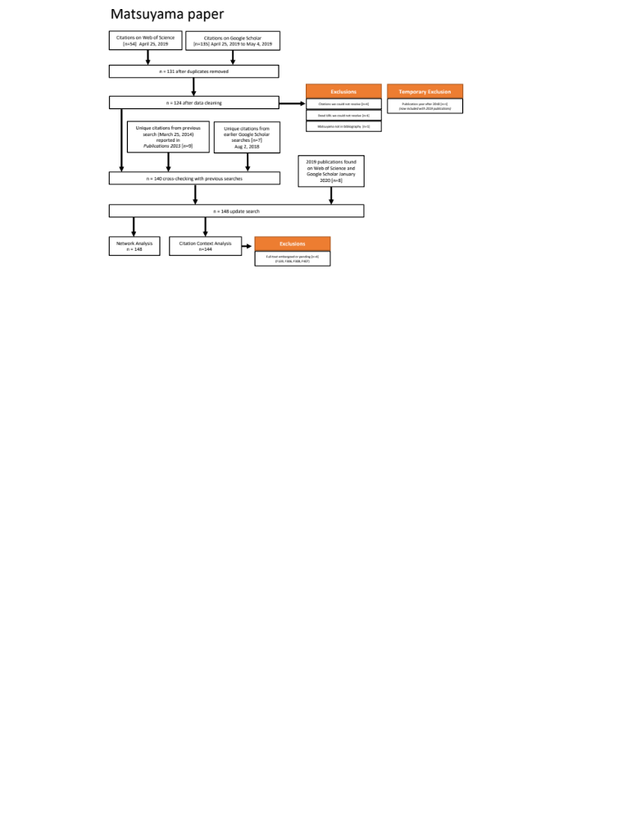
Appendix Fig. 1 Flow diagram for the analysis of the direct citations to the Matsuyama paper

Search
We searched Web of Science and Google Scholar for publications citing the Matsuyama paper. All forms of publications, published before December 31, 2019, in any language were included. Our search was conducted iteratively, as we refined our deduplication and cross-checking procedures over time. Our main data collection took place on April 25, 2019 for Web of Science and from April 25, 2019 to May 4, 2019 using Publish or Perish (Harzing, 2007) for Google Scholar. Items from publication year 2019 were temporarily excluded, and sought in an update search after year end, as described below.

Deduplication
We deduplicated records when multiple copies were found. For title matches or partial title matches, we compared the full metadata record (author, publisher, etc.) or linked publication in order to identify duplicates. Subsequently we spot-checked publications with the same author, same publication year, or same venue. When we found near-matches we checked for errors, and updated Google Scholar metadata where, e.g. book-level authors were listed instead of chapter-level authors, or where missing dates in blog-style websites could be attributed to dates in slug-style URLs.

Cross-checking with previous searches
We included all items from any search once they had been manually verified through the citation context analysis. An additional 7 items were included from earlier searches (from Web of Science on July 6, 2018, and from Google Scholar on July 15, 2018). An additional 9 items reported in (Fulton et al., 2015) were also included.

Update search

We searched for new 2019 publications on Google Scholar and Web of Science. Citing items found in any search before January 15, 2020 were included, resulting in an additional 8 items.

What counts as post-retraction citation
There is no universal operationalization of the time period comprising “post-retraction citation” (Chen et al., 2013). Possible interpretations include the month and year of retraction, the start of the calendar year following retraction, or a washout period of one to two years to account for time to publication. For the purpose of deeming articles as post-retraction, we use a 2-month washout period after the October 2008 retraction notice (CHEST, 2008). Thus, citations from the Matsuyama paper’s publication in December 2005 through December 2008 are considered pre-retraction while citations from January 2009 to December 31, 2019 (the end date of our study) are considered post-retraction.

Self-citation
In this case, there is minimal self-citation. We found 2 self-citations written by any of the 7 authors of the Matsuyama paper, both published before the 2008 retraction notice (CHEST, 2008). Two years before the Matsuyama paper was retracted, Chest printed a letter to the editor about possible confounding treatments in the Matsuyama paper; a letter from the authors replied (Matsuyama et al., 2006) (and this letter has not been cited). The second self-citation (Matsuyama et al., 2007) was published in the English-language journal of the Japanese Society of Internal Medicine, and it was also retracted in 2008 (Matsuyama et al., 2008), also for data problems, but it was retracted by the authors, unlike the case paper that is the focus of our study.

Citation context analysis for direct citations

Reused from prior study where available
In order to support our longitudinal analysis, definitions of citation context attributes are reused from the prior study (Fulton et al., 2015) which reported on 78 citations based on searches up to March 25, 2014, consisting of 24 citations published between 2006 and 2008 and 52 citations from 2009 forward.

Excluded items not available in full-text
We excluded 4 items whose full-text could not be obtained as of this writing: an embargoed Master’s thesis in traditional Chinese (Lin, Yun-Jou, 2015) due to become available August 28, 2020; an Indonesian Ph.D. thesis (Hani, 2019) whose full text is currently embargoed to repository staff only; and two items with interlibrary loan requests pending, a journal article (Giudetti & Cagnazzo, 2011) and a second Chinese Master’s thesis (Zheng, 2013).

Supplemental translations
In addition to Google Scholar, we used contributions from a native speaker (author DY) on texts in Chinese. Translations by a native speaker were used for three citation contexts in other languages (one article in Thai and two scanned articles in Japanese) due to problems copying non-Latin scripts and lossy optical character recognition.

Citation annotations
Citations were annotated as positive (i.e., affirmative use of the article) or negative (i.e., referring to the article as poor research), as in Appendix Table 1. Post-retraction citations were annotated as mentioning retraction or not, either by mentioning retraction in a citation context or in the bibliography by using words such as “Retraction” or “Retracted” or citing the retraction notice (CHEST, 2008), as in Appendix Table 2. Finally, we annotated whether the article described methods or results of the Matsuyama paper as opposed to citing a general concept. A fuller definition is given in (Fulton et al., 2015) using “specific” for the former and “in passing” for the latter, and we provide new examples below in Appendix Table 3. We classified an article as describing methods or results if at least one of its citation contexts did so.

Appendix Table 1 – Sample annotations of positive and negative citation contexts. Bolded reference numbers and strings refer to the Matsuyama paper.
Positive | Negative
"Additionally, some studies found that linoleic acid plays important anti-inflammatory roles and could also improve respiration in COPD patients [26, 27]." (Yang et al., 2015) | "Another trial was retracted and so not included (Matsuyama 2005)." (Abdelhamid et al., 2018)

Appendix Table 2 – Sample annotations of mentions and doesn’t mention citation contexts. Bolded reference numbers refer to the Matsuyama paper.
Mentions | Doesn’t Mention
"This paper was retracted by the journal in 2008 [7], following an institutional investigation that found data had been falsified by the lead author." (Fulton et al., 2015) | "In addition, according to the site of the first double bond in the alkyl chain, PUFAs are usually divided into two categories: omega-3 and omega-6 fatty acids (Fig. 2) [15,16]." (Sun et al., 2017)

(same as Table 1 of the paper – repeated for convenience) Appendix Table 3 – Sample annotations of citation contexts that described methods or results of the Matsuyama paper and that cited a general concept. Bolded reference numbers and strings refer to the Matsuyama paper.
Described Methods or Results of the Matsuyama paper | Cited a General Concept
"However, in a previous study conducted in Japan, patients with COPD were intervened with dietary supplementation of 400 kcal/d along with n-3 PUFAs of 0.6 g/d for 2 years, and compared to baseline SGRQ scores, the scores of symptoms, activity, impact, and total were 6, 4, 1.1 and 4 points lower respectively, yet the differences were insignificant, and so as the changes in lung function parameters (Matsuyama et al., 2005)." (Lin et al., 2016) | "In addition, according to the site of the first double bond in the alkyl chain, PUFAs are usually divided into two categories: omega-3 and omega-6 fatty acids (Fig. 2) [15,16]." (Sun et al., 2017)

Analysis of the publications citing the 148 direct citations to the Matsuyama paper

Appendix Figure 2 outlines the process we used for analyzing the publications citing the 148 direct citations to the Matsuyama paper, which we refer to as second-generation citations to the Matsuyama paper.
This resulted in the identification of 2542 articles.
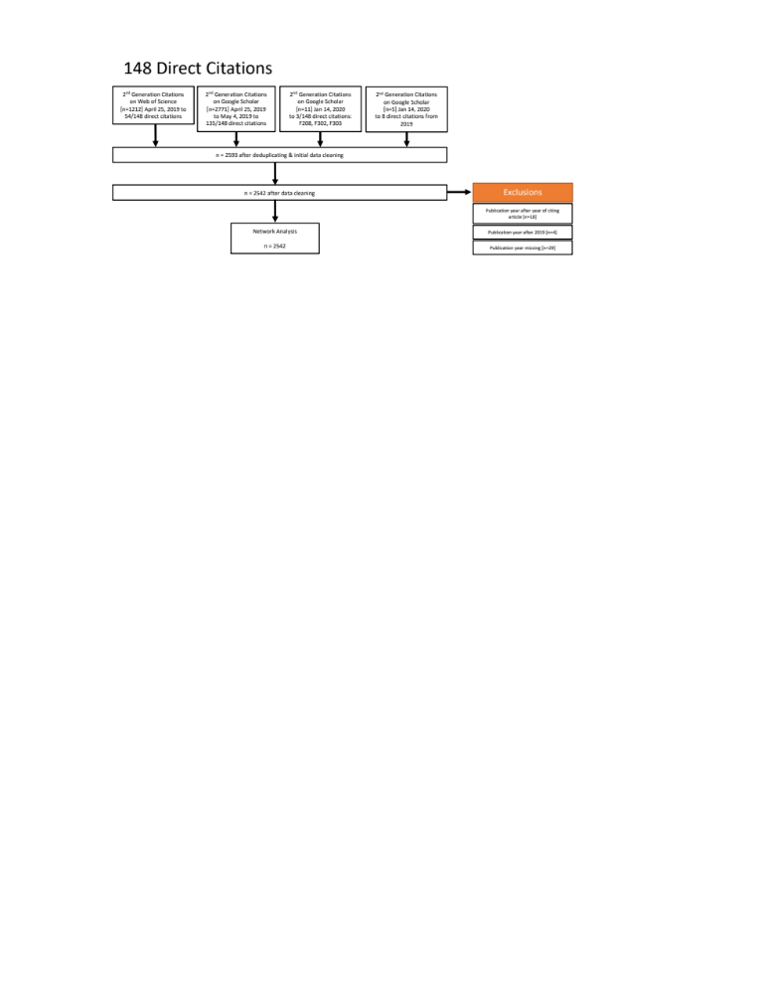
Appendix Fig. 2 Flow diagram for the analysis of the second-generation citations to the Matsuyama paper

Search
We searched Web of Science and Google Scholar for publications citing the 148 direct citations to the Matsuyama paper. All forms of publications, published before December 31, 2019, in any language were included. Our search was conducted iteratively, as we refined our deduplication and cross-checking procedures over time. Our main data collection took place on April 25, 2019 for Web of Science and from April 25, 2019 to May 4, 2019 using Publish or Perish Windows version 6 (Harzing, 2007) for Google Scholar, which covered 54 direct citations on Web of Science and (overlapping) 135 direct citations on Google Scholar. To update the search, an additional 11 direct citations were searched subsequently on January 15, 2020 (including the 8 new direct citations published in 2019).

Deduplication
We deduplicated records when multiple copies were found. First within Google Scholar, we checked second-generation citations citing the same article for title matches or partial title matches, and compared the full metadata record (author, publisher, etc.) or URL in order to identify duplicates. Then for second-generation citations citing the same article, we compared Web of Science and Google Scholar. Finally we identified second-generation citations that appeared multiple times (i.e., they cited multiple direct citations).

Data Cleaning for Year Information
We omitted publications with a missing publication year. When the listed publication year was before 2005 (the publication year of the Matsuyama paper), we manually verified the publication year, leading us to either update publication year errors or omitted publications actually published before 2005.
To keep a consistent end date in our data, we removed citations after December 31, 2019. We also omitted publications with publication year before the publication year of the article they were supposed to cite.

Networks
Networks were plotted in R using custom code using the ggplot2 and igraph libraries, filtered using the tidyverse library.

Assess visibility of retraction status in digital platforms
This section provides full details about the visibility of the retraction status of the Matsuyama paper (Matsuyama et al., 2005) and its retraction notice (CHEST, 2008) in digital platforms. We repeat tables, figures, and sentences from the text in order to add relevant URLs.

Our final evaluations took place on January 12, 2020 and January 20, 2020 and (for ChestNet only) February 14, 2020, using the subscriptions of the University of Pittsburgh Health Sciences Library System (Pitt), which serves the academic medical center and health sciences schools of the University of Pittsburgh as well as hosting the National Network of Libraries of Medicine Regional Medical Library for the Middle Atlantic Region. Persistent linking errors in retraction notices reported in Table 8 below were rechecked using the subscriptions of the Library of the Health Sciences of the University of Illinois Chicago (UIC) on January 20, 2020 to confirm that these errors were not institution-specific.

NOTE: For convenience, the following tables follow the numbering of the text. They merely add URLs to those tables.
Table 7 – Searches using the default search and entering the (Matsuyama et al., 2005) article title: Effects of omega-3 polyunsaturated fatty acids on inflammatory markers in COPD
Source | Retraction notice in search results
Chest – “All Content” search | Yes
CINAHL EBSCOhost | Yes
Cochrane CENTRAL | Yes
EMBASE | Yes
Google Scholar | No
MEDLINE – Ovid | Yes
PubMed | Yes
ScienceDirect – keywords search | Yes
Semantic Scholar | Yes
Scopus | Yes
Web of Science – All Databases | Yes
Web of Science – Core Collection | No

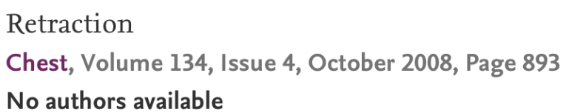
Fig. 10 ScienceDirect shows the retraction notice CITE as record 82 of 194 in the default search for Effects of omega-3 polyunsaturated fatty acids on inflammatory markers in COPD as of January 20, 2020.

The retraction notice is the fourth result of four on January 20, 2020 when entering the title string in the “Search in this journal” search from the ScienceDirect journal homepage for Chest. However, the retraction notice was not found by entering the title string in ScienceDirect’s Advanced search option “Title, abstract or author-specified keywords”; this search returned just 1 result, the retracted article, on January 20, 2020.

Retracted article on full-text sites
We considered full-text sources to be digital library sites that hosted PDFs.
Table 5 – Retracted article on full-text sites
 | “Retracted” text or watermark |  |  |  | Actionable link to retraction notice
Full-text source | On article landing page | On HTML article | On  PDF article |  | From landing page | From HTML article | From PDF article
ChestNet.org | No | No | No |  | No | No | No
Ovid Full Text | Yes | No | No |  | Yes | No | No
ScienceDirect | No | No | No |  | No | No | No
SemanticScholar | Yes |  | No |  | No |  | No

Retraction notice in full-text sites

Table 6 – Retraction notice (CHEST, 2008) at full-text sources
 | Front matter |  | Heading content |  | Textual content |  |  | Actionable links to the retracted article
Full-text source | Listed in the table of contents | Has a page number? | Includes “Retraction” in the heading | Includes the title of the article in the heading | Indicates its authorship | Indicates the reason for the retraction | Includes a formal citation to retracted article | From landing page | From HTML full-text | From PDF full-text
ChestNet.org | Yes | Yes | Yes | No | Yes | Yes | No | No | No | No
ScienceDirect | Yes | Yes | Yes | No | Yes | Yes | No | No | No | No

Database records for the retracted article

Table 7 – Database records for the Matsuyama paper (Matsuyama et al., 2005)
Database | “Retraction” or “retracted” appears in the article record | Actionable link to the retraction notice | Article record has sufficient bibliographic information to retrieve the retraction notice manually by volume and issue number
CINAHL (EBSCOhost) | No | No | No
Cochrane CENTRAL (Wiley) | Yes | No | Yes
EMBASE | Yes | No | Yes
MEDLINE - Ovid | Yes | Yes | Yes
PubMed | Yes | No | No
Scopus | Yes | No | Yes
Semantic Scholar | No | No | No
Web of Science – All Databases | No | No | No
Web of Science – Core Collection | No | No | No

The CINAHL database did show some improvements during our study; the retraction notice was not found in our searches for Effects of omega-3 polyunsaturated fatty acids on inflammatory markers in COPD on September 27, 2018, but by January 2020, a second record with the retraction notice had appeared.

Database records for the retraction notice
Table 8 - Database records for the retraction notice (Matsuyama et al., 2005). Multiple resolution errors are due to presence of multiple link resolver buttons from a database.
Database | “Retraction notice” appears in the notice record | Notice record resolves to full-text notice | Resolution error(s) | Notice record has an actionable link to the retracted article | Notice record has sufficient bibliographic information to retrieve the retracted article manually by volume and issue number
CINAHL EBSCOhost | Yes | Depends on link resolver | Chest “This page does not exist” (Figure 11) | No | No
Cochrane CENTRAL | Yes | No | Links to PubMed—see PubMed line | Yes (2 clicks via the article PMID) | No
EMBASE – record 1 (copyright Elsevier) | Yes | No | ScienceDirect error “No results found” (Figure 12); Resolves to erratum for a different article | No | No
EMBASE – 2 (MEDLINE sourced) | Yes | Depends on link resolver | Resolves to retraction notice for a different article (Figure 13) | No | Yes
MEDLINE – Ovid | Yes | Yes |  | Yes (2 clicks via the article PMID) | Yes
PubMed | Yes | No | Elsevier: “Requested article is not found in IHub.” (Figure 14) | Yes (2 clicks via the article PMID) | No
Semantic Scholar | Yes | No | Links to PubMed—see PubMed line | No | No
Scopus | No – classified as erratum | No | Chest “This page does not exist” ; Chest homepage; ScienceDirect “No results found”; WorldCat not found message | No | Yes
Web of Science – All Databases | Yes | Depends on link resolver | Elsevier: “Requested article is not found in IHub.” | No | No

Delays in updating were also a factor; for instance, the Cochrane record for the retraction notice indicates that it was added October 31, 2014, six years after the retraction notice was published in October 2008. There are several inaccuracies: Scopus lists the retraction notice as an erratum, which it is not.

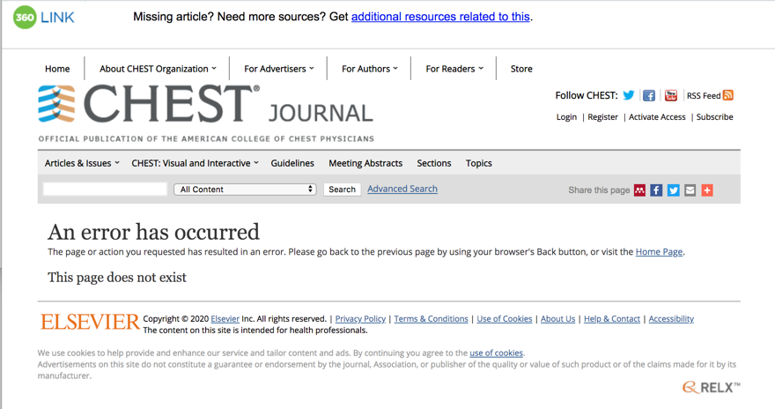
Fig. 9 The ChestNet error page stating “This page does not exist”, retrieved from the “Check article availability” link from the EBSCOhost CINAHL record for the retraction notice (CHEST, 2008) on January 20, 2020.

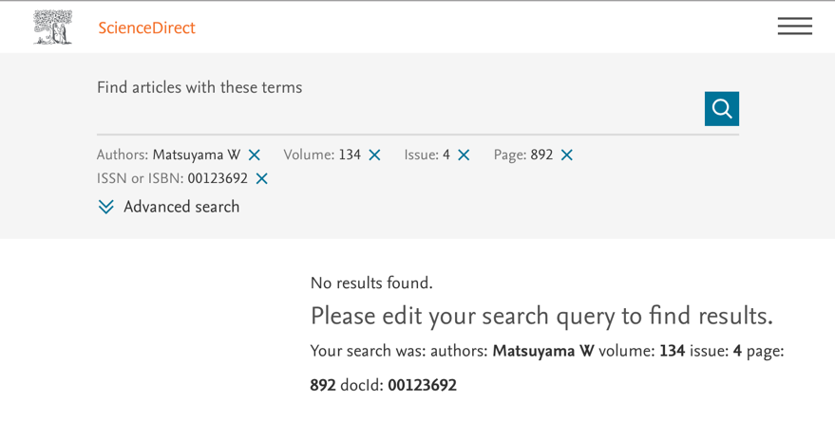
Fig. 10 The ScienceDirect Error page stating “No results found”, retrieved from EMBASE – record 1 (copyright Elsevier) for (CHEST, 2008) via the FindItUIC ScienceDirect journals link on January 20, 2020.

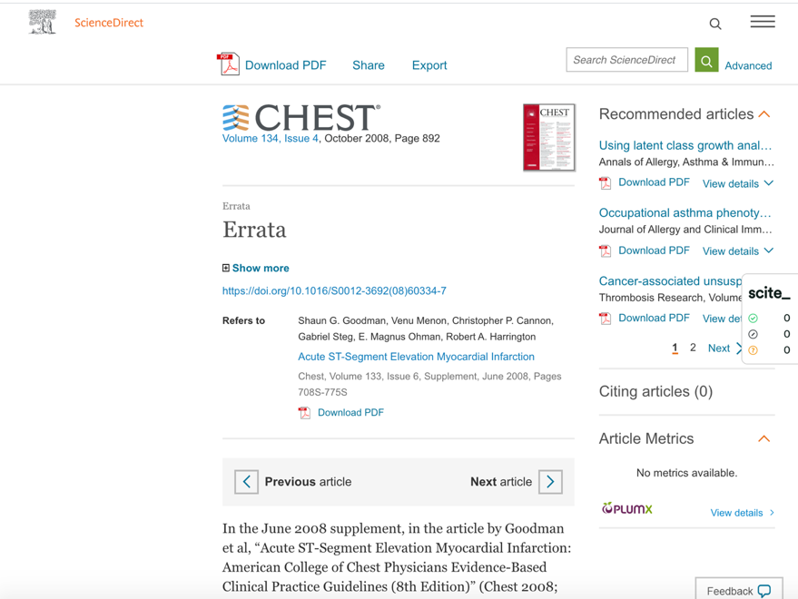
Fig. 11 The Elsevier errata notice for a different article (Acute ST-Segment Elevation Myocardial Infarction), retrieved from the “Full text on publisher’s website” from the EMBASE Elsevier record for the retraction notice (CHEST, 2008) on January 20, 2020.

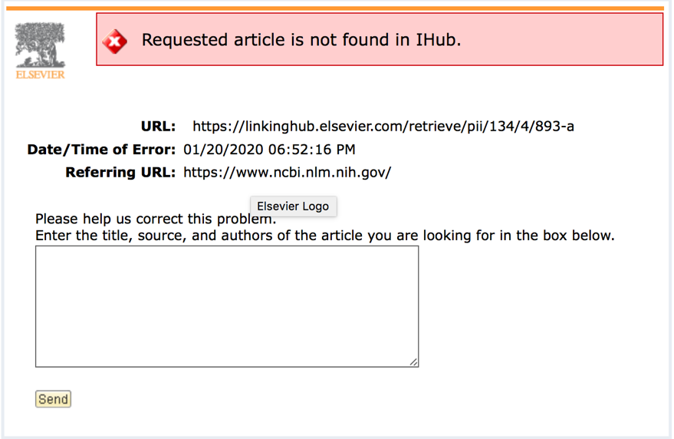

Fig. 12 The Elsevier error page stating “Requested article is not found in IHub.”, retrieved from the link out from the PubMed page for the retraction notice (CHEST, 2008) on January 20, 2020.

Bibliography
Abdelhamid, A. S., Brown, T. J., Brainard, J. S., Biswas, P., Thorpe, G. C., Moore, H. J., Deane, K. H. O., AlAbdulghafoor, F. K., Summerbell, C. D., Worthington, H. V., Song, F., & Hooper, L. (2018). Omega-3 fatty acids for the primary and secondary prevention of cardiovascular disease. Cochrane Database of Systematic Reviews, 11, CD003177. https://doi.org/10.1002/14651858.CD003177.pub4
Chen, C., Hu, Z., Milbank, J., & Schultz, T. (2013). A visual analytic study of retracted articles in scientific literature. Journal of the American Society for Information Science and Technology, 64(2), 234–253. https://doi.org/10.1002/asi.22755
CHEST. (2008). Retraction [of Effects of omega-3 polyunsaturated fatty acids on inflammatory markers in COPD]. Chest, 134(4), 893. https://doi.org/10.1016/S0012-3692(08)60339-6
Deng, C., Cao, Y.-F., Chen, X.-X., & Yin, Z. B. (2012). ω-3 鱼油脂肪乳对博莱霉素致肺纤维化大鼠的干预作用 [The effects of omega-3 fat emulsion on bleomycin-induced pulmonary fibrosis in rats]. 广东医学 [Guangdong Medical Journal], 32(18), 2370–2372.
Fulton, A. S., Coates, A. M., Williams, M. T., Howe, P. R. C., & Hill, A. M. (2015). Persistent citation of the only published randomised controlled trial of Omega-3 supplementation in Chronic Obstructive Pulmonary Disease six years after its retraction. Publications, 3(1), 7–26. https://doi.org/10.3390/publications3010017
Giudetti, A. M., & Cagnazzo, R. (2011). Lipids in the nutritional treatment of inflammatory diseases. Multidisciplinary Respiratory Medicine, 6(2), 97–106.
Hani, S. Z. (2019). Pengaruh pemberian suplemen omega 3 terhadap kadar TNF-α serum, massa otot, kekuatan otot, dan performa fisik pada pasien ppok dengan sarkopenia [Effect of omega 3 supplementation on serum TNF-α levels, muscle mass, muscle strength, and physical performance in patients with COPD with sarcopenia] [Master’s, Universitas Andalas]. http://scholar.unand.ac.id/49966/
Harzing, A. W. (2007). Publish or Perish. https://harzing.com/resources/publish-or-perish
Lin, Y.-C., Lin, Y.-J., Wu, T.-C., Cheng, C.-C., & Yeh, S.-L. (2016). Supplementation of fish oil improves functional capacity and quality of life in patients with Chronic Obstructive Pulmonary Disease. Current Topics in Nutraceutical Research, 14(3), 191–198.
Lin, Yun-Jou. (2015). 魚油補充對慢性阻塞性肺病患者骨骼健康狀況, 活動能力及生活品質之影響 [Effects of fish oil supplementation on bone health status, physical performance, and quality of life in patients with chronic obstructive pulmonary disease] [Master’s, Zhangjiakou University]. http://dx.doi.org/10.6834/CSMU.2013.00035
Matsuyama, W., Higashimoto, I., Osame, M., & Arimura, K. (2006). In Replay: Renin-Angiotensin System Blockade and COPD. Chest, 129(6), 1735. https://doi.org/10.1016/S0012-3692(15)50791-5
Matsuyama, W., Mitsuyama, H., Koreeda, Y., Higashimoto, I., Osame, M., & Arimura, K. (2007). [RETRACTED] Use of tiotropium bromide for pre-operative treatment in chronic obstructive pulmonary disease patients: Comparison with oxitropium bromide. Internal Medicine, 46(17), 1373–1380. https://doi.org/10.2169/internalmedicine.46.0072
Matsuyama, W., Mitsuyama, H., Koreeda, Y., Higashimoto, I., Osame, M., & Arimura, K. (2008). RETRACTION: Use of Tiotropium Bromide for Pre-operative Treatment in Chronic Obstructive Pulmonary Disease Patients: Comparison with Oxitropium Bromide. Internal Medicine, 47(14), 1371–1371. https://doi.org/10.2169/internalmedicine.47.R001
Matsuyama, W., Mitsuyama, H., Watanabe, M., Oonakahara, K., Higashimoto, I., Osame, M., & Arimura, K. (2005). [RETRACTED] Effects of Omega-3 Polyunsaturated Fatty Acids on Inflammatory Markers in COPD. Chest, 128(6), 3817–3827. https://doi.org/10.1378/chest.128.6.3817
Sun, B., Luo, C., Cui, W., Sun, J., & He, Z. (2017). Chemotherapy agent-unsaturated fatty acid prodrugs and prodrug-nanoplatforms for cancer chemotherapy. Journal of Controlled Release, 264, 145–159. https://doi.org/10.1016/j.jconrel.2017.08.034
Wang, H., Yin, Z., Chen, X., & Cao, Y. (2012). 鱼油脂肪乳和 20% 中/长链脂肪乳干预博莱霉素致大鼠肺纤维化效果的比较 [The intervention effect of ω-3 PUFA and MCT/LCT fatty acids in rats model of pulmonary fibrosis by Bleomycin]. 肠外与肠内营养 [Parenteral and Enteral Nutrition], 2012–04, 228-231+ 234.
Yang, L., Li, J., Li, Y., Tian, Y., Li, S., Jiang, S., Wang, Y., & Song, X. (2015). Identification of metabolites and metabolic pathways related to treatment with Bufei Yishen formula in a rat COPD model using HPLC Q-TOF/MS. Evidence-Based Complementary and Alternative Medicine, 2015. https://doi.org/10.1155/2015/956750
Yin, Z., Deng, C., Cao, Y., & Chen, Y. (2011). ω-3 鱼油脂肪乳和中/长链脂肪乳注射液干预博莱霉素致肺纤维化大鼠效果的比较 [Comparison of the effects of omega-3 fish oil fat emulsion and medium/long chain fat emulsion injection on bleomycin-induced pulmonary fibrosis in rats]. 中华临床营养杂志 [Chinese Journal of Clinical Nutrition], 19(6), 400–403.
Zheng J. (2013). [Effects of omega-3 polyunsaturated fatty acids and exercise rehabilitation on bone health in patients with chronic obstructive pulmonary disease] Omega-3多元不飽和脂肪酸及運動復健介入對慢性阻塞性肺病患者骨骼健康之影響 [Master’s, Zhongshan Medical University]. https://doi.org/10.6834/CSMU.2013.00035

https://github.com/infoqualitylab/Retraction-Case-Study-Matsuyama/blob/master/Python%20Code/wos%20web%20scraping.py
Google Scholar results change frequently. One thesis, found in the Jan 12, 2020 Google Scholar search and manually verified, no longer appeared in our February 4, 2020 search.
The 76 citations from (Fulton et al., 2015) grouped 3 publications from 2011 and 2012 (Deng et al., 2012; Wang et al., 2012; Yin et al., 2011) considered as duplicate publications; we ungroup these below for a total of 78 citations from the prior study.
https://github.com/infoqualitylab/Retraction-Case-Study-Matsuyama/blob/master/Python%20Code/wos%20web%20scraping.py
https://github.com/infoqualitylab/Retraction-Case-Study-Matsuyama/blob/master/Network%20Diagram%20%26%20Timeline.R
https://journal.chestnet.org
Institution-specific URL: http://web.b.ebscohost.com.pitt.idm.oclc.org/ehost/search/basic?vid=0&sid=1705b812-8d81-4f76-8430-f9d2956ccbd4%40pdc-v-sessmgr01
https://www.cochranelibrary.com
Institution-specific URL: https://www-embase-com.pitt.idm.oclc.org
https://scholar.google.com
Institution-specific URL: http://ovidsp.dc2.ovid.com.pitt.idm.oclc.org/sp-4.06.0a/ovidweb.cgi?&S=MBFOFPGOOEEBJPPKJPAKLHBHOJCGAA00&New+Database=Single%7c0
https://www.ncbi.nlm.nih.gov/pubmed/
https://www.sciencedirect.com
http://semanticscholar.org
Institution-specific URL: https://www-scopus-com.pitt.idm.oclc.org/
Institution-specific URL: http://apps.webofknowledge.com.pitt.idm.oclc.org/
Institution-specific URL: http://apps.webofknowledge.com.pitt.idm.oclc.org/
https://www.sciencedirect.com/search/advanced?qs=Effects%20of%20omega-3%20polyunsaturated%20fatty%20acids%20on%20inflammatory%20markers%20in%20COPD&show=100
https://www.sciencedirect.com/search/advanced?qs=Effects%20of%20omega-3%20polyunsaturated%20fatty%20acids%20on%20inflammatory%20markers%20in%20COPD&pub=Chest&cid=280288
https://www.sciencedirect.com/journal/chest
https://www.sciencedirect.com/search/advanced
https://www.sciencedirect.com/search/advanced?tak=Effects%20of%20omega-3%20polyunsaturated%20fatty%20acids%20on%20inflammatory%20markers%20in%20COPD
We excluded two sites, found via Google Scholar, that appeared to provide unofficial copies of the PDF, namely https://www.texasgrassfedbeef.com/sites/default/files/pdf/copd_effects_of_omega-3_efa_on_inflammatory_markers.pdf and https://smartfishsport.no/wp-content/uploads/2014/03/Matsuyama-W-Effects-of-Omega-3-Polyunsaturated-Fatty-Acids-on-Inflammatory-Markers-in-COPD.pdf
The CINAHL record lists an entry date of December 12, 2008 and revision date of February 27, 2019. Lacking further information about the revision, we hypothesize that it impacted the change in title search results. Pitt-specific URL: http://search.ebscohost.com.pitt.idm.oclc.org/login.aspx?direct=true&db=cin20&AN=134926201&site=ehost-live UIC-specific URL: http://proxy.cc.uic.edu/login?url=http://search.ebscohost.com/login.aspx?direct=true&db=rzh&AN=134926201
Pitt has CINHAL; UIC has CINAHL Plus with Full Text. Both are on the EBSCOhost platform.
Out of 3 links, resolution worked in 1: FindIt@UIC, a UIC-branded SerialSolutions link resolver, provides links to a landing page with two links. One, labelled “ScienceDirect journals” provides a correct result: a list of 2 search results giving retraction notices, one of which is the (CHEST, 2008) retraction notice at the UIC-specific URL https://www-sciencedirect-com.proxy.cc.uic.edu/search/advanced?page=893&docId=00123692&volume=134&issue=4 .The other UIC link, labelled “Publisher via CrossRef”, goes back to the landing page itself and does not resolve; this circular link appeared in all FindIt@UIC results; we omit this point in subsequent footnotes for brevity.
Pitt has CINHAL and their institution- and session-specific URL labelled “Check Article Availability” did not work: http://web.a.ebscohost.com.pitt.idm.oclc.org/ehost/SmartLink/OpenIlsLink?sid=77b4fb83-010c-49d0-bf13-23a142393ecb@sessionmgr4006&vid=2&sl=smartlink&st=ilslink_new&sv=sdbn%253Dcin20%2526pbt%253DAcademic%2520Journal%2526issn%253D00123692%2526ttl%253DCHEST%2526stp%253DC%2526asi%253DY%2526ldc%253DCHECK%252520ARTICLE%252520AVAILABILITY%2526lna%253DSerials%252520Solutions%2526lca%253DfullText%2526lo%255Fan%253D134926201&su=http%3A%2F%2FRT4RF9QN2Y%2Esearch%2Eserialssolutions%2Ecom%3Fgenre%3Darticle%26title%3DCHEST%26atitle%3DRetraction%2E%2520Effects%2520of%2520omega%2D3%2520polyunsaturated%2520fatty%2520acids%2520on%2520inflammatory%2520markers%2520in%2520COPD%2E%26author%3D%26authors%3D%26date%3D20081001%26volume%3D134%26issue%3D4%26spage%3D893%26issn%3D00123692 resolves to the institution-specific URL using SerialSolutions 360Link http://rt4rf9qn2y.search.serialssolutions.com.pitt.idm.oclc.org/?genre=article&title=CHEST&atitle=Retraction.%20Effects%20of%20omega-3%20polyunsaturated%20fatty%20acids%20on%20inflammatory%20markers%20in%20COPD.&author=&authors=&date=20081001&volume=134&issue=4&spage=893&issn=00123692 This goes to the Chest “This page does not exist” error shown in Figure 10.
The UIC-specific link, labelled FindIt@UIC, resolves to a ScienceDirect error “No results found”, apparently because the record page number, 892, should be 893, and the author name is a mismatch: with the UIC-specific URL https://www-sciencedirect-com.proxy.cc.uic.edu/search/advanced?authors=Matsuyama%20W&page=892&docId=00123692&volume=134&issue=4
“Full text on publisher’s website” link resolves to erratum notice in Chest October 2008 for a different article https://doi.org/10.1016/S0012-3692(08)60334-7 Pitt-specific URL: https://www-sciencedirect-com.pitt.idm.oclc.org/science/article/pii/S0012369208603347?via%3Dihub ; UIC-specific URL: https://www-sciencedirect-com.proxy.cc.uic.edu/science/article/pii/S0012369208603347?via%3Dihub
Out of 4 links at UIC and Pitt, resolution worked in one case: The FindIt@UIC “ScienceDirect journals” provides a correct result: a list of 2 search results giving retraction notices, one of which is the (CHEST, 2008) retraction notice at the UIC-specific URL https://www-sciencedirect-com.proxy.cc.uic.edu/search/advanced?page=893&docId=00123692&volume=134&issue=4 .
“Full text on publisher’s website” link resolves to a retraction notice in Chest October 2008 for a different article https://doi.org/10.1016/S0012-3692(08)60340-2 ; Pitt-specific URL: https://www-sciencedirect-com.pitt.idm.oclc.org/science/article/pii/S0012369208603347?via%3Dihub ; UIC-specific URL: https://www-sciencedirect-com.proxy.cc.uic.edu/science/article/pii/S0012369208603402?via%3Dihub
A page number error “3817-2827” needs to be interpreted to “3817-28”.
https://linkinghub.elsevier.com/retrieve/pii/134/4/893-a
“View at Publisher” goes to “This page does not exist” message at Chest: https://www.chestjournal.org/cgi/reprint/134/4/892
Pitt-specific URL “Full Text@Pitt” (360 Link Serials Solutions link resolver) goes to “This page does not exist” message at Chest: http://rt4rf9qn2y.search.serialssolutions.com.pitt.idm.oclc.org/?sid=Elsevier:Scopus&genre=article&issn=00123692&volume=134&issue=4&spage=892&epage=&pages=892&artnum=&date=2008&title=Chest&atitle=Effects+of+omega-3+polyunsaturated+fatty+acids+on+inflammatory+markers+in+COPD+%28Chest+%282005%29+128%2c+%283817-2827%29%29&aufirst=W.&auinit=W.&auinit1=W&aulast=Matsuyama&id=doi: and “View at Publisher” https://www.chestjournal.org/cgi/reprint/134/4/892
Pitt-specific URL: “Links@Pitt-UPMC” (EBSCOhost resolver) goes to Chest homepage http://resolver.ebscohost.com.pitt.idm.oclc.org/openurl?custid=s3733374&authtype=ip&sid=Elsevier:Scopus&?sid=Elsevier:Scopus&genre=article&issn=00123692&isbn=&volume=134&issue=4&spage=892&epage=&pages=892&artnum=&date=2008&title=Chest&atitle=Effects+of+omega-3+polyunsaturated+fatty+acids+on+inflammatory+markers+in+COPD+%28Chest+%282005%29+128%2c+%283817-2827%29%29&aufirst=W.&auinit=W.&auinit1=W&aulast=Matsuyama&id=doi:
The UIC-specific link, labelled FindIt@UIC, resolves to an error “No results found” with the UIC-specific URL XXX, apparently because the record page number, 892, should be 893, and the author name is a mismatch: https://www-sciencedirect-com.proxy.cc.uic.edu/search/advanced?authors=Matsuyama%20W&page=892&docId=00123692&volume=134&issue=4
Three UIC-specific links, labelled 1cate, Journal Finder, and an unlabeled box, each took us to a WorldCat Link Resolver page indicating “We were unable to find direct full text links for this item” https://uisbrookenslibrary-on-worldcat-org.proxy.cc.uic.edu/atoztitles/link/?sid=Elsevier:Scopus&genre=article&issn=00123692&volume=134&issue=4&spage=892&epage=&pages=892&artnum=&date=2008&title=Chest&atitle=Effects+of+omega-3+polyunsaturated+fatty+acids+on+inflammatory+markers+in+COPD+%28Chest+%282005%29+128%2c+%283817-2827%29%29&aufirst=W.&auinit=W.&auinit1=W&aulast=Matsuyama
A page number error “3817-2827” needs to be interpreted to “3817-28”.
Resolution worked in 1 of 2 “Find it@UIC links”, retrieving a list of 2 search results giving retraction notices, one of which is the (CHEST, 2008) retraction notice at the UIC-specific URL https://www-sciencedirect-com.proxy.cc.uic.edu/search/advanced?page=893&docId=00123692&volume=134&issue=4
“NCBI Links LinkOut” gave the “Requested article is not found in IHub.” Message Pitt-specific URL: https://linkinghub-elsevier-com.pitt.idm.oclc.org/retrieve/pii/134/4/893-a UIC-specific URL: https://linkinghub-elsevier-com.proxy.cc.uic.edu/retrieve/pii/134/4/893-a
Pitt-specific URL: https://www-cochranelibrary-com.pitt.idm.oclc.org/central/doi/10.1002/central/CN-01001062/full?highlightAbstract=in%7Cfatti%7Cinflammatory%7Cwithdrawn%7Cpolyunsaturated%7Comega%7Ccopd%7Cacid%7Ceffects%7Cacids%7C3%7Comeg%7Cfatty%7Cmarker%7Cof%7Cinflammatori%7Ceffect%7Cmarkers%7Cpolyunsatur
Pitt-specific URL: https://www-scopus-com.pitt.idm.oclc.org/record/display.uri?eid=2-s2.0-54249092126&origin=resultslist&sort=plf-f&src=s&st1=Effects+of+omega-3+polyunsaturated+fatty+acids+on+inflammatory+markers+in+COPD&st2=&sid=1d99b35c47cb8a7ed1a1f11b3648a3f7&sot=b&sdt=b&sl=93&s=TITLE-ABS-KEY%28Effects+of+omega-3+polyunsaturated+fatty+acids+on+inflammatory+markers+in+COPD%29&relpos=1&citeCnt=0&searchTerm=
Institution-specific URL http://rt4rf9qn2y.search.serialssolutions.com.pitt.idm.oclc.org/?genre=article&title=CHEST&atitle=Retraction.%20Effects%20of%20omega-3%20polyunsaturated%20fatty%20acids%20on%20inflammatory%20markers%20in%20COPD.&author=&authors=&date=20081001&volume=134&issue=4&spage=893&issn=00123692
Institution-specific URL http://web.a.ebscohost.com.pitt.idm.oclc.org/ehost/detail/detail?vid=2&sid=77b4fb83-010c-49d0-bf13-23a142393ecb%40sessionmgr4006&bdata=JnNpdGU9ZWhvc3QtbGl2ZQ%3d%3d#AN=134926201&db=cin20
UIC-specific URL https://www-sciencedirect-com.proxy.cc.uic.edu/search/advanced?authors=Matsuyama%20W&page=892&docId=00123692&volume=134&issue=4
UIC-specific URL https://www-embase-com.proxy.cc.uic.edu/a/#/search/results?subaction=viewrecord&rid=3&page=1&id=L352538781
UIC-specific URL http://hz9pj6fe4t.search.serialssolutions.com.proxy.cc.uic.edu/log?L=HZ9PJ6FE4T&D=FDB&J=CHES&P=Link&PT=EZProxy&A=Effects+of+omega-3+polyunsaturated+fatty+acids+on+inflammatory+markers+in+COPD+%28Chest+%282005%29+128%2C+%283817-2827%29%29&H=5432fd0f82&U=http%3A%2F%2Fproxy.cc.uic.edu%2Flogin%3Furl%3Dhttps%3A%2F%2Fwww.sciencedirect.com%2Fscience%2Flink%3Fref_val_fmt%3Dinfo%3Aofi%2Ffmt%3Akev%3Amtx%3Ajournal%26svc_val_fmt%3Dinfo%3Aofi%2Ffmt%3Akev%3Amtx%3Asch_srv%26rfr_dat%3Dsaltver%3A1%26rfr_dat%3Dorigin%3ASERIALSSOL%26ctx_enc%3Dinfo%3Aofi%2Fenc%3AUTF-8%26ctx_ver%3DZ39.88-2004%26rft.issn%3D00123692%26rft.volume%3D134%26rft.issue%3D4%26rft.spage%3D892%26rft.epage%3D-%26rft.aulast%3DMatsuyama%26rft.auinit1%3DW%26rft.date%3D2008%26rfr_dat%3Dmd5%3A3ca791f67be7b97c0c55553468cf468f resolving to UIC-specific URL https://www-sciencedirect-com.proxy.cc.uic.edu/search/advanced?authors=Matsuyama%20W&page=892&docId=00123692&volume=134&issue=4
https://doi.org/10.1016/S0012-3692(08)60334-7
Institution-specific URL: https://www-embase-com.pitt.idm.oclc.org/a/#/search/results?subaction=viewrecord&rid=3&page=1&id=L352538781
https://linkinghub.elsevier.com/retrieve/pii/134/4/893-a
https://www.ncbi.nlm.nih.gov/pubmed/18842931

