Supplementary material
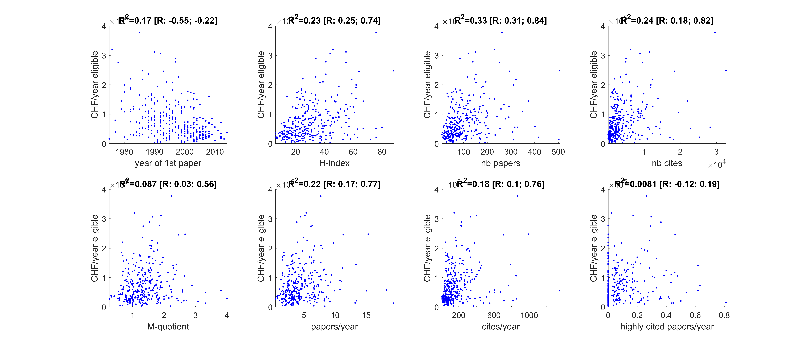
Figure 2 : Average funding of each researcher (computed over the last 10 years) as a function of various metrics of scientific excellence. Each dot represents a researcher in the fields of Earth Science or Environmental Science.

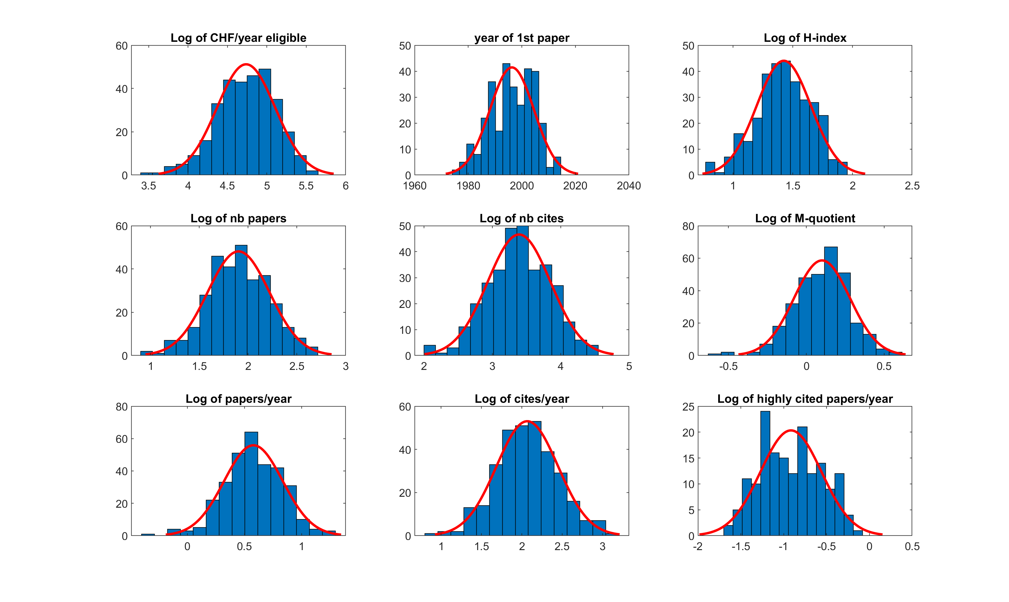
Figure 3 : Histograms of the log-transformed data with an overlaid Gaussian distribution showing that most variables are log-normally distributed except the year of the first published paper, which was kept untransformed.

