Appendix
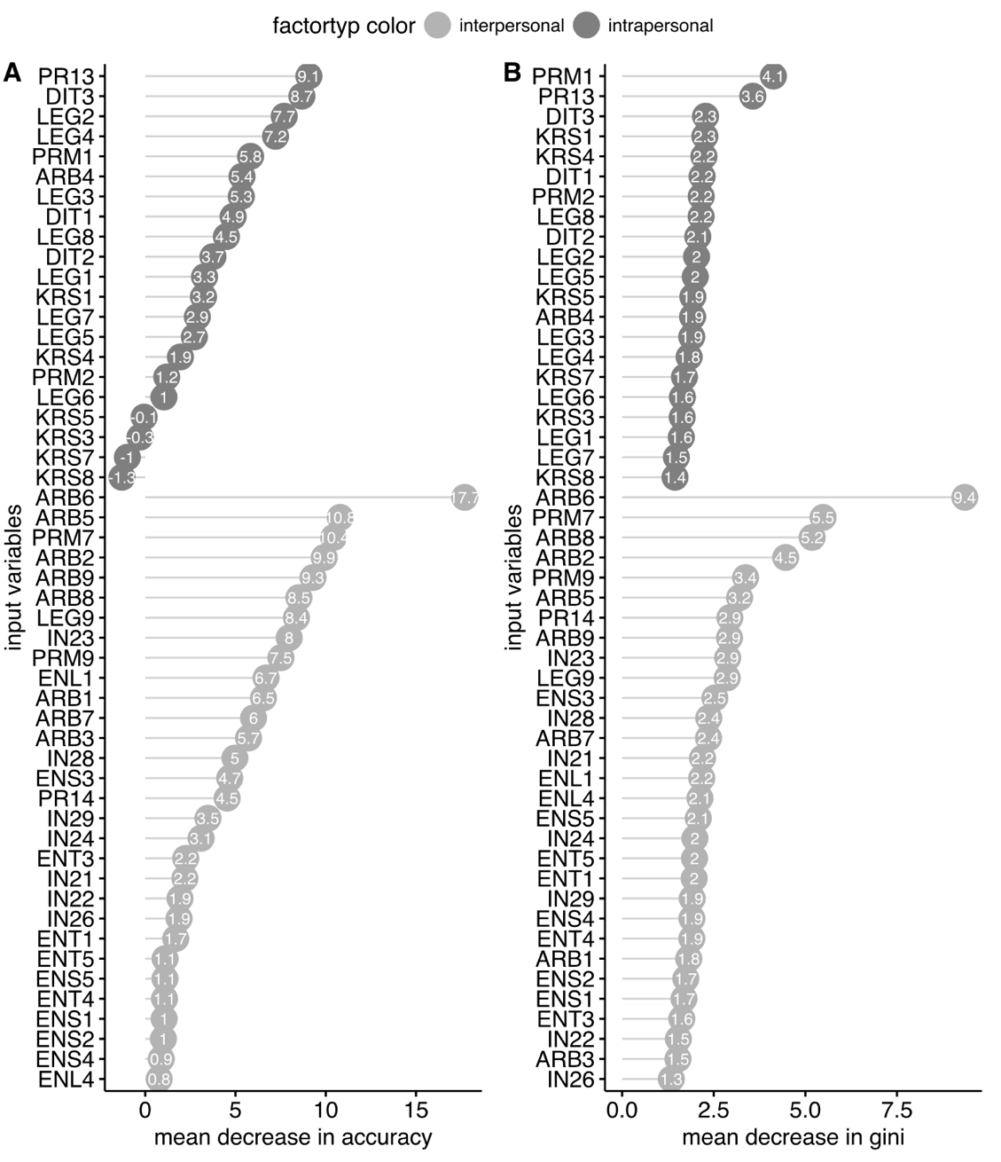

Supplementary Figure 4. A: Variables’ importance based on the Mean Decrease in Accuracy. B:Variables’ Importance based on the Mean Decrease in Gini.

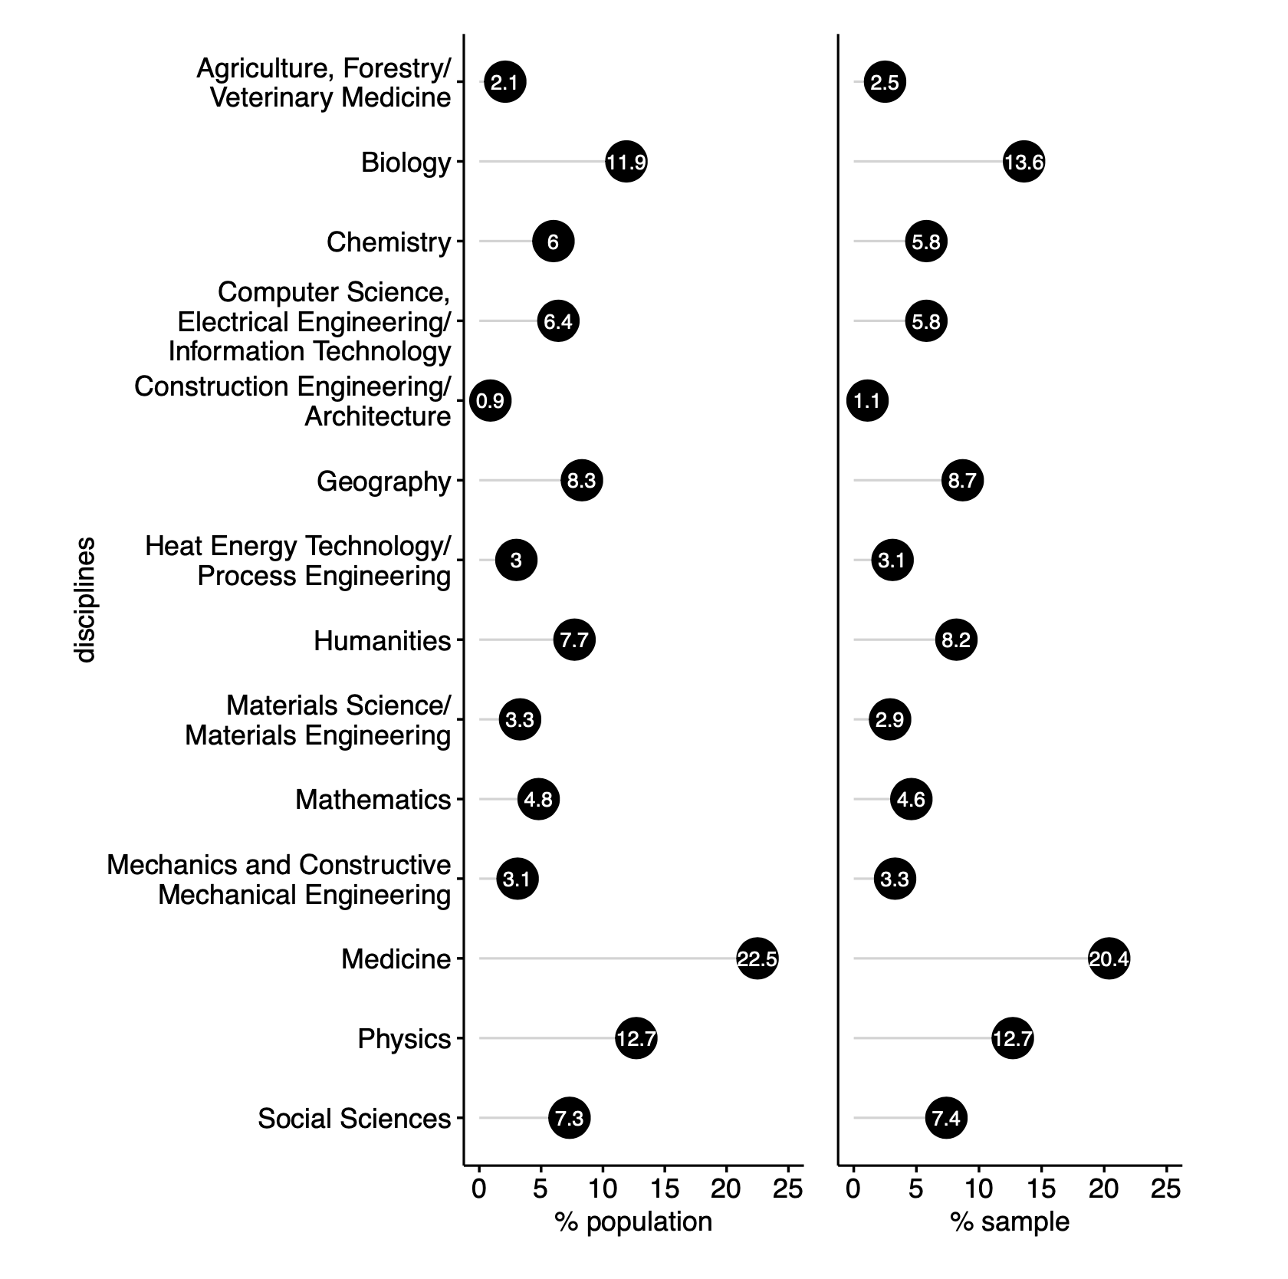
Supplementary Figure 5. Relative frequencies of the disciplinary affiliation of the PIs and spokespersons in the population and the sample

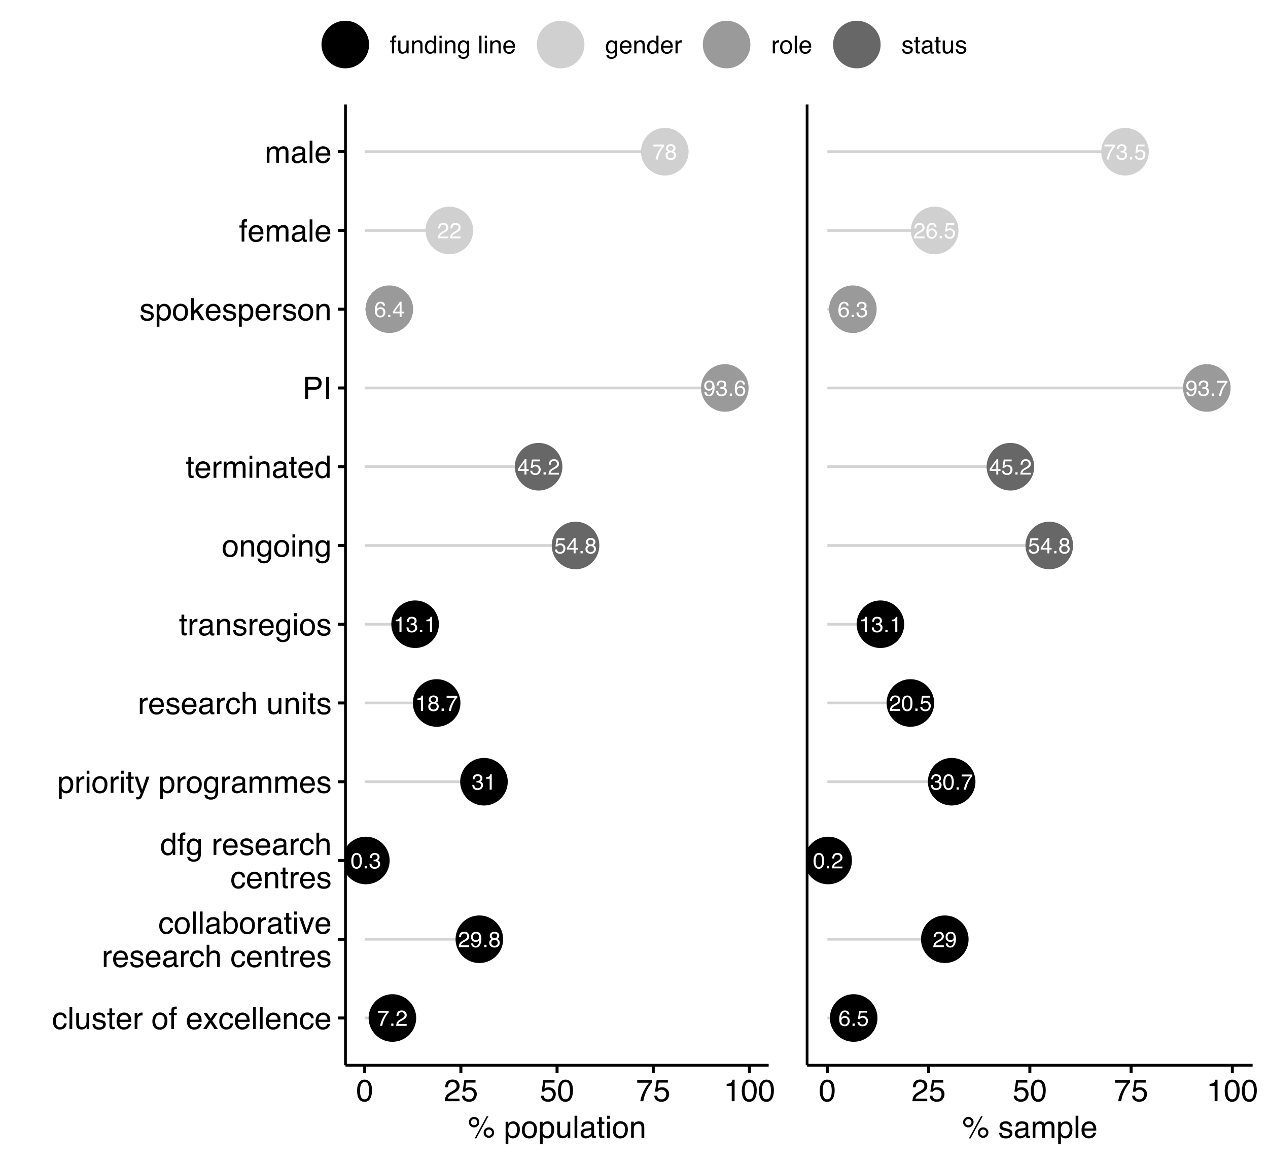
Supplementary Figure 6. Relative frequency of researchers’ gender and status roles, RC status and their funding line in the population and in the sample

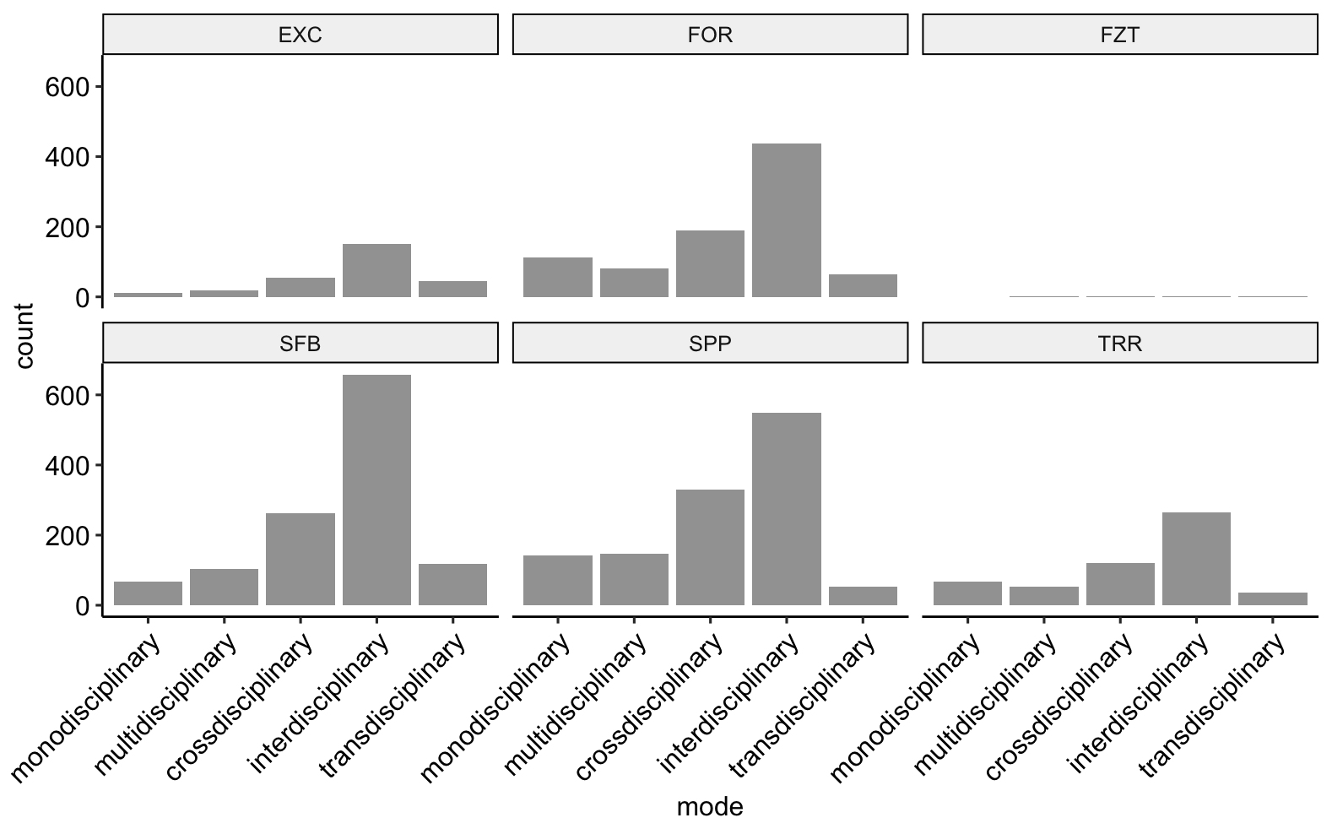

Supplementary Figure 7. Mode of collaboration of the research cluster according to DFG funding lines: Research Units (FOR), Research Centres (FZT), Clusters of Excellence (EXC), Collaborative Research Centres (SFB), Transregios (TRR) and Priority Programmes (SPP).
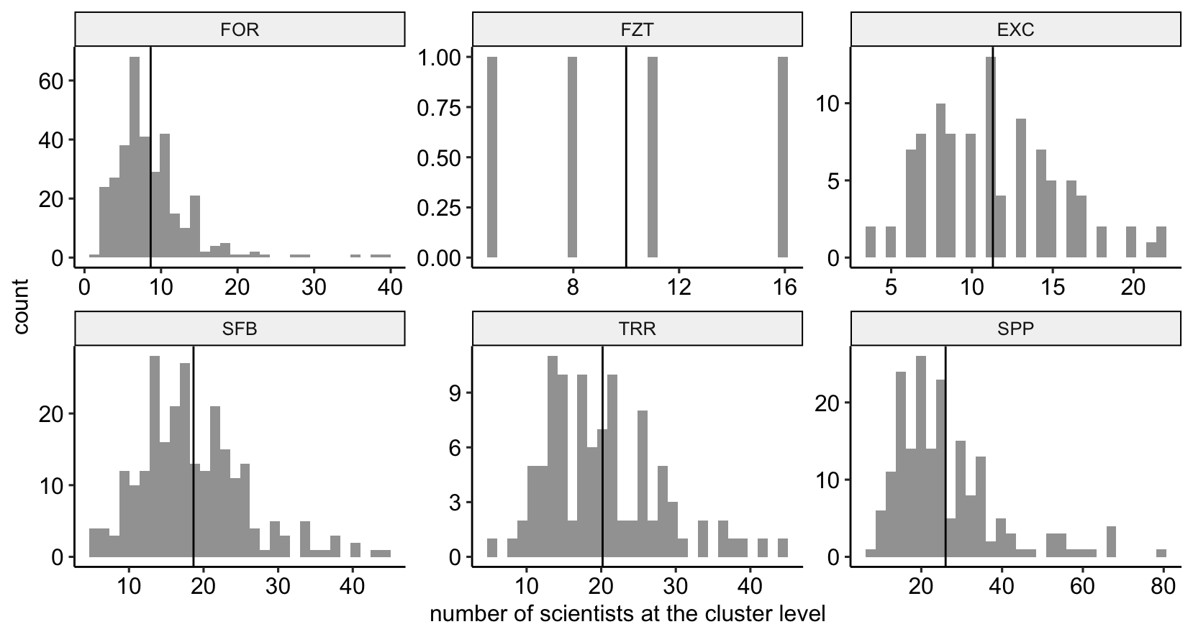
Supplementary Figure 8. Number of scientists at the cluster level according to funding lines of the German Research Foundation: Research Units (FOR), Research Centres (FZT), Clusters of Excellence (EXC), Collaborative Research Centres (SFB), Transregios (TRR) and Priority Programmes (SPP). Source: DEKiF-Survey

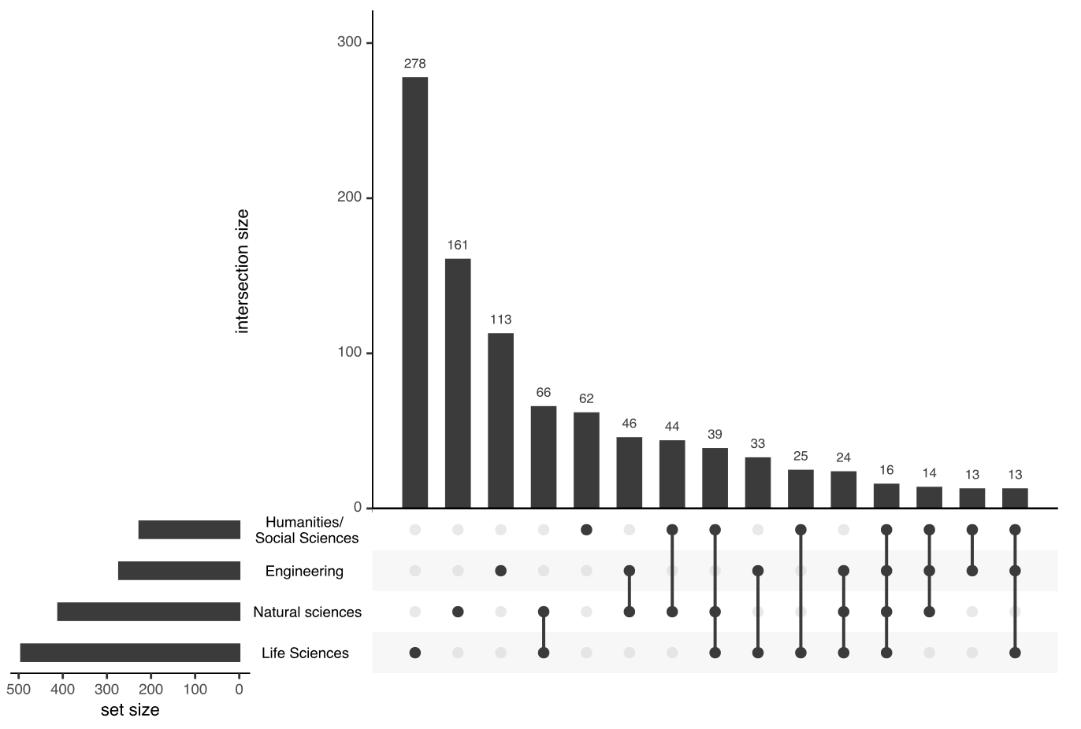
Supplementary Figure 9. The four most frequent disciplinary homo- and heterogeneities at the cluster level. Source: DEKiF-Survey

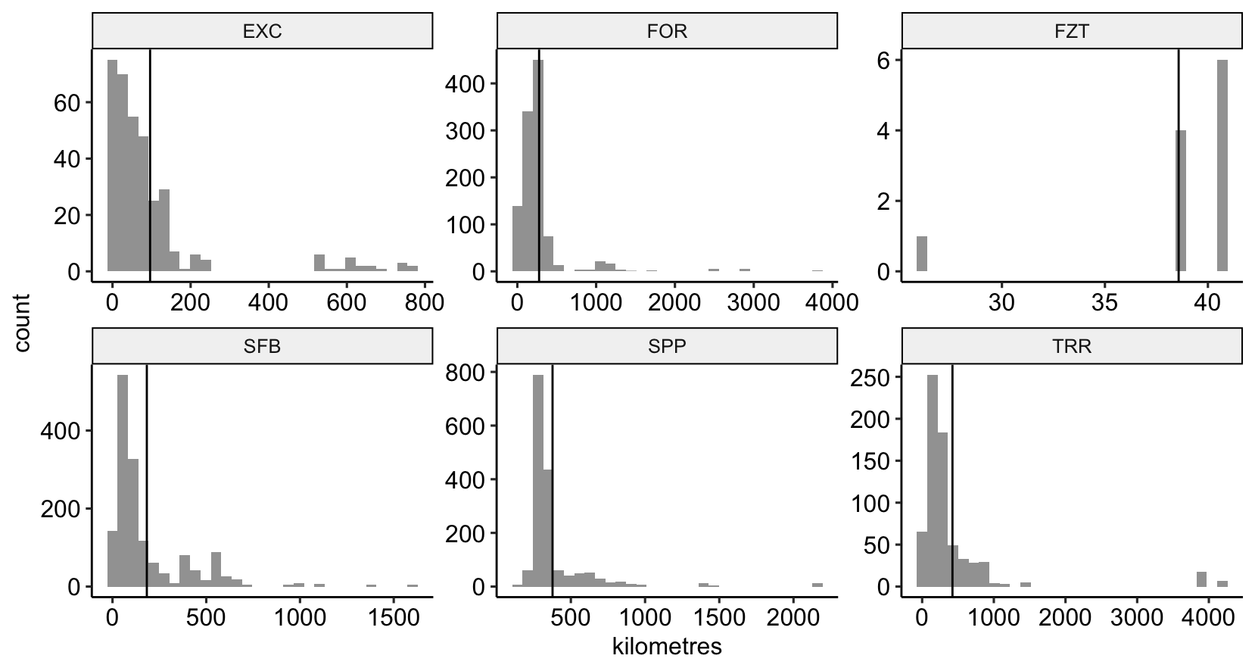
Supplementary Figure 10. Average spatial distribution of scientists per research cluster in kilometres, according to funding line: Research Units (FOR), Research Centres (FZT), Clusters of Excellence (EXC), Collaborative Research Centres (SFB), Transregios (TRR) and Priority Programmes (SPP). Source: DEKiF-Survey

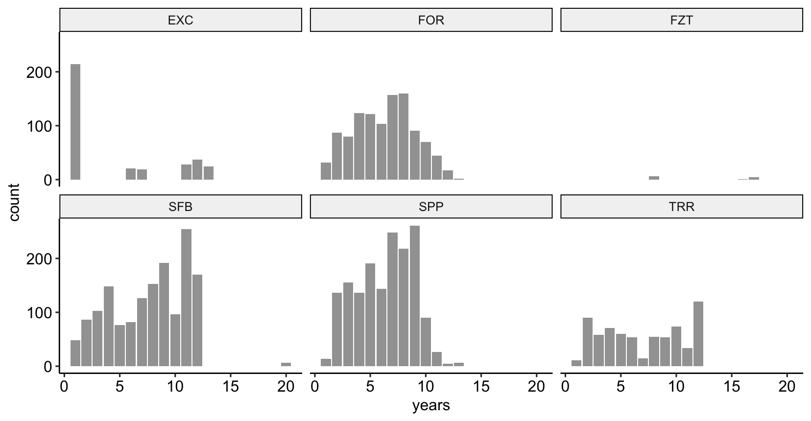
Supplementary Figure 11. Duration of the research cluster in years according to funding line: Research Units (FOR), Research Centres (FZT), Clusters of Excellence (EXC), Collaborative Research Centres (SFB), Transregios (TRR) and Priority Programmes (SPP). Source: DEKiF-Survey

Supplementary Figure 12. Distribution of the 51 input variables. A: input variable 1-24. B: input variable 25-51.

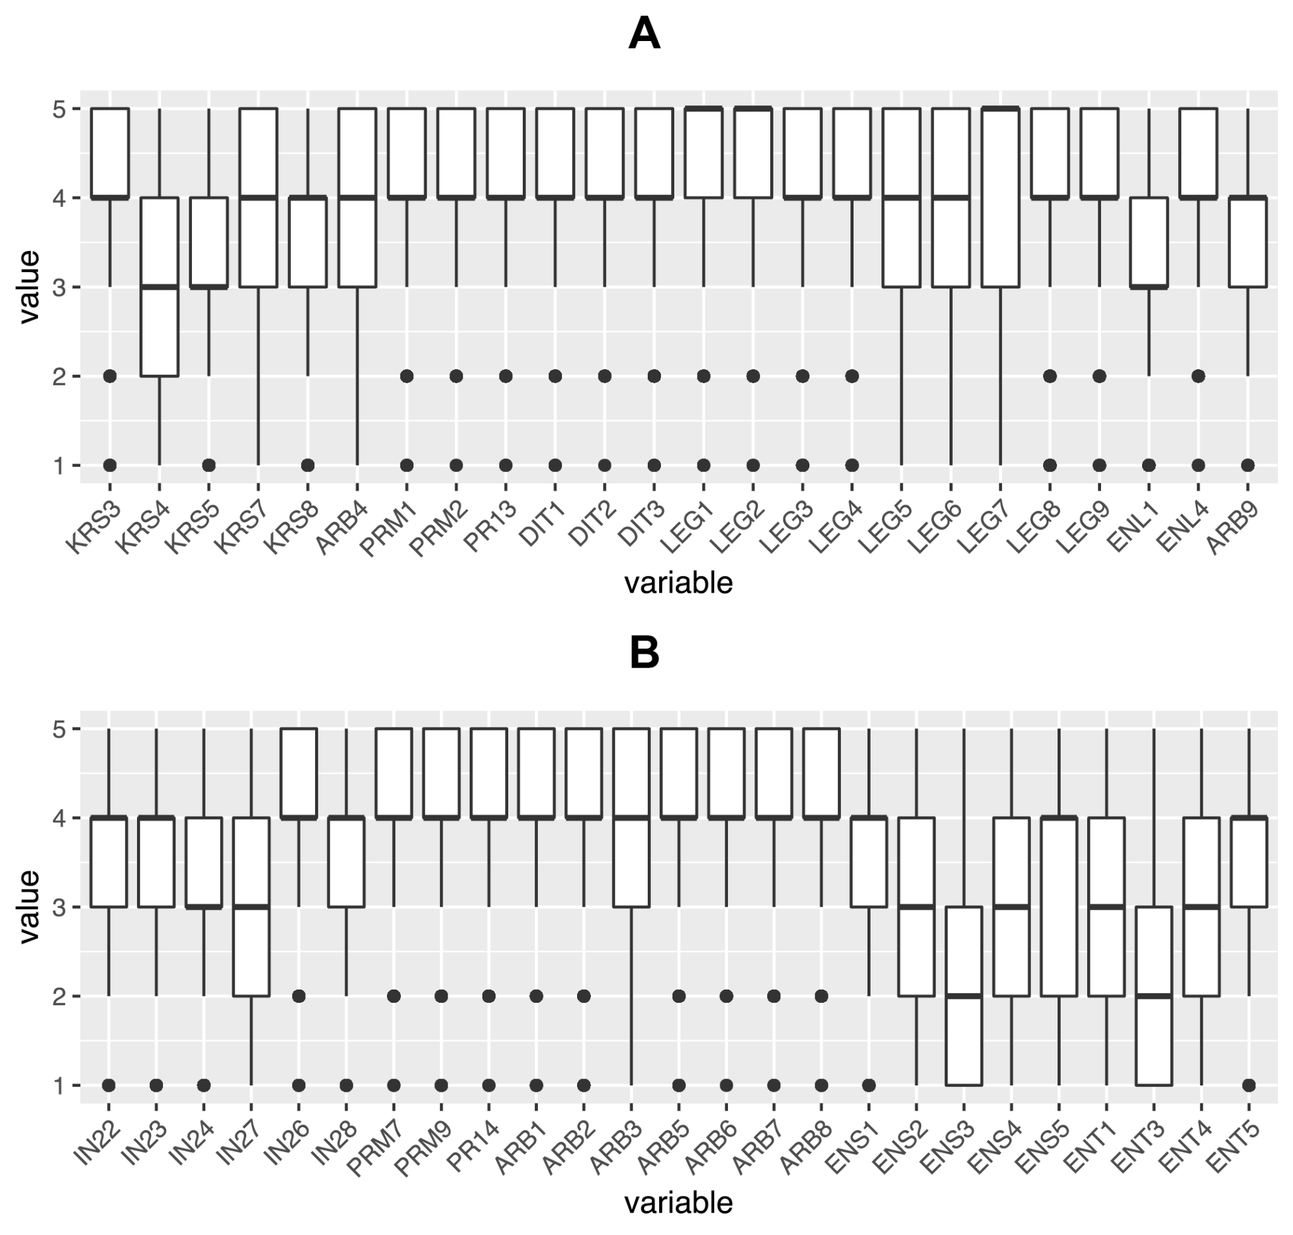

Supplementary Table 2. Input variables of the Random Forest classifier
Item | Name | Topic | $$\underline{x}(σ)$$
ORDINAL SCALED FACTORS OF STAFF SELECTION
CRITERIA IN RESEARCH CLUSTERS
What influence did the following characteristics have in selecting the PIs (subproject leader/applicant) in the research cluster?
Discipline-specific competence  (1=not at all, 5=fully)* | KRS1 | intrapersonal | 4.6 (0.7)
Access to infrastructure (large-scale facilities, data and information infrastructures, laboratories) (1=not at all, 5=fully)* | KRS4 | intrapersonal | 3.1 (1.2)
Personality (1=not at all, 5=fully) * | KRS5 | intrapersonal | 3.3 (1)
Previous personal or professional acquaintance with the initiators of the cluster  (1=not at all, 5=fully) * | KRS6 | intrapersonal | 3.7 (1)
Special research activities or research projects  (1=not at all, 5=fully) * | KRS7 | intrapersonal | 3.9 (0.9)
Networks within the inter(national) scientific community (1=not at all, 5=fully) * | KRS8 | intrapersonal | 3.5 (0.9)
ORDINAL SCALED FACTORS FOR
COLLABORATION READINESS
To what extent do the following statements apply to collaboration at the cluster level? | DIT1 | intrapersonal | 4.1 (0.8)
The cluster members are willing to see different points of view  (1=not at all, 5=fully)** | DIT2 | intrapersonal | 4.1 (0.7)
The cluster members can make their own viewpoint understandable to the other cluster members (1=not at all, 5=fully)** | DIT3 | intrapersonal | 4.1 (0.8)
The cluster members strive to understand the mindset and methodological approaches of the other disciplines (1=not at all, 5=fully)** | DIT1 | intrapersonal | 4.1 (0.8)
ORDINAL SCALED FACTORS IN DEVELOPING
SHARED RESEARCH QUESTIONS
What influence did the following points have on developing shared research questions and objectives at the cluster level?
Equal consideration of all disciplines represented (1=not at all, 5=fully) | ENL1 | interpersonal | 3.4 (1.1)
ORDINAL SCALED FACTORS FOR THE PROCEDURES FOR
INTEGRATING SUBPROJECTS’ RESEARCH RESULTS AT THE CLUSTER LEVEL
What influence do the following requirements and procedures have for integrating subprojects’ research results at the cluster level?
Conceptual coherence of the subprojects (1=not at all, 5=fully)* | IN21 | interpersonal | 4.2 (0.8)
Methodological coherence of the subprojects (1=not at all, 5=fully)* | IN22 | interpersonal | 3.6 (1)
Development of a shared theoretical framework (1=not at all, 5=fully)* | IN23 | interpersonal | 3.6 (1)
Development of a shared terminology (1=not at all, 5=fully)* | IN24 | interpersonal | 3.4 (1.1)
Continuous exchange between subprojects (regarding intermediate results) (1=not at all, 5=fully)* | IN26 | interpersonal | 4.1 (0.9)
Joint integration of the research results from the subprojects (1=not at all, 5=fully)* | IN28 | interpersonal | 3.7 (1)
*Based on Defila et al. (2006)
**Based on Steinheider et al. (2009)
***based on Anderson et al. (2000)

Supplementary Table 2. Input variables of the Random Forest classifier (continued)
Item | Name | Topic | $$\underline{x}(σ)$$
ORDINAL SCALED FACTORS OF THE SPOKEPERSON'S
CHARACTERISTICS AND ABILITIES
In your personal opinion, to what extent do the following characteristics and abilities apply to the spokesperson of the research cluster?
Has high strategic competence (1=not at all, 5=fully)* | LEG1 | intrapersonal | 4.4 (0.7)
Has high discipline-related competence (1=not at all, 5=fully)* | LEG2 | intrapersonal | 4.6 (0.6)
Has good moderation skills (1=not at all, 5=fully)* | LEG3 | intrapersonal | 4.2 (0.9)
Can motivate the cluster members to collaborate across subprojects (1=not at all, 5=fully)* | LEG4 | intrapersonal | 4.2 (0.9)
Communicates comprehensively and transparently (1=not at all, 5=fully)* | LEG5 | intrapersonal | 4 (1)
Supports conflict resolution at the cluster level (1=not at all, 5=fully)* | LEG6 | intrapersonal | 3.8 (1.1)
Does not promote themself at the expense of the cluster (1=not at all, 5=fully)* | LEG7 | intrapersonal | 4.1 (1.2)
Is open to criticism, suggestions, and proposals (1=not at all, 5=fully)* | LEG8 | intrapersonal | 4.2 (1)
Ensures an open and inclusive environment for communication at the cluster level (1=not at all, 5=fully)* | LEG9 | intrapersonal | 4.2 (1)
ORDINAL SCALED FACTORS FOR DECISION-MAKING PROCEDURES
FOR THE DISTRIBUTION OF RESOURCES
What influence do the following decision-making procedures have for the distribution of resources within the research cluster?
Spokesperson decides (1=not at all, 5=fully)* | ENS1 | interpersonal | 3.4 (1.2)
A subgroup (a subproject/committee) decides (1=not at all, 5=fully)* | ENS2 | interpersonal | 2.8 (1.4)
A person asserts their point of view (1=not at all, 5=fully)* | ENS3 | interpersonal | 1.9 (1.1)
Decision by majority (1=not at all, 5=fully)* | ENS4 | interpersonal | 3.1 (1.3)
Unanimous decision (1=not at all, 5=fully)* | ENS5 | interpersonal | 3.4 (1.3)
Unanimous decision, but in case of split decision the Spokesperson decides 1=not at all, 5=fully)* | ENS6 | interpersonal | 3  (1.4)
ORDINAL SCALED FACTORS FOR DECISION-MAKING
PROCEDURES FOR CONTENT-RELATED DECISIONS
Spokesperson decides (1=not at all, 5=fully)* | ENT1 | interpersonal | 3.1 (1.2)
A subgroup (a subproject/committee) decides (1=not at all, 5=fully)* | ENT2 | interpersonal | 3 (1.3)
A person asserts their point of view (1=not at all, 5=fully)* | ENT3 | interpersonal | 2 (1.1)
Decision by majority (1=not at all, 5=fully)* | ENT4 | interpersonal | 3.1 (1.2)
Unanimous decision (1=not at all, 5=fully)* | ENT5 | interpersonal | 3.5 (1.2)
Unanimous decision, but in case of split decision the Spokesperson decides (1=not at all, 5=fully)* | ENT6 | interpersonal | 2.9 (1.3)
*Based on Defila et al. (2006)
**Based on Steinheider et al. (2009)
***based on Anderson et al. (2000)

Supplementary Table 2. Input variables of the Random Forest classifier (continued)
Item | Name | Topic | $$\underline{x}(σ)$$
ORDINAL SCALED FACTORS FOR COLLABORATION
AT THE CLUSTER LEVEL
There is a sense of unity at cluster level (1=not at all, 5=fully) | ARB1 | interpersonal | 4.2 (0.9)
There is fair interaction between the cluster members at cluster level (1=not at all, 5=fully)*** | ARB2 | interpersonal | 4.3 (0.8)
Regular feedback is obtained from the subprojects as to whether the set (sub)goals of the cluster are being achieved (1=not at all, 5=fully*** | ARB3 | interpersonal | 3.9 (1)
All members at cluster level feel responsible for achieving the common cluster goals (1=not at all, 5=fully)*** | ARB4 | intrapersonal | 3.9 (0.9)
The requirements for the subprojects regarding the common cluster objectives are clearly formulated (1=not at all, 5=fully)*** | ARB5 | interpersonal | 4 (0.9)
The cluster members know what tasks they need to complete for the achievement of the common cluster objectives (1=not at all, 5=fully)*** | ARB7 | interpersonal | 4.2 (0.8)
The cluster members are committed to the common objectives of the cluster (1=not at all, 5=fully)*** | ARB8 | interpersonal | 4.1 (0.8)
The internal activities of the subprojects are coordinated with the common objectives of the cluster (1=not at all, 5=fully)*** | ARB9 | interpersonal | 3.9 (0.9)
Communication at cluster level is open and participative (1=not at all, 5=fully)*** | AR11 | interpersonal | 4.2 (0.9)
The cluster members reliably engage in the cluster (1=not at all, 5=fully) | PRM1 | interpersonal | 4 (0.8)
The cluster members collaborate towards achieving the common research objectives, also beyond the boundaries of subprojects (1=not at all, 5=fully) | PRM2 | interpersonal | 4.2 (0.8)
The communication at cluster level is comprehensive (1=not at all, 5=fully) | PRM5 | interpersonal | 4 (0.9)
The cluster members participate actively in communication within the cluster (1=not at all, 5=fully) | PRM6 | interpersonal | 3.8 (0.9)
There is sufficient agreement among cluster members on the common objectives at cluster level (1=not at all, 5=fully) | PRM7 | interpersonal | 4.1 (0.8)
The collaboration at cluster level is characterised by mutual trust (1=not at all, 5=fully) | PRM9 | interpersonal | 4.2 (0.8)
The cluster members do everything in their power to reliably deliver their contributions to the achievement of the common cluster objectives (1=not at all, 5=fully) | PR13 | interpersonal | 4 (0.8)
The cluster is adequately prepared for the fact that delays or unforeseen situations may occur in the research process (1=not at all, 5=fully) | PR14 | interpersonal | 4.1 (0.8)
*Based on Defila et al. (2006)
**Based on Steinheider et al. (2009)
***based on Anderson et al. (2000)
Supplementary Table 3. Output variable of the Random Forest classifier
Item | Name | Yes (%) | No (%)
Please estimate: To what extent do the following statements apply at the cluster level? The cluster achieves the objectives communicated to the DFG (1=not at all, 5=fully) | ER11 | 92 | 8

Supplementary Table 4. Mean decrease in Accuracy and the mean decrease in Gini of the ten most important influence variables.

Item | Mean Decrease in Accuracy | Mean Decrease in Gini
ARB6 | 17.70 | 9.35
PRM7 | 10.44 | 5.48
ARB8 | 8.51 | 5.18
ARB2 | 9.91 | 4.46
PRM1 | 5.84 | 4.13
PR13 | 9.07 | 3.57
PRM9 | 7.52 | 3.37
ARB5 | 10.80 | 3.20
ARB9 | 9.29 | 2.93
DIT3 | 8.68 | 2.28
Note: Sorted by mean decrease in Gini

