Supplementary Materials
This Supplementary Materials pursues the goal of providing detailed guidance for understanding and reproducing the problems when using the standard VADER lexicon as a tool for sentiment analysis of scientific texts and the construction of the modified sentiment dictionaries. Table 4 shows the three scientific areas along with their subordinate sub-disciplines, as they are represented by the MeSH structure in MEDLINE. Additionally the number of available papers per sub-discipline is shown. For the sake of space and simplicity and due to similarities only results of the long dictionary were provided in the main text of the paper. Additionally this Supplementary Materials provides the results for the short and medium dictionary for the two different statistical analyses (Tables 5 - 8).
Table 4 MesH Keywords in each one of the scientific disciplines. These were used as search terms
Psychology | n | Biology | n | Physics | n
Adolescent Psychology | 13784 | Botany | 7081 | Acoustics | 38836
Cognitive Science | 1409 | Cell Biology | 6421 | Astronomy | 1793
Economics Behavioral | 666 | Computational Biology | 223471 | Biophysics | 101325
Environmental Psychology | 19 | Cryobiology | 31 | Electronics | 40890
Ethnopsychology | 756 | Developmental Biology | 6486 | Health Physics | 2306
Forensic Psychology | 80 | Ecology | 39201 | Magnetics | 25800
Psychology, Child | 13527 | Exobiology | 2095 | Mechanics | 1328
Psychology, Clinical | 3225 | Genetics | 288202 | Meteorology | 990
Psychology, Comparative | 427 | Laboratory Animal Science | 1114 | Nuclear Physics | 28569
Psychology, Developmental | 439 | Microbiology | 155828 | Optics and Photonics | 81207
Psychology, Educational | 112133 | Natural History | 826 | Rheology | 50812
Psychology, Experimental | 1701 | Neurobiology | 2448
Psychology, Industrial | 92225 | Parasitology | 6559
Psychology, Medical | 505 | Photobiology | 1097
Psychology, Positive | 113 | Radiobiology | 3395
Psychology, Social | 951694 | Sociobiology | 283
Psychology, Sports | 48 | Synthetic Biology | 4066
 |  | Zoology | 3735
Total
Psychology | 1192751 | Biology | 752339 | Physics | 373856

Table 5 Results of binary logistic regression using the medium dictionary
 | Β |  | Z |  | p-value |  | Odds Ratio
Intercept | -1.27 | -1.16 | -45.74 | -42.64 | 0 | 0 | .28 | .31
Abstract Lengthª | .40 | .46 | 29.43 | 33.32 | <.001 | <.001 | 1.50 | 1.59
Yearª | .05 | .11 | 3.58 | 7.76 | <.001 | <.001 | 1.05 | 1.12
Field
Psy vs. Bio  Psy vs. Phy | -.12 | .00 | -4.14 | -0.12 | <.001 | .80 | .88 | 1.00
Psy vs. Bio  Psy vs. Phy | -.19 | -.04 | -5.14 | -1.02 | <.001 | .30 | .83 | .96
Parts
1st vs 2nd Part | .18 | .31 | 5.37 | 9.20 | <.001 | <.001 | 1.20 | 1.36
1st vs 3rd Part | .80 | .92 | 25.21 | 28.75 | <.001 | <.001 | 2.23 | 2.52
Pseudo R² = .087 - .102
Bootstrapping results are presented at the 95% confidence interval
ª the values of this variable have been z-standardized for better interpretability

Table 6 Results of binary logistic regression using the short dictionary
 | Β |  | Z |  | p-value |  | Odds Ratio
Intercept | -1.79 | -1.67 | -55.64 | -53.42 | 0 | 0 | .17 | .19
Abstract Lengthª | .38 | .44 | 25.13 | 29.03 | <.001 | <.001 | 1.46 | 1.55
Yearª | .03 | .10 | 1.68 | 6.00 | <.001 | .09 | 1.03 | 1.10
Field
Psy vs. Bio  Psy vs. Phy | -.17 | -.02 | -5.06 | -.67 | <.001 | 0.49 | .84 | .98
Psy vs. Bio  Psy vs. Phy | -.17 | -.02 | -4.27 | -.44 | <.001 | 0.63 | .84 | .98
Parts
1st vs 2nd Part | .15 | .29 | 3.85 | 7.48 | <.001 | <.001 | 1.16 | 1.34
1st vs 3rd Part | .80 | .93 | 22.40 | 25.75 | <.001 | <.001 | 2.23 | 2.55
Pseudo R² = .071 - .087
Bootstrapping results are presented at the 95% confidence interval
ª the values of this variable have been z-standardized for better interpretability

Table 7 Results of mixed-effects model on the positive abstract subsample using the medium dictionary
 | NumDf |  | DenDF |  | SumSQ |  | Mean SQ |  | F |  |  | p
Year* | 1 |  |  | 29990 | .02 | .09 | .02 | .09 |  | 8.19 | 42.04 | <.001 | .004
Field of Science* | 2 |  |  | 29990 | .03 | .11 | .02 | .06 |  | 7.56 | 26.99 | <.001 | .001
Part* | 2 |  |  | 29990 | 3.29 | 4.09 | 1.65 | 2.05 |  | 788.35 | 981.29 | <.001 | <.001
Part X Science* | 4 |  |  | 29990 | .16 | .33 | .04 | .08 |  | 18.49 | 38.90 | <.001 | <.001
Bootstrapping results are presented at the 95% confidence interval

Table 8 Results of mixed-effects model on the positive abstract subsample using the short dictionary
 | NumDf |  | DenDF |  | SumSQ |  | Mean SQ |  | F |  |  | p
Year* | 1 |  |  | 29990 | .04 | .10 | .04 | .10 |  | 24.81 | 66.50 | <.001 | <.001
Field of Science* | 2 |  |  | 29990 | .01 | .05 | .01 | .02 |  | 3.69 | 15.83 | <.001 | .025
Part* | 2 |  |  | 29990 | 2.71 | 3.31 | 1.35 | 1.65 |  | 880.12 | 1081.39 | <.001 | <.001
Part X Science* | 4 |  |  | 29990 | .11 | .24 | .03 | .06 |  | 17.21 | 38.70 | <.001 | <.001
Bootstrapping results are presented at the 95% confidence interval

Figure 6 depicts the words that displayed the greatest influence on the overall sentiment score in each of the three fields when using the standard VADER dictionary. Here we see that "care", for example, has the greatest influence among all words in psychology. Potentially more exciting terms that might have less relation to content and more to stylistic presentation, such as "best," "better," "important," "improve," and "significant," are also among the top 15 terms in psychology and were explored as part of further context analysis. Generally there was some overlap between the fields, however certain differences regarding the topics of each field, such as the presence of the word “energy” in physics also emerged. This study also attempted to validate its findings using the dictionary of Vinkers et al. (2015). Table 9 shows the predefined positive terms Vinkers et al. (2015) used in their research with their corresponding VADER values. Some words did not have a value in the VADER dictionary so that a synonymous term was used to assign a sentiment value to that word. Figure 7 shows the results when using the dictionary and the values shown in Table 9 to conduct a sentiment analysis on the abstracts. Using Vinkers et al. (2015) dictionary likewise led to a steep increase in sentiment over the past few decades. The development of the frequency of abstracts containing words in this dictionary relative to the number of papers in that respective year, can be seen in Figure 8. Only words that appeared more often than 500 times in the past four decades were retained. Figure 9 plots the same trend but this time showing the predefined negative terms Vinkers et al. (2015) used.
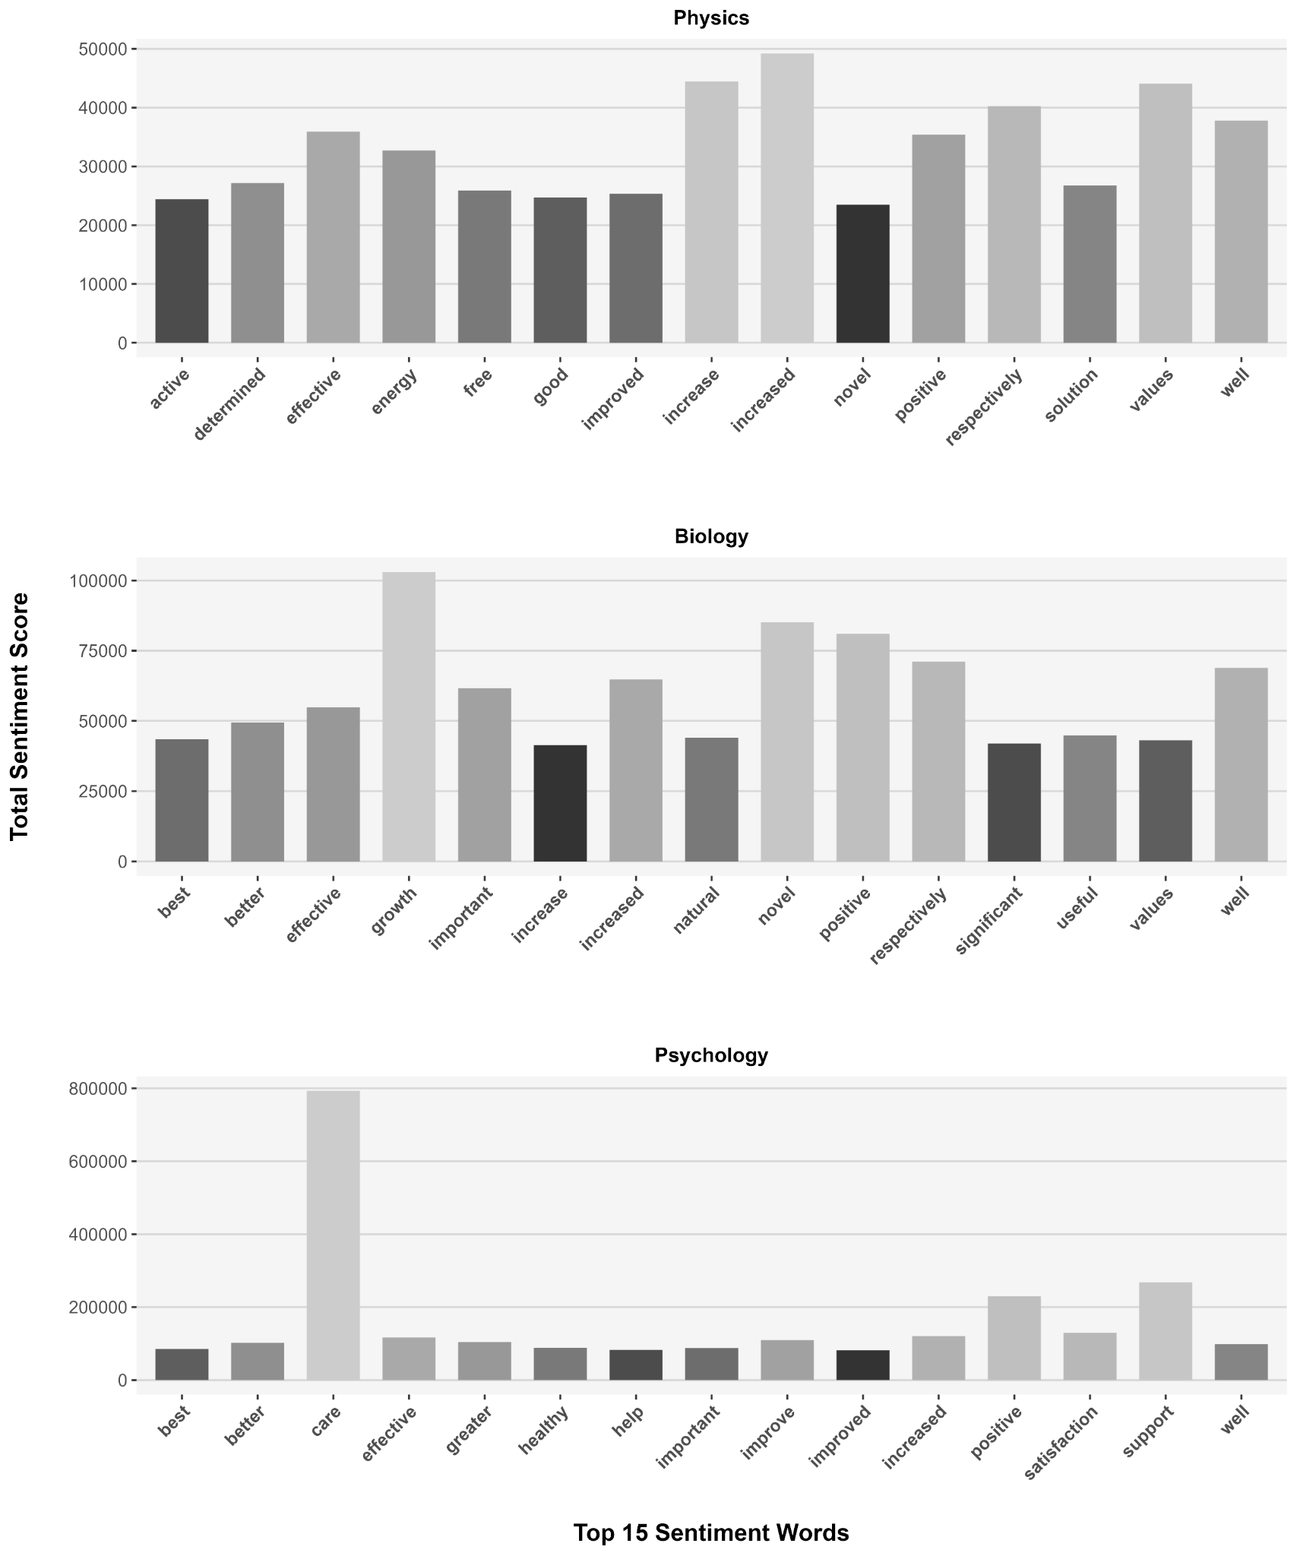
Fig. 6 The 15 most influential sentiment words in psychology, biology and physics using the standard VADER lexicon. The overall sentiment score is defined as the frequency of that word multiplied by the mean sentiment score of that term
Table 9 The terms of Vinkers et al. (2015) and their corresponding VADER values. If a certain word does not have a VADER value (in italics), the value of the synonymous term was used
Word (Vinkers) | Synonymous Term | Sentiment Value
amazing |  | 2.8
assuring |  | 1.6
astonishing | astonished | 1.6
bright |  | 1.9
creative |  | 1.9
encouraging |  | 2.4
enormous | huge | 1.3
excellent |  | 2.7
favourable | agreeable | 1.8
groundbreaking | innovative | 1.9
hopeful |  | 2.3
innovative |  | 1.9
inspiring |  | 1.8
inventive |  | 1.9
novel |  | 1.3
phenomenal | outstanding | 3.0
prominent |  | 1.3
promising |  | 1.7
reassuring |  | 1.7
remarkable |  | 2.6
robust |  | 1.4
spectacular | amazing | 2.8
supportive |  | 1.2
unique | exclusive | 0.5
unprecedented | fantastic | 2.6

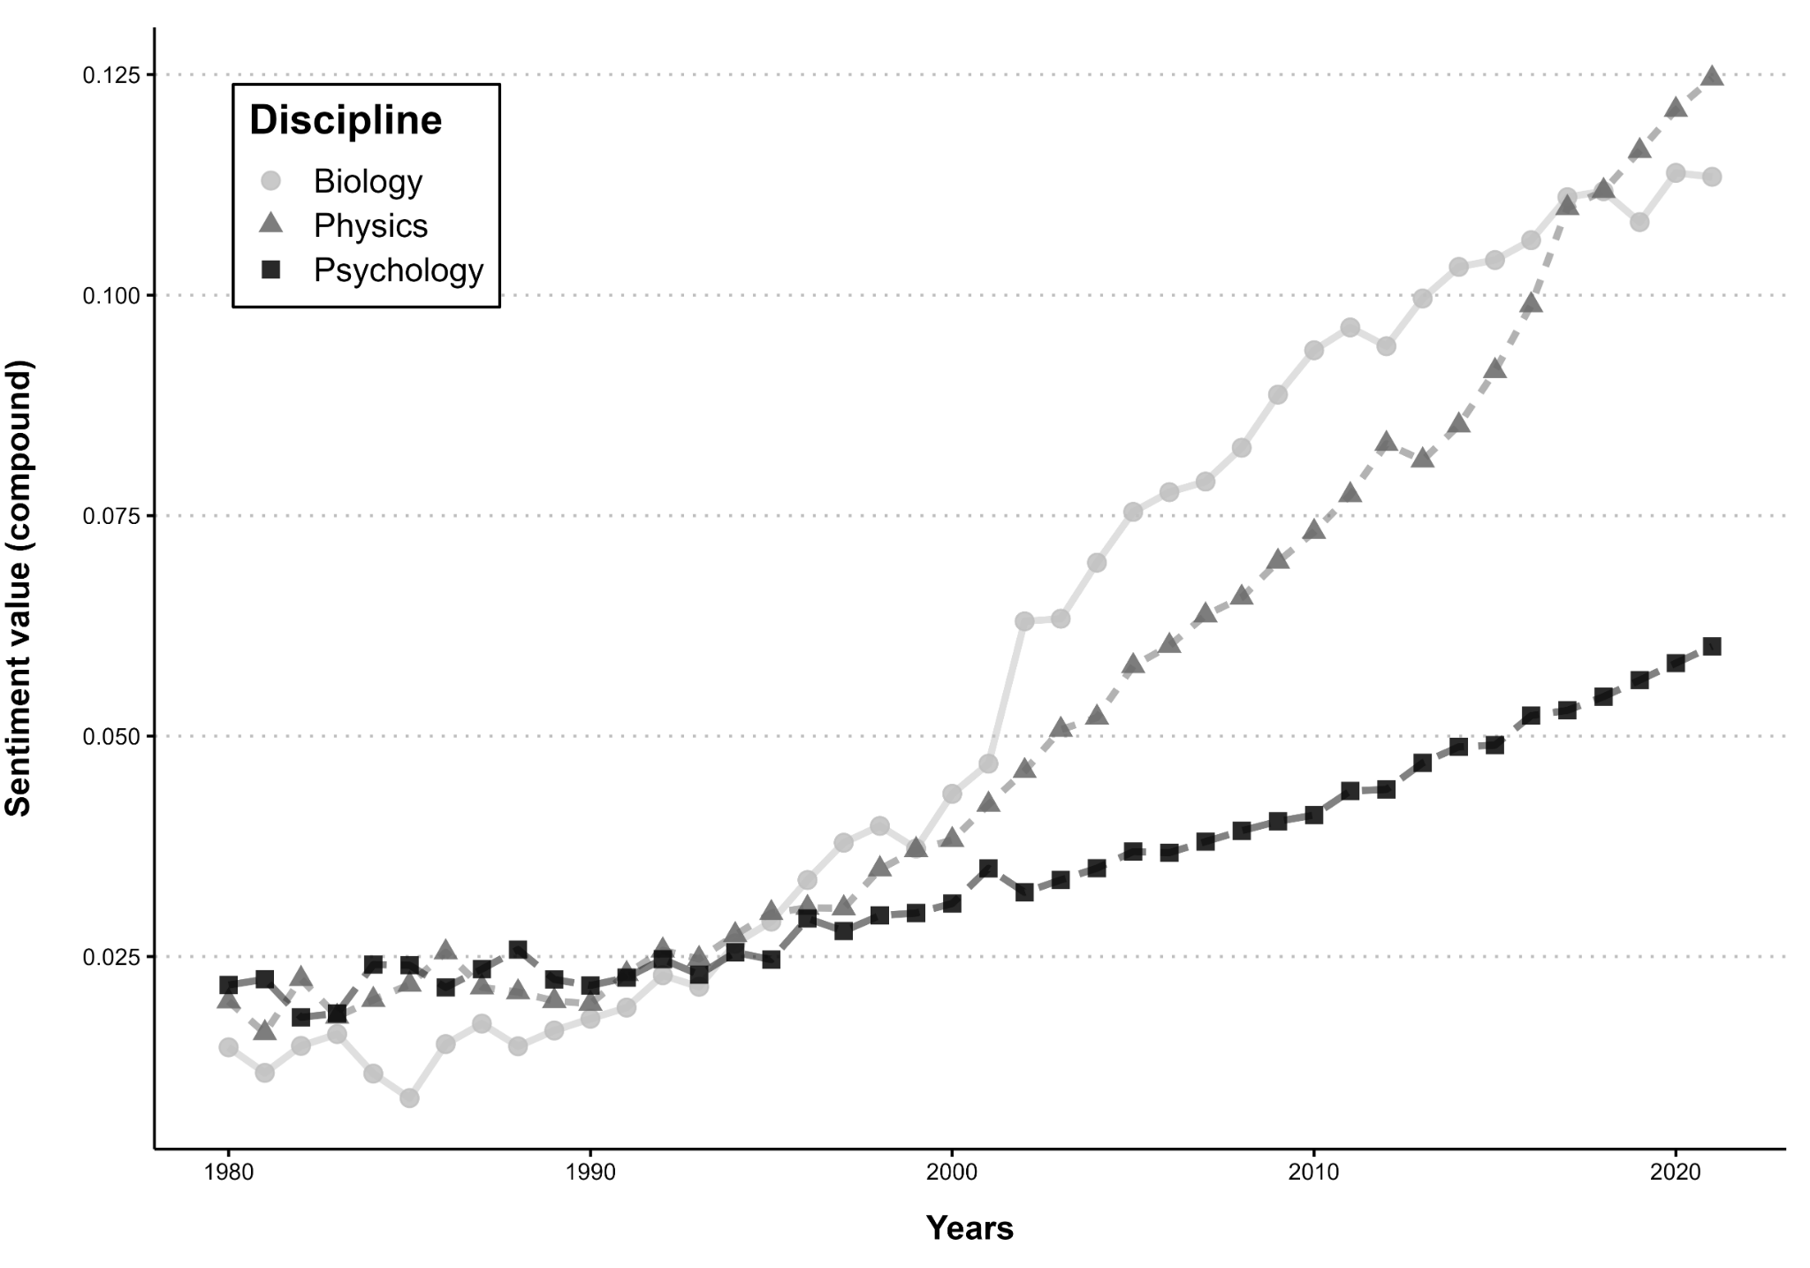Fig. 7 The development of the sentiment score using Vinkers et al. (2015) dictionary for a VADER analysis. The compound score was used to depict the sentiment which is calculated by the summation of all sentiment scores of words that were normalized in the range of - 1 to +1 (Rao et al., 2020). The close the compound score is to +1, the higher is the positivity of the text
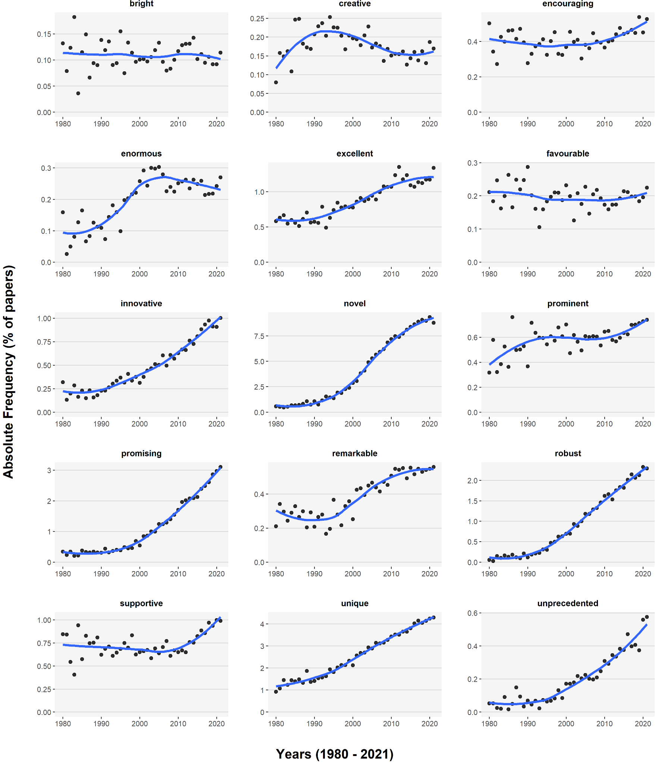
Fig. 8 The number of abstracts containing the corresponding word of the 15 positive words Vinkers et al. (2015) used in their study, related to the number of abstracts for that year. Only terms that occurred more than 500 times in 40 years were included. Therefore the words “amazing”, “assuring”, “"astonishing", "groundbreaking", "hopeful" , "inspiring","inventive", "phenomenal", "reassuring" and "spectacular” were not included.
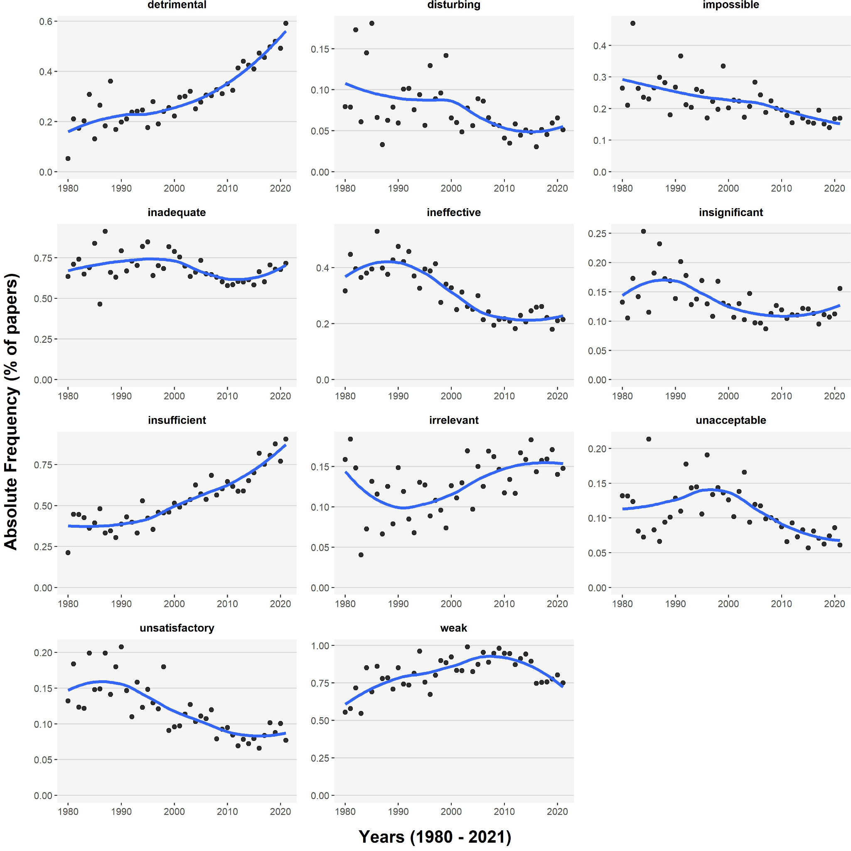
Fig. 9 The number of abstracts containing the corresponding word of the negative 11 words Vinkers et al. (2015) used in their study, related to the number of abstracts for that year. Only terms that occurred more than 500 times in 40 years were included. Therefore the words “disappointing”, “disconcerting”, “"discouraging", "disheartening", "frustrating" , "futile", "hopeless", "mediocre", "pessimistic", “substandard”, “unpromising”, “unsatisfying”, “useless” and "worrisome” were not included.
Table 10 lists the entire frequency of the bi- and tri-grams, separated into their respective scientific field, which formed the basis for the decision to include words in the revised dictionaries. The bi- and tri-grams in this table are aimed at providing the context in which the 35 words included in the long dictionary occur and why they were included in the science-specific dictionaries for sentiment analysis.

Table 10 Context Analysis: The most frequent bi- & tri-grams of the words which were used for the creation of the three differently sized science-specific dictionaries
Psychology | n | Biology | n | Physics | n
beneficial effects | 171 | beneficial effects | 83 | beneficial effects | 51
beneficial effect | 85 | beneficial mutations | 23 | beneficial effect | 34
beneficial newborn care | 6 | beneficial health effects | 9 | no beneficial effect | 3
mutually beneficial relationship | 5 | plant beneficial bacillus | 3 | exert beneficial effects | 2
the beneficial effects | 43 | the beneficial effects | 21 | the beneficial effects | 23
a beneficial effect | 30 | have beneficial effects | 10 | a beneficial effect | 11
may benefit | 214 | may benefit | 42 | may benefit | 31
can benefit | 93 | clinical benefit | 41 | will benefit | 12
cost benefit analysis | 20 | cost benefit analysis | 6 | cost benefit analysis | 4
may also benefit | 9 | clinical benefit rate | 3 | patients may benefit | 4
cost benefit analysis | 20 | who may benefit | 10 | the potential benefit | 5
who may benefit | 26 | the potential benefit | 9 | an additional benefit | 4
health benefits | 224 | health benefits | 79 | potential benefits | 22
potential benefits | 126 | potential benefits | 43 | health benefits | 12
long term benefits | 23 | potential health benefits | 7 | showed significant benefits | 2
health benefits associated | 11 | public health benefits | 5 | additional benefits expressed | 1
the potential benefits | 59 | the potential benefits | 24 | the potential benefits | 10
the health benefits | 37 | and health benefits | 11 | showed significant benefits | 2
better understand | 436 | better understanding | 593 | better understanding | 137
better understanding | 398 | better understand | 453 | significantly better | 105
performed significantly better | 32 | better overall survival | 7 | performed significantly better | 8
better mental health | 29 | gave better results | 6 | spatial resolution better | 6
to better understand  to better understand | 397  301 | a better understanding  to better understand | 437  431 | a better understanding  to better understand | 108  92
can effectively | 72 | can effectively | 90 | can effectively | 56
effectively manage | 27 | effectively reduce | 26 | effectively used | 19
nurses can effectively | 5 | can effectively reduce | 13 | can effectively increase | 3
model can effectively | 4 | can effectively identify | 5 | can effectively reduce | 3
to communicate effectively | 18 | be effectively used | 15 | be effectively used | 16
to effectively manage | 15 | can effectively reduce | 13 | and can effectively | 5
less efficient | 35 | highly efficient | 82 | highly efficient | 76
efficient use | 33 | efficient method | 63 | efficient method | 41
efficient health care | 4 | efficient cell factories | 5 | highly efficient light | 4
efficient health service | 4 | cost efficient method | 4 | computationally efficient way | 3
more efficient use | 12 | an efficient method | 26 | a highly efficient | 23
an efficient means | 9 | an efficient tool | 26 | an efficient method | 18
excellent internal | 16 | excellent model | 29 | excellent agreement | 130
excellent reliability | 13 | excellent agreement | 19 | showed excellent | 30
excellent internal consistency | 13 | excellent model system | 7 | show excellent agreement | 9
excellent test retest | 9 | showed excellent agreement | 3 | excellent long term | 8
excellent internal consistency | 13 | an excellent model | 26 | in excellent agreement | 58
excellent test retest | 9 | an excellent tool | 14 | an excellent correlation | 16
significantly greater | 448 | significantly greater | 127 | significantly greater | 214
greater risk | 243 | much greater | 54 | much greater | 54
showed significantly greater | 31 | greater p 0.05 | 9 | significantly greater p | 7
reported significantly greater | 20 | significantly greater proportion | 5 | greater p 0.05 | 6
at greater risk | 115 | a greater extent | 37 | was significantly greater | 88
a greater number | 105 | a greater number | 37 | a greater extent | 38
may help | 605 | can help | 297 | may help | 123
can help | 597 | may help | 276 | can help | 86
may help reduce | 32 | can help us | 17 | can also help | 7
self help groups | 28 | will help us | 15 | will help us | 5
that can help | 54 | that can help | 27 | and may help | 11
to help patients | 54 | and may help | 26 | to help understand | 9
relative importance | 134 | relative importance | 116 | relative importance | 32
great importance | 59 | great importance | 92 | great importance | 30
public health importance | 5 | public health importance | 15 | public health importance | 2
individual importance hypothesis | 3 | cultural importance index | 5 | assume clinical importance | 1
the relative importance | 98 | the relative importance | 98 | of great importance | 29
of great importance | 44 | of great importance | 79 | the relative importance | 27
important role | 843 | important role | 994 | important role | 500
important implications | 235 | important roles | 353 | important factor | 75
important public health | 56 | play important roles | 222 | play important roles | 36
important risk factors | 39 | may play important | 39 | become increasingly important | 15
an important role | 676 | an important role | 862 | an important role | 433
an important factor | 154 | play important roles | 222 | an important factor | 60
can improve | 356 | can improve | 122 | can improve | 107
may improve | 343 | may improve | 78 | may improve | 73
improve patient care | 53 | can significantly improve | 15 | can significantly improve | 14
improve health outcomes | 49 | improve patient care | 14 | improve patient care | 5
to improve patient | 130 | did not improve | 24 | did not improve | 30
to improve health | 99 | to improve patient | 23 | can significantly improve | 14
significantly improved | 239 | significantly improved | 121 | significantly improved | 104
improved significantly | 123 | improved understanding | 82 | improved significantly | 41
improved patient outcomes | 25 | improved water quality | 6 | improved mechanical properties | 8
improved health outcomes | 19 | improved risk prediction | 5 | improved image quality | 6
improved patient outcomes | 25 | an improved understanding | 42 | was significantly improved | 13
were significantly improved | 22 | an improved method | 12 | were significantly improved | 10
quality improvement | 474 | significant improvement | 68 | significant improvement | 131
significant improvement | 305 | genetic improvement | 43 | clinical improvement | 23
statistically significant improvement | 40 | clinical laboratory improvement | 10 | statistically significant improvement | 13
continuous quality improvement | 38 | integrated discrimination improvement | 6 | no significant improvement | 9
a significant improvement | 92 | a significant improvement | 32 | a significant improvement | 62
a quality improvement | 56 | for crop improvement | 11 | statistically significant improvement | 13
significant improvements | 217 | significant improvements | 45 | significant improvements | 49
greater improvements | 37 | recent improvements | 19 | technical improvements | 13
statistically significant improvements | 29 | showed significant improvements | 3 | statistically significant improvements | 9
showed significant improvements | 27 | improvements can still | 2 | 3 fold improvements | 2
statistically significant improvements | 29 | to significant improvements | 7 | statistically significant improvements | 9
showed significant improvements | 27 | in significant improvements | 4 | were significant improvements | 3
improving patient | 84 | thus improving | 17 | thereby improving | 7
improving health | 58 | thereby improving | 13 | thus improving | 7
improving patient care | 17 | improving water quality | 6 | improving image quality | 3
improving patient outcomes | 16 | improving patient care | 5 | improving arm function | 2
for improving patient | 17 | for improving clinical | 6 | and improving patient | 3
improving patient care | 17 | improving water quality | 6 | improving image quality | 3
significant increase | 305 | significant increase | 222 | significant increase | 317
may increase | 264 | fold increase | 157 | fold increase | 117
increase physical activity | 55 | 10 fold increase | 17 | statistically significant increase | 20
statistically significant increase | 32 | 2 fold increase | 12 | dose dependent increase | 18
a significant increase | 217 | a significant increase | 156 | a significant increase | 234
did not increase | 67 | did not increase | 41 | did not increase | 58
increased risk | 1289 | significantly increased | 463 | significantly increased | 371
significantly increased | 454 | increased risk | 267 | increased significantly | 166
increased physical activity | 71 | increased oxidative stress | 29 | increased blood flow | 35
significantly increased risk | 38 | significantly increased risk | 20 | blood flow increased | 22
an increased risk | 433 | an increased risk | 102 | was significantly increased | 65
at increased risk | 267 | were significantly increased | 67 | were significantly increased | 36
best interest | 65 | great interest | 84 | great interest | 53
growing interest | 64 | particular interest | 77 | increasing interest | 40
patient's best interest | 13 | public health interest | 7 | attracted increasing interest | 3
competing interest s | 9 | particular interest since | 6 | gained increasing interest | 3
of particular interest | 64 | of particular interest | 71 | of particular interest | 34
the best interest | 27 | of great interest | 58 | of great interest | 29
novel approach | 52 | novel species | 572 | novel method | 113
novel object | 45 | identify novel | 213 | novel approach | 103
novel object recognition | 26 | provide novel insights | 63 | novel three dimensional | 6
novel missense mutation | 12 | novel therapeutic targets | 45 | provide novel insights | 6
a novel approach | 44 | a novel species | 456 | a novel method | 90
novel object recognition | 26 | to identify novel | 165 | a novel approach | 80
optimal care | 55 | optimal growth | 103 | optimal conditions | 73
sub optimal | 40 | optimal conditions | 56 | optimal control | 18
optimal patient care | 15 | optimal growth temperature | 16 | optimal experimental conditions | 11
provide optimal care | 12 | optimal growth occurred | 12 | optimal reverberation time | 5
to provide optimal | 26 | the optimal conditions | 29 | the optimal conditions | 29
to ensure optimal | 21 | the optimal temperature | 17 | under optimal conditions | 24
unique opportunity | 51 | unique opportunity | 55 | unique opportunity | 21
opportunity costs | 30 | unprecedented opportunity | 27 | great opportunity | 3
capability opportunity motivation | 4 | capability opportunity motivation | 3 | almost unique opportunity | 1
drug use opportunity | 3 | opportunity motivation components | 2 | excellent investigative opportunity | 1
a unique opportunity | 46 | a unique opportunity | 53 | a unique opportunity | 15
an important opportunity | 11 | an unprecedented opportunity | 24 | the unique opportunity | 4
shows promise | 44 | great promise | 63 | great promise | 40
hold promise | 29 | holds promise | 29 | holds promise | 26
may hold promise | 7 | holds great promise | 23 | hold great promise | 9
holds great promise | 3 | hold great promise | 14 | holds great promise | 9
may hold promise | 7 | holds great promise | 23 | hold great promise | 9
and shows promise | 6 | hold great promise | 14 | holds great promise | 9
progress toward | 27 | recent progress | 109 | recent progress | 46
significant progress | 24 | significant progress | 44 | significant progress | 18
despite significant progress | 3 | review recent progress | 9 | despite significant progress | 3
made significant progress | 3 | summarize recent progress | 6 | recent progress made | 3
the progress made | 6 | the recent progress | 26 | the recent progress | 18
of medical progress | 4 | the progress made | 17 | the progress made | 5
statistical significance | 187 | biological significance | 182 | statistical significance | 72
clinical significance | 79 | clinical significance | 124 | clinical significance | 55
reach statistical significance | 45 | genome wide significance | 26 | reach statistical significance | 15
not reach significance | 14 | public health significance | 15 | no statistical significance | 8
reach statistical significance | 45 | the clinical significance | 46 | the functional significance | 18
the clinical significance | 30 | of great significance | 32 | of great significance | 16
significantly lower | 870 | significantly increased | 463 | significantly lower | 392
significantly increased | 454 | significantly lower | 315 | significantly increased | 371
significantly lower scores | 42 | not significantly affected | 27 | not significantly affected | 32
significantly lower levels | 41 | significantly increased risk | 20 | can significantly improve | 14
was significantly lower | 184 | were significantly lower | 90 | was significantly lower | 149
had significantly lower | 140 | was significantly lower | 82 | was significantly greater | 88
strong evidence | 143 | strong evidence | 95 | strong correlation | 64
strong association | 85 | strong correlation | 68 | strong evidenc | 35
provide strong evidence | 18 | strong cation exchange | 33 | provide strong evidence | 12
strong risk factor | 13 | provide strong evidence | 25 | strong magnetic field | 9
a strong association | 60 | a strong correlation | 49 | a strong correlation | 47
a strong predictor | 45 | strong cation exchange | 33 | a strong dependence | 21
strongly associated | 322 | strongly associated | 138 | strongly dependent | 71
strongly related | 155 | strongly correlated | 84 | strongly suggest | 54
results strongly suggest | 12 | results strongly suggest | 15 | results strongly suggest | 25
1 strongly disagree | 11 | findings strongly suggest | 8 | results strongly support | 8
was strongly associated | 73 | is strongly associated | 25 | is strongly dependent | 26
more strongly associated | 56 | were strongly associated | 20 | results strongly suggest | 25
can successfully | 32 | successfully identified | 111 | successfully applied | 97
successfully implemented | 24 | successfully applied | 94 | successfully used | 66
successfully quit smoking | 4 | model successfully predicted | 5 | successfully achieved using | 4
can successfully address | 3 | successfully validated using | 5 | model can successfully | 3
to successfully implement | 10 | were successfully identified | 42 | was successfully applied | 48
been successfully applied | 7 | was successfully applied | 33 | been successfully applied | 24
results supported | 85 | well supported | 69 | also supported | 21
not supported | 79 | also supported | 43 | supported lipid | 10
factor analysis supported | 16 | well supported clades | 10 | body weight supported | 8
factor analyses supported | 9 | chemotaxonomic data supported | 6 | supported lipid bilayers | 8
was not supported | 40 | a well supported | 16 | body weight supported | 8
the results supported | 30 | well supported clades | 10 | supported lipid bilayers | 8
evidence supporting | 94 | evidence supporting | 39 | evidence supporting | 20
supporting patients | 30 | supporting evidence | 17 | self supporting | 9
empirical evidence supporting | 6 | provide evidence supporting | 4 | experimental evidence supporting | 2
class norms supporting | 5 | additional evidence supporting | 3 | neural systems supporting | 2
the evidence supporting | 18 | the evidence supporting | 7 | of self supporting | 3
of evidence supporting | 15 | provide evidence supporting | 4 | and supporting cells | 2
study supports | 79 | study supports | 35 | study supports | 19
evidence supports | 75 | evidence supports | 30 | evidence supports | 14
present study supports | 8 | increasing evidence supports | 5 | robotic arm supports | 4
current evidence supports | 4 | accumulating evidence supports | 2 | present study supports | 2
this study supports | 37 | this study supports | 18 | this study supports | 13
the study supports | 13 | our study supports | 14 | this finding supports | 6
useful tool | 113 | useful tool | 210 | useful tool | 114
useful information | 68 | useful information | 152 | useful information | 58
provide useful information | 21 | provide useful information | 54 | may prove useful | 28
may prove useful | 19 | may prove useful | 25 | provide useful information | 25
a useful tool | 99 | a useful tool | 188 | a useful tool | 101
a useful framework | 33 | provide useful information | 54 | may prove useful | 28
provide valuable | 61 | valuable information | 148 | valuable tool | 59
valuable information | 56 | provide valuable | 121 | valuable information | 34
provide valuable information | 23 | provide valuable information | 58 | provide valuable information | 13
can provide valuable | 12 | provides valuable information | 19 | can provide valuable | 10
a valuable tool | 32 | a valuable tool | 97 | a valuable tool | 55
provide valuable information | 23 | a valuable resource | 76 | a valuable alternative | 13
psychological well | 372 | well known | 472 | well known | 264
well established | 310 | not well | 279 | well defined | 179
not well understood | 134 | not well understood | 135 | not well understood | 74
well child visits | 41 | not well characterized | 25 | results agree well | 19
not well understood | 134 | are not well | 138 | not well understood | 74
are not well | 121 | not well understood | 135 | the well known | 69
The table lists the 35 examined terms in the long dictionary, which was defined to enable a science-specific sentiment analysis. These terms were marked in bold in the top left corner of each section. There are six rows per term. The first two rows examine bi-grams, the last two rows examine tri-grams. The two tri-grams differ in that the second tri-gram (rows 5 & 6 respectively), allows a stop word in the first position of the tri-gram, while the first tri-gram (rows 3 & 4 respectively) does not. This was done for the purpose of increasing variability in assessing the context. Due to the amount of data, only a fraction of abstracts (15% in physics, 12.5% in biology and 10% in psychology) was analyzed

