Table 1A. Countries included in the global and regional datasets, in alphabetical order.
GLOBAL SAMPLE | REGIONAL SUBSAMPLE
Algeria, Argentina, Australia, Austria, Bangladesh, Belarus, Belgium, Brazil, Bulgaria, Canada, Chile, China, Colombia, Croatia, Cyprus, Czech Republic, Denmark, Ecuador, Egypt, England, Estonia, Ethiopia, Finland, France, Germany, Ghana, Greece, Hungary, Iceland, India, Indonesia, Iran, Iraq, Ireland, Israel, Italy, Japan, Jordan, Kazakhstan, Kenya, Latvia, Lebanon, Lithuania, Malaysia, Mexico, Morocco, Netherlands, New Zealand, Nigeria, Norway, Pakistan, Peru, Philippines, Poland, Portugal, Qatar, Romania, Russia, Saudi Arabia, Serbia, Singapore, Slovakia, Slovenia, South Africa, South Korea, Spain, Sri Lanka, Sweden, Switzerland, Thailand, Tunisia, Turkey, UA Emirates, Ukraine, US, Vietnam | Belarus, Bulgaria, Croatia, Czech Republic, Estonia, Hungary, Kazakhstan, Latvia, Lithuania, Poland, Romania, Ukraine, Serbia, Slovakia, Slovenia

Table 2A. Scientific output between 2010-2021 by entity and document type.
 | 2010 | 2011 | 2012 | 2013 | 2014 | 2015 | 2016 | 2017 | 2018 | 2019 | 2020 | 2021
Total document output
Romania | 15210 | 15326 | 16399 | 17961 | 19107 | 20435 | 19148 | 19509 | 19380 | 21216 | 18538 | 18981
Global set | 33681.96 | 35843.95 | 38379.16 | 40674 | 43508.83 | 45715.48 | 48708.92 | 50782.65 | 52978.19 | 57570.52 | 60914.24 | 65993.27
Regional set | 7232.857 | 7495.5 | 8202.143 | 8584.071 | 9490.929 | 10024.71 | 10681.5 | 11087.79 | 11416.07 | 12112.43 | 12359.43 | 12978.5
Total article output
Romania | 8322 | 8792 | 9425 | 10427 | 9691 | 10183 | 10155 | 10414 | 10676 | 12100 | 12246 | 13878
Global set | 22196.8 | 24096.92 | 25396.36 | 27196.39 | 28779.13 | 30287.12 | 32308.6 | 33855.09 | 35532.67 | 39794.81 | 44775.75 | 49923.79
Regional set | 4962.143 | 5372.214 | 5799 | 6021.357 | 6366.929 | 6691.714 | 7041.5 | 7307.429 | 7658.286 | 8346.357 | 9399.929 | 10365.93
MDPI articles
Romania | 8 | 20 | 34 | 36 | 35 | 70 | 101 | 178 | 421 | 963 | 2048 | 3434
Global set | 36.2933 | 56.3067 | 80.7467 | 104.7734 | 149.9733 | 218.6533 | 316.1067 | 502.0266 | 947.44 | 1614.387 | 2491.96 | 3534.76
Regional set | 10.6429 | 12.3572 | 15.0714 | 18.3571 | 24.3572 | 33.8572 | 52.2857 | 85.5715 | 260.1428 | 572.5 | 1227.572 | 1916.714
non-MDPI articles
Romania | 8314 | 8772 | 9391 | 10391 | 9656 | 10113 | 10054 | 10236 | 10255 | 11137 | 10198 | 10444
Global set | 22160.51 | 24040.61 | 25315.61 | 27091.61 | 28629.16 | 30068.47 | 31992.49 | 33353.07 | 34585.23 | 38180.43 | 42283.79 | 46389.03
Regional set | 4951.5 | 5359.857 | 5783.929 | 6003 | 6342.571 | 6657.857 | 6989.214 | 7221.857 | 7398.143 | 7773.857 | 8172.357 | 8449.214
Proceeding papers
Romania | 5554 | 5447 | 5518 | 5956 | 7576 | 8156 | 6869 | 6848 | 6238 | 6424 | 3584 | 1853
Global set | 4724.36 | 4528.947 | 4867.773 | 4976.72 | 5663.267 | 6163.4 | 6701.027 | 6816.053 | 6715.88 | 6184.56 | 4384.387 | 3315.28
Regional set | 1489.286 | 1278.786 | 1428.286 | 1474.5 | 1958.357 | 2105.357 | 2454.429 | 2548 | 2394.714 | 2218.071 | 1416.071 | 715

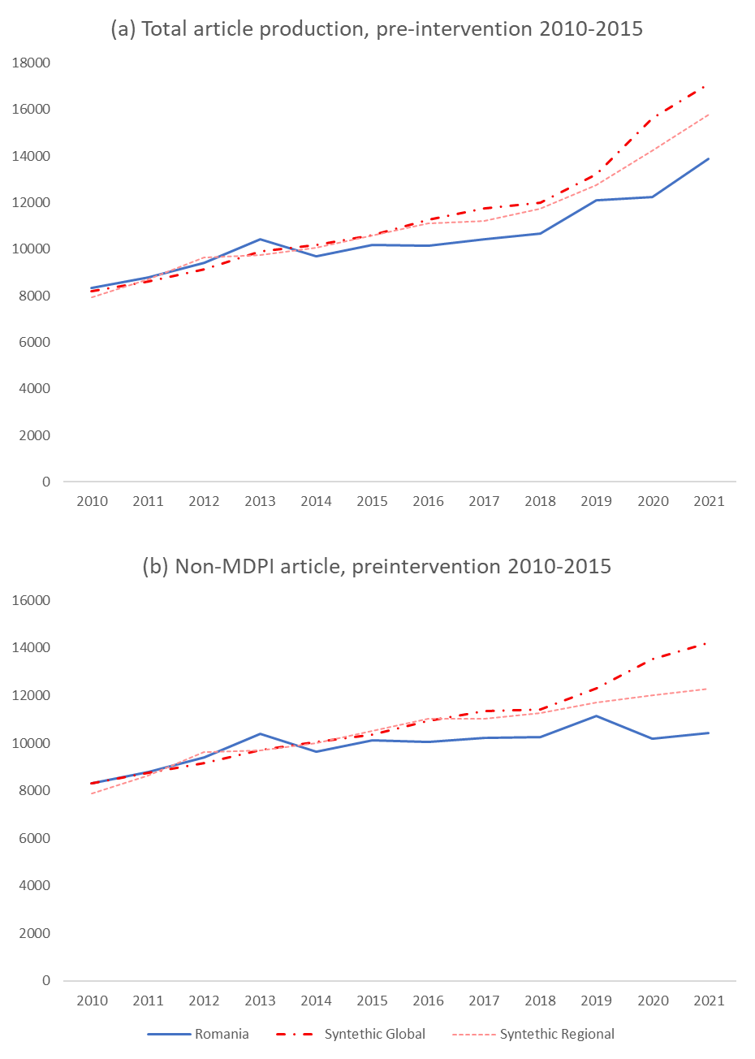

Figure 1A. Synthetic control estimations of the total and non-MDPI article output using 2010-2015 as a pre-intervention period.
Table 3A. Country weights, covariate weights, and placebo RSMPE ratios by group and output measure.
Output | Global sample
Output | Country weights |  | Covariate weights |  | Placebo inference
 | Country | Weight | Covariate | Weight | Country | RMSPE ratio
Total output
 | Sri Lanka | 0.317 | Population | 0.347 | Romania | 63.004
 | Vietnam | 0.154 | Inequality | 0.262 | France | 20.144
 | Kazakhstan | 0.127 | Mean outcome | 0.147 | Kenya | 10.030
 | Italy | 0.117 | GDP per capita | 0.119 | Italy | 6.147
 | UA Emirates | 0.102 | Corruption | 0.089 | China | 5.996
 | Qatar | 0.082 | GERD | 0.033 | Thailand | 5.496
 | Bulgaria | 0.079 | Political stability | 0.002 | Nigeria | 5.252
 | Croatia | 0.012 | Education expenditure | 0.001 | Turkey | 4.124
 | US | 0.005 | Rule of law | 0.000 | Egypt | 3.746
 | Chile | 0.001 | Urban population | 0.000 | Greece | 3.579
Total article output
 | Sri Lanka | 0.190 | Mean outcome | 0.516 | Romania | 96.124
 | Bulgaria | 0.163 | Inequality | 0.150 | Hungary | 18.118
 | UA Emirates | 0.129 | Political stability | 0.105 | Germany | 11.779
 | Vietnam | 0.118 | Population | 0.083 | Brazil | 11.233
 | Slovakia | 0.108 | Brain drain | 0.072 | South Korea | 10.631
 | Italy | 0.103 | Corruption | 0.026 | India | 10.420
 | Kazakhstan | 0.093 | GDP per capita | 0.024 | France | 10.049
 | South Africa | 0.067 | Urban population | 0.016 | China | 9.892
 | Indonesia | 0.025 | GERD | 0.007 | Ukraine | 9.528
 | China | 0.003 | Education expenditure | 0.001 | Greece | 6.126
Non-MDPI articles
 | Sri Lanka | 0.262 | Political stability | 0.485 | Romania | 101.804
 | Slovakia | 0.223 | Mean outcome | 0.174 | South Africa | 20.587
 | UA Emirates | 0.134 | Population | 0.162 | Hungary | 19.017
 | Vietnam | 0.131 | GDP per capita | 0.068 | Spain | 14.334
 | Kazakhstan | 0.123 | GERD | 0.046 | Ukraine | 14.202
 | Italy | 0.098 | Corruption | 0.043 | France | 9.904
 | India | 0.028 | Education expenditure | 0.010 | China | 9.356
 | Czech Republic | 0.002 | Rule of law | 0.006 | Canada | 8.825
 | Indonesia | 0.000 | Brain drain | 0.006 | Thailand | 8.653
 | Chile | 0.000 | Urban population | 0.000 | Belgium | 7.821
MDPI articles
 | Sri Lanka | 0.236 | Corruption | 0.295 | Saudi Arabia | 132.890
 | Kazakhstan | 0.208 | Rule of law | 0.140 | Romania | 106.031
 | Czech Republic | 0.136 | Inequality | 0.130 | Italy | 103.319
 | Chile | 0.106 | Political stability | 0.129 | Bulgaria | 98.347
 | Slovakia | 0.098 | Population | 0.111 | Poland | 94.040
 | South Africa | 0.085 | GDP per capita | 0.079 | Spain | 85.102
 | Indonesia | 0.050 | Urban population | 0.076 | Ghana | 57.441
 | Italy | 0.043 | Brain drain | 0.027 | Germany | 46.104
 | Bulgaria | 0.025 | Mean outcome | 0.008 | Pakistan | 37.903
 | Vietnam | 0.014 | GERD | 0.005 | Portugal | 36.622
Proceeding papers
 | Italy | 0.328 | Corruption | 0.216 | Indonesia | 7.844
 | Sri Lanka | 0.321 | Political stability | 0.184 | France | 6.492
 | Slovakia | 0.100 | Mean outcome | 0.146 | Poland | 6.265
 | Qatar | 0.089 | Urban population | 0.139 | Kenya | 6.232
 | Bulgaria | 0.063 | Rule of law | 0.129 | Lebanon | 5.968
 | Kazakhstan | 0.044 | Inequality | 0.092 | Russia | 5.835
 | Lebanon | 0.036 | Population | 0.054 | Iran | 5.179
 | China | 0.018 | Brain drain | 0.035 | Romania | 4.872
 | Greece | 0.000 | Education expenditure | 0.003 | Vietnam | 4.456
 | Indonesia | 0.000 | GERD | 0.001 | Algeria | 4.178
Output | Regional sample
 | Country weights |  | Covariate weights |  | Placebo inference
Total output | Country | Weight | Covariate | Weight | Country | RMSPE ratio
 | Poland | 0.353 | Mean outcome | 0.587 | Romania | 19.240
 | Bulgaria | 0.208 | Rule of law | 0.339 | Czech Republic | 6.558
 | Hungary | 0.163 | GDP per capita | 0.054 | Serbia | 4.422
 | Ukraine | 0.156 | Population | 0.020 | Belarus | 2.399
 | Kazakhstan | 0.095 | Brain drain | 0.000 | Lithuania | 1.862
 | Serbia | 0.025 | GERD | 0.000 | Ukraine | 1.724
 | Czech Republic | 0.000 | Inequality | 0.000 | Poland | 1.680
 | Belarus | 0.000 | Education expenditure | 0.000 | Slovakia | 1.642
 | Slovenia | 0.000 | Corruption | 0.000 | Hungary | 1.600
 | Croatia | 0.000 | Political stability | 0.000 | Latvia | 1.547
Total article output
 | Kazakhstan | 0.545 | Mean outcome | 0.380 | Romania | 31.717
 | Poland | 0.336 | Corruption | 0.286 | Bulgaria | 3.814
 | Slovakia | 0.119 | Population | 0.140 | Slovakia | 2.853
 | Bulgaria | 0.000 | GERD | 0.140 | Czech Republic | 2.496
 | Serbia | 0.000 | Education expenditure | 0.035 | Belarus | 2.251
 | Hungary | 0.000 | Urban population | 0.011 | Hungary | 1.832
 | Czech Republic | 0.000 | Inequality | 0.003 | Poland | 1.527
 | Estonia | 0.000 | Political stability | 0.003 | Croatia | 1.417
 | Slovenia | 0.000 | Rule of law | 0.003 | Latvia | 1.249
 | Croatia | 0.000 | Brain drain | 0.001 | Estonia | 1.048
Non-MDPI articles
 | Kazakhstan | 0.599 | Corruption | 0.439 | Romania | 26.942
 | Poland | 0.348 | Population | 0.221 | Slovenia | 3.505
 | Estonia | 0.053 | Mean outcome | 0.142 | Bulgaria | 3.310
 | Hungary | 0.000 | Political stability | 0.066 | Belarus | 3.210
 | Czech Republic | 0.000 | Rule of law | 0.060 | Czech Republic | 2.609
 | Bulgaria | 0.000 | GERD | 0.048 | Lithuania | 1.689
 | Slovakia | 0.000 | Education expenditure | 0.021 | Hungary | 1.333
 | Serbia | 0.000 | Urban population | 0.001 | Poland | 1.301
 | Croatia | 0.000 | GDP per capita | 0.000 | Ukraine | 1.157
 | Slovenia | 0.000 | Brain drain | 0.000 | Latvia | 1.141
MDPI articles
 | Serbia | 0.511 | Mean outcome | 0.215 | Czech Republic | 172.600
 | Poland | 0.315 | Inequality | 0.211 | Romania | 94.975
 | Kazakhstan | 0.174 | GDP per capita | 0.185 | Lithuania | 89.163
 | Bulgaria | 0.000 | Political stability | 0.157 | Poland | 85.913
 | Latvia | 0.000 | Population | 0.078 | Latvia | 46.826
 | Croatia | 0.000 | GERD | 0.058 | Belarus | 42.822
 | Lithuania | 0.000 | Corruption | 0.042 | Kazakhstan | 42.379
 | Hungary | 0.000 | Urban population | 0.025 | Slovenia | 42.123
 | Slovakia | 0.000 | Rule of law | 0.024 | Ukraine | 27.322
 | Belarus | 0.000 | Brain drain | 0.004 | Estonia | 24.237
Proceeding papers
 | Czech Republic | 0.907 | Mean outcome | 0.941 | Ukraine | 14.045
 | Poland | 0.093 | Corruption | 0.036 | Poland | 7.730
 | Serbia | 0.000 | Population | 0.013 | Lithuania | 4.566
 | Ukraine | 0.000 | Inequality | 0.005 | Hungary | 4.565
 | Kazakhstan | 0.000 | Education expenditure | 0.003 | Bulgaria | 4.375
 | Bulgaria | 0.000 | GERD | 0.001 | Romania | 3.677
 | Belarus | 0.000 | GDP per capita | 0.001 | Croatia | 3.284
 | Slovakia | 0.000 | Urban population | 0.000 | Serbia | 3.280
 | Croatia | 0.000 | Brain drain | 0.000 | Latvia | 2.409
 | Hungary | 0.000 | Political stability | 0.000 | Czech Republic | 2.039

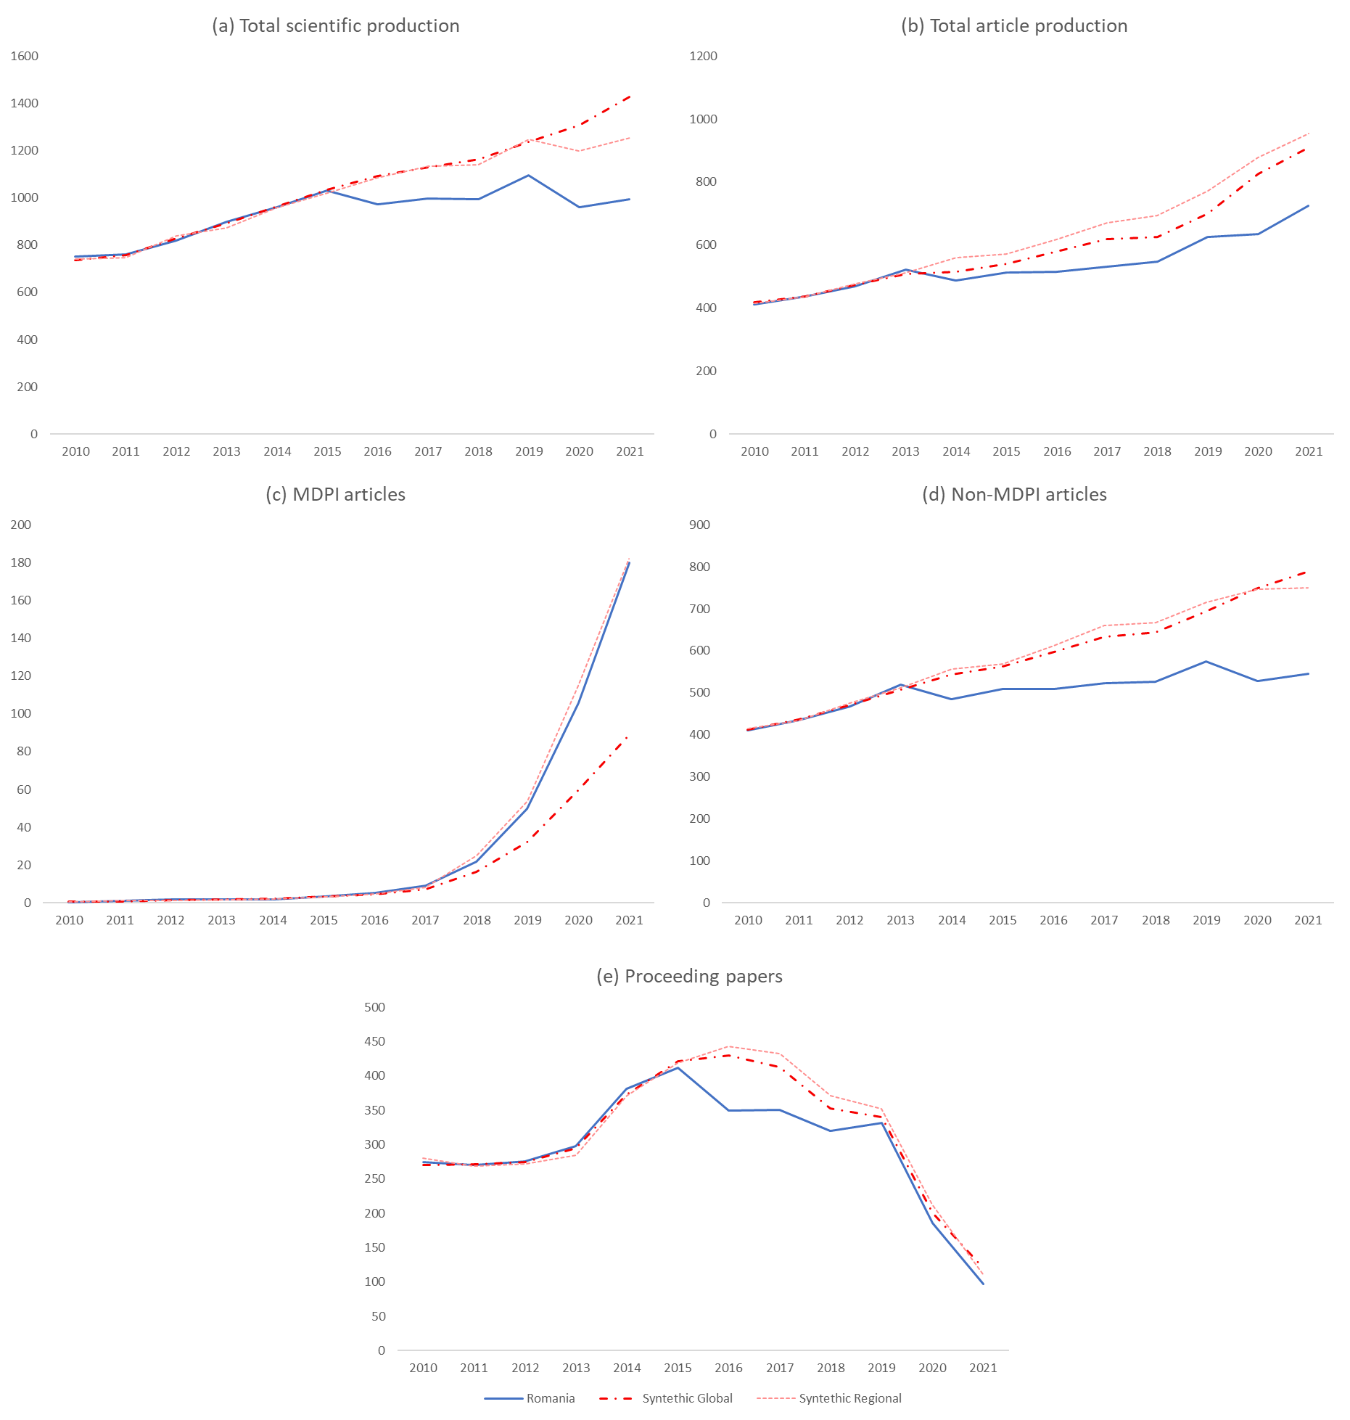
Figure 2A. Synthetic control estimations of Romania’s scientific output per million population, based on the global and regional samples.

