Why do some retracted articles continue to get cited?
Marion Schmidt
German Center for Higher Education Research and Science Studies (DZHW), Berlin, Germany
schmidt@dzhw
Scientometrics

Supplementary Information (1): More detailed information on methods

The study works with comparatively small amounts of data. Due to the lack of proven methods for the specific questions, exploratory methodical approaches have been developed. Because of this exploratory setting and as differences can be subtle, computational approaches were often supported by manual heuristics and decisions. In the following, parameter settings or algorithms as well as manual heuristics are described in detail.
Citation contexts which have been retrieved or analyzed by any of the following approaches and are the basis of figures or interpretations are documented in full text and with annotation.

Search and Linking Operations for Corpus Delineation

The delineation of the corpus is based on several steps that correspond to the methods developed in (Schmidt, 2018) and are documented in detail there. In this prior work it was shown that the WoS annotation of retracted publications and retractions was to a certain extent incomplete when compared to PubMed. The main steps are:
- A search heuristic for retracted publications and retractions in WoS, based on title annotation (as corresponding document types were only introduced somewhat later).
- An iterative, rule-based matching from PubMed retracted publications and retractions to WoS. These PubMed items have been retrieved and downloaded based on PubMed’s Retracted Publication and Retraction of Publication document types.
- The articles resulting from the first or second step are fed into an iterative, rule-based linking algorithm in WoS with the aim to find the retraction(s) for every input retracted publication and vice versa. This algorithm is based on bibliographic data and information from the retracted/retraction title annotations.
- The linking results are merged and a validation of the linking results, partly manual and partly supported by the PubMed matched data, is carried out.
The aim is thus to find as many retracted publications in WoS as possible at that point of time with the restriction that a linking to WoS items identifiable as retraction (or in some cases falsely as correction) had to be established. It is important to have an unambiguous year of retraction (i.e., the publication year of the retraction) for the calculation of pre- and post- retraction citations, and ideally a direct link to the retraction notice. Also, this setting ensures the status of the publications that are included in the corpus used for further sampling operations is at least in principle, but in most cases clearly noticeable in WoS and also clearly visible in PubMed if publications are also indexed in PubMed. For the twelve publications of the final sample the annotation has been manually checked and documented.
Coding of Retraction Reasons

For reasons of analytical flexibility, retraction notices for the entire corpus of retracted publications – as resulting from the linking and the time restriction 1980-2013 – have been retrieved and coded. Retraction notices are searched by 1) following the “full text at publisher” link of the retraction records in WoS online; or, if no links were available, 2) searching for them directly via the bibliographic data. The coding of the reasons is based solely on the information from the retraction notices, although it should be noted that in some cases these could not be found or are inaccessible (or the text cannot be copied which we treated as prerequisite for coding in MAXQDA). The coding scheme has been developed inductively.

Reference Corpora for Categorization of Citation Dynamics for Sampling

The most important dimension for the analysis is the distinction between cases in which citation counts drop massively after retraction and those in which the retraction does not seem to have a strong impact. In order to be able to categorize publications along this dimension, it is crucial not to confuse retraction-induced decreases with regular obsolescence. Therefore, I analyzed their citation curves in relation to individual reference corpora (or non-treatment corpora).
Reference publications have the same document type, publication year and epistemic proximity, the latter based on bibliographic coupling and co-citation (using time windows with a maximum difference of five years between citing and cited publication). Publications with similar early impact within these corpora were then identified by limiting the reference corpus of each retracted publication to 50 items based on minimizing distances between respective citation counts of retracted publications (RP) and related publications up to the first year after publication. The number of citations for each publication in a reference corpus is then recorded, restricted to the time period between the RP’s respective retraction year plus one, and 2017. The ratio between the RP’s post retraction citation count and the average of the reference corpus’ corresponding counts in the same time windows is taken and quartiles are calculated on the basis of these ratios in a distribution of RPs that fulfil both other sampling criteria (threshold of pre and post retraction citations, retraction reason). A couple of ambiguous cases, such as partial retractions, are manually excluded. From the list of publications resulting from these steps, five publications each from the top and bottom quartiles (in the latter case, partially including publications that are on the threshold value between lowest and lower middle quartile) were taken and supplemented by one from each of the two middle quartiles, with WoS subject categories (SCs) and time also taken into account in order to account further variance. At the same time, citation curves are manually inspected. Thus, six represent each side of the main dimension, respectively.

Delineation of Citation Contexts

For each sampled retracted publications, citations are obtained through a stratified random sampling. Full texts of citing articles are retrieved manually. A comprehensive method for delineating citation contexts within full texts is not yet available. Often only the sentence of the citation (citance) is used, sometimes uniformly supplemented by the precedent and one or two subsequent sentences (amongst others, Zhang, Ding, & Milojević, 2013, Lu, Zhang, & Ma, 2015, Taşkın & Al, 2018). However, Bertin & Atanassova (2016) as well as Teufel et al. (2006) and Athar & Teufel, 2012 show that significant information, especially negative sentiments, is missed when contexts are too narrowly defined. On the other hand, more broadly defined contexts lead to a decrease of discriminative power (Athar & Teufel, 2012). These problems have not yet been convincingly solved and working with either citation sentences or entire paragraphs is still widespread (see e.g. the new PubMed Central Citation Context Dataset).
Therefore, the delineation of citation contexts was done manually. In a first step, I follow Athar & Teufel (2012) by considering several sentences before and after the citation; attention is paid to linguistic markers like conjunctions, cataphora and anaphora, which were also mentioned by them. Contexts can thus include multiple citations if there are overarching argumentations that connect them (e.g.. „However, ..“, „This result is compatible with“, „Similarly“, „In addition“, „Among these…“). This seems crucial in order to include the citing authors‘ reflections on the broader state of research, including disputes and comparisons between several publications.

Network Approach
For the visualization of related publications in Figures 3 and 4 of the main text several approaches are combined:

General co-citation similarity
Co-cited articles – not limited to time periods and citation windows – are processed using Salton’s Cosine for normalization. A threshold of Salton’s cosinus > 0.2 is applied to select publications that are substantially co-cited.

ORLs/reference lists
This standard procedure is complemented by a more fine-grained approach based on the identification of articles that are co-cited consecutively in a list format of two or more references, like in this example:
The ago1 mutant in S. pombe is impaired in RNA-mediated heterochromatin formation [40,41,88-90].
Such a list of references can be interpreted as referring to the same or very similar claim (as suggested by Hargens (2000), who, however, has used the concept "Orientating Reference List" only for introductions). To identify these citations, ORL instances are manually coded for control and then citation contexts are parsed with RegEx patterns to identify and extract ORLs. The references enclosed in these ORLs are manually identified from the articles’ lists of references and are matched with WoS reference data. This procedure is only applied to the stratified sub-sample for which full texts have been gathered, in contrast to the normalized number of co-citations described above. A heuristic of four common ORL occurrences is used as threshold to categorize co-cited publications as “reference list”.

Supporting and conflicting references
Search heuristics. Furthermore, a semantic approach is based on a semi-automatic, exploratory coding of citation contexts followed by an extraction of references mentioned in citation contexts as supporting or conflicting with (or ambiguous on) the retracted article, as demonstrated in this example:
"In the presence of IgE, IL-33 may induce human cord blood MC degranulation and PGD2
generation [270], but this is not a consistent finding [55]." (retracted publication underlined, conflicting claim marked by grey coloring, reference 55 extracted as conflicting publication).
For this purpose, explorative manual coding was first carried out, which was gradually generalized into a RegEx-based search strategy after typical rhetorical patterns of dissent and consensus in referencing had been identified. There are recurring cue terms for both directions (such as “consisten*”, “similarly”, “debate*”, “controvers*”), but also less explicit forms that nevertheless indicate consensus or disagreement by presenting positions within the scientific debate as contrasting:
“Huang et all. [13] demonstrated the flowering hormone might be associated with the FT mRNA. This finding brought the attention of many scientists to the FT gene and its products. However, Corbesier [14] subsequently suggested the FT mRNA is not a flowering hormone but an intermediate product, while the real flowering hormone should be the end product FT protein. This claim was proven by two experiments (…)”
Albeit rhetorical forms like these are not unambiguous and their interpretation is somewhat more dependent on the factual (however imperfect) understanding of claims than in case of the other cue terms, some typical patterns such as “however” and “on the one hand… on the other hand” were also implemented by RegExp.
Apart from this bottom-up work, the “argument lexicon” from the MPQA Opinion Corpus (http://mpqa.cs.pitt.edu/corpora/mpqa_corpus/), a linguistic resource, was used to complement the bottom-up defined cue terms. The resulting terms were also checked against the (arguably more restricted) disagreement term list used by Lamers et al. (2021).
In a first step, the bottom-up derived list of cue terms consists of:
- controvers; doubt; debat; contaminat; contaminant; variety of results; (common|converged|realigned) understanding; contradistinction; artifact; reproduce; replicate; divergent; argue; conflict; contradict; disprov; further investigation; cross-contaminated; defects; impurit; different outcome; similarly; fail(ed)? to (detect|demonstrate); however,.{0,20}[0-9\,\-]{1,6}[^\w\s\d]; however, we
All terms are searched with right-truncation (restricted to up to 3 characters). The terms “defects” and “impurity/ies” directly relate to the Makarova case: Preliminary exploratory work has shown that the debate is in this case closely linked to these possible causes of the phenomenon. Explanations centered on defects are coded as supporting, as this is the reason proposed by the RP authors, as opposed to contamination.
In addition, a second level of less strong cue terms is defined. Following the concept of Lamers et al. (2021), a restriction is implemented, specifying that the following terms are only retrieved when co-occurring (within up to three words) with mentions of “publications”, “results” or the like. These terms are:
- stable; fail; taken together; refut; support; underlin; answer; converse; consensus; question; confirm; consisten; challeng; contrary; agree; agreement; disagree; disagreement; accept; similar; prove; however, ; on the one hand; on the other hand; conclusively; in contrast
The same restriction is applied to the list of terms and phrases from the argument lexicon corpus.
The lists of cue terms are processed with Perl RegExp in the sampled citation contexts. The final heuristics and term list result from repeated optimization cycles and was again checked against the preliminary manual coding. The approach is not strictly optimized for precision. Due to the still widespread nature of some terms, all contexts that were identified algorithmically were thus read repeatedly. Sometimes, however, it turns out that the retrieved cue terms themselves do not perfectly reflect the stance or meaning of a context regarding the retracted publication, but others do. The algorithmic part, however, remains useful in systematically identifying contexts with discursive character. This relationship between retrieved and manually identified terms and patterns is made transparent in the data documentation. Besides, contexts may have been discarded from the final analysis because identified cue terms did not strictly refer to the RP in relation to other publications, did not explicitly reference supporting or conflicting publications (but, e.g., debate in general), or had a proportional meaning. Finally, a few additional citation contexts were included that resulted from manual explorative work and/or preliminary algorithmic runs without being covered by the final version of the algorithm. Because contextual knowledge from the entire study was ultimately included in such considerations, no inter-rater reliability test has been pursued, but codings are documented and made available. The complete corpus of citation contexts could be shared on request.

Extraction of references. Analogous to the procedure for reference lists, relevant references are identified and matched with the WoS. Following any semantically relevant linguistic cues and markers in the text, the references were manually classified into to three categories (supporting, conflicting, ambiguous). In longer contexts, not all co-cited references were extracted. Instead, the focus was specifically on references within sentences marked with cue terms.
“Cho et al. reported that acupuncture at vision-related acupoints in the foot, which are used to treat eye diseases in Traditional Chinese Medicine (TCM), activate the visual cortex bilaterally [2]. Similar results were reported by Siedentopf et al. [13]. Stimulation of the acupoints at LI4 (Hegu), ST36 (Zusanli) and GB36 (Waiqiu) regulates the hypothalamus and limbic system [1,8,9,15,16]. These studies provide primary evidence for the mechanisms underlying acupuncture therapy.” (Reference 13 is coded as supporting)
Since academic writing is often very concise and oriented towards a neutral, objective style, we assume that contexts with metadiscourse can contain meaning in a highly concentrated form. When an overall mixed or controversial state of research is stated, all publications within this argumentative context are extracted and coded, when identifiable, even if they are not directly assigned to a cue term.
References are considered as supporting not only in terms of explicitly confirming or successfully replicating the RP, but also if they are cited together with the RP and this is contrasted with a conflicting reference.
“In response to FT expression, the florigen moves from the leaves to the meristem. This signal was initially thought to be the FT mRNA (Huang et al. 2005; Wigge et al. 2005). However, Corbesier (2007) found evidence for movement of a FT-GFP fusion protein from the phloem companion cells to the meristem that correlates with flowering and of the fusion protein across graft junctions. These data indicate that the FT protein is the signal transported through the phloem to the meristem.” (Wigge et al. 2005 coded as supporting, Corbesier (2007) as conflicting).
References are coded when they are explicitly grouped together within the context of the retracted publication or when they are positively reinforced by the citing author.
“There are recurrent reports that graphite [1] and other forms of carbon [2-4] can exhibit a weak ferromagnetic moment, which persists well above room temperature. ” (references 3 and 4 coded as supporting, reference 1 is not extracted as it is not clear from the context how the claims with regard to graphite and carbon relate to each other).
In other constellations, a string of publications is only described as being controversial by the citing author and then coded as ambiguous. “Ambiguous” is also used when the context information is neither clearly supporting nor conflicting, or in cases where the same related publication is referred to as supporting and conflicting with the RP in different contexts. Otherwise, if the same publication is recorded as either conflicting and ambiguous or supporting and ambiguous, the code whose citation context is more informative is chosen, or the code which is based on more citation contexts (if there are several) to map the publication in figures 3 and 4. The procedure is thus exploratory and the coding restricted to the citation context information. Care was also taken to ensure that supporting, ambiguous, and conflicting formulations were related to the RP's basic claims, which was nearly always the case.
Retractions and Expressions of Concern are not included in this module’s figures.

Propositional Approach: Concept Terms

Due to the problems of context delineation mentioned above and the fact that several citations are often combined in one sentence, the term base of citation contexts is not necessarily clear and distinct for a given citation. Another problem, of course, is the terminological variance in the referencing of claims that have not yet been fully codified. Therefore, a core vocabulary that describes claims is defined based on RP’s abstracts and retractions, and highly co-cited publications. I use NLP methods and the MeSH thesaurus to extract and expand this core vocabulary and then match it with the vocabulary of citation contexts.

Term extraction
Noun phrases as the main linguistic carriers of meaning have already been used to compare the epistemic content of research fields (Lamers, 2015). In this case study, it also seems useful to base an operationalization of epistemic claims on them, as many examples show that meanings would become more diffuse at the level of single words, as in the case of the empirical object “mesenchymal stem cells” vs simply “cells”. In a first step, noun phrases are extracted from the retracted publications‘ abstracts and retraction notices with the noun_chunks iterator based on SpaCy’s dependency parsing. "En_core_web_sm" is used as pre-trained model.
Reference strings based on various brackets have been removed. Another referencing pattern works only with (initially superscript) numbering. These have been kept but spaces have been inserted between numeric references and punctuation marks, as this, based on checks, improved syntax recognition. Resulting noun phrases were slightly cleaned up (i.e., removal of leading spaces).
Noun phrases are also extracted from the abstracts of highly co-cited publications (using the results from the Salton-normalized co-citation procedure developed for the Network Approach: co-cited publications whose normalized similarity value with the RP is higher than 0.25 have been selected).
In the case of abstracts and retractions, the resulting noun phrase lists were manually reviewed and, in some cases, single noun phrases were added that had not been correctly identified by the procedure.
To support the later interpretation of the results, as well as certain steps within the expansion procedures (see below), noun phrases were manually inspected and categorized, and ‘core’ concept terms are defined, meaning that these are crucial for describing a retracted publication’s empirical claim.

Qualitative steps: Concept terms
Based on the reading and tracing of the content structure of the abstracts, core concept terms are defined. Metadiscoursive markers (such as „we report“, „here we present“) and subheadings are taken as markers for different sections within the abstract focusing on background, (research questions), empirical claims, and conclusions. Following a simple heuristic, core concept terms are extracted mainly from empirical claim sections, focussing often on the first one or two empirical sentences and skipping additional more detailed passages within these segments. In some cases, information has been added from other segments, such as the conclusion, depending on whether concluding remarks were more a summary or interpretive. Empirical research objects are only defined as core concepts when closely connected to the empirical claim. Due to the existing variability of technical terminology, in some cases additional terms have been defined as core that occur in citation contexts but not literally in the respective abstract, while terms with similar meanings occur in the latter (i.e. „tumor“ apart from „cancer“). In addition to the core terms, some other terms have been defined, where possible, to represent aspects that are not part of the core content from an empirical point of view but may be relevant points of reference, such as methods or more general information about the research subject. Both categories are used for the expansion procedure and core concept terms are labelled accordingly in the resulting term frequency graphs.
To account for terminological variability, extracted noun phrases resulting from RP’s abstracts and retractions are expanded hereafter using two complementary approaches:

Expansion of vocabulary (MesH)
- Matching to MeSH (technical). Noun phrases are matched via an API to the intellectually maintained thesaurus Medical Subject Headings (MeSH) in order to find similar words or phrases. This is done by re-using two Perl example scripts that have been documented as part of the PubMed e-Utilities with setting appropriate parameters:
  - In a first step a list of terms – the extracted noun phrases – is sent to the MeSH database via the esearch call (db = “MeSH”; query for "[MeSH Terms]").
  - Search results contain the PMID of the respective MeSH record if a match was achieved. Result files are parsed for these PMID.
  - In the next step equery is used to fetch and download the MeSH full records of these PMID in XML format (db = "MeSH", tool = "ebot", retmode = "xml", retype = "medline").
- Error tolerance and pre-processing. After a manual inspection of the results of a first run, core and selected other noun phrases (as described above) were additionally split in order to facilitate the matching of at least the technically specific phrase components (example: extracted NP "human mesenchymal stem cells" is not matched to the MeSH database, but the modified NP "mesenchymal stem cells" is found; similarly "pure carbon" is modified to "carbon"). This procedure is done only for core and selected terms in order to limit the extent of manual steps and not to inflate the expanded vocabulary with less-specific terms. Partly because the MeSH database curates several "Entry Terms" for each "MeSH term", the MeSH database provides a certain error tolerance in mapping input to the controlled vocabulary.
- Term expansion. In case extracted noun phrases could be successfully mapped to MeSH terms, all “Entry Terms” and “See Also” terms assigned to that MeSH term are stored, as well as MeSH terms that are one level lower in the hierarchical structure, based on a parsing of the result documents.

Expansion of vocabulary (Word Embeddings)
- Ten most similar terms based on Word Embeddings: The word-embedding implementations FastText and Word2Vec (based on Python/Gensim) are additionally used to find synonyms and similar words based on empirical occurrences in large data sets. As pre-trained models are not expected to work well with highly specific scientific vocabulary, specific training corpora for each sampled retracted publication were set up:
- Reference Corpora: PubMed Central‘s PMC Author Manuscript Collection has been downloaded completely (in txt format). The packages PMC004xxxxxx-PMC005xxxxxx are used, which together comprise about 13.5 GB.
  - The first step is to reduce this dataset by parsing the full texts for a set of terms, each specific to each of the 12 RPs (via a Perl script): 'acupuncture', 'fmri', 'computational design', 'enzyme activity', 'epilepsy', 'epileptic', 'shoot apex', 'arabidopsis', 'C60', 'magnetism', 'menopause', 'anaphylactic', 'anaphylaxis', 'il-33', 'mesenchymal', 'superconductor', 'superconducting', 'anthracene', 'flowering', 'hairpin rna', 'dna ploidy', 'leukoplakia' (searched with logical OR).
  - In a second step, the reduced corpus resulting from step 2.1 is used to create specific corpora for each case, again using a Perl script that parses for the same and additional core terms (logical OR):
    - Cho: 'acupuncture', 'fMRI', 'occipital lobes'
    - Dwyer: 'computational design', 'enzyme activity', 'mutations', 'TIM'
    - Haug: 'epilepsy', 'IGE', 'genes', 'mutations', ‘CLC’
    - Huang: 'flowering locus', 'shoot apex', 'FT mRNA', 'arabidopsis'
    - Makarova: 'C60', 'ferromagnetism', 'carbon'
    - Poehlman: 'metabolic', 'menopause', 'premenopausal', 'fat mass', 'adiposity'
    - Pushparaj: 'interleukin', 'anaphylactic shock', 'anaphylaxis', 'IL-33'
    - Reyes: 'mesodermal progenitor cells', 'mpcs', 'endothelial cells', 'mesoderm'
    - Rubio: 'mesenchymal stem cells', 'transformation', 'cancer'
    - Schoen: 'superconductors', 'crystals', ‘anthracene’
    - Schramke: 'ltrs', 'chromatin', 'long terminal repeats', 'loci'
    - Sudbo: 'carcinoma', 'lesions', 'ploidy'
For performance reasons and to create corpora of relatively similar size, the RP-specific sets were reduced until there were not more than 1750 files.
- Processing: For each case, the text files of the respective reference corpus are concatenated to one corpus file. Gensim models of FastText and Word2Vec are used to train the corpus data. For performance reasons and again to balance variability and specificity of terms in the expanded vocabulary, only the core terms defined above and other selected terms were fed into the procedure. For each term, the 10 most similar terms were given by each of the two procedures. In case of Word2Vec, noun phrases were always split and then fed into the procedure as appropriate, whereas FastText can also process phrases consisting of multiple words. Here, noun phrases are split up and components are searched when the use of the complete phrase is not successful, analogously to the MeSH-related procedure.

Search heuristics
The noun phrases from abstracts along with their expanded vocabulary are then mapped to noun phrases extracted from citation contexts.
A search algorithm matches the extracted and expanded vocabulary with noun phrases extracted from citation contexts. For every noun phrase extracted from citation contexts (NP_{cc}), the algorithm proceeds in the following steps:
- exact match with each input noun phrase (NP_{input}, extracted from the same case’s abstract, or if feasible, retraction and co-cited publications’ abstracts),
- left and right truncated match (NP_{cc} contains NP_{input}) where the truncation respects word boundaries,
- exact match with related terms of that case (NP_{MeSH}),
- left and right truncated match with related terms (NP_{cc} contains NP_{MeSH} or NP_{MeSH} contains NP_{cc})
- multi-word NP_{input} and related terms (MeSH) are split and steps 1-2 are repeated with single words
- steps (3) and (4) are repeated with expanded related terms stemming from Word Embeddings.
For each NP_{cc}, a new matched term is compared with up to three previous matches (if any) in each step: If the newly matched NP and the former matched NPs are similar (i.e., one is contained in the other), then the one with a length more similar to NP_{cc} overwrites this previous matched term. If they are not similar, the newly matched NP is stored besides three others (if any). This procedure is repeated for a potential second and third previous matched term. Additionally, ‘s’ at the end of NP_{input} and related terms are removed to account for singular/plural variance.

Unifying result terms
Results are unified in several steps. First, if several single terms are matched separately to the same NP_{cc}, the terms are concatenated matching the word order of the input phrase. A mapping file between matched words, phrases, concatenated words and NP_{input} is created based on the Levenshtein-Damerau word similarity (using a threshold). Second, this was complemented by a manual merging of name variants of important empirical objects and methods (where it is usually clear that it is the same scope of meaning). Consider the phrase ‘human mesenchymal cells’ as NP_{cc}, whereas NP_{input} is ‘(human) mesenchymal stem cells’. ‘Mesenchymal’ and ‘cells’ are each found individually by the search algorithm, combined, and are identified to form an equivalent of the input phrase. However, this only applies for two matched words per phrase and in some cases complex noun phrases (such as ‘bone marrow-derived progenitor cells’) as a whole cannot be matched to input noun phrases, only to individual words. If unclear, merging decisions are supported by looking up information in Wikipedia, abstracts, or assessing term frequencies in citation contexts.
In the third step, phrases or single words resulting from the search algorithm as well as these concatenated terms are run against the input vocabulary NP_{input} and the manually maintained mapping file. If this does not succeed, combinations of are split up in up to three words, and the attempt is repeated with word pairs or residual words. Overall, the procedures are thus exploratory and restricted by input vocabularies and chosen heuristics.

Metadiscoursive Approach: Search for Stance and Framing Patterns

Stance
The aim of this module is to assess the frequency of uncertainty-related terms to identify possible patterns in how citing writers handle the retraction or data/reproducibility problems, whether they mention contamination issues, open questions or skepticism.
A term list with cue terms for uncertainty was created bottom-up: Citation contexts with a negative tendency were first identified based on a tentative manual coding and a basic sentiment coding procedure (SentimentIntensityAnalyzer from the NLTK toolkit), and manually investigated for cue terms. The final list of cue terms is the result of several successive reading and parsing cycles and consists of the following terms:
- artifact; conflicting (data|reports); contaminat; contaminant; contradict; contradistinction; contrary; controvers; debate; disgree; doubt; falsified; fraud; false reports; impurit; not a consistent finding; not (.)* confirmed; not (.)* replicated; not (.)* reproduced; not stable; not well established; question whether; retired; retract; scepticism; skepticism; unclear; not clear; unknown; unresolved; withdrawn; more studies needed; necessary to conduct more studies; not been substantiated; question needs to be resolved
Cue terms for this module partly overlap with the vocabulary used to retrieve conflicting or ambiguous citations in the Network Approach; in contrast to the latter, however, the uncertainty cue terms used here always refer to explicit negative or skeptical formulations by citing writers, whereas contrast or conflict in the sense used in the Network Approach partly amounts to a linguistically neutral representation or juxtaposition of conflicting findings.
Based on a parsing with a list of uncertainty markers, I identified and manually grouped similar markers for negatively connotated citations into two groups: „Contamination“ refers to formulations that allude to this (possible) reason for erroneous findings, in case of Makarova also referred to as „(iron) impurities“. All other mentions allude to unsolved questions or implications, or expressions of doubt and hints to controversies.

Keyword Extraction
The basic idea is to find terms that occur unusually often in relation to the disciplinary vocabulary and writing style. Common text-analytical approaches with this purpose are based on significant differences in term frequencies in the analysis corpus compared to reference corpora. I determine keywords with Wordsmith, a tool frequently used in corpus linguistics. The reference corpora that have been created for the propositional approach are re-used but are now further reduced by limiting the files to lines containing text, excluding references. This is based on a simple heuristic (at least five consecutive words; no consecutive blanks). Thanks to these specific reference corpora, the weight of technical or subject terms that occur in similar articles is reduced.
In one case, the pre-compiled wordlist British National Corpus (BNC) is used for comparison; these results indeed contain more keywords, with metadiscoursive keywords having relatively lower keyness values and various technical and factual terms having higher values, thus confirming the assumption of the importance of adequate reference corpora.

Keywords are calculated using the standard statistical test and default settings of the WordSmith keyword procedure (Wordsmith version 8.0.0.152), except for a minimum dispersion difference of 0 instead of 0.1, and a p value of <0.0000001 to determine keyness. The minimum frequency of keywords in the analysis corpora was set as 3. The keyword procedure results in several dozen keywords for each RP. With the aim of identifying keywords that are predominantly emotional, cognitive or discoursal, several linguistic resources are mapped to the extracted keywords. The idea is close to the concept of metadiscourse, a popular framework for analyzing rhetorical characteristics of scientific texts. Metadiscourse can be roughly described as a commentary textual layer related to propositional claims with the aim to guide the reader „through a text so both the text and the writer’s stance is understood“ (Hyland, 2005). Several resources and tools have been used:
- Hyland (2002) has inductively developed a categorization scheme of reporting verbs through corpus linguistic work. The use of reporting verbs is regarded as “one of the most explicit ways of attributing content to another source”. Hyland argues that “the wide range of verbs that can be used to introduce reports allow writers to convey both the kind of activity reported and whether the claims are to be taken as accepted or not” (Hyland 2002, p.118). I categorized verbs resulting from the keyword procedure using this scheme and only used discourse verbs for filtering extracted keywords. Discourse acts “focus on the verbal expression of cognitive or research activities (e.g. ascribe, discuss, hypothesize, report, state)” (Hyland 2002, p.121). Inflexed and base forms are used for mapping.
- The software and data suite MPQA comprises several linguistic resources and corpora of news articles annotated for opinions and sentiments. MPQA's subjectivity lexicon contains 8222 entries comprising stemmed and non-stemmed variants of words that have been assigned to negative, neutral and positive prior polarity, i.e., the polarity assigned to a word regardless of a particular context. Extracted keywords were matched in an exact manner to stemmed and non-stemmed variants of the resource. The filtered terms based on these resources turned out to be often very ambiguous and inaccurate, as many terms that have negative or positive connotations in everyday language have specific technical meanings in our contexts (e.g., “magnetic”, “juvenile”, “malignant”, etc.). However, in other cases, the annotations are apt.
- Frame semantics has been proposed for structuring metadiscoursive i.e. abstract nouns (Schmid, 2000). Semantic frames can be understood as defining coherent structures of concepts and their relations. FrameNet, a dictionary based on frame semantics, is used to systematically assign extracted keywords to frames – or classes – with cognitive, discoursal or emotional content. Through an initial mapping and manual inspection, a set of frames along these categories is identified and then these pre-selected frames are used as filters for all extracted keywords: Achieving_first; Alternatives; Attempt; Attention; Awareness; Becoming_aware; Being_at_risk; Studying; Cause_emotion; Emotion_directed; Certainty; Daring; Difficulty; Discussion; Evidence; Importance; Perception_active; Point_of_dispute; Risky_situation; Run_risk; Usefulness; Capability; Using. Extracted keywords are matched in an exact manner to (singular and plural forms of) the resource.
- The tool Concordancer as part of the Wordsmith software is used to check the direct textual environment of a keyword in a given length and thereby evaluate the meaning and usage patterns of the word. A couple of extracted keywords have been discarded because they are only used in a propositional context.

Additional Graphs

Data and Sampling Strategy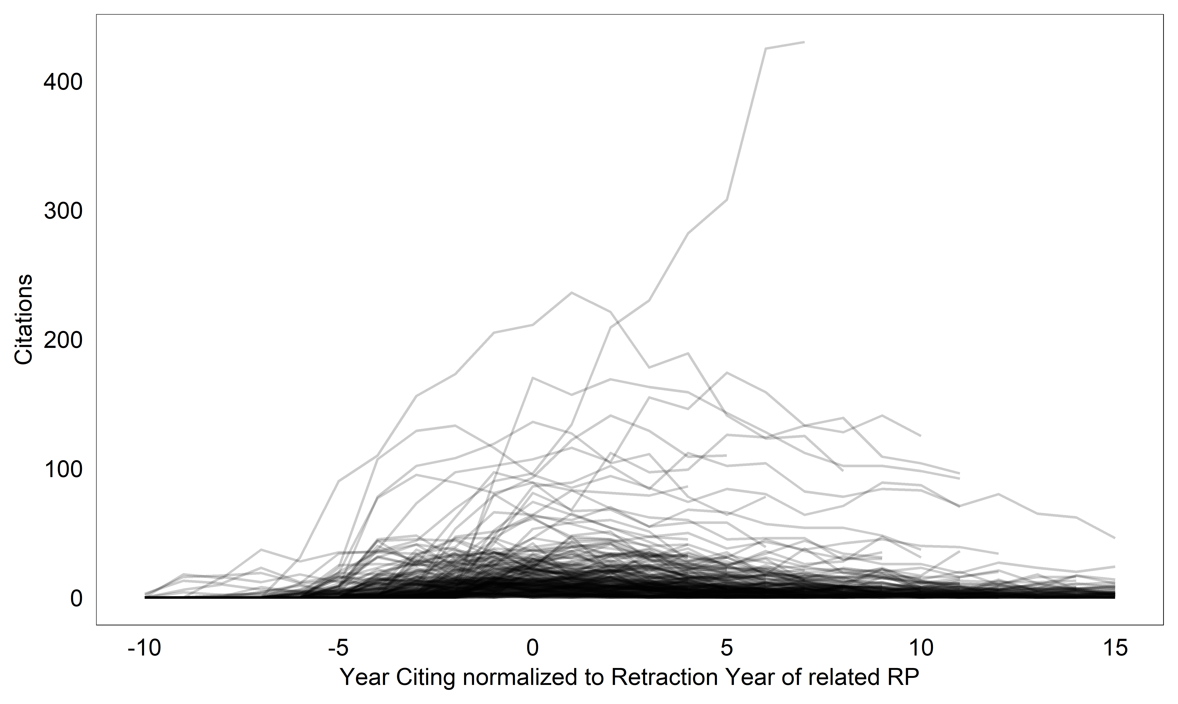
Figure 1: Citation distribution of a random sample of publications related to the retracted publications (RP reason: fabrication, falsification, failure to reproduce and other data problems) that meet a threshold > 10 pre and post-retraction citations. Relatedness is processing according to the heuristics outlined above.

Concept Term Frequencies

Due to the smaller number of contexts, the term counts are often very small and should be interpreted even more cautiously than in the first sample group. However, we can observe that terms that refer to core knowledge claims are also in the focus of the citing publications.

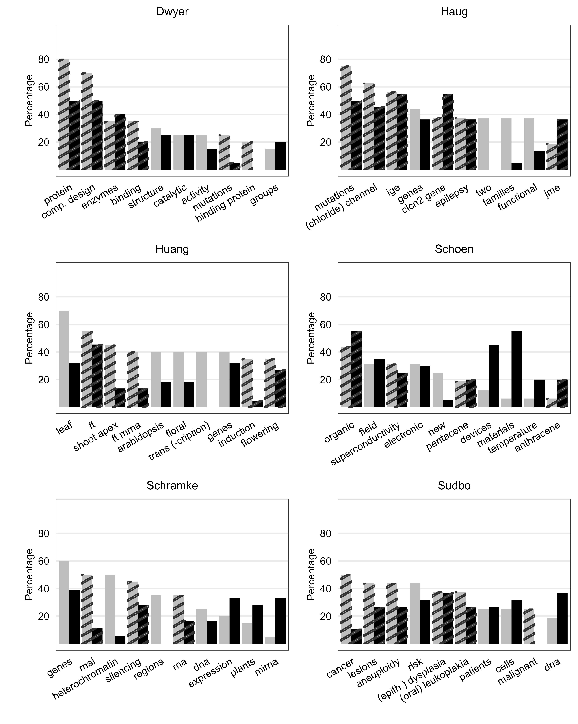

Figure 2 a-f: Rank orders of fifteen most frequent noun phrases of cases on the second sample group (in pre and post retraction contexts)

Literature

Athar, A., & Teufel, S. (2012). Context-Enhanced Citation Sentiment Detection. 2012 conference of the North American Chapter of the Association for Computational Linguistics: Human Language Technologies, 597–601.
Bertin, M., & Atanassova, I. (2016). Weak Links and Strong Meaning: The Complex Phenomenon of Negational Citations. BIR@ECIR.
Hargens, L. L. (2000). Using the Literature: Reference Networks, Reference Contexts, and the Social Structure of Scholarship. American Sociological Review, 65(6), 846–865.
Hyland, K. (2002). Activity and evaluation: Reporting practices in academic writing. In Academic discourse (S. 115–130). Longman.
Hyland, K. (2005). Metadiscourse. Exploring Interaction in Writing. Continuum.
Lamers, W. S. (2015). Content words as measure of structure in the science space [Master Thesis]. Universiteit Utrecht.
Lamers, W. S., Boyack, K., Larivière, V., Sugimoto, C. R., van Eck, N. J., Waltman, L., & Murray, D. (2021). Investigating disagreement in the scientific literature. eLife, 10, e72737. https://doi.org/10.7554/eLife.72737
Lu, C., Zhang, C., & Ma, S. (2015). How does citing behavior for a scientific article change over time? Proceedings of the Association for Information Science and Technology, 52(1), 1–4. https://doi.org/10.1002/pra2.2015.145052010097
Schmid, H.-J. (2000). English Abstract Nouns as Conceptual Shells: From Corpus to Cognition. DE GRUYTER. https://doi.org/10.1515/9783110808704
Schmidt, M. (2018). An analysis of the validity of retraction annotation in pubmed and the web of science. Journal of the Association for Information Science and Technology, 69(2), 318–328. https://doi.org/10.1002/asi.23913
Taşkın, Z., & Al, U. (2018). A content-based citation analysis study based on text categorization. Scientometrics, 114(1), 335–357. https://doi.org/10.1007/s11192-017-2560-2
Teufel, S., Siddharthan, A., & Tidhar, D. (2006). Automatic classification of citation function. Proceedings of the 2006 Conference on Empirical Methods in Natural Language Processing (EMNLP 2006).
Zhang, G., Ding, Y., & Milojević, S. (2013). Citation content analysis (CCA): A framework for syntactic and semantic analysis of citation content: Citation Content Analysis (CCA): A Framework for Syntactic and Semantic Analysis of Citation Content. Journal of the American Society for Information Science and Technology, 64(7), 1490–1503. https://doi.org/10.1002/asi.22850

There are cases where further information could be researched via ORI reports or other third-party sources, for example, but the consistent limitation to notices in the coding means that we use the same information that is easily accessible to the community. For example, the Wakefield case is also complex because the actual retraction from 2010 (there is a partial one before) is very short and explicitly mentions only the lack of approval by the ethics committee (coded by us as an ethical/approval problem). In the case of Makarova et al., part of the final sample, the correction that precedes the retraction by one year has been used as limitation to pre-retraction citations because its content seems to already weaken the claim that magnetism is due to defects.
In case the SC “Multidisciplinary Science” has been originally attributed to a publication, a dominant other SC is selected from its references (Glänzel & Schubert, 2003).
which, however, yields few matches to the citation contexts, after two terms were excluded from this list for being too broad („still“ and „according to“). One term, „however“ was used, but restricted to more specific wording patterns
experiment; pattern; outcome; study; studies; result; article; work; finding; report; observation; data; literature; effect; correlation; investigation (with right truncation)
https://spacy.io/usage/linguistic-features#noun-chunks
The two used scripts have been authored by Eric W. Sayers as part of e-utils course material: https://www.ncbi.nlm.nih.gov/Class/PowerTools/eutils/course.html, MeSH database was accessed on 2023/01/19
Index of /pub/pmc/manuscript/txt (nih.gov), downloaded 2023/01/14
https://metacpan.org/pod/Text::Levenshtein::Damerau; a Levenshtein similarity value is normalized to the longer word length of a word pair and a threshold of 0.75 is set
There are term overlaps with cue terms for conflicting co-citations, e.g. “debate”.
https://www.nltk.org/api/nltk.sentiment.SentimentIntensityAnalyzer.html?highlight=sentimentintensity
The degree of dispersion of the keywords across the corpora was gauged to be of lesser relevance in this scenario.
http://mpqa.cs.pitt.edu , downloaded 2022/06/26
https://framenet.icsi.berkeley.edu/fndrupal/, downloaded 2019/08/17

