Supplementary Materials for

Libraries, Research and Development Funding, and Economic Prosperity:
Data for the Holistic University

Authors: R. Eugene Turner¹*, Suzanne L. Marchand²

Affiliations:
¹Department of Oceanography and Coastal Sciences, Louisiana State University; Baton Rouge, Louisiana, 70803, USA. ORCID 0000-0003-0776-7506

²Department of History, Louisiana State University, Baton Rouge, Louisiana, 70803, USA. ORCID 0000-0002-2518-4630

The file includes:

Data availability (data for individual graphs are in a Dryad data repository https://doi.org/10.5061/dryad.w6m905r18)
Supplementary Text
Figs. S1 to S4

S1. Data availability
Comparisons of library holdings at the largest research universities are available at: https://www.arl.org/.
Research and development funding from 2014 to 2022 for individual campuses is available at: https://ncsesdata.nsf.gov/profiles/site?method=rankingBySource&ds=HERD&o=n&s=a.
Per capita income data for individual States is available at: https://fred.stlouisfed.org/release/tables?eid=257197&rid=110.
Rankings of 250 Arts and Humanities program in the world are at: https://www.usnews.com/education/best-global-universities/search?country=united-states.
Arts and Humanities (A&H) programs are ranked by the US News and World Report at: https://www.usnews.com/education/best-global-universities/search?country=united-states.
AD global rankings of universities are at:
https://www.adscientificindex.com/citation-ranking/?s=25&q=harvard+university
The 20th edition of the QS World University Rankings by Quacquarelli Symonds are at:
https://www.topuniversities.com/world-university-rankings.
The Times Higher Education global rankings of universities are at:
https://www.timeshighereducation.com/world-university-rankings/2023/world-ranking#!/length/-1/sort_by/rank/sort_order/asc/cols/scores.

Data availability (data for individual graphs are in a Dryad data repository https://doi.org/10.5061/dryad.w6m905r18)

S2. Supplementary Text

S2. 1 State R&D funding
R&D expenditures from 2014 to 2020 at ARL universities are from the National Science Foundation (https://ncsesdata.nsf.gov/profiles/site?method=rankingBySource&ds=HERD&o=n&s=a). The R&D expenditures of the 332 universities with library expenditures of > $10 million from 2014 to 2020 were summed for each State, amounting to 89% of all funding (Fig. S1; Johns Hopkins University was excluded because R&D expenditures include significant amounts in military-related grants and contracts. The District of Columbia (DC) was excluded from the State cumulative total library expenditures because of its small geographic footprint and nearby national libraries (e.g., Library of Congress, $447 million y⁻¹; National Archives, $361 million y⁻¹).

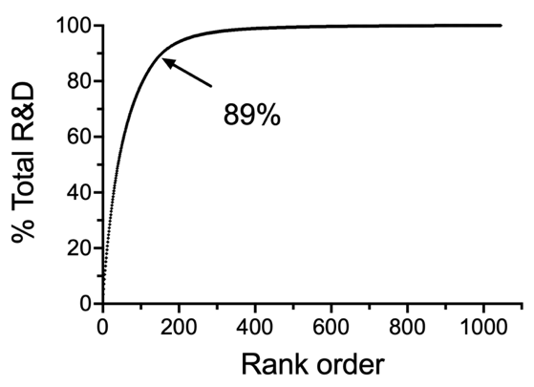

Figure S1. The cumulative percent of R&D funding to universities in order from highest to lowest amounts. The $10 Million threshold for each state from 2014 to 2020 is 89% of all funding.

S2. 2 Comparisons among university rankings
The four rankings of universities are similar: Aggregate Ranking of Top Universities (ARTU; https://research.unsw.edu.au/artu), Academic Ranking of World Universities (ARWU; https://www.shanghairanking.com/), Quacquarelli Symonds (QS) World University Rankings (https://www.topuniversities.com/university-rankings) and the Times Higher Education World University Rankings (THE; https://www.timeshighereducation.com/student/best-universities/best-universities-united-states) (Fig. S2).
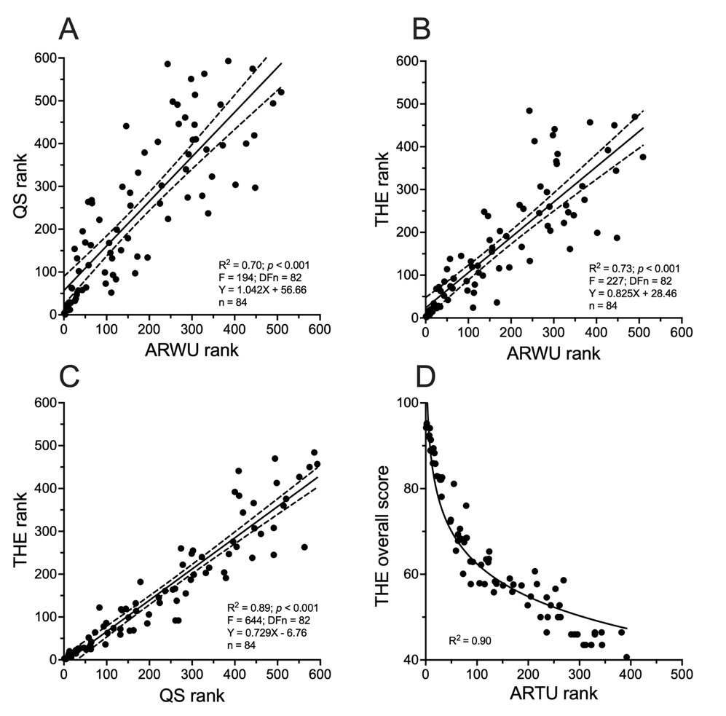

Figure S2. Comparisons of individual university rankings by ARTU, ARWU, QS and THE. A) ARWU rank versus QS rank. B) ARWU rank versus THE rank. C) QS rank versus THE rank. D) ARTU rank versus THE overall score. A linear regression with the 95% confidence limit is shown for S2A, B, and C. Values in ‘D’ are fit to a semi-log equation.

S2.3 Comparison of Arts and Humanities scores
Arts and Humanities (A&H) programs are ranked similarly by the US News and World Report (https://www.usnews.com/education/best-global-universities/search?country=united-states) and the Times Higher Education (https://www.timeshighereducation.com/student/best-universities/best-universities-united-states) (Fig. S3).
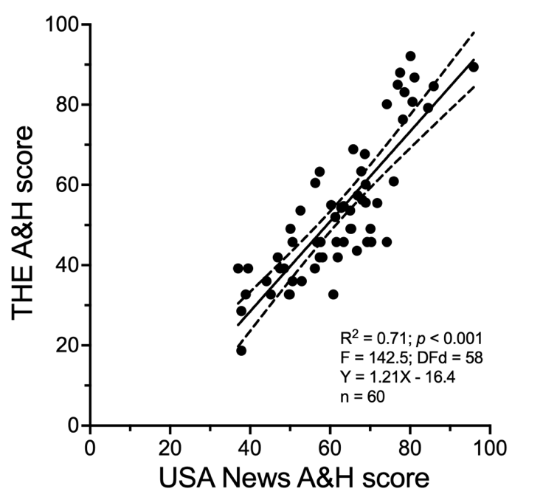

Figure S3. Arts and Humanities programs are ranked similarly by the US News and World Report and the Times Higher Education. A linear regression with the 95% confidence limit is shown.

S2.4 Comparison of teaching and research scores
The rankings of individual university teaching and research competencies are ranked similarly by the Times Higher Education. Either they are complimentary and integrated or driven by the same metrics (Fig. S4).

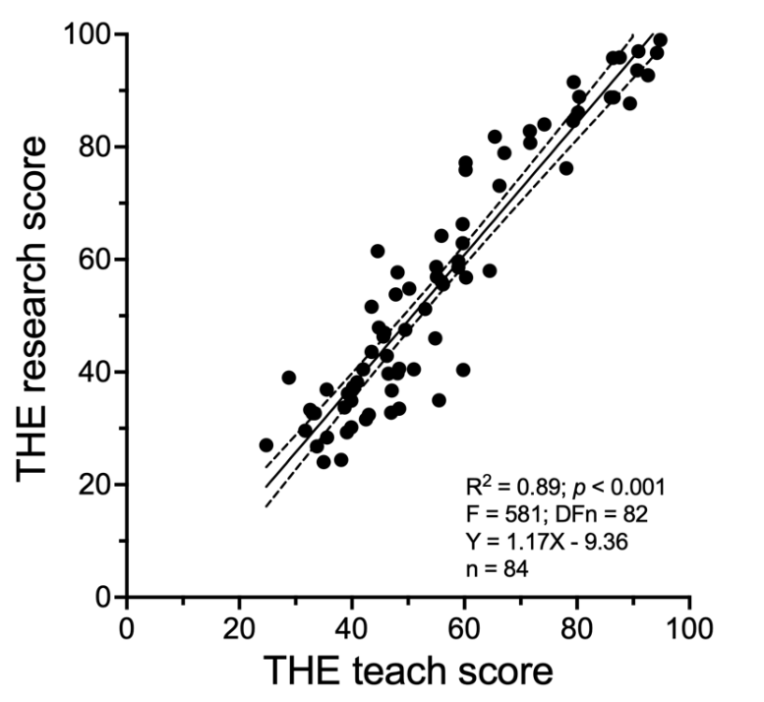

Figure S4. Rankings of individual university teaching and research by the Times Higher Education. A linear regression with the 95% confidence limit is shown.

