Measuring research-related academic performance in a comprehensive university: individual heterogeneity, institutional context, and multidimensional output profiles

Claudiu Vasile Kifor¹* · Horațiu Rusu² · Ana-Maria Benedek³ · Ioan Sîrbu³^{,4} · Roxana Florența Săvescu¹

¹ Research Center for Sustainable Products and Processes, Lucian Blaga University of Sibiu, Sibiu, Romania
² Center for Social Research, Lucian Blaga University of Sibiu, Sibiu, Romania
³ Biology and Ecology Research Center, Lucian Blaga University of Sibiu, Sibiu, Romania
⁴ Doctoral School of Engineering Sciences and Mathematics, Lucian Blaga University of Sibiu, Romania
*Corresponding author: Claudiu Vasile Kifor, claudiu.kifor@ulbsibiu.ro

ELECTRONIC SUPPLEMENTARY MATERIAL

Table S1. Effects of fixed factors (predictors) compared to the null model of the response variable Perform in a generalized linear mixed model (GLMM) with Tweedie distribution, log link function and respondent identity (IdF) included as random factor. Estimate – estimated value of the regression coefficient, Std. Error – standard error of the regression coefficient, z – z test statistic, df – degrees of freedom, LRT – likelihood ratio test statistic. Because significance of effect is evaluated overall, for categorical variables with df > 1 regression coefficients are not available. For Sex the reference level is F (female). Codes of predictors are given in the Data and methods section.

 | Estimate | Std. Error | z value | df | LRT | p
Faculty |  |  |  | 8 | 24.60 | 0.002
DepF |  |  |  | 22 | 42.05 | 0.006
StudF |  |  |  | 44 | 113.71 | < 0.001
Year | 0.06 | 0.01 | 6.63 | 1 | 42.98 | < 0.001
Title | 0.18 | 0.05 | 3.77 | 1 | 13.56 | < 0.001
Sex | -0.02 | 0.09 | -0.19 | 1 | 0.04 | 0.851
Manag | 0.47 | 0.13 | 3.57 | 1 | 12.61 | < 0.001
PhdCoord | 0.08 | 0.09 | 0.92 | 1 | 0.85 | 0.356
Age | 0.01 | 0.01 | 1.08 | 1 | 1.19 | 0.276
WkSenYr | 0.02 | 0.01 | 3.60 | 1 | 13.15 | < 0.001
TsPromYr | 0.03 | 0.01 | 3.95 | 1 | 15.91 | < 0.001

Table S2. Estimates of fixed factors predicting performance in the best generalized linear mixed model (GLMM) with Tweedie distribution and log link function. The model includes respondent identity (IdF) as random factor with random slopes for Year. Codes of the predictors and factor levels are given in the Data and methods section. The reference level for study field (StudF) is StF1.

 | Estimate | Std. Error | z value | p
Year | 0.04 | 0.01 | 2.73 | 0.006
Age | -0.03 | 0.01 | -5.19 | 0.000
Title | 0.31 | 0.05 | 6.36 | 0.000
StudFStF11 | -0.89 | 0.38 | -2.36 | 0.018
StudFStF16 | -0.25 | 0.76 | -0.33 | 0.739
StudFStF2 | -0.26 | 0.29 | -0.88 | 0.378
StudFStF20 | 0.16 | 0.33 | 0.48 | 0.631
StudFStF23 | -0.30 | 0.77 | -0.39 | 0.698
StudFStF24 | -0.16 | 0.74 | -0.21 | 0.833
StudFStF26 | 0.26 | 0.27 | 0.95 | 0.340
StudFStF28 | -0.19 | 0.29 | -0.66 | 0.509
StudFStF29 | -0.52 | 0.75 | -0.70 | 0.486
StudFStF3 | 0.97 | 0.44 | 2.19 | 0.028
StudFStF30 | -0.69 | 0.42 | -1.64 | 0.100
StudFStF31 | -0.26 | 0.24 | -1.10 | 0.273
StudFStF36 | -0.25 | 0.75 | -0.34 | 0.736
StudFStF37 | 1.36 | 0.70 | 1.94 | 0.053
StudFStF38 | 0.27 | 0.29 | 0.94 | 0.348
StudFStF39 | 1.39 | 0.52 | 2.70 | 0.007
StudFStF41 | -0.47 | 0.22 | -2.08 | 0.037
StudFStF43 | -0.55 | 0.27 | -2.01 | 0.044
StudFStF44 | -0.03 | 0.41 | -0.08 | 0.933
StudFStF45 | -0.48 | 0.26 | -1.86 | 0.062
StudFStF47 | -0.28 | 0.30 | -0.95 | 0.343
StudFStF48 | -0.02 | 0.46 | -0.04 | 0.972
StudFStF49 | 0.38 | 0.32 | 1.20 | 0.229
StudFStF5 | 1.52 | 0.70 | 2.16 | 0.031
StudFStF51 | 0.10 | 0.32 | 0.32 | 0.746
StudFStF53 | -0.79 | 0.79 | -1.00 | 0.315
StudFStF54 | 0.69 | 0.53 | 1.31 | 0.189
StudFStF55 | -0.38 | 0.39 | -0.99 | 0.324
StudFStF56 | 0.20 | 0.28 | 0.69 | 0.487
StudFStF57 | -0.26 | 0.32 | -0.81 | 0.420
StudFStF58 | -0.28 | 0.30 | -0.94 | 0.346
StudFStF59 | 0.19 | 0.41 | 0.47 | 0.638
StudFStF6 | 0.72 | 0.74 | 0.96 | 0.335
StudFStF60 | -0.81 | 0.79 | -1.02 | 0.308
StudFStF61 | -0.52 | 0.29 | -1.80 | 0.072
StudFStF62 | 0.00 | 0.32 | -0.01 | 0.990
StudFStF63 | 0.13 | 0.24 | 0.53 | 0.598
StudFStF64 | -1.02 | 0.30 | -3.43 | 0.001
StudFStF66 | -0.06 | 0.30 | -0.20 | 0.841
StudFStF68 | 0.03 | 0.26 | 0.10 | 0.922
StudFStF72 | -0.32 | 0.48 | -0.66 | 0.507
StudFStF73 | 0.28 | 0.31 | 0.91 | 0.364
StudFStF76 | 0.01 | 0.32 | 0.05 | 0.963
StudFStF8 | 0.10 | 0.32 | 0.31 | 0.758

Table S3. The parameters of the Tweedie generalized additive model (GAM) with log link function of activity indicators (i#) explained by year of study. Codes of activity indicators are explained in the Data and methods section. EDF—effective degrees of freedom, Ref_df—effective degrees of freedom, F—F-statistic, p—p-value, p(adj)—p-value adjusted for multiple testing using the false discovery rate correction.
Response | EDF | Ref_df | F | Deviance explained | p | p(adj)
i1 | 1.00 | 1.01 | 30.8 | 0.033 | < 0.001 | < 0.001
i4 | 1.00 | 1.00 | 9.1 | 0.008 | 0.003 | 0.006
i5 | 1.00 | 1.00 | 29.8 | 0.015 | < 0.001 | < 0.001
i9 | 1.00 | 1.01 | 92.2 | 0.035 | < 0.001 | < 0.001
i15 | 1.00 | 1.00 | 40.9 | 0.020 | < 0.001 | < 0.001
i16 | 2.54 | 2.85 | 10.3 | 0.014 | < 0.001 | < 0.001
i17 | 2.84 | 2.98 | 14.6 | 0.066 | < 0.001 | < 0.001
i18 | 2.58 | 2.86 | 6.0 | 0.024 | 0.003 | 0.006
i20 | 1.21 | 1.38 | 18.8 | 0.011 | < 0.001 | < 0.001

Table S4. Statistics of Tweedie generalized additive model (GAM) with log link function relating activity indicators (i#) to academic title, considered as a numeric variable (1-4). Codes of activity indicators are explained in the Data and methods section. EDF—effective degrees of freedom, Ref_df—effective degrees of freedom, F—F-statistic, p—p-value, p(adj)—p-value adjusted for multiple testing using the false discovery rate correction.

Response | EDF | Ref_df | F | Deviance_explained | p | p_adj
i1 | 1.00 | 1.00 | 87.40 | 0.088 | 0.000 | 0.000
i2 | 1.13 | 1.24 | 22.24 | 0.030 | 0.000 | 0.000
i3 | 1.35 | 1.58 | 26.25 | 0.031 | 0.000 | 0.000
i4 | 1.89 | 1.99 | 21.57 | 0.037 | 0.000 | 0.000
i5 | 1.00 | 1.00 | 50.77 | 0.026 | 0.000 | 0.000
i6 | 1.00 | 1.00 | 31.15 | 0.043 | 0.000 | 0.000
i7 | 1.78 | 1.95 | 4.48 | 0.005 | 0.026 | 0.030
i8 | 1.06 | 1.11 | 51.51 | 0.068 | 0.000 | 0.000
i9 | 1.35 | 1.58 | 258.00 | 0.140 | 0.000 | 0.000
i10 | 1.75 | 1.94 | 4.89 | 0.101 | 0.018 | 0.022
i12 | 1.67 | 1.89 | 6.48 | 0.073 | 0.006 | 0.008
i14 | 1.91 | 1.99 | 189.20 | 0.185 | 0.000 | 0.000
i15 | 1.00 | 1.00 | 186.28 | 0.087 | 0.000 | 0.000
i16 | 1.49 | 1.74 | 57.03 | 0.045 | 0.000 | 0.000
i17 | 1.35 | 1.57 | 6.02 | 0.017 | 0.004 | 0.006
i18 | 1.00 | 1.00 | 51.21 | 0.071 | 0.000 | 0.000
i19 | 1.86 | 1.98 | 3.12 | 0.008 | 0.036 | 0.040
i20 | 1.86 | 1.98 | 19.38 | 0.017 | 0.000 | 0.000

Table S5. Statistics of Tweedie generalized additive model (GAM) with log link function between activity indicators and age of the respondent. Codes of activity indicators are explained in the Data and methods section. EDF—effective degrees of freedom, Ref_df—effective degrees of freedom, F—F-statistic, p—p-value, p(adj)—p-value adjusted for multiple testing using the false discovery rate correction.

Response | EDF | Ref_df | F | Deviance_explained | p | p_adj
i1 | 2.28 | 2.65 | 4.56 | 0.013 | 0.006 | 0.016
i4 | 2.77 | 2.96 | 3.10 | 0.011 | 0.017 | 0.042
i7 | 1.00 | 1.00 | 8.84 | 0.006 | 0.003 | 0.010
i9 | 2.89 | 2.99 | 14.76 | 0.016 | 0.000 | 0.000
i12 | 2.75 | 2.96 | 13.69 | 0.145 | 0.000 | 0.000
i15 | 2.84 | 2.98 | 8.89 | 0.013 | 0.000 | 0.000
i17 | 1.00 | 1.01 | 14.07 | 0.021 | 0.000 | 0.001
i18 | 1.31 | 1.55 | 12.29 | 0.025 | 0.000 | 0.001

Table S6. Statistics of Tweedie generalized additive model (GAM) with log link function between activity indicators and work seniority (WkSenYr). Codes of activity indicators are explained in the Data and methods section. EDF—effective degrees of freedom, Ref_df—effective degrees of freedom, F—F-statistic, p—p-value, p(adj)—p-value adjusted for multiple testing using the false discovery rate correction.

Response | EDF | Ref_df | F | Deviance_explained | p | p_adj
i1 | 1.00 | 1.00 | 10.06 | 0.010 | 0.002 | 0.003
i3 | 1.95 | 2.00 | 15.13 | 0.026 | 0.000 | 0.000
i4 | 1.92 | 1.99 | 6.01 | 0.011 | 0.002 | 0.004
i6 | 1.91 | 1.99 | 9.09 | 0.032 | 0.000 | 0.000
i7 | 1.88 | 1.99 | 6.58 | 0.010 | 0.001 | 0.002
i8 | 1.56 | 1.81 | 5.85 | 0.012 | 0.013 | 0.024
i9 | 1.00 | 1.00 | 32.35 | 0.013 | 0.000 | 0.000
i12 | 1.79 | 1.96 | 8.46 | 0.094 | 0.000 | 0.001
i13 | 1.91 | 1.99 | 4.14 | 0.051 | 0.015 | 0.024
i14 | 1.79 | 1.96 | 23.90 | 0.025 | 0.000 | 0.000
i15 | 1.50 | 1.75 | 17.29 | 0.014 | 0.000 | 0.000
i16 | 1.89 | 1.99 | 4.05 | 0.004 | 0.015 | 0.024
i20 | 1.93 | 1.99 | 8.59 | 0.008 | 0.000 | 0.000

Table S7. Statistics of Tweedie generalized additive model (GAM) with log link function between activity indicators and time since last promotion (TsPromYr). EDF—effective degrees of freedom, Ref_df—effective degrees of freedom, F—F-statistic, p—p-value, p(adj)—p-value adjusted for multiple testing using the false discovery rate correction.

Response | EDF | Ref_df | F | Deviance_explained | p | p_adj
i1 | 1.32 | 1.54 | 8.00 | 0.015 | 0.001 | 0.002
i2 | 1.00 | 1.00 | 34.66 | 0.039 | 0.000 | 0.000
i5 | 1.90 | 1.99 | 7.25 | 0.010 | 0.001 | 0.001
i9 | 1.98 | 2.00 | 46.79 | 0.039 | 0.000 | 0.000
i10 | 1.89 | 1.99 | 6.60 | 0.120 | 0.001 | 0.002
i12 | 1.87 | 1.98 | 6.30 | 0.091 | 0.002 | 0.004
i14 | 1.97 | 2.00 | 32.81 | 0.047 | 0.000 | 0.000
i15 | 1.94 | 2.00 | 11.65 | 0.014 | 0.000 | 0.000
i16 | 1.85 | 1.98 | 37.06 | 0.037 | 0.000 | 0.000
i17 | 1.82 | 1.97 | 5.45 | 0.020 | 0.003 | 0.005
i18 | 1.94 | 2.00 | 16.27 | 0.065 | 0.000 | 0.000
i20 | 1.00 | 1.00 | 106.38 | 0.043 | 0.000 | 0.000

Fig. S1. Partitioning of the variation explained by the components of the mixed models, on logarithmic scale. R²_{m} is the marginal coefficient of determination, which quantifies the variation in the response variable (Performance) explained by the fixed factors (predictors). R²_{a} is the random effects coefficient of determination, which quantifies the variation explained by the random factor (IdF), expressing the inter-individual variation. The sum of R²_{a} and R²_{m} equals the conditional coefficient of determination, expressing the variation explained by the whole model. Codes of predictors are explained in the Data and methods section.

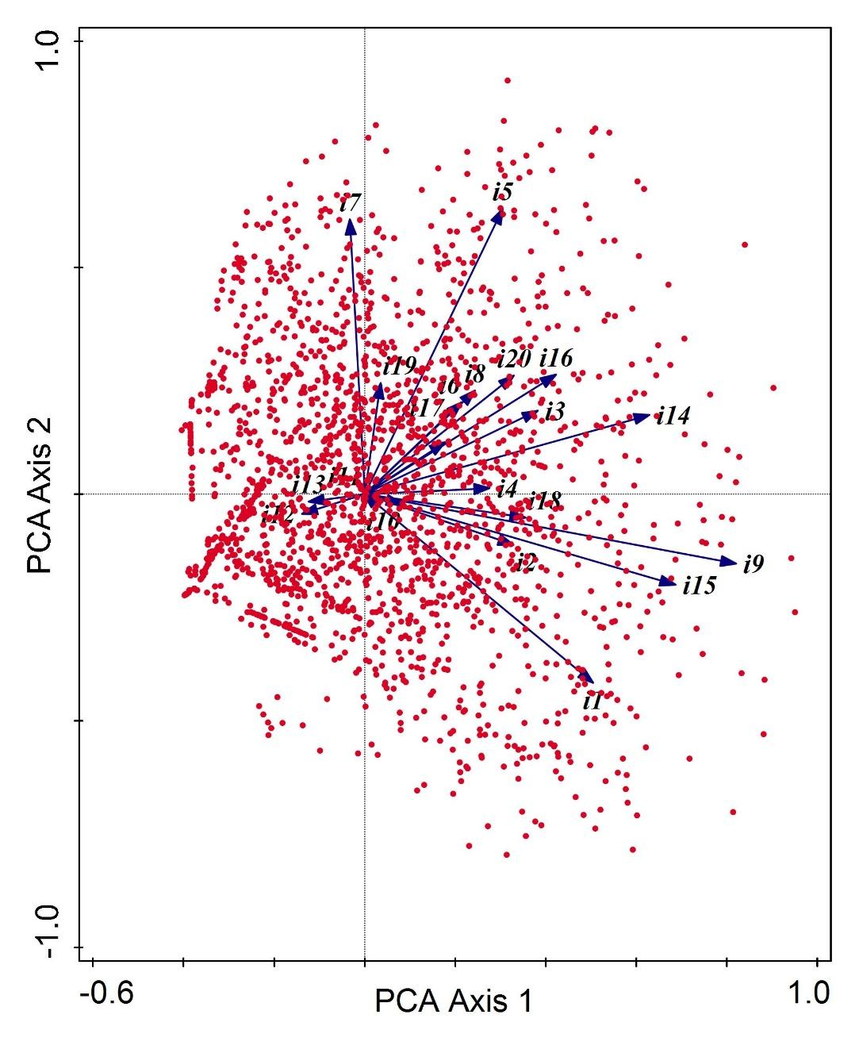
Fig. S2. Principal component analysis (PCA) biplot of activity indicators and respondents, showing a continuous distribution of activity profiles and the absence of a single dominant global trend. Codes of activity indicators are explained in the Data and methods section.

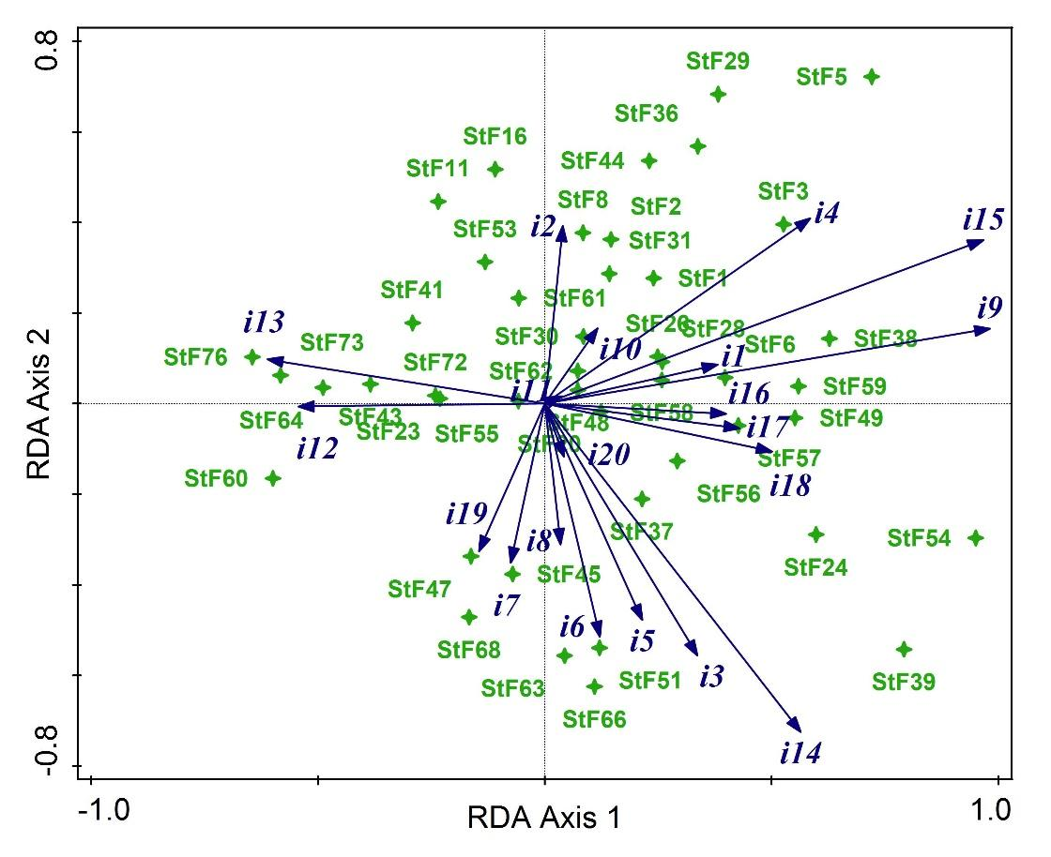
Fig. S3. Redundancy analysis (RDA) of relations between activity indicators (i#) and study fields (StF#). Codes of variables are presented in the Data and methods section.

