Supplementary Information
Mutualism in Socio-Semantic Networks: Structural Correlates of Publication Output Across Ecosystem approaches to health
P. Mongeau, J. Saint-Charles, and L. Renaud-Desjardins

This Supplementary Information document provides additional materials supporting the analyses reported in the main text. It is organised in four sections: (S1) sensitivity analysis to publications with very large author counts; (S2) detailed structural metric values across the four community detection algorithms; (S3) LDA topic modelling specifications and complete topic labels; (S4) robustness analysis with between-approach controls.

S1. Sensitivity to publications with very large author counts
The corpus contains 59 publications (0.9% of the corpus) with more than 30 co-authors. As reported in Sect. 3.1 of the main text, these publications contribute approximately 53% of the edges in the co-authorship network owing to the combinatorial growth of edge counts with team size (k(k − 1)/2 for a team of k authors). To assess the sensitivity of the H1 result to the inclusion of these publications, we examine their distribution across the 18 approach × period cells and reproduce the main analysis on a restricted corpus excluding them.
Table S1. Distribution of publications with more than 30 authors by approach and period. The full corpus (n = 6,406) and the restricted corpus (n = 6,347, after excluding 59 hyperauthor publications) are compared cell by cell. Counts are reported per approach; because a small number of publications are associated with more than one approach, the per-approach figures sum to slightly more than the unique totals — the 59 unique hyperauthored publications appear as 60 across the approach rows, one publication belonging to two approaches.
Approach | Period | Full corpus (n) | Restricted (n) | Hyper (n) | Hyper (%)
EcoHealth | 2004-2016 | 290 | 290 | 0 | 0.00
EcoHealth | 2017-2019 | 89 | 89 | 0 | 0.00
EcoHealth | 2020-2020 | 34 | 34 | 0 | 0.00
EcoHealth | 2021-2021 | 39 | 39 | 0 | 0.00
EcoHealth | 2022-2022 | 22 | 22 | 0 | 0.00
EcoHealth | 2023-2023 | 22 | 22 | 0 | 0.00
One Health | 2004-2016 | 625 | 622 | 3 | 0.48
One Health | 2017-2019 | 838 | 828 | 10 | 1.19
One Health | 2020-2020 | 504 | 501 | 3 | 0.60
One Health | 2021-2021 | 862 | 852 | 10 | 1.16
One Health | 2022-2022 | 1050 | 1039 | 11 | 1.05
One Health | 2023-2023 | 1020 | 1011 | 9 | 0.88
Planetary Health | 2004-2016 | 33 | 33 | 0 | 0.00
Planetary Health | 2017-2019 | 134 | 132 | 2 | 1.49
Planetary Health | 2020-2020 | 150 | 147 | 3 | 2.00
Planetary Health | 2021-2021 | 234 | 230 | 4 | 1.71
Planetary Health | 2022-2022 | 305 | 302 | 3 | 0.98
Planetary Health | 2023-2023 | 302 | 300 | 2 | 0.66
Note. Restricted (n) = Full corpus (n) − Hyper (n). Hyper (%) = Hyper (n) / Full corpus (n) × 100. EcoHealth contains no hyperauthored publications; hyperauthored publications are concentrated in One Health (46 across its rows) and Planetary Health (14).
Hyperauthor publications are heavily concentrated in One Health (46 of 59, ranging from 3 to 11 per period) and Planetary Health (14 of 59, ranging from 0 to 4 per period); EcoHealth contains zero hyperauthor publications. The proportion of hyperauthor publications does not exceed 2% of any cell. The rank ordering of cells by publication output is preserved between the full and restricted corpora (Spearman ρ on cell ranks = 1.00). Consequently, the H1 Spearman correlation between modularity and publication output is essentially unchanged.

S2. Algorithmic robustness — detailed structural metrics
Table 2 of the main text reports the Spearman correlations between structural metrics and publication output under each of the four community detection algorithms (Louvain, Leiden, HSBM₀, HSBM₁). For completeness, Tables S2a and S2b provide the underlying structural metric values per approach × period cell and per algorithm. The Louvain values reproduce those of Table 3 in the main text.
Table S2a. Bipartite modularity (DIRTLPAwb+) per approach × period cell and per community detection algorithm.
Approach × Period | Pubs | Louvain | Leiden | HSBM₀ | HSBM₁
EcoHealth · 2004-2016 | 290 | 0.536 | 0.661 | 0.432 | 0.067
EcoHealth · 2017-2019 | 89 | 0.681 | 0.811 | 0.627 | 0.108
EcoHealth · 2020-2020 | 34 | 0.765 | 0.833 | 0.731 | 0.150
EcoHealth · 2021-2021 | 39 | 0.787 | 0.807 | 0.702 | 0.107
EcoHealth · 2022-2022 | 22 | 0.781 | 0.782 | 0.611 | 0.121
EcoHealth · 2023-2023 | 22 | 0.767 | 0.767 | 0.544 | 0.113
One Health · 2004-2016 | 625 | 0.436 | 0.612 | 0.435 | 0.065
One Health · 2017-2019 | 838 | 0.456 | 0.619 | 0.470 | 0.073
One Health · 2020-2020 | 504 | 0.638 | 0.709 | 0.511 | 0.067
One Health · 2021-2021 | 862 | 0.510 | 0.628 | 0.479 | 0.061
One Health · 2022-2022 | 1050 | 0.501 | 0.627 | 0.461 | 0.054
One Health · 2023-2023 | 1020 | 0.512 | 0.631 | 0.446 | 0.059
Planetary Health · 2004-2016 | 33 | 0.573 | 0.575 | 0.428 | 0.121
Planetary Health · 2017-2019 | 134 | 0.648 | 0.723 | 0.599 | 0.098
Planetary Health · 2020-2020 | 150 | 0.765 | 0.769 | 0.545 | 0.081
Planetary Health · 2021-2021 | 234 | 0.624 | 0.739 | 0.566 | 0.086
Planetary Health · 2022-2022 | 305 | 0.657 | 0.739 | 0.556 | 0.066
Planetary Health · 2023-2023 | 302 | 0.585 | 0.618 | 0.468 | 0.069

Table S2b. WNODA per approach × period cell and per community detection algorithm.
Approach × Period | Pubs | Louvain | Leiden | HSBM₀ | HSBM₁
EcoHealth · 2004-2016 | 290 | 71.77 | 33.29 | 73.30 | 83.07
EcoHealth · 2017-2019 | 89 | 74.92 | 29.87 | 74.11 | 73.61
EcoHealth · 2020-2020 | 34 | 68.56 | 37.10 | 59.41 | 70.14
EcoHealth · 2021-2021 | 39 | 74.32 | 23.84 | 70.21 | 73.39
EcoHealth · 2022-2022 | 22 | 65.68 | 33.56 | 65.21 | 74.00
EcoHealth · 2023-2023 | 22 | 66.62 | 30.98 | 74.01 | 82.00
One Health · 2004-2016 | 625 | 71.80 | 34.87 | 68.08 | 81.29
One Health · 2017-2019 | 838 | 73.22 | 28.58 | 69.28 | 78.95
One Health · 2020-2020 | 504 | 72.62 | 31.72 | 71.38 | 76.87
One Health · 2021-2021 | 862 | 72.13 | 26.55 | 69.41 | 84.45
One Health · 2022-2022 | 1050 | 70.95 | 25.28 | 68.85 | 83.86
One Health · 2023-2023 | 1020 | 71.42 | 26.13 | 69.71 | 81.82
Planetary Health · 2004-2016 | 33 | 70.57 | 41.54 | 59.26 | 80.56
Planetary Health · 2017-2019 | 134 | 70.90 | 25.96 | 70.11 | 76.53
Planetary Health · 2020-2020 | 150 | 71.68 | 34.04 | 72.08 | 80.69
Planetary Health · 2021-2021 | 234 | 71.57 | 32.90 | 67.94 | 76.48
Planetary Health · 2022-2022 | 305 | 72.70 | 24.60 | 70.77 | 80.05
Planetary Health · 2023-2023 | 302 | 66.74 | 29.36 | 67.19 | 85.33

Modularity values are tightly aligned across the four algorithms (inter-algorithm Pearson correlations range from 0.62 to 0.92; cf. Table 2 Panel A of the main text). The Louvain modularity, which we report in the main text, is therefore representative of the broader algorithmic family. WNODA, by contrast, varies substantially across algorithms, particularly between modularity-based methods (Louvain, Leiden) and the hierarchical stochastic block model (HSBM₀, HSBM₁), as discussed in Sect. 4.1 of the main text.

S3. LDA topic modelling: specification and topic labels

S3.1 Choice of K = 20 topics
Latent Dirichlet Allocation (LDA, Blei et al. 2003; Blei 2012) was estimated globally on the entire 2004-2023 corpus (n = 6,406 publications), with K = 20 latent topics. The choice of K was made jointly on the basis of statistical and substantive criteria. K = 20 provided fine enough thematic resolution to distinguish neighbouring subdomains (e.g., antimicrobial resistance versus antimicrobial resistance genomics; zoonoses in livestock versus zoonoses in companion animals) while remaining tractable for substantive interpretation by a domain specialist (J. Saint-Charles). Empirical diagnostics of K supporting this choice are shown in Fig. S1 below.
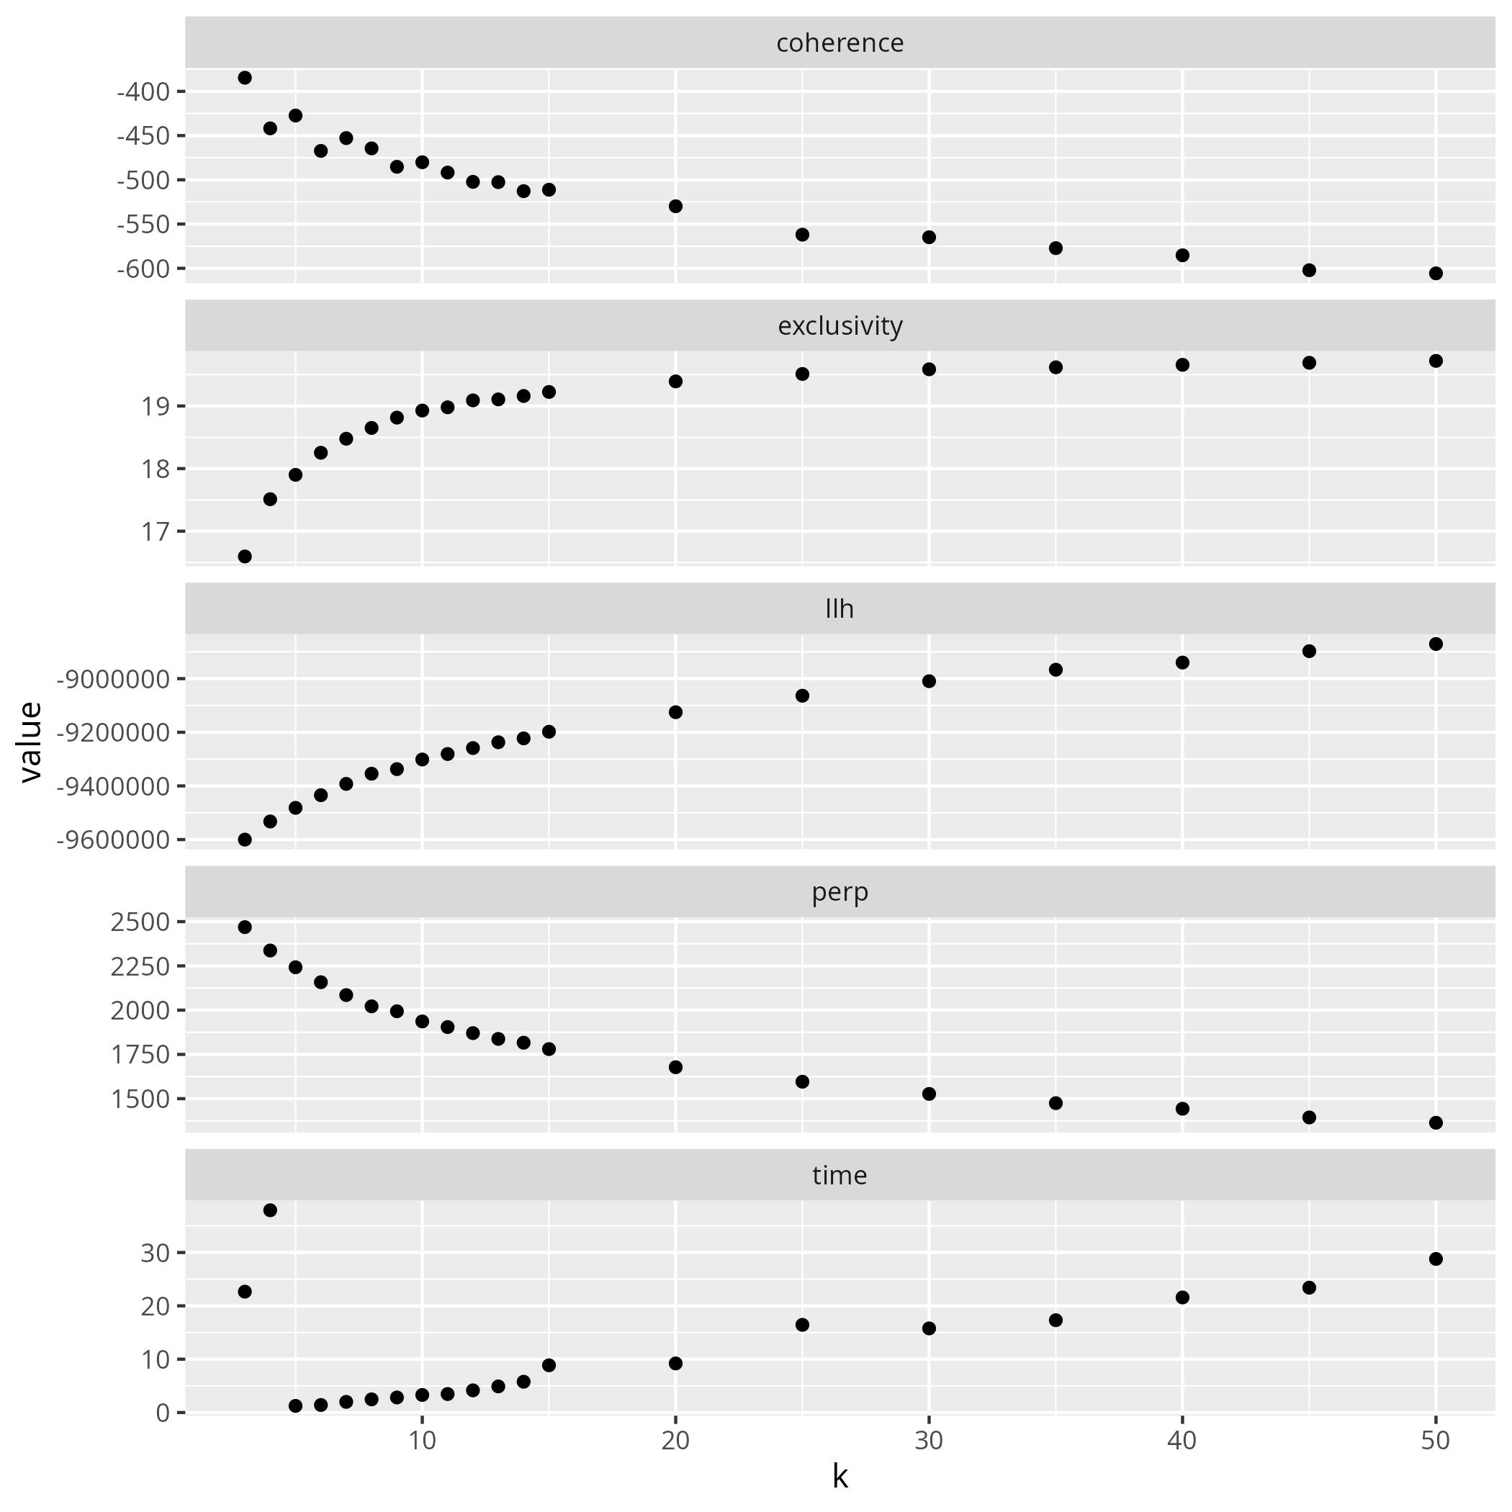
Fig. S1. LDA diagnostics on the full 2004–2023 corpus (n = 6,406). Panels: semantic coherence, exclusivity, held-out log-likelihood (llh), perplexity (perp), and computation time (s), as a function of K.

S3.2 Complete topic labels and top 30 LDA words
Table S3. Complete labels and top 30 LDA words for the 20 topics identified on the global 2004-2023 corpus. Labels were reviewed and validated by a domain specialist (J. Saint-Charles).
Topic | Label | Top 30 LDA words (by decreasing probability)
T1 | One Health conceptual framework | animal, human, onehealth, environment, approach, disease, ecosystem, concept, can, na, wildlife, environmental, new, one, medicine, publichealth, well, also, science, onehealthapproach, environmentalhealth, review, interaction, research, challenge, understanding, humanhealth, history, perspective, issue
T2 | Parasites and microbiomes | species, disease, human, animal, cell, host, cryptosporidium, study, parasite, infection, model, microbiome, pathogen, genetic, immune, cancer, review, nonhuman, gene, giardia, interaction, response, diversity, system, microbiota, dog, research, factor, molecular, potential
T3 | Animal food production and safety | food, animal, human, meat, production, poultry, salmonella, livestock, safety, risk, campylobacter, farm, disease, pig, chain, product, pathogen, infection, foodborne, industry, agricultural, agriculture, control, market, chicken, transmission, source, swine, can, system
T4 | Water and aquatic ecosystem contamination | water, environmental, soil, environment, risk, wastewater, pollution, exposure, waste, contamination, river, human, ecosystem, chemical, aquatic, assessment, marine, difficile, study, plant, fish, source, management, hev, antifungal, monitoring, community, aquaculture, effect, concentration
T5 | Respiratory viruses and pandemics | virus, coronavirus, animal, human, cov, sar, covid19, pandemic, influenza, infection, disease, respiratory, transmission, syndrome, viral, acute, severe, rna, swine, avian, genetic, zoonotic, bat, hepatiti, antibody, vaccine, nonhuman, study, sequence, sequencing
T6 | Antimicrobial resistance | resistance, antimicrobialresistance, bacterial, antibiotic, bacterium, gene, antibioticresistance, resistant, animal, agent, staphylococcus, isolate, human, aureus, antimicrobial, study, arg, tetracycline, salmonella, drug, infection, strain, genetic, sample, multidrug, derivative, ecoli, environment, antiinfective, sensitivity
T7 | Medical education | education, student, medical, veterinary, study, human, practice, knowledge, veterinarian, curriculum, animal, attitude, survey, questionnaire, article, care, school, professional, patient, pet, clinical, training, university, perception, participant, program, female, onehealth, among, learning
T8 | Rabies control | raby, disease, dog, animal, human, control, vaccine, vaccination, cost, zoonosi, country, prevention, case, bite, healthcare, onehealth, elimination, publichealth, veterinary, population, death, burden, diseasecontrol, exposure, economic, strategy, neglected, effective, onehealthapproach, endemic
T9 | Antimicrobial resistance genomics (ESBL, mcr) | ecoli, gene, isolate, human, bacterial, genome, animal, resistance, strain, lactamase, sequence, beta, genetic, plasmid, producing, esbl, study, infection, sequencing, bacterium, colistin, mcr, resistant, genomic, analysis, whole, spectrum, extended, virulence, agent
T10 | Zoonoses and companion animals | dog, animal, cat, tick, disease, human, study, infection, spp, sample, leptospira, prevalence, dna, antibody, case, leptospirosi, polymerase, reaction, domestic, brazil, chain, leishmaniasi, blood, species, analysis, article, parasite, positive, leishmania, nonhuman
T11 | Zoonoses and livestock | cattle, animal, human, livestock, study, brucellosi, bovine, disease, tuberculosi, goat, sheep, brucella, milk, mycobacterium, fever, dairy, ci, risk, anthrax, q, control, transmission, prevalence, infection, sample, case, cross, farmer, farm, sectional
T12 | One Health governance and surveillance | onehealth, antimicrobialresistance, surveillance, human, datum, system, country, animal, national, policy, onehealthapproach, disease, international, collaboration, global, capacity, sector, action, implementation, level, information, healthcare, tool, laboratory, publichealth, response, development, challenge, approach, plan
T13 | Community-based research | research, approach, community, study, social, human, practice, framework, policy, knowledge, analysis, based, method, management, qualitative, article, interview, science, process, model, onehealth, stakeholder, project, intervention, system, environmental, group, factor, development, decision
T14 | Global change, climate and sustainability | human, climatechange, planetaryhealth, environmental, global, policy, social, pandemic, system, change, ecosystem, covid19, biodiversity, impact, can, climate, sustainability, sustainabledevelopment, future, environment, economic, healthcare, nature, action, challenge, natural, humanhealth, need, ecological, publichealth
T15 | Sustainable food and environmental footprint | food, diet, dietary, consumption, nutrition, meat, based, intake, environmental, plant, study, human, nutritional, impact, sustainable, obesity, emission, protein, planetaryhealth, footprint, sustainability, pattern, nutrient, population, group, disease, vegetable, healthy, foodsystem, gas
T16 | Antimicrobial use and stewardship | antimicrobial, antibiotic, use, drug, agent, antimicrobialresistance, animal, human, treatment, plant, bacterial, stewardship, antibioticresistance, effect, protein, used, development, resistance, review, anti, medicine, therapy, activity, application, antiinfective, can, clinical, study, system, microbial
T17 | Emerging zoonoses | disease, virus, human, animal, infection, fever, vector, zoonosi, transmission, pathogen, outbreak, risk, emerging, infectiousdisease, surveillance, borne, wildlife, control, epidemic, west, zoonotic, emergence, species, review, case, communicable, host, population, nile, zoonoticdisease
T18 | Systematic reviews and meta-analyses | review, human, systematic, study, africa, country, animal, analysis, prevalence, literature, datum, research, meta, infection, south, article, published, america, publication, search, disease, region, reported, included, author, china, databasis, onehealth, evidence, asia
T19 | Prevalence of parasitic diseases | disease, child, human, study, control, infection, animal, prevalence, parasite, transmission, vector, adult, aged, male, female, household, schistosomiasi, area, risk, pig, cysticercosi, community, population, water, solium, chagas, malaria, rural, adolescent, endemic
T20 | Risk studies | urban, study, population, risk, environmental, area, datum, analysis, factor, model, community, level, city, exposure, disease, air, pollution, human, forest, indicator, result, associated, spatial, using, land, rural, quality, high, social, index

Note. LDA words are stemmed; non-standard tokens (e.g. 'raby' for 'rabies', 'ecoli' for 'E. coli') reflect the stemming and lemmatisation choices made in pre-processing. The labels were validated independently of the algorithmic output and are intended to capture the dominant substantive content rather than the surface form of the words.

S4. Robustness analysis: between-approach controls
The principal regression analyses reported in Table 4 of the main text (M1, M2, M3) do not control for differences between approaches. Model M4 below adds approach as a categorical variable (with One Health as reference) to assess the persistence of the structural associations under this explicit control.
Table S4. Ordinary least squares regression model M4 (n = 18 approach–period observations), including approach dummies as a robustness check against between-approach differences. Reference category for approach = One Health.
Predictor | M4
Intercept | 1372.4 NS
Modularity | −818.4 NS
WNODA | −1.9 NS
EcoHealth (vs One Health) | −564.8***
Planetary Health (vs One Health) | −517.2***
R² | 0.87
R²_adj | 0.84
Durbin–Watson | 1.70

Note: * p < 0.05, ** p < 0.01, *** p < 0.001, NS = not significant.

This robustness check examines whether the structure–publication associations persist under explicit control for between-approach differences. The attenuation of the modularity coefficient (β = −818, p = 0.11) in this specification reflects shared variance between modularity and approach context: the three approaches differ systematically in their average modularity, so a contrast that holds approach constant by construction necessarily removes a portion of the modularity signal that the mutualist framework treats as partly constitutive of each approach. The substantial significant approach dummies (EcoHealth β = −565***, Planetary Health β = −517***) document that between-approach differences extend beyond the structural metrics, capturing factors such as field maturity, editorial norms, and funding contexts not modelled here. The primary support for H1 therefore comes from M1, M3, and the cell-level rank correlations reported in the main manuscript (Sect. 4.1, Table 4), with M4 documenting that residual approach-level variance is not negligible.

End of Supplementary Information.

