Online supplement for Stanley, S.K., Day, C., & Brown, P.M. Masculinity matters for meat consumption: An examination of self-rated gender typicality, meat consumption, and veg*nism in Australian men and women. Sex Roles. Samantha K. Stanley, Australian National University. Email: samantha.stanley@anu.edu.au

Supplement A. Pilot Study
We initially analysed data from a convenience sample of Australian citizens or people living in Australia to test the role of self-rated gender typicality in in moderating the association between gender and meat consumption attitudes. As well as intentions to reduce meat consumption, this dataset included meat attachment as one central barrier to adopting a meat-reduced diet (DeBacker et al., 2020; Graça et al., 2016; 2015). Research suggests men may eat more meat than women because they are more attached to meat, meaning they have a more positive connection to meat (De Backer et al., 2020; Graça et al., 2015). Men typically score higher on each dimension of meat attachment: hedonism (eating meat as a source of pleasure), affinity (viewing meat consumption as natural), entitlement (believing humans have the right to kill and eat animals), and dependence (believing meat is needed for well-being). We expected men to score higher than women in meat attachment, and lower in intentions to reduce their meat consumption. However, we expected an interaction whereby the effect of gender is moderated by self-rated gender typicality, with greater meat attachment and lower willingness to consider reducing meat for men who view themselves as more gender-typical.
Method
Participants and Procedure
In total, 505 people responded to a 15-minute online survey advertised as a study “examining factors which influence dietary choices” via social media and the University of Canberra student research participation system between June and August 2020. To be eligible for the survey, prospective participants either had to live in Australia or confirm they were Australian citizens living overseas. We removed 23 participants who identified as vegetarian and 12 who identified as vegan so that the sample consisted of current meat-eaters. The final sample of 470 were aged between 17 and 77 years (M = 38.26, SD = 14.68), and there was a severe gender bias: 20.9% identified as men, 78.7% as women, and 0.4% other (removed prior to analyses that compare binary gender responses). The project was approved by the Human Research Ethics Committee of the University of Canberra (Approval #4463) and participants provided informed consent by continuing onto the survey after reading a detailed participant information sheet.
Materials
Self-Rated Gender Typicality
Participants completed Kachel et al.’s (2016) Traditional Masculinity and Femininity scale by rating six items presented as sentence fragments (e.g., “Traditionally, my behaviour would be regarded as…” and, “Traditionally, my attitudes and beliefs would be regarded as…”) along 7-point response scales from very masculine (1) to very feminine (7). As in Rosenfeld and Tomiyama’s (2021) study, we reverse scored men’s ratings so that higher scores indicate stronger self-rated gender typicality (i.e., greater femininity for women, and greater masculinity for men).
Intention to Reduce Meat Intake
Participants responded to the item “How likely are you to reduce your meat consumption in the next six months?” on a seven-point scale from extremely unlikely (1) to extremely likely (7). A ‘not applicable’ option was included, and the 5 participants who selected this were removed from analysis of this item. This single item measure was adapted from De Backer et al. (2020).
Meat Attachment
Graça et al.’s (2015) Meat Attachment Questionnaire captured the four subscales of meat-related attitudes. This included meat-related hedonism (4 items, e.g., “To eat meat is one of the good pleasures in life”), affinity (4 items, e.g., “I feel bad when I think of eating meat”), entitlement (3 items, e.g., “Eating meat is a natural and indisputable practice”), and dependence (5 items, e.g., “Meat is irreplaceable in my diet”). Responses were on a five-point scale from strongly disagree (1), to strongly agree (5).
Results and Discussion
De-identified data are available on the Open Science Framework linked in the main text. Bivariate correlations between variables measured on binary or continuous scales are displayed in Table S1. Binary gender identification was significantly associated with greater intention to reduce meat consumption and meat attachment, with women more likely to intend to reduce their meat consumption and less attached to meat than men. Importantly, self-rated gender typicality did not significantly correlate with any variable in these analyses. To uncover whether this is because the variable only has predictive ability for men and not women, we next conducted moderation analyses. This involved including binary gender and self-rated gender typicality in Step 1 of a hierarchical multiple linear regression, then the interaction between these variables in Step 2. These results are presented in Table S2, and counter to predictions, did not reveal any significant interaction effects. The null results may be because of sample size, and in particular the limited sample of males in the pilot study.
As our pilot study was exploratory, we still visualised the (non-significant) moderation on intention to reduce meat consumption to inform development of our second study. Results shown in Figure S1 were in the expected direction, suggesting that for men, there is a slight trend towards lower willingness to reduce meat at higher levels of masculinity. For women, the relationship appears slightly positive: intentions to reduce meat may increase slightly at higher levels of femininity. As there was no statistically significant moderation, the associations did not significantly depend on gender.

Table S1
Descriptive Statistics and Correlations – Pilot study.
 | 1. | 2. | 3. | 4. | 5. | 6. | 7.
1. Gender  (1 = male, 2 = female) | -
2. Self-rated gender typicality | .05 | -
3. Intention to reduce meat intake | .11* | .06 | -
4. Hedonism | -.11* | .02 | -.48*** | -
5. Affinity | -.12* | .05 | -.49*** | .52*** | -
6. Entitlement | -.12* | .08 | -.44*** | .54*** | .54*** | -
7. Dependence | -.15** | -.03 | -.59*** | .70*** | .48*** | .56*** | -
Mean (SD) | - | 5.19 (0.93) | 3.04 (1.90) | 3.65 (0.94) | 3.89 (0.88) | 3.38 (0.87) | 2.99 (0.99)
Reliability | - | .94 | - | .86 | .81 | .73 | .86
Note. Reliability information is not available for single item measures. ***p < .001, **p < .01, *p < .05

Table S2
Results of a Series of Hierarchical Multiple Linear Regressions Testing the Moderating Effect of Gender on the Association Between Self-Rated Gender Typicality and Meat Attitudes and Intentions – Pilot Study.
 | Intention to reduce meat intake | Hedonism | Affinity | Entitlement | Dependence
Step 1 | R² = .01 | R² = .01 | R² = .02 | R² = .02 | R² = .02
Gender (1 = male, 2 = female) | .10* | -.12 | 0.13** | -.12* | -.15**
Self-rated gender typicality | .06 | .02 | .06 | .08 | -.02
Step 2 | ΔR² = .002 | ΔR² = .001 | ΔR² = .004 | ΔR² = .000 | ΔR² = .003
Gender (1 = male, 2 = female) | -.15 | .06 | .21 | -.01 | .12
Self-rated gender typicality | -.14 | .16 | .31 | .17 | .18
Gender * self-rated gender typicality | .33 | -.23 | -.43 | -.15 | -.34
Note. Standardised regression coefficients (β) are shown. ***p < .001, **p < .01, *p < .05
Figure S1
The Association Between Men’s Masculinity (Black) and Women’s Femininity (Grey) and Intention to Reduce Meat Consumption in our Pilot Study.
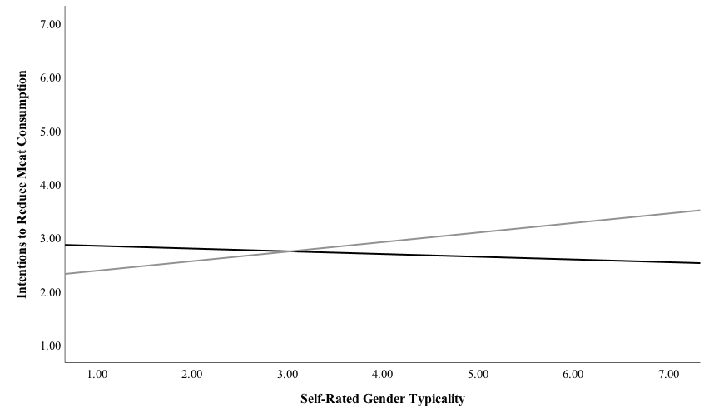
Supplement B. Selecting a Single Self-Rated Gender Typicality Item for the Main Study
Due to space constraints in the main study, we also reviewed our pilot study data to select a single item to measure the self-rated gender typicality construct in the main study. Table S3 presents corrected item-total correlations for each item, which capture the association each item has with the sum of the remaining items. The first item, which measures a more global assessment of one’s masculinity-femininity, is most strongly associated with the others, which capture (in order): ideal masculinity-femininity, perceived masculinity-femininity of interests, attitudes, behaviour, and appearance. This suggests that the more global assessment of one’s masculinity-femininity is the best single-item measure of the construct of interest. This result matches Kachel et al.’s (2016) findings, where the corrected item total of this item (.91) was higher than all others, which ranged from .72-.87 in Study 1. Additionally, at face value, this item captures holistic self-perceived masculinity-femininity to a greater extent than the remaining items, which are domain specific and ask either about ideals or second-order beliefs. For these reasons, item 1 was retained in the main study. The most likely effect on our results of using a single item measure is attenuated effect sizes (Kachel et al., 2016).
Table S3.
Corrected Item-Total Correlations for Each Item of the Traditional Masculinity-Femininity Scale in our Pilot Study and the Original Scale Development Paper.
 | Corrected item-total correlation
Item | Pilot study | Kachel et al. (2016, Study 1)
I consider myself as… | .89 | .91
Ideally, I would like to be… | .86 | .87
Traditionally, my interests would be regarded as… | .81 | .77
Traditionally, my attitudes and beliefs would be regarded as… | .77 | .72
Traditionally, my behaviour would be regarded as… | .83 | .85
Traditionally, my outer appearance would be regarded as… | .80 | .83

