Online supplement for Perales, F., Kuskoff, E., Flood, M., & King, T. (2023). Like father, like son: Empirical insights into the intergenerational continuity of masculinity ideology . Sex Roles. Francisco Perales, University of Queensland. Email: f.perales@uq.edu.au

Table S1
Sample Means and Standard Deviations for Items and Subscales of the CMNI-22
 | Young Men |  | Father Figures
 | Mean | SD | Mean | SD
Items (range: 0-3)
Work/school is the most important part of my life | 1.62 | 0.75 | 1.28 | 0.72
I make sure people do as I say | 1.19 | 0.66 | 1.22 | 0.68
In general, I do not like risky situations (RC) | 1.43 | 0.73 | 1.27 | 0.63
It would be awful if someone thought I was gay | 1.67 | 1.03 | 1.64 | 0.94
I love it when men are in charge of women | 0.73 | 0.71 | 0.78 | 0.68
I like to talk about my feelings | 1.63 | 0.80 | 1.63 | 0.74
I would feel good if I had many sexual partners | 0.96 | 0.83 | 0.74 | 0.70
It is important that people think I am heterosexual | 1.67 | 0.94 | 1.48 | 0.83
I believe that violence is never justified (RC) | 1.37 | 0.85 | 1.05 | 0.87
I tend to share my feelings (RC) | 1.62 | 0.76 | 1.61 | 0.68
I should be in charge | 1.19 | 0.72 | 1.26 | 0.62
I would hate to be important (RC) | 1.95 | 0.66 | 1.81 | 0.56
Sometimes violent action is necessary | 1.46 | 0.87 | 1.25 | 0.84
I do not like giving all my attention to work/school | 1.34 | 0.78 | 1.30 | 0.68
More often than not, losing does not bother me (RC) | 1.43 | 0.80 | 1.43 | 0.65
I would frequently change sexual partners if I could | 0.73 | 0.73 | 0.62 | 0.65
I never do things to be an important person (RC) | 1.53 | 0.68 | 1.33 | 0.65
I never ask for help | 1.06 | 0.66 | 1.21 | 0.59
I enjoy taking risks | 1.57 | 0.75 | 1.29 | 0.65
Men and women should respect each other as equals (RC) | 0.42 | 0.58 | 0.53 | 0.58
Winning is the most important thing | 1.08 | 0.69 | 1.02 | 0.58
It bothers me when I have to ask for help | 1.40 | 0.76 | 1.34 | 0.65
Subscales (range: 0-3)
Primacy of work | 1.48 | 0.62 | 1.29 | 0.56
Importance of being dominant | 1.19 | 0.57 | 1.24 | 0.53
Endorsement of risk-taking | 1.50 | 0.65 | 1.28 | 0.55
Salience of heterosexual presentation | 1.67 | 0.87 | 1.56 | 0.77
Salience of power over women | 0.57 | 0.53 | 0.65 | 0.51
Importance of emotional control | 1.63 | 0.73 | 1.62 | 0.65
Salience of playboy status | 0.85 | 0.70 | 0.68 | 0.61
Importance of social status | 1.74 | 0.53 | 1.57 | 0.49
Importance of winning | 1.26 | 0.62 | 1.22 | 0.51
Endorsement of violence as a solution to problems | 1.42 | 0.72 | 1.15 | 0.71
Importance of self-reliance | 1.23 | 0.61 | 1.28 | 0.54
n | 839
Note. Ten to Men data, Wave 1 (2013/2014). SD: Standard deviation.

Table S2
Abridged Results Of Ordinary Least Squares Regression Models of Young Men’s CMNI Domain/Item Scores, Model Coefficients on Father Figure’s CMNI Domain/Item Scores
Outcome variable  (Young man’s CMNI domain/item) | β  (Father’s score in the same CMNI domain/item)
CMNI domains
Primacy of work | 0.13**
Importance of being dominant | 0.14**
Endorsement of risk-taking | 0.15**
Salience of heterosexual presentation | 0.23**
Salience of power over women | 0.12**
Importance of emotional control | 0.12**
Salience of playboy status | 0.25**
Importance of social status | 0.12**
Importance of winning | 0.15**
Endorsement of violence as a solution to problems | 0.17**
Importance of self-reliance | 0.08*
CMNI items
Work/school is the most important part of my life | 0.08*
I make sure people do as I say | 0.10**
In general, I do not like risky situations (RC) | 0.12**
It would be awful if someone thought I was gay | 0.22**
I love it when men are in charge of women | 0.12**
I like to talk about my feelings | 0.10**
I would feel good if I had many sexual partners | 0.21**
It is important that people think I am heterosexual | 0.16**
I believe that violence is never justified (RC) | 0.07#
I tend to share my feelings (RC) | 0.13**
I should be in charge | 0.12*
I would hate to be important (RC) | 0.12*
Sometimes violent action is necessary | 0.15**
I do not like giving all my attention to work/school | 0.22**
More often than not, losing does not bother me (RC) | 0.11*
I would frequently change sexual partners if I could | 0.13**
I never do things to be an important person (RC) | 0.18**
I never ask for help | 0.08*
I enjoy taking risks | 0.05
Men and women should respect each other as equals (RC) | 0.10*
Winning is the most important thing | 0.12*
It bothers me when I have to ask for help | 0.14**
Note. Ten to Men data, Wave 1 (2013/2014). Each row shows the results of a separate regression model. Unstandardized regression coefficients. Control variables as in Table 2. Models estimated using Stata 17’s multiple imputation procedures. Standard errors clustered by household. CMNI: Conformality to Masculine Norms Inventory. Statistical significance: # p < 0.10, * p < 0.05, ** p < 0.01.

Table S3
Ordinary Least Squares Regression Models of Young Men’s CMNI Total Scores, Interactions Between Father Figure’s CMNI Total Score and Other Model Predictors
 | Coefficient | 95% CI
Main effects
CMNI total score (father figure) | –0.07 | [–1.43,1.29]
Income (household)
Low: <$100,000 | Reference | Reference
Medium: $100,000–$149,999 | 0.10 | [–0.18,0.38]
High: >=$150,000 | 0.07 | [–0.20,0.34]
Major city (household) | 0.06 | [–0.14,0.25]
English spoken at home (household) | –0.08 | [–0.41,0.26]
Age in years (young man) | –0.01 | [–0.10,0.08]
Heterosexual (young man) | 0.17 | [–0.17,0.51]
Importance of religion (father figure) | –0.05 | [–0.13,0.02]
Partnered (father figure) | 0.01 | [–0.24,0.27]
Has other children (father figure) | –0.12 | [–0.41,0.17]
Education (father figure)
Below school Year 12 | Reference | Reference
Year 12 | 0.16 | [–0.17,0.50]
Certificate or diploma | –0.27# | [–0.57,0.03]
University qualification | 0.08 | [–0.25,0.42]
Age in years (father figure) | 0.00 | [–0.02,0.03]
Interaction effects: Masculinity × …
Income (household)
Low: <$100,000 | Reference | Reference
Medium: $100,000–$149,999 | –0.07 | [–0.29,0.16]
High: >=$150,000 | –0.04 | [–0.26,0.18]
Major city (household) | –0.04 | [–0.19,0.12]
English spoken at home (household) | 0.01 | [–0.26,0.29]
Age in years (young man) | 0.01 | [–0.06,0.08]
Heterosexual (young man) | –0.05 | [–0.33,0.23]
Importance of religion (father figure) | 0.05# | [–0.01,0.11]
Partnered (father figure) | –0.05 | [–0.24,0.15]
Has other children (father figure) | 0.16 | [–0.08,0.40]
Education (father figure) | Reference | Reference
Below school Year 12 | –0.14 | [–0.39,0.12]
Year 12 | 0.17 | [–0.07,0.40]
Certificate or diploma | –0.15 | [–0.42,0.12]
University qualification | –0.00 | [–0.02,0.02]
Constant | 1.19 | [–0.56,2.95]
n | 839
R² | 0.13
Note. Ten to Men data, Wave 1 (2013/2014). Unstandardized regression coefficients, with 95% confidence intervals in brackets. Models estimated using Stata 17’s multiple imputation procedures. Standard errors clustered by household. CMNI: Conformality to Masculine Norms Inventory. Statistical significance: # p < . 10, * p < .05, ** p < .01.

Figure S1
Age Distribution of Young Men and Father Figures in The Sample
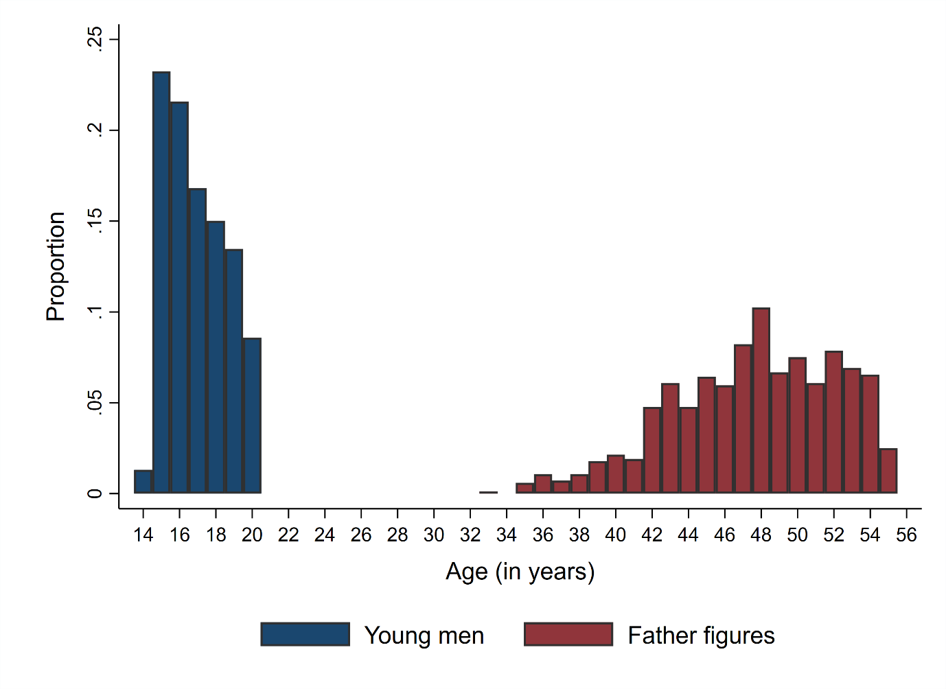
Note. Ten to Men data, Wave 1 (2013/2014).
Figure S2
Distribution of the CMNI Total Scores for Young Men and Father Figures in the Sample
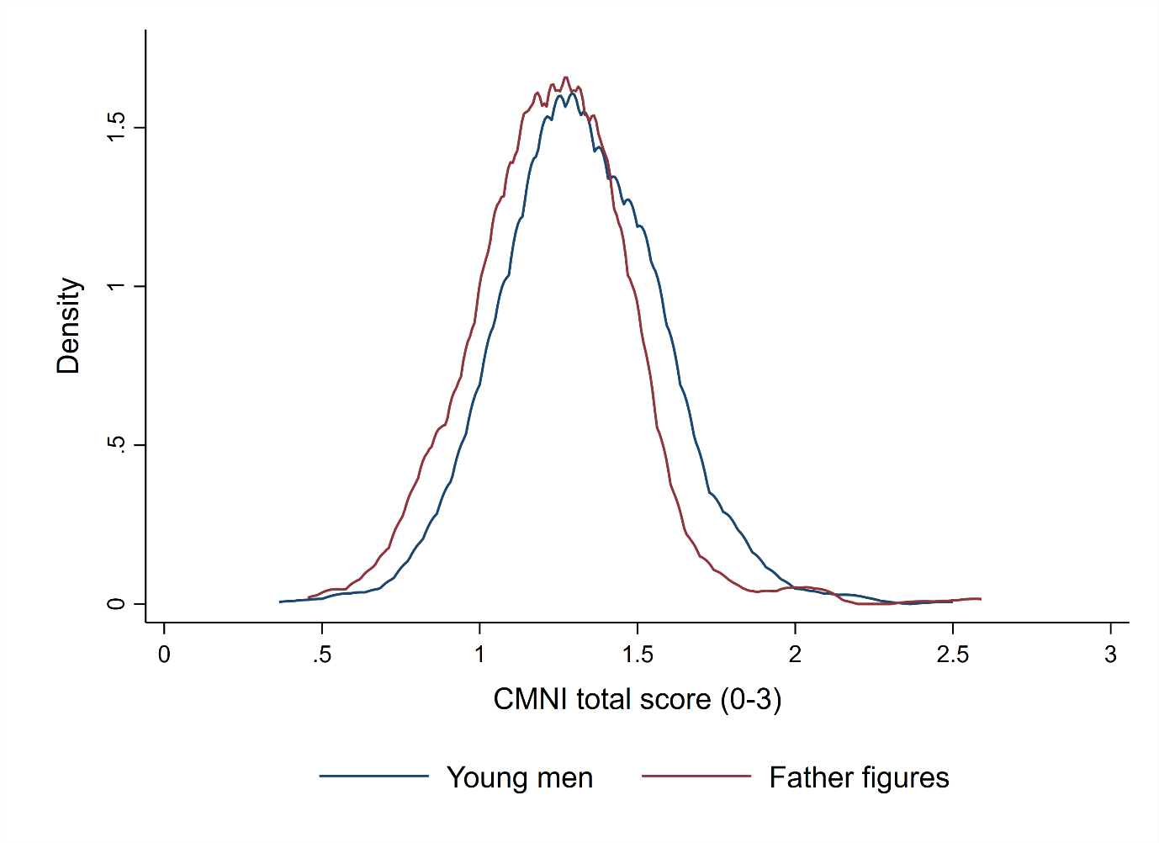
Note. Ten to Men data, Wave 1 (2013/2014). CMNI: Conformality to Masculine Norms Inventory.

Figure S3
Associations between CMNI-22 Items for Young Men (Y) and Father Figures (X)
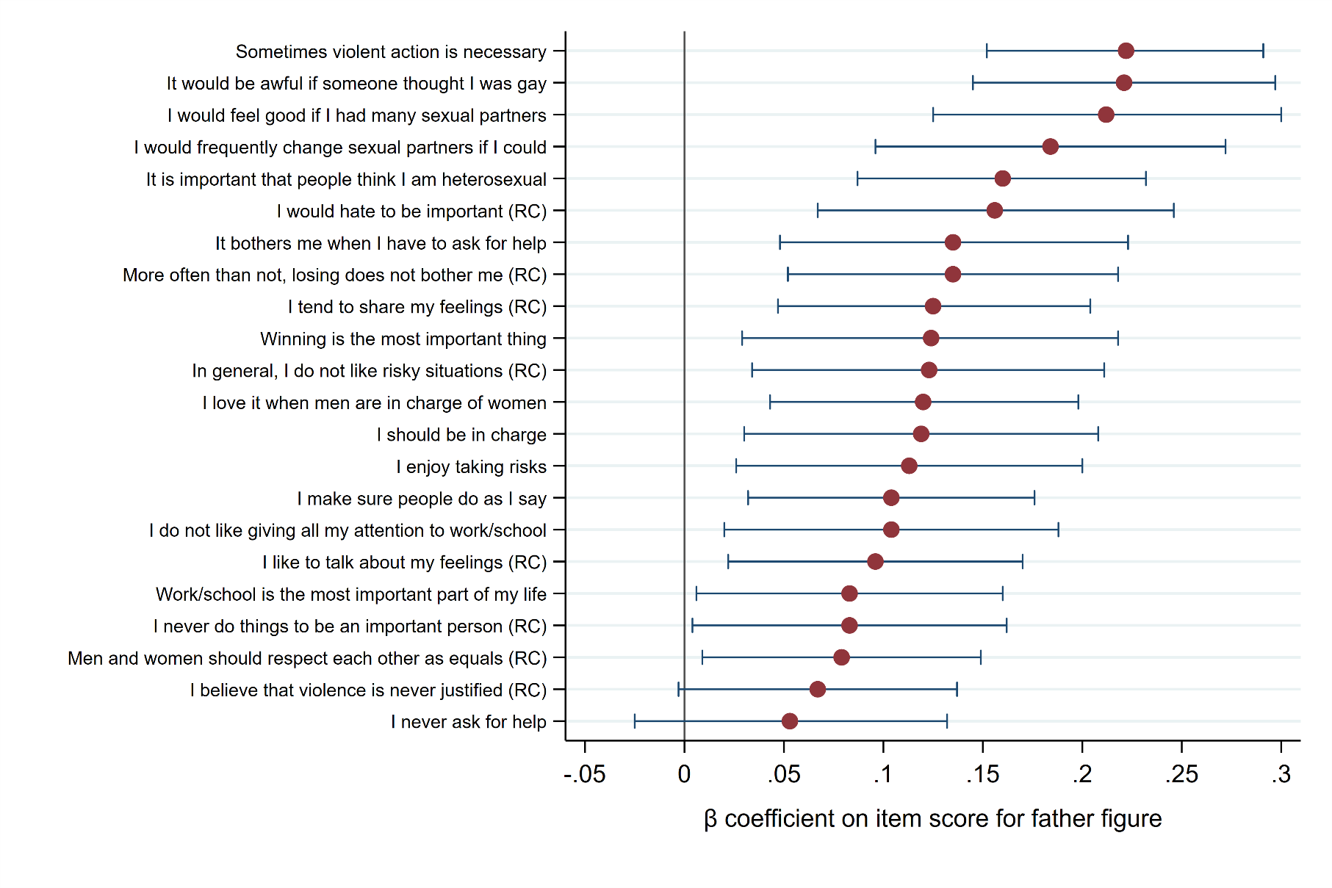
Note. Ten to Men data, Wave 1 (2013/2014). Whiskers represent 95% confidence intervals. Results from multivariable regression models controlling for the same covariates as Model 2 in Table 2.

