Online supplement for Golec, Agnieszka, & Keenan, O. (2023). National and gender collective narcissism and pursuit of gender equality. Sex Roles. Agnieszka Golec, Goldsmiths University of London. Email: Agnieszka.golec@gmail.com

SUPPLEMENTAL MATERIAL
Study 1—Validation Study
Measurement invariance for each predictor measure
Multiple group (i.e., for men and women) confirmatory factor analysis was carried for each measure of ingroup identification (gender collective narcissism, gender ingroup identification, national narcissism, national ingroup identification) in order to confirm the measurement invariance of each measure. Configural and metric models showed ΔCFI < .01, indicating metric invariance was confirmed for each measure.

Table S1
Measurement Invariance Analyses of Measures of Aspects of National and Gender Ingroup Identification, Study 1
Model | X² | Df | TLI | CFI | RMSEA | SRMR
 | Gender collective narcissism
Overall | 40.228 | 5 | 0.985 | 0.992 | 0.076 | 0.012
Male | 47.243 | 5 | 0.962 | 0.981 | 0.118 | 0.02
Female | 11.485 | 5 | 0.994 | 0.997 | 0.038 | 0.013
Configural | 58.728 | 10 | 0.976 | 0.988 | 0.086 | 0.017
Metric | 65.268 | 14 | 0.982 | 0.987 | 0.074 | 0.027
 | Gender ingroup satisfaction
Overall | 56.629 | 2 | 0.954 | 0.985 | 0.153 | 0.019
Male | 32.408 | 2 | 0.946 | 0.982 | 0.16 | 0.022
Female | 8.688 | 2 | 0.992 | 0.997 | 0.065 | 0.01
Configural | 41.096 | 4 | 0.972 | 0.991 | 0.12 | 0.016
Metric | 58.087 | 7 | 0.977 | 0.987 | 0.109 | 0.042
 | National collective narcissism
Overall | 16.092 | 5 | 0.997 | 0.999 | 0.033 | 0.007
Male | 19.329 | 5 | 0.994 | 0.997 | 0.052 | 0.011
Female | 2.29 | 5 | 1.005 | 1 | 0 | 0.004
Configural | 21.619 | 10 | 1 | 1 | 0.014 | 0.007
Metric | 27.852 | 14 | 0.999 | 0.999 | 0.022 | 0.021
 | National ingroup satisfaction
Overall | 0.983 | 2 | 1.003 | 1 | 0 | 0.001
Male | 7.365 | 2 | 0.998 | 0.999 | 0.041 | 0.005
Female | 1.312 | 2 | 1.003 | 1 | 0 | 0.003
Configural | 8.677 | 4 | 1 | 1 | 0 | 0.004
Metric | 16.05 | 7 | 0.999 | 0.999 | 0.031 | 0.024
Note. Robust fit indices are presented.

Study 2
Analyses without covariates
In the present main manuscript, we presented analyses that examined unique contributions of national narcissism, national ingroup satisfaction, gender collective narcissism and gender ingroup satisfaction. Here, we present analyses to test each hypothesis without covariates.
Gender collective narcissism and gender equality
In order to test H1, a multiple regression analysis was run on each collective action outcome entering gender collective narcissism, gender, and their interaction. Results are consistent with H1. There were significant interactions of gender collective narcissism by gender for each outcome (Table S2). Simple slopes analyses (Figure S1) revealed that among women, gender collective narcissism was positively associated with all collective action outcomes. Among men, gender collective narcissism was negatively associated with participation in the Women’s Strike and had null relationships with the other forms of collective action.
National narcissism and gender equality
In order to test H2 and to probe for interaction effects, multiple regression analyses were specified with national narcissism, gender, and their interaction as predictors (Table S3). Somewhat consistent with H2, national narcissism was significantly negatively associated with participation in the Women’s Strike and had null relationships with the other forms of collective action. There were no significant interaction effects.
Table S2
Multiple Regression Analysis of Gender Collective Narcissism with Each Outcome, Study 2
 | Support for APWS |  |  |  | Normative collective action |  |  |  | Non-normative collective action
Predictors | b(SE) | 95%CI LL,UL | P | β | b(SE) | 95%CI LL,UL | p | β | b(SE) | 95%CI LL,UL | p | β
Gender collective narcissism | -0.14  (0.06) | -0.26,-0.01 | 0.028 | -0.12  (0.06) | -0.11  (0.05) | -0.20,-0.01 | 0.023 | -0.12  (0.05) | 0.07  (0.05) | -0.03,0.18 | 0.184 | 0.07  (0.06)
Gender group (Women = 1) | -2.22  (0.36) | -2.92,-1.52 | <0.001 | 0.13  (0.07) | -2.28  (0.27) | -2.81,-1.75 | <0.001 | 0.13  (0.06) | -2.53  (0.30) | -3.13,-1.93 | <0.001 | -0.23  (0.07)
Gender collective narcissism X Group | 0.60  (0.08) | 0.43,0.76 | <0.001 | 0.55  (0.08) | 0.60  (0.06) | 0.48,0.73 | <0.001 | 0.67  (0.07) | 0.53  (0.07) | 0.39,0.67 | <0.001 | 0.54  (0.07)
Observations | 1075 |  |  |  | 1075 |  |  |  | 1075
R² / R² adjusted | 0.080 / 0.078 |  |  |  | 0.130 / 0.128 |  |  |  | 0.124 / 0.122

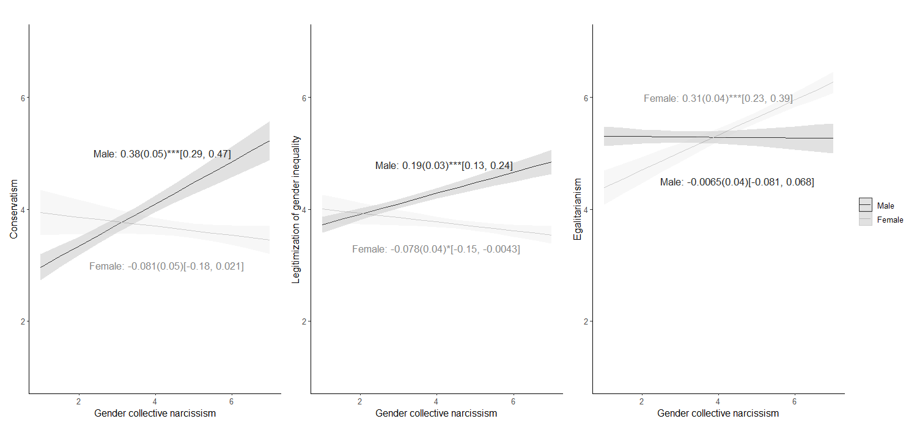
Figure S1
Simple Slopes Analysis of Gender Collective Narcissism with Each Outcome, Study 2, Note. *** p < .001, ** p < .01, * p < .05

Table S3
Multiple Regression Analysis of National Narcissism with Each Outcome, Study 2
 | Support for APWS |  |  |  | Normative collective action |  |  |  | Non-normative collective
Predictors | b(SE) | 95%CI  LL,UL | P | Β | b(SE) | 95%CI LL,UL | p | β | b(SE) | 95%CI  LL,UL | p | β
National narcissism | -0.38(0.05) | -0.48,-0.27 | <.001 | -.34 | -0.05(0.04) | -0.13,0.03 | .242 | -.06 | -0.07(0.05) | -0.17,0.03 | .186 | -.07
Gender group (Women = 1) | -0.13(0.29) | -0.70,0.45 | .662 | .26 | 0.12(0.25) | -0.37,0.61 | .628 | .32 | -0.27(0.31) | -0.87,0.33 | .374 | .11
National narcissism X Group | 0.14(0.07) | -0.00,0.28 | .052 | .13 | 0.07(0.06) | -0.04,0.18 | .220 | .09 | 0.11(0.07) | -0.03,0.25 | .130 | .11
Observations | 1075 |  |  |  | 1075 |  |  |  | 1075
R² / R² adjusted | 0.095 / 0.093 |  |  |  | 0.028 / 0.026 |  |  |  | 0.006 / 0.003

Gender asymmetry
In order to test H3, multiple regression analyses on national narcissism were run, entering gender collective narcissism, gender and their interaction as predictors. Results are in line with H3. There was a significant negative interaction by female gender group for the association between gender collective narcissism and national narcissism (Table S4). The findings were replicated in Study 2. Simple slopes (Figure S2) show that the association between gender and national collective narcissism is stronger among men.

Table S4
 | Study 1 |  |  |  | Study 2
Predictors | b(SE) | 95%CI LL,UL | p | Β | b(SE) | 95%CI LL,UL | p | β
Gender collective narcissism | 0.59(0.04) | 0.51,0.67 | <.001 | .60 | 0.59(0.04) | 0.50,0.67 | <.001 | .59
Gender group (Women = 1) | 0.10(0.33) | -0.54,0.74 | .755 | -.52 | 0.38(0.31) | -0.22,0.99 | .216 | -.46
Gender collective narcissism X Group | -0.22(0.07) | -0.36,-0.08 | .002 | -.23 | -0.28(0.07) | -0.41,-0.14 | <.001 | -.28
Observations | 1075 |  |  |  | 1084
R² / R² adjusted | 0.199 / 0.196 |  |  |  | 0.182 / 0.180
Multiple Regression Analysis of Gender Collective Narcissism Predicting National Narcissism among Men and Women in Studies 2 & 3
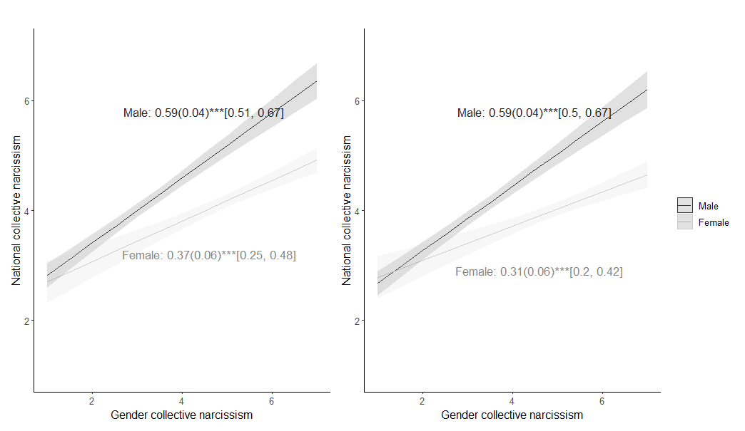
Figure S2
Multiple Regression Analysis of Gender Collective Narcissism Predicting National Narcissism among Men and Women, Study 2 & 3
Note. *** p < .001, ** p < .01, * p < .05. Left panel: Study 1, Right panel: Study 2
Gender asymmetry – alternative analyses
We used an alternative approach to test and specify H3 including national ingroup satisfaction as an outcome. We performed a path analysis using the lavaan package (version 0.6-9; Roessel, et al., 2021). To account for heteroscedasticity, we used robust maximum likelihood estimation (MLR) with Huber-White robust standard errors. To assess the unique associations between the predictors and the outcomes, we used a just-identified multigroup model where all associations were specified. The paths were unconstrained allowing for estimation of regression coefficients for each group. The path coefficients were tested for equivalence between men and women in order to probe interactions by gender group.
As can be seen in Figure S3, the findings are in line with H3. The association between gender collective narcissism and national narcissism was significantly stronger among men than among women (Path A: Study 1: χ²(1) = 11.6, p = .001, Study 2: χ² (1) = 14.2, p < .001). There was no difference between groups for the associations between gender ingroup satisfaction and national ingroup satisfaction (Path B) or national narcissism (Path C). There were significant interactions for the relationships between gender collective narcissism and national ingroup satisfaction (Path D: Study 1: χ²(1) = 8.18, p = .004, Study 2: χ² (1) = 4.25, p < .039), with women showing null relationships and men showing weakly positive relationships.
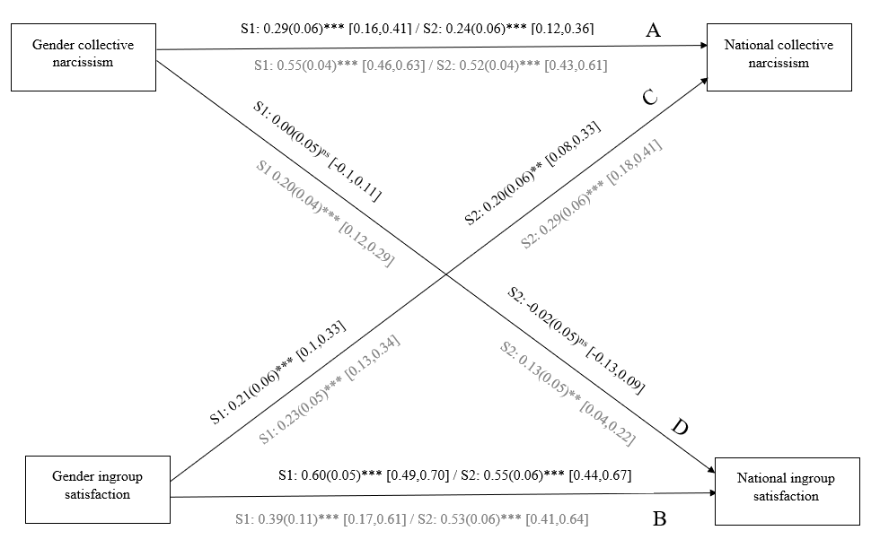
Figure S3
Path Analysis of Gender Asymmetry in Collective Narcissism in Studies 2 & 3

Study 3
Analyses without covariates
Following the same procedure as Study 2, we tested H1 and H2 without covariates.
Gender collective narcissism and gender equality
Results are consistent with H1. There were significant interactions of gender collective narcissism by gender for each outcome (Table S5). Simple slopes analyses (Figure S4) revealed the among women, gender collective narcissism had a null relationship with political conservatism, a negative relationship with legitimization of gender equality and was positively associated egalitarianism. Among men, gender collective narcissism was positively associated with political conservatism and legitimization of gender equality, and had a null relationship with egalitarianism.
National narcissism and gender equality
Largely consistent with H2 (Table S6), national narcissism was significantly positively associated with political conservatism and legitimization of gender equality, and showed a small positive association egalitarianism. There were no significant interaction effects.
Table S5
Multiple Regression Analysis of Gender Collective Narcissism with Each Outcome, Study 3
 | Political conservatism |  |  |  | Legitimization of gender equality |  |  |  | Egalitarianism
Predictors | b(SE) | 95%CI  LL,UL | p | β | b(SE) | 95%CI LL,UL | p | β | b(SE) | 95%CI  LL,UL | p | β
Gender collective narcissism | 0.28(0.03) | 0.22,0.33 | <.001 | .44 | 0.19(0.03) | 0.13,0.24 | <.001 | .30 | 0.02(0.03) | -0.05,0.08 | .610 | .03
Gender group (Women = 1) | 1.25(0.21) | 0.84,1.66 | <.001 | -.47 | 0.55(0.21) | 0.13,0.96 | .010 | -.52 | -0.91(0.22) | -1.34,-0.48 | <.001 | .07
Gender collective narcissism X Group | -0.43(0.04) | -0.51,-0.34 | <.001 | -.68 | -0.27(0.05) | -0.36,-0.17 | <.001 | -.43 | 0.24(0.05) | 0.15,0.34 | <.001 | .37
Observations | 1084 |  |  |  | 1084 |  |  |  | 1084
R² / R² adjusted | 0.135 / 0.132 |  |  |  | 0.090 / 0.088 |  |  |  | 0.069 / 0.066

Figure S4
Simple Slopes Analysis of Gender Collective Narcissism with Each Outcome, Study 3, Note. *** p < .001, ** p < .01, * p < .05

Table 6S
Multiple Regression Analysis of National Narcissism with Each Outcome, Study 3
Political conservatism |  |  |  |  | Legitimization of gender equality |  |  |  |  |  |  | Egalitarianism
Predictors | b(SE) | 95%CI LL,UL | P | β |  | b(SE) |  | 95%CI LL,UL | p | β | b(SE) |  | 95%CI LL,UL |  | p | β
National narcissism | 0.46(0.03) | 0.40,0.51 | <.001 | .65 |  | 0.27(0.02) |  | 0.22,0.31 | <.001 | .43 | 0.10(0.04) |  | 0.03,0.17 |  | .006 | .13
Gender group (Women = 1) | -0.15(0.15) | -0.44,0.15 | .336 | -.29 |  | -0.69(0.15) |  | -0.99,-0.39 | <.001 | -.42 | 0.49(0.22) |  | 0.07,0.91 |  | .023 | .24
National collective narcissism X Group | -0.05(0.04) | -0.12,0.03 | .212 | -.07 |  | 0.07(0.04) |  | -0.00,0.14 | .068 | .11 | -0.05(0.05) |  | -0.14,0.04 |  | .288 | -.07
Observations | 1084 |  |  |  |  |  | 1084 |  |  |  |  |  |  | 1084
R² / R² adjusted | 0.403 / 0.401 |  |  |  |  |  | 0.279 / 0.277 |  |  |  |  |  |  | 0.025 / 0.022

