Online supplement for Kretschmer, D. (2024). The gendered influence of cross-gender friends on the development of adolescents’ gender role attitudes. Sex Roles. David Kretschmer, University of Oxford Nuffield College. Email: david.kretschmer@nuffield.ox.ac.uk

Supplement A: Selectivity of the analysis sample
The SAOM analysis relies on an analytical sample of 3,194 students in 149 classrooms instead of the full CILS4EU sample of 5,013 students nested in 271 classrooms. Classrooms were excluded from the analysis sample for two reasons:

- Lack of longitudinal network data: Network data was unavailable for some classrooms in the second wave of the CILS4EU survey. This mainly applied to classrooms in lower secondary schools. In many cases, lower secondary schooling ended after grade 9, and the second wave of the CILS4EU survey was conducted when students attended grade 10. In total, 71 classrooms were excluded from the analysis sample due to a lack of network data in the second wave.
- Low levels of student response: To obtain accurate estimates, network analysis requires a sufficiently large participation rate at the student level. Therefore, I excluded all 51 classrooms with a student non-response of more than 50% in at least one of the waves.

Figure A1 shows that, unsurprisingly, these exclusion criteria resulted in a sample that is selective with respect to students’ school types. Lower secondary schools are underrepresented in the analytical sample compared to the full sample.

Despite this selectivity, Figure A2 shows that in terms of basic demographics, classrooms in the full CILS4EU sample and the analysis sample hardly differ. The only notable difference concerns classroom size, as the total number of students in classrooms in the analysis sample is slightly higher than in the full sample. However, when assessing demographics separately by school type in Figure A3 to account for the underrepresentation of lower secondary schools, these minor differences disappear as well.

Turning to the key individual characteristics of substantive interest in this study, Figure A4 shows that, among both boys and girls, average levels of egalitarian gender role attitudes are virtually indistinguishable between the full CILS4EU sample and the analysis sample. Figure A5 further shows that, among boys, the proportion of cross-gender friends is also very similar in both the full CILS4EU sample and the analysis sample (11.6 vs. 12.3 percent). There is more variation between samples in the proportion of girls’ cross-gender friends. In the full sample, 13.5 percent of girls’ friends are cross-gender, while the proportion is 12.0 percent in the analysis sample.

Reassuringly, however, Figure A6 shows that the link between cross-gender friendships and gender role attitudes, which is this study’s greatest substantive interest, is very similar in the full and the analysis sample. In both samples, estimates from a bivariate linear regression model show that girls’ gender role attitudes are independent of the proportion of cross-gender friends. In contrast, boys with a higher proportion of cross-gender friends hold more egalitarian gender role attitudes in both samples. (Qualitative results are very similar when only differentiating between adolescents who have no vs. any cross-gender friends rather than along the full range of the proportion of cross-gender friendships.) Given these findings, there is little indication that sample selectivity issues threaten this study's conclusions.

Figure S1
Distribution of Classrooms Across School Types in the Full CILS4EU and the Analysis Sample
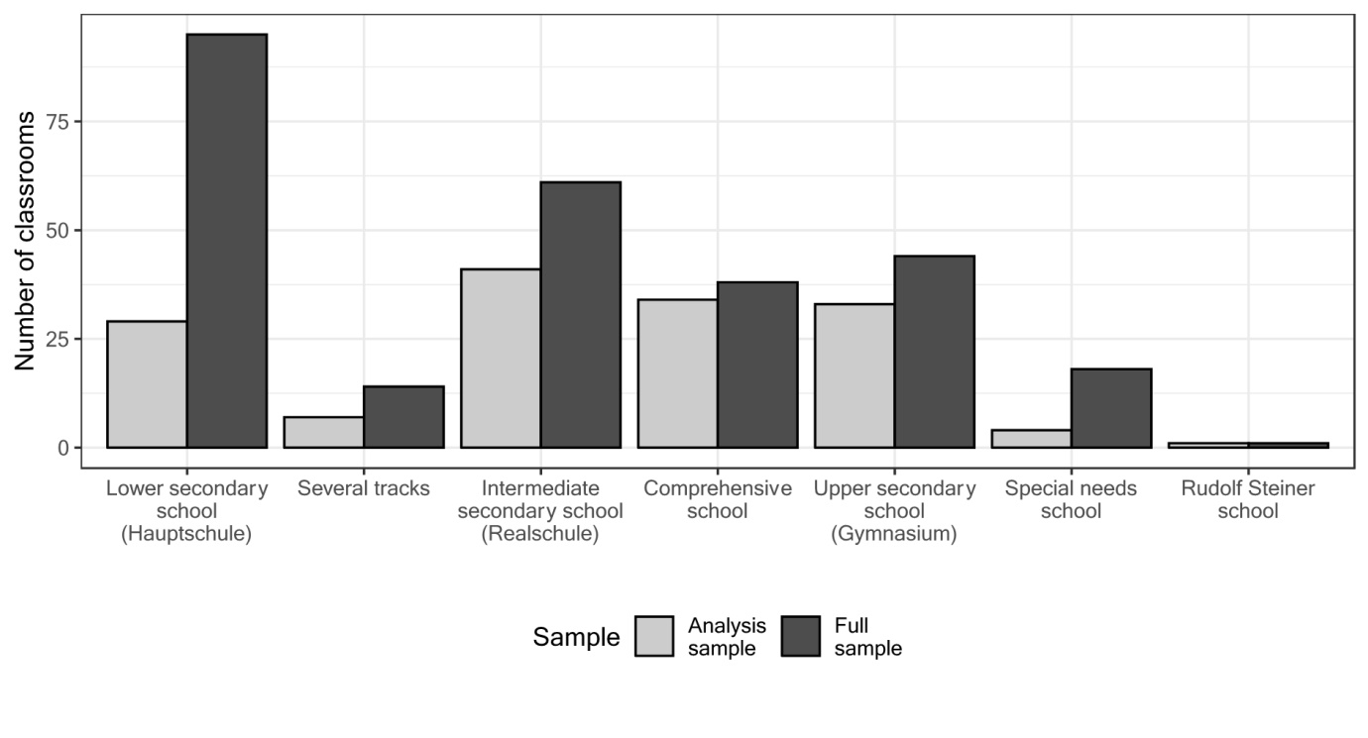

Figure S2
Distribution of Demographics in the Full CILS4EU and the Analysis Sample Classrooms
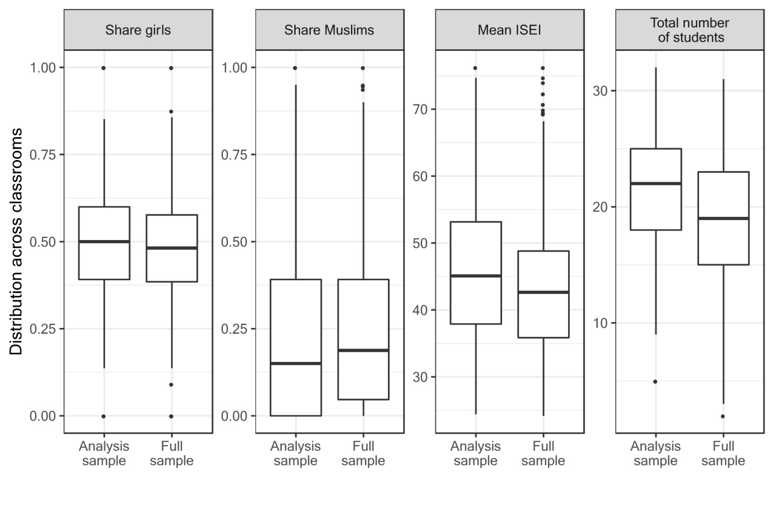

Figure S3
Distribution of Demographics in the Full CILS4EU and the Analysis Sample Classrooms by School Type

Figure S4
Mean Number of Egalitarian Gender Role Attitudes in the Full CILS4EU and the Analysis Sample
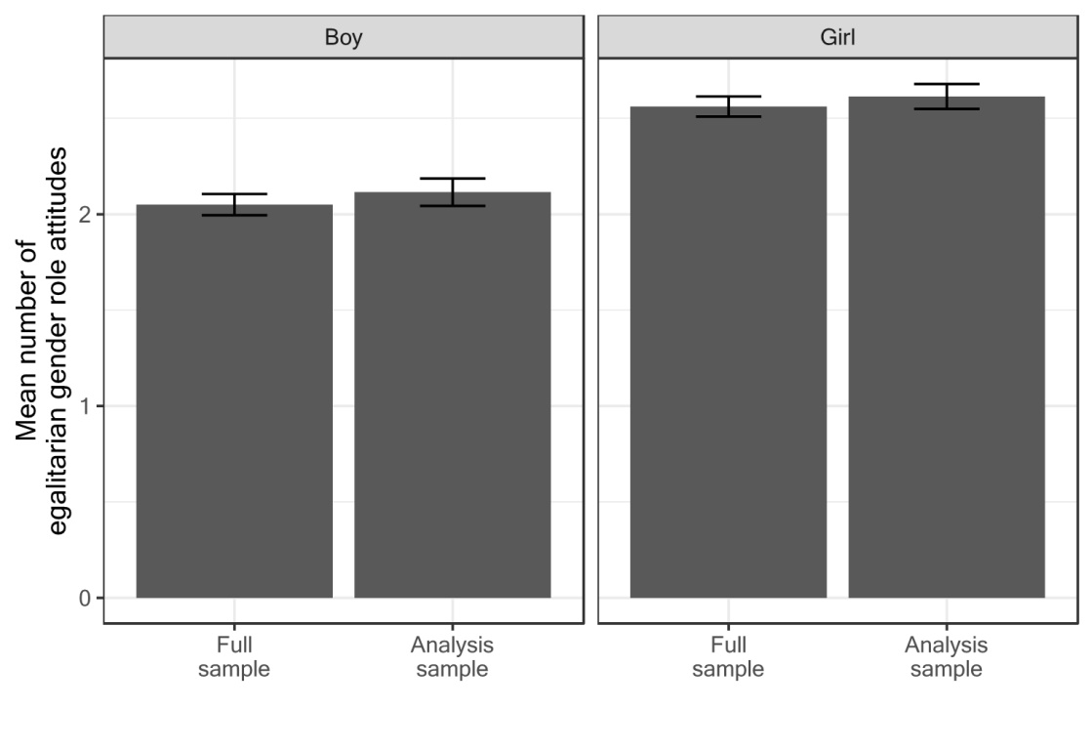

Figure S5
Mean Proportion of Cross-Gender Friends in the Full CILS4EU and the Analysis Sample
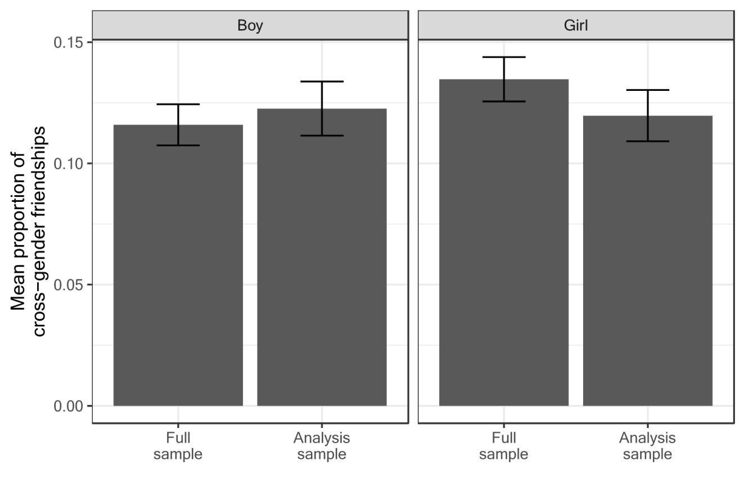

Figure S6
Link Between the Proportion of Cross-Gender Friends and Gender Role Attitudes in the Full CILS4EU and the Analysis Sample
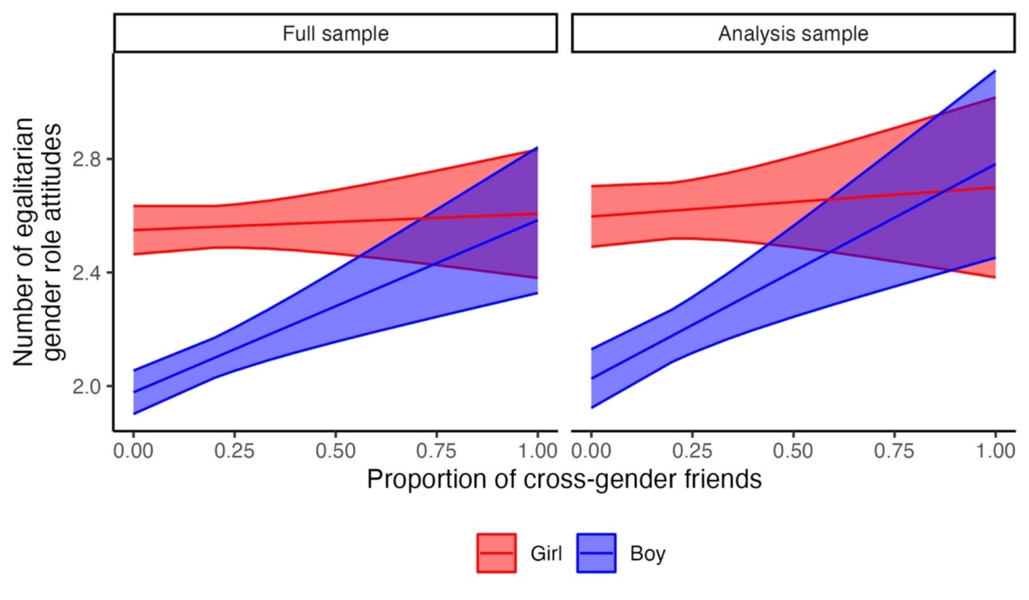

Supplement B: Details on random-coefficients multilevel SAOMs
This supplement provides more detailed information on the Bayesian random-coefficients multilevel SAOMs used in the main analysis (Koskinen & Snijders, 2023; Ripley et al., 2023). I discuss all the effects included in the SAOM analysis and formally derive how the gender-related effects in the model’s friendship component capture the selection of same- and cross-gender friends (section B1), introduce the specification of priors for the Bayesian analysis (section B2), and discuss convergence diagnostics (section B3).

B1: Control effects included in the SAOM analysis

Evolution of gender role attitudes
The study’s main substantive interest is in how cross-gender friends influence adolescents’ gender role attitudes. To capture this, I include an avXalt effect that captures how gender role attitudes evolve depending on the proportion of cross-gender friends. To capture differences in cross-gender friends’ influence between boys and girls, I include an interaction of the avXalt effect with gender, separately for boys and girls (rather than the avXalt main effect). Results from this model are identical to a model that includes the avXalt main effect and an interaction effect for only one category of the gender variable. I use the same strategy to model the influence effect of having any vs. no cross-gender friends (using the maxXalt effect, see Table C2 for results).

However, to accurately model the development of gender role attitudes, I do not only account for the influence of cross-gender friends but also a series of control effects. First, I include the linear and quadratic shape effects, which jointly model general trends in the development of gender role attitudes. Positive estimates of the linear shape effect indicate that gender role attitudes tend to become more egalitarian over time. Positive estimates of the quadratic shape effect indicate a tendency towards polarization, with both highly egalitarian and traditional attitudes becoming more prevalent. Second, I include so-called from covariate effects, which capture how various covariates relate to the development of gender role attitudes. I include a from girl effect that captures whether girls or boys develop more egalitarian attitudes, a from Muslim effect that investigates whether Muslims or non-Muslims develop more egalitarian attitudes, and both a from praying frequency and a from socioeconomic background (ISEI) effect, which capture how gender role attitudes develop based on adolescents’ religiosity and socioeconomic status.

Evolution of friendship networks
In this study, the primary rationale for modeling the evolution of not only gender role attitudes but also friendship networks is the necessity to capture the selection of cross-gender friends based on gender role attitudes to ensure influence effects are accurately identified. To account for this selection, the model’s friendship network component includes three effects that jointly capture boys’ and girls’ tendency to select same- and cross-gender friends, as well as their interaction with gender role attitudes. The three effects modeling the general tendency to select same- vs. cross-gender friends are the Girl ego, Girl alter, and Girl ego x Girl alter effect, with corresponding coefficients $β_{Girl ego},β_{Girl alter}$ and $β_{Girl ego x Girl alter}$. A positive parameter value $β_{Girl ego}$ for the Girl ego effect indicates that girls nominated more friends than boys. A positive parameter $β_{Girl alter}$ for the Girl alter effect indicates that students more frequently selected girls as friends than boys. Finally, a positive parameter $β_{Girl ego x Girl alter}$ on the interaction Girl ego x Girl alter indicates that girls more frequently nominated girls as friends than boys did.
Accordingly, for girls, the tendency to be friends with girls (Girl ego = Girl alter = 1) is captured by the sum
$$β_{Girl ego}+ β_{Girl alter} + β_{Girl ego x Girl alter.}$$
In contrast, girls’ tendency to be friends with boys (Girl ego = 1, Girl alter = 0) is captured by $β_{Girl ego}$, and therefore, the tendency to select same- rather than cross-gender friends is the difference of both expressions:
$$β_{Girl alter} + β_{Girl ego x Girl alter.}$$
For boys (Girl ego = 0), the tendency to be friends with boys (Girl alter = 0) is 0. Boys’ tendency to be friends with girls (Girl alter = 1) is $β_{Girl alter}$. Accordingly, boys’ tendency to have same- rather than cross-gender peers is ${0-β}_{Girl alter}={-β}_{Girl alter}$.
Therefore, the Girl ego, Girl alter, and Girl ego x Girl alter effect jointly capture both boys’ and girls’ tendency to make same- and cross-gender friends. To account for the selection of same- and cross-gender friends based on gender role attitudes, I interact all three effects with the Gender role attitudes ego effect (and also include the Gender role attitudes ego main effect).
To accurately capture the evolution of friendship networks beyond the selection of same- and cross-gender friends, I also account for various other friendship-making processes. On the one hand, this includes selection processes on a variety of covariates that can also be related to adolescents’ gender role attitudes:

- religion: Like the selection of same- and cross-gender friends, I capture the tendency of Muslim and non-Muslim youth to make friends with peers from the same religious group with the Muslim ego, Muslim alter, and Muslim ego x Muslim alter effect
- religiosity: I capture friendship-making with peers of different levels of religiosity with the religiosity ego, religiosity alter, and religiosity similarity effect, the latter of which accounts for the tendency to befriend others with similar levels of religiosity
- ethnic background: With the same ethnic background effect, I capture adolescents’ tendency to be friends with peers from the same country of origin more than with those from other countries of origin
- socioeconomic background (ISEI): I capture variation in friendship-making by socioeconomic status by including the ISEI ego, ISEI alter, and ISEI similarity effect.

On the other hand, the development of friendship networks also depends on structural network effects, i.e., friendship-making processes that result from the structural characteristics of social networks. Following guidelines on the modeling of social networks (Ripley et al., 2023), I include the following structural network effects:

- the outdegree effect, which captures network density, i.e., the frequency of friendships relative to network size
- the reciprocity effect, which captures the fact that friendships tend to be reciprocated, as reflected by a positive coefficient associated with the parameter
- the transitive triplets effects, which captures the tendency to be friends with one’s friends’ friends, as reflected by a positive coefficient associated with the parameter
- the transitive reciprocated triplets effects, which captures that the tendency towards transitive closure modeled by the transitive triplets effect tends to be weaker in reciprocated relationships, as reflected by a negative coefficient associated with the parameter
- the outdegree-activity, indegree-popularity, and indegree-activity effect, which jointly capture dispersion in the number of friendships sent and received as well as the correlation between friendships sent and received.

B2: Specifying priors for the Bayesian analysis
In Bayesian random-coefficients multilevel SAOMs, priors are not explicitly specified for fixed parameters, i.e., parameters assumed to be constant across networks. By default, SAOMs rely on flat improper priors for these parameters. At the same time, these priors are also hardly relevant for posterior estimates because fixed parameters are estimated across all networks. Hence, the substantial amount of data feeding into the estimates trumps prior information.

Other than for fixed parameters, priors need to be explicitly specified for random parameters, i.e., those parameters that are allowed to vary across networks. In the RSiena software, normally distributed priors are implemented for random parameters, and the researcher must specify the means and variances of these priors. In specifying these priors, I follow the suggestions provided by the developers (Koskinen & Snijders, 2023; Ripley et al., 2023) to use prior means of 0 and prior variances of .01 (standard deviations of .1) in the absence of specific information on the expected sign and size of the parameters. Prior means of 0 mean that estimates are not a priori skewed in either direction, and standard deviations of .1 reflect realistic amounts of variation in estimates across networks, according to previous research (Ripley et al., 2023).

I deviate from this general guideline for the outdegree and the reciprocity parameters, in line with suggestions by the developers (Ripley et al. 2023). I specify a prior mean of 1.5 for the reciprocity parameter because of the strong reciprocity effects frequently observed in the literature (Snijders et al., 2010). For the outdegree parameter, I specify a prior mean of -1 and a prior variance of .1 (rather than .01) because the outdegree effect is known to vary more widely between networks and is usually negative in friendship networks. However, given the large number of networks included in our analysis, the impact of the specified priors is expected to be small even for the random effects (Raabe et al., 2019; Ripley et al., 2023).

B3: Assessing convergence
Bayesian multilevel SAOMs are based on an iterative estimation process using Markov chain Monte Carlo methods. I assessed the convergence of this estimation process in two ways. First, I used trace plots to graphically inspect the evolution of parameter estimates along the Markov chain to ensure that parameter estimates converge towards stable values. Second, I estimated all models repeatedly (at least six times) with independent starting points and then assessed convergence by investigating whether the results were similar across the different Markov chains. To determine this, I relied on two measures (Ripley et al., 2023):

- $\hat{R}$, which indicates the potential scale reduction of the posterior distribution if simulations were continued indefinitely
- the effective sample size $n_{eff}$, the estimated equivalent sample size under independent sampling.

For all models and all parameters, the trace lines indicate good convergence, as do values of $\hat{R}<1.1$ and of $n_{eff}>5 × n_{chains}$ (Gelman et al., 2014). All these analyses thus suggest that the reported models are well-converged.

Supplement C: Results from the SAOM analysis
Table S1
Full results of SAOM analysis
Gender role attitudes component:
Effects on the development of gender role attitudes
 |  |  | 95% CI
 | Posterior  mean | Posterior  SD | lower | upper
Influence of cross-gender friends
Effect from boy x Proportion cross-gender friends | 0.709** | 0.214 | 0.311 | 1.153 | FE
Effect from girl x Proportion cross-gender friends | 0.072 | 0.220 | -0.358 | 0.516 | FE
Control effects on the development
of gender role attitudes
Linear shape | 0.282** | 0.100 | 0.080 | 0.475 | RE
Quadratic shape | -0.023 | 0.018 | -0.059 | 0.013 | RE
Effect from Muslim (Ref.: non-Muslim) | -0.151+ | 0.088 | -0.327 | 0.021 | RE
Effect from girl (Ref.: boy) | 0.541*** | 0.070 | 0.404 | 0.682 | FE
Effect from praying frequency | -0.046+ | 0.024 | -0.092 | 0.002 | RE
Effect from socioeconomic background (ISEI) | 0.032+ | 0.019 | -0.004 | 0.069 | RE
Friendship network component
Effects on the development of friendship networks
 |  |  | 95% CI
 | Posterior  mean | Posterior  SD | lower | upper
Selection of cross-gender friends
based on gender role attitudes
Girl alter (Ref.: boy) | -0.257*** | 0.037 | -0.330 | -0.185 | FE
Girl ego (Ref.: boy) | -0.491*** | 0.041 | -0.572 | -0.408 | FE
Girl ego x Girl alter | 0.717*** | 0.052 | 0.615 | 0.816 | FE
Gender role attitudes ego | 0.007 | 0.017 | -0.025 | 0.040 | FE
Gender role attitudes ego x Girl ego | 0.034 | 0.037 | -0.038 | 0.106 | FE
Gender role attitudes ego x Girl alter | 0.005 | 0.032 | -0.055 | 0.068 | FE
Gender role attitudes ego x Girl ego x Girl alter | -0.038 | 0.048 | -0.134 | 0.056 | FE
Structural network control effects
Outdegree | 0.668*** | 0.174 | 0.336 | 1.019 | RE
Reciprocity | 1.743*** | 0.050 | 1.647 | 1.844 | RE
Transitive triplets | 0.524*** | 0.017 | 0.490 | 0.559 | RE
Transitive reciprocated triplets | -0.208*** | 0.024 | -0.256 | -0.161 | RE
Indegree-popularity (sqrt) | 0.081* | 0.039 | 0.004 | 0.158 | RE
Indegree-activity (sqrt) | -0.257*** | 0.045 | -0.341 | -0.165 | RE
Outdegree-activity (sqrt) | -0.884*** | 0.057 | -1.004 | -0.778 | RE
Covariate control effects
Muslim alter (Ref.: non-Muslim) | -0.202*** | 0.055 | -0.308 | -0.091 | RE
Muslim ego (Ref.: non-Muslim) | -0.127+ | 0.064 | -0.259 | -0.002 | RE
Muslim ego x Muslim alter | 0.473*** | 0.090 | 0.291 | 0.645 | RE
Same ethnic background | 0.065* | 0.033 | 0.001 | 0.129 | RE
Praying frequency ego | 0.002 | 0.013 | -0.024 | 0.028 | RE
Praying frequency alter | 0.012 | 0.013 | -0.013 | 0.037 | RE
Praying frequency similarity | 0.057 | 0.055 | -0.049 | 0.167 | RE
Socioeconomic background (ISEI) alter | 0.006 | 0.010 | -0.014 | 0.027 | RE
Socioeconomic background (ISEI) ego | -0.013 | 0.011 | -0.035 | 0.008 | RE
Socioeconomic background (ISEI) similarity | -0.034 | 0.072 | -0.174 | 0.114 | RE
Note. +p < .10, *p < .05, **p < .01, ***p < .001. SD: standard deviation; FE: fixed effect, RE: random effect.

Table S2
Full results of SAOM analysis for any cross-gender friends
Gender role attitudes component:
Effects on the development of gender role attitudes
 |  |  | 95% CI
 | Posterior  mean | Posterior  SD | lower | upper
Influence of cross-gender friends
Effect from boy x Any cross-gender friends | 0.322** | 0.121 | 0.084 | 0.552 | FE
Effect from girl x Any cross-gender friends | 0.031 | 0.129 | -0.215 | 0.292 | FE
Control effects on the development
of gender role attitudes
Linear shape | 0.274** | 0.107 | 0.071 | 0.487 | RE
Quadratic shape | -0.024 | 0.019 | -0.061 | 0.012 | RE
Effect from Muslim (Ref.: non-Muslim) | -0.146 | 0.090 | -0.319 | 0.038 | RE
Effect from girl (Ref.: boy) | 0.554*** | 0.086 | 0.385 | 0.721 | FE
Effect from praying frequency | -0.045* | 0.023 | -0.091 | -0.0003 | RE
Effect from socioeconomic background (ISEI) | 0.032+ | 0.019 | -0.005 | 0.070 | RE
Friendship network component
Effects on the development of friendship networks
 |  |  | 95% CI
 | Posterior  mean | Posterior  SD | lower | upper
Selection of cross-gender friends
based on gender role attitudes
Girl alter (Ref.: Boy) | -0.257*** | 0.037 | -0.329 | -0.185 | FE
Girl ego (Ref.: Boy) | -0.492*** | 0.041 | -0.573 | -0.412 | FE
Girl ego x Girl alter | 0.717*** | 0.052 | 0.615 | 0.820 | FE
Gender role attitudes ego | 0.002 | 0.017 | -0.030 | 0.034 | FE
Gender role attitudes ego x Girl ego | 0.041 | 0.038 | -0.033 | 0.115 | FE
Gender role attitudes ego x Girl alter | 0.011 | 0.031 | -0.051 | 0.071 | FE
Gender role attitudes ego x Girl ego x Girl alter | -0.045 | 0.048 | -0.139 | 0.050 | FE
Structural network control effects
Outdegree | 0.680*** | 0.165 | 0.359 | 1.004 | RE
Reciprocity | 1.739*** | 0.051 | 1.639 | 1.839 | RE
Transitive triplets | 0.525*** | 0.017 | 0.491 | 0.559 | RE
Transitive reciprocated triplets | -0.208*** | 0.024 | -0.256 | -0.160 | RE
Indegree-popularity (sqrt) | 0.082* | 0.039 | 0.005 | 0.157 | RE
Indegree-activity (sqrt) | -0.253*** | 0.046 | -0.344 | -0.161 | RE
Outdegree-activity (sqrt) | -0.891*** | 0.056 | -1.003 | -0.786 | RE
Covariate control effects
Muslim alter (Ref.: non-Muslim) | -0.210*** | 0.057 | -0.319 | -0.098 | RE
Muslim ego (Ref.: non-Muslim) | -0.124+ | 0.065 | -0.253 | 0.001 | RE
Muslim ego x Muslim alter | 0.483*** | 0.091 | 0.301 | 0.662 | RE
Same ethnic background | 0.064+ | 0.032 | 0.000 | 0.129 | RE
Praying frequency ego | 0.002 | 0.013 | -0.024 | 0.028 | RE
Praying frequency alter | 0.012 | 0.013 | -0.013 | 0.037 | RE
Praying frequency similarity | 0.058 | 0.054 | -0.050 | 0.165 | RE
Socioeconomic background (ISEI) alter | 0.007 | 0.010 | -0.014 | 0.027 | RE
Socioeconomic background (ISEI) ego | -0.013 | 0.011 | -0.035 | 0.009 | RE
Socioeconomic background (ISEI) similarity | -0.030 | 0.070 | -0.166 | 0.107 | RE

Note. +p < .10, *p < .05, **p < .01, ***p < .001. SD: standard deviation; FE: fixed effect, RE: random effect.

Figure S7
Selection and Influence Estimates From SAOM for Any vs. No Cross-Gender Friends
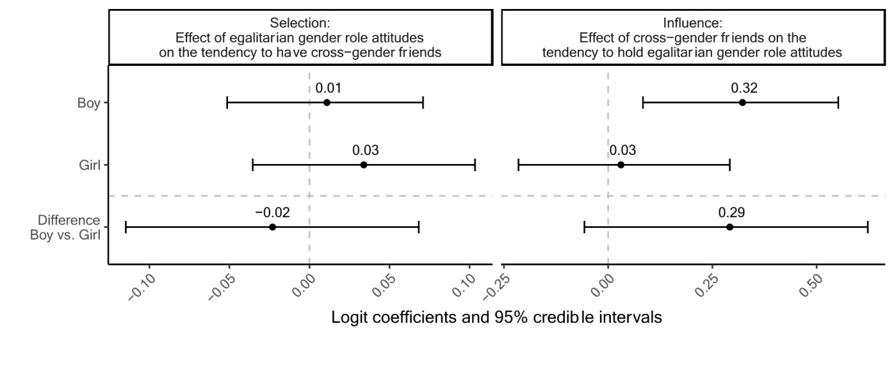

References (Online Supplement)
Gelman, A., Carlin, J. B., Stern, H. S., & Rubin, D. B. (2014). Bayesian Data Analysis. Chapman & Hall/CRC.
Koskinen, J., & Snijders, T. A. B. (2023). Multilevel longitudinal analysis of social networks. Journal of the Royal Statistical Society Series A: Statistics in Society, 186(3), 376–400. https://doi.org/10.1093/jrsssa/qnac009
Raabe, I. J., Boda, Z., & Stadtfeld, C. (2019). The social pipeline: How friend influence and peer exposure widen the STEM gender gap. Sociology of Education, 92(2), 105–123. https://doi.org/10.1177/0038040718824095
Ripley, R. M., Snijders, T. A., Boda, Z., Vörös, A., & Preciado, P. (2023). Manual for RSiena. University of Oxford, Department of Statistics, Nuffield College. https://www.stats.ox.ac.uk/~snijders/siena/RSiena_Manual.pdf
Snijders, T. A. B., van de Bunt, G. G., & Steglich, C. E. G. (2010). Introduction to stochastic actor-based models for network dynamics. Social Networks, 32(1), 44–60. https://doi.org/10.1016/j.socnet.2009.02.004

