Online supplement for Hofer, G., Hünninghaus, M., Platzer, J., Grinschgi, S., & Neubauer, A.C. (2025). Women’s humility and men’s lack of hubris: Gender biases in self-estimated spatial intelligence. Sex Roles. Gabriela Hofer, University of Graz. Email: gabriela.hofer@uni-graz.at;gabriela.hofer.uni@gmail.com

This supplement contains details on the sample composition, the performance tests for spatial intelligence, and the full German versions of all self-estimate measures we presented to participants.

Supplement A

Sample composition (section 2.1. in the paper)
For contextualization, we aimed to determine what percentage of our participants were enrolled in a STEM-related college major and how these numbers differed for women and men. However, identifying a field as clearly STEM-related or clearly unrelated is oftentimes not possible and classifications often depend on the study registry one uses and the specifics of the given major at the university it is taught (e.g., at the university this study took place, psychology is part of the faculty for natural sciences). Therefore, we followed the approach of Goldman and Hewitt (1976) and Kelly and Beltz (2022)and rated the “STEM-ness” of each participants’ named field of study on a scale from 1 (Arts) to 5 (Physical Science; for more details see Goldman & Hewitt). Specifically, we used a large-language tool (Google’s NotebookLM, based on Gemini 1.5) for a first version of these ratings, which were then checked by a human rater (the first author), who then clarified any inconsistencies based on additional research (e.g., checking the local curricula) and further prompting.

Table S1 shows an overview of all reported study fields and their STEM-ness ratings. For more details on the prompting, see https://osf.io/5atxd?view_only=13cad163773e4a8386f84de6ef49df4c.

Table S1
Study fields per gender.
Study field | M | W | Sum | STEM-ness | Reasoning
Art history | 0 | 1 | 1 | 1 | Fine arts as per table 1.
Graphic and communication design | 0 | 1 | 1 | 1 | Fine arts as per table 1.
Musicology | 0 | 1 | 1 | 1 | Fine arts as per table 1.
Business law for technical professions | 1 | 0 | 1 | 2 | Humanities. Law is closely related to history, a humanity as per table 1.
English and American studies | 1 | 1 | 2 | 2 | Humanities as per table 1.
European ethnology | 0 | 1 | 1 | 2 | Humanitiesas it aligns with historical and cultural studies.
European ethnology & law | 0 | 1 | 1 | 2 | Humanities. Law and ethnology both align with historical and cultural studies.
European studies | 0 | 1 | 1 | 2 | Humanities. Encompasses history, culture, and languages.
History | 0 | 1 | 1 | 2 | Humanities as per table 1.
Law | 5 | 4 | 9 | 2 | Humanities. Law is closely related to history, a humanity as per table 1.
Library science | 0 | 1 | 1 | 2 | Humanities. Traditionally associated with the preservation and organization of literary and historical materials.
Religious education | 0 | 1 | 1 | 2 | Humanities. Focuses on religious texts and history.
Spanish romance studies | 0 | 1 | 1 | 2 | Humanities as per table 1.
Teaching | 3 | 4 | 7 | 2 | Humanities. Teaching often focuses on humanities subjects like history, language and literature.
Teaching (primary level) | 0 | 1 | 1 | 2 | Humanities. Primary education is closely aligned with language and history, both humanities.
Teaching (secondary level) | 1 | 2 | 3 | 2 | Humanities. Teaching often focuses on humanities subjects like history, language and literature.
Teaching general education: English & Spanish  (secondary level) | 0 | 1 | 1 | 2 | Humanities. English and spanish are classified as humanities in table 1.
Teaching: German & history | 0 | 1 | 1 | 2 | Humanities as per table 1.
Teaching: Latin & ethics | 0 | 1 | 1 | 2 | Humanities. Latin is a classical language, and ethics often falls under philosophy, both humanities.
Adult education | 0 | 1 | 1 | 3 | Social science. Focuses on adult learning, often within a societal context.
Business administration | 2 | 0 | 2 | 3 | Social science as it falls under the category of economics in table 1.
Educational science | 0 | 1 | 1 | 3 | Social science. Focuses on pedagogy and educational systems.
Educational science & psychology | 0 | 1 | 1 | 3 | Social science. Psychology is listed as a social science in table 1.
Global studies - economics and environment | 1 | 0 | 1 | 3 | Social science. Combines economics and environmental studies, both with social science aspects.
Health promotion and education | 0 | 1 | 1 | 3 | Social science, as it focuses on public health and education.
Inclusive education | 0 | 1 | 1 | 3 | Social science. Deals with social and educational inclusion, a societal issue.
Philosophy & teaching: physics & psychology-philospohy | 1 | 0 | 1 | 3 | Mix of humanities (philosophy), physical science (physics), and social science (psychology).
Psychology | 32 | 34 | 66 | 3 | Social science as per table 1.
Psychology & business administration | 1 | 0 | 1 | 3 | Social science. Both psychology and business administration fall under social sciences.
Psychology & educational science | 0 | 1 | 1 | 3 | Social science. Both psychology and educational science fall under social sciences.
Social pedagogy | 0 | 1 | 1 | 3 | Social science as it involves the study of human behavior and social systems.
Teaching: biology & social sciences | 0 | 1 | 1 | 3 | Mix of biological and social sciences, therefore falls in between.
Biochemistry | 1 | 1 | 2 | 4 | Biological science as per table 1.
Biochemistry and molecular biomedicine | 3 | 1 | 4 | 4 | Biological science as per table 1.
Bioinformatics | 0 | 1 | 1 | 4 | Biological science that heavily incorporates computer science.
Biology | 0 | 3 | 3 | 4 | Biological science as per table 1.
Medical sciences | 1 | 0 | 1 | 4 | Biological science as per table 1.
Medicine | 11 | 7 | 18 | 4 | Biological science as per table 1.
Molecular biology | 3 | 1 | 4 | 4 | Biological science as per table 1.
Sport and exercise science | 1 | 0 | 1 | 4 | Biological science as it pertains to the human body and movement.
Biomedical engineering | 0 | 1 | 1 | 5 | Physical science as per table 1, closely related to engineering.
Chemistry | 0 | 3 | 3 | 5 | Physical science as per table 1.
Computer science | 4 | 1 | 5 | 5 | Physical science as per table 1.
eHealth | 1 | 0 | 1 | 5 | Physical science as it heavily relies on technology and computer science.
Electrical engineering | 2 | 0 | 2 | 5 | Physical science as per table 1.
Engineering | 1 | 0 | 1 | 5 | Physical science as per table 1.
Mathematics | 1 | 1 | 2 | 5 | Physical science as per table 1.
Mechanical engineering | 4 | 0 | 4 | 5 | Physical science as per table 1.
Pharmaceutical sciences | 2 | 1 | 3 | 5 | Closely related to chemistry, a physical science as per table 1.
Pharmacy | 1 | 2 | 3 | 5 | Closely related to chemistry, a physical science as per table 1.
Physics | 1 | 1 | 2 | 5 | Physical science as per table 1.
Software engineering and management | 1 | 0 | 1 | 5 | Physical science as per table 1.
Sound engineering | 1 | 0 | 1 | 5 | Physical science as the program leans heavily toward the scientific and technical aspects of sound engineering.
Teaching: mathematics & chemistry (secondary level) | 0 | 1 | 1 | 5 | Physical science. Both math and chemistry are listed as physical sciences in table 1.
Technical physics | 1 | 0 | 1 | 5 | Physical science as per table 1.
None | 17 | 11 | 28
Note. n = 208.
STEM-ness ratings (1 = Arts to 5 = Physical Science). Ratings based on Table 1 in Goldman and Hewitt (1976) and Kelly and Beltz (2022), with assistance of NotebookLM (Gemini 1.5).

Supplement B.

Schematics of spatial intelligence test items (section 2.2.1. in the paper)
We measured spatial intelligence across six tests stemming from two well-validated intelligence test batteries (kit; Ekstrom et al., 1976; BIS-4; Jäger et al., 1997). They corresponded to three subcomponents of spatial intelligence with each component being measured with two tests. The tests were presented in quasi randomized order to avoid order effects. As the test material is copy-right protected, we cannot share the original items for a better understanding of the tasks. Instead, we provide schematics of the different item types (see Figure S1) and further details on the task specifics.

Spatial visualization:
- Paper-folding (kit):
Each item of the paper-folding test consists of a depiction of a paper that is folded and has a hole punched in it. Participants then must choose which out of five images depicts how the paper would look like when unfolded again (only one response is correct). This requires complex, multi-step mental manipulations (as usual for tests of spatial visualization; see e.g., Linn & Petersen, 1985). The test contains 20 items split into two parts of ten items. For each part, participants have three minutes. In the original scoring, all incorrectly solved items are deducted from the number of correctly solved items to determine the final score.
- Figure selection (BIS):
Each item of the figure selection test consists of a depiction of multiple parts of a two-dimensional figure. Participants must mentally assemble these parts and select which out of five images depicts the resulting figure (only one response is correct). This test corresponds to the principle of form board tests, which Carroll (1993) assigned to the spatial visualization factor. The test contains six items and participants have three and a half minutes to solve them. Each correctly solved item results in one point.

Spatial relations/mental rotation:
Note: there are differences in terminology for this component. In the manuscript, we refer to it as “mental rotation” as this is the term that might be more well-known outside of the narrow field of spatial intelligence research.
- Card rotations (kit):
The card rotations test consists of a depiction of a two-dimensional target figure together with eight more comparison figures that either depict a rotated version of the target figure or a rotated and flipped/mirrored version. For each of these eight figures, participants must decide whether it is only rotated (“same”) or rotated and flipped (“different”). The test contains a total of 20 lines, where each line consists of one target and eight comparison figures (i.e., a total of 160 decisions). The test is again split into two parts. For each part, participants have three minutes. In the original scoring, all incorrectly solved items are deducted from the number of correctly solved items to determine the final score.
- Cube comparisons (kit):
Each item of the cube comparison test consists of a pair of three-dimensional cubes. Participants have to decide whether the two cubes are rotated versions of one another (“same”) or ”different”. There is a total of 42 cube pairs that are again split into two parts of three minutes each. In the original scoring, all incorrectly solved items are deducted from the number of correctly solved items to determine the final score.

Visuo-spatial memory:
- Recalling routes (BIS):
The recalling routes test shows an abstract city map onto which a complex route is drawn (for a much simpler version, see the yellow line in Figure A). Participants have 30 seconds to memorize this route and another 30 seconds to draw it onto an empty map. There was a total of 31 parts to the route and participants received one point for each part they correctly included.
- Orientational memory (BIS):
The orientational memory test shows an abstract, fictional city map on which a total of 27 buildings is highlighted (for a much simpler version, see the yellow shapes in Figure S1). Participants have one and a half minutes to memorize the map and another one and a half minutes to mark all highlighted buildings on an empty map. They received one point for each correctly marked building.

Figure S1
Schematics of spatial intelligence test items.
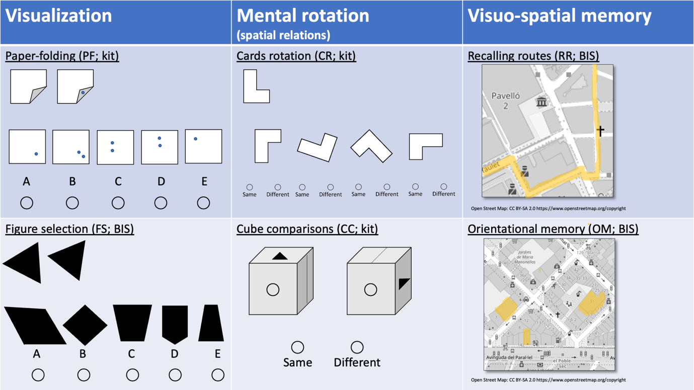
Note. Kit = kit of factor-referenced cognitive tests (Ekstrom et al., 1976); BIS = Berliner Intelligenzstruktur-Test (BIS-4; Jäger et al., 1997).

Supplement C.

Unpublished test material
All unpublished test material is provided in the original German versions. Please contact the study authors to obtain English translations.

Proximal self-estimates (section 2.2.2. in the paper) 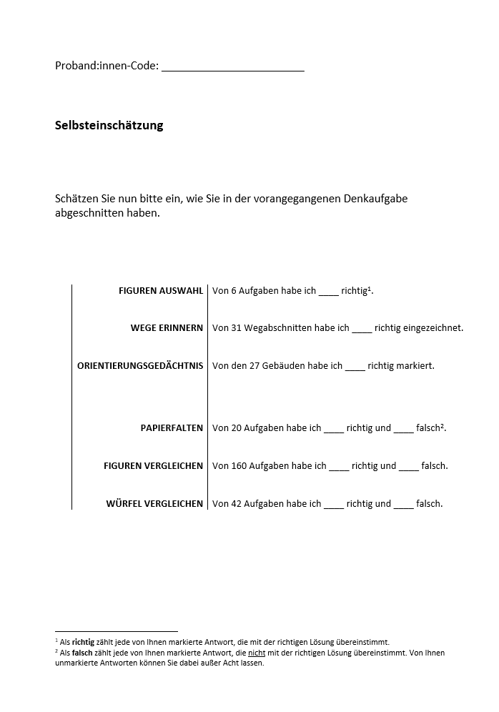

Distal self-estimates (section 2.2.2. in the paper)
Based on Hofer et al. (2022)

Teil 1 – im Vergleich zur Gesamtbevölkerung

Im Folgenden möchten wir Sie bitten, Ihre räumliche Intelligenz (= räumliches Vorstellungsvermögen) einzuschätzen.

In der Abbildung unten sehen Sie die Verteilung des IQs in der Bevölkerung. Der durchschnittliche IQ (= Intelligenzquotient) liegt bei 100 Punkten, wobei knapp 2/3 der Bevölkerung einen IQ zwischen 85 und 115 haben und damit im Normalbereich liegen (graue Fläche). Personen mit Werten unter diesem Bereich gelten als unterdurchschnittlich intelligent (70 bis 85 Punkte) bzw. leicht beeinträchtigt (unter 70 Punkte). Personen mit Werten zwischen 115 und 130 gelten als überdurchschnittlich intelligent und Personen mit Werten über 130 als hochbegabt.
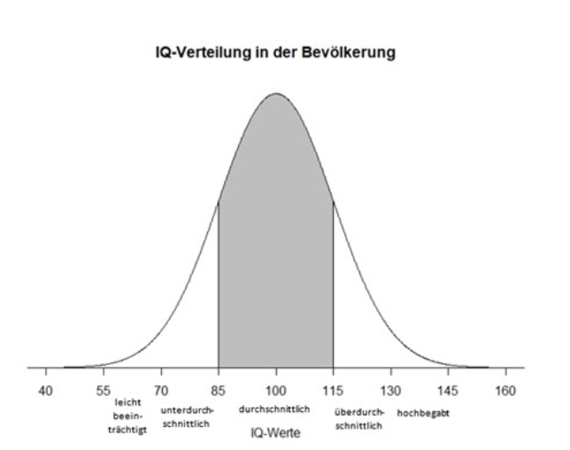
Der räumliche IQ folgt ebenso dieser Verteilung. Bitte schätzen Sie nun Ihren räumlichen IQ im Vergleich zur Gesamtbevölkerung mit Hilfe des Schiebereglers ein.
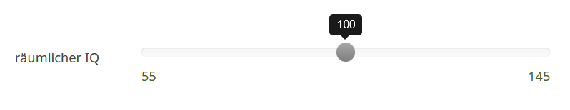

Teil 2 – im Vergleich zur Stichprobe
Nun bitten wir Sie, Ihre räumliche Intelligenz ein weiteres Mal einzuschätzen. Dieses Mal allerdings im Vergleich zur unten beschriebenen Stichprobe, nicht mehr im Vergleich zur Gesamtbevölkerung.
Lesen Sie den untenstehenden Text bitte aufmerksam durch, um sich anschließend im Vergleich zur Stichprobe dieser Untersuchung einschätzen zu können.

An dieser Untersuchung nehmen etwa 200 Personen (ca. 50% Frauen/ 50% Männer) in einem Altersbereich von 18-40 Jahren teil. Ein Großteil der Proband:innen studiert(e) an verschiedenen Universitäten sowie Fachhochschulen, es werden aber auch vereinzelt Berufstätige aus verschiedenen Berufsfeldern vertreten sein.
Bitte schätzen Sie Ihren räumlichen IQ im Vergleich zur oben beschriebenen Stichprobe der Studie mit Hilfe des Schiebereglers ein.

Additional measure: Multi-item self-estimate measure (2.3. in the paper; not included in pre-registered main analyses)

Based on Neubauer et al. (2018)

Im Folgenden finden Sie eine Reihe von Aussagen. Bitte antworten Sie je nachdem, ob Sie persönlich meinen, dass eine Aussage auf Sie zutrifft oder nicht zutrifft. Bearbeiten Sie den Fragebogen zügig und bedenken Sie, dass es um Ihre persönliche Einschätzung geht. Es gibt keine richtigen oder falschen Antworten! Wenn Sie sich bei einer Frage unsicher sind, wählen Sie die Option, die am ehesten auf Sie zutrifft.
Wenn mir jemand sein Haus beschreibt, kann ich mir dieses sehr gut vorstellen.
Die Orientierung in einer fremden Stadt anhand einer Karte fällt mir ausgesprochen leicht.
Ich kann mir sehr gut vorstellen, wie ein Objekt aus einem anderen Blickwinkel aussieht.
Ich kann anderen Personen sehr gut einen Weg erklären.
Ich kann mich sehr gut in einer unbekannten Umgebung zurechtfinden.
Ich kann sehr gut die Größe eines Raumes einschätzen.
Ich kann mir dreidimensionale Dinge sehr gut im Kopf vorstellen.
Ich kann die Entfernung zwischen zwei Orten sehr gut einschätzen.
Es fällt mir leicht, mir ein Gebäude schnell aus der Vogelperspektive vorzustellen.
Ich bin schnell darin, ein Objekt aus verschiedenen Perspektiven zu erkennen.
Ich kann mir die Wege zu verschiedenen Orten sehr gut einprägen.
Ich kann schnell zwei- oder dreidimensionale Objekte in der Vorstellung drehen.
Ich kann mir problemlos vorstellen, wie mein Zimmer ausschaut, wenn ich meine Möbel umstelle.
Ich kann schnell erkennen, ob zwei gedrehte Figuren dasselbe darstellen oder es sich um unterschiedliche Figuren handelt.
Wenn ich puzzle, kann ich mir bei einem Puzzleteil gedanklich gut vorstellen, wo oder wie ich es korrekt platzieren muss.
Anhand einer Landkarte kann ich mir diverse Standorte gut einprägen.
Es fällt mir leicht, mir gedanklich vorzustellen, wie ein zersplittertes Gefäß wieder zusammengesetzt ausschauen könnte.
Ich bin äußerst begabt im räumlichen Denken.

Einzuschätzen auf einer Likert-Skala von 1 = „Trifft nicht zu“ bis 5 = „Trifft genau zu“

References

Carroll, J. B. (1993). Human cognitive abilities: A survey of factor-analytic studies. Cambridge University Press.
Ekstrom, R. B., French, J. W., & Harman, H. H. (1976). Kit of factor-referenced cognitive tests. Educational Testing Service.
Goldman, R. D., & Hewitt, B. N. (1976). The Scholastic Aptitude Test “explains” why college men major in science more often than college women. Journal of Counseling Psychology, 23(1), 50–54. 10.1037/0022-0167.23.1.50
Hofer, G., Macher, S., & Neubauer, A. C. (2022). Love is not blind: What romantic partners know about our abilities compared to ourselves, our close friends, and our acquaintances. Journal of Research in Personality, 98, 104211. 10.1016/j.jrp.2022.104211 (Advance online publication)
Jäger, A. O., Süß, H.-M., & Beauducel, A. (1997). Berliner Intelligenzstruktur-Test (BIS-4). Hogrefe. https://www.hogrefe.com/at/shop/berliner-intelligenzstruktur-test.html
Kelly, D. P., & Beltz, A. M. (2022). Spatial skills and self-perceived masculinity: Considering college major STEM-ness, directionality, and gender. Sex Roles, 87(5), 251–266. 10.1007/s11199-022-01308-y
Linn, M. C., & Petersen, A. C. (1985). Emergence and characterization of sex differences in spatial ability: A meta-analysis. Child Development, 56(6), 1479–1498. 10.2307/1130467
Neubauer, A. C., Pribil, A., Wallner, A., & Hofer, G. (2018). The self–other knowledge asymmetry in cognitive intelligence, emotional intelligence, and creativity. Heliyon, 4(12), 01061. 10.1016/j.heliyon.2018.e01061

