Supplementary Materials
Table of Contents
Supplementary Materials 1
1. Google Trends Graphs 2
2. Variables 4
2.1 Dependent Variables 4
2.2 Attitudinal Covariates: 4
2.3 Demographic Variables: 6
3. Kitagawa-Oaxaca-Blinder Decomposition 7
3.1 K-O-B Decomposition: Victim Blaming 7
3.2 K-O-B Decomposition: Perpetrator Culpability 10
4. Models used for moderation analysis 13
4.1 Victim Blaming 13
4.2 Perpetrator Culpability 15
References 16

Google Trends Graphs
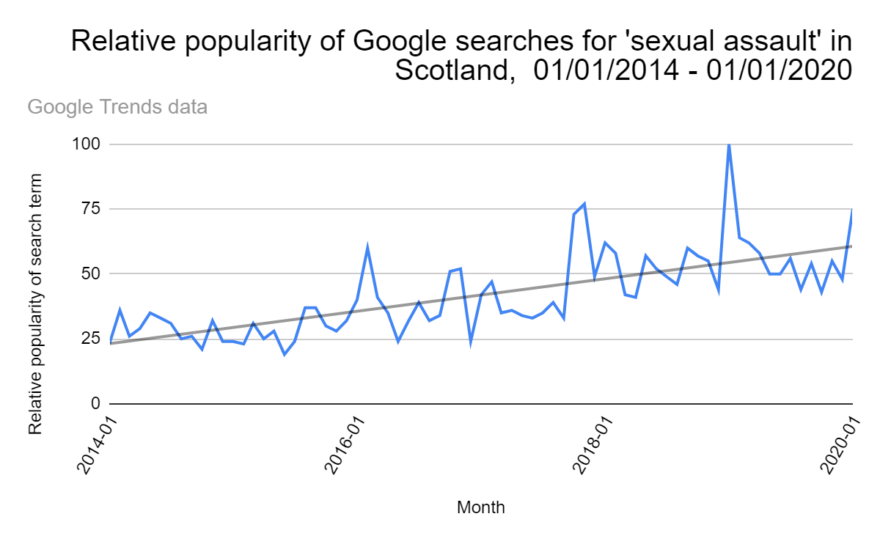
Figure A: Searches for 'Sexual Assault' in Scotland, 2014-2020 (Google Trends data)

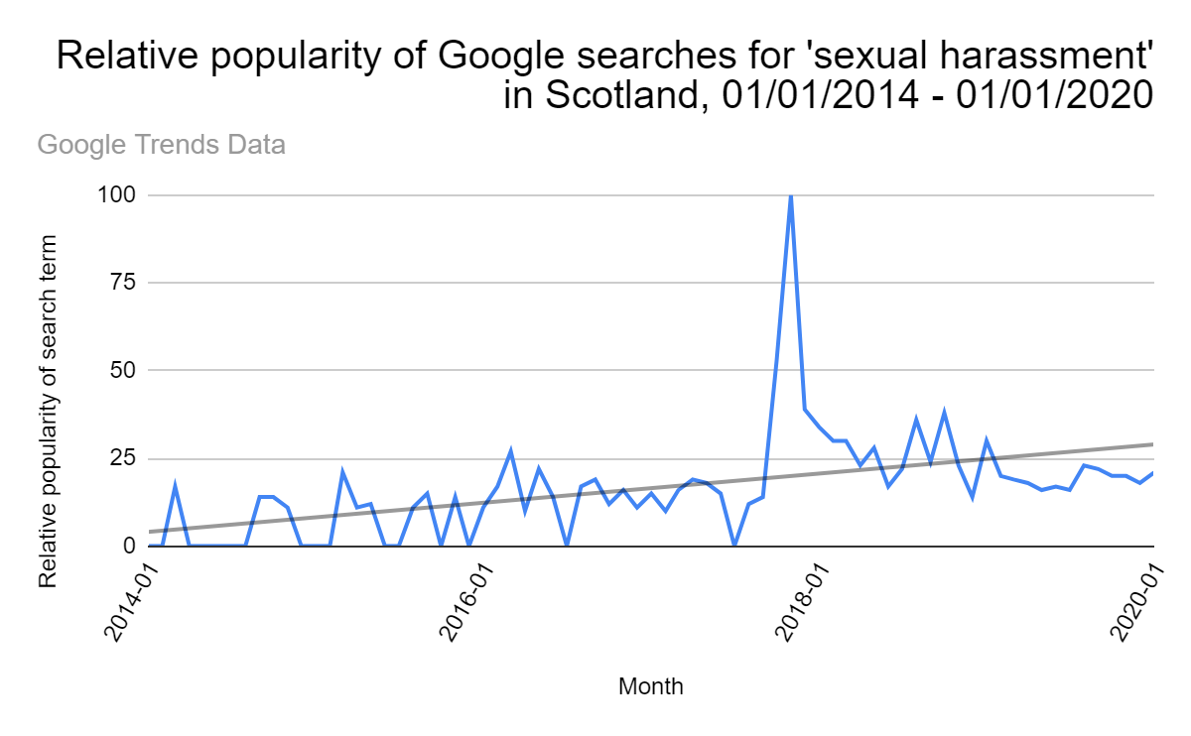
Figure B: Searches for 'Sexual Harassment in Scotland, 2014-2020 (Google Trends data)

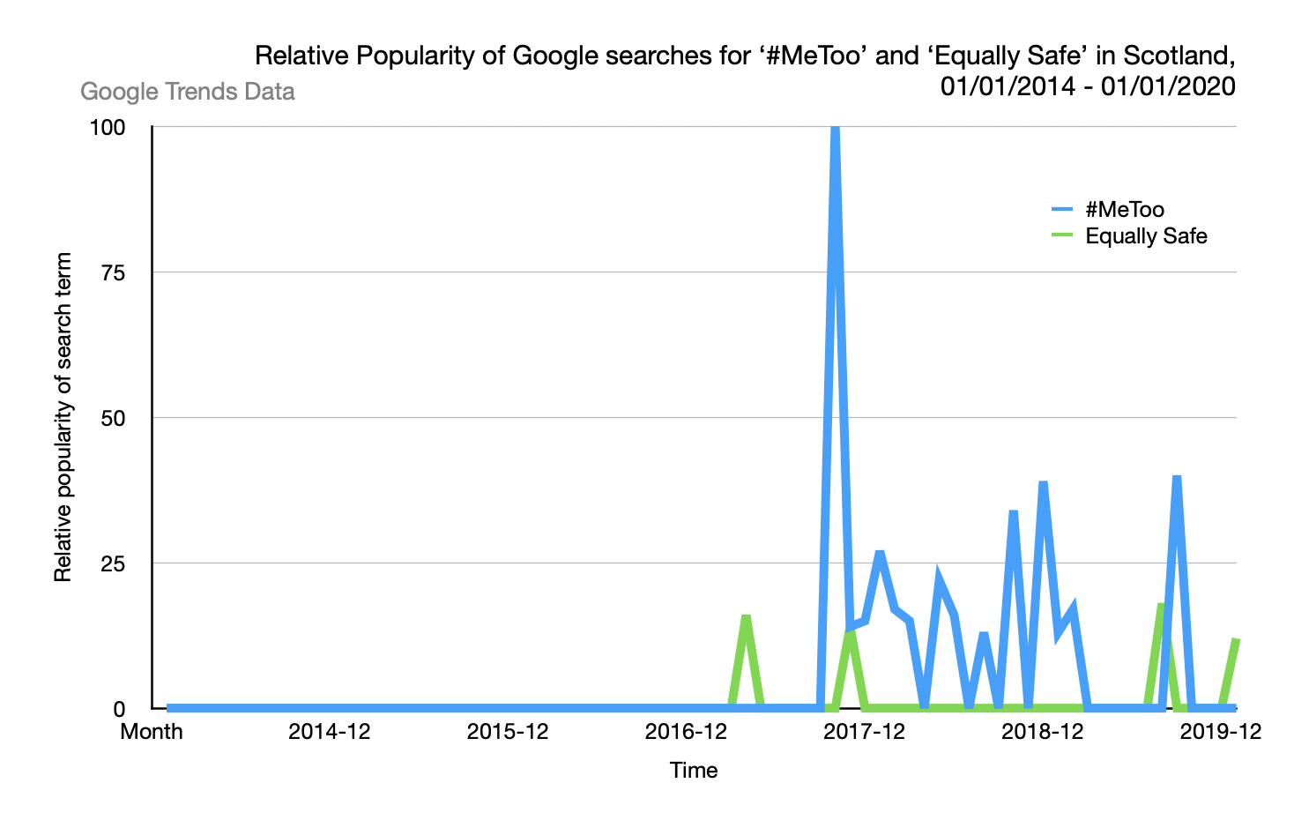
Figure C: Searches for ‘#MeToo and ‘Equally Safe’ in Scotland, 2014-2020 (Google Trends data)

This data from Google Trends shows that #MeToo received 15.5 times as much interest as Equally Safe on Google. Since the launch of Equally Safe in June 2014, its average level of interest was 0.88, compared with an average of 13.4 for #MeToo since its launch in October 2017.

2. Data and Variables
The total sample size from the merged datasets was 2,523 people, comprising 1,498 from the 2014 sample and 1,022 from the 2019 sample. Because the 2019 survey included 16-17-year-olds, these individuals were excluded to match the 2014 sample. Individuals with missing data for the dependent variables and covariates were also excluded. Survey weights were not used because the 2014 and 2019 datasets did not have weights with equivalent functions. There is an absence of information about how the weights are calculated in the surveys’ technical reports. Descriptive statistics (displayed in Table 1) show that the 2014 and 2019 samples have broadly comparable demographic characteristics.

2.1 Dependent Variables

Confirmatory factor analysis

Model |  | Df | p | CFI | TLI | RMSEA
Main two-factor model (Victim Blaming and Perpetrator Culpability) | 1.143 | 6 | 0.285 | 1.000 | 1.000 | 0.008

Multiple-group confirmatory factor analysis

Model |  | Df | p | CFI | TLI | RMSEA
Configural invariance | 1.533 | 10 | 0.821 | 1.000 | 1.008 | 0.000
Metric invariance | 8.293 | 10 | 0.600 | 1.000 | 1.002 | 0.000
Scalar invariance | 21.976 | 16 | 0.144 | 0.997 | 0.995 | 0.026
Strict invariance | 47.694 | 28 | 0.012 | 0.989 | 0.991 | 0.035

2.2 Attitudinal Covariates:

Political Interest:
This variable was labelled ‘Politics’ in the survey documentation. The variable was then reverse scored, so that a higher score represented higher levels of political interest.
How much interest do you generally have in what is going on in politics?
- A great deal
- Quite a lot
- Some
- Not very much
- None at all

Gender Role Attitudes:
The ‘Gender Role Attitudes’ variable was an average of two variables found in the 2014 and 2019 SSAS, labelled ‘GenRolB’ and ‘GenRolG’.
GenRolB:
  - Imagine you are taking a 3 year old boy to a shop to buy a toy. When you get there he picks a princess doll. Which of the phrases below best describes what you would do?
      - Buy it for him without saying anything
      - Buy it, but first try to get him to pick a toy that’s more common for boys
      - Make him put the doll back and pick a toy more common for boys
GenRolG:
  - Imagine you are taking a 3 year old girl to a shop to buy a toy. When you get there she picks a toy truck. Which of the phrases below best describes what you would do?
      - Buy it for her without saying anything
      - Buy it, but first try to get her to pick a toy that’s more common for girls
      - Make her put the truck back and pick a toy more common for girls

Libertarianism-Authoritarianism Political Orientation
Libertarian-Authoritarian Political Orientation was measured using a scale derived from six different items within the SSAS, using the variable ‘libauth’.
- 'Young people today don't have enough respect for traditional British values'
- 'People who break the law should be given stiffer sentences'
- 'For some crimes, the death penalty is the most appropriate sentence'
- ‘Schools should teach children to obey authority'
- 'The law should always be obeyed, even if a particular law is wrong'
- ‘Censorship of films and magazines is necessary to uphold moral standards'

Left-Right Political Orientation
Left-Right Political Orientation was measured using a scale derived from five different items within the SSAS, using the variable ‘leftrigh’.

- ‘Government should redistribute income from the better-off to those who are less well off'
- ‘Big business benefits owners at the expense of workers'
- 'Ordinary working people do not get their fair share of the nation's wealth'
- 'There is one law for the rich and one for the poor'
- 'Management will always try to get the better of employees if it gets the chance'

2.3 Demographic Variables:
The decomposition breaks down the effect of each variable into the endowment, coefficient and interaction effect, which makes it somewhat sensitive to small sample sizes. Scale variables were used for class and education to preserve statistical power, and curve estimation, correlations, and linear and logistic regression confirmed that treating class and education as scalar variables yields equivalent results for the two dependent variables as when the covariates are treated as categorical.

3. Kitagawa-Oaxaca-Blinder Decomposition

3.1 K-O-B Decomposition: Victim Blaming

Endowment component of decomposition for Victim Blaming

Variable | Coefficient | SE | 95% CI | p
Gender | 0.002 | 0.004 | (-0.006, 0.009) | 0.691
Age | 0.178 | 0.076 | (0.029, 0.326) | 0.019
Age Squared | -0.234 | 0.095 | (-0.420, -0.048) | 0.014
Education | -0.005 | 0.008 | (-0.020, 0.010) | 0.524
Occupational Class | <0.001 | 0.003 | (-0.007, 0.007) | 0.986
Religious | 0.046 | 0.023 | (0.002, 0.091) | 0.042
Married | <0.001 | 0.002 | (-0.005, 0.005) | 0.992
Political Interest | 0.018 | 0.011 | (-0.003, 0.040) | 0.098
Gender Roles | 0.094 | 0.027 | (0.042, 0.146) | <0.001
Libertarianism-Authoritarianism | 0.023 | 0.013 | (-0.002, 0.048) | 0.068
Left-Right | 0.013 | 0.008 | (-0.003, 0.029) | 0.113

Coefficient component of decomposition for Victim Blaming

Variable | Coefficient | SE | 95% CI | p
Intercept | -0.719 | 0.800 | (-2.287, 0.850) | 0.369
Gender | 0.061 | 0.075 | (-0.086, 0.207) | 0.417
Age | 0.466 | 1.306 | (-2.093, 3.025) | 0.721
Age Squared | -0.086 | 0.773 | (-1.600, 1.429) | 0.912
Education | -0.124 | 0.226 | (-0.568, 0.319) | 0.583
Occupational Class | -0.078 | 0.145 | (-0.363, 0.207) | 0.593
Religious | -0.046 | 0.058 | (-0.160, 0.068) | 0.431
Married | 0.025 | 0.073 | (-0.119, 0.169) | 0.732
Political Interest | 0.394 | 0.207 | (-0.011, 0.799) | 0.057
Gender Roles | -0.063 | 0.185 | (-0.425, 0.300) | 0.735
Libertarianism-Authoritarianism | 0.280 | 0.346 | (-0.399, 0.958) | 0.419
Left-Right | 0.023 | 0.191 | (-0.351, 0.396) | 0.906

Interaction component of decomposition for Victim Blaming

Variable | Coefficient | SE | 95% CI | p
Gender | 0.002 | 0.006 | (-0.009, 0.014) | 0.683
Age | -0.018 | 0.0516 | (-0.119, 0.083) | 0.727
Age Squared | 0.006 | 0.055 | (-0.101, 0.113) | 0.912
Education | 0.005 | 0.010 | (-0.015, 0.025) | 0.613
Occupational Class | 0.002 | 0.004 | (-0.007, 0.010) | 0.689
Religious | -0.021 | 0.027 | (-0.074, 0.031) | 0.423
Married | <0.001 | 0.003 | (-0.007, 0.007) | 0.985
Political Interest | -0.020 | 0.013 | (-0.045, 0.005) | 0.109
Gender Roles | -0.010 | 0.031 | (-0.070, 0.050) | 0.745
Libertarianism-Authoritarianism | 0.014 | 0.018 | (-0.022, 0.050) | 0.440
Left-Right | 0.001 | 0.010 | (-0.018, 0.020) | 0.911

3.2 K-O-B Decomposition: Perpetrator Culpability

Endowment component of decomposition for Perpetrator Culpability

Variable | Coefficient | SE | 95% CI | p
Gender | 0.004 | 0.005 | (-0.005, 0.014) | 0.363
Age | -0.026 | 0.024 | (-0.073, 0.021) | 0.274
Age Squared | 0.042 | 0.026 | (-0.009, 0.093) | 0.107
Education | -0.009 | 0.006 | (-0.020, 0.002) | 0.117
Occupational Class | <0.001 | 0.002 | (-0.004, 0.004) | 0.878
Religious | -0.005 | 0.011 | (-0.027, 0.017) | 0.639
Married | <-0.001 | 0.002 | (-0.004, 0.004) | 0.949
Political Interest | -0.004 | 0.005 | (-0.014, 0.006) | 0.467
Gender Roles | -0.014 | 0.011 | (-0.035, 0.008) | 0.225
Libertarianism-Authoritarianism | -0.061 | 0.014 | (-0.089, 0.034) | <0.001
Left-Right | -0.007 | 0.004 | (-0.015, 0.002) | 0.111

Coefficient Component of Decomposition for Perpetrator Culpability

Variable | Coefficient | SE | 95% CI | p
Intercept | -0.117 | 0.438 | (-0.975, 0.742) | 0.790
Gender | -0.090 | 0.040 | (-0.168, -0.013) | 0.022
Age | -0.931 | 0.663 | (-2.231, 0.369) | 0.161
Age Squared | 0.506 | 0.369 | (-0.216, 1.229) | 0.170
Education | -0.166 | 0.120 | (-0.402, 0.069) | 0.165
Class | 0.063 | 0.086 | (-0.106, 0.232) | 0.466
Religious | -0.020 | 0.031 | (-0.080, 0.040) | 0.520
Married | -0.003 | 0.042 | (-0.085, 0.078) | 0.934
Political Interest | 0.035 | 0.116 | (-0.193, 0.263) | 0.765
Gender Roles | -0.061 | 0.084 | (-0.225, 0.104) | 0.469
Libertarianism-Authoritarianism | 0.113 | 0.196 | (-0.271, 0.496) | 0.565
Left-Right | 0.291 | 0.116 | (0.064, 0.517) | 0.012

Interaction Component of Decomposition for Perpetrator Culpability

Variable | Coefficient | SE | 95% CI | p
Gender | -0.004 | 0.005 | (-0.013, 0.005) | 0.420
Age | 0.034 | 0.029 | (-0.023, 0.092) | 0.241
Age Squared | -0.034 | 0.029 | (-0.091, 0.023) | 0.241
Education | 0.007 | 0.006 | (-0.005, 0.019) | 0.273
Class | -0.001 | 0.002 | (-0.006, 0.004) | 0.583
Religious | -0.009 | 0.014 | (-0.038, 0.019) | 0.524
Married | <0.001 | 0.002 | (-0.003, 0.003) | 0.994
Political Interest | -0.002 | 0.006 | (-0.013, 0.010) | 0.772
Gender Roles | -0.010 | 0.014 | (-0.036, 0.017) | 0.472
Libertarianism-Authoritarianism | 0.006 | 0.010 | (-0.014, 0.026) | 0.574
Left-Right | 0.014 | 0.007 | (0.001, 0.027) | 0.036

4. Models used for moderation analysis

4.1 Victim Blaming

Political Interest x Year Interaction: Victim Blaming
Predictors | Estimates | SE | p
Intercept | 1.557 | (0.388) | <0.001
Gender (Woman) | 0.152 | (0.068) | 0.027
Age | -0.079 | (0.012) | <0.001
Age Squared | 0.001 | (<0.001) | <0.001
Education | 0.013 | (0.038) | 0.727
Class | -0.011 | (0.019) | 0.555
Religious Identity (Religious) | 0.192 | (0.070) | 0.006
Marital Status (Married) | 0.008 | (0.068) | 0.906
Political Interest | 0.001 | (0.038) | 0.972
Gender Roles | 0.374 | (0.052) | <0.001
Libertarianism-Authoritarianism | 0.172 | (0.049) | <0.001
Left-Right | 0.123 | (0.043) | 0.004
Survey Year | 0.176 | (0.188) | 0.349
Political Interest x Survey Year | -0.094 | (0.056) | 0.094
Observations | 2136
R² / R² adjusted | 0.201 / 0.197

Gender x Year Interaction: Victim Blaming

Predictors | Estimates | SE | p
Intercept | 1.651 | (0.384) | <0.001
Gender (Woman) | 0.176 | (0.087) | 0.043
Age | -0.079 | (0.012) | <0.001
Age Squared | 0.001 | (<0.001) | <0.001
Education | 0.012 | (0.036) | 0.745
Class | -0.010 | (0.019) | 0.572
Religious Identity (Religious) | 0.201 | (0.070) | 0.004
Marital Status (Married) | 0.005 | (0.068) | 0.947
Political Interest | -0.036 | (0.031) | 0.244
Gender Roles | 0.370 | (0.052) | <0.001
Libertarianism-Authoritarianism | 0.176 | (0.049) | <0.001
Left-Right | 0.122 | (0.043) | 0.005
Survey Year | -0.079 | (0.099) | 0.964
Gender x Survey Year | -0.069 | (0.132) | 0.600
Observations | 2136
R² / R² adjusted | 0.200/0.196

4.2 Perpetrator Culpability

Left-Right Political Orientation x Year Interaction: Perpetrator Culpability

Predictors | Estimates | SE | p
Intercept | 4.164 | (0.220) | <0.001
Gender (Woman) | 0.108 | (0.038) | 0.005
Age | 0.003 | (0.006) | 0.697
Age Squared | <0.001 | (<0.001) | 0.113
Education | 0.043 | (0.020) | 0.034
Class | 0.004 | (0.010) | 0.681
Religious Identity (Religious) | -0.058 | (0.039) | 0.136
Marital Status (Married) | 0.057 | (0.038) | 0.134
Political Interest | 0.031 | (0.017) | 0.070
Gender Roles | -0.080 | (0.029) | 0.006
Libertarianism-Authoritarianism | -0.341 | (0.027) | <0.001
Left-Right | 0.063 | (0.032) | 0.047
Survey Year | 0.652 | (0.114) | <0.001
Left-Right x Survey Year | -0.119 | (0.047) | 0.011
Observations | 2133
R² / R² adjusted | 0.227 / 0.222

Gender x Year Interaction: Perceived Perpetrator Culpability

Predictors | Estimates | SE | p
Intercept | 4.320 | (0.214) | <0.001
Gender (Woman) | 0.049 | (0.048) | 0.310
Age | 0.002 | (0.006) | 0.740
Age Squared | <0.001 | (<0.001) | 0.127
Education | 0.042 | (0.020) | 0.035
Class | 0.044 | (0.010) | 0.672
Religious Identity (Religious) | -0.060 | (0.039) | 0.124
Marital Status (Married) | 0.059 | (0.038) | 0.123
Political Interest | 0.030 | (0.017) | 0.075
Gender Roles | -0.081 | (0.029) | 0.005
Libertarianism-Authoritarianism | -0.338 | (0.027) | <0.001
Left-Right | 0.010 | (0.024) | 0.663
Survey Year | 0.298 | (0.055) | <0.001
Gender x Survey Year | 0.149 | (0.074) | 0.043
Observations | 2133
R² / R² adjusted | 0.226 / 0.222

References

Google Trends. (2024, August 10). Sexual assault. Retrieved from Google Trends: https://trends.google.com/trends/explore?date=2014-01-01%202020-01-01&geo=GB-SCT&q=Sexual%20assault
Google Trends. (2024, August 10). Sexual harassment. Retrieved from Google Trends: https://trends.google.com/trends/explore?date=2014-01-01%202020-01-01&geo=GB-SCT&q=Sexual%20harassment
Google Trends. (2025, April 10). Equally Safe and #MeToo. Retreived from Google Trends: https://trends.google.com/trends/explore?date=2014-01-01%202020-01-01&geo=GB-SCT&q=Equally%20Safe,%23MeToo&hl=en

A p > 0.05 denotes that the observed covariance matrix does not significantly differ from the expected covariance matrix, indicating that the model fits well.

