Table S1: Cross-tabulation informal flexibility and flexi-time (jbflex4 only)
 |  | Access to Informal Flexibility |  | Total
 |  | No | Yes
Access to flexi-time | No | 3984 | 5194 | 9178
Access to flexi-time |  | 43.4% | 56.6% | 100.0
Access to flexi-time | Yes | 572.8 | 3804 | 4377
Access to flexi-time |  | 13.1% | 87% | 100%
Note: weighted count and row proportion . Source UKHLS Wave 8, 2016-18

S1 Model specifications
The multinomial logit model as described by Greene (2012, 763–766), considers k categorical outcomes – in our case the six job classes. Taking the base outcome to be k=1, the probability that the response for the jth observation is equal to the i^{th} outcome is:
p_{ij} = Pr (y_{j} = i) = (1+$\sum_{m=2}^{k}{exp⁡(x_{j}β_{m}))^{-1}}$ if i=1
p_{ij} = Pr (y_{j} = i) = ($exp⁡(x_{j}β_{i}))/$ (1+$\sum_{m=2}^{k}{exp⁡(x_{j}β_{m}))}$ if i>1

X_{j} = f(α₀, β₁Gender, β₂Parenthood, β₃ Gender x Parenthood, γ₁Age, γ₂Age², γ₃Education, γ₄Working hours, γ₅Sector, γ₆Occupation).

Specification 1 (base)
X_{j} = (β₁F_{j}, β_{2, 0to4}YC_{0to4, j}, β_{2, 5to10}YC_{5to10, j}, β_{2, 11to16}YC_{11to16, j}, β_{2, 16+}YC_{16+, j}, β_{3, 0to4}F_{i} x YC_{0to4, j}, β_{3, 5to10}F_{i} x YC_{5to10, j}, β_{3, 11to16}F_{j} x YC_{11to16, j}, β_{3, 16+}F_{i} x YC_{16+, j}, γ₁Age_{j}, γ₂Age_{j2}, γ₃Education_{j})

Specification 2 (Base + working hours)
X_{j} = (β₁F_{j}, β_{2, 0to4}YC_{0to4, j}, β_{2, 5to10}YC_{5to10, j}, β_{2, 11to16}YC_{11to16, j}, β_{2, 16+}YC_{16+, j}, β_{3, 0to4}F_{i} x YC_{0to4, j}, β_{3, 5to10}F_{i} x YC_{5to10, j}, β_{3, 11to16}F_{j} x YC_{11to16, j}, β_{3, 16+}F_{i} x YC_{16+, j}, γ₁Age_{j}, γ₂Age_{j2}, γ₃Education_{j}, γ₄Working hours_{j})

Specification 3 (Base + sector)
X_{j} = (β₁F_{j}, β_{2, 0to4}YC_{0to4, j}, β_{2, 5to10}YC_{5to10, j}, β_{2, 11to16}YC_{11to16, j}, β_{2, 16+}YC_{16+, j}, β_{3, 0to4}F_{i} x YC_{0to4, j}, β_{3, 5to10}F_{i} x YC_{5to10, j}, β_{3, 11to16}F_{j} x YC_{11to16, j}, β_{3, 16+}F_{i} x YC_{16+, j}, γ₁Age_{j}, γ₂Age_{j2}, γ₃Education_{j}, γ₅Sector_{j})

Specification 4 (Base + occupation)
X_{j} = (β₁F_{j}, β_{2, 0to4}YC_{0to4, j}, β_{2, 5to10}YC_{5to10, j}, β_{2, 11to16}YC_{11to16, j}, β_{2, 16+}YC_{16+, j}, β_{3, 0to4}F_{i} x YC_{0to4, j}, β_{3, 5to10}F_{i} x YC_{5to10, j}, β_{3, 11to16}F_{j} x YC_{11to16, j}, β_{3, 16+}F_{i} x YC_{16+, j}, γ₁Age_{j}, γ₂Age_{j2}, γ₃Education_{j}, γ₆Occupation)

Specification 5 (full)
X_{j} = (β₁F_{j}, β_{2, 0to4}YC_{0to4, j}, β_{2, 5to10}YC_{5to10, j}, β_{2, 11to16}YC_{11to16, j}, β_{2, 16+}YC_{16+, j}, β_{3, 0to4}F_{i} x YC_{0to4, j}, β_{3, 5to10}F_{i} x YC_{5to10, j}, β_{3, 11to16}F_{j} x YC_{11to16, j}, β_{3, 16+}F_{i} x YC_{16+, j}, γ₁Age_{j}, γ₂Age_{j2}, γ₃Education_{j}, γ₄Working hours_{j}, γ₅Sector_{j}, γ₆Occupation)

Where
Gender: F_{j} – female and M_{j} – male (reference)
Parenthood: YC_{0to4, j} - Youngest child preschool age (0-4), YC_{5to10, j} - Youngest child primary school age (5-10), YC_{11to16, j} - Youngest children secondary school age (11-15), YC_{16+, j} - Youngest child 16+ or non-resident), NoC_{j} - No children (reference)
Age: Age_{j}, Age²_{j} - age and age-squared)
Education: Educ_{GCSE_lower, j} – highest educational qualification lower than GCSE, Educ_{GCSE, j} - highest educational qualification GCSE, Educ_{Alevel, j} – highest educational qualification A-levels or equivalent, Educ_{Degree, j} - highest educational qualification degree level or higher (reference).
Working hours: PT_{j} - Working hours are captured via a variable that measures part-time work (1 if respondent works less than 30 hours a week), full-time work (reference).
Sector: Sector_{j} - Job sector is captured via a dummy variable (1 if respondent works in the private sector); public sector (reference)
Occupation: SEC_{1, j} - Occupation five class NS-SEC, Managerial, administrative, and professional occupations (reference), SEC_{2, j} - Occupation five class NS-SEC, Intermediate occupations, , SEC_{4, j} - Occupation five class NS-SEC, Lower supervisory and technical occupations, SEC_{5, j} - Occupation five class NS-SEC, Semi-routine and routine occupations.
Male, not a parent
F_{j} = YC_{0to4, j} = YC_{5to10, j} = YC_{11to16, j} = YC_{16+, j} = 0
F_{j} x YC_{0to4, j}, F_{j} x YC_{5to10, j}, F_{j} x YC_{11to16, j}, F_{j} x YC_{16+, j} = 0

Female, not a parent
F_{j} = 1
M_{j} = YC_{0to4, j} = YC_{5to10, j} = YC_{11to16, j} = YC_{16+, j} = 0
F_{j} x YC_{0to4, j}, F_{j} x YC_{5to10, j}, F_{j} x YC_{11to16, j}, F_{j} x YC_{16+, j} = 0

Parent if any
YC_{0to4, j}, YC_{5to10, j}, YC_{11to16, j}, YC_{16+, j} not equal to 0

Male, parent
F_{j} = F_{j} x YC_{0to4, j}, F_{j} x YC_{5to10, j}, F_{j} x YC_{11to16, j}, F_{j} x YC_{16+, j} = 0
Effect depends upon the age of the youngest child (β_{2, 0to4}YC_{0to4, j}, β_{2, 5to10}YC_{5to10, j}, β_{2, 11to16}YC_{11to16, j}, β_{2, 16+}YC_{16+, j})

Female, parent
F_{j} = 1
M_{j} = 0
Effect depends upon the age of the youngest child (β_{2, 0to4}YC_{0to4, j}, β_{2, 5to10}YC_{5to10, j}, β_{2, 11to16}YC_{11to16, j}, β_{2, 16+}YC_{16+, j}) and interactions with gender (β_{3, 0to4}F_{i} x YC_{0to4, j}, β_{3, 5to10}F_{i} x YC_{5to10, j}, β_{3, 11to16}F_{j} x YC_{11to16, j}, β_{3, 16+}F_{i} x YC_{16+, j})

Greene, W. H. 2012. Econometric Analysis. 7th ed. Upper Saddle River, NJ: Prentice Hall

Fig S1: Fit Statistics for Latent Class Models with 1-8 Classes
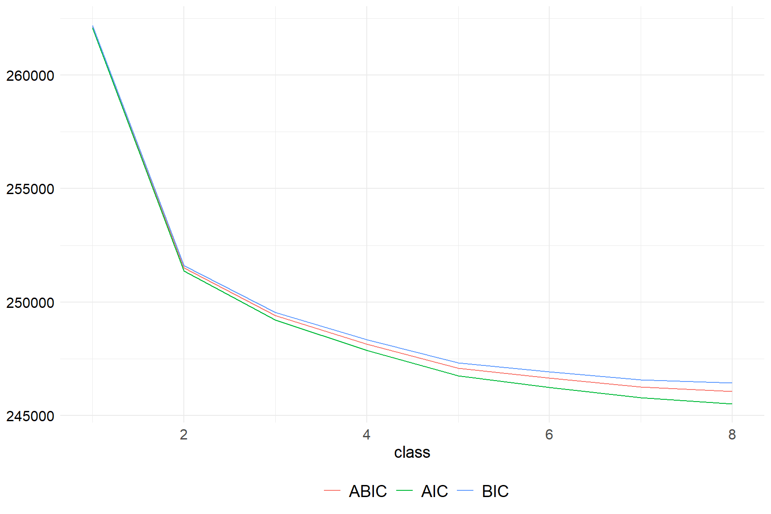

Table S2: Average Latent Class Probabilities for Most Likely Latent Class Membership (Row) by Latent Class (Column)

1 | 2 | 3 | 4 | 5 | 6
0.698 | 0.150 | 0.020 | 0.067 | 0.064 | 0.000
0.106 | 0.764 | 0.037 | 0.083 | 0.007 | 0.003
0.020 | 0.049 | 0.730 | 0.026 | 0.069 | 0.107
0.064 | 0.092 | 0.032 | 0.751 | 0.039 | 0.023
0.036 | 0.016 | 0.091 | 0.051 | 0.684 | 0.122
0.000 | 0.009 | 0.100 | 0.011 | 0.087 | 0.792

Table S3: Rho and Gamma Estimates for the Average Latent Class Probabilities for Most Likely Latent Class Membership (Row) by Latent Class (Column)
Variable | High quality jobs | High prospect, high reward / poor working-time quality | Low control / medium rewards and prospects | High control/ low rewards & prospects | Inflexible odd hours with low discretion | Poor quality jobs
Sample Proportion | 26.2% | 14.4% | 16.1% | 17.5% | 10.2% | 15.6%
Likely to undertake work related training | 0.47 | 0.61 | 0.51 | 0.22 | 0.50 | 0.21
Likely to get better job at same company | 0.17 | 0.28 | 0.16 | 0.07 | 0.20 | 0.07
Overtime of 15% regular hours + | 0.14 | 0.59 | 0.29 | 0.12 | 0.47 | 0.10
Overtime 1-15% regular hours | 0.30 | 0.24 | 0.22 | 0.13 | 0.23 | 0.12
No overtime | 0.56 | 0.17 | 0.49 | 0.75 | 0.30 | 0.78
Doesn't work weekends | 0.77 | 0.14 | 0.51 | 0.52 | 0.01 | 0.53
Annual pay increments | 0.59 | 0.51 | 0.68 | 0.12 | 0.43 | 0.17
Workplace pension | 0.99 | 0.95 | 1.00 | 0.61 | 0.93 | 0.76
Salaried | 0.95 | 0.76 | 0.90 | 0.51 | 0.23 | 0.31
Receives Bonus | 0.34 | 0.45 | 0.16 | 0.23 | 0.38 | 0.20
Low task discretion | 0.10 | 0.03 | 0.33 | 0.13 | 0.43 | 0.50
Medium task discretion | 0.18 | 0.13 | 0.21 | 0.13 | 0.20 | 0.17
High task discretion | 0.72 | 0.84 | 0.46 | 0.75 | 0.37 | 0.34
Some control over start and finish times | 0.95 | 1.00 | 0.29 | 0.99 | 0.36 | 0.04
Access to flexitime or location flexibility | 0.75 | 0.60 | 0.17 | 0.30 | 0.23 | 0.11
Able to informally vary work hours | 0.95 | 0.94 | 0.21 | 0.81 | 0.61 | 0.26

Table S4: Proportion of the Sample in each Job Quality Category

Variable | Proportion
Likely to undertake work related training | 0.41
Likely to get better job at same company | 0.16
Overtime of 15% regular hours + | 0.25
Overtime 1-15% regular hours | 0.21
No overtime | 0.53
Doesn't work weekends | 0.48
Annual pay increments | 0.43
Workplace pension | 0.88
Salaried | 0.66
Receives Bonus | 0.29
Low task discretion | 0.23
Medium task discretion | 0.17
High task discretion | 0.61
Some control over start and finish times | 0.66
Access to flexitime and location flexibility | 0.40
Able to informally vary work hours | 0.66

Note: Source UKHLS Wave 8, 2016-18

Table S5: Descriptive Statistics, Explanatory variables
 | Women without children | Men without children | Women Resident pre-school child | Men Resident pre-school child | Women Resident primary age child | Men Resident primary age child | Women Resident secondary age child | Men Resident secondary age child | Women Child age 16+ or non-resident | Men Child age 16+ or non-resident | Total
full-time | 2204 | 2286 | 590 | 1079 | 614 | 840 | 595 | 569 | 1873 | 1810 | 12460
 | 17.69 | 18.35 | 4.74 | 8.66 | 4.93 | 6.74 | 4.78 | 4.57 | 15.03 | 14.53 | 100.00
part-time | 370 | 221 | 560 | 57 | 591 | 49 | 386 | 32 | 970 | 181 | 3417
 | 10.83 | 6.47 | 16.39 | 1.67 | 17.30 | 1.43 | 11.30 | 0.94 | 28.39 | 5.30 | 100.00
Public | 1086 | 639 | 527 | 262 | 573 | 224 | 533 | 174 | 1435 | 453 | 5906
 | 18.39 | 10.82 | 8.92 | 4.44 | 9.70 | 3.79 | 9.02 | 2.95 | 24.30 | 7.67 | 100.00
Private | 1488 | 1868 | 623 | 874 | 632 | 665 | 448 | 427 | 1408 | 1538 | 9971
 | 14.92 | 18.73 | 6.25 | 8.77 | 6.34 | 6.67 | 4.49 | 4.28 | 14.12 | 15.42 | 100.00
Management & Professional | 1320 | 1249 | 616 | 618 | 552 | 492 | 444 | 351 | 1143 | 881 | 7666
 | 17.22 | 16.29 | 8.04 | 8.06 | 7.20 | 6.42 | 5.79 | 4.58 | 14.91 | 11.49 | 100.00
Intermediate | 563 | 323 | 211 | 127 | 217 | 94 | 194 | 52 | 575 | 171 | 2527
 | 22.28 | 12.78 | 8.35 | 5.03 | 8.59 | 3.72 | 7.68 | 2.06 | 22.75 | 6.77 | 100.00
Lower supervisory & Technical | 113 | 251 | 42 | 133 | 49 | 107 | 54 | 62 | 149 | 288 | 1248
 | 9.05 | 20.11 | 3.37 | 10.66 | 3.93 | 8.57 | 4.33 | 4.97 | 11.94 | 23.08 | 100.00
Semi-routine & routine | 578 | 684 | 281 | 258 | 387 | 196 | 289 | 136 | 976 | 651 | 4436
 | 13.03 | 15.42 | 6.33 | 5.82 | 8.72 | 4.42 | 6.51 | 3.07 | 22.00 | 14.68 | 100.00
Total | 2574 | 2507 | 1150 | 1136 | 1205 | 889 | 981 | 601 | 2843 | 1991 | 15877
 | 16.21 | 15.79 | 7.24 | 7.16 | 7.59 | 5.60 | 6.18 | 3.79 | 17.91 | 12.54 | 100.00
Note: weighted observations and row percentages. Source UKHLS Wave 8, 2016-18

Figure S2: Predicted Class Prevalences, by Occupational Class
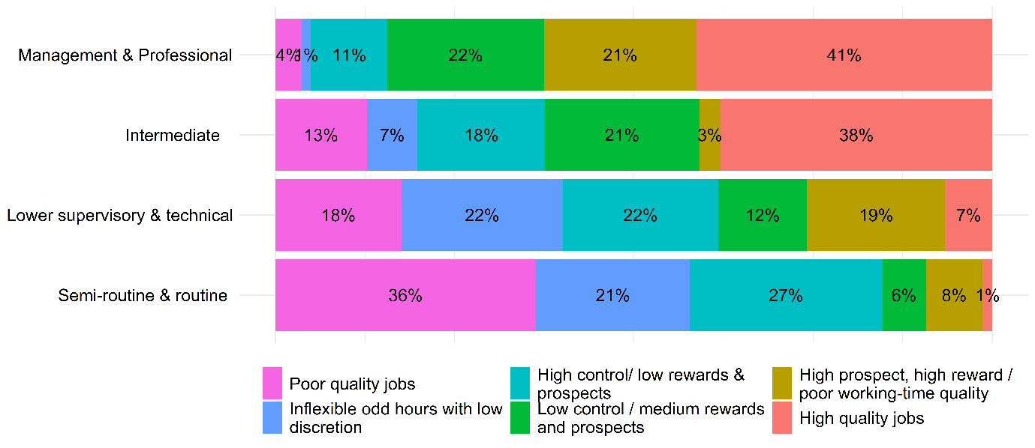
Note: Source UKHLS Wave 8, 2016-18

Figure S3: Predicted Class Prevalences, by Working Hours

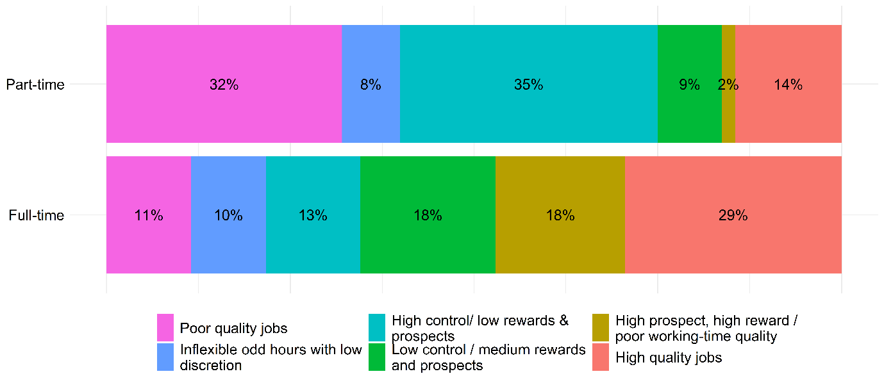
Note: Source UKHLS Wave 8, 2016-18

Figure S4: Predicted Class Prevalences, by Sector

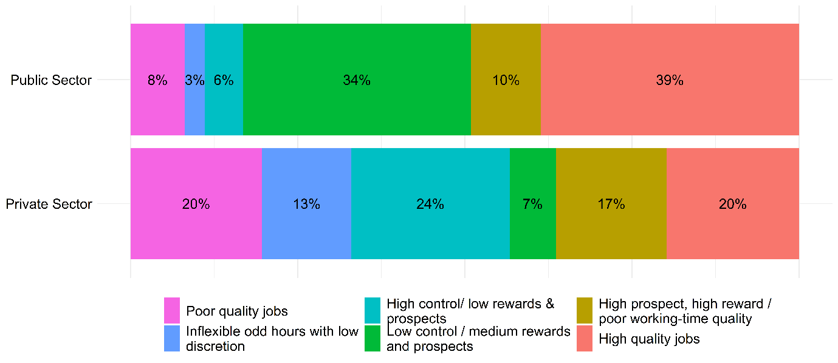
Note: Source UKHLS Wave 8, 2016-18

Table S6: Average Marginal Effect of Parental Status on Class Membership, by Gender, with 95% confidence intervals
Class | Gender | Group | (1) Base Model | (2) Base + Working Hours | (3) Base + Sector | (4) Base + Occupation | (5) Full Model
High quality jobs
2 | male | pre-school child | 3.8***  [1.5,6] | 3.5  [-0.3,7.3] | 3.4***  [1.5,5.3] | 2.9  [-0.5,6.3] | 2.9***  [1.3,4.5]
2 | male | primary age child | -5.6***  [-8.4,-2.8] | -5.5***  [-6.8,-4.1] | -5***  [-7.6,-2.5] | -2.7**  [-4.4,-1.1] | -2.6  [-5.4,0.2]
2 | male | secondary age child | 0.6  [-0.8,2.1] | 0.3  [-4.3,4.9] | 0.4  [-1.8,2.5] | 0.8  [-4.4,5.9] | 0.4  [-2.2,3.1]
2 | male | Child age 16+ or non-resident | -10***  [-11.9,-8.1] | -10.1***  [-14,-6.1] | -9***  [-9.6,-8.3] | -7.3***  [-8.5,-6.2] | -6.1***  [-7.8,-4.4]
2 | female | pre-school child | -2.8  [-6.2,0.6] | 2.9*  [0.6,5.2] | -2.8***  [-3.6,-1.9] | -1.1***  [-1.7,-0.5] | 3.1**  [1.2,4.9]
2 | female | primary age child | -11.1***  [-14.3,-7.9] | -5.5***  [-8,-3] | -12.5***  [-16,-9] | -8.8***  [-11,-6.5] | -4.7***  [-7.5,-2]
2 | female | secondary age child | -4.5*  [-8.1,-0.9] | 0  [-3,3.1] | -6.1***  [-9.6,-2.7] | -1.6  [-5.7,2.5] | 1.6  [-1.6,4.7]
2 | female | Child age 16+ or non-resident | -13.6***  [-15,-12.3] | -12***  [-14.3,-9.8] | -14.7***  [-15.9,-13.4] | -9.5***  [-12.7,-6.2] | -9***  [-10.8,-7.3]
High prospect, high reward / poor working-time quality
1 | male | pre-school child | 4.4**  [1.1,7.7] | 3*  [0.3,5.7] | 3.7**  [1.1,6.2] | 4.3***  [3.4,5.1] | 2.4**  [0.9,3.9]
1 | male | primary age child | 7.4***  [5,9.7] | 6.1***  [3.3,8.8] | 6.7***  [4.2,9.3] | 5.3***  [3.7,6.9] | 4.4***  [2.9,6]
1 | male | secondary age child | 8***  [3.8,12.1] | 6.8***  [4.5,9.1] | 7.4***  [6,8.9] | 6.9***  [4.4,9.5] | 5.8***  [4.2,7.3]
1 | male | Child age 16+ or non-resident | 6.8***  [3.3,10.3] | 5.8***  [3.8,7.7] | 7***  [5.6,8.4] | 6.8***  [5.6,8] | 5.9***  [5.3,6.6]
1 | female | pre-school child | -3.7**  [-6.4,-1] | 0.2  [-3.2,3.5] | -4.3***  [-6.2,-2.3] | -3.4*  [-6.2,-0.6] | 0  [-0.9,1]
1 | female | primary age child | -4.7***  [-7.1,-2.3] | 0.9  [-1.1,2.9] | -4.9***  [-6.3,-3.5] | -3  [-6.2,0.2] | 2.1*  [0.3,3.8]
1 | female | secondary age child | -5.1***  [-7.6,-2.6] | -2.3***  [-3.5,-1] | -5.6***  [-7.2,-4] | -4*  [-7.8,-0.2] | -1.5  [-4,1]
1 | female | Child age 16+ or non-resident | -2.1  [-4.6,0.5] | 0.3  [-1.3,1.9] | -2.1  [-4.7,0.4] | -1.7**  [-2.8,-0.7] | 0.4  [-0.9,1.7]
Low control / medium rewards and prospects
3 | male | pre-school child | -0.8  [-4.2,2.5] | -0.7  [-1.6,0.1] | 0.9  [-1.1,2.9] | -0.2  [-2.1,1.8] | 1.1  [-1.2,3.5]
3 | male | primary age child | -3.2*  [-6.4,-0.1] | -3.2***  [-4.3,-2] | -0.9  [-1.9,0.2] | -3.6***  [-5,-2.2] | -1.5  [-5,2.1]
3 | male | secondary age child | -1  [-3.3,1.4] | -1  [-4.5,2.6] | 0.6  [-1.5,2.7] | -1.7  [-3.9,0.4] | -0.8  [-4.7,3.1]
3 | male | Child age 16+ or non-resident | -2.7**  [-4.8,-0.7] | -3**  [-4.9,-1] | 0.1  [-1.7,1.9] | -2.6***  [-4.1,-1.1] | -0.6  [-2.9,1.7]
3 | female | pre-school child | 0  [-1.3,1.3] | 5***  [2.3,7.7] | 0.8  [-2.3,3.9] | 2.1  [-0.7,4.9] | 5.7***  [2.9,8.5]
3 | female | primary age child | -4.3***  [-6.4,-2.1] | 1  [-0.5,2.4] | -2.4  [-5.3,0.5] | -1.9  [-4.3,0.5] | 3.2*  [0.6,5.8]
3 | female | secondary age child | -2.5*  [-4.7,-0.3] | 1.4  [-1.8,4.6] | -1.5  [-4.5,1.4] | -0.9  [-2.1,0.3] | 1.8  [-1.4,5]
3 | female | Child age 16+ or non-resident | 4.9***  [4.1,5.8] | 6***  [3.5,8.4] | 4.8**  [1.4,8.2] | 5.6***  [4,7.2] | 5.7***  [2.8,8.7]
High control/ low rewards & prospects
4 | male | pre-school child | -5.2***  [-7,-3.3] | -4.1**  [-6.6,-1.6] | -4.9*  [-8.9,-0.8] | -5***  [-7.2,-2.8] | -3.9***  [-5.6,-2.1]
4 | male | primary age child | -0.6  [-3.5,2.3] | -0.1  [-1.6,1.5] | -1.2  [-4.5,2.1] | -2.3***  [-2.9,-1.6] | -2.1  [-6.1,2]
4 | male | secondary age child | -0.1  [-1.5,1.3] | 0.9  [-2.4,4.2] | -0.5  [-2.3,1.2] | 0  [-1.9,1.8] | 0.7  [-1.5,2.8]
4 | male | Child age 16+ or non-resident | 0.4  [-0.9,1.6] | 1.2  [-1.4,3.8] | -1.1  [-2.7,0.5] | -0.2  [-1.8,1.4] | -0.8  [-4.6,2.9]
4 | female | pre-school child | 6.1***  [3.6,8.5] | -1.9  [-4.7,0.8] | 6.6***  [5.5,7.7] | 6.1***  [3,9.2] | -2.5**  [-4.3,-0.6]
4 | female | primary age child | 15.9***  [14.5,17.2] | 5.9***  [4.2,7.6] | 17.2***  [14.1,20.3] | 15.6***  [13.2,18.1] | 5.7**  [1.8,9.6]
4 | female | secondary age child | 6.8***  [4.1,9.5] | 1.1  [-0.8,2.9] | 8.6***  [6.7,10.4] | 5.9***  [3.2,8.7] | 0.6  [-2.4,3.6]
4 | female | Child age 16+ or non-resident | 3.9***  [2.6,5.2] | 0.8  [-1.9,3.6] | 5.1**  [2,8.3] | 2.7**  [0.9,4.4] | 0.9  [-2.1,3.8]
Inflexible odd hours with low discretion
5 | male | pre-school child | 1.7  [-1.2,4.5] | 1.8  [-0.2,3.8] | 1.3  [-1.7,4.2] | 1.1  [-1.5,3.7] | 1  [-1.5,3.4]
5 | male | primary age child | 1.3  [-1.1,3.7] | 1.1  [-2.2,4.4] | 0.3  [-1.6,2.1] | 1.8**  [0.6,3] | 0.5  [-3.6,4.6]
5 | male | secondary age child | -4.9*  [-9.4,-0.3] | -5**  [-8.6,-1.4] | -4.2***  [-6.7,-1.8] | -4.1***  [-6.3,-1.9] | -3.6*  [-6.5,-0.7]
5 | male | Child age 16+ or non-resident | 5.8***  [4.1,7.6] | 5.3***  [3.8,6.9] | 4.3***  [2.9,5.8] | 4.2  [-0.1,8.5] | 2.7**  [0.8,4.6]
5 | female | pre-school child | -0.3  [-2.8,2.1] | 0  [-3.1,3.2] | -0.2  [-3.8,3.4] | -1.7  [-4.3,0.8] | 0.4  [-0.5,1.4]
5 | female | primary age child | -1.3  [-3.5,0.9] | -1.1  [-4,1.8] | -1.4  [-5.1,2.2] | -3.8***  [-5,-2.7] | -3.1*  [-5.7,-0.4]
5 | female | secondary age child | -1.6  [-3.8,0.6] | -0.9  [-4.1,2.2] | -2  [-4.6,0.6] | -4***  [-5.1,-2.8] | -2.6**  [-4.4,-0.9]
5 | female | Child age 16+ or non-resident | 2.2*  [0.2,4.1] | 2.5  [-1.3,6.3] | 2.6  [-0.9,6.2] | 1.1  [-0.5,2.8] | 1.8**  [0.4,3.2]
Poor quality jobs
6 | male | pre-school child | -3.8***  [-6,-1.6] | -3.5***  [-4.6,-2.4] | -4.4*  [-8.3,-0.5] | -3.1  [-6.5,0.3] | -3.5*  [-6.6,-0.4]
6 | male | primary age child | 0.8  [-1.1,2.6] | 1.5  [-2.5,5.6] | 0.1  [-2.1,2.3] | 1.5  [-1,3.9] | 1.2  [-1.2,3.5]
6 | male | secondary age child | -2.7**  [-4.3,-1] | -2.1*  [-3.8,-0.4] | -3.6  [-7.5,0.3] | -1.9  [-5.8,2.1] | -2.5  [-6,1]
6 | male | Child age 16+ or non-resident | -0.2  [-2.8,2.4] | 0.7  [-0.8,2.2] | -1.4  [-2.9,0.2] | -0.9  [-3.7,1.9] | -1.2  [-3.6,1.3]
6 | female | pre-school child | 0.8  [-0.7,2.4] | -6.1***  [-6.8,-5.5] | -0.2  [-3.1,2.8] | -1.9  [-4.5,0.6] | -6.8***  [-8.8,-4.8]
6 | female | primary age child | 5.5***  [4.1,6.9] | -1.1  [-3.8,1.5] | 4.1*  [0.7,7.5] | 1.8  [-0.7,4.3] | -3.2*  [-5.6,-0.7]
6 | female | secondary age child | 6.9***  [5.1,8.7] | 0.7  [-1.4,2.7] | 6.7***  [4.6,8.8] | 4.5**  [1.1,7.8] | 0.2  [-2,2.3]
6 | female | Child age 16+ or non-resident | 4.7***  [2.4,7] | 2.4*  [0,4.9] | 4.3*  [0.4,8.1] | 1.8  [-0.6,4.2] | 0.1  [-1.3,1.6]

Table S7a Average Marginal Effect of Female on Class Membership, with 95% confidence intervals
class | Group | (1) Base Model | (2) Base + Working Hours | (3) Base + Sector | (4) Base + Occupation | (5) Full Model
High quality jobs
2 | female | -0.2  [-1.2,0.8] | 3.4***  [2.4,4.3] | -3.5**  [-5.7,-1.3] | -0.6  [-2.5,1.4] | -0.4  [-3,2.3]
High prospect, high reward / poor working-time quality
1 | female | -10.5***  [-11.6,-9.3] | -6.5***  [-8.5,-4.5] | -9.3***  [-10.9,-7.6] | -9.1***  [-10.6,-7.7] | -4.8***  [-5.8,-3.7]
Low control / medium rewards and prospects
3 | female | 8.6***  [7.6,9.7] | 11.3***  [9.8,12.8] | 3.9***  [2.6,5.2] | 8.8***  [6.3,11.2] | 6.4***  [4.4,8.3]
High control/ low rewards & prospects
4 | female | 1.7  [-0.6,3.9] | -4.2***  [-5.8,-2.5] | 5.4***  [4,6.8] | 1.1  [-0.3,2.6] | -1.5*  [-3.1,0]
Inflexible odd hours with low discretion
5 | female | -2.5***  [-2.9,-2] | -2.2***  [-3,-1.4] | -0.9  [-2,0.2] | -2.5*  [-4.7,-0.2] | 0.2  [-1.5,1.9]
Poor quality jobs
6 | female | 2.9***  [2.1,3.7] | -1.9**  [-3.2,-0.5] | 4.4***  [3.3,5.4] | 2.3***  [1.4,3.1] | 0.2  [-2.1,2.5]

Table S7b Average Marginal Effect of Female on Class Membership, with 95% confidence intervals, by Parental Status
Class | Group | (1) Base Model | (2) Base + Working Hours | (3) Base + Sector | (4) Base + Occupation | (5) Full Model
High quality jobs
2 | Childless | 3***  [1.3,4.8] | 4.4***  [3.1,5.6] | 0.7  [-0.3,1.8] | 1.6*  [0.2,3.1] | 0.8  [-1.4,2.9]
2 | pre-school child | -3.4***  [-4.7,-2.1] | 3.5***  [1.9,5] | -5.3***  [-6.8,-3.8] | -2.3***  [-3.4,-1.1] | 0.8  [-0.6,2.3]
2 | primary age child | -2.3*  [-4.3,-0.3] | 4.1***  [2.3,5.9] | -6.5***  [-7.9,-5] | -4.3***  [-5.4,-3.1] | -1.4*  [-2.8,-0.1]
2 | secondary age child | -1.8*  [-3.6,0] | 4.1***  [2.8,5.3] | -5.4***  [-7,-3.8] | -0.6  [-2,0.8] | 1.9  [-0.3,4]
2 | Child age 16+ or non-resident | -0.8  [-2.3,0.7] | 2.1**  [0.5,3.6] | -4.9***  [-6.5,-3.3] | -0.7  [-2.4,1] | -2.2*  [-4.2,-0.3]
High prospect, high reward / poor working-time quality
1 | Childless | -4.3***  [-6.1,-2.5] | -3.2*  [-5.7,-0.8] | -2.9***  [-4.5,-1.4] | -3.8***  [-5.2,-2.4] | -2.1  [-4.6,0.4]
1 | pre-school child | -12.2***  [-13.9,-10.5] | -6***  [-7.3,-4.7] | -10.8***  [-12,-9.7] | -11.3***  [-12.8,-9.8] | -4.4***  [-5.9,-2.9]
1 | primary age child | -16***  [-17.6,-14.4] | -8.3***  [-10.2,-6.3] | -14.4***  [-16.2,-12.6] | -11.7***  [-13.4,-10] | -4.3***  [-4.7,-3.9]
1 | secondary age child | -17.3***  [-18.4,-16.2] | -12.5***  [-14.1,-10.8] | -16.1***  [-17.6,-14.6] | -14.6***  [-16,-13.3] | -9.5***  [-10.7,-8.3]
1 | Child age 16+ or non-resident | -12.7***  [-14.1,-11.3] | -8.5***  [-10.2,-6.7] | -11.8***  [-13.2,-10.4] | -11.9***  [-13.4,-10.4] | -7.5***  [-9.2,-5.8]
Low control / medium rewards and prospects
3 | Childless | 6.8***  [5,8.7] | 7.2***  [5.6,8.8] | 3.3***  [2,4.5] | 6.1***  [4.3,7.8] | 3.2***  [1.4,5]
3 | pre-school child | 7.3***  [5.7,9] | 13***  [11.7,14.4] | 2.9***  [1.3,4.6] | 8.1***  [6.6,9.6] | 7.8***  [5.9,9.7]
3 | primary age child | 5.4***  [3.7,7] | 11.3***  [10.4,12.3] | 1.2  [-0.1,2.6] | 7.4***  [6,8.7] | 7.9***  [6.5,9.3]
3 | secondary age child | 5***  [3.4,6.6] | 9.4***  [8.2,10.6] | 0.8  [-0.5,2.1] | 6.7***  [5.2,8.3] | 5.7***  [4.5,6.9]
3 | Child age 16+ or non-resident | 14.6***  [12.8,16.4] | 16.3***  [14.9,17.7] | 7.7***  [5.9,9.4] | 14.3***  [12.5,16] | 9.4***  [7.9,10.9]
High control/ low rewards & prospects
4 | Childless | -3.3***  [-4.8,-1.9] | -5.1***  [-6.5,-3.6] | -1.1  [-2.9,0.6] | -3.8***  [-5.2,-2.3] | -3.3***  [-5,-1.5]
4 | pre-school child | 7.8***  [6.2,9.3] | -3**  [-4.9,-1.1] | 10.2***  [8.8,11.6] | 7.1***  [5.9,8.4] | -1.9  [-3.9,0.1]
4 | primary age child | 12.9***  [10.9,14.8] | 0.7  [-1,2.4] | 17.1***  [15.5,18.6] | 13.8***  [12,15.5] | 4.3***  [2.6,6]
4 | secondary age child | 3.5***  [2.2,4.8] | -4.6***  [-5.9,-3.4] | 7.9***  [6.6,9.3] | 2.1**  [0.7,3.5] | -3.1**  [-5.3,-0.9]
4 | Child age 16+ or non-resident | 0  [-1.6,1.6] | -5.4***  [-6.9,-4] | 5***  [3.7,6.3] | -1.1  [-2.9,0.8] | -1.5*  [-2.7,-0.3]
Inflexible odd hours with low discretion
5 | Childless | -1.3  [-2.7,0.2] | -1.3  [-3,0.4] | -0.2  [-1.6,1.1] | -0.6  [-1.7,0.4] | 0.9  [-0.4,2.2]
5 | pre-school child | -3.1***  [-4.3,-1.9] | -3***  [-4.8,-1.2] | -1.5*  [-3,-0.1] | -3.3***  [-4.6,-1.9] | 0.4  [-2.3,3.1]
5 | primary age child | -3.6***  [-4.9,-2.2] | -3.4***  [-4.5,-2.3] | -1.7*  [-3.1,-0.4] | -5.9***  [-7.4,-4.3] | -2.7***  [-3.8,-1.5]
5 | secondary age child | 1.9**  [0.8,3.1] | 2.8***  [1.3,4.3] | 2*  [0.4,3.6] | -0.5  [-1.8,0.9] | 1.8*  [0.2,3.4]
5 | Child age 16+ or non-resident | -4.8***  [-6.2,-3.3] | -4***  [-5.8,-2.3] | -1.8*  [-3.3,-0.3] | -3.6***  [-5,-2.2] | 0  [-1.7,1.7]
Poor quality jobs
6 | Childless | -0.9  [-2.5,0.6] | -2**  [-3.4,-0.6] | 0.3  [-1,1.6] | 0.5  [-1.3,2.2] | 0.5  [-1.4,2.4]
6 | pre-school child | 3.6***  [2.1,5.1] | -4.5***  [-6.5,-2.6] | 4.5***  [3.2,5.8] | 1.6  [0,3.2] | -2.8**  [-4.6,-0.9]
6 | primary age child | 3.6***  [2.1,5.2] | -4.5***  [-6.3,-2.7] | 4.3***  [3,5.6] | 0.7  [-1.1,2.4] | -3.7***  [-5.8,-1.6]
6 | secondary age child | 8.6***  [7.4,9.9] | 0.8  [-1.2,2.7] | 10.8***  [9.3,12.2] | 6.8***  [5.3,8.3] | 3.2***  [1.5,4.9]
6 | Child age 16+ or non-resident | 3.7***  [1.8,5.6] | -0.4  [-1.7,0.9] | 5.9***  [4.1,7.6] | 3***  [1.5,4.5] | 1.8*  [0.2,3.4]

SEC_{3, j} - Occupation five class NS-SEC, Small employers and own account workers. Excluded as self-employed are excluded from the analysis.

