Supplementary Material

Two Sources of Social Alienation: The Role of Economic Relative Deprivation and Perceived Ingroup Injustice
Authors: anonymized for peer review
*Correspondence: anonymized for peer review

Table of contents:
Table S1. Samples Sociodemographic Composition.
Table S2. Missing data count in studies 1a-3b.
Table S3. Montecarlo 95% robust confidence interval for pooled estimates of the indirect and total effects from alternative datasets with imputed missing data in studies 1a-3b.
Table S4. Frequency of participants selecting each group in Study 2.
Figure S1. Path analysis for the full model in Study 1a with pooled estimates from alternative datasets with imputed missing data.
Figure S2. SEM analysis for the full model in Study 1a with pooled estimates from alternative datasets with imputed missing data.
Figure S3. SEM analysis for the full model in Study 1a with pooled estimates from alternative datasets with imputed missing data.
Figure S4. SEM analysis for the full model in Study 1b with pooled estimates from alternative datasets with imputed missing data.
Figure S5. SEM analysis for the full model in Study 1b with pooled estimates from alternative datasets with imputed missing data.
Figure S6. SEM analysis for the full model in Study 2 with pooled estimates from alternative datasets with imputed missing data
Figure S7. SEM analysis for the full model in Study 3a with pooled estimates from alternative datasets with imputed missing data
Figure S8. SEM analysis for the full model in Study 3b with pooled estimates from alternative datasets with imputed missing data
Figure S9. SEM analysis with exploratory variables in Study 1a
Figure S10. SEM analysis with exploratory variables in Study 1b

Table S1. Samples Sociodemographic Composition.
Variables | Study 1a  N = 628 | Study 1b  N = 1536 | Study 2  N = 258 | Study 3a  N = 419 | Study 3b  N = 443
Age | 30.27 (17.21)¹ | 27.86 (13.20)
18-24 years old |  |  | 27 (10.47%)² | 31 (7.40%) | 39 (8.80%)
25-34 years old |  |  | 45 (17.44%) | 67 (15.99%) | 70 (15.80%)
35-44 years old |  |  | 46 (17.83%) | 74 (17.66%) | 94 (21.22%)
45-54 years old |  |  | 50 (19.38%) | 88 (21.00%) | 68 (15.35%)
55-64 years old |  |  | 59 (22.87%) | 69 (16.47%) | 101 (22.80%)
65+ years old |  |  | 31 (12.02%) | 90 (21.48%) | 71 (16.03%)
Gender
Male | 255 (40.61%) | 518 (43.97%) | 107 (41.47%) | 213 (50.84%) | 202 (45.60%)
Female | 373 (59.39%) | 660 (56.03%) | 147 (56.98%) | 205 (48.93%) | 238 (53.72%)
Occupation
Unemployed | 93 (14.81%) | 163 (13.87%) | 8 (3.10%)
Student | 266 (42.36%) | 666 (56.54%) | 14 (5.43%)
Employed | 248 (39.49%) | 317 (13.84%) | 173 (67.06%)
Retired | 11 (1.75%) | 15 (1.27%) | 35 (13.57%)
Household work | 6 (0.96%) | 5 (0.42%) | 14 (5.43%)
Educational Attainment
Primary School | 58 (9.24%) | 102 (8.66%) | 6 (2.33%) | 45 (10.74%) | 16 (3.61%)
Secondary school | 57 (9.08%) | 137 (11.63%) | 43 (16.67%) | 136 (32.45%) | 191 (43.11%)
Vocational or similar | 150 (23.88%) | 193 (16.38%) | 41 (15.89%) | 44 (10.50%) | 46 (10.38%)
University Bachelors degree | 155 (24.68%) | 320 (27.16%) | 121 (46.90%) | 175 (41.77%) | 58 (13.10%)
Graduate or professional degree | 205 (32.64%) | 421 (35.74%) | 45 (17.44%) | 13 (3.10%) | 120 (27.09%)
Gross annual household income
< £20,000 |  |  | 61 (23.64%)
£20,000- £39,999 |  |  | 90 (34.88%)
£40,000- £59,999 |  |  | 62 (24.03%)
£60,000- £99,999 |  |  | 34 (13.18%)
> £100,000 |  |  | 11 (4.26%)
< 150€ |  |  |  | 3 (0.72%)
150€- 300€ |  |  |  | 8 (1.91%)
300€ - 500€ |  |  |  | 16 (3.82%)
500€ - 1000€ |  |  |  | 25 (5.97%)
1000€ - 1500€ |  |  |  | 66 (15.75%)
1500€ - 2000€ |  |  |  | 67 (15.99%)
2000€ - 2500€ |  |  |  | 50 (11.93%)
2500€ - 3000€ |  |  |  | 60 (14.32%)
3000€ - 5000€ |  |  |  | 81 (19.33%)
5000€ - 7500€ |  |  |  | 18 (4.30%)
7500€ - 10000€ |  |  |  | 3 (0.72%)
> 10000€ |  |  |  | 7 (1.67%)
< 1.497 PLN |  |  |  |  | 12 (2.71%)
1.497 - 2.009 PLN |  |  |  |  | 23 (5.19%)
2,010 - 2.610 PLN |  |  |  |  | 18 (4.06%)
2.611 - 3.172 PLN |  |  |  |  | 33 (7.45%)
3.173 - 3.750 PLN |  |  |  |  | 33 (7.45%)
3.751 - 4.374 PLN |  |  |  |  | 35 (7.90%)
4.375 - 5.099 PLN |  |  |  |  | 46 (10.38%)
5.100 - 6.047 PLN |  |  |  |  | 55 (12.42%)
6.048 - 7.580 PLN |  |  |  |  | 53 (11.96%)
> 7580 PLN |  |  |  |  | 123 (27.77%)
Ethnicity
White |  |  | 219 (84.88%)
Black |  |  | 6 (2.33%)
Asian |  |  | 16 (6.20%)
Mixed |  |  | 10 (3.88%)
Regions
South |  |  |  | 92 (21.96%)
Madrid area |  |  |  | 69 (16.47%)
Central |  |  |  | 35 (8.35%)
Central East |  |  |  | 45 (10.74%)
North East |  |  |  | 41 (9.79%)
Barcelona area |  |  |  | 41 (9.79%)
North Cenral |  |  |  | 21 (5.01%)
North West |  |  |  | 68 (16.23%)
Łódzkie |  |  |  |  | 49 (11.06%)
Warmińsko – Mazurskie |  |  |  |  | 63 (14.22%)
Lubuskie |  |  |  |  | 30 (6.77%)
Świętokrzyskie |  |  |  |  | 24 (5.42%)
Pomorskie |  |  |  |  | 29 (6.55%)
Śląskie |  |  |  |  | 12 (2.71%)
Opolskie |  |  |  |  | 29 (6.55%)
Wielkopolskie |  |  |  |  | 35 (7.90%)
Małopolskie |  |  |  |  | 31 (7.00%)
Zachodniopomorskie |  |  |  |  | 21 (4.74%)
Mazowieckie |  |  |  |  | 22 (4.97%)
Dolnośląskie |  |  |  |  | 26 (5.87%)
Lubelskie |  |  |  |  | 15 (3.39%)
Podlaskie |  |  |  |  | 11 (2.48%)
Podkarpackie |  |  |  |  | 18 (4.06%)
Kujawsko-Pomorskie |  |  |  |  | 12 (2.71%)
Note: N, Total sample size; ¹Mean (SD); ²Total number of participants (%)

Table S2. Missing data count in studies 1a-3b.
 | Study 1a | Study 1b | Study 2 | Study 3a | Study 3b
Humiliation | 2 | 4 | 5
Economic relative deprivation | 2 | 3 | 5
Group injustice | 8 | 3 | 21
Social alienation | 2 | 1
Political identities opposing the Government |  | 62
Political orientation |  |  | 1 | 1 | 2
Ethnicity |  |  | 1
Gender |  |  | 4 | 1 | 3
Education | 2 | 1 | 2 | 6 | 12
Age |  | 1

Table S3. Montecarlo 95% robust confidence interval for pooled estimates of the indirect and total effects from alternative datasets with imputed missing data in studies 1a-3b.
 | Study 1a | Study 1b | Study 2 | Study 3a | Study 3b
Indirect effect  Group injustice > Humiliation > Social alienation | 0.021, 0.062 | 0.065, 0.120 | 0.020, 0.105 | 0.008,  0.090 | -0.025, 0.093
Total effect  Group injustice > Social alienation | 0.127, 0.235 | 0.312, 0.451 | 0.020, 0.105 | 0.008,  0.090 | 0.128,  0.426
Indirect effect  Opposing Government / anti-mainstream identities > Group injustice > Humiliation |  | 0.028, 0.104 | 0.030, 0.343 | 0.043,  0.305 | -0.048, 0.179
Indirect effect  Opposing Government / anti-mainstream identities > Group injustice > Humiliation > Social alienation |  | 0.010, 0.042 | 0.006, 0.115 | 0.008,  0.097 | -0.023, 0.094
Total effect  Opposing Government / anti-mainstream identities > Social alienation |  | 0.370, 0.710 | 0.006, 0.115 | 0.494,  1.013 | 0.114,  0.456
Indirect effect  Personal economic relative deprivation > Humiliation > Social alienation |  |  | 0.019, 0.163 | 0.093,  0.333 | 0.152,  0.352
Total effect  Personal economic relative deprivation > Social alienation |  |  | 0.019, 0.163 | 0.352,  0.679 | 0.152, 0.352

Table S4. Frequency of participants selecting each group in Study 2.
 | Count | %
Anti-mainstream groups
People who are critical of political correctness. | 11 | 4.26
People who are critical of conventional medicine. | 0 | 0
People who are critical of official “truths” coming from established authorities, scientists, and the media. | 4 | 1.55
People who are critical of capitalism. | 6 | 2.33
People who are critical of EU. | 2 | 0.78
People who oppose political, economic, and cultural elites. | 7 | 2.71
People who are critical of liberal democracy. | 0 | 0
Other groups
People for whom being [nationality] is very important. | 1 | 0.39
People who stand for their national values. | 4 | 1.55
People who are involved in the protection of their nation from refugees. | 2 | 0.78
People who fight for refugees’ rights. | 2 | 0.78
People for whom their religion is very important. | 10 | 3.88
People who engage in the protection of their religion’s standing in society. | 1 | 0.39
People to whom spirituality beyond religion is very important. | 6 | 2.33
People who fight for LGBTQ rights. | 14 | 5.43
People for whom traditional family values are very important. | 21 | 8.14
People who fight for women's rights. | 21 | 8.14
People who criticize, or are against, feminism. | 2 | 0.78
People who question the LBGTQ-movement. | 1 | 0.39
People who fight to preserve the earth from climate change. | 29 | 11.24
People who fight against abortion. | 0 | 0
People who fight for animal rights and veganism. | 12 | 4.65
People who fight for social fairness. | 24 | 9.30
People who fight against inequalities. | 28 | 10.85
Volunteers helping people in need. | 13 | 5.04
People who are engaged in charity. | 9 | 3.49
People who fight for civic rights. | 6 | 2.33
People who question the assumption that climate change is mainly caused by human behavior. | 1 | 0.39
Do not belong to any of those groups. | 21 | 8.14

Figure S1. Path analysis for the full model in Study 1a.
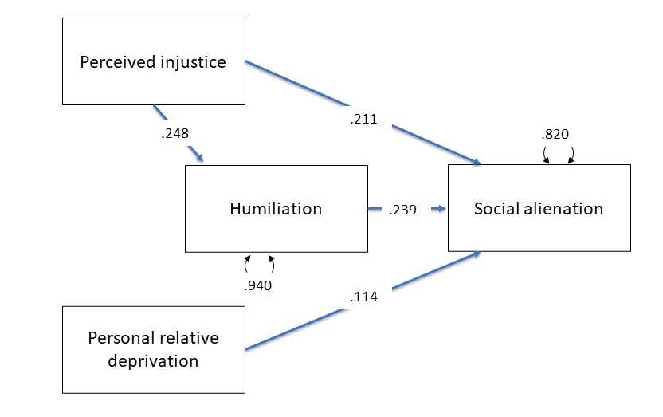
Note:
Blue lines indicate significant positive effect (p < .05). Coefficients are standardized and estimated with MLR.
Control variables: gender, age, education. Two nested models were compared: one estimating the direct effect of perceived injustice toward the group and another where this same effect was not estimated. The model estimating the direct effect of perceived injustice towards the group demonstrated superior fit to the data (Δχ² = 25.808, p < .001; χ² (1) = 0.155, CFI = 1, TLI = 1, robust RMSEA 90% CI [.000, .090], SRMR = .003). Additionally, the inclusion of an effect of personal economic relative deprivation on humiliation did not improve the model fit (Δχ² = 0.155, p = 0.694).

Figure S2. Path analysis for the full model in Study 1a with pooled estimates from alternative datasets with imputed missing data.
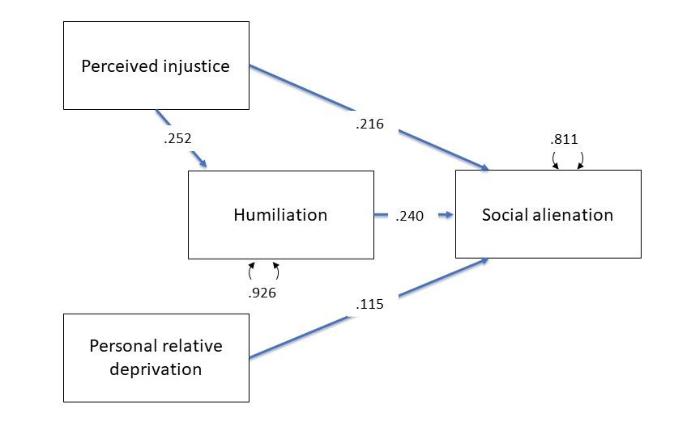
Note:
Blue lines indicate significant positive effect (p < .05). Coefficients are standardized and estimated with MLR.
Robust fit indices:
χ² (1) = 0.151, p = .697, CFI = 1, TLI = 1, RMSEA 90% CI [.000, .089], SRMR = .003, Control variables: gender, age, education.

Figure S3. SEM analysis for the full model in Study 1a.
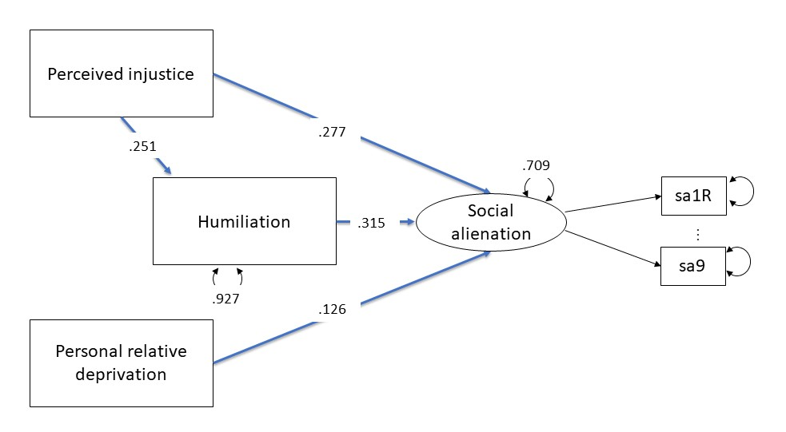
Note:
Blue lines indicate significant positive effect (p < .05). Coefficients are standardized and estimated with MLR.
A covariance was estimated between residuals of item 6 and item 8 from the social alienation scale to improve the model fit (β = 0.412, p < .001).
Indirect effect group injustice on social alienation: ab = [0.042, 0.114].
Robust fit indices:
χ² (75) = 158.684, p < .001, CFI = .916, TLI = 1, RMSEA 90% CI [.036, .056], SRMR = .040, Control variables: gender, age, education.

Figure S4. SEM analysis including anti-mainstream identities in Study 1a with pooled estimates from alternative datasets with imputed missing data.
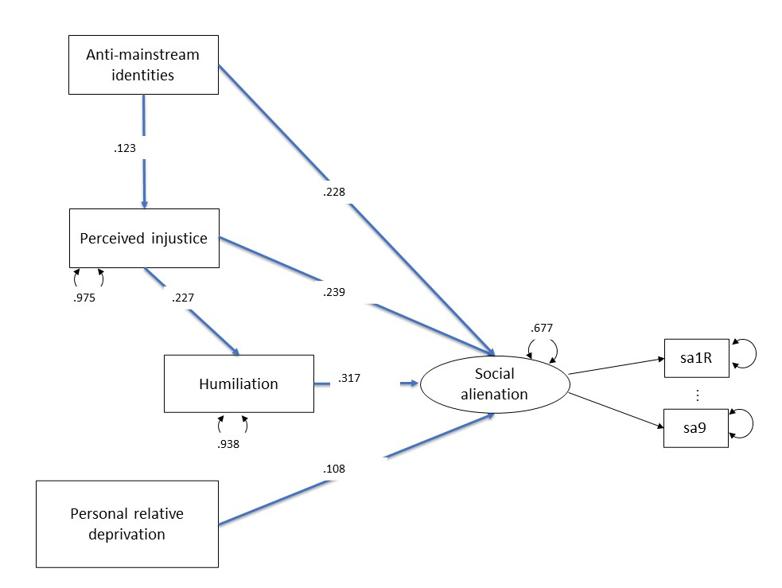
Note:
Blue lines indicate significant positive effect (p < .05). Coefficients are standardized and estimated with MLR.
A covariance was estimated between residuals of item 6 and item 8 from the social alienation scale to improve the model fit (β = 0.415, p < .001).
Serial indirect effect anti-mainstream identities on social alienation Montecarlo 95% robust confidence interval = [0.012, 0.058].
Total effect anti-mainstream identities on social alienation Montecarlo 95% robust confidence interval = [0.440, 0.909].
Robust fit indices:
χ² (85) = 185.563, p < .001, CFI = .905, TLI = 1, RMSEA 90% CI [.038, .056], SRMR = .042, Control variables: Gender, age, education.

Figure S5. SEM analysis for the full model in Study 1b with pooled estimates from alternative datasets with imputed missing data.
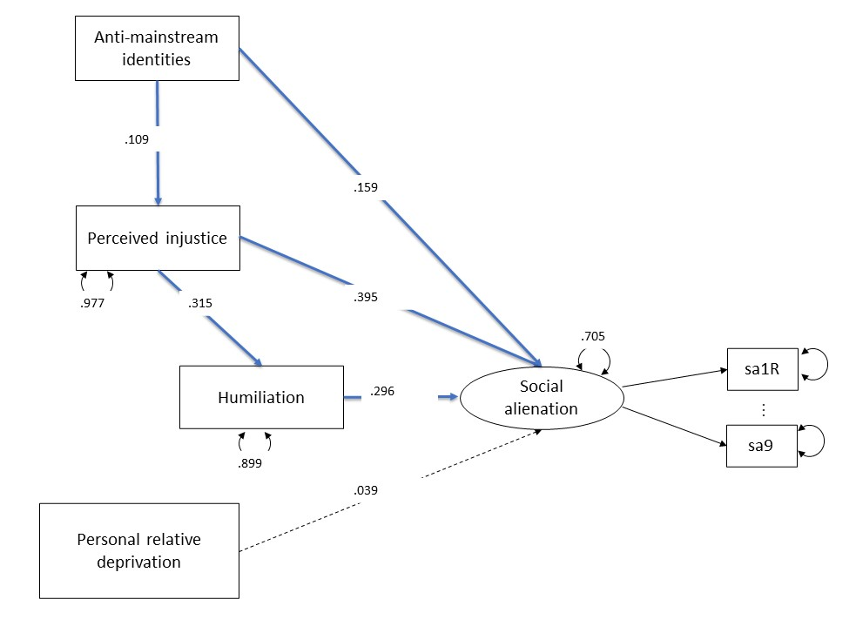
Note:
Blue lines indicate significant positive effect (p < .05). Coefficients are standardized and estimated with MLR.
A covariance was estimated between residuals of item 6 and item 8 from the social alienation scale to improve the model fit (β = 0.324, p < .001).
Robust fit indices:
χ² (71) = 283.911, p < .001, CFI = .869, TLI = .824, RMSEA 90% CI [.048, .041], SRMR = .042, Control variables: gender, age, education.

Figure S6. SEM analysis for the full model in Study 2 with pooled estimates from alternative datasets with imputed missing data
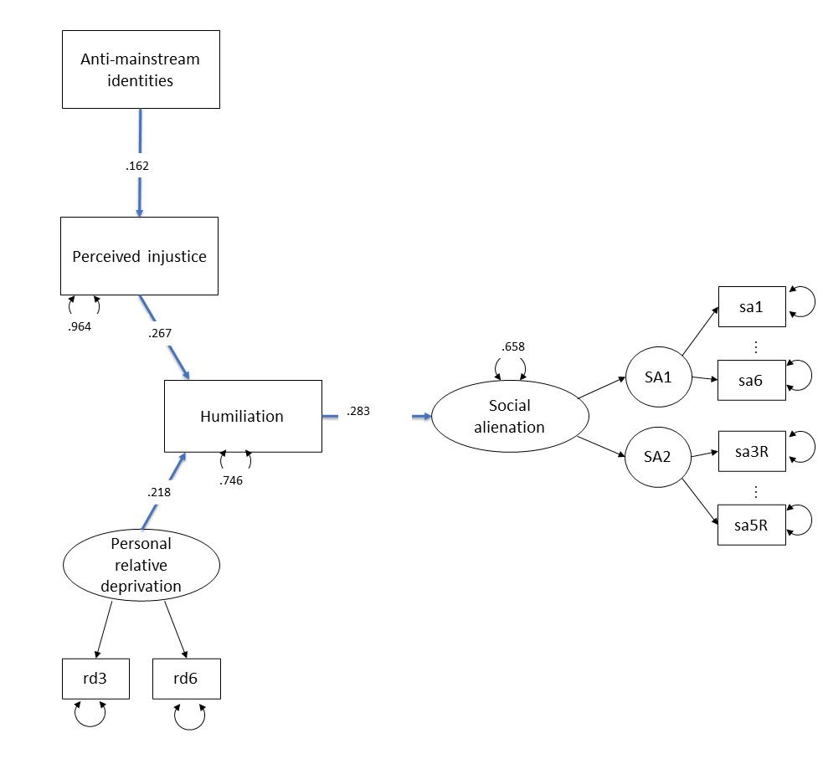
Note:
Blue lines indicate significant positive effect (p < .05). Coefficients are standardized and estimated with MLR.
Robust fit indices:
χ² (97) = 1109.229, p < .001, CFI = .931, TLI = .904, RMSEA 90% CI [.042, .069], SRMR = .065, Control variables: Political orientation, ethnicity, gender, age, education.

Figure S7. SEM analysis for the full model in Study 3a with pooled estimates from alternative datasets with imputed missing data
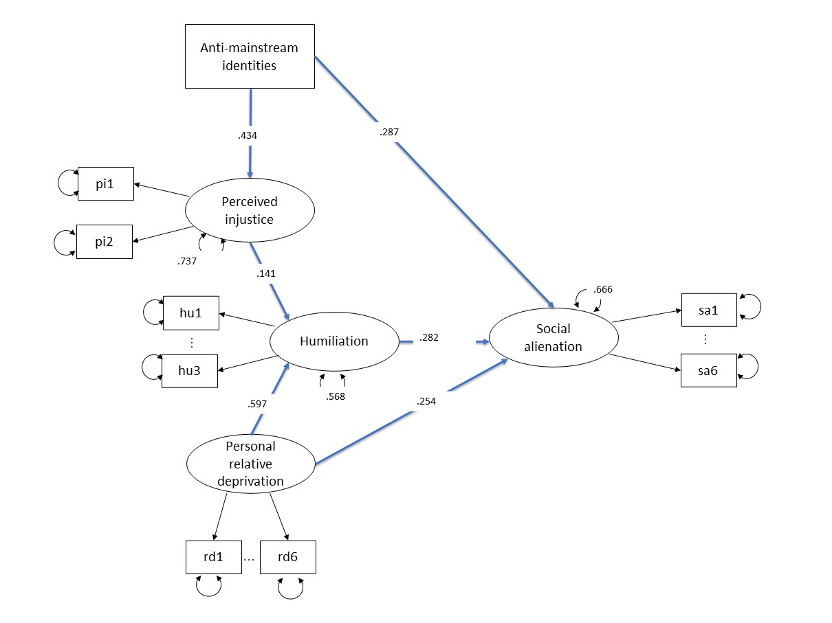
Note:
Blue lines indicate significant positive effect (p < .05). Coefficients are standardized and estimated with MLR.
Robust fit indices:
χ² (228) = 540.321, p < .001, CFI = .926, TLI = .912, RMSEA 90% CI [.055, .067], SRMR = .097, Control variables: Political orientation, gender, age, education.
Figure S8. SEM analysis for the full model in Study 3b with pooled estimates from alternative datasets with imputed missing data
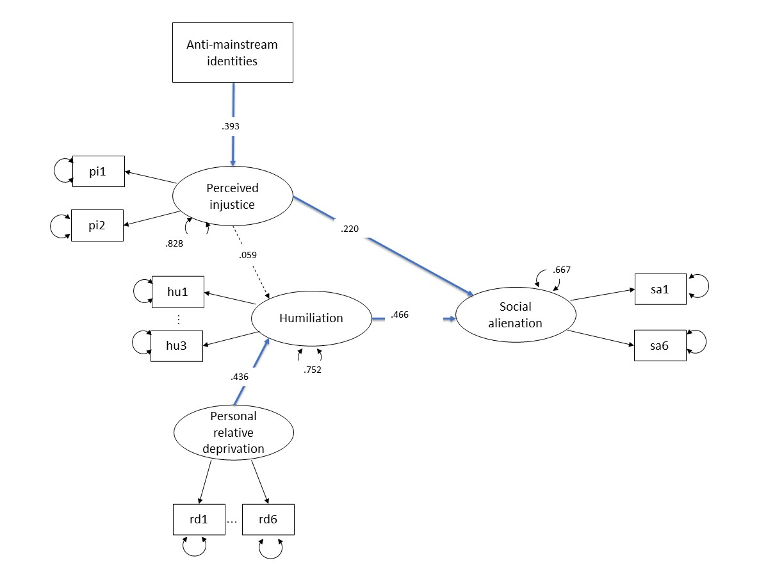
Note:
Blue lines indicate significant positive effect (p < .05). Coefficients are standardized and estimated with MLR.
Robust fit indices:
χ² (208) = 547.776, p < .001, CFI = .910, TLI = .894, RMSEA 90% CI [.060, .073], SRMR = .092, Control variables: Political orientation, gender, age, education.

Figure S9. SEM analysis with exploratory variables in Study 1a.
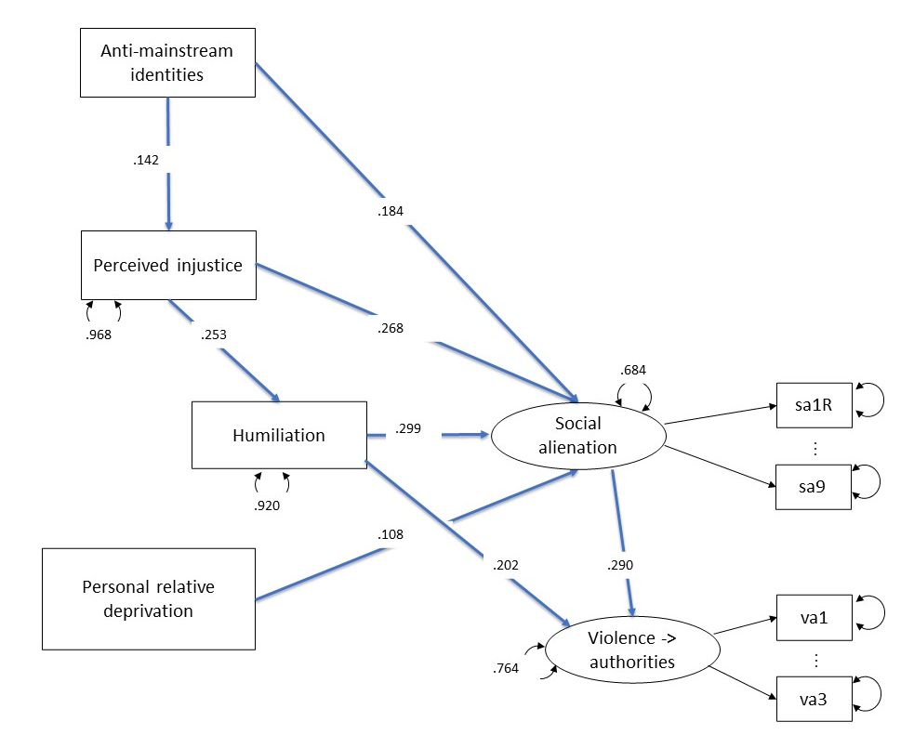
Note:
Support for Violence Toward Authorities was measured with three items (e.g., “To achieve political change, violence towards police officers is sometimes needed”). Participants indicated their level of agreement on a scale ranged 1 (Strongly disagree) to 6 (Strongly agree) (ω = .83).
Blue lines indicate significant positive effect (p < .05). Coefficients are standardized and estimated with MLR.
A covariance was estimated between residuals of item 6 and item 8 from the social alienation scale to improve the model fit (β = 0.403, p < .001).
The resulting model showed acceptable fit to the data (χ² (130) = 250.890, CFI =0.928, TLI = 0.911, robust RMSEA 95% CI [.037, .053], SRMR = .050). Estimating an effect of personal economic relative deprivation on humiliation did not improve the model fit (Δχ² = 0.130, p = 0.719). The effects in the model resulted in an indirect effect of economic relative deprivation on support for violence toward authorities through higher social alienation (ML bootstrapped 95% CI [0.007, 0.064]), and serial indirect effect of identification with politicized groups opposing the policies of the actual government on support for violence toward authorities through higher perceived injustice, humiliation, and social alienation (ML bootstrapped 95% CI [0.001, 0.007]).
Pooled estimates from multiple imputations did not differ from those obtained treating missing values by listwise deletion.

Figure S10. SEM analysis with exploratory variables in Study 1b.
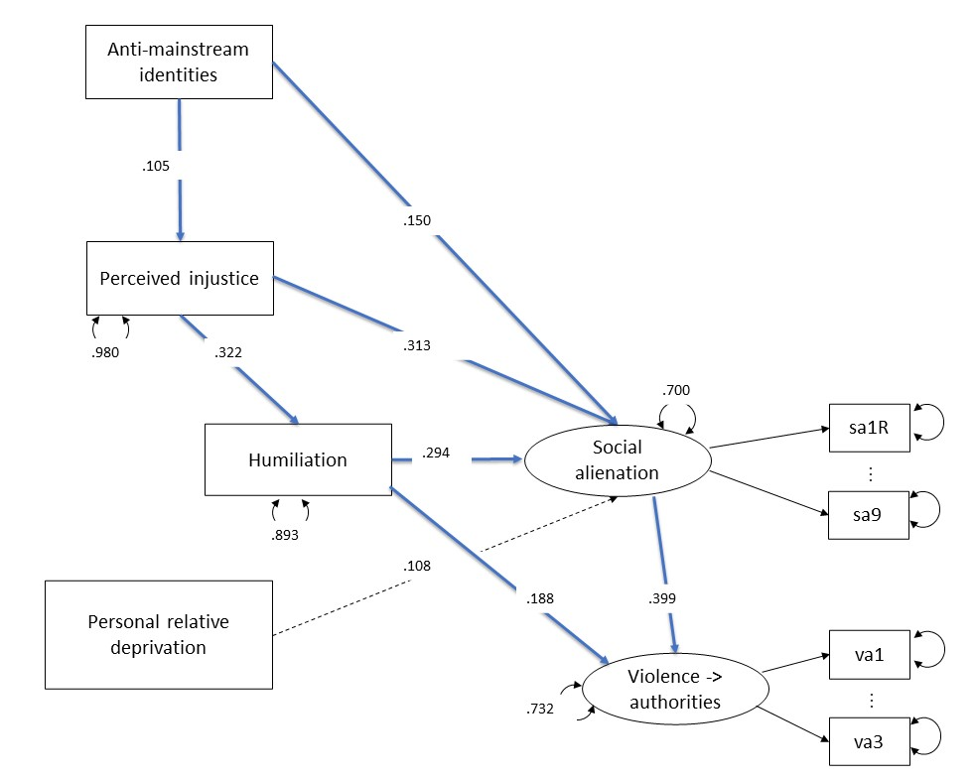
Note:
Support for Violence Toward Authorities was measured with three items (e.g., “To achieve political change, violence towards police officers is sometimes needed”). Participants indicated their level of agreement on a scale ranged 1 (Strongly disagree) to 6 (Strongly agree) (ω = .80).
Blue lines indicate significant positive effect (p < .05). Coefficients are standardized and estimated with MLR.
A covariance was estimated between residuals of item 6 and item 8 from the social alienation scale to improve the model fit (β = 0.318, p < .001).
The resulting model showed acceptable fit to the data (χ² (111) = 372.499, CFI =0.913, TLI = 0.888, robust RMSEA 95% CI [.044, .055], SRMR = .044).
The effects in the model resulted in a serial indirect effect of identification with politicized groups opposing the policies of the actual government on support for violence toward authorities through higher perceived injustice, humiliation, and social alienation (ML bootstrapped 95% CI [0.001, 0.006]). However, contrary to Study 1a, we found no indirect effect of economic relative deprivation on support for violence toward authorities through higher social alienation (ML bootstrapped 95% CI [-0.009, 0.039]),
Pooled estimates from multiple imputations did not differ from those obtained treating missing values by listwise deletion.

