Appendix 1
Figure A1a-e: Mean values of predictor variables by income quartiles over time (SSPW2020, waves 1-4)
a) Economic vulnerability
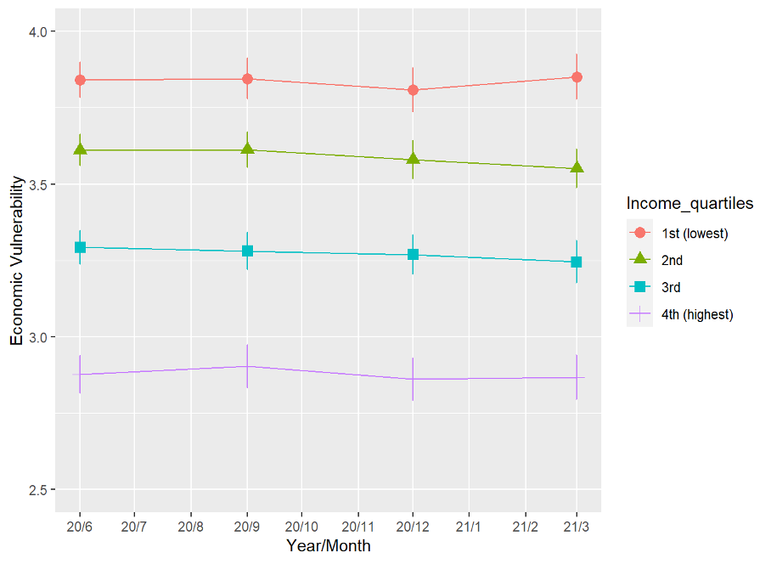
Note: Mean values of economic vulnerability (1-5). Significant differences between income quartiles at each time point (p < 0.001). Within-group changes over time were not significant.

b) Future anxiety

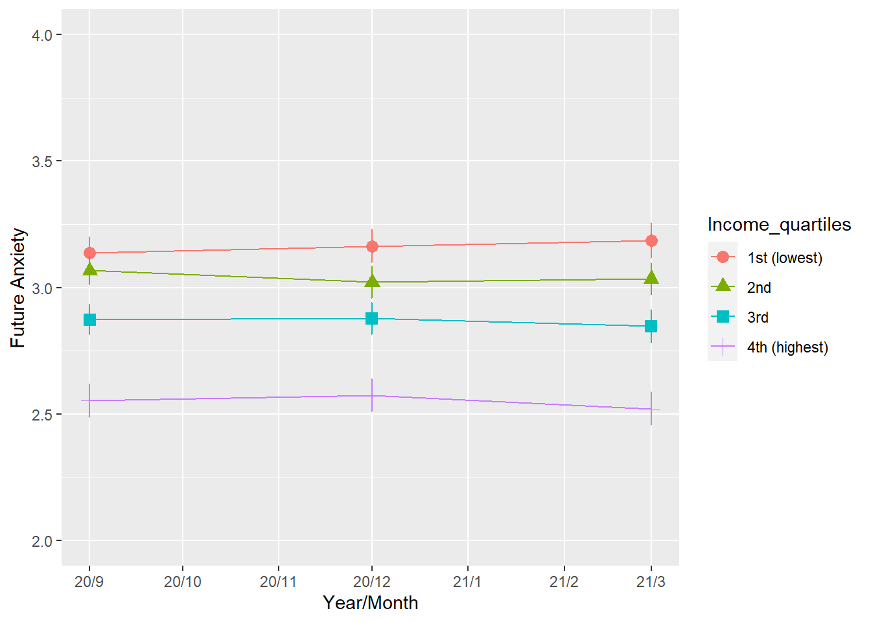
Note: Mean values of future anxiety (1-4). Significant differences between income quartiles at each time point (p < 0.001). Within-group changes over time not signficant.

c) Face-to-face communiction
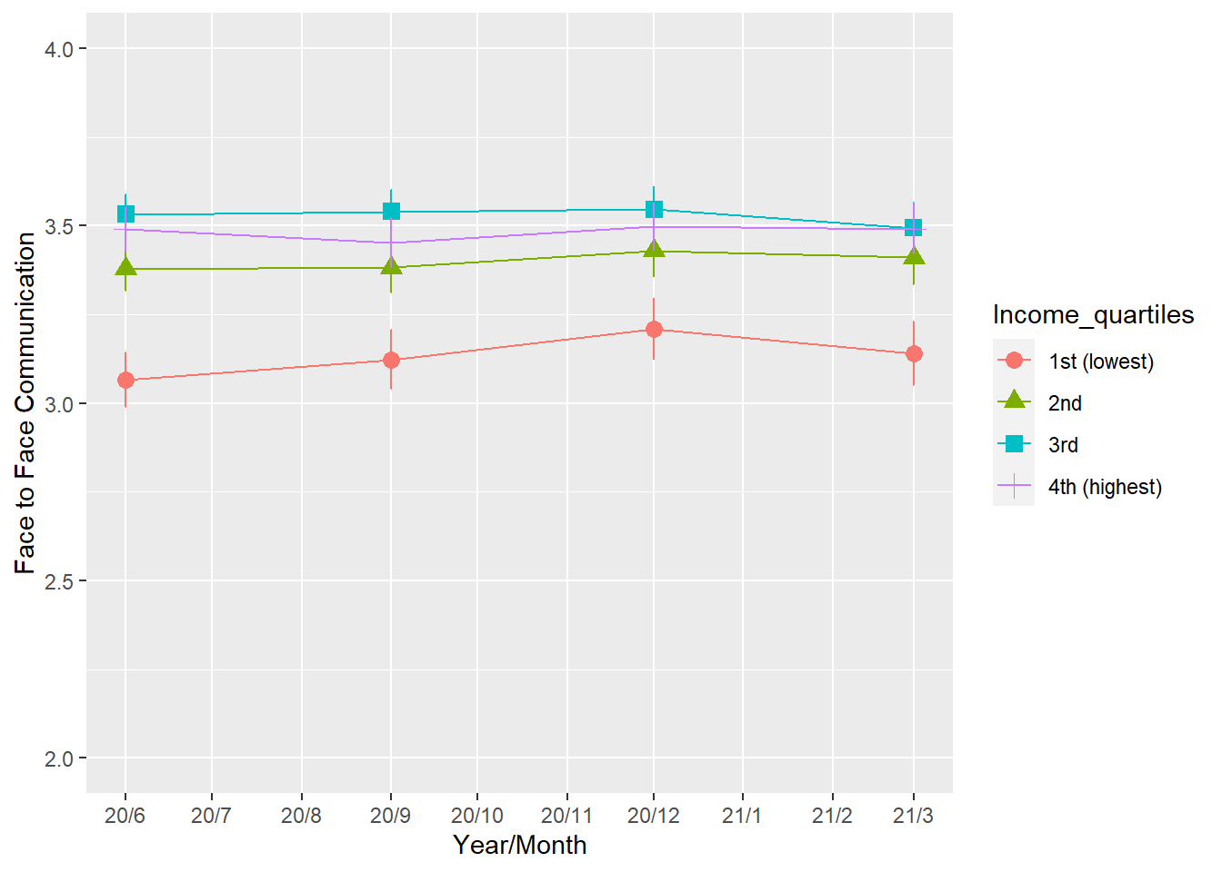Note: Mean values of face-to-face communication (1-4). Significant differences between income quartiles at each time point (p < 0.001). Within-group changes over time not signficant.

d) Remote communication
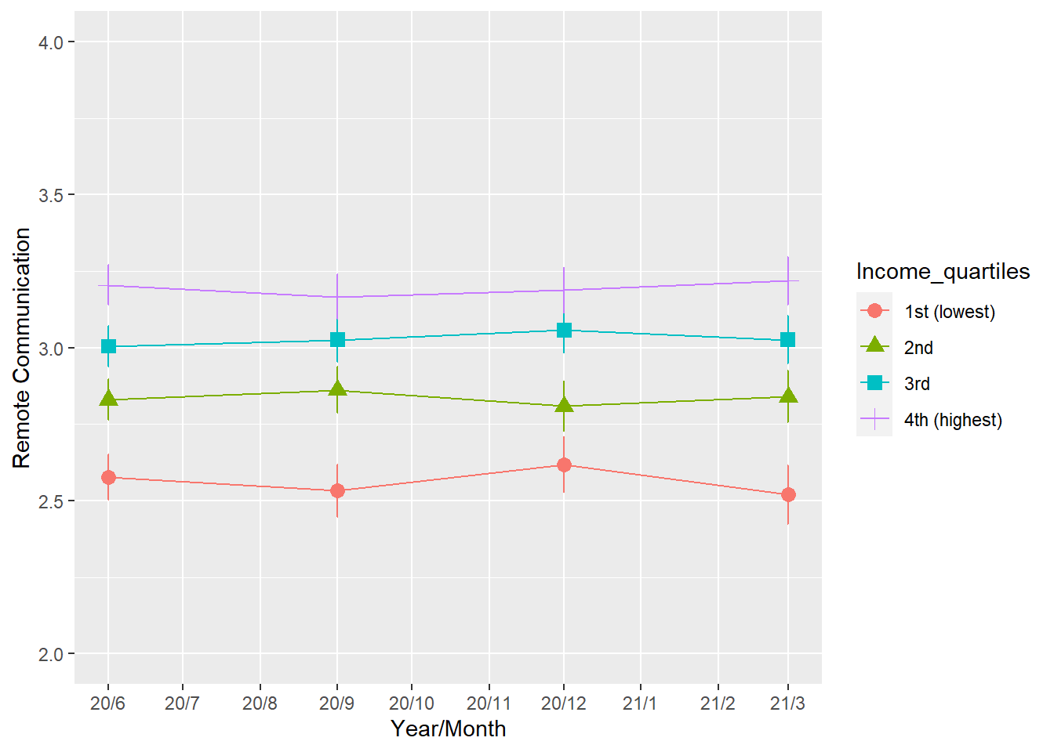
Note: Mean values of remote communication (1-4). Significant differences between income quartiles at each time point (p < 0.001). Within-group changes over time not signficant.

e) General social trust
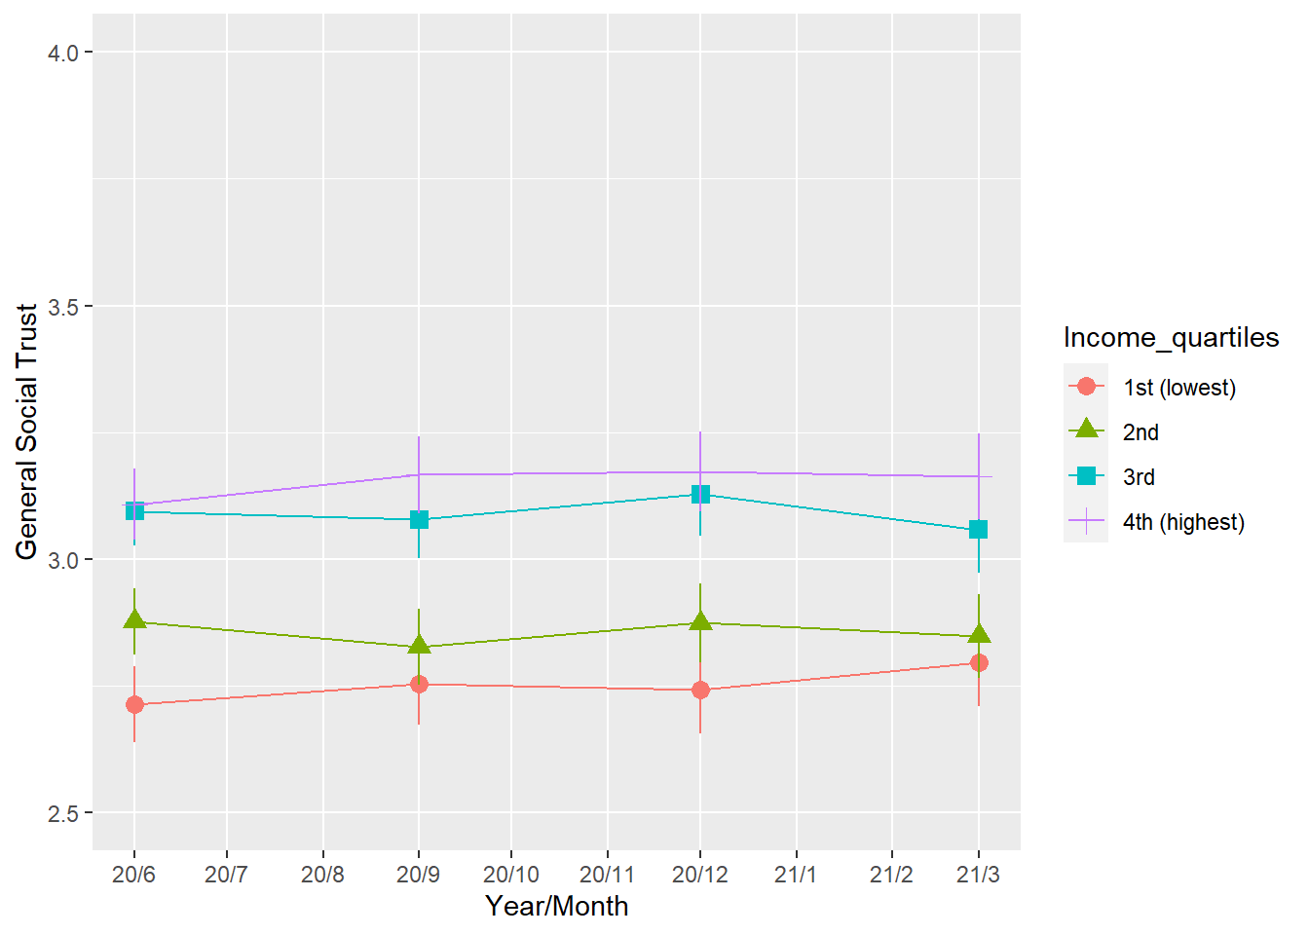

Note: Mean values of general social trust (1-5). Significant differences between income quartiles at each time point (p < 0.01). Within-group changes over time not signficant.

Appendix 2
Figure A2a-g: Mean values of predictor variables by income quartiles over time (SSPW2021, waves 1-4)
a) Economic vulnerabilty
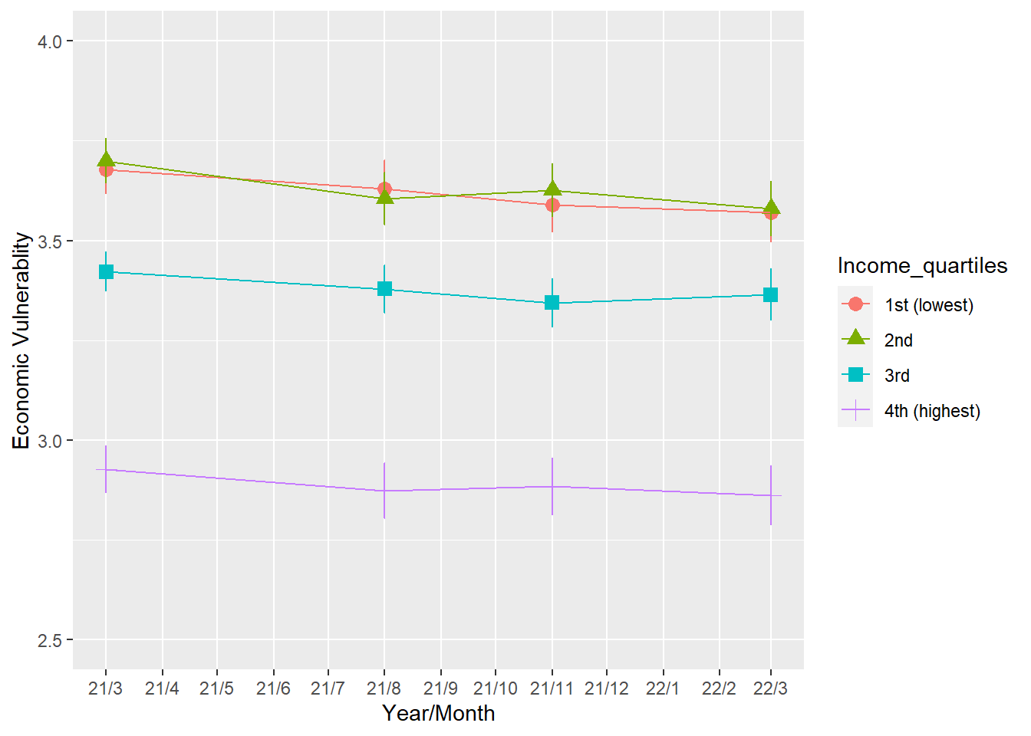
Note: Mean values of economic vulnerability (1-5). Significant differences between income quartiles at each time point (p < 0.001). Within-group changes over time only significant for the 2nd income quartile (p < 0.05).

b) Future Anxiety
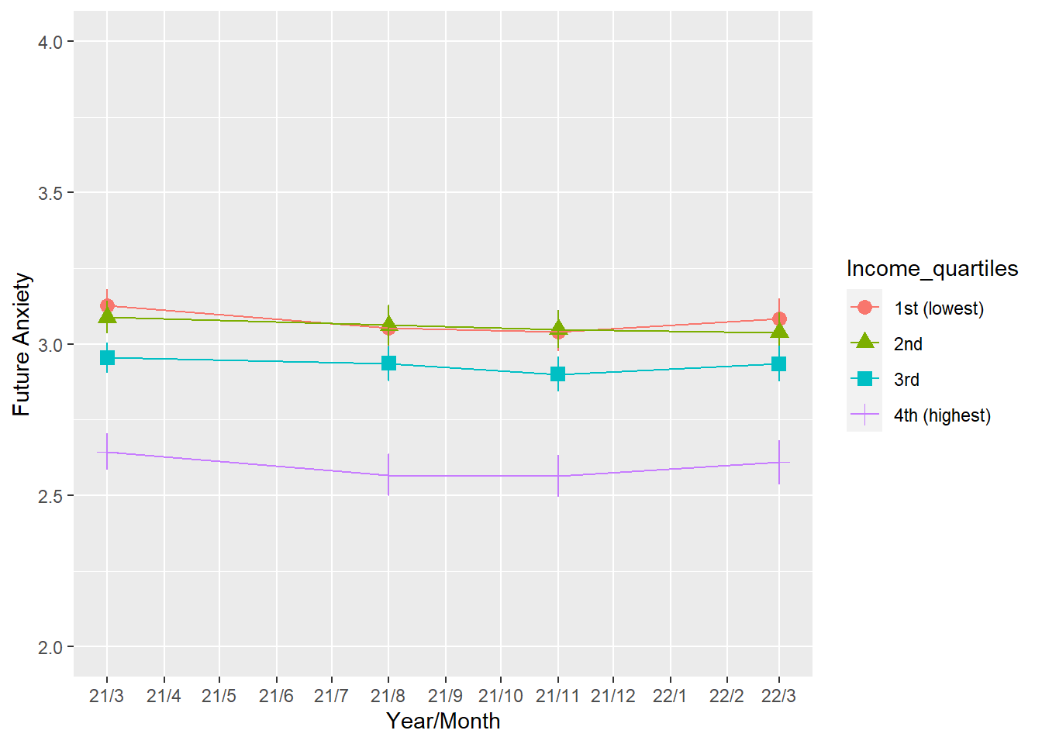
Note: Mean values of future anxiety (1-4). Significant differences between income quartiles at each time point (p < 0.001). Within-group changes over time not signficant.

c) Face-to-face communication
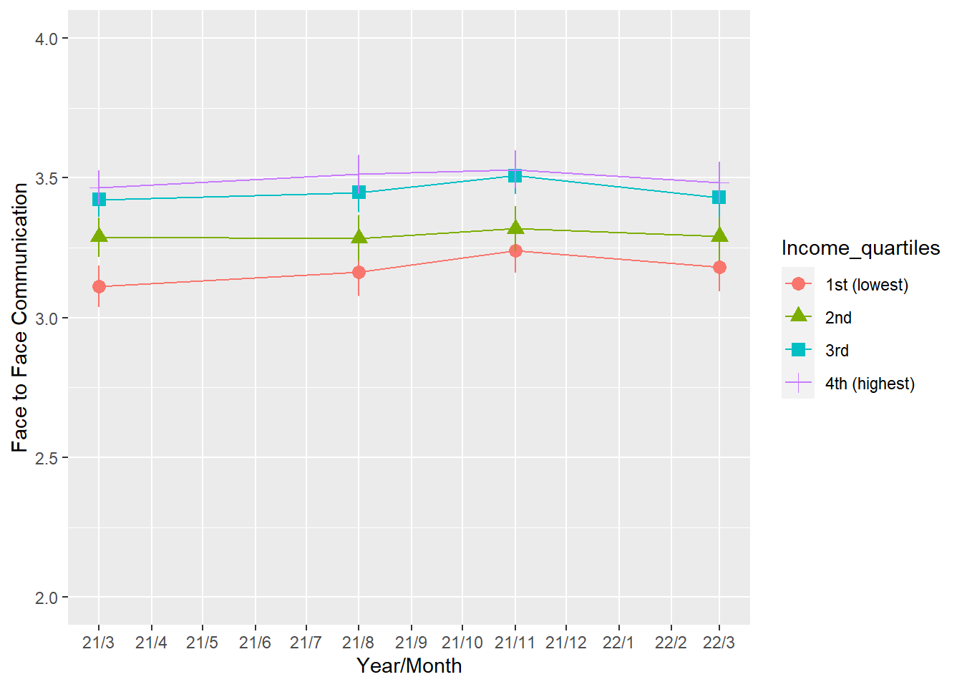
Note: Mean values of face-to-face communication (1-4). Significant differences between income quartiles at each time point (p < 0.001). Within-group changes over time not signficant.

d) Remote communication
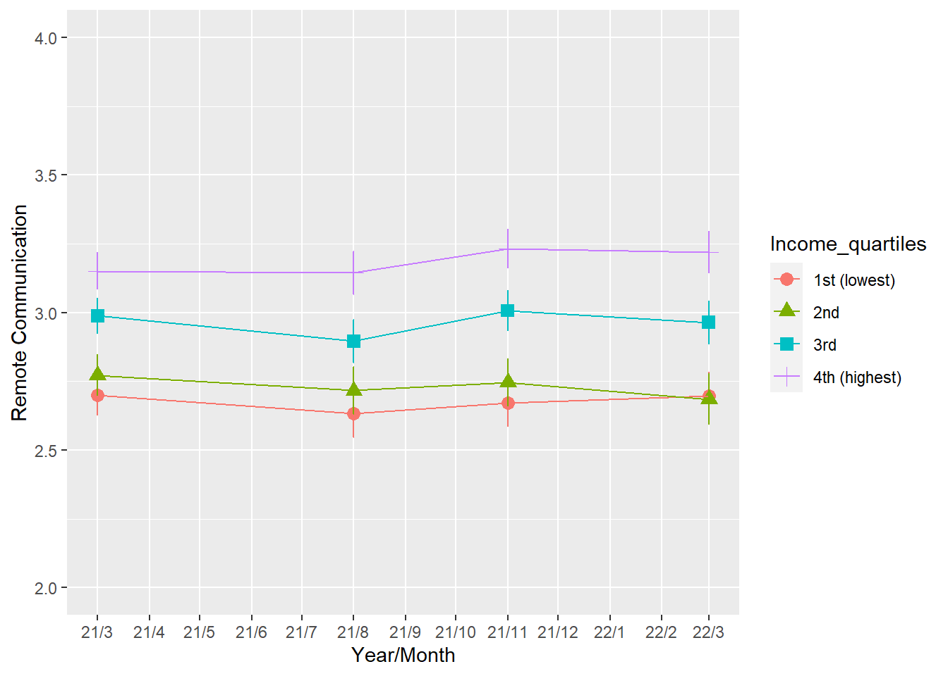
Note: Mean values of remote communication (1-4). Significant differences between income quartiles at each time point (p < 0.001). Within-group changes over time not signficant.

e) Social support
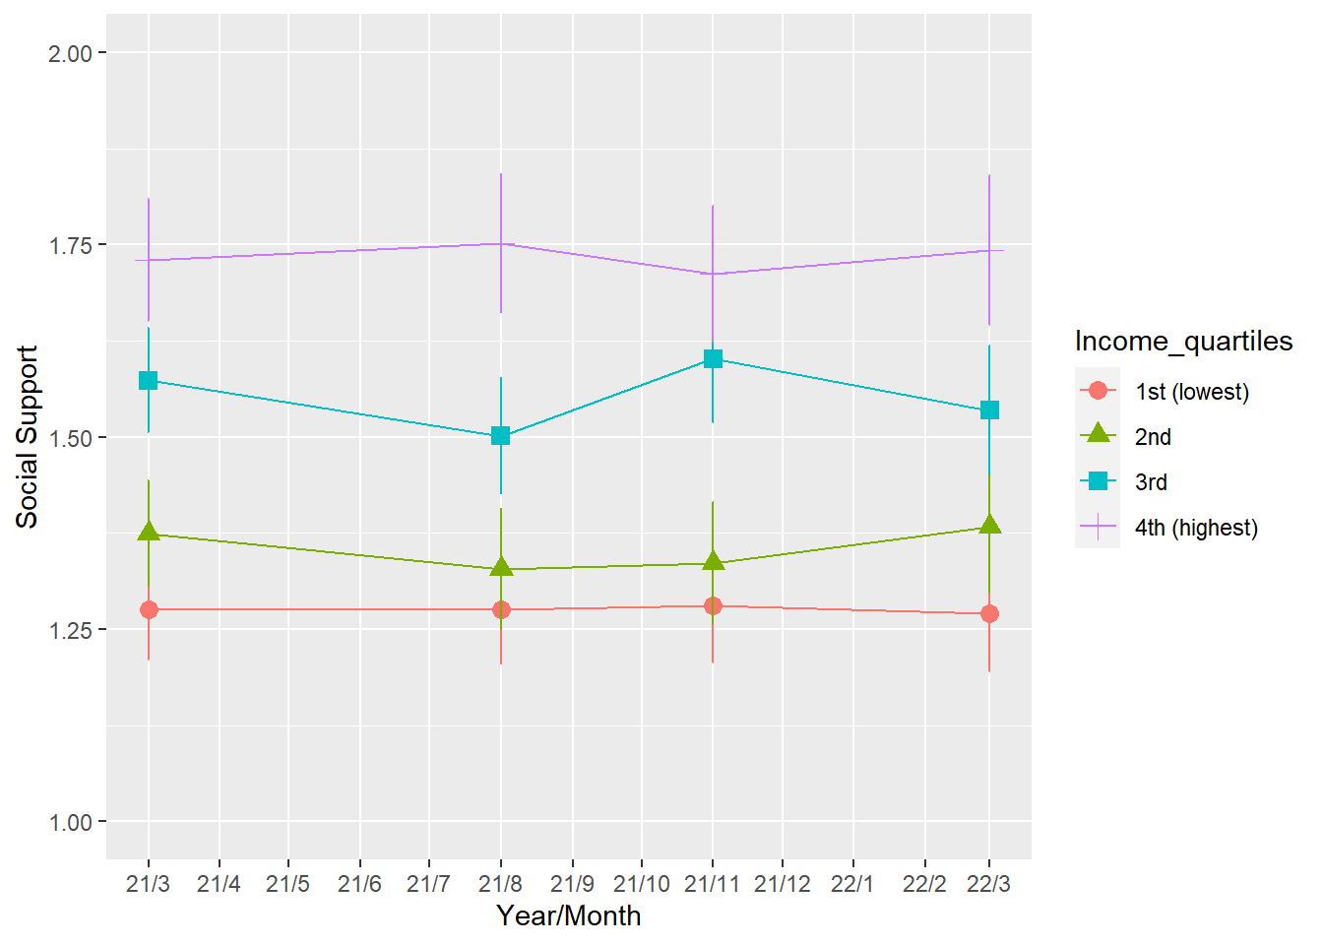
Note: Mean values of social support (0-6). Significant differences between income quartiles at each time point (p < 0.001). Within-group changes over time not signficant.

f) General social trust
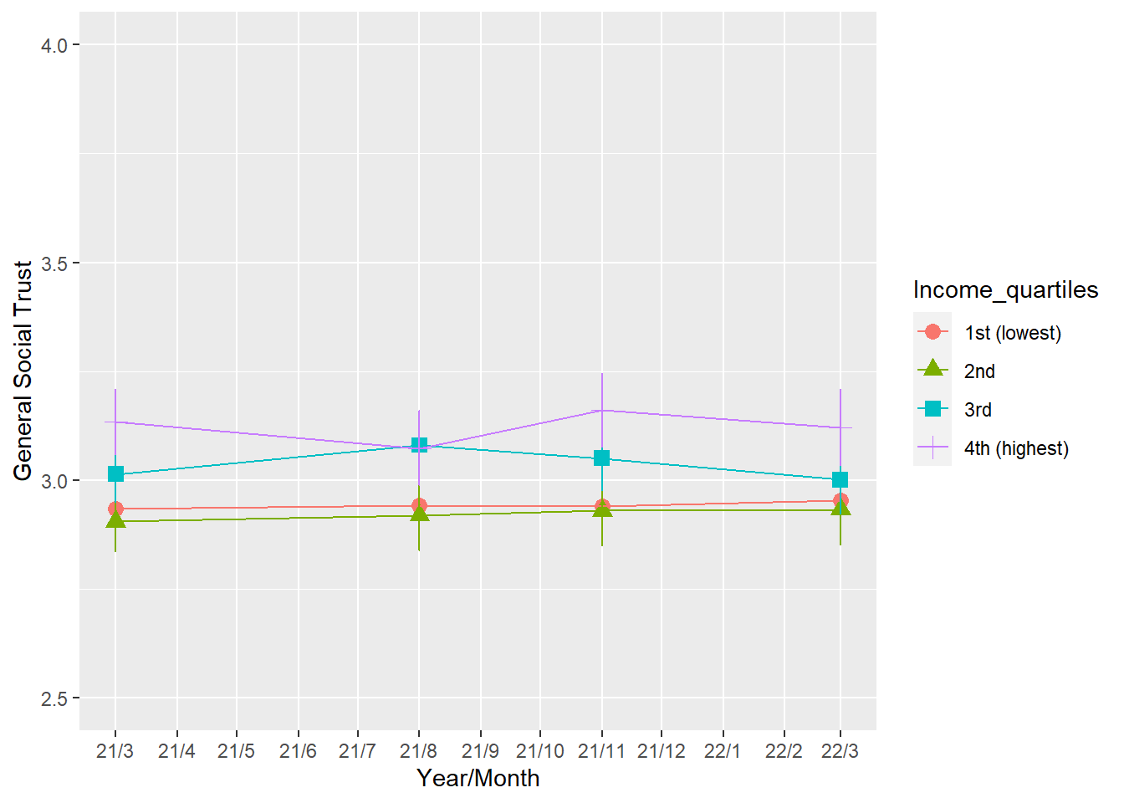
Note: Mean values of general social trust (1-5). Significant differences between income quartiles at each time point (p < 0.01). Within-group changes over time not signficant.

g) Trust in government
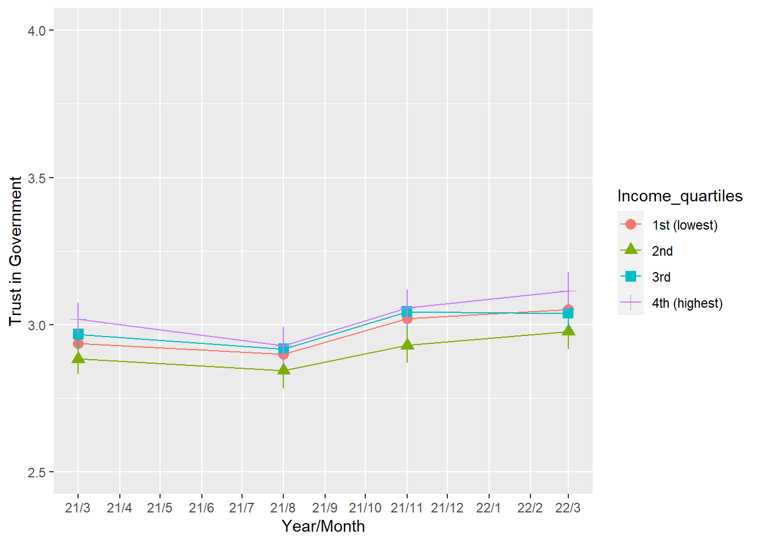
Note: Mean values of trust in government (1-5). Significant differences between income quartiles at each time point (p < 0.05), except wave 2. Within-group changes over time signficant for all income quartile (p < 0.05).

Appendix 3
Table A3: Results of Two-way Fixed Effects Models on Mental Health (Quasi-panel)
