Supplementary Material

Figure S1. Incidence of diagnosis of six ICD-10 disease categories in 2015
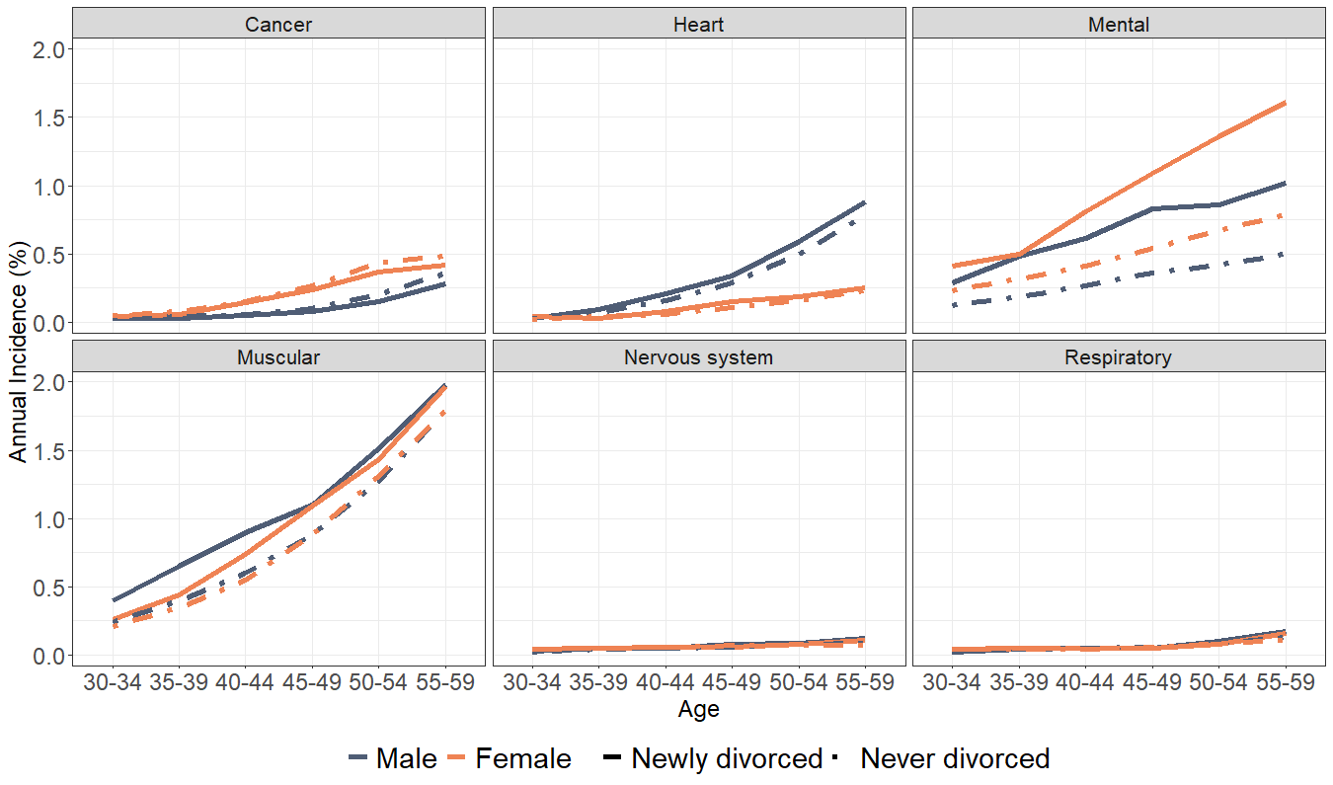
Source: AKVS statistics, REHA statistics, and VA statistics 2015; own estimates.
Note: Cancer (N=43,301); heart disease (N= 48,140); mental disease (N= 95,718); muscular disease (N=200,837); nervous system disease (N= 13,496); respiratory disease (N=14,880).

Table S1. Distribution of mental disease according to ICD-10 classification
Mental disease | Percent
Dementia and Alzheimer disease (F00) | 0.01
Vascular dementia (F01) | 0.00
Dementia in other diseases classified elsewhere (F02) | 0.00
Unspecified dementia (F03) | 0.02
Organic amnestic syndrome, not included by alcohol and other psychoactive substances (F04) | 0.01
Delirium, not included by alcohol and other psychoactive substances (F05) | 0.00
Other mental disorders due to brain damage and dysfunction and to physical disease (F06) | 0.25
Personality and behavioral disorders due to brain disease, damage and dysfunction (F07) | 0.13
Unspecified organic or symptomatic mental disorder (F09) | 0.00
Schizophrenia (F20) | 0.67
Schizotypal disorder (F21) | 0.03
Persistent delusional disorders (F22) | 0.07
Acute and transient psychotic disorders (F23) | 0.06
Induced delusional disorder (F24) | 0.00
Schizoaffective disorders (F25) | 0.52
Other nonorganic psychotic disorders (F28) | 0.00
Unspecified nonorganic psychosis (F29) | 0.00
Manic episode (F30) | 0.01
Bipolar affective disorder (F31) | 0.97
Depressive episode (F32) | 24.06
Recurrent depressive disorder (F33) | 29.02
Persistent mood [affective] disorders (F34) | 1.20
Other mood [affective] disorder (F38) | 0.01
Unspecified mood [affective] disorder (F39) | 0.01
Phobic anxiety disorders (F40) | 1.97
Other anxiety disorders (F41) | 5.88
Obsessive-compulsive disorder (F42) | 0.46
Reaction to severe stress, and adjustment disorders (F43) | 15.58
Dissociative [conversion] disorders (F44) | 0.27
Somatoform disorders (F45) | 8.37
Other neurotic disorders (F48) | 3.97
Eating disorders (F50) | 0.88
Nonorganic sleep disorders (F51) | 0.15
Sexual dysfunction, not caused by organic disorder or disease (F52) | 0.00
Mental and behavioral disorders associated with the puerperium, not elsewhere classified (F53) | 0.01
Psychological and behavioral factors associated with disorders or diseases classified elsewhere (F54) | 0.39
Abuse of non-dependence-producing substances (F55) | 0.01
Unspecified behavioral syndromes associated with physiological disturbances and physical factors (F59) | 0.00
Specific personality disorders (F60) | 0.96
Mixed and other personality disorders (F61) | 0.59
Enduring personality changes, not attributable to brain damage and disease (F62) | 0.12
Habit and impulse disorders (F63) | 1.04
Gender identity disorders (F64) | 0.00
Disorders of sexual preference (F65) | 0.01
Psychological and behavioral disorders associated with sexual development and orientation (F66) | 0.00
Other disorders of adult personality and behavior (F68) | 0.05
Unspecified disorder of adult personality and behavior (F69) | 0.01
Mild mental retardation (F70) | 0.03
Moderate mental retardation (F71) | 0.00
Severe mental retardation (F72) | 0.00
Unspecified mental retardation (F79) | 0.00
Specific developmental disorders of speech and language (F80) | 0.53
Specific developmental disorders of scholastic skills (F81) | 0.02
Specific developmental disorder of motor function (F82) | 0.03
Mixed specific developmental disorders (F83) | 0.15
Pervasive developmental disorders (F84) | 0.06
Other disorders of psychological development (F88) | 0.00
Unspecified disorder of psychological development (F89) | 0.02
Hyperkinetic disorders (F90) | 0.72
Conduct disorders (F91) | 0.09
Mixed disorders of conduct and emotions (F92) | 0.10
Emotional disorders with onset specific to childhood (F93) | 0.26
Disorders of social functioning with onset specific to childhood and adolescence (F94) | 0.04
Tic disorders (F95) | 0.02
Other behavioral and emotional disorders with onset usually occurring in childhood and adolescence (F98) | 0.18
Mental disorder, not otherwise specified (F99) | 0.00
Total | 100

Table S2. Predicted incidence of mental disease diagnosis (model 1), for the never divorced sample, by social strata
Strata | Sex | Age group | Income | % of individuals | Predicted incidence | SE
1 | Male | 30-39 | High | 3.11 | 0.04 | 0.16
2 | Male | 30-39 | Upper middle | 4.32 | 0.08 | 0.16
3 | Male | 30-39 | Lower middle | 4.83 | 0.08 | 0.16
4 | Male | 30-39 | Low | 5.47 | 0.32 | 0.16
5 | Male | 40-49 | High | 4.71 | 0.15 | 0.16
6 | Male | 40-49 | Upper middle | 4.33 | 0.25 | 0.16
7 | Male | 40-49 | Lower middle | 3.96 | 0.23 | 0.16
8 | Male | 40-49 | Low | 4.25 | 0.60 | 0.16
9 | Male | 50-59 | High | 4.49 | 0.28 | 0.16
10 | Male | 50-59 | Upper middle | 4.24 | 0.35 | 0.16
11 | Male | 50-59 | Lower middle | 3.73 | 0.37 | 0.16
12 | Male | 50-59 | Low | 4.40 | 0.83 | 0.16
13 | Female | 30-39 | High | 0.83 | 0.13 | 0.16
14 | Female | 30-39 | Upper middle | 2.10 | 0.15 | 0.16
15 | Female | 30-39 | Lower middle | 3.49 | 0.20 | 0.16
16 | Female | 30-39 | Low | 9.05 | 0.34 | 0.16
17 | Female | 40-49 | High | 1.11 | 0.19 | 0.16
18 | Female | 40-49 | Upper middle | 2.34 | 0.40 | 0.16
19 | Female | 40-49 | Lower middle | 3.78 | 0.37 | 0.16
20 | Female | 40-49 | Low | 8.87 | 0.56 | 0.16
21 | Female | 50-59 | High | 1.15 | 0.38 | 0.16
22 | Female | 50-59 | Upper middle | 2.58 | 0.58 | 0.16
23 | Female | 50-59 | Lower middle | 3.84 | 0.63 | 0.16
24 | Female | 50-59 | Low | 9.03 | 0.84 | 0.16
Total |  |  |  | 100
Note: N=22,884,321.

Table S3. Predicted incidence of mental disease diagnosis (model 1), for the newly divorced sample, by social strata
Strata | Gender | Age group | Income | % of individuals | Predicted incidence | SE
1 | Male | 30-39 | High | 1.59 | 0.24 | 0.14
2 | Male | 30-39 | Upper middle | 2.81 | 0.18 | 0.14
3 | Male | 30-39 | Lower middle | 3.30 | 0.26 | 0.14
4 | Male | 30-39 | Low | 3.41 | 0.85 | 0.14
5 | Male | 40-49 | High | 5.11 | 0.33 | 0.14
6 | Male | 40-49 | Upper middle | 5.73 | 0.54 | 0.14
7 | Male | 40-49 | Lower middle | 5.07 | 0.45 | 0.14
8 | Male | 40-49 | Low | 4.86 | 1.67 | 0.14
9 | Male | 50-59 | High | 4.19 | 0.49 | 0.14
10 | Male | 50-59 | Upper middle | 4.05 | 0.64 | 0.14
11 | Male | 50-59 | Lower middle | 3.38 | 0.63 | 0.14
12 | Male | 50-59 | Low | 4.02 | 1.86 | 0.14
13 | Female | 30-39 | High | 0.29 | 0.32 | 0.14
14 | Female | 30-39 | Upper middle | 1.24 | 0.31 | 0.14
15 | Female | 30-39 | Lower middle | 3.40 | 0.29 | 0.14
16 | Female | 30-39 | Low | 11.29 | 0.54 | 0.14
17 | Female | 40-49 | High | 0.74 | 0.50 | 0.14
18 | Female | 40-49 | Upper middle | 2.85 | 0.62 | 0.14
19 | Female | 40-49 | Lower middle | 6.27 | 0.62 | 0.14
20 | Female | 40-49 | Low | 12.81 | 1.23 | 0.14
21 | Female | 50-59 | High | 0.62 | 0.61 | 0.14
22 | Female | 50-59 | Upper middle | 2.12 | 1.18 | 0.14
23 | Female | 50-59 | Lower middle | 3.64 | 1.08 | 0.14
24 | Female | 50-59 | Low | 7.21 | 1.75 | 0.14
Note: N=543,318.

Table S4. Strata-level residuals of the model adjusted for covariates (model 2), for the never divorced sample
Stratum rank | Strata | Gender | Age group | Income | Residuals | SE
1 | 24 | Female | 50-59 | Low | -0.38 | 0.11
2 | 20 | Female | 40-49 | Low | -0.30 | 0.11
3 | 1 | Male | 30-39 | High | -0.29 | 0.13
4 | 3 | Male | 30-39 | Lower middle | -0.23 | 0.12
5 | 2 | Male | 30-39 | Upper middle | -0.17 | 0.12
6 | 10 | Male | 50-59 | Upper middle | -0.07 | 0.11
7 | 17 | Female | 40-49 | High | -0.05 | 0.13
8 | 7 | Male | 40-49 | Lower middle | -0.04 | 0.12
9 | 14 | Female | 30-39 | Upper middle | -0.03 | 0.12
10 | 5 | Male | 40-49 | High | -0.02 | 0.12
11 | 11 | Male | 50-59 | Lower middle | -0.02 | 0.12
12 | 19 | Female | 40-49 | Lower middle | 0.01 | 0.11
13 | 12 | Male | 50-59 | Low | 0.03 | 0.11
14 | 6 | Male | 40-49 | Upper middle | 0.04 | 0.12
15 | 16 | Female | 30-39 | Low | 0.04 | 0.11
16 | 22 | Female | 50-59 | Upper middle | 0.08 | 0.12
17 | 23 | Female | 50-59 | Lower middle | 0.09 | 0.11
18 | 13 | Female | 30-39 | High | 0.09 | 0.14
19 | 21 | Female | 50-59 | High | 0.12 | 0.12
20 | 18 | Female | 40-49 | Upper middle | 0.15 | 0.12
21 | 9 | Male | 50-59 | High | 0.15 | 0.12
22 | 15 | Female | 30-39 | Lower middle | 0.19 | 0.12
23 | 8 | Male | 40-49 | Low | 0.21 | 0.12
24 | 4 | Male | 30-39 | Low | 0.39 | 0.12

Table S5. Strata-level residuals of the model adjusted for covariates (model 2), for the newly divorced sample
Stratum rank | Strata | Gender | Age group | Income | Residuals | SE
1 | 16 | Female | 30-39 | Low | -0.24 | 0.11
2 | 2 | Male | 30-39 | Upper middle | -0.20 | 0.13
3 | 24 | Female | 50-59 | Low | -0.19 | 0.11
4 | 20 | Female | 40-49 | Low | -0.19 | 0.12
5 | 10 | Male | 50-59 | Upper middle | -0.13 | 0.11
6 | 11 | Male | 50-59 | Lower middle | -0.12 | 0.11
7 | 5 | Male | 40-49 | High | -0.11 | 0.12
8 | 7 | Male | 40-49 | Lower middle | -0.10 | 0.11
9 | 9 | Male | 50-59 | High | -0.08 | 0.12
10 | 15 | Female | 30-39 | Lower middle | -0.01 | 0.12
11 | 3 | Male | 30-39 | Lower middle | 0.01 | 0.12
12 | 21 | Female | 50-59 | High | 0.02 | 0.14
13 | 6 | Male | 40-49 | Upper middle | 0.02 | 0.11
14 | 19 | Female | 40-49 | Lower middle | 0.02 | 0.11
15 | 14 | Female | 30-39 | Upper middle | 0.02 | 0.13
16 | 18 | Female | 40-49 | Upper middle | 0.02 | 0.11
17 | 13 | Female | 30-39 | High | 0.03 | 0.15
18 | 12 | Male | 50-59 | Low | 0.03 | 0.11
19 | 17 | Female | 40-49 | High | 0.06 | 0.14
20 | 1 | Male | 30-39 | High | 0.08 | 0.14
21 | 23 | Female | 50-59 | Lower middle | 0.20 | 0.11
22 | 22 | Female | 50-59 | Upper middle | 0.28 | 0.11
23 | 8 | Male | 40-49 | Low | 0.28 | 0.11
24 | 4 | Male | 30-39 | Low | 0.32 | 0.11

