Appendix A
Table A1: Logistic regression predicting odds of employment — unadjusted and adjusted for selection into motherhood (IPW)

 |  | Unadjusted |  |  | Adjusted for selection into motherhood
Employed | Model 1 |  | Model 2 | Model 3 |  | Model 1 | Model 2 | Model 3
Number of children | -0.291***  (0.008) |  | -0.289***  (0.008) | -0.444***  (0.011) |  | -0.298***  (0.011) | -0.292***  (0.012) | -0.334***  (0.014)
Non-European origin (both parents) | -0.726***  (0.052) |  | -0.561***  (0.078) | -0.362***  (0.084) |  | -0.670***  (0.065) | -0.552***  (0.108) | -0.385**  (0.117)
European origin (both parents) | 0.118  (0.084) |  | 0.021  (0.137) | -0.143  (0.140) |  | -0.099  (0.110) | -0.426*  (0.192) | -0.551**  (0.209)
One non-European origin parent | -0.197***  (0.039) |  | -0.152*  (0.059) | -0.192**  (0.063) |  | -0.207***  (0.050) | -0.148  (0.083) | -0.108  (0.088)
Second-generation (other) | 0.078  (0.041) |  | -0.041  (0.062) | -0.066  (0.065) |  | 0.034  (0.051) | -0.005  (0.083) | 0.011  (0.086)
Graduate education | - |  | - | 0.829***  (0.036) |  | - | - | 1.024***  (0.045)
Living with a partner | - |  | - | 0.551***  (0.023) |  | - | - | 0.542***  (0.027)
Age | - |  | - | 0.075***  (0.002) |  | - | - | 0.061***  (0.003)
Living in disadvantaged area (ZUS) | - |  | - | -0.751***  (0.041) |  | - | - | -0.765***  (0.051)
Non-European origin × n children | - |  | -0.115**  (0.042) | -0.102*  (0.046) |  | - | -0.083  (0.054) | -0.058  (0.057)
European origin × n children | - |  | 0.058  (0.076) | 0.094  (0.077) |  | - | 0.254*  (0.102) | 0.306**  (0.109)
One non-European parent × n children | - |  | -0.032  (0.032) | -0.021  (0.035) |  | - | -0.043  (0.042) | -0.062  (0.043)
Second-generation × n children | - |  | 0.085*  (0.034) | 0.058  (0.037) |  | - | 0.029  (0.043) | 0.018  (0.044)
Constant | 1.664***  (0.015) |  | 1.661***  (0.016) | -1.059***  (0.067) |  | 1.619***  (0.023) | 1.611***  (0.025) | -0.900***  (0.090)
Pseudo R² | 0.029 |  | 0.029 | 0.076 |  | 0.029 | 0.029 | 0.081
N | 70,280 |  | 70,280 | 64,020 |  | 64,020 | 64,020 | 64,020
*p<0.05, **p<0.01, ***p<0.001
IPW models weighted by inverse probability of motherhood. Unweighted Model 1 N=70,280 includes full sample; Models 2–3 restricted to N=64,020 due to missing values on covariates.
SOURCE: Enquête emploi en continu (EEC) 2015–2020.

Table A2: Predicted probabilities of employment by origin and children (adjusted for selection into motherhood)

Group | Predicted Prob. | 95% CI Lower | 95% CI Upper
All women without children (average) | 0.940 | 0.935 | 0.946
All women with two children (average) | 0.889 | 0.880 | 0.897
Non-European origin without children | 0.917 | 0.899 | 0.935
Non-European origin with two children | 0.835 | 0.814 | 0.856
European origin without children | 0.902 | 0.866 | 0.938
European origin with two children | 0.894 | 0.874 | 0.915
One non-European parent without children | 0.935 | 0.925 | 0.945
One non-European parent with two children | 0.868 | 0.855 | 0.882
Second-generation (other) without children | 0.941 | 0.932 | 0.950
Second-generation (other) with two children | 0.892 | 0.881 | 0.904
Wald test | 1894.55 |  | p<0.001
Note | Representative case: age 35, partnered, bac+5, not in ZUS
*p<0.05, **p<0.01, ***p<0.001
SOURCE: Enquête emploi en continu (EEC) 2015–2020.

Table A3: Predicted monthly income by origin and children (adjusted for selection into motherhood and employment)

Group | Predicted Income (EUR) | CI Lower (EUR) | CI Upper (EUR)
Native origin without children | €2,078.87 | €2,046.21 | €2,111.54
Native origin with two children | €2,052.36 | €2,024.67 | €2,080.04
Non-European origin without children | €2,058.56 | €1,949.01 | €2,168.11
Non-European origin with two children | €2,032.30 | €1,926.38 | €2,138.22
European origin without children | €1,964.63 | €1,830.43 | €2,098.83
European origin with two children | €1,939.57 | €1,806.73 | €2,072.41
One non-European parent without children | €2,040.74 | €1,973.15 | €2,108.33
One non-European parent with two children | €2,014.71 | €1,946.89 | €2,082.54
Second-generation (other) without children | €2,140.00 | €2,057.76 | €2,222.24
Second-generation (other) with two children | €2,112.70 | €2,031.34 | €2,194.07
F test | 766.17 | P-value | <0.0001
Representative case: 35-year-old woman, living with a partner, bac+5, working 35 hours per week.
SOURCE: Enquête emploi en continu (EEC) 2015–2020.

Figure A1: Predicted monthly income by Origin and Children (based on model 3 adjusted for selection into motherhood and employment)

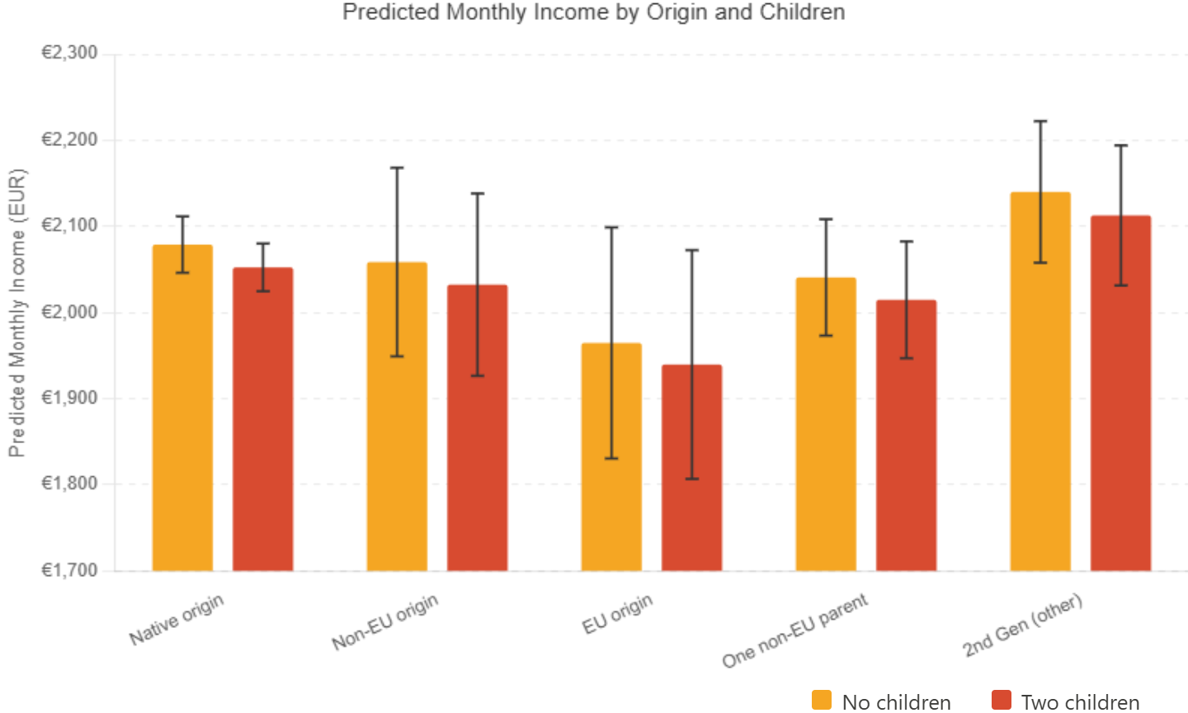

SOURCE: Enquête emploi en continu (EEC) 2015–2020.

Appendix B

Table B2: Normalized earnings differences associated with motherhood, by origin group (Kleven et al. 2019-style specification)

Origin group | Normalized earnings difference per child (%) | 95% CI
Native origin | -10.71*** | [-11.53, -9.89]
Non-European origin (both parents) | -21.74*** | [-27.20, -16.29]
European origin (both parents) | -10.14** | [-16.88, -3.40]
One non-European parent | -11.62*** | [-15.13, -8.12]
Other second-generation | -8.85*** | [-12.54, -5.16]
*p<0.05, **p<0.01, ***p<0.001.
Notes: Normalized earnings differences are computed following Kleven, Landais and Søgaard (2019).
Total monthly earnings in levels, including zeros for non-employed women, are regressed on number of children, origin group, education, partnership status, and age.
The absolute earnings difference per child for each origin group is the sum of the baseline coefficient on number of children and the relevant origin-specific interaction term. This absolute difference is then divided by average predicted childless earnings for each group, estimated from a restricted model excluding the motherhood variable, and multiplied by 100.
Source: Enquête Emploi en Continu (EEC) 2015–2020.

Appendix C
Table C1: Correlation between propensity to mother and employment status among childless women, by origin group

Origin group | r | N
Native origin | −0.021 | 16,732
Non-European origin (both parents) | −0.049 | 1,538
One non-European origin parent | −0.055 | 3,190
Second-generation (other) | −0.061 | 3,470
European origin (both parents) | −0.177 | 336
Note: Correlations are computed between the estimated propensity score for motherhood and employment status among childless women within each origin group.
Source: Enquête emploi en continu (EEC) 2015–2020.

