ONLINE RESOURCE 1 – Mars Science Laboratory Mission Narrative, Sols 2845-4266
Space Science Reviews
Scientific Highlights and Status of the Mars Science Laboratory Mission, Years 9 through 12

Ashwin R. Vasavada¹, Abigail A. Fraeman¹, John P. Grotzinger², J. Michael Battalio³, Jeff A. Berger⁴, Alex B. Bryk⁵, Joel M. Davis⁶, William E. Dietrich⁵, Olivier Gasnault⁷, John A. Grant⁸, Scott D. Guzewich⁹, Alexandra Holloway¹, Reidar Larsen¹, Jack Quade¹, Elizabeth B. Rampe¹⁰, Susanne P. Schwenzer¹¹, Allan H. Treiman¹², Benjamin M. Tutolo¹³, Amy J. Williams¹⁴
Corresponding author: ashwin.r.vasavada@jpl.nasa.gov ORCID: 0000-0003-2665-286X

¹Jet Propulsion Laboratory, California Institute of Technology, Pasadena, CA, USA
²Division of Geological and Planetary Sciences, California Institute of Technology, Pasadena, CA, USA
³Department of Earth and Planetary Sciences, Yale University, New Haven, CT, USA
⁴Jacobs – JETS, NASA Johnson Space Center, Houston, TX, USA
⁵Department of Earth & Planetary Science, University of California, Berkeley, CA, USA
⁶Department of Earth Science and Engineering, Imperial College London, London, UK
⁷Institut de Recherche en Astrophysique et Planétologie, Universite de Toulouse, Toulouse, France
⁸Smithsonian National Air and Space Museum, Center for Earth and Planetary Studies, Washington, DC, USA
⁹NASA Goddard Space Flight Center, Greenbelt, MD, USA
¹⁰NASA Johnson Space Center, Houston, TX, USA
¹¹AstrobiologyOU, School of Environment, Earth and Ecosystem Sciences, The Open University, Milton Keynes, UK
¹²Lunar and Planetary Institute, Universities Space Research Association, Houston, TX, USA
¹³Department of Earth, Energy, and Environment, University of Calgary, Calgary, AB, Canada
¹⁴Department of Geological Sciences, University of Florida, Gainesville, FL, USA

Email of Primary Author: ashwin.r.vasavada@jpl.nasa.gov

Mars Science Laboratory Mission Narrative, Sols 2845-4266 (Earth Years 9-12)

This document contains a detailed narrative of the Mars Science Laboratory (MSL) mission from Sols 2845 through 4266, corresponding to the ninth through twelfth Earth years of the surface mission (August 6, 2020, through August 5, 2024). Complementary narratives can be found in Vasavada et al. (2014) for Sols 0-500 and in the supplementary information of Vasavada (2022) for launch, cruise, and the first eight years on Mars. Table OR-1 provides a conversion between the Mars sol number and the Earth date of mission milestones. Online Resource 2 contains a list of rover drive distances and parking coordinates.

This narrative is intended to provide context for those studying the mission or using its scientific data by recounting mission events, rover and instrument activities, science-related decisions and strategies, and place names. It describes scientific findings only to the extent needed to support the narrative. A set of figures shows the rover’s traverse and place names. Additional contextual information including weekly mission status reports, daily downlink and uplink planning reports, and a table of activities by sol number can be found in the Curiosity (MSL) Analyst’s Notebook at the NASA Planetary Data System’s Geosciences Node (https://an.rsl.wustl.edu/msl). Mission press releases and a daily science operations blog can be found on the mission’s web site (https://science.nasa.gov/mission/msl-curiosity/).

1. Completion of the Glen Torridon Campaign

At the start of Curiosity’s ninth year on Mars, the science team was wrapping up its exploration of Glen Torridon, a roughly linear topographic depression that largely overlaps the clay-bearing unit on Mount Sharp as defined using orbiter spectroscopy. The rover had arrived at the Mary Anning drill site (Figs. OR-1, OR-2) where the team had strategically planned two specialized SAM experiments involving wet chemical processing (Mahaffy et al. 2012): the mission’s third use of chemical derivatization with N-methyl‐N‐(tert‐butyldimethylsilyl) trifluoroacetamide and dimethylformamide (MTBSTFA and DMF), and the first use of thermochemolysis with tetramethylammonium hydroxide (TMAH). The rover successfully acquired a sample on Sol 2838. Sample material was delivered to CheMin on Sol 2842 and SAM for evolved gas analysis (EGA) on Sol 2844. Two SAM gas chromatograph columns were cleaned on Sol 2846 and additional sample material was delivered to SAM for a dual-column gas chromatograph and mass spectrometer (GCMS) experiment on Sol 2849. On Sol 2857 the team acquired contact science observations on Ayton, a spot on the same slab as Mary Anning with small, dark nodules. ChemCam had previously associated these nodules with enrichments in Mn and P.

Focus then shifted to a second drilling operation that would provide sample material for the SAM wet chemistry experiments. First the team needed to complete the final of three dry runs of the TMAH wet chemistry procedure but was delayed by an apparent clog in SAM’s fourth gas chromatograph column (GC4). The dry run was completed on Sol 2868 after commissioning GC2 to replace GC4. The drilling attempt at Mary Anning 3 (Mary Anning 2 was not used) occurred on Sol 2870. Sample material was delivered to a TMAH wet chemistry cup on Sol 2879 after which the TMAH experiment completed successfully. Sample material was again delivered to SAM on Sol 2885, this time for a derivatization experiment using an MTBSTFA wet chemistry cup (Mahaffy et al. 2012), which immediately followed the delivery. The team usually analyzes sample material with CheMin first so that the mineralogy can be used to motivate and design subsequent SAM experiments. This time, delivery to CheMin took place after SAM, on Sol 2887, to lower the risk of running out of sample portions for the wet chemistry experiments. Furthermore, the team already had mineralogy from the first Mary Anning drill hole.

In parallel with the wet chemistry activities, the team captured additional remote science observations of the small, dark nodules noted above, leading to the decision to attempt to sample them with the drill. It was argued that additional compositional information about the nodules could reveal the redox conditions and processes involved in their formation, including any link to the organic molecules found in the Mary Anning samples. The team acknowledged the risk in trying to sample small nodules with an unknown vertical distribution in the bedrock using the drill, which ingests pulverized rock powder over a few cm. The sampling campaign was delayed between Sols 2892 and 2903 as the engineering team diagnosed an anomaly with the brake in the motor that rotates the turret at the end of the rover’s arm (Sect. 5.1.1 of main paper). The science team made use of the time by executing SAM experiments designed to monitor atmospheric chemical and isotopic composition (Sol 2897) and methane (Sol 2899). On Sol 2904 the rover was moved into position for drilling near Ayton. The target Groken was successfully drilled on Sol 2910 and sample material was delivered to CheMin on Sol 2912 and, after team discussion of the CheMin results, to SAM on Sol 2918 for a GCMS run.

The rover left the Mary Anning/Groken area on Sol 2923 to resume its detour around the Sands of Forvie toward higher levels of Mount Sharp. This also re-started the “Sulfate Unit or Bust” expedited drive strategy which prioritized the planning of longer drives along the strategic route above pursuing local investigations. The team planned in advance to stop for mini-campaigns at a blocky unit (Fig. OR-2) with a distinct steep near-infrared slope in MRO-CRISM spectra, and at the Sands of Forvie sand sheet. The first drive took the rover toward the Maybole outcrop for a close look at its sedimentary structures. Maybole was one of several topographic benches in the local area that resulted from variable levels of resistance to erosion in the stratified bedrock. The resistant and recessive strata of the benches were investigated as the rover ascended through them. On Sol 2956, Curiosity left the benches and headed toward the blocky unit exposed along the northern margin of the Sands of Forvie (Fig. OR-2). Over Sols 2960-2964 the engineering team installed the R-Hope flight software (Sect. 5.1.4 of main paper) on the rover’s A-side computer, precluding arm use and drives during that time.

Sol 2971 contained SAM monitoring of atmospheric chemical and isotopic composition. The rover entered the blocky unit on Sol 2972 and found a variety of diagenetic textures. Sol 2979 marked the start of a ten-sol plan that covered the winter holiday, including a drive to the edge of the Sands of Forvie on the first sol and subsequent observations that made use of the long holiday to observe sand grain and bedform movements. The rover’s first activities in 2021 (planned before the holiday) involved using its right front wheel to disturb a large ripple in the sand sheet on Sol 2991. The ripple crest, trough, and wheel-disturbed area were observed with the rover’s remote and contact science instruments in following plans. The rover drove northward back across the blocky unit on Sol 2995 (starting with a re-scuff and imaging), performed a seasonal methane measurement on Sol 2997, and returned to smoother terrain on Sol 3000 to continue eastward along its detour around the sand sheet.

ChemCam experienced an issue with its high-voltage power supply on Sol 3007 that temporarily precluded use of its laser (Sect. 5.2.1 of main paper). The 86-meter drive on Sol 3008 brought the rover into the Nontron mapping quad, named after the type locality in France for a clay mineral called nontronite, also found on Mars, including on Mount Sharp. The drive on Sol 3013 was a brief southward diversion back to the contact with the rubbly unit to characterize it at that location before returning to smoother terrain to the north. On Sol 3017 the team acquired nighttime images with MAHLI in “periscope mode” (i.e., horizontal imaging while the arm is extended upward) to attempt to witness triboelectric discharges resulting from saltation in the Sands of Forvie. On Sol 3020 the rover once again reached the rubbly unit, this time intending to drive through it and around the eastern margin of the Sands of Forvie (Fig. OR-3). At this point the team also ended the “Sulfate Unit or Bust” drive strategy so that the unit could be examined at a more deliberate pace. A movie of Deimos transiting the Sun was included in the Sol 3022 plan.

2. The Clay-Sulfate Transition

As Curiosity left Glen Torridon and the orbitally defined clay-bearing unit, the team began a multiyear study of the transitional region between lower-elevation areas with MRO-CRISM spectral absorptions interpreted to indicate phyllosilicate enrichment, and higher areas associated with enrichments in hydrated magnesium sulfate, i.e., the orbitally defined clay- and Mg sulfate-bearing unit (MSBU), respectively. The mission timeframe described in Sect. 2.1 below includes the final sampling campaign in the clay-bearing unit which was closely followed by the first observations of the clay-sulfate transition (CST), at Mont Mercou (Fig. OR-3).

2.1 Reaching Mont Mercou

Although Curiosity had reached the eastern extent of the sand sheet and could now begin going around it and returning to the west, the team decided to extend the traverse path further east to reach Mont Mercou, a prominent mound with a ~6-m-high cliff face. Mont Mercou was an attractive target for two reasons. First, it was hypothesized that it was the first accessible outcrop of the MSBU (though ultimately, it was not). And second, the cliff offered a rare opportunity to examine a vertical outcrop face. The team also decided to acquire a sample of the rubbly unit prior near its contact with Mont Mercou.

The Sol 3036 plan included a movie of Phobos transiting the Sun. On Sol 3049, Mastcam acquired stereo mosaics of Mont Mercou, one before driving and one about four meters into the drive, which together formed a long-baseline stereo pair. The Sol 3049 drive brought the rover to Mont Mercou, where imaging of the cliff face began. On Sol 3052, the team moved the rover to a drilling site on the rubbly unit close to the cliff. It was speculated that erosion may have more recently exposed the surface there, which would be favorable for the preservation of organic molecules. The Nontron target was successfully drilled on Sol 3056 and sample material was delivered to CheMin on Sol 3058 and SAM on Sol 3061 (EGA) and Sol 3065 (GCMS). Imaging of the cliff face continued during the sampling campaign.

The team also acquired several post-sunset mosaics of the sky to follow up on the previous Mars year’s discovery of high-altitude, noctilucent clouds. The drive on Sol 3072 backed the rover as close as possible to the cliff face so that active DAN measurements could receive neutrons backscattered from the cliff. This location also allowed the RAD instrument to quantify the reduction and modification of the cosmic ray flux due to Mont Mercou blocking part of the sky. After wrapping up at Nontron, the rover was positioned east (Sol 3074) and west (Sol 3079) of the cliff to image it from different angles. In between the rover approached the cliff for a closer look at truncated beds (Sol 3076).

After completing the investigation of the front face of Mont Mercou and sampling the rubbly unit below it, the team focused on ascending to the upper surface of Mont Mercou for a sampling campaign in the CST. The drive on Sol 3086 brought Curiosity nearly to the top and within a few meters of the ultimate drilling site, which was reached on Sol 3088. Bardou was successfully drilled on Sol 3090 and sample material was delivered to CheMin on Sol 3096 and SAM (EGA) on Sol 3098. Sol 3105 included the first use of the ChemCam laser since Sol 3007. Curiosity departed Mont Mercou on Sol 3109 and began heading southwest, starting the final leg of the extensive detour around the Sands of Forvie.

2.2 Traversing the Transition: Mont Mercou to Maria Gordon

For several weeks after leaving Mont Mercou, the team continued to investigate the variety of diagenetic textures observed in the bedrock, such as nodules, nodules aligned with ridges and polygonal fractures, and veins. Progress was slowed by relatively minor challenges and anomalies. A drive fault on Sol 3110 led to a fortuitous discovery of diagenetic colorations within a rock broken by the rover’s wheel. The MAHLI cover mechanism faulted on Sol 3126 (after related faults on Sols 3103 and 3122) and the elevation actuator of the remote sensing mast faulted on Sol 3127 (after a related fault on Sol 2488). Both required multiple planning cycles to diagnose and recover. A seasonal SAM atmospheric analysis was run on Sol 3118.

The rover’s southwest traverse took it across the northern face of Rafael Navarro Mountain (Fig. OR-4), named after an MSL-SAM team member who passed away during the pandemic. Given that the mountain appeared representative of the layered buttes of the MSBU, the team documented it from a variety of angles. On Sol 3163 the team identified the next sampling site, following the desired cadence of every ~25 meters of elevation gain. A seasonal SAM analysis of atmospheric composition occurred on Sol 3168. After an additional re-positioning, Pontours was successfully drilled on Sol 3170 with delivery to CheMin on Sol 3171 and SAM (EGA) on Sol 3176. CheMin began using a new approach to maximize the reusability of their sample cells, which sometimes fail to empty for reasons not fully understood. Only one portion of sample material was delivered, and after no novel crystalline minerals were detected during the first night’s analysis, the CheMin team decided to dump the sample cell instead of extending the integration time.

Driving resumed on Sol 3183 and the wheels were inspected with MAHLI and Mastcam on Sols 3195, following the desired 1000-m inspection cadence. The traverse took the rover near isolated buttes that appeared related to the layered MSBU upslope, though some had textures not observed previously. Nodules and veins remained abundant in the bedrock. Sol 3199 completed Curiosity’s ninth Earth year on Mars. On Sol 3203, Curiosity crossed back into the Torridon quad (first reached on Sol 1896), chosen in tribute to geological highlights in Scotland such as Siccar Point, where Hutton used an unconformity to illustrate the concept of geological time. The mission already had given the name Siccar Point to the stratigraphic group that unconformably overlies the through-going strata of the Mount Sharp (the Mount Sharp group).

Benign terrain and the allure of prominent outcrops of the eastern Greenheugh Pediment (Fig. OR-4) ahead led to longer drives and rapid forward progress. The team noted several out-of-place stones along the traverse that they suspected were derived from the pediment capping unit. After a team discussion, on Sol 3216 the rover turned sharply to approach the pediment scarp more closely near a striking promontory that the team named Siccar Point. The drive on Sol 3222 reached the next sampling site, following the desired cadence of every ~25 meters of elevation gain. A SAM seasonal atmospheric analysis also took place on Sol 3222. The drill area coincided with observations that the bedrock had become rougher, laminations less visible, and nodules rarer. The target was named Maria Gordon, after the pioneering Scottish geologist and paleontologist. The target was successfully drilled on Sol 3229 and sample material was delivered to CheMin on Sol 3232 (dumped after one analysis) and SAM on Sol 3238 (EGA) and Sol 3242 (GCMS). On Sol 3228, the team conducted a mid-winter frost detection experiment by acquiring a pre-dawn ChemCam LIBS observation on sand.

2.3 Traversing the Transition: Maria Gordon to the Prow

The Maria Gordon sampling campaign marked the completion of the long detour around the Sands of Forvie. Drives now headed more directly southward and uphill toward Maria Gordon Notch (Fig. OR-4), a small passageway through the topography. As the rover departed from the drill site on Sol 3247, the team purposely drove the rover’s left front wheel on top of a nodular slab near the end of the drive and then placed that area in the rover’s workspace. This was done to crush the nodules and expose dust-free interior surfaces to improve measurements, particularly of Mg sulfate, by APXS and other instruments. However, before the nodules could be analyzed, it was time to start winding down activities in preparation for the mission’s fifth solar conjunction over Sols 3254 to 3271. Curiosity executed a strategically developed plan consisting of change detection and dust devil imaging, environmental monitoring, and a daily readout of the rover’s inertial measurement unit for gravimetry. Post-conjunction operations resumed on Sol 3272 with contact science on the crushed nodule target, Helmsdale Boulder Beds.

Curiosity reached its closest distance to Siccar Point for the Sol 3276-77 plan. A seasonal atmospheric methane measurement was conducted on Sol 3282. By Sol 3286 the rover already had ascended another ~25 meters in elevation from Maria Gordon and the team planned a drive to the next sampling site. Zechstein was successfully drilled on Sol 3289 and sample material was delivered to CheMin on Sol 3292 and SAM (EGA) on Sol 3297. The team continued to acquire images of the Greenheugh Pediment capping unit during the sampling campaign.

As sampling activities were concluding at Zechstein, the actuator on the “wrist” (i.e., fourth) joint of the rover’s robotic arm faulted on Sol 3304. The fault mirrored the issue with the turret joint actuator on Sol 2892 (Sect. 5.1.1 of main paper). Arm use other than diagnostic and recovery activities was precluded until Sol 3312 (which also precluded driving), after which wrist motion was recovered. Heightened concern with the issues with the wrist and turret actuators led to new constraints that kept the wrist and turret in specific positions overnight. In case the backup brakes are lost overnight, these joint positions offer the best chance for continued drill-based sampling. However, placing the arm in this configuration overnight precludes overnight APXS integrations. Instead, shorter evening integrations became standard. During the arm recovery, on Sol 3310 SAM analyzed material that was drilled on Sol 2261 from Rock Hall (on Vera Rubin Ridge) and delivered to SAM as a “doggie bag” (i.e., for deferred analysis). The run was an “opportunistic derivatization” experiment that exposed the sample to the residual vapors of the MTBSTFA wet chemistry reagent that had previously been found to have leaked within the instrument.

Upon leaving Zechstein on Sol 3312, the team diverted the rover to the west to inspect boulders that were suspected to be derived from the Greenheugh Pediment capping unit. SAM completed a seasonal measurement of atmospheric composition on Sol 3314. On Sol 3318, Curiosity continued southward to Maria Gordon Notch and imaged its eastern wall on Sol 3320. A multipart drive on Sol 3324 placed the rover parallel and then perpendicular to the towering western wall at a very close distance, allowing the DAN investigation team to attempt to measure its composition with active neutron spectroscopy. Meanwhile, at this location the RAD team observed the shielding and modification of cosmic rays that traveled through the rock wall. The stratification and diagenetic features on the cliff face and other nearby buttes were documented. On Sol 3333 the team uplinked an eleven-sol plan to cover the winter holidays. The last planning session of 2021 had the team uplink the first three sols of the new year in advance, which also corresponded to the beginning of the rover’s sixth Mars year on the surface.

Curiosity began 2022 with a drive into the Roraima mapping quad on Sol 3345 (Fig. OR-5), named after the northernmost state of Brazil that shares the “tabletop” Pacaraima mountains with Guyana and Venezuela. Curiosity’s traverse through Maria Gordon Notch brought it next to the flat-topped pediment scarp and into the rounded, layered buttes that are characteristic of the hydrated MSBU as defined from orbit (though not yet to an area where orbiter spectroscopy indicates sulfates along the traverse). Rover plans were filled with panoramas of the landscape in addition to the usual observations of the rover’s immediate surroundings. On Sol 3347 the foreoptics of the SAM tunable laser spectrometer were pumped down to improve the measurement of CO₂ isotopes.

Although the rover had arrived at the elevation desired for the next sampling campaign, sampling operations were still precluded by the wrist and turret joint anomalies. The team decided to bide time by approaching a dark, lens-shaped outcrop with sedimentary structures distinct from the surrounding bedrock. A drive on Sol 3354 placed the rover at this outcrop, called the Prow, for contact science (Fig. OR-5). Over the next few weeks, the team approached the Prow at four locations, with parking challenges due to the mix of sand and wheel-sized rocks at the base of the outcrop. MAHLI was offline for part of the Prow campaign while diagnosing a memory issue, motivating the team to return to a previous spot after MAHLI activities resumed. Mastcam panoramas, ChemCam remote micro-images, and MAHLI “dog’s eye” mosaics (mosaics taken with the camera held low to be in the plane of the bedding) captured a detailed dataset for sedimentological analysis.

After planning on Sol 3364, the team discussed what the future sampling strategy should be given that the engineering team had recently concluded that drilling could resume after the brake anomalies (Sect 5.1.1 of main paper), but for the moment, only without using percussion. After a lengthy discussion that included project and science leadership, the team decided not to drill at either the 25-m interval or at the Prow, primarily because the engineering team had not yet been able to assess any risk to MAHLI and APXS from sample material spilling from the drill bit assembly, given that it could not be fully emptied between drill attempts without using percussion.

2.4 Ascent of the Eastern Greenheugh Pediment

With the Prow investigation complete, the next step according to the previously planned Mount Sharp Ascent Route (MSAR) was to ascend the eastern margin of the Greenheugh Pediment (onto the Siccar Point group), and traverse along the pediment surface near the lower Gediz Vallis Ridge (GVR) for a few months. Some team members expressed concern that this traverse would create a nearly 100-m elevation gap in in the record of the Mount Sharp group before the rover returned to the Mount Sharp group further upslope. After a team discussion the decision was made to follow the MSAR, with some new ideas of how to moderately reduce the gap with a small route change. The rover’s wheels were imaged on Sol 3369.

On Sol 3379 the rover left the Prow and headed north to the ascent point, imaging additional dark, lens-shaped outcrops to the west. Curiosity crossed back into the Torridon quad on Sol 3381. During the subsequent ascent of the Greenheugh Pediment scarp, the team watched for any unique textures or compositions that may have resulted from the proximity to the overlying pediment capping unit. Around Sol 3401 Curiosity crossed onto the capping unit, after a few challenging drives in blocky and sandy terrain. From here the rover’s cameras were able to capture not only the pediment surface but also the stratified lower GVR in the distance.

Driving on the pediment capping unit was slowed by rough terrain and telecom issues. On Sol 3417 (Fig. OR-5) the rover first reached an area with the distinctive “washboard texture” seen in orbiter images. The rows of decimeter-scale wind-sharpened rocks that produce the washboard texture led to the team calling the surface “gator-back terrain,” originally after the gator gar fish, but also like the back of an alligator. The fact that gator-back terrain appeared to cover hundreds of lateral meters of the upcoming MSAR raised major concerns about steering faults, traction control faults, and wheel wear (Fig. 7 of main paper). The team made the difficult decision to abandon the pediment traverse and to instead return to the Mount Sharp group bedrock and continue southward just east of the pediment (Fig. OR-1). The re-routing meant that the rover could not investigate lower GVR up close, but it could build a continuous stratigraphic record of the clay-sulfate transition.

A SAM seasonal atmospheric analysis occurred on Sol 3426. After the team struggled with an issue with the rover’s remote sensing mast for several plans, on Sol 3435 the rover retraced its tracks as it descended through the challenging terrain along the margin of the pediment, taking the time to re-examine some of the sedimentary textures and structures observed on the ascent.

2.5 Traversing the Transition: The Prow to Paraitepuy Pass
Drives on Sol 3456 and 3461 brought Curiosity back into the CST and back into the Roraima quad, respectively. The team also resumed imaging both the local terrain and the stratigraphy exposed in surrounding buttes. On Sol 3463, the rover completed retracing its tracks past the Prow and climbed uphill into new terrain. SAM measured atmospheric methane on Sol 3477. The warmer seasonal temperatures during this traverse sometimes precluded the use of APXS before drives. Additional atmospheric observations were included in response to an unusually early (seasonally early) dust event first detected in orbiter data. On Sol 3487, SAM completed an experiment on a blank sample to characterize the instrument background.

The science and rover planner teams assessed a potential deviation to the northwest (ascending the north-facing slope near Bolívar, Fig. OR-6) to bring the rover to the lower GVR near the location it would have reached if not turned back from crossing the pediment by the gator-back terrain (Fig. OR-1). The route was determined to be too difficult, however, and the team continued to move the rover south along the re-routed MSAR. On Sol 3492 the rover arrived at and observed an outcrop with thin resistant beds reminiscent of the Prow. Sols 3496-3503 were dedicated to recovering from an anomaly with the Rover Power and Analog Module (RPAM) on the A side of the avionics. After switching to the B-side RPAM, restrictions on driving and arm placement remained through Sol 3507 as camera and arm thermal deflection models were updated for use with the different temperature sensors controlled by the new RPAM. SAM measured the chemical and isotopic composition of the atmosphere on Sol 3508.

The team held discussions on where the next sampling site should be, given that the CST was predicted to end soon as the rover reached the area where hydrated Mg sulfate minerals were interpreted from MRO-CRISM spectra. A decision was made to drill, which the rover successfully did at Avanavero (Fig. OR-6) on Sol 3512. Sample material was dropped to CheMin on Sol 3517 and SAM (EGA) on Sol 3525, and the rover departed on Sol 3530. The team decided to shift the drive path westward to image the stratigraphy exposed on the Bolívar butte at better resolution. Curiosity also began examining boulders thought to have come from higher on Bolívar, including reaching the rover-sized Ilha Nova Destino boulder on Sol 3533.

The focus of both the science and engineering teams now turned toward getting the rover safely through Paraitepuy Pass, a steep and narrow passage between the tall Deepdale and Bolívar buttes (Fig. OR-6). Sand, sand ridges, and float rocks made the traverse challenging. In addition, the high walls meant that communication paths to both Earth and relay orbiters could be precluded if near the east or west horizons. The engineering team developed new processes for accurately predicting when communication would be successful based on the rover’s orientation and its proximity to the walls, the results of which also fed into drive planning (Wiederhold et al. 2023). Sol 3554 ended the rover’s tenth Earth year on Mars. A large sand ridge was examined on Sols 3562-3566.

3. The Mg Sulfate-Bearing Unit

3.1 Into Marker Band Valley

As the rover crossed Paraitepuy Pass, the view opened to the long-awaited destination of Marker Band Valley (MBV, Fig. OR-7). Two key mission destinations awaited within MBV: the first bedrock where hydrated Mg sulfates were confidently interpreted in MRO-CRISM spectra, i.e., the base of the MSBU (Sect. 2.3 of main paper), and a distinct erosion-resistant layer called the Amapari Marker Band (AMB, Sect. 2.3.3 of main paper). The valley also revealed panoramic views of several large buttes which not only were scenic but also allowed the team to laterally correlate the sedimentary textures and structures of the buttes with those observed in situ along the rover’s path. The upper GVR remained visible to the west, adding another target to compete for long-range imaging.

3.2 The MSBU Below the Marker Band

On Sol 3574 the rover reached a patch of bright, erosionally recessive rocks that were hypothesized to be part of the MSBU. Rather than immediately acquiring a drilled sample there, the team decided to traverse to the west to investigate a small mesa that appears oval-shaped in MRO-HiRISE images. The rover found the feature to have darker rocks along its margin as well as lighter rocks in its interior that were enriched in Mg and S. After some re-positioning, the team got the rover in place for sampling at Canaima in the interior of the oval-shaped feature (Fig. OR-7). Canaima was successfully drilled on Sol 3612 and sample material was delivered to CheMin on Sol 3614, SAM (EGA) on Sol 3619, and SAM (GCMS) on Sol 3622. Curiosity’s fourth extended mission began on Sol 3610.

The rover drove onward on Sol 3626, heading west toward an AMB outcrop and an area where the rover could attempt to ascend to upper GVR. The team agreed to try this ascent to recover some of what was lost when the rover was unable to reach lower GVR via the pediment (Sect. 2.4). Along several traverses in MBV the team acquired MARDI “sidewalk mosaics” by taking MARDI images periodically during drives to create continuous and stereo image strip. This technique was used to observe lithological variations and geological contacts as the rover crossed from the MSBU below the AMB, to the AMB, and then to the rocks above.

3.3 The Amapari Marker Band

While en route to the ascent point, the team made initial observations of the AMB, reaching the first outcrop on Sol 3639. The unusual textures and compositions of the AMB warranted several additional observations before Curiosity resumed the ascent. Edge-on views were especially important for constraining the origin of undulating beds in the lower unit of the AMB (interpreted as wave ripples). The rover then was positioned on top of the upper, thickly laminated unit of the AMB on Sol 3645.

The team next brought the rover to an elevation above the AMB where upper GVR could be imaged (Sol 3655 on Fig. OR-7). After assessing the terrain and the likely cost of continuing upward (1-2 months), the team decided not to approach upper GVR from this location and instead to try further south. On Sol 3658 the rover began returning to the floor of MBV.

The drive on Sol 3667 took Curiosity back onto the surface of the thickly laminated unit of the AMB. From this location the science team searched for horizontal bedding-plane exposures of the ripple unit that would be suitable for drilling. The ripple unit was fractured into decimeter-sized slabs just wide enough to drill, but their size and appearance raised the concern that the slabs were thin, brittle, and/or unstable. The rover was placed at a drill target on Sol 3672. Remote and contact science confirmed that Amapari had the desired composition, and the target was drilled on Sol 3676. The drill did not reach sampling depth due to a stall in the rotation motor, but the team quickly decided to make another attempt on Sol 3680 in the same workspace at Amapari2, thinking that the spatial heterogeneity of the rock might result in a different outcome. This time the drilling process faulted, again before sampling depth, when the pressure on the drill bit suddenly decreased due to a shift or fracture of the slab. With no obviously better target in the area around Amapari, and with much of the AMB surface yet to be explored, the team decided to forgo further attempts and instead try again to the south, where there was a much broader exposure of the AMB.

Before leaving the area, the team desired additional observations of the thickly laminated unit of the AMB. On Sol 3687 the rover was parked just downslope of the AMB, facing it edge-on, with the goal of acquiring a MAHLI mosaic across the thickly laminated unit and capturing hollow nodules observed within the unit. These measurements occurred on the first two sols of the Sol 3689-3698 winter holiday plan.

On Sol 3690 the rover drove to an area on the MSBU below the AMB where bright patches were seen in the rover’s previous tracks and enhanced subsurface hydration had been detected by DAN. Before parking, the rover’s right rear wheel was steered in place to scuff the surface. The resulting bright surface was analyzed on the first sol of the Sol 3699-3702 plan that was assembled prior to the holiday but executed as 2023 began. Curiosity then traversed across the MBV floor, with the team paying close attention to any changes in the MSBU as the rover approached the overlying AMB in the southern part of the valley. Imaging objectives included searching for outcrops of the lower AMB unit (ripple unit) to drill and documenting the stratigraphy of the surrounding buttes. A SAM seasonal atmospheric measurement took place on Sol 3721.

The rover ascended onto the AMB surface on Sol 3714 (Fig. OR-7) and reached an exposure of the ripple unit, though it was deemed too rough for drilling. A short drive brought Curiosity to Encanto where the desired composition was verified. Drilling was attempted on Sol 3718 but failed to reach sampling depth when the drilling procedure was halted due to insufficient rate of penetration by the drill. Instead of trying again, the team decided to explore further to the south, where the surface texture appeared smoother in MRO-HiRISE images. The broad surface of the southern AMB was littered with dark float rocks that were suspected to come from Siccar Point group strata higher above, although some rocks had textures suggestive of meteorites. An effort was made to capture their compositions. On Sol 3724 Curiosity investigated Cacao, a large, fluted rock found to be an iron-nickel meteorite. The Atmosphere and Environment theme group began a campaign to observe noctilucent clouds during the short time they form over Gale each Mars year.

After discovering that the smooth-appearing portion of the AMB did not have bedrock exposed for drilling, the team decided to head 92 m back on Sol 3733 to the Encanto area for a fourth sampling attempt. The team searched for a relatively large coherent exposure of the ripple unit that offered a smooth place for the drill, and that was thick enough to prevent fracturing or “punching through” and stable enough not to move under the forces of drilling. The latter was challenging to assess but the team looked for exposures that the rover had driven over without shifting or fracturing them. After confirming the desired composition, and after much discussion within the rover engineering team on the best technical approaches for drilling the unit, Dinira was drilled on Sol 3742. Once again, the drill failed to reach sampling depth due to a rotation stall, so the team made the difficult decision to move forward without a sample of the ripple unit.

On the way south out of MBV on Sol 3748, a large sand ripple was intentionally scuffed by rotating the right front wheel once while in place, creating a “road cut” to reveal the internal structure for MAHLI imaging. The team then discussed whether to devote mission resources to attempting to sample the thickly laminated unit of the AMB at its southern margin and ultimately decided to do that, given that this unit had some of the unique compositional aspects of the ripple unit. Tapo Caparo was successfully drilled on Sol 3752 and sample material was delivered to CheMin on Sol 3755 and SAM on Sol 3759 (EGA) and Sol 3766 (GCMS).

3.4 The MSBU Above the Marker Band, Upper Gediz Vallis Ridge

Curiosity drove a short distance from Tapo Caparo on Sol 3771 to study an outcrop at the southern margin of the AMB that showed a contact between laminated and nodular bedrock. Having ascended above the AMB, the next challenge for the rover was to climb out of MBV to the south through the small canyon bounded on one side by the Owenteik promontory (Fig. OR-8). The ascent occurred on fractured bedrock and sand, making for tough driving. The rover traversed through several beds with distinct textures that could be correlated laterally with beds in surrounding buttes. An effort was made to capture remote and contact science observations within each bed. The team also continued to investigate gray “foreign stones” (small rocks with textures/colors distinct from the local bedrock). The effort began at the AMB and continued up to upper GVR, where gray stones are abundant. There were no science operations from Sols 3789 to 3792, when the rover’s flight software was transitioned to a new version (Sect. 5.1.5 of main paper).

The drive on Sol 3805 brought the rover to the top of the canyon. SAM made a seasonal measurement of the atmosphere on Sol 3808. The team began searching for a drill target that would be representative of the MSBU above the AMB. The team also desired that the target be within a layer that, when correlated with layers on surrounding buttes, is just above a scour surface and might represent a different depositional environment than layers below. The rover successfully drilled Ubajara on Sol 3823 and sample material was delivered to CheMin on Sol 3825 and SAM (EGA) on Sol 3830. The CheMin portion was delivered post-sunset for the first time to minimize the warming that it would experience in the rover chassis before analysis, given the potential for mineral phase changes.

On Sol 3839 the rover drove southwest from Ubajara and began climbing a hillslope that led to a plateau that retained a few dozen meter- and decameter-sized impact craters. The team decided to inspect the Jau crater cluster (Sect. 2.4 of main paper). The team also planned to bring the rover to the foot of upper GVR west of Jau to add to earlier observations of the ridge and to study it in situ. A direct route up the sandy hillslope proved slippery and after multiple attempts the team decided to take an extended detour and ascend within a small canyon to the east (Fig. OR-8). The detour began on Sol 3857. On Sol 3865 Curiosity entered the Kalavryta mapping quad, named in recognition of the Chelmos-Vouraikos UNESCO Global Geopark in Greece.

The drive on Sol 3871 brought the rover to top of the canyon where it turned to the west and later re-entered the Roraima quad on Sol 3892. A SAM seasonal atmospheric measurement took place on Sol 3890. The Sol 3892 drive also brought Curiosity to the first local depressions of the Jau crater cluster. The team decided against accessing the upper GVR here, given that it would require climbing a hillslope that appeared similarly challenging as the one that forced the recent detour. An alternate location for climbing the ridge was identified to the southwest. After inspecting several Jau craters the rover headed southwest on the MSAR and returned to the Kalavryta quad on Sol 3905. The team conducted a pre-dawn search for water frost with the ChemCam instrument on Sol 3910 during the plan that completed Curiosity’s eleventh year on Mars.

After several attempts earlier in the mission, the rover reached upper GVR (Fig. OR-9) on Sol 3924 following a steep ascent on sloped, slippery terrain. The science team’s objectives were to investigate a diversity of rocks and search for the contact between the ridge and the underlying rocks of the MSBU. The area, called Bouboukas, was chosen at a cluster of small boulders. Two plans were spent at the first location and a short drive on Sol 3928 allowed access to additional rocks. On Sol 3931 Curiosity returned downhill to the MSAR and resumed driving to its next area of interest: a hillslope with alternating light and dark bands of the MSBU.

Along the drive the science team continued to image upper GVR, foreign stones thought to be representative of the ridge deposits, and Zagori, a ripple field in the valley north of the rover. The team also imaged the Kukenán butte to the east, particularly layers that appeared to be laterally continuous with those along the traverse. The drive on Sol 3946 took Curiosity into the Bishop mapping quadrangle, named after the town near the Sierra Nevada range in California. Downlink from Sol 3953 revealed that the filter wheel on the left Mastcam was not in the commanded position (Sect. 5.2.2 of main paper). The team used SAM to measure the abundance of atmospheric methane in the pre-dawn timeframe of Sol 3959.

The rover reached the base of the banded hillslope on Sol 3958. The mission’s strategic planning had identified this region as a site to acquire a pair of drilled samples to characterize this elevation of the MSBU and to look for any textural or compositional differences between the light and dark bands. On Sol 3974 Curiosity arrived at Sequoia, a block representative of the light bands (Fig. OR-9). The Sequoia target was successfully drilled on Sol 3980 and sample material was delivered to CheMin on Sol 3982 and to SAM on Sol 3989 (EGA) and Sol 3995 (GCMS).

Toward the end of the Sequoia sampling campaign, the mission reached Sol 4000 and the team began preparing for the mission’s sixth solar conjunction by ensuring that the arm and rover were in safe configurations. Over conjunction on Sols 4004-4022, the rover monitored the environment and acquired images with the mast fixed in place. DAN observations from Sol 4014 onward revealed that neutron generation by the instrument was no longer possible, ending the active component of its investigation (Sect. 5.2.3 of main paper). During the conjunction plan Curiosity began its seventh Mars Year.

After conjunction and wrapping up at Sequoia, the team decided to resume driving uphill while making additional observations to determine which of the varied textures and compositions within the dark bands to sample. The uphill traverse was challenging on blocky and sandy terrain. SAM completed an atmospheric methane experiment on Sol 4034. On Sol 4045 an 11-sol plan began executing to cover the winter holiday, consisting of remote science, contact science, and a drive, interleaved with eight sols of environmental monitoring. A SAM seasonal atmospheric measurement took place on Sol 4066.

Several plans before and after the start of 2024 took the rover to investigate bedrock with polygonal fractures. The team also continued to image the buttes around the rover as well as upper GVR to the west. After investigating additional targets within the dark bands, the team decided to search for a block with a dark, platy appearance and with co-enrichments in Na-Mg-S but not Cl to collect a drilled sample. On Sol 4089 (Fig. OR-10), Curiosity reached the top of the hillslope of light and dark bands without identifying such a target that also was thick and stable enough for drilling.

3.5 The MSBU Above the Marker Band, Gediz Vallis Canyon

The top of the hillslope brought the rover adjacent to Gediz Vallis Canyon (Fig. OR-10), a channel-incised bedrock canyon in the MSBU along the floor of Gediz Vallis. The canyon was a major investigation site for the fourth extended mission given the possibility that liquid water was involved in its formation. The science team began following the strategically planned Gediz Vallis canyon campaign which called for driving along the canyon margin and imaging the interior, starting with the nearest mound called Fascination Turret. While traversing south along the margin of the canyon, the rover’s arm workspaces were on the MSBU outside of the canyon. The team continued their systematic study of that unit, including the search for a dark band target for sampling.

On Sol 4102 Curiosity reached the dark band target Mineral King (Fig. OR-10) and the team began a sampling campaign. The first drill attempt at Mineral King on Sol 4107 did not reach full depth, but the depth was sufficient to collect enough sample material for a successful delivery to CheMin on Sol 4110. The delivery to SAM (EGA) on Sol 4114 was found to be unsuccessful (insufficient mass) after low signals were measured. While at Mineral King, observations of the surrounding surface were collected throughout the day for a photometry experiment. A second Mineral King target was assessed but was too close to the rover to safely drill. Drilling at third target on Sol 4125 did not reach sufficient depth. Rather than try again at Mineral King, the team decided to move onward and look for another dark band target uphill. SAM completed a measurement of atmospheric methane on Sol 4101 and atmospheric composition on Sol 4135.

The drive on Sol 4137 took the rover close to the canyon to allow better visibility of Fascination Turret and to search for a basal contact below the deposits. The Atmosphere and Environment science theme group declared a “dust storm watch” starting on Sol 4120 after MRO detected increased regional dust activity across Mars. This protocol raises the frequency of meteorological measurements according to a strategically approved global dust storm campaign plan. On Sol 4142 Curiosity reached Hinman Col, a small rock mound that was thought to be an erosional remnant of Fascination Turret even though it is located outside of the canyon form.

Curiosity progressed uphill while imaging the canyon and continuing to acquire regular observations of the MSBU in the rover’s arm workspaces. Imaging of the surrounding buttes and of aeolian bedforms within the canyon also continued. As the rover approached Pinnacle Ridge (Fig. OR-11), the mound south of Fascination Turret, the team noticed dark float blocks scattered on the surface of the MSBU. These blocks were assessed with occasional remote and contact science observations given their possible association with canyon materials.

The science team revised the Gediz Vallis canyon campaign plan by deciding to take the rover into the canyon to access blocks on the southern (still hidden) slope of Pinnacle Ridge. Accessing the interior originally had been planned only in the Arc Pass region. The team also decided to forgo in situ exploration of Milestone Peak, given the uncertain access to materials of interest and the traverse distance. As the rover approached Pinnacle Ridge, the team also found safe access to blocks on the northern slope. The drive on Sol 4166 brought Curiosity to a large dark block at the margin of Pinnacle Ridge. The following drive on Sol 4169 took the rover a few meters further to a second grouping of bright and dark rocks. On Sol 4176, the rover drove around the eastern side of Pinnacle Ridge, stopping to image a steep scarp on that side of the mound.

Curiosity reached the southern side of Pinnacle Ridge on Sol 4180, but the team decided not to drive onto the mound there, given the success of the investigation on the northern side. The rover was commanded instead to drive along the margin of the canyon to survey the mound and the MSBU under the wheels. Although a trough typically separates the MSBU from the interior of the canyon, it was shallow here, so the team got additional access to Pinnacle Ridge blocks after the drive on Sol 4183. SAM completed a seasonal measurement of atmospheric composition on Sol 4189. On Sol 4190, Curiosity’s RAD instrument observed the largest solar particle event of the mission to date.

The next navigational challenge became how to descend into the canyon interior at Arc Pass (Fig. OR-11). From reconnaissance imaging over a few drives, the team determined that the safest crossing (lowest slope and avoiding a wide patch of rippled sand) was to the east at Echo Ridge, another mound within the canyon. Meanwhile the view of the canyon interior revealed dark ridges, isolated rock slabs, and a field of small, very bright clasts on a sloping surface. The strategic route would have the rover cross over this surface, but new concerns arose about steep, cross-slope driving on loose material that would be encountered further down this path. A new route over flatter, coarser material was adopted. However, the team still desired to access the bright clasts. The drive on Sol 4193 took Curiosity into the canyon and onto Echo Ridge. Two subsequent drives carefully steered the rover to a parking spot at Whitebark Pass (near the bright clasts), navigating through rocks and slopes and ending in a direction that maintained a clear line of sight to Earth for communication.

The Whitebark Pass area proved interesting, with bright clasts, bright-rimmed outcrops, and gray/purple coatings all in proximity to each other. Furthermore, compositional measurements of the clasts and images of one crushed by the wheels revealed crystalline elemental sulfur. Several plans were spent investigating the variety of materials and discussing the findings. The bright clasts were too small to sample with the drill. However, the team decided to drill the nearby bright-rimmed Whitebark Pass outcrop due to its interest as the first sampling target within the canyon and because of its potential relationship to the bright clasts. Curiosity moved into position on Sol 4210.

Drilling was initially scheduled for Sol 4214, but it was determined from the earlier arm preload test that the configuration for this target would not give the arm the control authority needed to safely drill or retract the drill from the hole if significant side-loads accumulated. A slightly shifted target passed the preload test, and the Mammoth Lakes target (also referred to as Mammoth Lakes 2) was drilled successfully on Sol 4219. Sample material was delivered to CheMin on Sol 4222, and to SAM on Sols 4226 (EGA) and 4230 (GCMS). An extensive set of change detection and photometry images was collected at the site.

The team continued to study the surroundings while pausing the sampling campaign to allow the SAM team to receive and assess the GCMS results and decide if the sample warranted a wet chemistry experiment. The SAM team decided against, so on Sol 4234 the team began wrapping up by collecting measurements of the tailings around the drill hole. MAHLI observed the wall of the hole in LED-illuminated images during the evening of Sol 4236, and the rover drove away from Whitebark Pass on Sol 4237. The first waypoint was a native sulfur clast 11 m away that allowed the team to search on Sols 4239-41 for any lateral changes in composition (e.g., minor elements). The Sol 4243 plan contained observations of a rubbly outcrop characteristic of several in the area.

A pair of drives then brought the rover on Sol 4246 to Fairview Dome, the first in a series of large, pale rock exposures aligned with the canyon in HiRISE imaging (Fig. OR-11). One of these had been identified as a sampling target for the Gediz Vallis canyon campaign because these pale rocks comprise a major type of canyon fill. Fairview Dome was investigated on Sols 4248-51. Its relatively high perch motivated a Mastcam 360-degree mosaic. The next set of drives attempted to place the rover in a position for drilling. The largest exposure visible in MRO-HiRISE images would have required a traverse through loose, sharp rocks, so nearer targets were assessed. Contact science measurements showed that the exposures share a common composition. On Sol 4257 the team began a sampling campaign at Kings Canyon. Drilling completed successfully on Sol 4263, two sols before Curiosity completed its twelfth Earth year on Mars.

References

Mahaffy PR, Webster CR, Cabane M, Conrad PG, Coll P, Atreya SK, Arvey R, Barciniak M, Benna M, Bleacher L, et al (2012) Space Sci Rev. https://doi.org/10.1007/s11214-012-9879-z
Vasavada AR, Grotzinger JP, Arvidson RE, Calef FJ, Crisp JA, Gupta S, Hurowitz J, Mangold N, Maurice S, Schmidt ME et al (2014) Overview of the Mars Science Laboratory mission: Bradbury Landing to Yellowknife Bay and beyond. J Geophys Res Planets. https://doi.org/10.1002/2014JE004622
Vasavada AR, Mission overview and scientific contributions from the Mars Science Laboratory Curiosity rover after eight years of surface operations (2022) Space Sci Rev. https://doi.org/10.1007/s11214-022-00882-7
Wiederhold E, Larsen R, Chandler L, Mukai R, Oij S, Dula W, Ellison D, Vasavada A (2023) Playing telephone through Martian rock: Assessing terrain occlusions to enhance telecom predictions. In: 2023 IEEE Aerospace Conference, pp 1-11. https://doi.org/10.1109/AERO55745.2023.10115628

Table OR-1 Mars and Earth dates (UTC) of key mission milestones
Milestone | Sol | Date Planned | Date Executed  (12:00 LMST)
Start of EM3 | 2544 | October 1, 2019 | October 3, 2019
Sol 3000 | 3000 | January 11, 2021 | January 13, 2021
Sol 3500 | 3500 | June 10, 2022 | June 11, 2022
Start of EM4 | 3610 | September 30, 2022 | October 2, 2022
Sol 4000 | 4000 | November 5, 2023 | November 7, 2023

Fig. OR-1 Overview map of Curiosity’s traverse from January 2019 through February 2025. The interval covered in this paper is between “Start” and “End”. The numbers indicate the locations of Figs. OR-2 through OR-11. North is up, and a scale bar is in the upper left corner. Image credit: NASA/JPL-Caltech/U. of Arizona
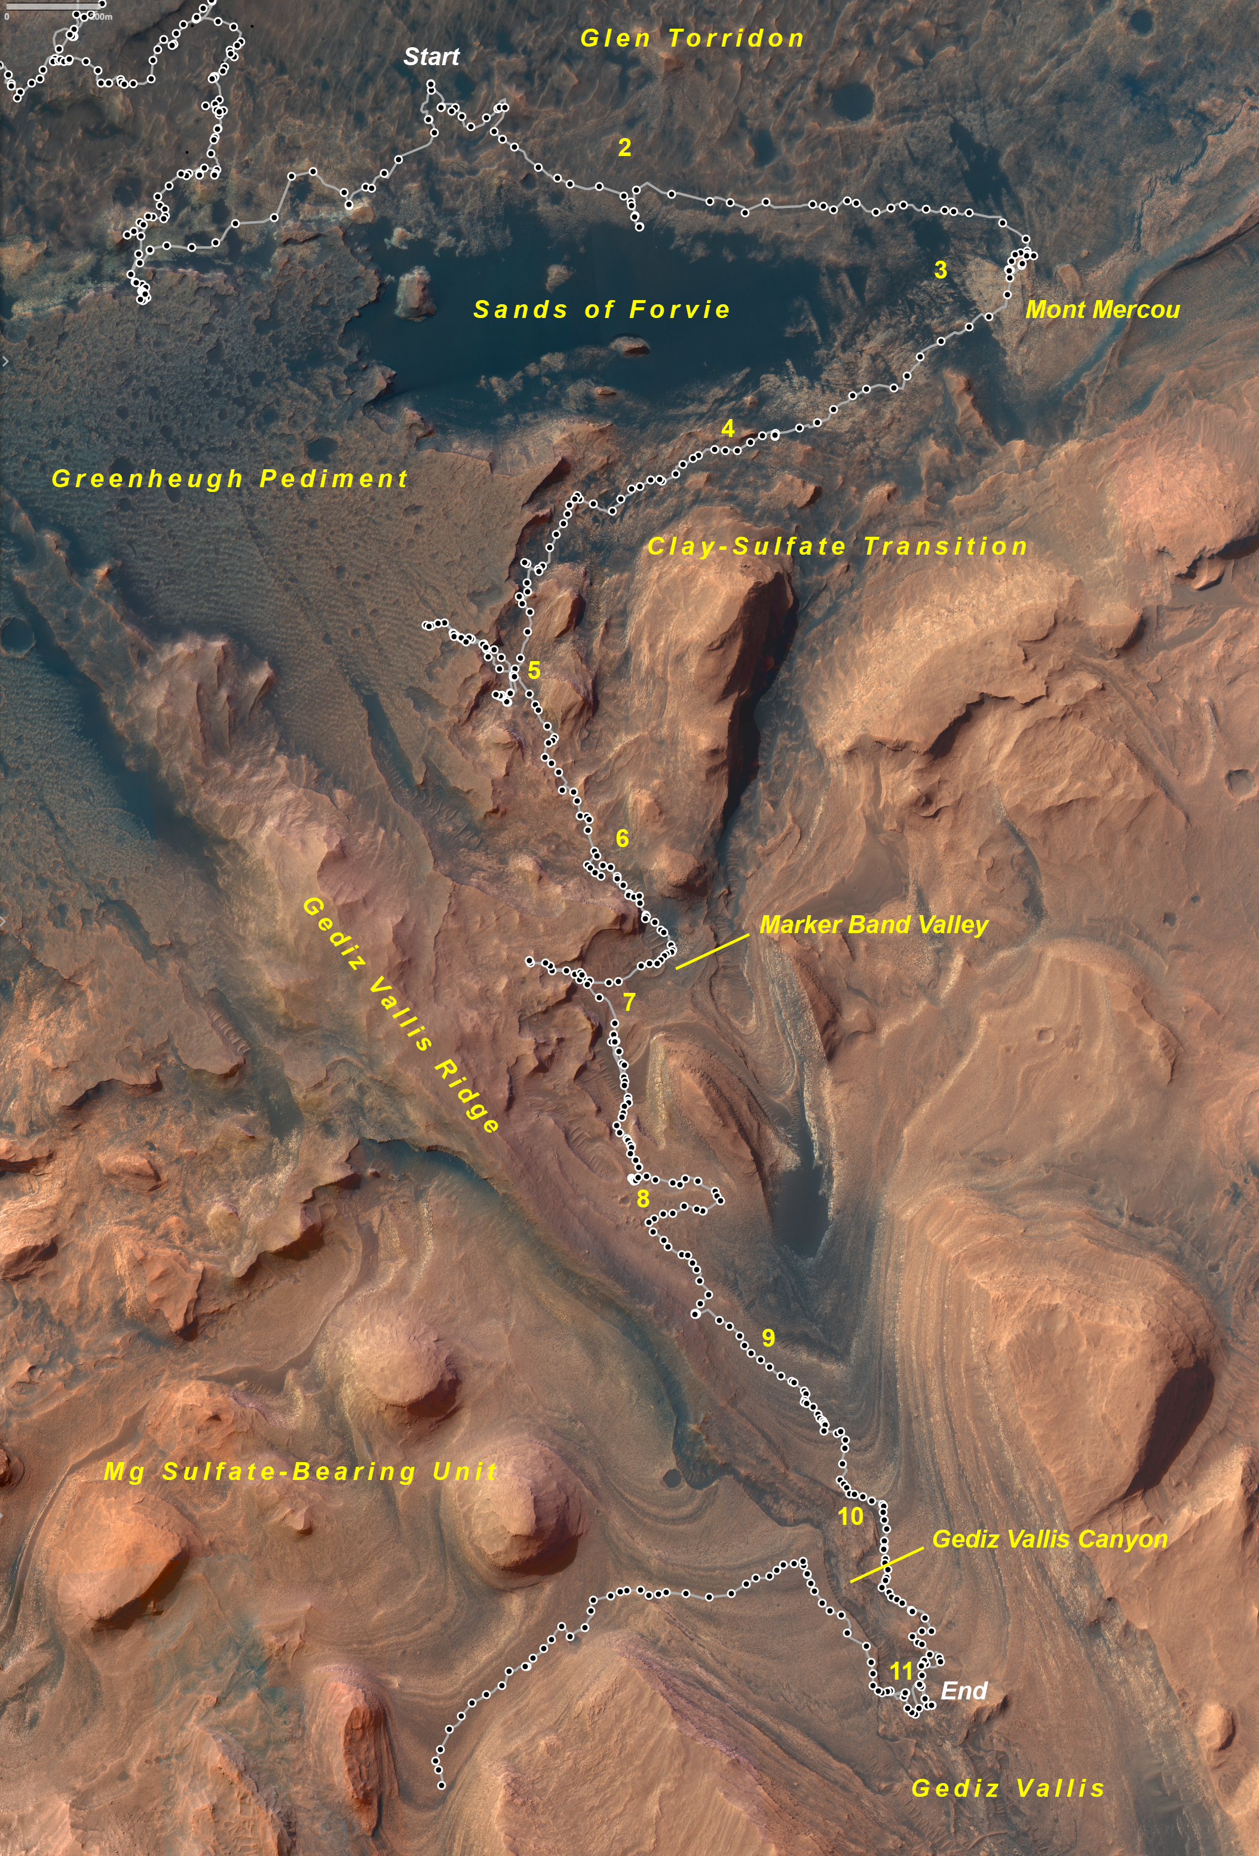
Fig. OR-2 Map of Curiosity’s traverse (Sols 2817-3025) from the Mary Anning sampling site across the northern margin of the Sands of Forvie. In Figs. OR-2 through OR-11, geographic features are in italics, sites where samples were drilled are in bold, and the sols that the rover arrived at overnight parking spots (dots) are in white. Online Resource 2 contains a list of rover drive distances and parking coordinates. North is up, and a scale bar is in the upper left corner. Image credit: NASA/JPL-Caltech/U. of Arizona
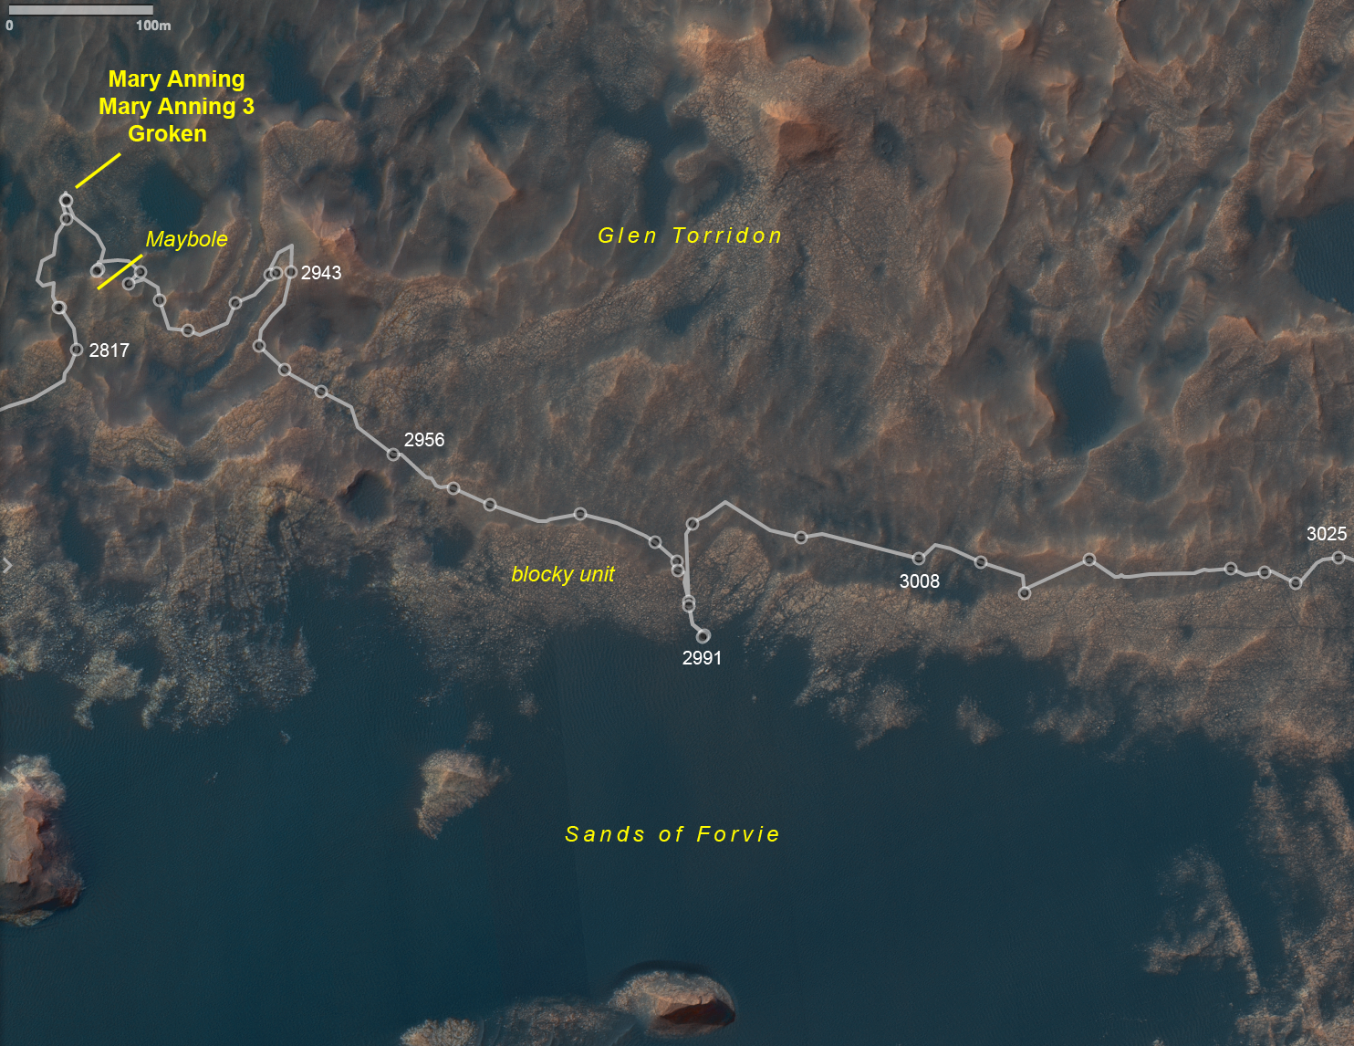

Fig. OR-3 Map of Curiosity’s traverse (Sols 3022-3143) near Mont Mercou
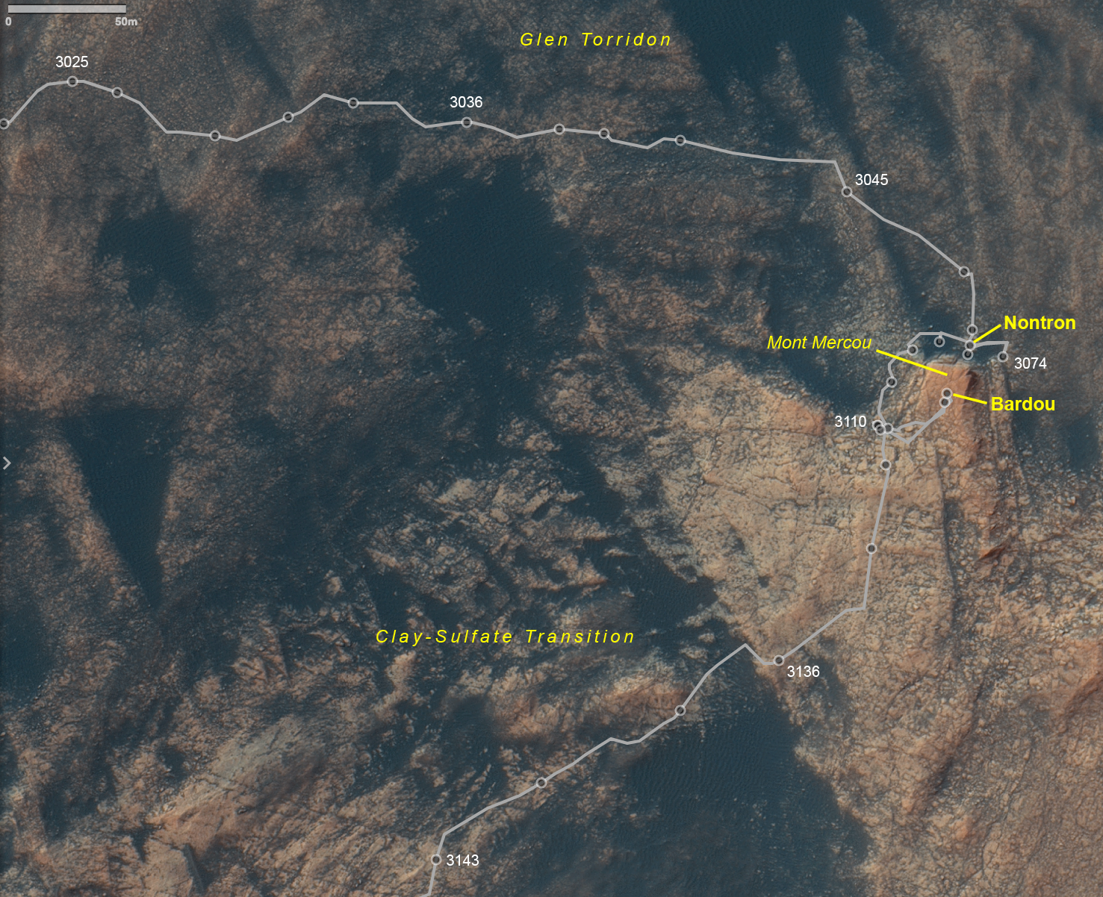

Fig. OR-4 Map of Curiosity’s traverse (Sols 3140-3331) approaching Maria Gordon Notch
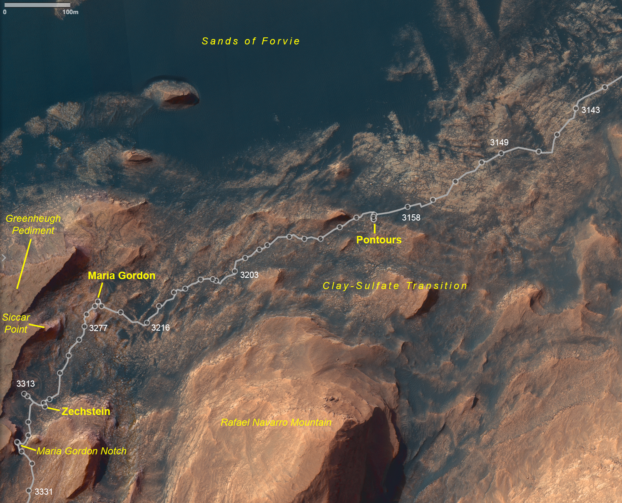

Fig. OR-5 Map of Curiosity’s traverse (Sols 3324-3481) including investigations of eastern Greenheugh Pediment and The Prow
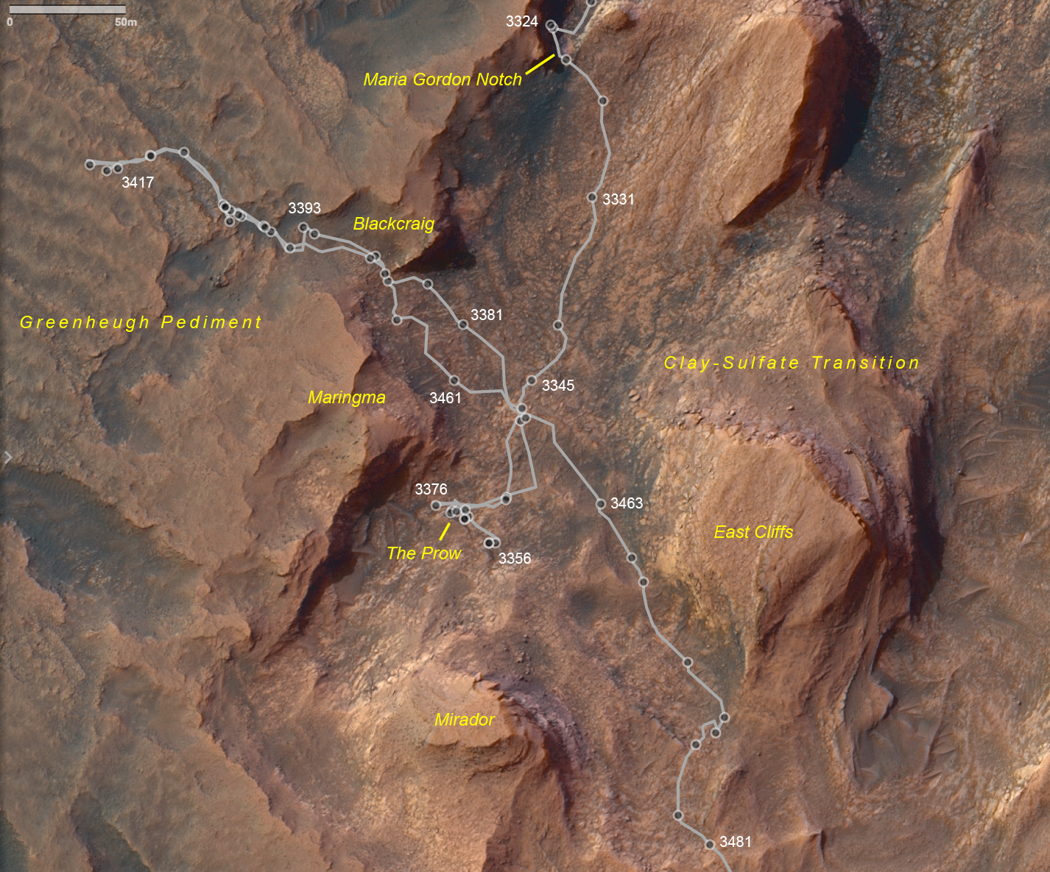

Fig. OR-6 Map of Curiosity’s traverse (Sols 3478-3570) approaching Paraitepuy Pass
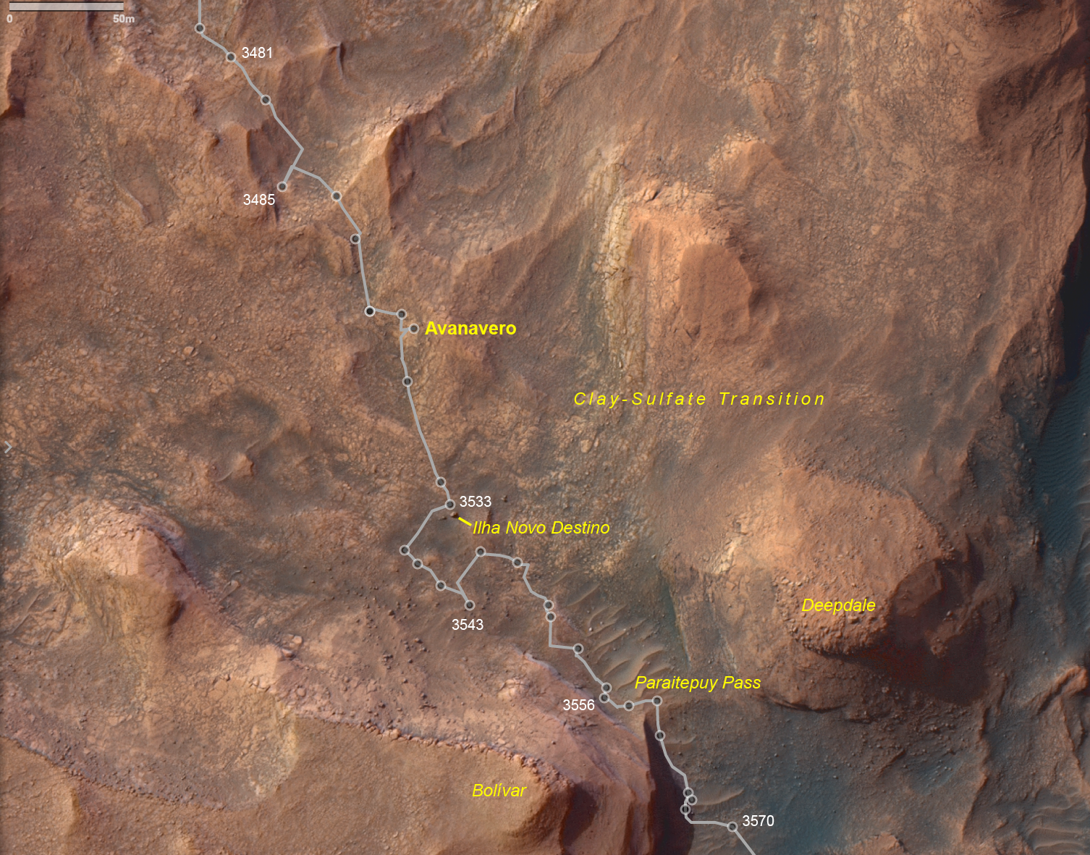

Fig. OR-7 Map of Curiosity’s traverse (Sols 3571-3774) in Marker Band Valley
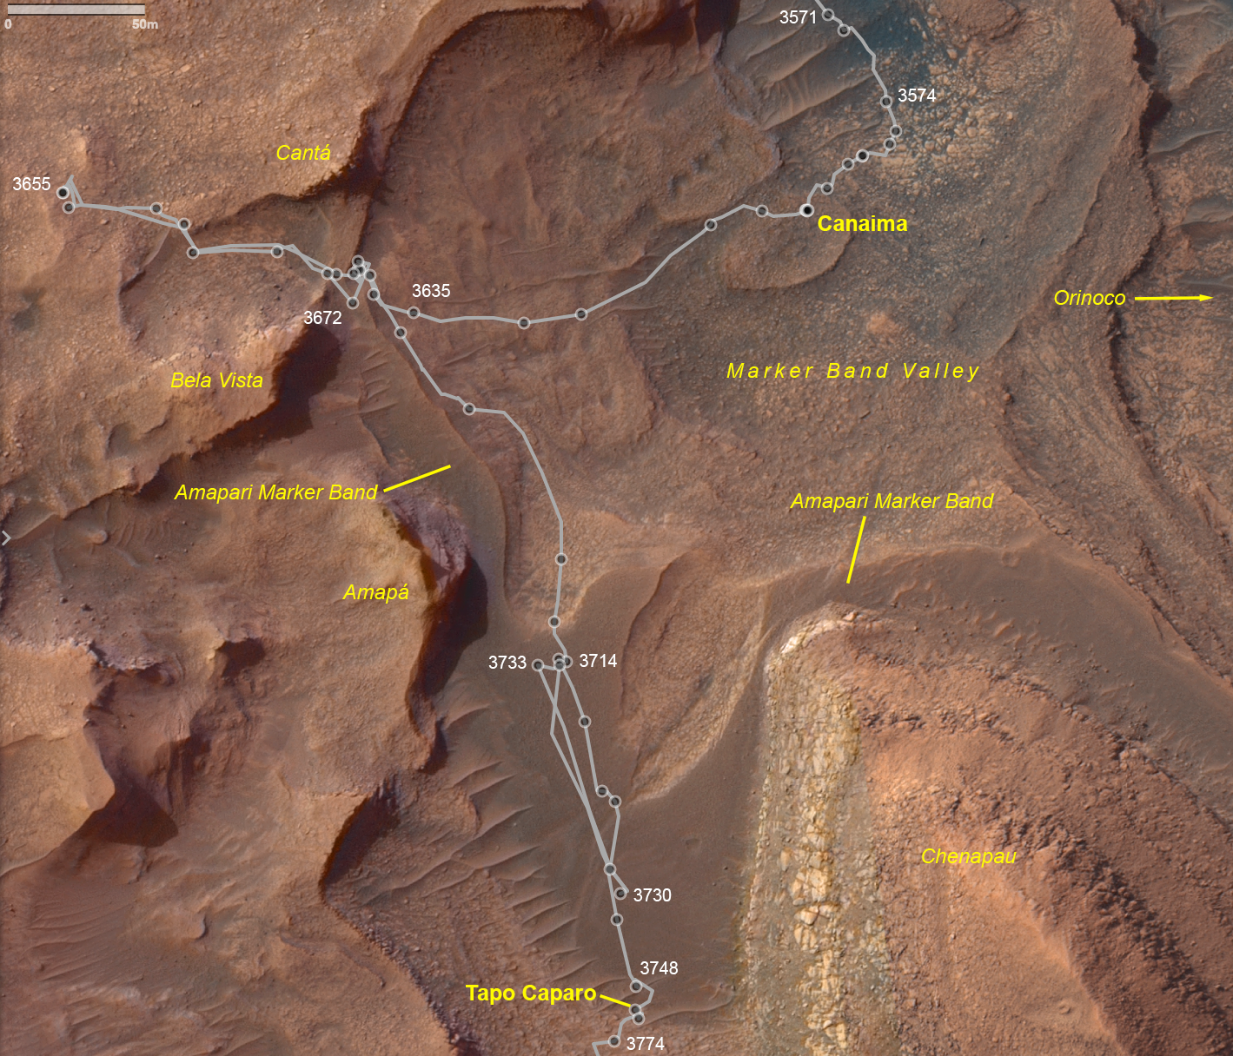

Fig. OR-8 Map of Curiosity’s traverse (Sols 3749-3910) near Jau crater cluster and upper Gediz Vallis Ridge
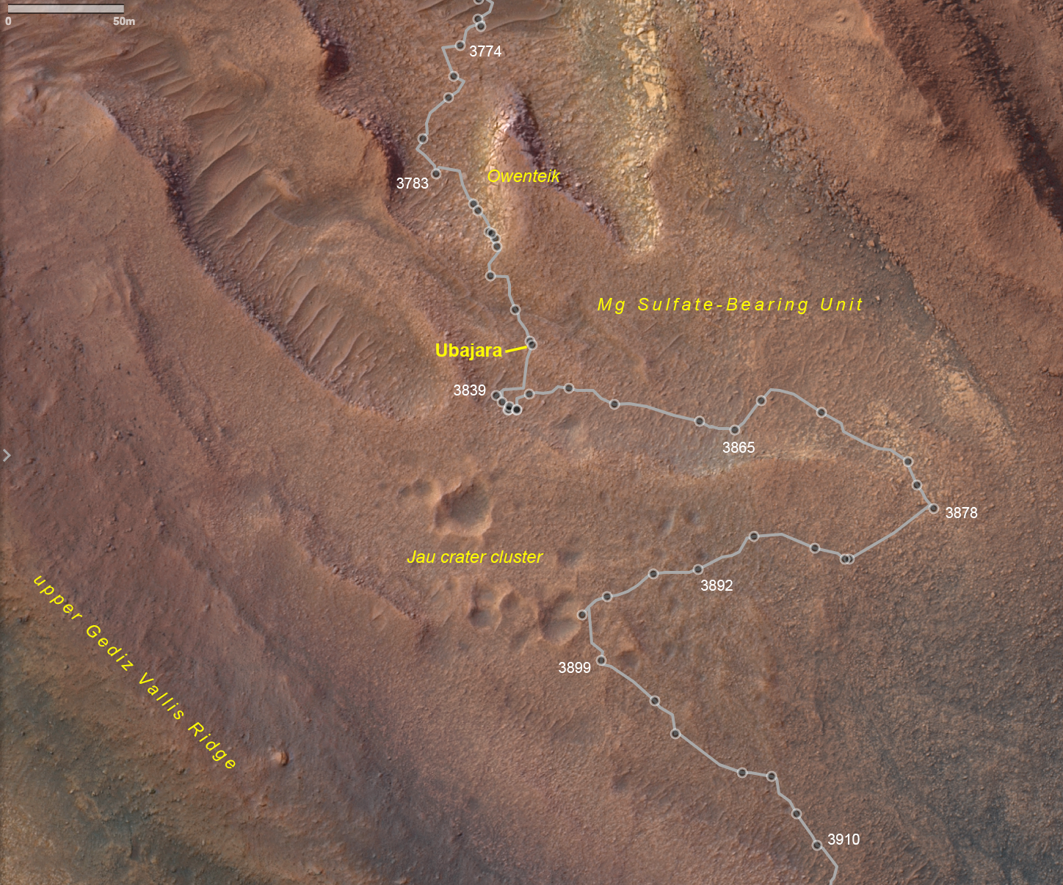

Fig. OR-9 Map of Curiosity’s traverse (Sols 3910-4071) along upper Gediz Vallis Ridge
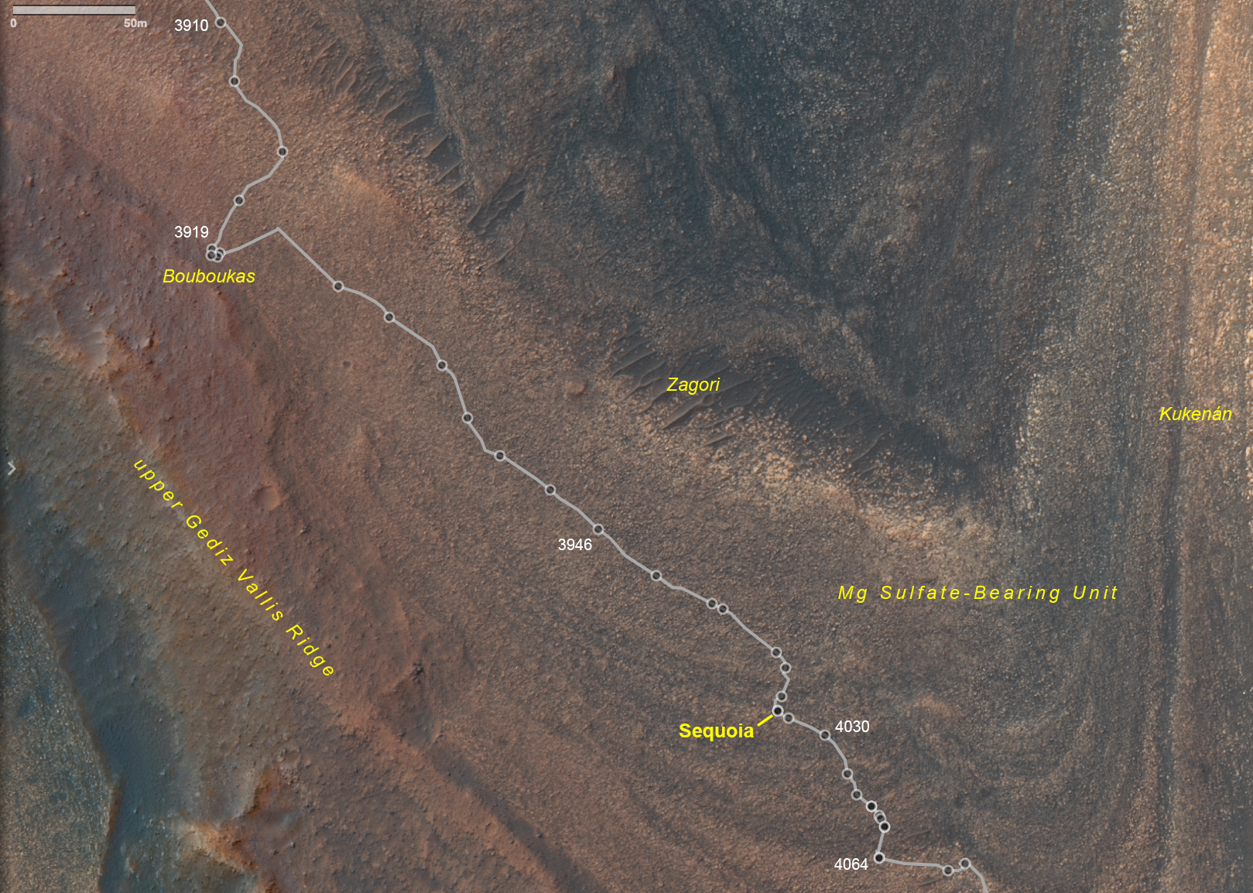

Fig. OR-10 Map of Curiosity’s traverse (Sols 4064-4162) along Gediz Vallis Canyon
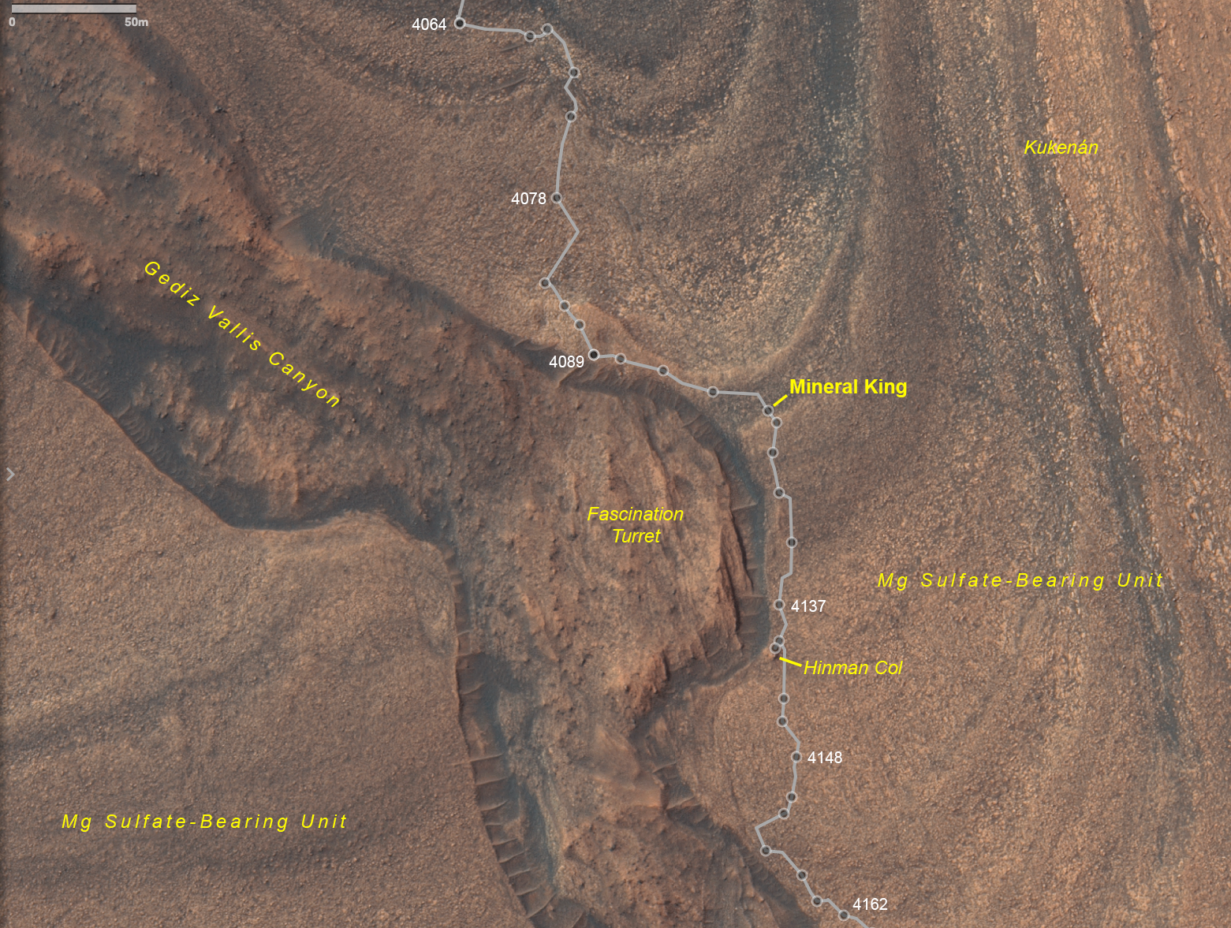

Fig. OR-11 Map of Curiosity’s traverse (Sols 4159-4255) exploring Gediz Vallis Canyon
