Supplementary material for:
Non-Communicated Judgments of vs. Feedback on Students’ Essays: Is Feedback Inflation Larger for Students With a Migration Background?
Anna K. Nishen¹ & Ursula Kessels¹
¹ Freie Universität Berlin, Germany
Corresponding author: Anna K. Nishen, anna.nishen@fu-berlin.de

Moderator analyses on motivation to respond without prejudice
As reported in the article, the results for this moderator were complex and only partially supported the hypothesis. With regards to the internal and external motivation to avoid prejudice, we expected that participants low in internal and simultaneously high in external motivation to respond without prejudice would show a stronger positive bias (H3c). This hypothesis was formulated for the feedback condition only, so that the sample for these analyses consists of half the original sample. The regression analyses were conducted using difference scores, that is, the extent of the positive or negative bias was predicted using internal and external motivation to avoid prejudice as well as their interaction. The difference scores were created by subtracting the values of students without a migration background from the values of students with a Turkish migration background. Therefore, values greater than zero indicate a positive bias towards students with a Turkish migration background and values smaller than zero a negative bias, with the exception of the negative comments, where the interpretation is reversed.
Contrary to our hypothesis, those participants who were low in internal motivation and simultaneously high in external motivation did not consistently show a stronger positive bias (see Table S1). Instead, there was a negative main effect of internal motivation for some dimensions. The greater the internal motivation to respond without prejudice was, the more similar were the participants’ ratings of the two students’ success in higher education (b = −0.51, SE = 0.23, p = .032), in tendency, their writing skills (b = −0.39, SE = 0.21, p = .066) as well as the number of negative comments on essay content they provided (b = 1.55, SE = 0.71, p = .032). Regardless of their external motivation, participants higher in internal motivation to respond without prejudice gave less positively biased feedback on those dimensions, whereas participants lower in internal motivation showed a stronger positive feedback bias. Participants’ external motivation to respond without prejudice was unrelated to their bias.
However, as we report in the manuscript, some effects of internal motivation were, in tendency, further qualified by the level of participants' external motivation, partially supporting Hypothesis 3c. In tendency, when external motivation to respond without prejudice was low, internal motivation tended to have only small or no effects on participants’ positive bias regarding grade (b_{interaction} = −0.28, SE = 0.16, p = .088), essay style/mechanics (b_{interaction} = −0.18, SE = 0.11, p = .088), total number of positive comments (b_{interaction} = −0.53, SE = 0.28, p = .063), and number of positive comments on content (b_{interaction} = −0.44, SE = 0.25, p = .087). Contrarily, when external motivation was high, greater internal motivation was associated with less positive bias (see Figure 1a-d). Participants tended to show the greatest positive bias towards students with a Turkish migration background on these dimensions when they were purely motivated to do so by external reasons, i.e., when they were low in internal and simultaneously high in external motivation (see Figure S1).

Table S1
Results of the Regression Predicting Difference Scores in the Feedback Condition by Internal/External Motivation
Dependent variable  (difference scores) | Intercept |  | Internal motivation |  | External motivation |  | IMS*EMS |  | Adj. R²
Dependent variable  (difference scores) |  |  | B (SE) | β | B (SE) | β | B (SE) | β | Adj. R²
Rating scale impressions
Grade | 0.33 (0.25) |  | −0.91* (0.39) | −0.39* | 0.19 (0.12) | 0.22 | −0.28⁺ (0.16) | −0.30⁺ | .041
Writing skills | 0.19 (0.13) |  | −0.39⁺ (0.21) | −0.32⁺ | 0.08 (0.07) | 0.16 | −0.04 (0.09) | −0.09 | .031
Content¹ | 0.42* (0.19) |  | −0.32 (0.23) | −0.24 | 0.07 (0.07) | 0.14 | −0.12 (0.10) | −0.23 | .006
Style/mechanics¹ | −0.19 (0.20) |  | −0.74** (0.24) | −0.48** | 0.04 (0.07) | 0.07 | −0.17⁺ (0.10) | −0.27⁺ | .188
Success in higher education | 0.23 (0.15) |  | −0.51* (0.23) | −0.37* | 0.01 (0.07) | 0.02 | −0.11 (0.10) | −0.20 | .042
Open text impressions
Positive comments
Total | 1.02* (0.42) |  | −0.94 (0.67) | −0.24 | 0.27 (0.21) | −0.19 | −0.53⁺ (0.28) | −0.33⁺ | .011
Content | 1.01* (0.38) |  | −0.99 (0.60) | −0.27 | 0.32⁺ (0.19) | −0.24⁺ | −0.44⁺ (0.25) | −0.30⁺ | .016
Style/mechanics | 0.00 (0.22) |  | −0.05 (0.36) | −0.03 | 0.02 (0.11) | 0.02 | −0.05 (0.15) | −0.06 | −.044
Negative comments
Total¹ | 0.54 (0.75) |  | 0.83 (0.88) | 0.16 | 0.06 (0.27) | 0.03 | −0.04 (0.37) | −0.02 | .059
Content¹ | −0.80 (0.60) |  | 1.51* (0.71) | 0.36* | −0.20 (0.22) | −0.13 | 0.35 (0.30) | 0.20 | .028
Style/mechanics¹ | 1.33* (0.60) |  | −0.69 (0.71) | −0.16 | 0.29 (0.22) | 0.19 | −0.42 (0.30) | −0.25 | .030
Number of suggestions | 0.50 (0.39) |  | −0.61 (0.63) | −0.17 | 0.17 (0.19) | 0.13 | −0.09 (0.26) | −0.06 | −.021
Tone | 0.10 (0.23) |  | −0.17 (0.37) | −0.08 | 0.01 (0.11) | 0.01 | −0.04 (0.16) | −0.04 | −.042
Percent positive comments | 0.05* (0.03) |  | −0.04 (0.04) | −0.19 | 0.00 (0.01) | 0.04 | −0.01 (0.02) | −0.15 | −.025
Note. The dependent variables are difference scores (value student with Turkish migration background – value of student without a migration background). Values greater than zero indicate a positive bias towards students with a Turkish migration background and values smaller than zero a negative bias, with the exception of the negative comments, where the interpretation is reversed. Sample size varied between 67 and 70 due to item-level missingness. IMS = Internal motivation to respond without prejudice. EMS = External motivation to respond without prejudice.
¹In this analysis, we controlled for writer order (reference group: student with a Turkish migration background first) because t-tests suggested that the difference between participants’ judgments/feedback differed by writer order (see section 6.2 Preliminary Analyses).
** p < .01. * p < .05. ⁺ p < .10.

Fig. S1 a-d
Effect of Internal Motivation at High and Low Levels of External Motivation to Respond Without Prejudice
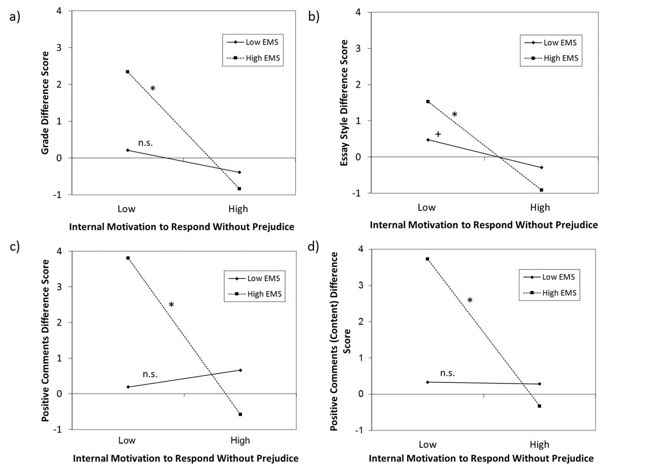
Note. Effects are plotted at +1 SD and −1SD, respectively. Values greater than zero indicate a positive bias towards students with a Turkish migration background and negative values a negative bias. IMS = internal motivation to avoid prejudice. EMS = external motivation to respond without prejudice.
* p < .05. ⁺ p < .10.

