Figure S1: Mildly threatening article about teacher bias.
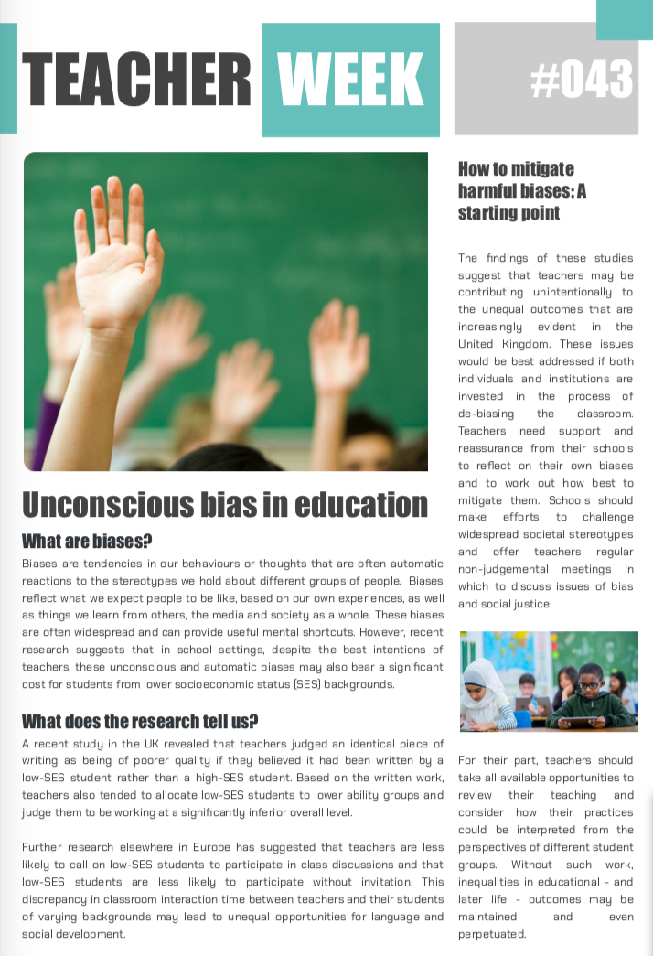

Table S1: Regression of key outcome variables on self-affirmation condition and control variables (without exclusions)

Outcome | Group | B | SE | t(296) | p | 95% CI
 | Intercept | 5.38 | .25 | 21.23 | < .001 | 4.88, 5.88
Message Acceptance | Self-affirmation | -.09 | .16 | -.57 | .566 | -.41, .22
 | % FSM | -.01 | .00 | -1.45 | .148 | -.01, .00
 | Age | -.00 | .01 | -.53 | .594 | -.02, .01
 | Intercept | 4.03 | .22 | 18.32 | < .001 | 3.60, 4.47
Message Derogation | Self-affirmation | -.04 | .14 | -.29 | .770 | -.32, .23
 | % FSM | .01 | .00 | 1.64 | .102 | -.00, .01
 | Age | -.01 | .01 | -1.09 | .278 | -.02, .01
 | Intercept | 3.75 | .28 | 13.20 | <.001 | 3.19, 4.31
Psychological Discomfort | Self-affirmation | .03 | .18 | -.16 | .876 | -.33, .38
 | % FSM | -.01 | .00 | -1.51 | .133 | -.01, .00
 | Age | -.02 | .01 | -1.92 | .056† | -.03, .00
 | Intercept | 3.62 | .19 | 19.54 | <.001 | 3.26, 3.99
Personal Relevance | Self-affirmation | -.02 | .11 | -.21 | .834 | -.26, .21
 | % FSM | -.01 | .00 | -2.98 | .003** | -.01, -.00
 | Age | -.01 | .01 | -2.42 | .016* | -.02, -.00
 | Intercept | 4.11 | .14 | 30.37 | <.001 | 3.84, 4.38
Relevance to Others | Self-affirmation | -.01 | .09 | -.14 | .886 | -.16, .18
 | % FSM | -.00 | .00 | -1.21 | .227 | -.01, .00
 | Age | -.01 | .00 | -2.42 | .016* | -.02, -.00
 | Intercept | 2.92 | .24 | 12.39 | <.001 | 2.45, 3.38
Support for CPD: Video | Self-affirmation | .36 | .15 | 2.39 | .017* | .06, .65
 | % FSM | .01 | .00 | 2.17 | .031* | .00, .01
 | Age | -.00 | .01 | -.24 | .814 | -.02, .01
 | Intercept | 3.86 | .22 | 17.73 | <.001 | 3.43, 4.29
Support for CPD: Meetings | Self-affirmation | .18 | .14 | 1.29 | .199 | -.09, .45
 | % FSM | .00 | .00 | .66 | .509 | -.00, .01
 | Age | -.02 | .01 | -3.05 | .002** | -.03, -.01
Professional Beliefs about Diversity | Intercept | 3.65 | 1.00 | 36.34 | <.001 | 3.45, 3.85
Professional Beliefs about Diversity | Self-affirmation | .04 | .06 | .62 | .539 | -.08, .16
Professional Beliefs about Diversity | % FSM | -.00 | .00 | -.05 | .959 | -.00, .00
Professional Beliefs about Diversity | Age | -.00 | .00 | -2.38 | .018* | -.01, -.00
Notes: † = p < .10, * = p < .05, ** = p < .01. Condition was coded 0 = Control, 1 = Self-Affirmation.

Table S2: Demographic breakdown of the sample by condition
 | Condition
 | Control |  | Self-affirmation
Demographic | M | SD | M | SD
Age (years) | 39.84 | 10.09 | 42.61 | 11.04
Experience (years) | 12.94 | 8.84 | 14.29 | 10.48
% students eligible for FSM in school | 37.97 | 22.57 | 31.17 | 20.99
% ethnic minority students in school | 26.82 | 24.69 | 25.31 | 23.64
 | n | % | n | %
Leadership position
Yes | 64 | 43.2 | 63 | 45.3
No | 84 | 56.8 | 76 | 54.7
Gender
Male | 8 | 5.4 | 9 | 6.5
Female | 139 | 93.9 | 129 | 92.8
Non-binary | - | - | 1 | 0.7
Ethnicity
Asian or Asian British – Bangladeshi | - | - | 1 | 0.7
Asian or Asian British – Indian | 1 | 0.7 | 1 | 0.7
Asian or Asian British – Chinese | 1 | 0.7 | - | -
Black or Black British – Caribbean | 1 | 0.7 | - | -
Mixed – White and Black African | - | - | 1 | 0.7
Mixed – White and Asian | - | - | 3 | 2.2
Other Mixed/Multiple Ethnic Background | 1 | 0.7 | 1 | 0.7
White – British | 131 | 88.5 | 123 | 88.5
White – Irish | 3 | 2.0 | 1 | 0.7
Other White Background | 9 | 6.1 | 7 | 5.0
Prefer not to say | 1 | 0.7 | 1 | 0.7
FSM eligibility as a child
Yes | 33 | 22.3 | 35 | 25.2
No | 105 | 70.9 | 91 | 65.5
Don’t know | 10 | 6.8 | 13 | 9.4
Note: Only genders and ethnicities that were represented by at least one participant are listed.

