Online supplement

Supplement A: Summary and information on the stories chosen for the interventions.
A1. Summary Richy and the Barbies (Linderbaum, 2017).
A2. Summary Half of John (Lienas, 2008).
Supplement B: Studies Methodology.
B1. Socioeconomic Information.
B2. Measure Dependent Variables.
B3. Procedure Study 3.
B4. Procedure Study 4.
Supplement C: Annexed Tables of Results
C1. Table S2

Supplement A: Summary and information on the stories chosen for the interventions.
Supplement A1. Summary Richy and the Barbies (Linderbaum, 2017)
Richy is an ace at playing football, although he doesn't really like to play. He prefers to play dolls. But it is not easy for him to integrate with the group of girls, who at first leave him out of their circle. Finally, they let him in, but the embarrassment that Richy himself feels when the boys see him playing princesses has yet to be resolved. The happy ending of the story sees the full acceptance of everyone in the game, abolishing gender discrimination.
This story deals with gender stereotypes in toys, specifically with traditionally feminized toys (dolls, princess costumes) as well as gender-based exclusion in play (boys are not allowed to play with dolls).
Supplement A2. Summary Half of John (Lienas, 2008).
Boys don't cry - how many times have we heard that? Boys don't play with dolls, and they don't wear pink clothes... That's how John lives, harassed by the clichés of the "man", both in his family and among his friends. And when he decides to listen to everyone and be a "boy", he realises that he is very sad. Until Fairy Menta arrives and teaches him a nice lesson.
This story works on gender stereotypes in toys, in the main the traditionally feminized toys through the main character John; but it also includes the traditionally masculinized toys through Marta.

Supplement B: Studies Methodology
Supplement B1. Socioeconomic Information
Table S1
Descriptive Socioeconomic Information (INE, 2020)
 |  | Media net income per person 2019
 | National | 11.680
Study 1 | (1) Logroño, La Rioja | 13.911
Study 1 | (2) Arnedo, La Rioja | 11.488
Study 2 | (1) Logroño, La Rioja | 13.911
Study 2 | (2) Arnedo, La Rioja | 11.488
Study 2 | (3) Rincón de Soto, La Rioja | 11.127
Study 3 | (1) Albaicín, Granada, Andalucía | 11.105
Study 3 | (2) Zaidín, Granada, Andalucía | 13.295
Study 4 | (1) Albaicín, Granada, Andalucía | 11.105
Study 4 | (2) Zaidín, Granada, Andalucía | 13.295
Study 4 | (3) La Chana, Granada, Andalucía | 13.408
Study 4 | (4) Sevilla Este, Sevilla, Andalucía | 10.707
Study 4 | (5) Nervión, Sevilla, Andalucía | 17.547

Supplement B2. Measures Dependent Variables
Example of Attitudes towards Stereotypical Toys.
"How much would you like to play with this toy?"

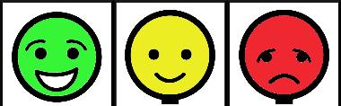
A lot/ Somewhat/ Not at all
Example of Gender Attribution of Stereotypical Toys.
"Who do you think would like to play with the toy?"
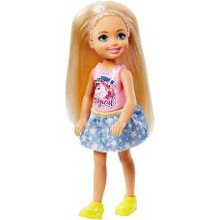
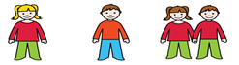
Girl/ Boy/ Both
Example of Gender-Based Social Exclusion.
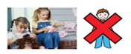
The other day some girls were playing with dolls. A boy came up to them and asked if he could play. The girls told him he couldn't play because he was a boy. What do you think about the girls telling the boy he couldn't play?
Okay/ A little okay/ Not okay
Example of Gender Attribution of Professional Roles.

A person who works caring for sick people is_______________________. Who do you think takes care of sick people?
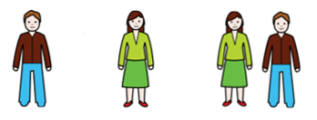
Man/ Woman/ Both
Supplement B3. Study Procedure 3
Session 1.
Pre questionnaire:
- Objective: Promote the reduction of gender roles and stereotypes.
- Development: It will be a questionnaire that presents a series of questions. In the first one, children will be shown various images of toys, which they will have to classify as "for boys," "for girls," or "for everyone." The second question shows two stereotypical situations where each child must indicate what they think. In the last one, they will be asked about the name of different professions and the gender of the adult who practices them. We will distribute the questionnaires and do the first toy example together as a trial.
- Material: Supplement B2. Measures Dependent Variables

Storytelling:
-Objective: Reduce gender roles and stereotypes in toy usage.
- Development: The story Richy and the Barbies will be read, and then the children will be asked what they think. Are there toys just for boys or girls? Do they agree that all boys and girls should be able to play with whatever they want? Why?
- Material: Richy and the Barbies story (Linderbaum, 2017).

Researcher's Notebook:
- Objective: Promote the reduction of gender roles and stereotypes.
- Development: Over the next few weeks, we will need their help to conduct research on toys because they are the "children of today," and who better than them to research something as important as toys? For this, we will give each child their “Researcher's Notebook” and explain the research task to be done at home during that week.
- Material: Researcher's Notebook
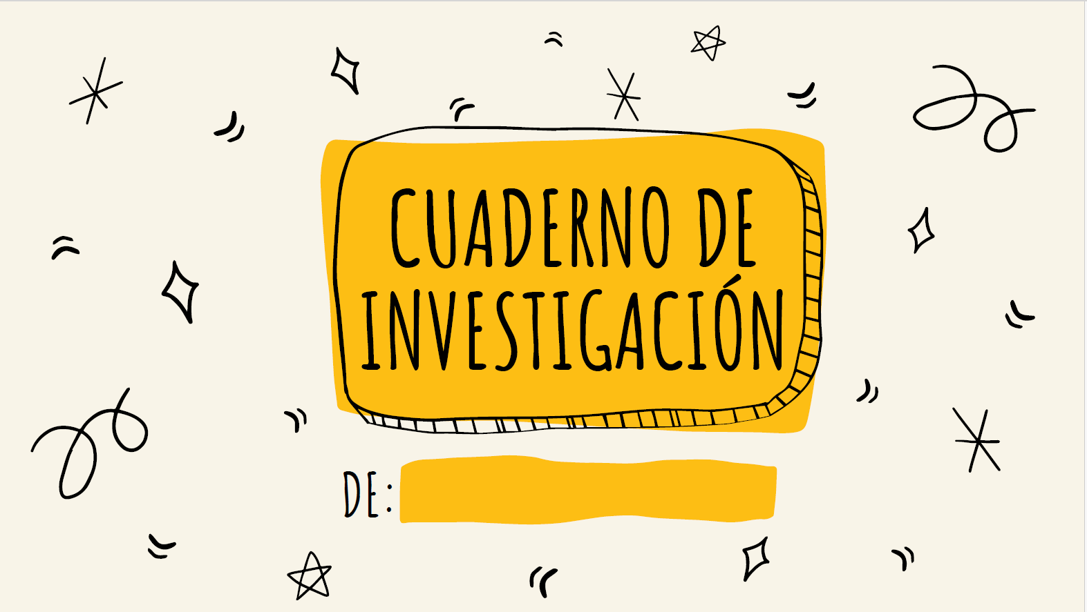
Homework 1:
- Objective: Reduce gender roles and stereotypes in toy usage.
- Development: The first homework will be to take a photo of their three favorite toys and paste each one on a page of the notebook. Below the photo, they will have to answer some important questions for their research:
- Who do you play with when you use each of these toys?
- Who in your household uses these toys in real life?
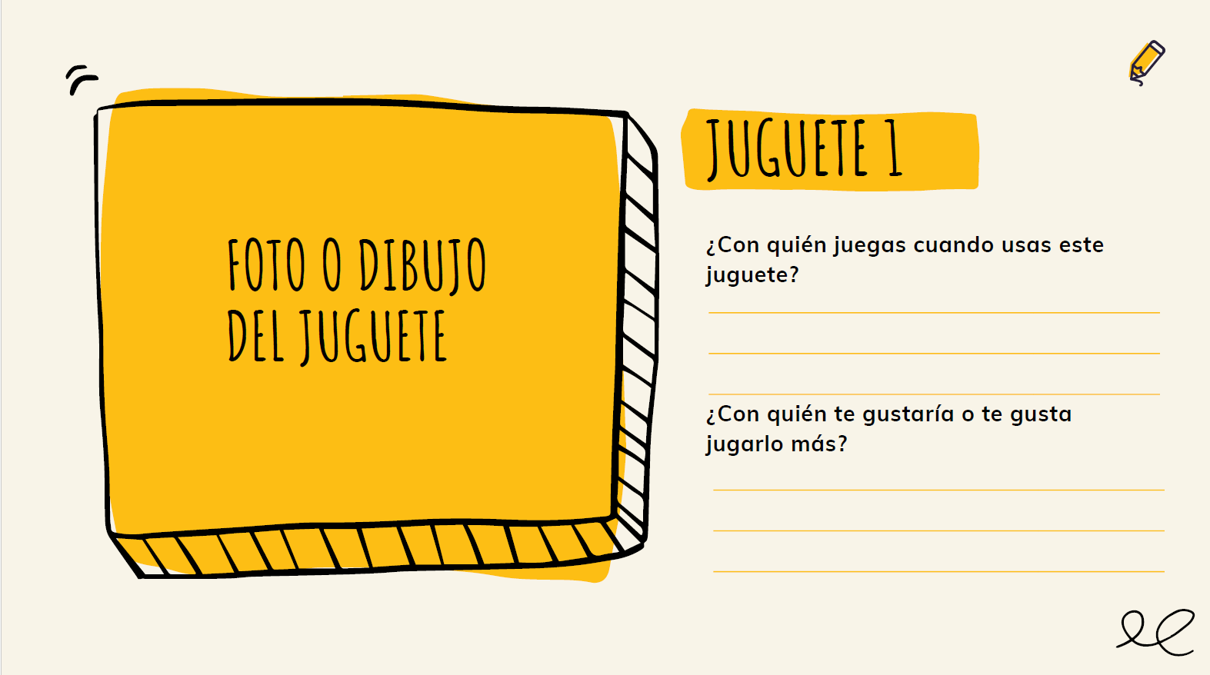

Session 2.
Sharing:
- Objective: Reduce stereotypes in household chores and career choices.
- Development: Each child will present their first research results to the class, including their favorite toys and their answers to the questions. We will reflect together, highlighting cases where gender role stereotypes in task distribution are not followed.

Video: Gift Equality
- Objective: Reduce stereotypes in household chores and career choices.
- Development: The video will have already been shown to the students in class, so when we meet in the park, we will discuss it together. We will talk about the variety of tasks and jobs adults do, both inside and outside the home, and how many toys are used to practice those tasks.
- Material: Video Gift Equality: https://www.youtube.com/watch?v=V-siux-rWQM.

Homework 2:
- Objective: Reduce stereotypes in household chores and career choices.
- Development: They will look through toy catalogs for toys that allow children to practice adult activities, cut them out, and paste them into their notebook. Below, they will have to write whether the adults who use them in real life are "only men," "only women," or "both."
- Material: Researcher's Notebook:
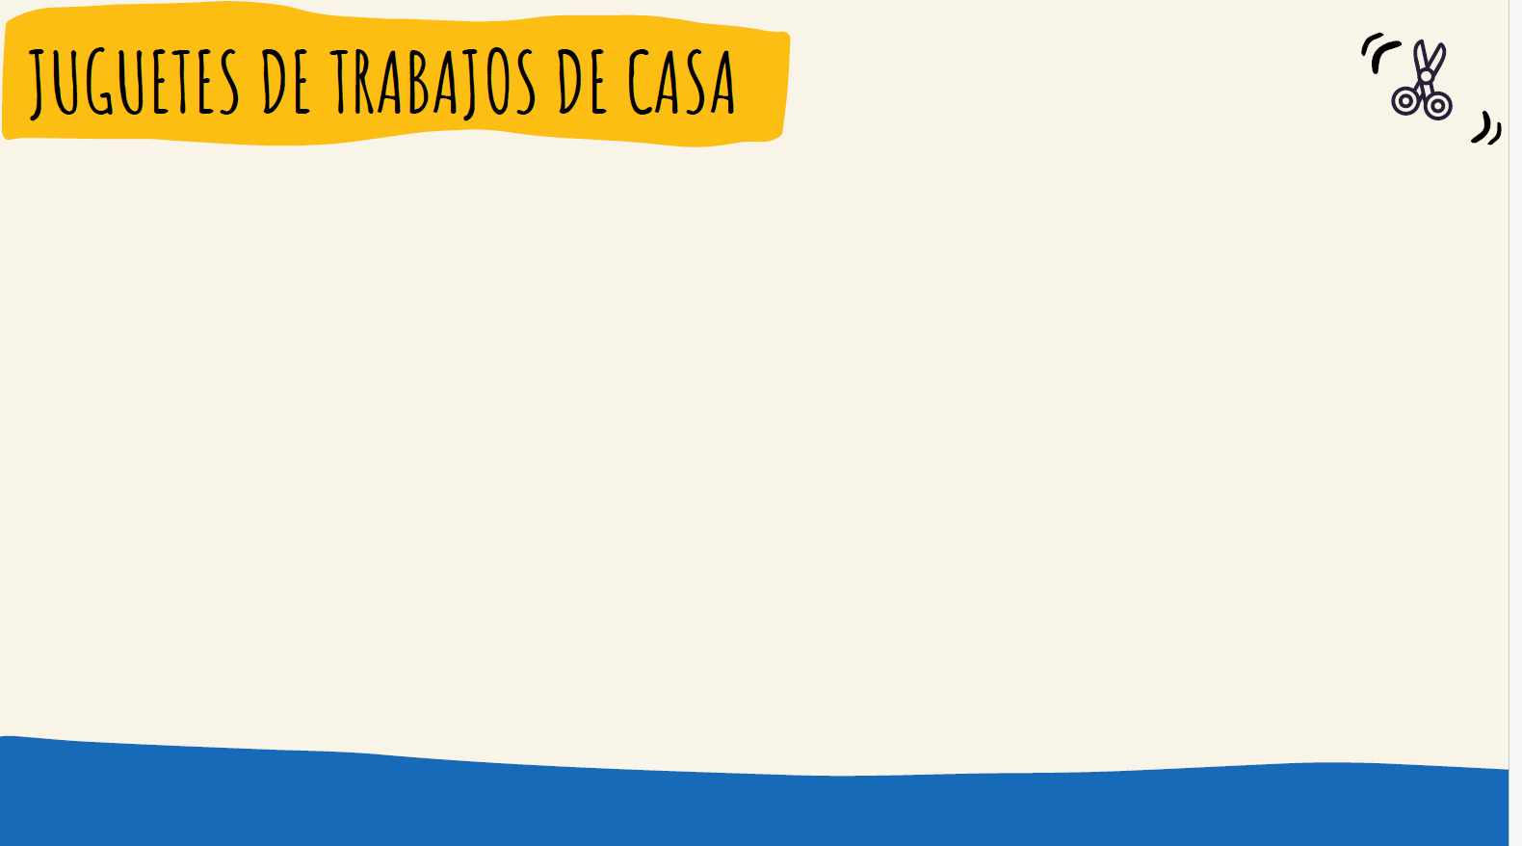
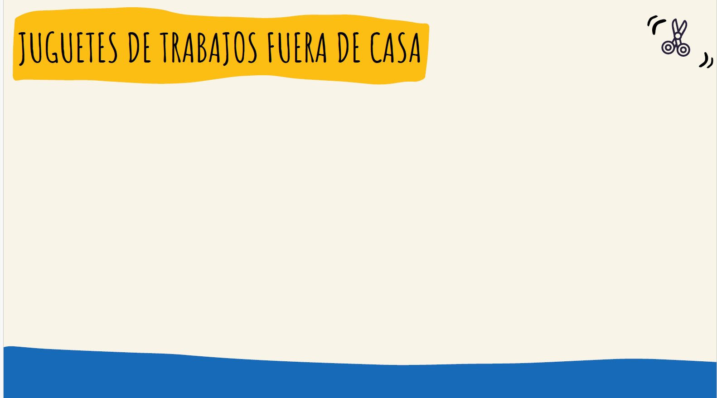

Session 3.
Sharing:
- Objective: Reduce stereotypes in household chores and career choices.
- Development: Each child will present their second research results to the class, focusing on the toy that surprised them the most. We will reflect together, highlighting cases where gender role stereotypes in task execution are not followed.

Roles:
- Objective: Reduce stereotypes in household chores and career choices.
- Development: Some toy cards that represent professional and housechores roles were presented and discussed about who can play with it and who can work and do these professions and housechores.
- Material:
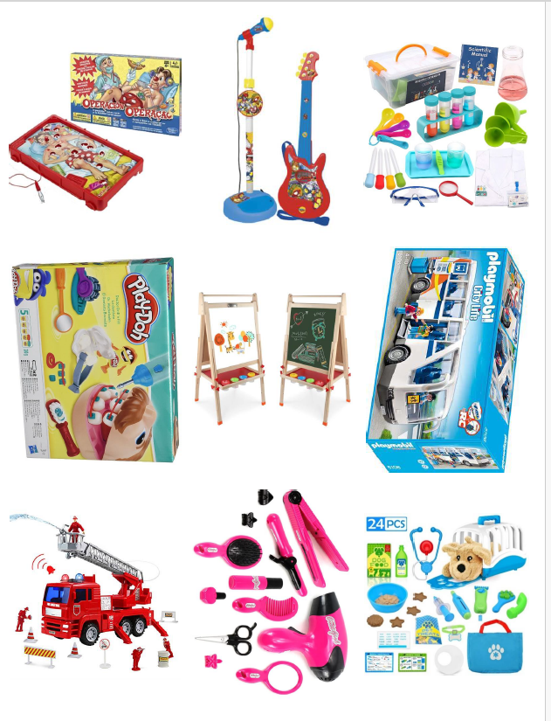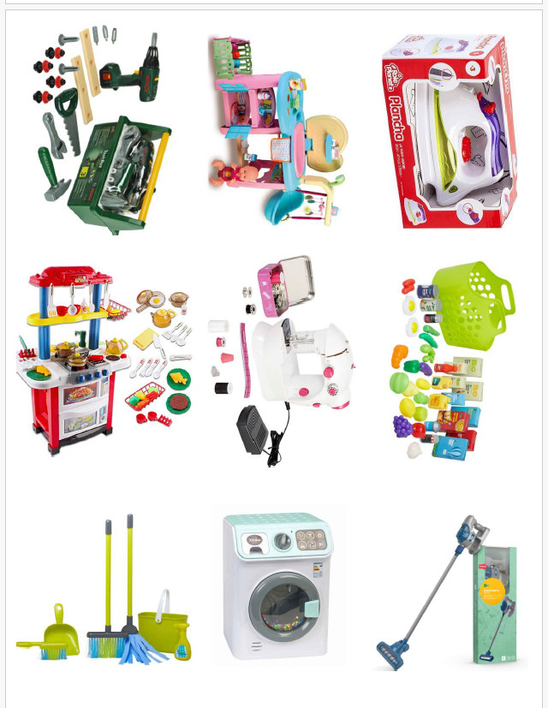
Video: The Barbie Who Chose To Drive
- Objective: Reduce gender roles and stereotypes in toy usage.
- Development: The video will have already been shown to the students in class, so when we meet in the park, we will discuss it together. We will talk about the variety of toys available and how in many toy stores, toys are arranged in two separate aisles: one for boys and one for girls. The same happens with toy catalogs.
- Material: Video The Barbie who chose to drive: https://www.youtube.com/watch?v=UEI0tdi5XDo

Homework 3:
- Objective: Reduce gender roles and stereotypes in toy usage.
- Development: We will explain that the next day will be the final day of our research and that to conclude, we would like to create a super catalog with them, featuring toys from the children of classes 2A and 2B, where toys are for everyone, and anyone can play with any toy. To achieve this, we will need to agree on how to create the catalog. The homework will be for each child to draw a toy to include in the catalog. The condition is that the toy must relate to a task adults do, and everyone should be able to play with it.
- Material:
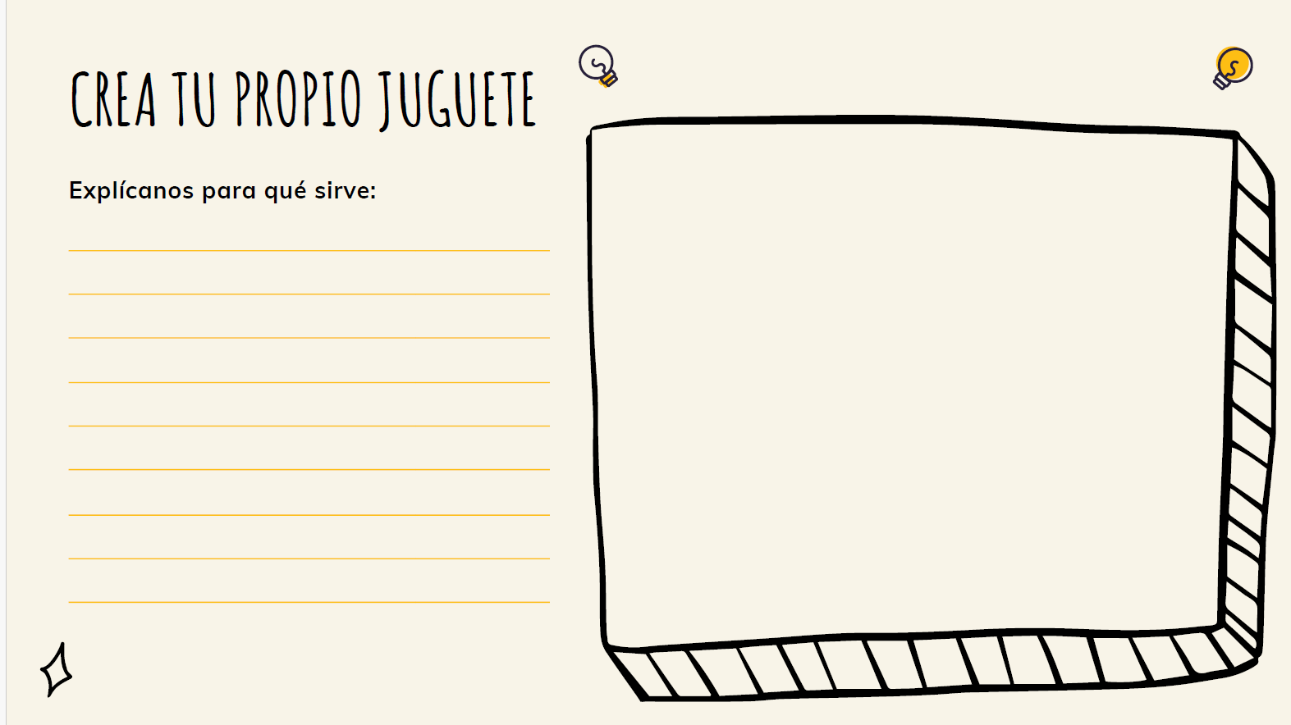

Session 4.
Sharing:
- Objective: Reduce gender roles and stereotypes in toy usage.
- Development: Each child will present their toy drawing and explain what it is used for.
- Material (example):
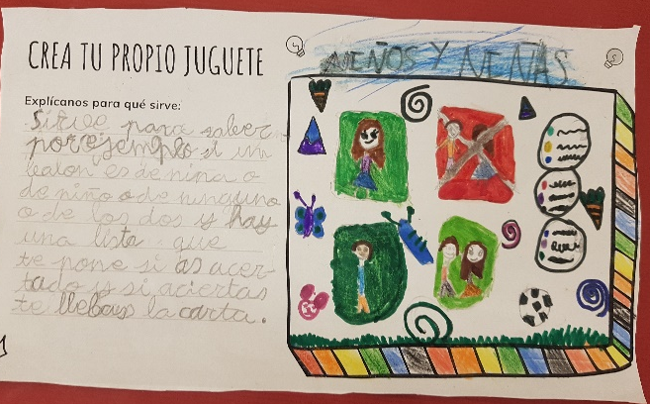

Creating The Non Sexist Catalog:
- Objective: Promote the reduction of gender roles and stereotypes.
- Development: We will paste the drawings of the toys on a large continuous sheet, which will become our catalog and will be displayed in the schoolyard.
- Material:
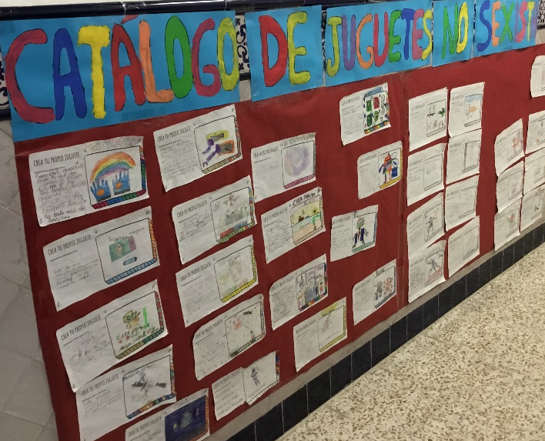

Final Questionnaire:
- Objective: Promote the reduction of gender roles and stereotypes.
- Development: The initial questionnaire will be given again, and after analyzing the responses, we will determine if the intervention has modified their gender role stereotypes
- Material: Supplement B2. Measures Dependent Variables.
Supplement B4. Procedure Study 4
Session 1.
The first session consisted of providing Questionnaire 1 to all students. In the case for the children in 5 years of kindergarten, the questionnaire was administered by a team of evaluators who asked the questions through a game with cards in small teams of 3-5 participants; In the case of first year of primary school, the questionnaire was projected on the digital whiteboard and completed individually by the students.
Session 2.
The second session consisted of the reading of the story, followed by a short discussion and, at the end, the completion of Questionnaire 2. In Line 1 schools, the students in the classes were randomly divided in two, with each subgroup being taken to a different classroom. In Line 2 schools, each class (A/B) was randomly assigned to an experimental or control group. The question for the short debate was: in the case of the experimental group: (1) What did you think of the story? / (2) What did Richy like to play? / (3). What do you think about Richy preferring to take his Barbie doll to school over his soccer ball? / (4) When the girls invited Richy to play with them, what did you think? / (5) What would you have done? / (6) Do you like to dress up? / (7) And play ball? / (8) What do you think of the end of the story?
In the case of the control group: (1) What did you think of the story? / (2) What was happening to the chameleon? / (3) Was what he did right or wrong? / (4) Have you ever done something wrong and then heard a little voice and regretted it? / (5) Who was the little voice I heard in the end? / (6) What happened at the end of the story?
Session 3.
For the design of the third session ("Generalization") an activity was developed in which the class was organized into groups of 4-6 students, and they were presented with images of either role-playing toys (experimental group) or animals (control group) for them to organize them. For the experimental group: At first, they were asked to arrange them as they wished in order to familiarize themselves with the cards and then they were asked to classify them between domestic tasks and professions (or domestic and wild animals) after which a subsequent discussion was held in which the emphasis was on discussing counter-stereotypical examples: (1) What toys have you found to practice that housework? / (2) Do you know any men/women who do it in real life? (discuss each one) / (3) Do you think that anyone can play with those toys, only boys or only girls? (4) Do you know any boys or girls who play in real life? (ask about each one) / (5) What toys have you found to practice these professions? / Do you know any men/women who do it in real life? (discuss each one).
For the control group: We divide the animals between domestic and savage animals. And in the end we ask the following questions: (1) What animals have you found that are domestic? / (2) For each animal, ask where it lives and what it gives to us humans; and if it could live in freedom anyway. / (3) What animals have you found that are wild? / (4) For each animal ask if it is dangerous, where it lives, if it is in danger of extinction or not. / (5) Do you think that human beings take care of nature? / (6) Could we do better? / (7) What things could we do?
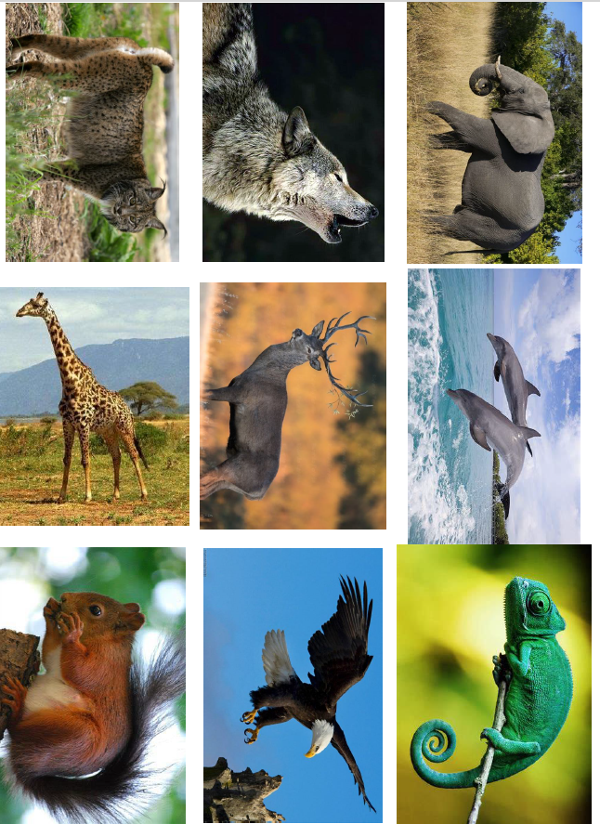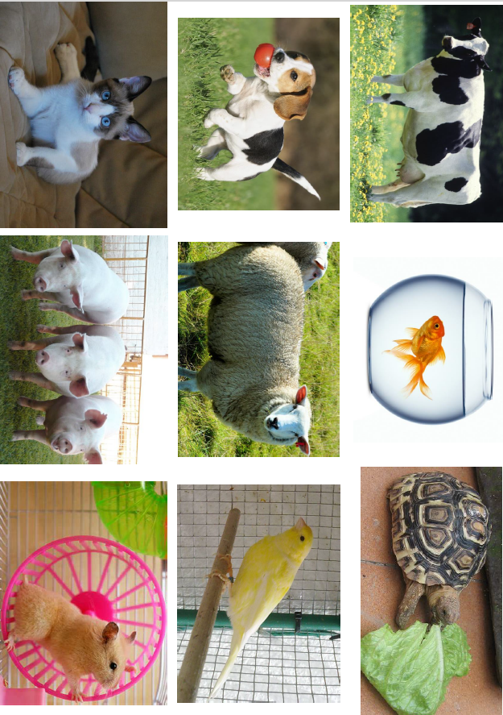
We ended the session with Questionnaire 3.
Session 4.
Two weeks after the end of the intervention, Questionnaire 4 was administered.

Supplement C: Annexed Tables of Results
Supplement C1. Table S1
Descriptive statistics and effect size for attitudes towards stereotypical toys in Study 1.
 |  | Control |  |  | Intervention
 |  | Pre | Post | Pre-Post | Pre | Post | Pre-Post
 | Gender | M (SD) | M (SD) | d | M (SD) | M (SD) | d
Attitude feminized toys (general) | Boys | 1.14 (.60) | 1.11 (.59) | 0.05 | 1.14 (.65) | 1.17 (.62) | -0.05
Attitude feminized toys (general) | Girls | 1.77 (.27) | 1.83 (.23) | -0.24 | 1.89 (.25) | 1.76 (.36) | 0.45*
Attitude feminized toys (story) | Boys | 0.70 (.82) | 0.67 (.73) | 0.04 | 0.67 (.82) | 0.79 (.88) | -0.14
Attitude feminized toys (story) | Girls | 1.77 (.53) | 1.86 (.35) | -0.20 | 1.75 (.52) | 1.71 (.60) | 0.07
Attitude feminized toys(new) | Boys | 1.25 (.59) | 1.22 (.58) | 0.05 | 1.26 (.68) | 1.26 (.65) | 0
Attitude feminized toys(new) | Girls | 1.77 (.27) | 1.82 (.28) | -0.18 | 1.92 (.26) | 1.77 (.36) | 0.48*
Attitude masculinized toys (general) | Boys | 1.82 (.30) | 1.82 (.27) | 0 | 1.76 (.34) | 1.76 (.36) | 0
Attitude masculinized toys (general) | Girls | 1.15 (.63) | 1.11 (.64) | 0.06 | 1.42 (.40) | 1.36 (.48) | 0.14
Attitude masculinized toys (story) | Boys | 2.00 (.00) | 2.00 (.00) | 0 | 1.79 (.51) | 1.83 (.57) | -0.07
Attitude masculinized toys (story) | Girls | 1.27 (.88) | 1.18 (.96) | 0.09 | 1.64 (.62) | 1.68 (.61) | -0.07
Attitude masculinized toys (new) | Boys | 1.78 (.36) | 1.78 (.34) | 0 | 1.75 (.42) | 1.74 (.41) | 0.02
Attitude masculinized toys (new) | Girls | 1.13 (.63) | 1.09 (.66) | 0.06 | 1.37 (.51) | 1.28 (.56) | 0.17
Note. Mean comparisons between pre-post: *p <.05. **p < .01. ***p < .001.

