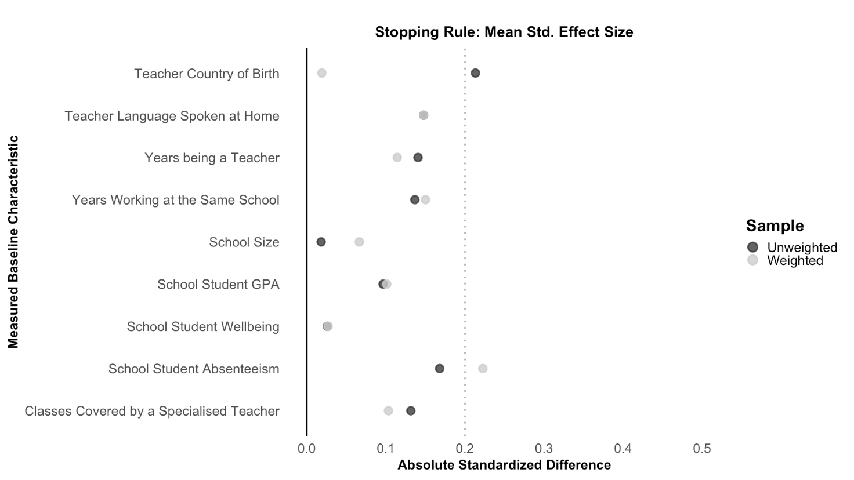
Figure A. Generalised balance plot of teacher and school baseline characteristics in the study sample across imputations and vignette sets

Figure A. Generalised balance plot showing teacher and school baseline characteristics across imputations and vignette sets. Most standardised mean differences (SMDs) were below 0.20 after weighting, indicating adequate balance.

