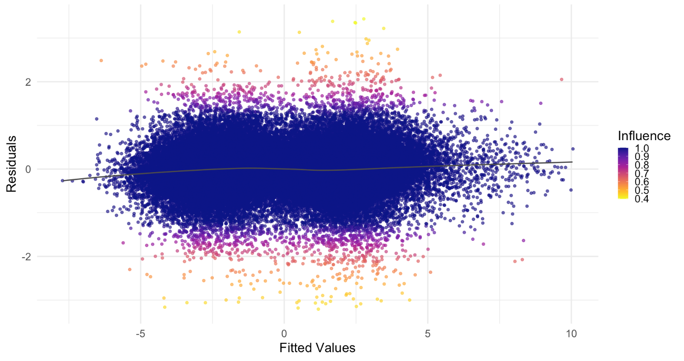
Figure C : Diagnostic plot with averaged residuals vs. fitted values of robust mixed-effects models across all imputations using the Latent Trait Score of teacher expectations as the dependent variable.

Fig C. Diagnostic plot of averaged residuals versus fitted values for robust mixed-effects models across all imputations, using the Latent Trait Score of teacher expectations as the dependent variable. The colour gradient represents the influence of individual observations as determined by the robust weighting estimator. The plot shows that the model captures the overall trend well, with no significant patterns in the residuals which might suggest systematic bias or poor fit.

