Figure D. Diagnostic plot with average residuals versus theoretical quantiles (normal distribution) of robust mixed-effects models across all imputations using the latent trait score of teacher expectations
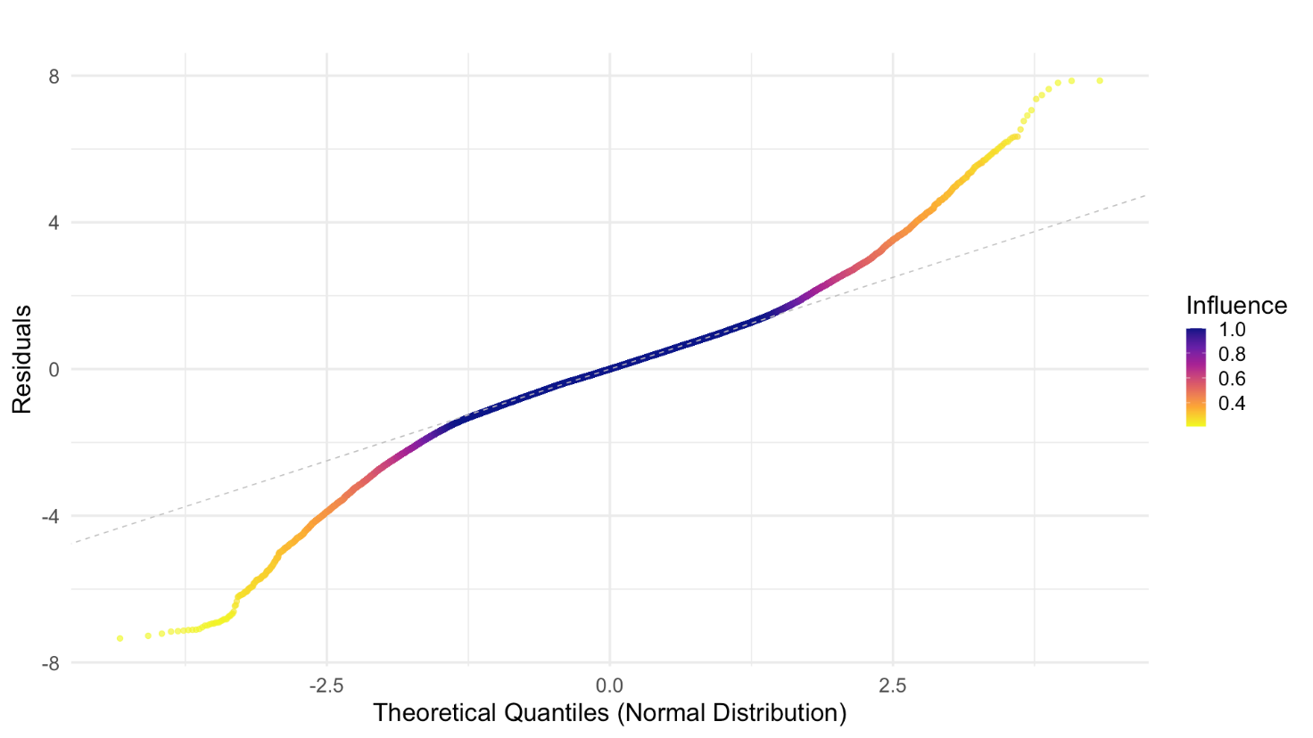

Fig D. Diagnostic plot of average residuals versus theoretical quantiles (normal distribution) for robust mixed-effects models across all imputations, using the latent trait score of teacher expectations as the dependent variable. The residuals were scaled using the Median Absolute Deviation (MAD), minimizing the influence of extreme outliers and providing a more accurate representation of the residual distribution. The plot reveals deviations in the residuals from normality at the tails of the distribution. However, these deviations are effectively downweighted by the robust estimator, ensuring they do not disproportionately influence the model estimates.

