SUPPLEMENTARY MATERIALS

a)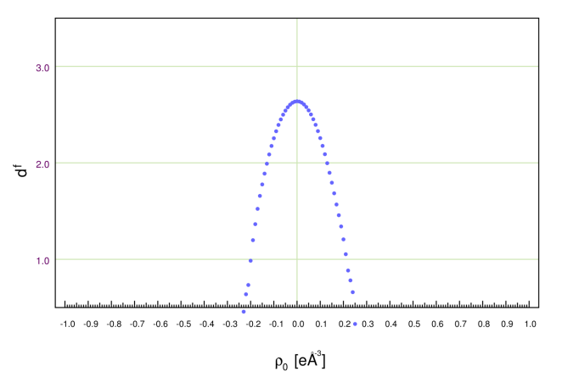 | b)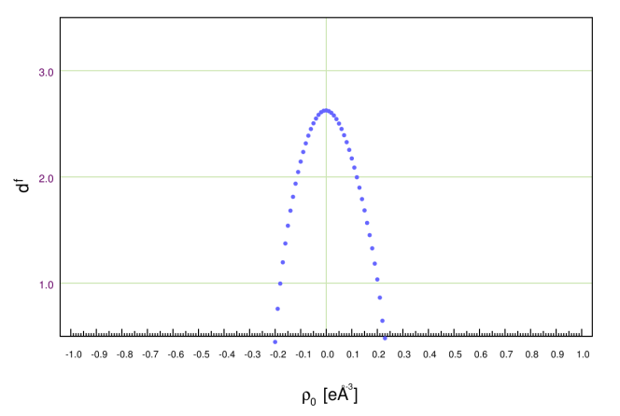
Fig. 1. The RDA plots for a) cytisine and b) N-methylcytisine

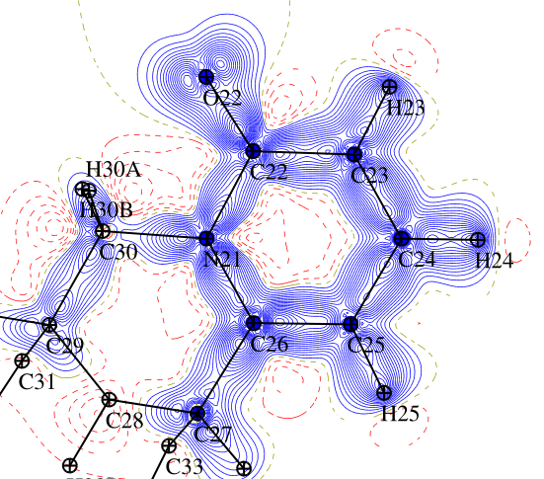 | 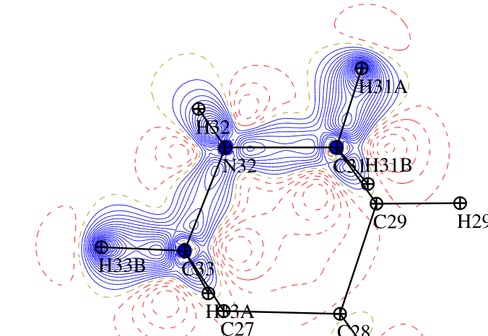 | 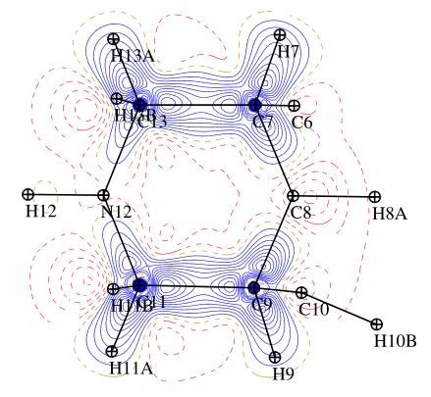
a | b | c
Fig. 2 The static deformation electron density distribution for second cytisine moleculein plane of a) b) pyridine ring c) e) N12-C11-C13 plane d) f) C9-C22-C7-C23 plane, the positive (blue) and negative (dashed red) contours are drawn at intervals 0.05 eÅ⁻³.
Cytisine | 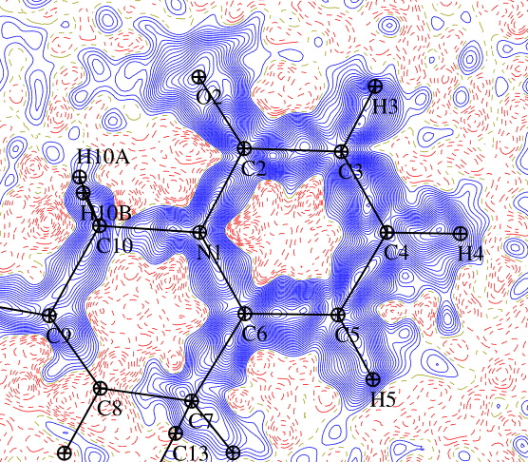 | 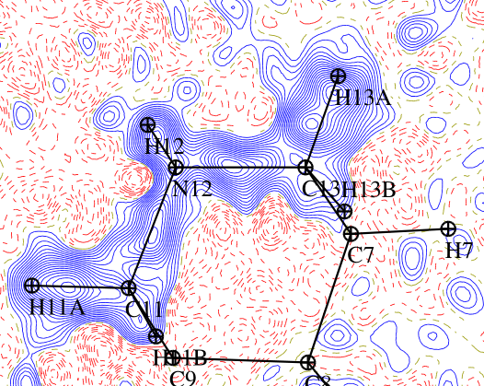 | 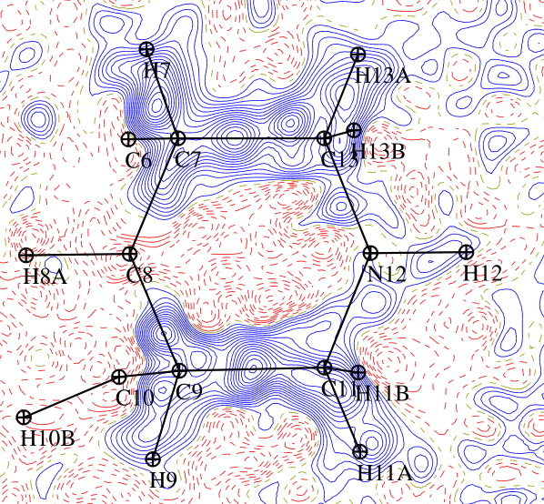
Cytisine | a | b | c
Cytisine | 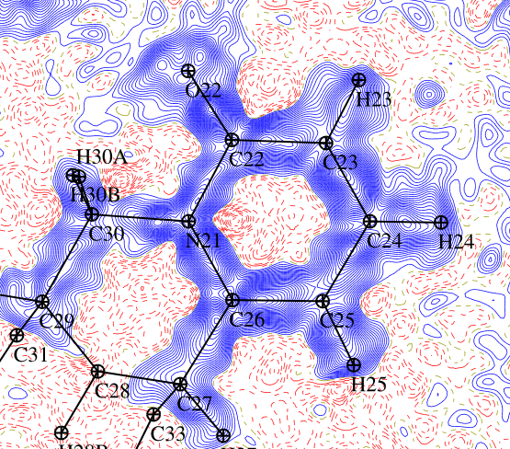 | 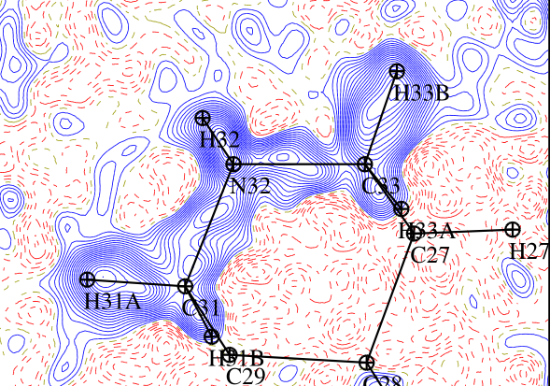 | 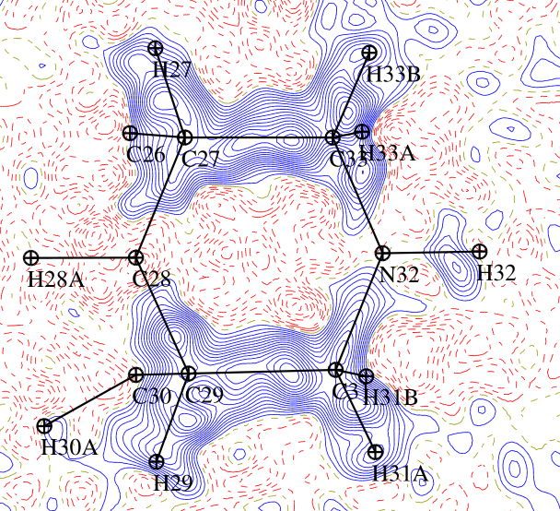
Cytisine | d | e | f
N-methylcytisine | 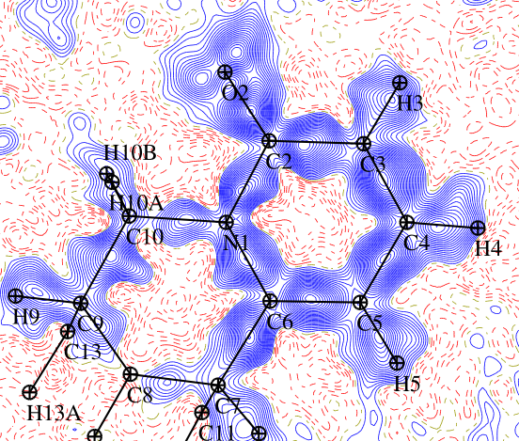 | 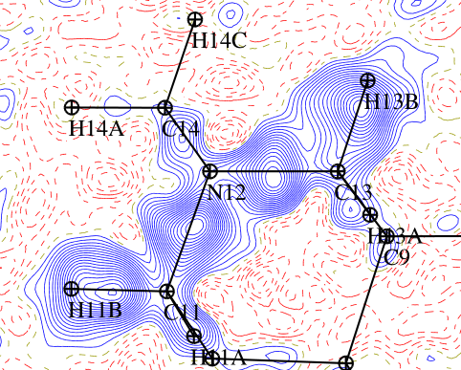 | 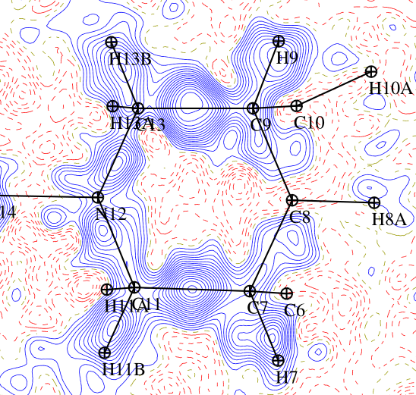
N-methylcytisine | f | g | h
Fig. 3. The dynamic deformation electron density distribution in plane of a) d) f) pyridine ring b) e) g) N12-C11-C13 plane c) f) h) C9-C22-C7-C23 plane, the positive (blue) and negative (dashed red) contours are drawn at intervals 0.05 eÅ⁻³
Cytisine | 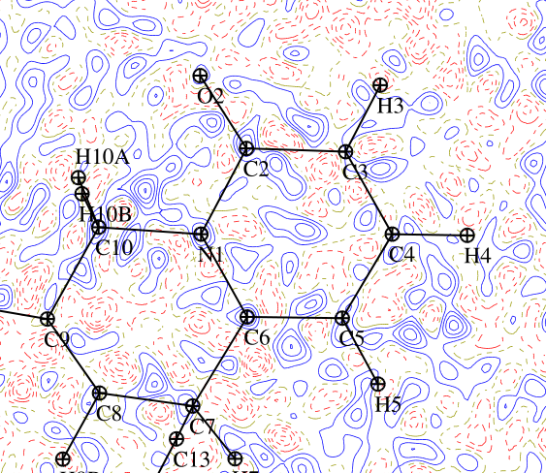 | 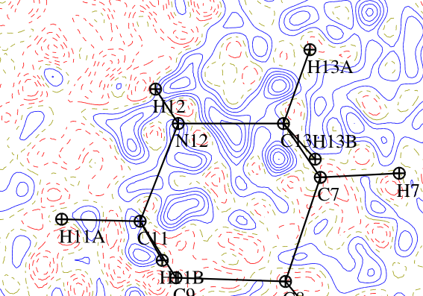 | 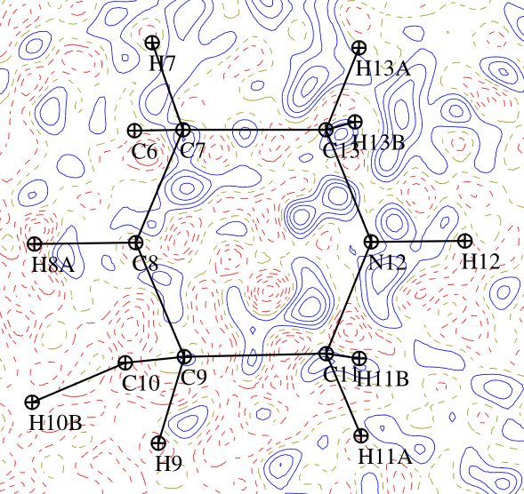
Cytisine | a | b | c
Cytisine | 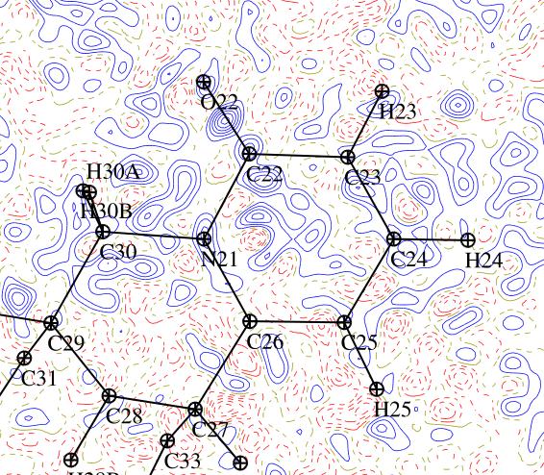 | 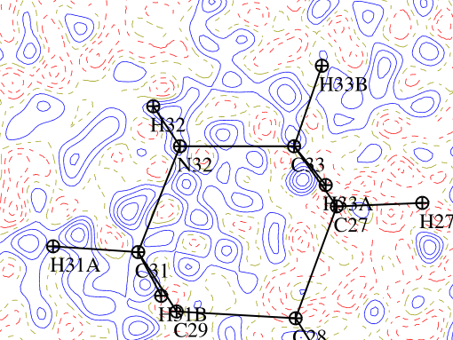 | 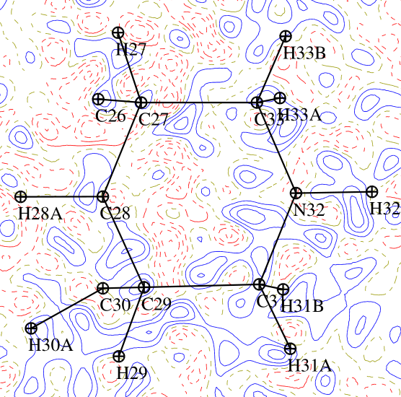
Cytisine | d | e | f
N-methylcytisine | 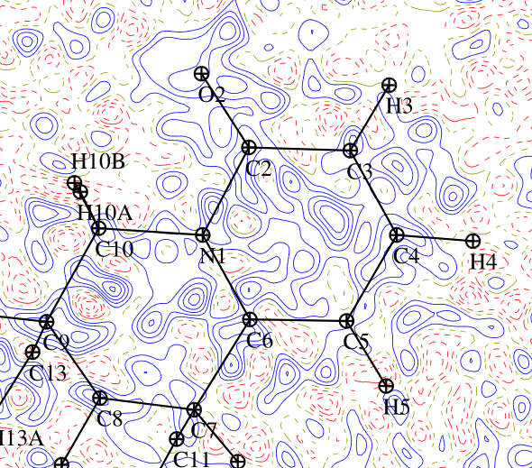 | 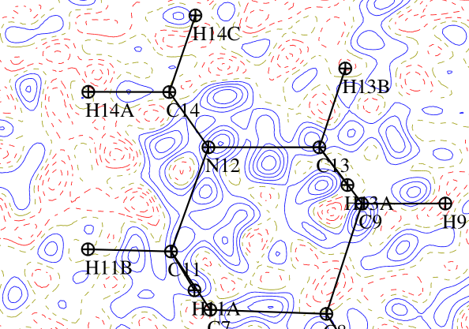 | 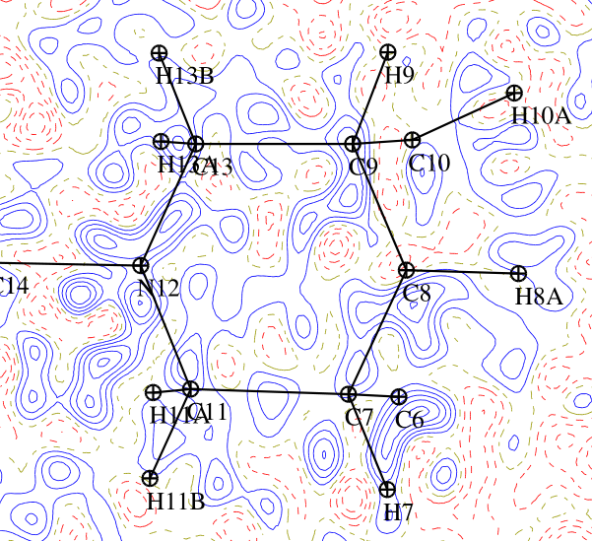
N-methylcytisine | f | g | h
Fig. 4. The residual electron density map in plane of a) d) f) pyridine ring b) e) g) N12-C11-C13 plane c) f) h) C9-C22-C7-C23 plane, the positive (blue) and negative (dashed red) contours are drawn at intervals 0.05 eÅ⁻³, for all data.
Cytisine | 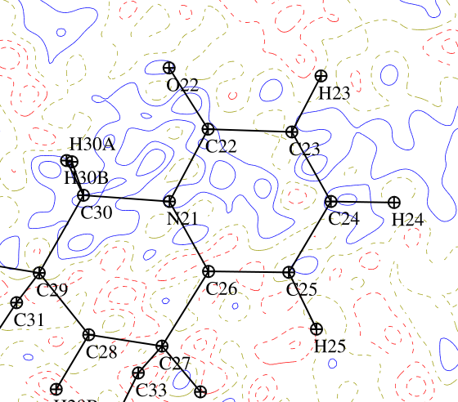 | 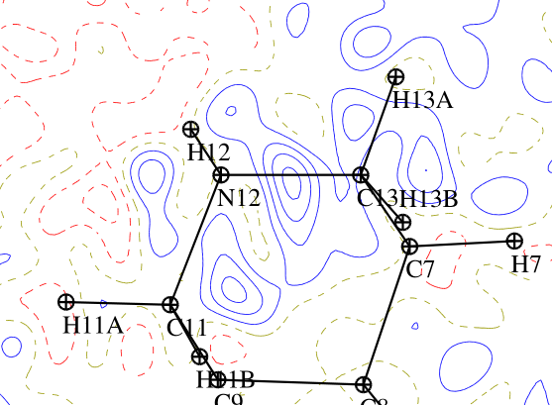 | 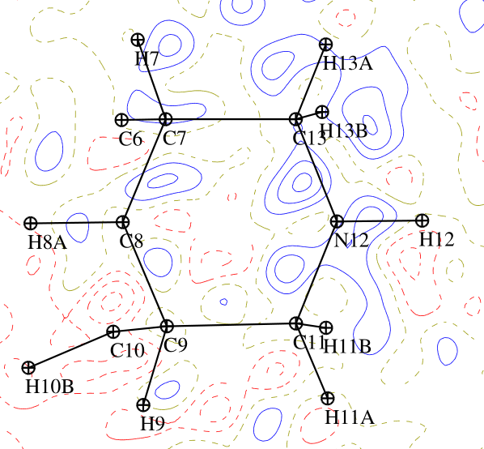
Cytisine | a | b | c
Cytisine | 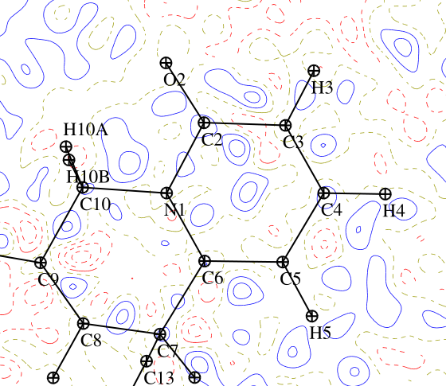 | 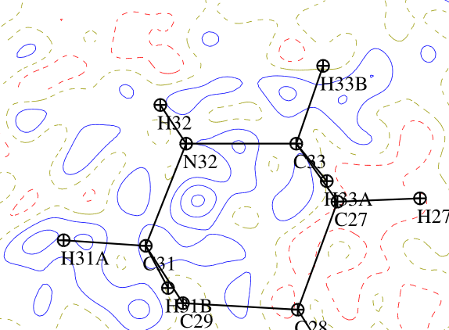 | 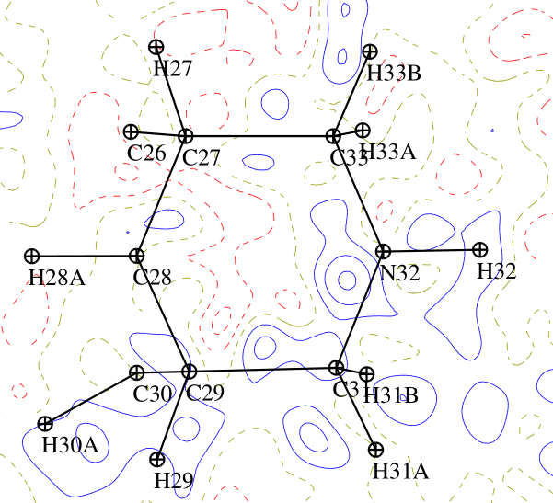
Cytisine | d | e | f
N-methylcytisine | 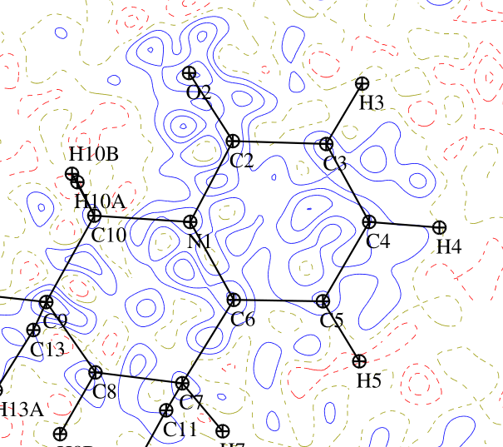 | 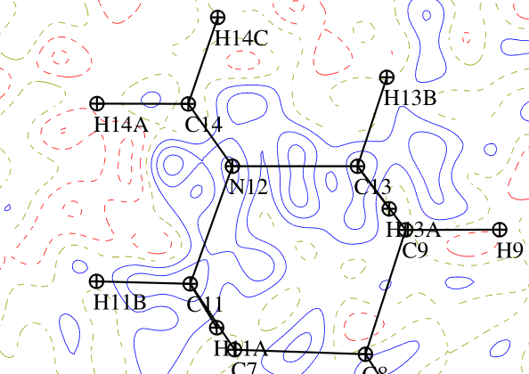 | 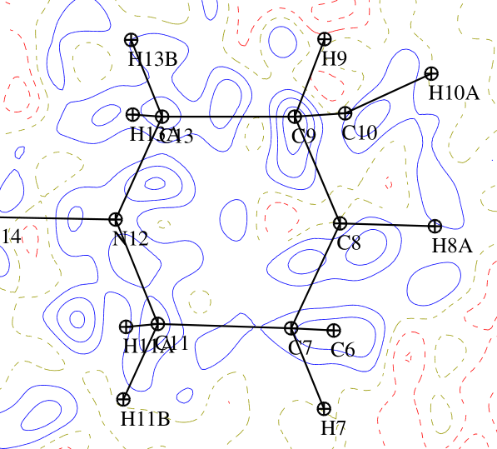
N-methylcytisine | f | g | h
Fig. 5. The residual electron density map in plane of a) d) f) pyridine ring b) e) g) N12-C11-C13 plane c) f) h) C9-C22-C7-C23 plane, the positive (blue) and negative (dashed red) contours are drawn at intervals 0.05 eÅ⁻³, for resolution 0.8 Å⁻¹.

D12: distance between two atoms; Gcp- kinetic energy density (kJ/mol/Bohr³), Vcp potential energy density (kJ/mol/Bohr³)
E∼(1/2)Vcp, D1cp, D2cp: distance from the first and the second atom to the critical point, laplacian ${[∇}^{2}\left(ρ_{bcp}\right)$(eÅ⁻⁵)] electron density $[ρ_{bcp}$ (eÅ⁻³)] and mean curvature of the Hessian matrix λ_{1,} λ_{2,}λ_{3,} symm- ORTEP symmetry code,

Table 1. Distances and topological characteristics of the BCPs in cytisine.
 | atom 1 | atom 2 | D12 | D1cp | D2cp | $$ρ_{bcp}$$ | $$∇^{2}$$ | λ₁ | λ₂ | λ₃ | Ellipt
MOLECULE 1 | C2 | O2 | 1,2466 | 0,4945 | 0,7523 | 3,0007 | -35,22 | -28,88 | -25,17 | 18,83 | 0,1473
MOLECULE 1 | C3 | C4 | 1,3674 | 0,6998 | 0,6677 | 2,3719 | -19,74 | -18,82 | -14,9 | 13,98 | 0,2631
MOLECULE 1 | C5 | C6 | 1,3723 | 0,6681 | 0,7043 | 2,3417 | -19,62 | -19,01 | -15,1 | 14,49 | 0,2584
MOLECULE 1 | C6 | N1 | 1,3703 | 0,5736 | 0,7968 | 2,2093 | -17,71 | -18,46 | -15,94 | 16,7 | 0,1584
MOLECULE 1 | N12 | H12 | 1,009 | 0,7342 | 0,2748 | 2,1699 | -22,3 | -27,45 | -26,23 | 31,38 | 0,0464
MOLECULE 1 | C4 | C5 | 1,4112 | 0,7085 | 0,7028 | 2,1288 | -14,96 | -15,99 | -13,09 | 14,11 | 0,221
MOLECULE 1 | C2 | C3 | 1,4324 | 0,7267 | 0,7057 | 2,0983 | -16,02 | -17,07 | -13,77 | 14,82 | 0,2394
MOLECULE 1 | C2 | N1 | 1,4017 | 0,6019 | 0,7999 | 2,0706 | -15,25 | -18,25 | -14,31 | 17,31 | 0,2751
MOLECULE 1 | C4 | H4 | 1,083 | 0,7256 | 0,3575 | 1,9471 | -17,79 | -18,34 | -17,78 | 18,32 | 0,0313
MOLECULE 1 | C5 | H5 | 1,083 | 0,724 | 0,359 | 1,9155 | -17,23 | -18,46 | -17,6 | 18,83 | 0,0488
MOLECULE 1 | C3 | H3 | 1,083 | 0,7222 | 0,3609 | 1,8898 | -17,18 | -18,38 | -17,47 | 18,67 | 0,0525
MOLECULE 1 | C10 | H10A | 1,092 | 0,7206 | 0,3715 | 1,8183 | -15,93 | -18,06 | -17,22 | 19,35 | 0,0485
MOLECULE 1 | C13 | H13A | 1,092 | 0,7123 | 0,3798 | 1,7878 | -14,53 | -16,87 | -16,6 | 18,94 | 0,016
MOLECULE 1 | C8 | H8B | 1,092 | 0,7007 | 0,3914 | 1,7859 | -15,49 | -16,84 | -16,7 | 18,06 | 0,0086
MOLECULE 1 | C10 | H10B | 1,092 | 0,7201 | 0,3719 | 1,7814 | -15,19 | -17,3 | -17,08 | 19,2 | 0,0129
MOLECULE 1 | C11 | N12 | 1,4601 | 0,6629 | 0,7972 | 1,7671 | -7,68 | -13,62 | -12,9 | 18,85 | 0,0557
MOLECULE 1 | C11 | H11B | 1,092 | 0,7118 | 0,3802 | 1,7633 | -14,11 | -16,69 | -16,48 | 19,06 | 0,0127
MOLECULE 1 | C8 | H8A | 1,092 | 0,6983 | 0,3938 | 1,762 | -15,09 | -16,47 | -16,44 | 17,81 | 0,0018
MOLECULE 1 | C13 | H13B | 1,092 | 0,7097 | 0,3825 | 1,7596 | -13,96 | -16,62 | -16,07 | 18,73 | 0,0341
MOLECULE 1 | C11 | H11A | 1,092 | 0,7114 | 0,3806 | 1,7578 | -14,06 | -16,71 | -16,4 | 19,04 | 0,0188
MOLECULE 1 | C9 | H9 | 1,099 | 0,713 | 0,3861 | 1,7344 | -13,04 | -16,62 | -16,11 | 19,69 | 0,0318
MOLECULE 1 | C13 | N12 | 1,4638 | 0,654 | 0,8099 | 1,729 | -7,46 | -12,91 | -12,69 | 18,14 | 0,0173
MOLECULE 1 | C7 | H7 | 1,099 | 0,7043 | 0,3947 | 1,7046 | -11,56 | -15,53 | -15,09 | 19,06 | 0,0297
MOLECULE 1 | C10 | N1 | 1,4799 | 0,6282 | 0,8521 | 1,6371 | -7,04 | -12,61 | -11,23 | 16,8 | 0,1235
MOLECULE 1 | C6 | C7 | 1,5079 | 0,813 | 0,6951 | 1,6032 | -5,76 | -10,59 | -9,66 | 14,49 | 0,0961
MOLECULE 1 | C8 | C9 | 1,5258 | 0,7526 | 0,7732 | 1,5427 | -6,54 | -10,83 | -10,77 | 15,05 | 0,0056
MOLECULE 1 | C9 | C11 | 1,5285 | 0,7487 | 0,7799 | 1,5368 | -6,28 | -10,56 | -10,33 | 14,61 | 0,0223
MOLECULE 1 | C7 | C8 | 1,5282 | 0,7598 | 0,7687 | 1,5149 | -5,93 | -10,28 | -10,13 | 14,48 | 0,0148
MOLECULE 1 | C7 | C13 | 1,5396 | 0,7597 | 0,7799 | 1,5041 | -5,63 | -10,08 | -9,76 | 14,21 | 0,0332
MOLECULE 1 | C9 | C10 | 1,5224 | 0,7419 | 0,7806 | 1,4793 | -5,5 | -10,18 | -9,76 | 14,44 | 0,0433
MOLECULE 2 | C22 | O22 | 1,244 | 0,4938 | 0,7503 | 2,9733 | -34,47 | -28,4 | -24,79 | 18,72 | 0,1453
MOLECULE 2 | C23 | C24 | 1,3664 | 0,6868 | 0,6796 | 2,3749 | -18,31 | -18,57 | -15,17 | 15,44 | 0,2242
MOLECULE 2 | C25 | C26 | 1,3733 | 0,6606 | 0,7129 | 2,3025 | -18,48 | -18,5 | -14,71 | 14,74 | 0,2576
MOLECULE 2 | C26 | N21 | 1,3732 | 0,5831 | 0,7901 | 2,2495 | -16,65 | -19,02 | -16,12 | 18,48 | 0,1798
MOLECULE 2 | N32 | H32 | 1,009 | 0,7309 | 0,2782 | 2,1856 | -21,95 | -27,39 | -25,75 | 31,18 | 0,0637
MOLECULE 2 | C24 | C25 | 1,4127 | 0,7319 | 0,6809 | 2,1603 | -15,44 | -16,48 | -13,63 | 14,67 | 0,2089
MOLECULE 2 | C22 | N21 | 1,4045 | 0,607 | 0,7975 | 2,0784 | -14,81 | -17,5 | -14,7 | 17,4 | 0,1904
MOLECULE 2 | C22 | C23 | 1,4341 | 0,7263 | 0,708 | 2,0546 | -13,95 | -16,1 | -13,44 | 15,59 | 0,1983
MOLECULE 2 | C25 | H25 | 1,083 | 0,7272 | 0,3559 | 1,9455 | -18,13 | -18,82 | -18,3 | 18,99 | 0,0289
MOLECULE 2 | C24 | H24 | 1,083 | 0,7311 | 0,3519 | 1,9443 | -18,06 | -18,65 | -18,28 | 18,87 | 0,0205
MOLECULE 2 | C23 | H23 | 1,083 | 0,7233 | 0,3598 | 1,8815 | -16,2 | -17,75 | -17,68 | 19,23 | 0,0038
MOLECULE 2 | C30 | H30B | 1,092 | 0,7206 | 0,3715 | 1,8066 | -15,79 | -17,62 | -17,33 | 19,16 | 0,0168
MOLECULE 2 | C28 | H28B | 1,092 | 0,7003 | 0,3917 | 1,8044 | -16,78 | -17,12 | -17,01 | 17,35 | 0,0067
MOLECULE 2 | C33 | H33B | 1,092 | 0,7143 | 0,3777 | 1,7959 | -14,82 | -17,14 | -17,01 | 19,32 | 0,0075
MOLECULE 2 | C31 | H31A | 1,092 | 0,7105 | 0,3816 | 1,7811 | -14,65 | -16,96 | -16,49 | 18,8 | 0,029
MOLECULE 2 | C30 | H30A | 1,092 | 0,7169 | 0,3752 | 1,7778 | -15,18 | -17,27 | -16,82 | 18,91 | 0,0263
MOLECULE 2 | C31 | N32 | 1,4575 | 0,6565 | 0,801 | 1,7713 | -8,17 | -13,81 | -12,58 | 18,22 | 0,0983
MOLECULE 2 | C31 | H31B | 1,092 | 0,7103 | 0,3817 | 1,7706 | -14,33 | -16,86 | -16,32 | 18,84 | 0,0329
MOLECULE 2 | C33 | H33A | 1,092 | 0,7126 | 0,3796 | 1,7614 | -14,19 | -16,69 | -16,63 | 19,12 | 0,0033
MOLECULE 2 | C33 | N32 | 1,4608 | 0,6626 | 0,7982 | 1,7458 | -7,23 | -13,41 | -12,55 | 18,73 | 0,0687
MOLECULE 2 | C27 | H27 | 1,099 | 0,7148 | 0,3843 | 1,7416 | -12,72 | -16,72 | -16 | 20 | 0,0455
MOLECULE 2 | C28 | H28A | 1,092 | 0,7075 | 0,3846 | 1,7285 | -15,49 | -16,37 | -16,33 | 17,21 | 0,0024
MOLECULE 2 | C29 | H29 | 1,099 | 0,703 | 0,396 | 1,702 | -11,83 | -15,47 | -15,45 | 19,09 | 0,0018
MOLECULE 2 | C26 | C27 | 1,5084 | 0,8042 | 0,7044 | 1,6363 | -5,82 | -11,37 | -10,17 | 15,72 | 0,1174
MOLECULE 2 | C30 | N21 | 1,4803 | 0,6322 | 0,8486 | 1,6137 | -6,4 | -12,38 | -10,82 | 16,8 | 0,1438
MOLECULE 2 | C29 | C30 | 1,5313 | 0,751 | 0,7809 | 1,5303 | -6,36 | -10,78 | -10,22 | 14,65 | 0,0547
MOLECULE 2 | C27 | C28 | 1,5279 | 0,7648 | 0,7632 | 1,5226 | -6,41 | -10,57 | -10,31 | 14,47 | 0,0262
MOLECULE 2 | C28 | C29 | 1,5264 | 0,7603 | 0,7661 | 1,5222 | -6,47 | -10,47 | -10,36 | 14,36 | 0,0112
MOLECULE 2 | C29 | C31 | 1,5311 | 0,7418 | 0,7893 | 1,5031 | -5,4 | -10,03 | -9,61 | 14,24 | 0,0433
MOLECULE 2 | C27 | C33 | 1,538 | 0,7478 | 0,7905 | 1,5022 | -5,28 | -10,35 | -9,61 | 14,68 | 0,0777

Table 2. Distances and topological characteristics of the BCPs in N-methylcytisine
atom 1 | atom 2 | D12 | D1cp | D2cp | $$ρ_{bcp}$$ | $$∇^{2}$$ | λ₁ | λ₂ | λ₃ | Ellipt
O2 | C2 | 1,2422 | 0,8155 | 0,4267 | 2,9363 | -33,92 | -29,29 | -25,9 | 21,27 | 0,13
C4 | C3 | 1,3667 | 0,6341 | 0,7327 | 2,3869 | -25,83 | -19,14 | -15,23 | 8,54 | 0,26
C6 | C5 | 1,3701 | 0,7293 | 0,6411 | 2,2769 | -23,33 | -17,57 | -14,17 | 8,41 | 0,24
N1 | C6 | 1,3708 | 0,8442 | 0,527 | 2,2536 | -26,04 | -18,27 | -15,81 | 8,04 | 0,16
C4 | C5 | 1,4108 | 0,7127 | 0,6981 | 2,1065 | -18,84 | -15,93 | -13,25 | 10,34 | 0,2
N1 | C2 | 1,4028 | 0,848 | 0,5551 | 2,0659 | -23,05 | -16,61 | -14,3 | 7,86 | 0,16
C3 | C2 | 1,4364 | 0,6437 | 0,793 | 2,0254 | -19,25 | -15,37 | -12,53 | 8,65 | 0,23
N12 | C11 | 1,456 | 0,8275 | 0,6285 | 1,9643 | -14,97 | -14,47 | -13,3 | 12,79 | 0,09
C9 | H9 | 1,099 | 0,7111 | 0,3881 | 1,9003 | -19,37 | -16,71 | -16,08 | 13,42 | 0,04
N12 | C13 | 1,4584 | 0,8327 | 0,6258 | 1,8759 | -13,38 | -13,27 | -12,54 | 12,44 | 0,06
C5 | H5 | 1,083 | 0,7243 | 0,3588 | 1,875 | -19,66 | -18,06 | -16,66 | 15,06 | 0,08
N12 | C14 | 1,4542 | 0,8161 | 0,6385 | 1,8503 | -9,98 | -12,56 | -12,5 | 15,09 | 0
C14 | H14B | 1,066 | 0,6938 | 0,3724 | 1,8424 | -15,62 | -16,68 | -16,63 | 17,68 | 0
C7 | H7 | 1,099 | 0,7325 | 0,3674 | 1,8384 | -18,71 | -16,54 | -16,34 | 14,17 | 0,01
C11 | H11B | 1,092 | 0,7111 | 0,3809 | 1,8263 | -17,33 | -16,53 | -15,99 | 15,19 | 0,03
C8 | H8A | 1,092 | 0,7194 | 0,3728 | 1,8253 | -17,04 | -16,43 | -16,13 | 15,51 | 0,02
C10 | H10B | 1,092 | 0,7252 | 0,3669 | 1,8151 | -17,13 | -16,58 | -15,99 | 15,45 | 0,04
C11 | H11A | 1,092 | 0,7127 | 0,3794 | 1,8115 | -16,71 | -16,12 | -15,65 | 15,06 | 0,03
C4 | H4 | 1,083 | 0,7471 | 0,3359 | 1,8114 | -18,98 | -17,77 | -17,25 | 16,04 | 0,03
C13 | H13A | 1,092 | 0,7101 | 0,3819 | 1,8097 | -17,07 | -16,14 | -15,59 | 14,66 | 0,04
C13 | H13B | 1,092 | 0,718 | 0,374 | 1,8089 | -16,57 | -16,05 | -15,63 | 15,12 | 0,03
C10 | H10A | 1,092 | 0,7258 | 0,3663 | 1,8066 | -15,9 | -16,49 | -15,6 | 16,18 | 0,06
C3 | H3 | 1,083 | 0,7144 | 0,3691 | 1,795 | -17,34 | -16,95 | -15,34 | 14,96 | 0,11
C14 | H14A | 1,066 | 0,6871 | 0,379 | 1,7886 | -15,44 | -15,85 | -15,8 | 16,2 | 0
C14 | H14C | 1,066 | 0,6566 | 0,4095 | 1,7842 | -15,96 | -15,78 | -14,71 | 14,53 | 0,07
C8 | H8B | 1,092 | 0,6986 | 0,3938 | 1,777 | -16,15 | -15,41 | -15,16 | 14,42 | 0,02
C6 | C7 | 1,5049 | 0,802 | 0,7033 | 1,7766 | -13,14 | -12,49 | -10,79 | 10,14 | 0,16
N1 | C10 | 1,478 | 0,8402 | 0,6378 | 1,72 | -10,14 | -12,61 | -10,87 | 13,35 | 0,16
C9 | C10 | 1,5224 | 0,7417 | 0,781 | 1,6886 | -11,83 | -11,11 | -10,6 | 9,89 | 0,05
C13 | C9 | 1,527 | 0,7718 | 0,7554 | 1,6827 | -12,24 | -11,26 | -10,51 | 9,53 | 0,07
C9 | C8 | 1,5235 | 0,8119 | 0,7116 | 1,6702 | -11,16 | -10,64 | -10,16 | 9,65 | 0,05
C7 | C8 | 1,5268 | 0,7261 | 0,8011 | 1,6568 | -10,58 | -10,56 | -10,37 | 10,35 | 0,02
C7 | C11 | 1,5361 | 0,7654 | 0,7711 | 1,6538 | -10,74 | -10,72 | -10,22 | 10,19 | 0,05

Fig.6. Graphical representation of laplacian ${[∇}^{2}\left(ρ_{bcp}\right)$(eÅ⁻⁵)] electron density $[ρ_{bcp}$ (eÅ⁻³)] and positive curvature of the Hessian matrix λ₃ in bond critical points

Table 2. (a) Atomic charges (e) calculated as N_{val}-P_{val} and by integration over atomic basins for 1
ATOM_MOL1 | Nval-Pval | TOPO | Atom_MOL2 | Nval-Pval | TOPO
N1 | -0,214 | -0,88401 | N21 | -0,269 | -0,95718
C2 | 0,192 | 0,894055 | O22 | 0,148 | 0,900176
O2 | -0,287 | -1,0427 | C22 | -0,302 | -1,06024
C3 | -0,117 | -0,4451 | C23 | -0,154 | -0,50133
C4 | -0,368 | -0,47669 | C24 | -0,361 | -0,5312
C5 | -0,377 | -0,44453 | C25 | -0,345 | -0,3817
C6 | -0,115 | 0,228191 | C26 | -0,12 | 0,183858
C7 | 0,118 | -0,01554 | C27 | 0,144 | -0,02294
C8 | -0,018 | 0,281848 | C28 | -0,026 | 0,334686
C9 | 0,171 | 0,02312 | C29 | 0,147 | -0,0193
C10 | 0,145 | 0,419417 | C30 | 0,104 | 0,412364
C11 | 0,016 | 0,362706 | C31 | -0,009 | 0,375751
N12 | -0,058 | -0,69776 | N32 | -0,099 | -0,95718
C13 | -0,007 | 0,355949 | C33 | 0,005 | 0,34504
H3 | 0,008 | 0,044038 | H23 | 0,014 | 0,079941
H4 | 0,004 | 0,002371 | H24 | 0,011 | 0,016956
H5 | 0 | 0,035793 | H25 | 0,007 | 0,045435
H7 | -0,043 | 0,115635 | H27 | -0,038 | 0,129269
H8A | 0,141 | 0,146839 | H28A | 0,169 | 0,161432
H8B | 0,136 | 0,139309 | H28B | 0,136 | 0,128444
H9 | -0,033 | 0,129721 | H29 | -0,039 | 0,125895
H10A | 0,136 | 0,144482 | H30A | 0,137 | 0,133474
H10B | 0,142 | 0,142273 | H30B | 0,136 | 0,131802
H11A | 0,103 | 0,080267 | H31A | 0,1 | 0,066432
H11B | 0,102 | 0,073618 | H31B | 0,098 | 0,063089
H12 | 0,116 | 0,343107 | H32 | 0,106 | 0,323466
H13A | 0,101 | 0,064839 | H33A | 0,102 | 0,072621
H13B | 0,102 | 0,06923 | H33B | 0,102 | 0,072667

(b) Atomic charges (e) calculated as N_{val}-P_{val} and by integration over atomic basins for 2
 | Pval-Nval | Plm
N1 | -0,0497 | -1,04804
C2 | -0,18322 | 1,269351
O2 | -0,11358 | -1,17973
C3 | -0,13075 | -0,03898
C4 | 0,10243 | -0,00547
C5 | -0,09744 | 0,027763
C6 | -0,01103 | 0,355842
C7 | -0,04129 | 0,054135
C8 | -0,06492 | -0,07497
C9 | -0,29477 | -0,06344
C10 | -0,16414 | 0,063421
C11 | -0,16187 | 0,154312
N12 | -0,24574 | -0,927
C13 | -0,16094 | 0,193048
H3 | 0,16345 | 0,171844
H4 | 0,18029 | 0,096102
H5 | 0,17508 | 0,198577
H7 | 0,17786 | 0,138336
H8A | 0,0886 | 0,117195
H8B | 0,0843 | 0,052406
H9 | 0,15286 | 0,059335
H10A | 0,08857 | 0,051868
H10B | 0,10066 | 0,048915
H11A | 0,09031 | 0,088544
H11B | 0,0869 | 0,047067
C14 | -0,005 | 0,014503
H13A | 0,09279 | 0,026223
H13B | 0,09435 | 0,048647
H14A | 0,05001 | 0,074104
H14B | -0,00984 | -0,02738
H14C | 0,00575 | 0,014034

Table 3. Distances and topological characteristics of the intermolecular CPs in cytisine
Atom1 | Atom2 | sym | Gcp | Vcp | E | D12 | D1cp | DCcp | $$ρ_{bcp}$$ | $$∇^{2}$$ | λ₁ | λ₂ | λ₃ | ELLIP | TYPE
H32 | O2 | 55501 | 37,36 | -27,35 | 13,675 | 2,1296 | 0,8024 | 1,3278 | 0,0912 | 1,74 | -0,36 | -0,35 | 2,46 | 0,0279 | (3,-1)
H12 | O22 | 74503 | 24,05 | -17,35 | 8,675 | 2,3209 | 0,9481 | 1,3879 | 0,068 | 1,13 | -0,25 | -0,25 | 1,63 | 0,0178 | (3,-1)
H24 | O2 | 56501 | 21,47 | -15,79 | 7,895 | 2,4062 | 1,0004 | 1,4129 | 0,066 | 1 | -0,23 | -0,22 | 1,45 | 0,0048 | (3,-1)
H33B | O22 | 45501 | 20,9 | -14,94 | 7,47 | 2,4232 | 1,0138 | 1,422 | 0,0614 | 0,99 | -0,22 | -0,22 | 1,43 | 0,0043 | (3,-1)
H4 | N32 | 45501 | 17,53 | -12,79 | 6,395 | 2,5289 | 1,028 | 1,5127 | 0,0576 | 0,82 | -0,14 | -0,14 | 1,09 | 0,0095 | (3,-1)
H11B | C3 | 64503 | 14,65 | -10,84 | 5,42 | 2,631 | 1,0738 | 1,5674 | 0,0531 | 0,68 | -0,14 | -0,11 | 0,93 | 0,1799 | (3,-1)
H25 | O22 | 45501 | 14,78 | -10,28 | 5,14 | 2,555 | 1,0998 | 1,4676 | 0,0472 | 0,71 | -0,15 | -0,14 | 1 | 0,072 | (3,-1)
H11B | H33B | 64503 | 14,06 | -9,68 | 4,84 | 2,1364 | 1,0993 | 1,0455 | 0,0448 | 0,68 | -0,16 | -0,14 | 0,98 | 0,1306 | (3,-1)
H4 | H31A | 45501 | 12,67 | -9,23 | 4,615 | 2,4288 | 1,2256 | 1,2132 | 0,0472 | 0,59 | -0,14 | -0,03 | 0,77 | 3,2411 | (3,-1)
H13B | N32 | 64503 | 13,62 | -8,99 | 4,495 | 2,5965 | 1,0341 | 1,5653 | 0,0398 | 0,67 | -0,11 | -0,1 | 0,89 | 0,113 | (3,-1)
H10B | H24 | 54501 | 11,82 | -8,47 | 4,235 | 2,4082 | 1,178 | 1,2379 | 0,0439 | 0,56 | -0,12 | -0,1 | 0,78 | 0,2857 | (3,-1)
H28A | O22 | 46604 | 12,2 | -8,37 | 4,185 | 2,5932 | 1,1016 | 1,6647 | 0,0408 | 0,59 | -0,11 | -0,05 | 0,75 | 1,3483 | (3,-1)
H25 | H28A | 46604 | 12,3 | -8,26 | 4,13 | 2,0785 | 1,0989 | 1,0386 | 0,039 | 0,6 | -0,13 | -0,12 | 0,85 | 0,0709 | (3,-1)
H5 | H8B | 55503 | 11,57 | -8,14 | 4,07 | 2,3443 | 1,1644 | 1,1972 | 0,0417 | 0,55 | -0,15 | -0,1 | 0,8 | 0,3978 | (3,-1)
H23 | C6 | 66501 | 11,22 | -7,97 | 3,985 | 2,737 | 1,1215 | 1,6558 | 0,0417 | 0,53 | -0,09 | -0,03 | 0,66 | 1,5612 | (3,-1)
H9 | N12 | 64503 | 10,18 | -6,74 | 3,37 | 2,8301 | 1,259 | 1,6203 | 0,0337 | 0,5 | -0,09 | -0,07 | 0,65 | 0,3369 | (3,-1)
H3 | H30B | 45501 | 10,28 | -6,73 | 3,365 | 2,2495 | 1,2053 | 1,0572 | 0,033 | 0,51 | -0,1 | -0,1 | 0,7 | 0,0393 | (3,-1)
C24 | H13A | 65503 | 9,65 | -6,73 | 3,365 | 2,9174 | 1,7616 | 1,1937 | 0,0368 | 0,46 | -0,08 | -0,04 | 0,59 | 0,7825 | (3,-1)
H29 | O2 | 55604 | 10,45 | -6,6 | 3,3 | 2,6345 | 1,0943 | 1,5701 | 0,0302 | 0,53 | -0,09 | -0,09 | 0,71 | 0,0671 | (3,-1)
H10B | N12 | 64503 | 9,99 | -6,6 | 3,3 | 2,8587 | 1,155 | 1,711 | 0,0332 | 0,49 | -0,1 | -0,06 | 0,65 | 0,5606 | (3,-1)
H5 | H10A | 45501 | 10,26 | -6,43 | 3,215 | 2,2009 | 1,2053 | 1,0183 | 0,0292 | 0,52 | -0,08 | -0,08 | 0,69 | 0,0167 | (3,-1)
H9 | N1 | 64503 | 9,58 | -6,37 | 3,185 | 2,8297 | 1,1642 | 1,7103 | 0,0328 | 0,47 | -0,06 | -0,03 | 0,56 | 1,0683 | (3,-1)
H29 | H31B | 55604 | 9,16 | -6,06 | 3,03 | 2,3896 | 1,2209 | 1,1765 | 0,0316 | 0,45 | -0,09 | -0,09 | 0,64 | 0,0064 | (3,-1)
H28B | C3 | 55604 | 8,58 | -5,67 | 2,835 | 2,813 | 1,142 | 1,7197 | 0,0302 | 0,42 | -0,08 | -0,04 | 0,55 | 1,0248 | (3,-1)
H8B | O2 | 64503 | 8,7 | -5,57 | 2,785 | 2,7028 | 1,1544 | 1,7051 | 0,0281 | 0,43 | -0,07 | -0,04 | 0,55 | 0,6332 | (3,-1)
H12 | C25 | 64503 | 7,98 | -5,3 | 2,65 | 2,905 | 1,1778 | 1,7351 | 0,0293 | 0,39 | -0,07 | -0,05 | 0,51 | 0,3284 | (3,-1)
H8A | N12 | 64503 | 8,18 | -5,23 | 2,615 | 2,8711 | 1,2676 | 1,6686 | 0,027 | 0,41 | -0,07 | -0,03 | 0,52 | 1,0726 | (3,-1)
H30A | C25 | 56604 | 7,33 | -4,79 | 2,395 | 2,9334 | 1,2022 | 1,792 | 0,0268 | 0,36 | -0,06 | -0,06 | 0,48 | 0,0135 | (3,-1)
H33A | C30 | 45501 | 6,88 | -4,4 | 2,2 | 3,1988 | 1,3903 | 1,8893 | 0,0245 | 0,34 | -0,05 | -0,02 | 0,42 | 1,9742 | (3,-1)
H24 | C5 | 66501 | 6,51 | -4,4 | 2,2 | 3,1476 | 1,3846 | 1,8208 | 0,0271 | 0,32 | -0,04 | -0,03 | 0,38 | 0,4535 | (3,-1)
H8B | H10A | 64503 | 5,81 | -3,59 | 1,795 | 2,6137 | 1,3626 | 1,3067 | 0,0198 | 0,29 | -0,05 | -0,02 | 0,37 | 1,5233 | (3,-1)
H3 | H31B | 45604 | 5,25 | -3,28 | 1,64 | 2,5913 | 1,3384 | 1,3298 | 0,0195 | 0,26 | -0,05 | -0,03 | 0,34 | 0,7644 | (3,-1)
H7 | H11A | 45501 | 2,95 | -1,65 | 0,825 | 2,7024 | 1,3288 | 1,3769 | 0,0089 | 0,16 | -0,02 | -0,02 | 0,2 | 0,3547 | (3,-1)

Table 4. Distances and topological characteristics of the intermolecular CPs in N-methylcytisine
Atom1 | Atom2 | CP | sym | Gcp | Vcp | E | D12 | D1cp | DCcp | $$ρ_{bcp}$$ | $$∇^{2}$$ | λ₁ | λ₂ | λ₃ | ELLIP | TYPE
O2 | H5 | cp3 | 65502 | 16,36 | -10,87 | 5,435 | 2,4495 | 1,5137 | 0,9375 | 0,0452 | 0,8 | -0,13 | -0,1 | 1,03 | 0,34 | (3,-1)
H7 | H10B | cp55 | 74604 | 15,19 | -10,75 | 5,375 | 1,9922 | 0,9698 | 1,0527 | 0,0497 | 0,72 | -0,16 | -0,14 | 1,02 | 0,18 | (3,-1)
O2 | H10B | cp11 | 45703 | 14,39 | -9,97 | 4,985 | 2,6744 | 1,4902 | 1,1997 | 0,046 | 0,69 | -0,17 | -0,13 | 0,99 | 0,32 | (3,-1)
O2 | H3 | cp2 | 55703 | 14,49 | -9,59 | 4,795 | 2,4804 | 1,4889 | 0,9918 | 0,0415 | 0,71 | -0,12 | -0,11 | 0,94 | 0,03 | (3,-1)
H9 | H11A | cp61 | 75502 | 13,25 | -9,54 | 4,77 | 2,1454 | 1,0915 | 1,0563 | 0,0475 | 0,62 | -0,19 | -0,13 | 0,94 | 0,4 | (3,-1)
O3 | H7 | cp13 | 75604 | 12,88 | -9,16 | 4,58 | 2,655 | 1,5232 | 1,1568 | 0,0454 | 0,61 | -0,13 | -0,12 | 0,86 | 0,05 | (3,-1)
H13B | C5 | cp26 | 75604 | 12,57 | -9,21 | 4,605 | 2,6898 | 1,043 | 1,6765 | 0,0475 | 0,59 | -0,15 | -0,11 | 0,84 | 0,29 | (3,-1)
H4 | H13A | cp93 | 45501 | 11,15 | -7,95 | 3,975 | 2,2712 | 1,113 | 1,1832 | 0,0419 | 0,53 | -0,14 | -0,13 | 0,8 | 0,09 | (3,-1)
H4 | H9 | cp30 | 45501 | 10,21 | -7,13 | 3,565 | 2,3254 | 1,1466 | 1,1842 | 0,0381 | 0,49 | -0,15 | -0,11 | 0,74 | 0,34 | (3,-1)
H3 | H10B | cp39 | 45703 | 9,97 | -7,04 | 3,52 | 2,3863 | 1,166 | 1,2375 | 0,0385 | 0,47 | -0,12 | -0,09 | 0,69 | 0,34 | (3,-1)
O2 | H9 | cp10 | 45703 | 8,84 | -5,7 | 2,85 | 2,8852 | 1,5726 | 1,3258 | 0,029 | 0,44 | -0,1 | -0,08 | 0,62 | 0,31 | (3,-1)
H3 | H7 | cp37 | 65502 | 7,44 | -5,3 | 2,65 | 2,5156 | 1,3529 | 1,2325 | 0,0328 | 0,35 | -0,09 | -0,08 | 0,53 | 0,11 | (3,-1)
C6 | H14C | cp21 | 74604 | 8,67 | -5,84 | 2,92 | 2,8495 | 1,7074 | 1,1537 | 0,0318 | 0,42 | -0,08 | -0,02 | 0,52 | 4,37 | (3,-1)
H11B | H14B | cp70 | 45603 | 7,3 | -4,84 | 2,42 | 2,5739 | 1,2189 | 1,3636 | 0,0277 | 0,36 | -0,07 | -0,06 | 0,49 | 0,09 | (3,-1)
C5 | C14 | cp20 | 45603 | 7,96 | -5,45 | 2,725 | 3,4496 | 1,7186 | 1,7712 | 0,0315 | 0,38 | -0,04 | -0,03 | 0,45 | 0,32 | (3,-1)
H14A | H13A | cp115 | 45603 | 6,01 | -3,69 | 1,845 | 2,4189 | 1,162 | 1,2666 | 0,0199 | 0,31 | -0,05 | -0,05 | 0,4 | 0,14 | (3,-1)
O2 | H13B | cp14 | 45703 | 5,7 | -3,47 | 1,735 | 3,0545 | 1,6815 | 1,3841 | 0,0188 | 0,29 | -0,04 | -0,03 | 0,35 | 0,36 | (3,-1)
H8A | H14B | cp100 | 75502 | 4,66 | -2,88 | 1,44 | 2,6254 | 1,321 | 1,3335 | 0,0175 | 0,24 | -0,05 | -0,04 | 0,33 | 0,09 | (3,-1)
N12 | H8A | cp17 | 75604 | 4,7 | -2,92 | 1,46 | 3,1819 | 1,8813 | 1,3128 | 0,0177 | 0,24 | -0,05 | -0,03 | 0,32 | 0,49 | (3,-1)

