Supplementary Material
for
“On the aromaticity of uracil and its 5-halogeno derivatives as revealed by theoretically derived geometric and magnetic indexes”

Kacper Rzepiela, Aneta Buczek, Teobald Kupka* and Małgorzata A. Broda*

Table S1. B3LYP/aug-cc-pVQZ calculated ³He nuclear magnetic shieldings (σ) and chemical shiftsª (δ) of helium atom 1 Å above the center of uracil and its 5XU derivatives tautomers in the gas phase^{ab}
Molecule (tautomer) | σ (ppm) | δ (ppm)
U1 | 56.155 | 3.719
U2 | 57.631 | 2.243
U3 | 58.046 | 1.828
U4 | 56.957 | 2.917
U5 | 57.990 | 1.884
U6 | 62.297 | -2.423
5FU1 | 56.943 | 2.930
5FU2 | 58.297 | 1.576
5FU3 | 58.631 | 1.243
5FU4 | 57.833 | 2.041
5FU5 | 58.832 | 1.041
5FU6 | 62.804 | -2.930
5ClU1 | 56.464 | 3.409
5ClU2 | 57.783 | 2.091
5ClU3 | 57.976 | 1.898
5ClU4 | 57.339 | 2.534
5ClU5 | 58.295 | 1.579
5ClU6 | 62.192 | -2.319
5BrU1 | 56.320 | 3.553
5BrU2 | 57.616 | 2.258
5BrU3 | 57.787 | 2.086
5BrU4 | 57.193 | 2.680
5BrU5 | 58.137 | 1.737
5BrU6 | 62.007 | -2.133
5IU1 | 56.140 | 3.734

ª calculated with respect to isolated ³He atom (σ = 59.8735 ppm); ^{b}Tautomer No 6 is marked with bold font

Table S2. B3LYP/aug-cc-pVQZ calculated HOMO, LUMO and Eg energies (in eV) of uracil and its 5XU derivatives tautomers in the gas phaseª

Molecule (tautomer) | HOMO | LUMO | E_{g}
U1 | -7.31 | -1.69 | 5.62
U2 | -6.99 | -1.71 | 5.28
U3 | -6.81 | -1.72 | 5.09
U4 | -6.91 | -1.22 | 5.69
U5 | -6.94 | -1.53 | 5.41
U6 | -7.22 | -1.28 | 5.95
5FU1 | -7.25 | -1.93 | 5.32
5FU2 | -6.97 | -2.01 | 4.96
5FU3 | -6.80 | -2.08 | 4.73
5FU4 | -7.12 | -1.43 | 5.69
5FU5 | -6.96 | -1.73 | 5.24
5FU6 | -7.17 | -1.59 | 5.58
5ClU1 | -7.14 | -1.99 | 5.15
5ClU2 | -6.93 | -2.03 | 4.90
5ClU3 | -6.84 | -2.06 | 4.78
5ClU4 | -7.02 | -1.53 | 5.49
5ClU5 | -6.87 | -1.83 | 5.04
5ClU6 | -7.07 | -1.61 | 5.46
5BrU1 | -7.07 | -2.00 | 5.07
5BrU2 | -6.89 | -2.03 | 4.86
5BrU3 | -6.83 | -2.05 | 4.78
5BrU4 | -6.95 | -1.55 | 5.41
5BrU5 | -6.81 | -1.84 | 4.97
5BrU6 | -7.00 | -1.61 | 5.39
5IU1 | -6.86 | -1.97 | 4.89

ªTautomer No 6 is marked with bold font

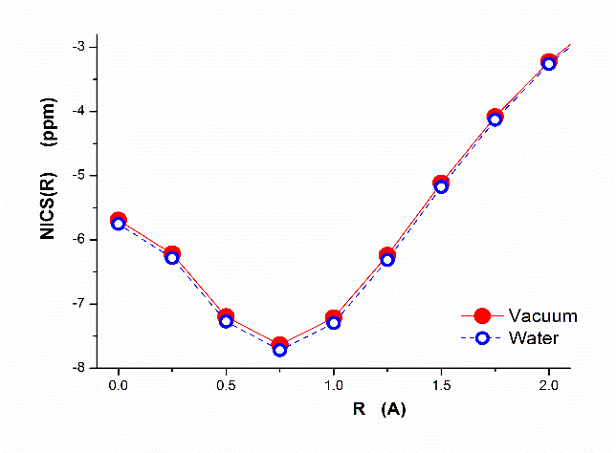
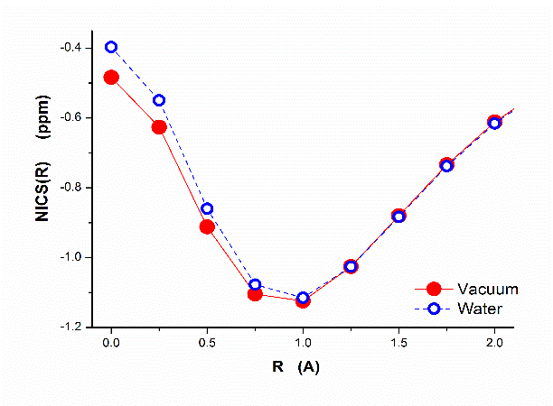

Fig. S1 Negligible impact of water environment modeled by PCM on NICS(R) vs. R for tautomer 1 (left) and for tautomer 6 (right) of uracil

Fig. S2 Dependence of the B3LYP-D3/aug-ccpVQZ calculated NICS(R) in vacuum on the distance R from the center of ring for benzene mono derivatives C6H5X, where X = H, F, Cl, Br and I (the arbitrary placed purple dashed line goes through the curve minima)
Fig. S3 Approximate linear correlation between Pauling electronegativity of X substituent and (left) R_{min} and (right) NICS(R_{min}) for benzene mono derivatives C₆H₅X, where X = H, F, Cl, Br and I
Fig. S4 Relations between electronegativity of halogen X and NBO charge at X, C_{i} atoms and their difference (X – C_{i}) in substituted benzene (C₆H₅X, where X = H, I, Br, Cl and F) Polynomial 2 was used for fitting
Fig. S5 Linear correlation between NICS(1) and E_{g} for tautomers 1 of 5XU, where X = F, Cl, Br and I

