Electronic Supporting Information
Thermochemistry in 21th century – Quo Vadis? In silico assisted diagnostics of available thermochemical data

Sergey P. Verevkin^{a,b,}* and Artemiy A. Samarov^{c,}*
ªFaculty of Interdisciplinary Research, Competence Centre CALOR, University of Rostock, 18059 Rostock, Germany
^{b} Department of Physical Chemistry, Kazan Federal University, 420008 Kazan, Russia
^{c} Saint Petersburg State University, Peterhof, 198504 Saint Petersburg, Russia.

Transpiration method [1–3].

Absolute vapour pressures of benzophenones were measured using the transpiration method. The details of this method can be found elsewhere [1–3]. A brief description and the necessary details are compiled here. The main idea of this method is to saturate the gas stream flowing over the sample and to determine the amount of compound transferred by the gas within a given time. Approximately 0.5 to 0.8 g of the sample is mixed with glass beads (diameter 1 mm) and placed in the thermostatted U-shaped saturator. The glass beads are needed to enlarge the contact area between gas and sample. A stream of nitrogen at a well-defined flow rate was passed through the saturator at constant temperature (± 0.1 K), and the transported material was collected in a cold trap. The amount of the condensed substance was determined by GC. The saturation vapour pressure p_{i} at each temperature T_{i} was calculated from the amount of condensate collected within a definite period of time:
p_{i} = m_{i}·R·T_{a} / V·M_{i} ; V = (n_{N2} + n_{i})·R·T_{a} / P_{a} (S1)
where V is the volume of the gas phase consisting of the n_{N2} moles of the carrier gas and n_{i} mole of gaseous compound under study (with the molar mass M_{i}) at the atmospheric pressure P_{a} and the ambient temperature T_{a}. The volume of the carrier gas V_{N2} was determined by the digital flow rate sensor from integration with a microcontroller. We used the Honeywell S&C - HAFBLF0200C2AX5 digital flow rate sensor with uncertainty at the level of 2.5 %. The flow rate of the nitrogen stream was also controlled by using a soap bubble flow meter (HP soap film flowmeter (model 0101-0113)) and optimized in order to reach the saturation equilibrium of the transporting gas at each temperature under study. The volume of the carrier gas V_{N2} was readied from the digital flow rate sensor. The amount of the compound under investigation n_{i} in the carrier gas was estimated at each temperature using the ideal gas law.
Before starting the vapour pressure measurements, the sample was first pre-conditioned at 310-320 K (within about one hour) in order to remove possible traces of water. The saturator was then kept at 310-315 K (to remove possible traces of volatile compounds). In order to assure the competition of pre-conditioning at the selected temperature, three samples were taken during the sample flashing at and analyzed by the GC. A constant vapour pressure at this temperature indicated that the transpiration experiments could begin. GC analysis of the transported material did not reveal any additional contamination. The absence of impurities and decomposition products was re-checked by GC analysis of the saturator content at the end of the entire series of experiments.

Table S1

Compilation of data on molar heat capacities $C_{\text{p,m}}^{\text{o}}$(cr or liq) and heat capacity differences $∆_{\text{cr,l}}^{\text{g}}C_{\text{p,m}}^{\text{o}}$ at T = 298.15 K (in J.K⁻¹.mol⁻¹)
Compounds | $C_{\text{p,m}}^{\text{o}}(cr)$ ª | $-∆_{\text{cr}}^{\text{g}}C_{\text{p,m}}^{\text{o}}$ ^{b} | $C_{\text{p,m}}^{\text{o}}(liq)$ ª | ${-∆}_{\text{l}}^{\text{g}}C_{\text{p,m}}^{\text{o}}$^{b}
benzophenone | 226.5 | 34.7 | 298.0 | 88.1
x-methyl-benzophenone | 254.1 | 38.9 | 326.4 | 95.4
4-ethyl-benzophenone | 281.0 | 42.9 | 358.3 | 103.7
4-iso-propyl-benzophenone | - | - | 383.7 | 110.3
4-tert-butyl-benzophenone | - | - | 410.2 | 117.2
3,4-dimethyl-benzophenone | 281.7 | 43.0 | 354.8 | 102.8
4-iso-propyl-acetophenone | - | - | 259.4 | 78.0
4-tert-butyl-acetophenone | - | - | 285.9 | 84.9
ª Calculated by the group-contribution procedure developed by Chickos et al. [4].
^{b} Calculated according to the procedure developed by Acree and Chickos [5].

Table S2
Vapor pressures, p_{i}, at different temperatures compiled from the literature [6], standard molar vaporisation enthalpies, $∆_{l}^{g}H_{m}^{o}$, and standard molar vaporisation entropies, $∆_{l}^{g}S_{m}^{o}$
T/  Kª | $p_{i}$/  Pa^{e} | $∆_{l}^{g}H_{m}^{o}$(T)/ ª  kJ⋅mol⁻¹ | $∆_{l}^{g}S_{m}^{o}$(T)/  J⋅K⁻¹⋅mol⁻¹
4-ethyl-benzophenone: $∆_{l}^{g}H_{m}^{o}$(298.15 K) = (67.6±0.7) kJ.mol⁻¹
$\text{ln} (p/p_{ref})=\frac{364.7}{R}-\frac{117652.3}{RT}-\frac{103.7}{R}ln\frac{T}{298.15}$ ; p_{ref} = 1 Pa
605 | 101325 | 54.9 | 90.9
599 | 95992 | 55.5 | 92.3
598 | 95992 | 55.6 | 92.7
597 | 99058 | 55.7 | 93.2
593 | 101325 | 56.1 | 94.8
591 | 101325 | 56.3 | 95.4
449 | 1333 | 71.1 | 122.3
447 | 1333 | 71.3 | 123.5
4-tert-butyl-benzophenone: $∆_{l}^{g}H_{m}^{o}$(298.15 K) = (67.6±0.7) kJ.mol⁻¹
$\text{ln} (p/p_{ref})=\frac{386.9}{R}-\frac{129802.1}{RT}-\frac{117.2}{R}ln\frac{T}{298.15}$ ; p_{ref} = 1 Pa
648 | 101325 | 53.8 | 83.2
443 | 267 | 77.9 | 126.4
441 | 267 | 78.1 | 127.8
426 | 133 | 79.9 | 132.3
424 | 133 | 80.1 | 133.8
3.4-dimethyl-benzophenone: $∆_{l}^{g}H_{m}^{o}$(298.15 K) = (67.6±0.7) kJ.mol⁻¹
$\text{ln} (p/p_{ref})=\frac{365.0}{R}-\frac{119492.6}{RT}-\frac{102.8}{R}ln\frac{T}{298.15}$ ; p_{ref} = 1 Pa
614 | 101325 | 56.4 | 91.9
613 | 99192 | 56.5 | 92.0
608 | 101325 | 57.0 | 93.8
421 | 267 | 76.2 | 131.6
411 | 133 | 77.2 | 132.8
4-iso-propyl-acetophenone: $∆_{l}^{g}H_{m}^{o}$(298.15 K) = (67.6±0.7) kJ.mol⁻¹
$\text{ln} (p/p_{ref})=\frac{313.5}{R}-\frac{91485.9}{RT}-\frac{78.0}{R}ln\frac{T}{298.15}$ ; p_{ref} = 1 Pa
527 | 101325 | 50.4 | 95.7
432 | 6533 | 57.8 | 111.0
431 | 5600 | 57.9 | 110.2
428 | 5600 | 58.1 | 111.7
406 | 2666 | 59.8 | 117.1
404 | 2400 | 60.0 | 117.4
403 | 2400 | 60.0 | 117.9
401 | 1600 | 60.2 | 115.7
399 | 1600 | 60.4 | 116.8
397 | 1333 | 60.5 | 116.5
396 | 1307 | 60.6 | 116.9
395 | 1333 | 60.7 | 117.6
395 | 1307 | 60.7 | 117.5
393 | 1333 | 60.8 | 118.8
392 | 1333 | 60.9 | 119.4
378 | 453 | 62.0 | 119.1
376 | 453 | 62.1 | 120.3
345 | 107 | 64.6 | 130.2
4-tert-butyl-acetophenone: $∆_{l}^{g}H_{m}^{o}$(298.15 K) = (67.6±0.7) kJ.mol⁻¹
$\text{ln} (p/p_{ref})=\frac{318.9}{R}-\frac{93739.6}{RT}-\frac{84.9}{R}ln\frac{T}{298.15}$ ; p_{ref} = 1 Pa
535 | 99992 | 48.3 | 90.3
439 | 6133 | 56.5 | 105.3
423 | 2933 | 57.8 | 107.3
422 | 2933 | 57.9 | 107.8
417 | 2666 | 58.3 | 109.7
410 | 2000 | 58.9 | 111.1
408 | 1467 | 59.1 | 109.7
407 | 1467 | 59.2 | 110.2
381 | 667 | 61.4 | 119.4
380 | 667 | 61.5 | 120.0
ª Uncertainties of the vaporisation enthalpies are expressed as the expanded uncertainty (0.95 level of confidence, k = 2). They include uncertainties from the fitting equation, and uncertainties from temperature adjustment to T = 298.15 K. Uncertainties in the temperature adjustment of vaporisation enthalpies to the reference temperature T= 298.15 K are estimated to account with 20 % to the total adjustment.

Table S3
Calculations of vaporisation enthalpies, $∆_{\text{l}}^{\text{g}}H_{\text{m}}^{\text{o}}$, of 4-alkyl-subtituted benzophenones and acetophenones using the “centerpiece” approach (at 298.15 K, in kJ.mol⁻¹) ª

Benzophenone | $∆_{l}^{g}H_{\text{m}}^{\text{o}}$(H→R₁)^{b} | $∆_{l}^{g}H_{\text{m}}^{\text{o}}$(CP) | $∆_{l}^{g}H_{\text{m}}^{\text{o}}$_{(add)} ^{c}
4-methyl- | 4.2±0.2 | 78.0±0.2 ^{d} | 82.2±1.0
1,2-dimethyl- | 9.6±0.2 | 78.0±0.2 ^{d} | 87.6±1.0
4-ethyl- | 8.4±0.2 | 78.0±0.2 ^{d} | 86.4±1.0
4-iso-propyl- | 11.3±0.3 | 78.0±0.2 ^{d} | 89.3±1.0
4-tert-butyl- | 13.6±0.4 | 78.0±0.2 ^{d} | 91.6±1.0
4-iso-propyl- | 11.3±0.3 | 55.4±0.3 e | 66.7±2.0
4-tert-butyl- | 13.6±0.4 | 55.4±0.3 e | 69.0±2.0

ª Uncertainties of vaporisation enthalpy ($∆_{l}^{g}H_{m}^{o}$) are the expanded uncertainties (0.95 level of confidence, k = 2).
^{b} From Table S5.
^{c} Calculated as the sum of columns 2 and 3.
^{d} Enthalpy of vaporisation of the “centerpiece” molecule benzophenone, evaluated in Table 2.
^{e} Enthalpy of vaporisation of the “centerpiece” molecule acetophenone, given in Table S7.
Table S4
Specific “transfer” contribution, $∆_{l}^{g}H_{\text{m}}^{\text{o}}$(H→R₁) derived from vaporisation enthalpies of substituted benzenes (at 298.15 K in kJ·mol⁻¹)ª
R₁ | $∆_{\text{l}}^{\text{g}}H_{\text{m}}^{\text{o}}$(298.15 K) [7] | $∆_{l}^{g}H_{\text{m}}^{\text{o}}$(H→R₁) ^{b}
methyl- | 38.1±0.2 | 4.2±0.2
1,2-dimethyl- | 43.5±0.2 | 9.6±0.2
ethyl- | 42.3±0.2 | 8.4±0.2
iso-propyl- | 45.0±0.2 | 11.3±0.3
tert-butyl- | 47.5±0.4 [8] | 13.6±0.4
ª Uncertainties are expanded unc08verertainties (0.95 level of confidence, k = 2).
^{b} Calculated as the difference between the vaporisation enthalpy of alkyl-benzene and benzene $∆_{\text{l}}^{\text{g}}H_{\text{m}}^{\text{o}}$(298.15 K) = 33.9 ± 0.1 kJ·mol⁻¹ [9]

Table S5
Compilation of enthalpies of vaporisation $∆_{l}^{g}H_{m}^{o}$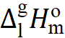 for the acetophenone derivatives derived in this work from the data available in the literature.

Compound | Mª | T- range | $∆_{l}^{g}H_{m}^{o}$(T_{av}) | $∆_{l}^{g}H_{m}^{o}$(298.15 K)^{b} | Ref.
CAS |  | K | kJ·mol⁻¹ | kJ·mol⁻¹
4-iso-propyl-acetophenone (liq) | BP | 345-527 | 58.4±2.8 | 68.2±3.4 | Table S3
645-13-6 | CP |  |  | 66.7±2.0 | Table S4
 | T_{b} |  |  | 68.2±2.0 | Table S6
 |  |  |  | 67.5±1.3 ^{c} | average
4-tert-butyl-acetophenone (liq) | BP | 380-535 | 55.7±2.5 | 68.4±3.6 | Table S3
943-27-1 | CP |  |  | 69.0±2.0 | Table S4
 | T_{b} |  |  | 70.8±2.0 | Table S6
 |  |  |  | 69.7±1.3 ^{c} | average
ª Techniques: BP = derived from boiling points at different temperatures available in the literature (see Table S2); CP = derived using the “centerpiece” approach (see Table S3); T_{b} = derived from correlation of vaporisation enthalpies with the normal boiling points (see Table S6).

^{b} Vapor pressures available in the literature were treated using heat capacity differences from Table S1 to evaluate the enthalpy of vaporisation at 298.15 K in the same way as our own results in Table 1. Uncertainty of the vaporisation enthalpy U($∆_{l}^{g}H_{m}^{o}$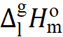) is the expanded uncertainty (0.95 level of confidence) calculated according to procedure described elsewhere [2, 3].
^{c} Weighted mean value (uncertainties were taken as the weighing factor). Values in bold are recommended for further thermochemical calculations.

Table S6
Correlation of vaporisation enthalpies, $∆_{\text{l}}^{\text{g}}H_{\text{m}}^{\text{o}}$(298.15 K), of acetophenone derivatives with their normal boiling temperatures (T_{b})
 |  | T_{b} ª | $∆_{\text{l}}^{\text{g}}H_{\text{m}}^{\text{o}}$(298 K)_{exp} | $∆_{\text{l}}^{\text{g}}H_{\text{m}}^{\text{o}}$(298 K)_{calc} ^{b} | Δ^{c}
CAS | Compound | K | kJ·mol⁻¹ | kJ·mol⁻¹ | kJ·mol⁻¹
98-86-2 | acetophenone | 475 | 55.4±0.3 [10] | 55.7 | -0.3
577-16-2 | 2-methyl-acetophenone | 487 | 59.2±0.3 [10] | 58.6 | 0.6
585-74-0 | 3-methyl-acetophenone | 493 | 59.9±0.3 [10] | 60.0 | -0.1
122-00-9 | 4-methyl-acetophenone | 499 | 61.5±0.3 [10] | 61.5 | 0.0
2142-64-5 | 2-ethyl-acetophenone | 505 | 62.3±0.5 [10] | 62.9 | -0.6
22699-70-3 | 3-ethyl-acetophenone | 514 | 64.7±0.6 [10] | 65.0 | -0.3
937-30-4 | 4-ethyl-acetophenone | 518 | 66.4±0.6 [10] | 66.0 | 0.4
645-13-6 | 4-iso-propyl-acetophenone | 527 |  | 68.2±2.0
943-27-1 | 4-tert-butyl-acetophenone | 538 |  | 70.8±2.0
ª Normal boiling temperatures, T_{b}, [6].
^{b} Calculated using equation: $∆_{\text{l}}^{\text{g}}H_{\text{m}}^{\text{o}}$(298.15 K) /(kJ·mol⁻¹) = 0.2390×T_{b} - 57.8 with (R² = 0.986).
^{c} Difference between column 4 and 5 in this table.

Table S7
Correlation of experimental vaporisation enthalpies, $∆_{\text{l}}^{\text{g}}H_{\text{m}}^{\text{o}}$(298.15 K), of benzene and acetophenone derivatives (in kJ·mol⁻¹)
 | R-benzene | 4-R-Acetophenone
 | $∆_{\text{l}}^{\text{g}}H_{\text{m}}^{\text{o}}$(298 K)_{exp} [7] | $∆_{\text{l}}^{\text{g}}H_{\text{m}}^{\text{o}}$(298 K)_{exp} | $∆_{\text{l}}^{\text{g}}H_{\text{m}}^{\text{o}}$(298 K)_{calc} ª | Δ^{b}
R = H | 33.9±0.2 | 55.4±0.3 [10] | 56.4 | -1.0
R = Me | 38.1±0.2 | 61.5±0.3 [10] | 60.7 | 0.8
R = Et | 42.3±0.2 | 66.4±0.6 [10] | 65.0 | 1.4
R = iso-Pr | 45.2±0.2 | 67.5±1.3 [Table S5] | 68.0 | -0.5
R = t-Bu | 47.5±0.4 [8] | 69.7±1.3[Table S5] | 70.3 | -0.6
R = 2,3-diMe | 43.5±0.2 |  | 66.2±2.0
ª Calculated using equation:
$∆_{\text{l}}^{\text{g}}H_{\text{m}}^{\text{o}}$(298.15 K) /(kJ·mol⁻¹) = 1.0283×$∆_{\text{l}}^{\text{g}}H_{\text{m}}^{\text{o}}$(298 K, R-benzene)_{exp} + 21.5 with (R² = 0.968).
^{b} Difference between column 3 and 4 in this table.

Table S8
G4 total energies at 0 K and enthalpies at 298.15 K (in Hartree) of the benzophenones studied in this work
Compounds | E_{o} | H₂₉₈
benzophenone | -576.311899 | -576.300064
2-methyl-benzophenone | -615.594242 | -615.580729
3-methyl-benzophenone | -615.595658 | -615.581892
4-methyl-benzophenone | -615.595923 | -615.582156
3,4-dimethyl-benzophenone | -654.879403 | -654.864213
4-ethyl-benzophenone | -654.874288 | -654.859350
4-iso-propyl-benzophenone | -694.155055 | -694.138725
4-tert-butyl-benzophenone | -733.435663 | -733.418139

Table S9
Thermochemical data at T = 298.15 K (p° = 0.1 MPa) for reference compounds (in kJ·mol⁻¹)

Compound | $∆_{f}H_{\text{m}}^{\text{o}}$ (liq) | $$∆_{l}^{g}H_{m}^{o}$$ | $∆_{f}H_{\text{m}}^{\text{o}}$(g)_{exp.}
benzene | 49.0±0.9 [9] | 33.9±0.1 [9] | 82.9±0.9
methyl-benzene | 12.0±1.1 [9] | 38.1±0.1 [9] | 50.1±1.1
ethyl-benzene | -12.3±0.9 [11] | 42.3±0.2 [11] | 29.9±1.1
1,2-dimethylbenzene | -24.4±1.1 [11] | 43.5±0.2 [11] | 19.1±1.1
iso-propylbenzene | -41.1±1.0 [11] | 45.2±0.2 [11] | 4.0±1.0
tert-butyl benzene | -71.2±0.5 [8] | 47.5±0.4 [8] | -23.7±0.6
formaldehyde |  |  | -108.6±0.5 [11]
acetone |  |  | -217.3±0.7 [11]
methane |  |  | -74.4±0.4 [11]
ethane |  |  | -83.8±0.4 [11]
n-butane |  |  | -125.6±0.7 [11]
acetophenone | -142.5±1.0 [12] | 55.4±0.3 [13] | -87.1±1.0
nitrobenzene | 10.6±1.6 [14] | 55.0±0.1 [14] | 65.6±1.6 [14]
chlorobenzene | 11.0±1.3 [2] | 41.8±0.3 [2] | 52.8±1.3 [2]

Table S10
The theoretical gas-phase enthalpies of well-balanced reactions (10) (18) calculated using G4 method (at T = 298.15 K, in kJ.mol⁻¹) ª
Number | Reaction | $∆_{r}H_{\text{m}}^{\text{o}}$(g)_{theor}
10 | benzophenone + ethane = acetone + 2 × benzene | -15.8±1.5
11 | benzophenone + acetone = 2 × acetophenone | -3.5±1.6
12 | benzophenone + n-butane = acetone + 2 × methylbenzene | -41.0±1.7
13 | benzophenone + 2 methane = formaldehyde + 2 × methylbenzene | 187.8±1.7
14a | 2-methyl-benzophenone + benzene = methylbenzene + benzophenone | -2.3±1.6
14b | 3-methyl-benzophenone + benzene = methylbenzene + benzophenone | 0.7±1.6
14c | 3-methyl-benzophenone + benzene = methylbenzene + benzophenone | 1.4±1.6
15 | 4-ethyl-benzophenone + benzene = ethylbenzene + benzophenone | 1.3±1.7
16 | 3,4-dimethyl-benzophenone + benzene = + 1,2-dimethylbenzene + benzophenone | 2.2±1.6
17 | 4-iso-propyl-benzophenone + benzene = iso-proylbenzene + benzophenone | 1.4±1.6
18 | 4-tert-buyl-benzophenone + benzene = tert-butylbenzene + benzophenone | 1.4±1.5
ª Uncertainties in this table represent two standard deviations. They were calculated using uncertainties of the reaction participants (see Table S9).

Table S11
Specific “transfer” contribution, $∆_{f}H_{\text{m}}^{\text{o}}$(g)(H→R₁) derived from enthalpies of formation of substituted benzenes (at 298.15 K in kJ·mol⁻¹)ª
R₁ | $∆_{f}H_{\text{m}}^{\text{o}}$(g) | $∆_{f}H_{\text{m}}^{\text{o}}$(g)(H→R₁) ^{b}
methyl- | 50.1±1.1 [9] | -32.8±1.4
1,2-dimethyl- | 19.1±1.1 [11] | -63.8±1.4
ethyl- | 29.9±1.1 [11] | -53.0±1.4
iso-propyl- | 4.0±1.0 [11] | -78.9±1.4
tert-butyl- | -23.7±0.6 [8] | -106.6±1.1
nitro- | 65.6±1.6 [14] | -17.3±1.8
chloro- | 52.0±1.3 [2] | -30.9±1.6
ª Uncertainties are expanded uncertainties (0.95 level of confidence, k = 2).
^{b} Calculated as the difference between the enthalpy of formation of alkyl-benzene and benzene $∆_{f}H_{\text{m}}^{\text{o}}$(g)(298.15 K) = 82.9 ± 0.9 kJ·mol⁻¹ [9]

Table S12
Parameters and pairwise nearest and non-nearest neighbor interactions of substituents on the “centerpieces” for calculation of thermodynamic properties of substituted benzenes and benzophenones at 298.15 K (in kJ⋅mol⁻¹).
Centerpiece | $∆_{f}H_{\text{m}}^{\text{o}}$(g) | $$∆_{l}^{g}H_{m}^{o}$$
benzene | 82.9 | 33.9
acetophenone | -87.1 | 55.4
benzophenone | 49.4 | 78.0
Contributions
ΔH(H→C=O(CH₃) | -170.0 | 21.5
ΔH(H→CH₃) | -32.8 | 4.2
ΔH(H→NO₂) | -17.3 | 21.1
ΔH(H→Cl) | -30.9 | 7.9
Interactions
meta C=O(CH₃) - NO₂ | 5.0 [15] | -
para C=O(CH₃) - NO₂ | 5.3 [15] | -
ortho C=O(CH₃) - Cl | 15.2 [16] | -3.2
meta C=O(CH₃) - Cl | 2.5 [16] | 0.7
para C=O(CH₃) - Cl | 0.5 [16] | -0.2

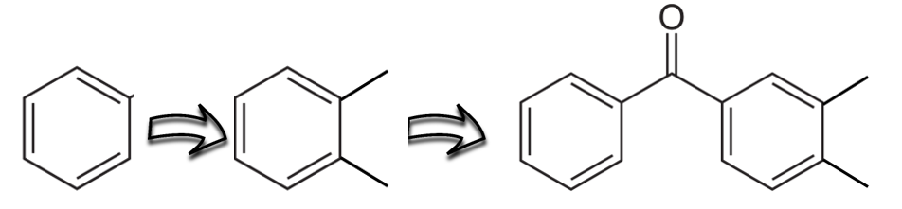
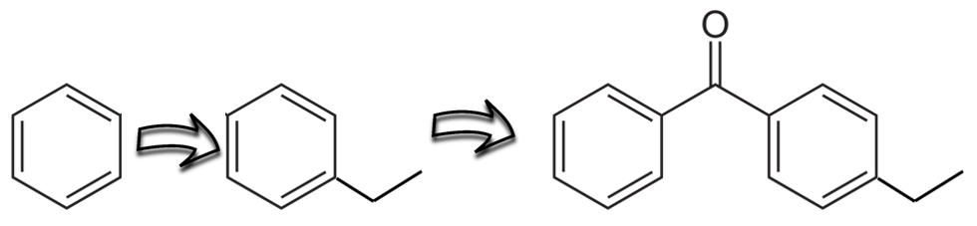
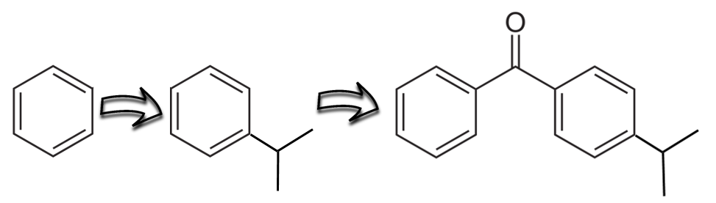
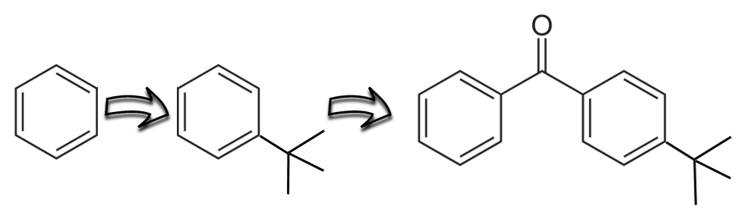
Fig. S1. Quantification of the enthalpic contributions for the alkyl substituents on the benzene ring and propagation of this contributions to the benzophenone. The scheme is valid for the for the standard molar enthalpies of vaporisation, $∆_{l}^{g}H_{m}^{o}$(298.15 K), as well as for the gas-phase standard molar enthalpies of formation, $∆_{f}H_{\text{m}}^{\text{o}}$(g, 298.15 K). The numerical values of contributions are given in Table 10. They were derived using thermochemical data collected in Table S8.

References
1. Verevkin SP, Emel´yanenko VN (2008) Transpiration method: Vapor pressures and enthalpies of vaporization of some low-boiling esters. Fluid Phase Equilib 266:64–75. https://doi.org/10.1016/j.fluid.2008.02.001
2. Verevkin SP, Sazonova AY, Emel´yanenko VN, et al (2015) Thermochemistry of Halogen-Substituted Methylbenzenes. J Chem Eng Data 60:89–103. https://doi.org/10.1021/je500784s
3. Emel´yanenko VN, Verevkin SP (2015) Benchmark thermodynamic properties of 1,3-propanediol: Comprehensive experimental and theoretical study. J Chem Thermodyn 85:111–119. https://doi.org/10.1016/j.jct.2015.01.014
4. Chickos JS, Hosseini S, Hesse DG, Liebman JF (1993) Heat capacity corrections to a standard state: a comparison of new and some literature methods for organic liquids and solids. Struct Chem 4:271–278. https://doi.org/10.1007/BF00673701
5. Acree W, Chickos JS (2016) Phase Transition Enthalpy Measurements of Organic and Organometallic Compounds. Sublimation, Vaporization and Fusion Enthalpies From 1880 to 2015. Part 1. C 1 − C 10. J Phys Chem Ref Data 45:033101. https://doi.org/10.1063/1.4948363
6. SciFinder - Chemical Abstracts Service (2022) http://scifinder.cas.org/
7. Majer V, Svoboda V (1985) Enthalpies of Vaporization of Organic Compounds: A Critical Review and Data Compilation, Blackwell Scientific Publications, Oxford
8. Verevkin SP, Kozlova SA, Emel´yanenko VN, et al (2008) Thermochemistry of Ionic Liquid-Catalyzed Reactions. Experimental and Theoretical Study of Chemical Equilibria of Isomerization and Transalkylation of tert -Butylbenzenes. J Phys Chem A 112:11273–11282. https://doi.org/10.1021/jp806410x
9. Roux MV, Temprado M, Chickos JS, Nagano Y (2008) Critically evaluated thermochemical properties of polycyclic aromatic hydrocarbons. J Phys Chem Ref Data 37:1855–1996. https://doi.org/10.1063/1.2955570
10. Andreeva IV, Verevkin SP (2022) Thermochemistry of substituted benzenes: acetophenones with methyl, ethyl, cyano and acetoxy substituents. J Therm Anal Calorim 147:11401–11415. https://doi.org/10.1007/s10973-022-11326-3
11. Pedley JB, Naylor RD, Kirby SP (1986) Thermochemical data of organic compounds, Chapman and Hall, New York. 1–792
12. Colomina M, Latorre C, Perez-Ossorio R (1961) Heats of combustion of five alkyl phenyl ketones. Pure Appl Chem 2:133–136. https://doi.org/10.1351/pac196102010133
13. Steele WV, Chirico RD, Knipmeyer SE, Nguyen A (1996) Vapor Pressure of Acetophenone, (±)-1,2-Butanediol, (±)-1,3-Butanediol, Diethylene Glycol Monopropyl Ether, 1,3-Dimethyladamantane, 2-Ethoxyethyl Acetate, Ethyl Octyl Sulfide, and Pentyl Acetate. J Chem Eng Data 41:1255–1268. https://doi.org/10.1021/je9601117
14. Verevkin SP, Emel´yanenko VN, Diky V, Dorofeeva OV (2014) Enthalpies of formation of nitromethane and nitrobenzene: New experiments vs. quantum chemical calculations. J Chem Thermodyn 73:163–170. https://doi.org/10.1016/j.jct.2013.12.013
15. Ribeiro Da Silva MAV, Amaral LMPF, Ortiz R V. (2011) Experimental study on the thermochemistry of 3-nitrobenzophenone, 4-nitrobenzophenone and 3,3′-dinitrobenzophenone. J Chem Thermodyn 43:546–551. https://doi.org/10.1016/j.jct.2010.11.005
16. Ribeiro da Silva MAV, Amaral LMPF, Gomes JRB (2007) Experimental and Computational Studies on the Molecular Energetics of Chlorobenzophenones. J Phys Chem B 111:13033–13040. https://doi.org/10.1021/jp076522j

