Supplementary Information

Construction of biphenylene dimers and surface-bound layers to explore donor-acceptor interactions

Kristóf Molnár,¹ Rita Dobszay,¹ Pál T. Szabó,² Tamás Holzbauer,³ Attila Kunfi,¹* Gábor London¹*

¹ Institute of Organic Chemistry, HUN-REN Research Centre for Natural Sciences, Magyar Tudósok krt. 2, 1117 Budapest, Hungary
² MS Metabolomics Research Group, Centre for Structural Science, HUN-REN Research Centre for Natural Sciences, Magyar Tudósok krt. 2, 1117 Budapest, Hungary
³ Institute of Organic Chemistry, Centre for Structural Science, HUN-REN Research Centre for Natural Sciences, Magyar Tudósok krt. 2, HU-1117 Budapest, Hungary

E-mailes: kunfi.attila@ttk.hu, london.gabor@ttk.hu

Table of contents

1. X-Ray Crystallography S2
2. NMR spectra S3

X-Ray Crystallography

Table S1. Crystal data and structure refinement for BP/TCNQ and 10.

Identification code | BP/TCNQ | 10
CCDC | 2384673 | 2384674
Empirical formula | C₂₄H₁₂N₄ | C₃₀H₂₂O₄
Formula weight | 356.390 | 446.47
Temperature/K | 294.15 | 113.7(3)
Crystal system | triclinic | triclinic
Space group | P-1 | P-1
a/Å | 6.711(3) | 5.92890(10)
b/Å | 8.079(3) | 7.55090(10)
c/Å | 8.974(4) | 24.3170(3)
α/° | 99.11(4) | 92.1230(10)
β/° | 97.269(11) | 91.3660(10)
γ/° | 103.276(12) | 90.8870(10)
Volume/Å³ | 460.8(4) | 1087.43(3)
Z | 1 | 2
ρ_{calc}g/cm³ | 1.284 | 1.364
μ/mm⁻¹ | 0.079 | 0.722
F(000) | 184.1 | 468.0
Crystal size/mm³ | 0.5 × 0.15 × 0.15 | 0.3 × 0.3 × 0.06
Radiation | Mo Kα (λ = 0.71075) | Cu Kα (λ = 1.54184)
2Θ range for data collection/° | 6.32 to 50.7 | 7.278 to 150.884
Index ranges | -8 ≤ h ≤ 8,  -9 ≤ k ≤ 9,  -10 ≤ l ≤ 10 | -7 ≤ h ≤ 7,  -9 ≤ k ≤ 8,  -30 ≤ l ≤ 29
Reflections collected | 1949 | 20802
Independent reflections | 1682 [R_{int} = 0.0492,  R_{sigma} = 0.0696] | 4281 [R_{int} = 0.0292, R_{sigma} = 0.0234]
Data/restraints/parameters | 1682/0/127 | 4281/0/307
Goodness-of-fit on F² | 1.095 | 1.022
Final R indexes [I>=2σ (I)] | R₁ = 0.1045,  wR₂ = 0.2207 | R₁ = 0.0383,  wR₂ = 0.1008
Final R indexes [all data] | R₁ = 0.1387,  wR₂ = 0.2425 | R₁ = 0.0424,  wR₂ = 0.1038
Largest diff. peak/hole / e Å⁻³ | 0.46/-0.37 | 0.29/-0.19

NMR spectra
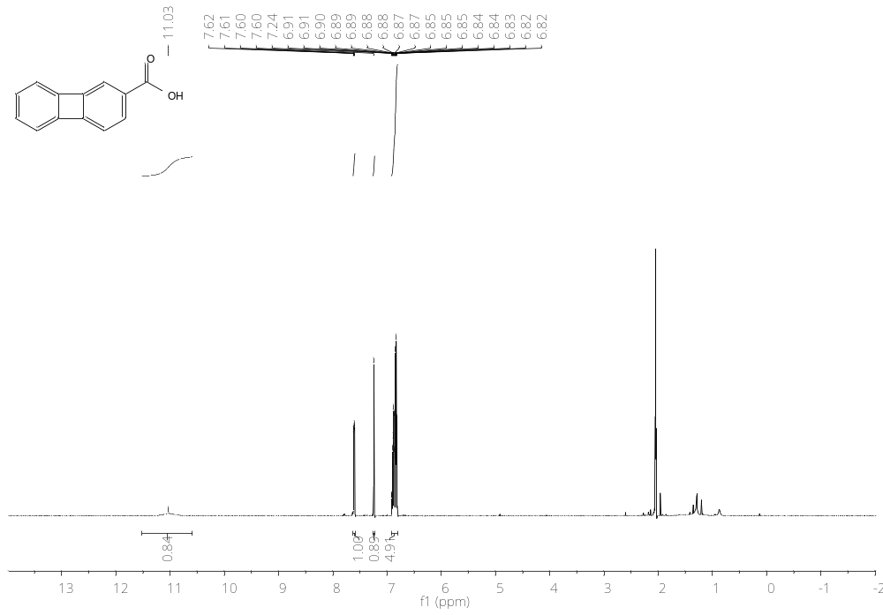
Figure S1. ¹H NMR spectrum of 1 in acetone-d6 (500 MHz).
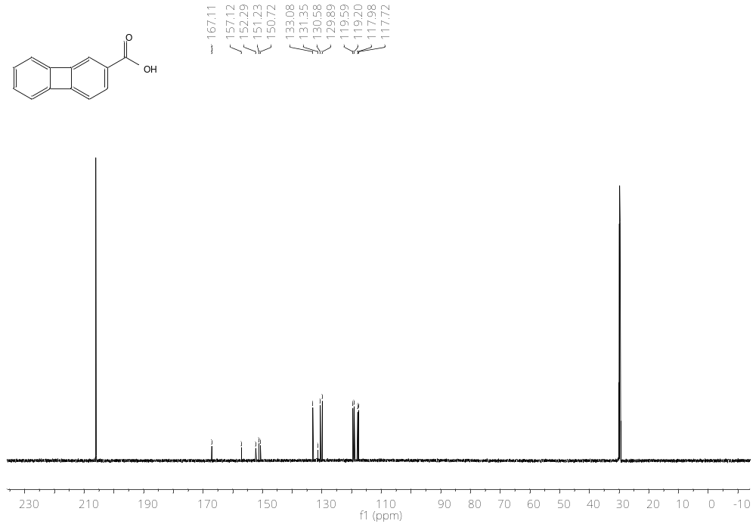
Figure S2. ¹³C{¹H} NMR spectrum of 1 in acetone-d6 (126 MHz).
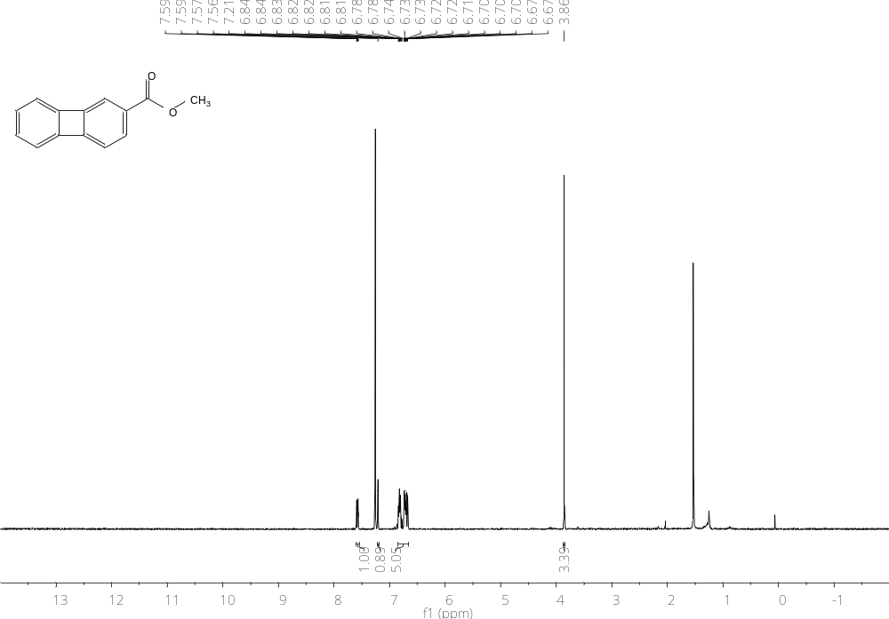
Figure S3. ¹H NMR spectrum of 4 in CDCl₃ (300 MHz).
0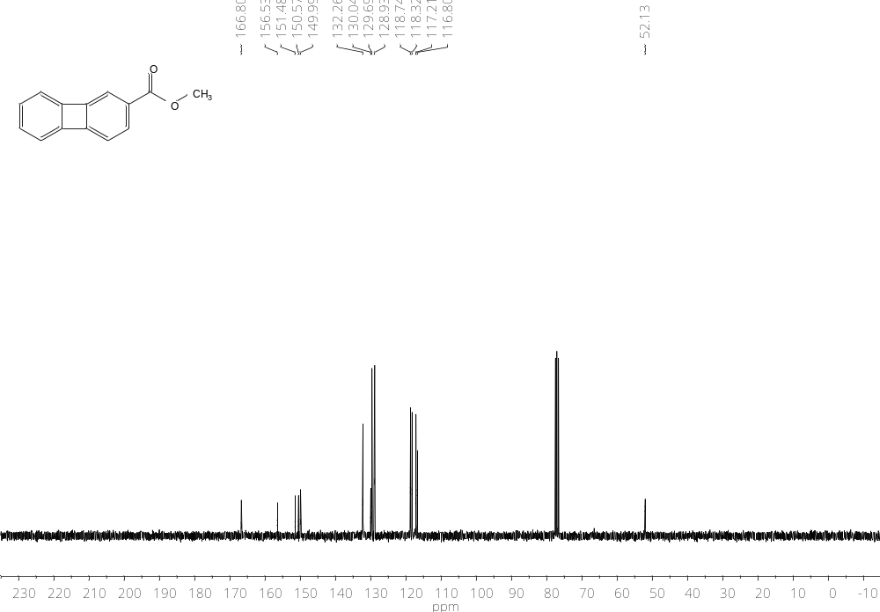
Figure S4. ¹³C{¹H} NMR spectrum of 4 in CDCl₃ (75 MHz).

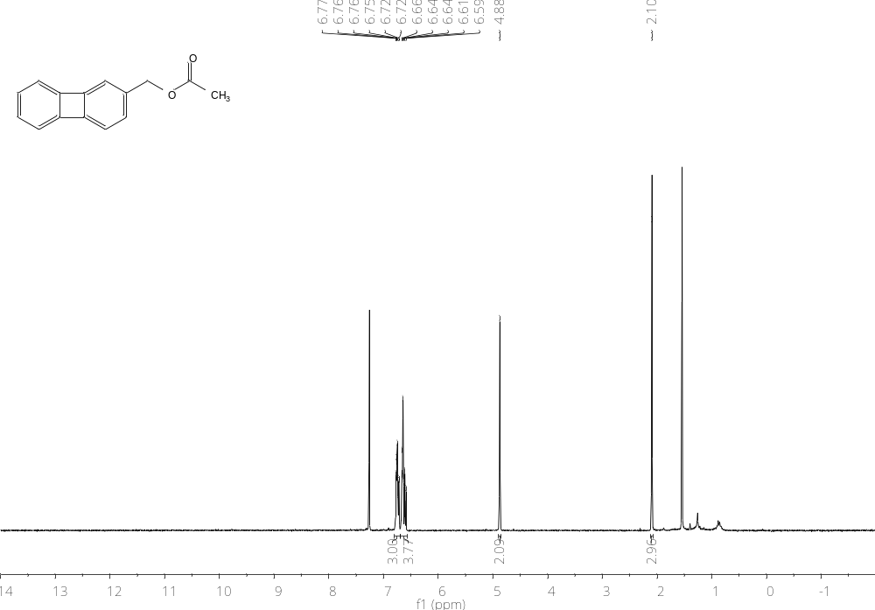
Figure S5. ¹H NMR spectrum of 5 in CDCl₃ (300 MHz).
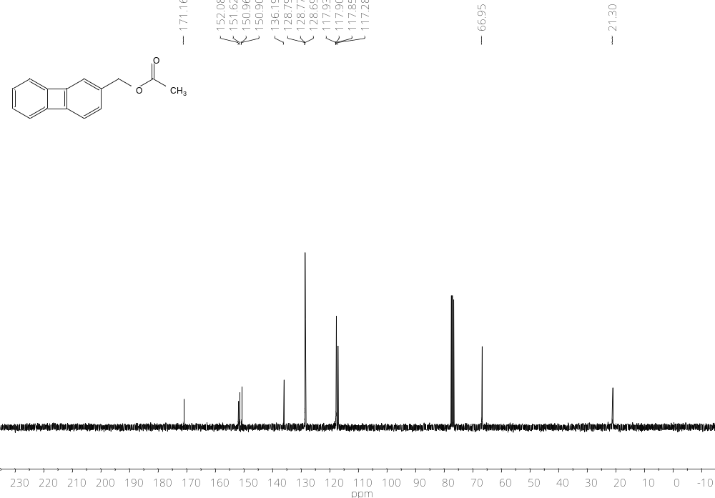
Figure S6. ¹³C{¹H} NMR spectrum of 5 in CDCl₃ (75 MHz).
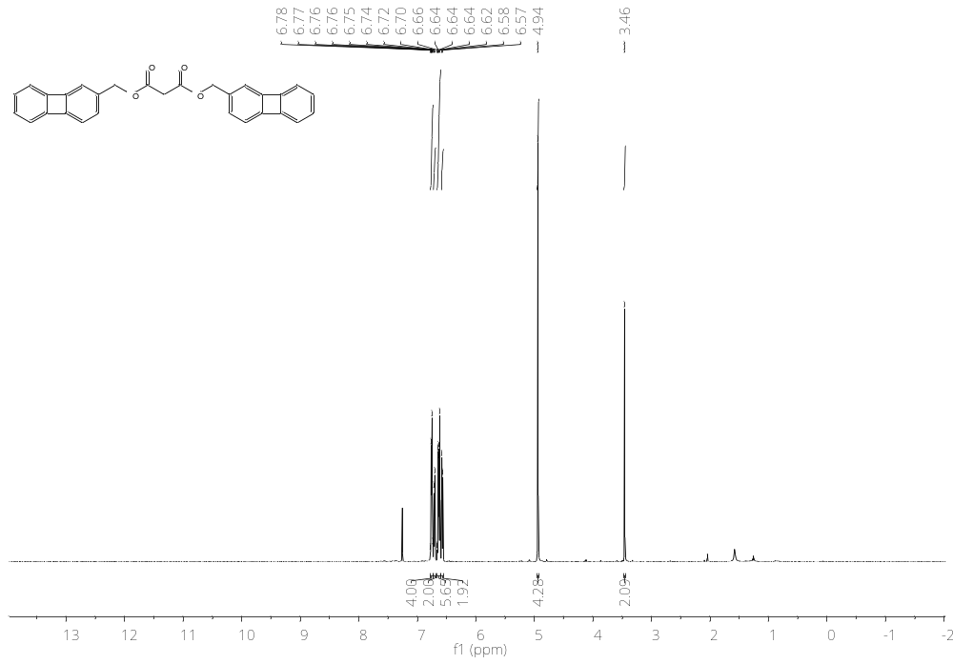
Figure S7. ¹H NMR spectrum of 9 in CDCl₃ (500 MHz).
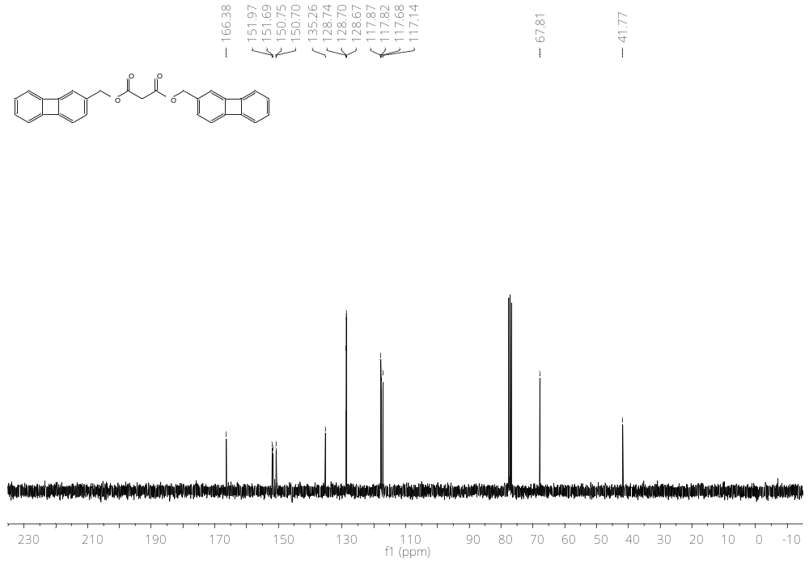
Figure S8. ¹³C{¹H} NMR spectrum of 9 in CDCl₃ (75 MHz).

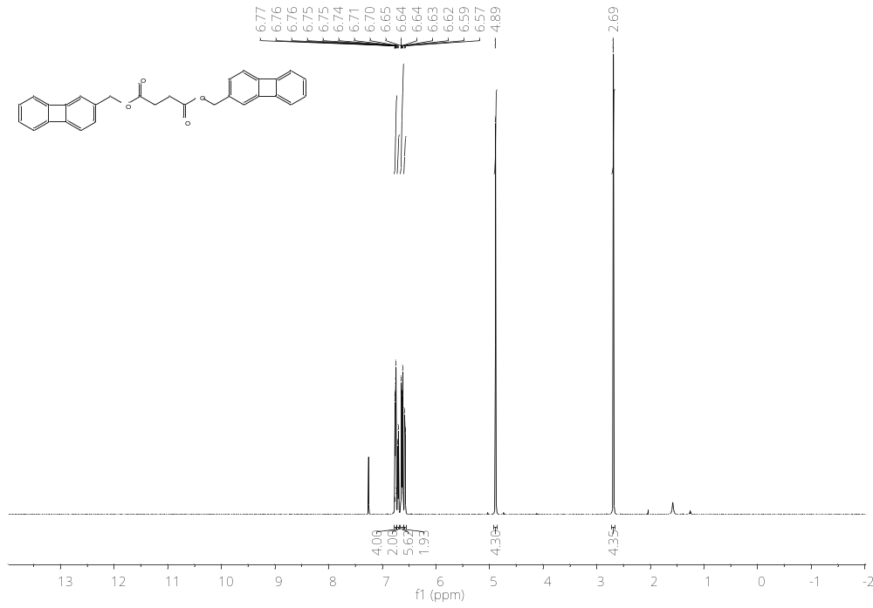
Figure S9. ¹H NMR spectrum of 10 in CDCl₃ (500 MHz).
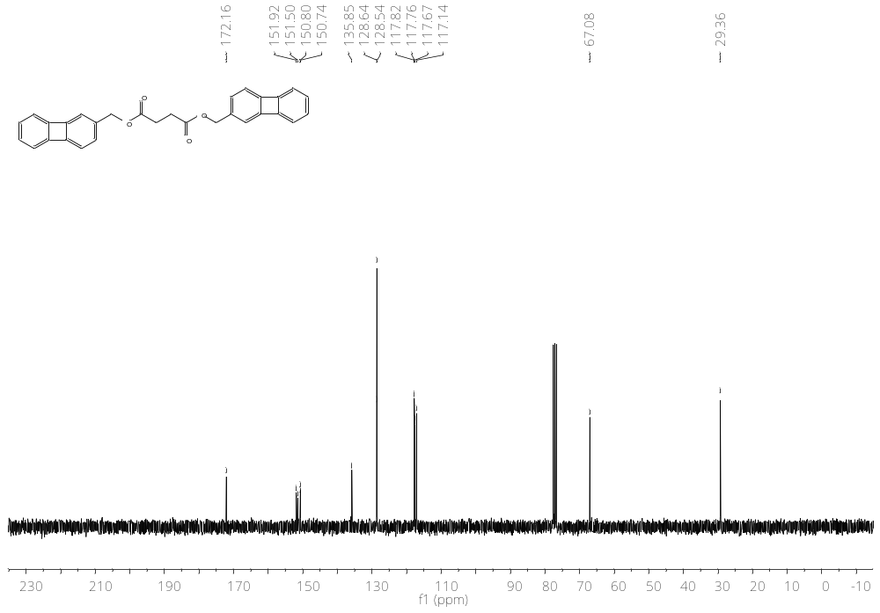
Figure S10. ¹³C{¹H} NMR spectrum of 10 in CDCl₃ (75 MHz).
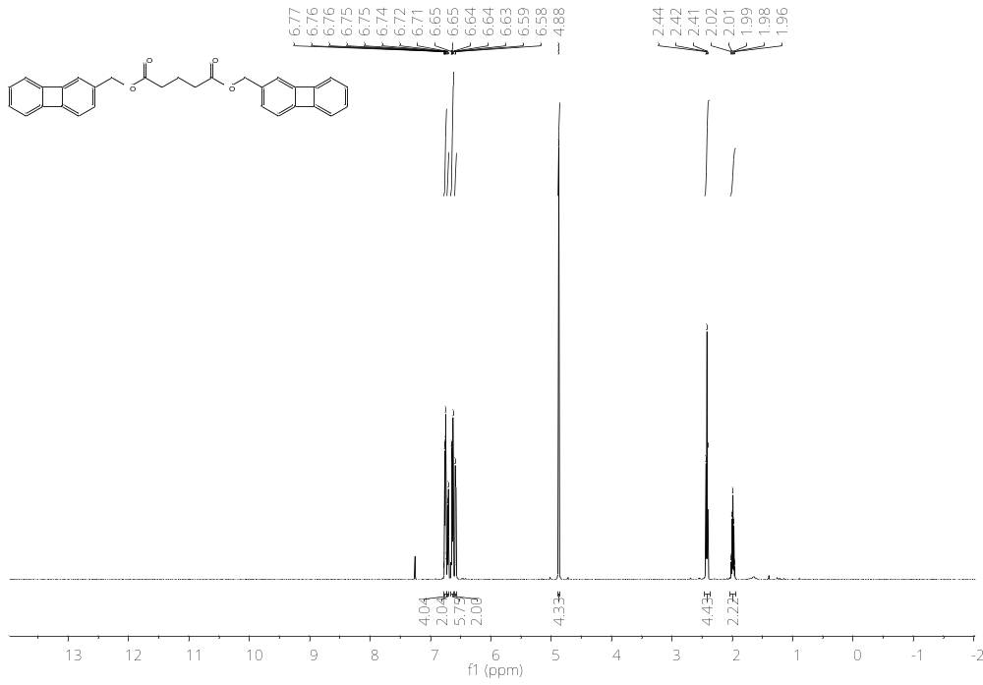
Figure S11. ¹H NMR spectrum of 11 in CDCl₃ (500 MHz).

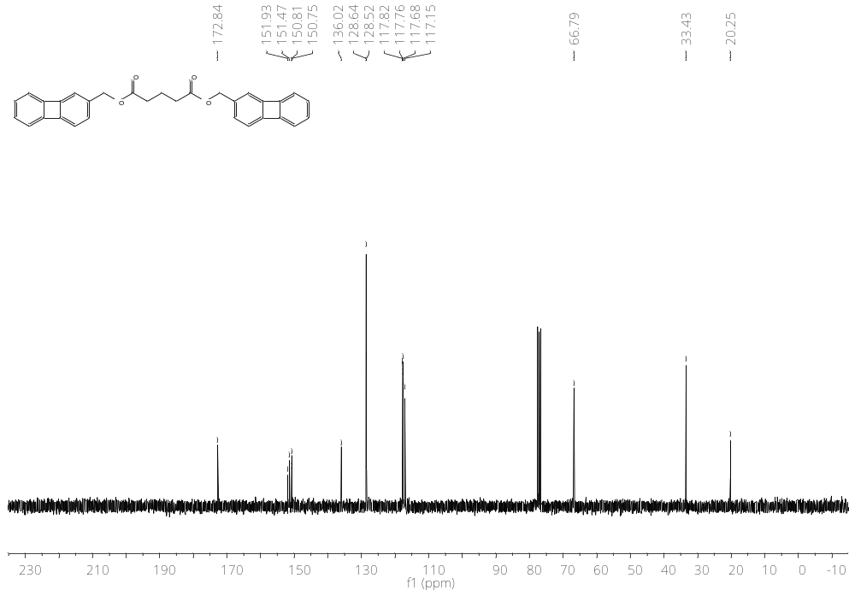
Figure S12. ¹³C{¹H} NMR spectrum of 11 in CDCl₃ (75 MHz).

