Supporting information

Nickel(II) complexes with 2-aminomethylbenzimidazole: Crystal structures and Hirshfeld surface analysis

Rudolf Varga ¹, Matúš Lištiak ¹, Vladimír Kuchtanin ¹, Jana Braniša ²,Miroslava Litecká ³, Jozef Švorec ¹ and Ján Moncoľ ¹
¹ Department of Inorganic Chemistry, Faculty of Chemical and Food Technology, Slovak University of Technology, Radlinského 9, 812 37 Bratislava, Slovakia
² Department of Chemistry, Faculty of Natural Sciences, Constantine the Philosopher University in Nitra, Trieda Andreja Hlinku 1, 949 74 Nitra, Slovakia
³ Department of Materials Chemistry, Institute of Inorganic Chemistry of the Czech Academy of Science, Husinec-Řež č.p. 1001 250 68 Řež, Czech Republic

1. Structural Characterisation of 1-4

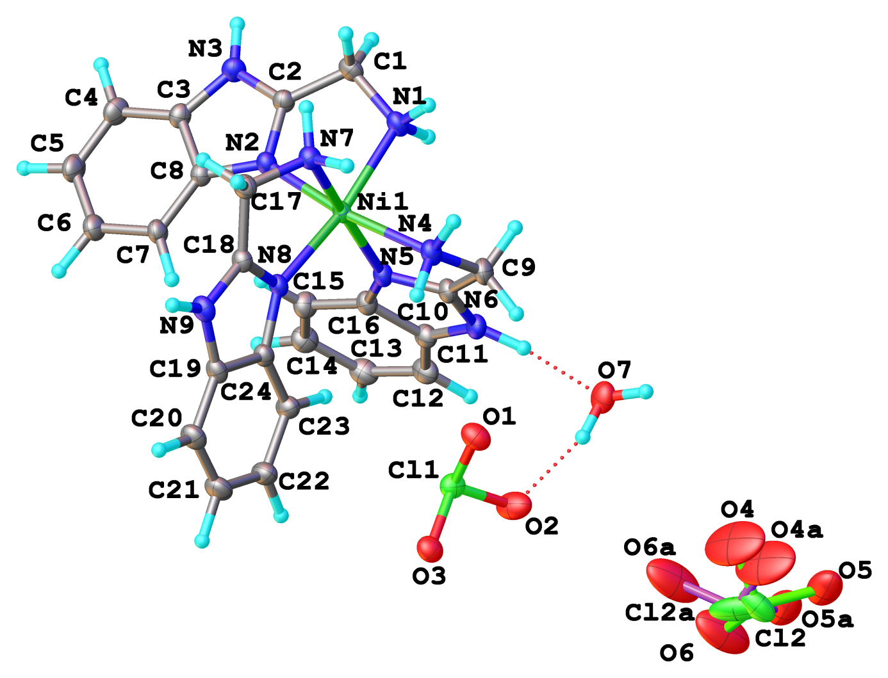
Figure S1. Ortep–like representations of the independent part of the crystal structure of complex 1
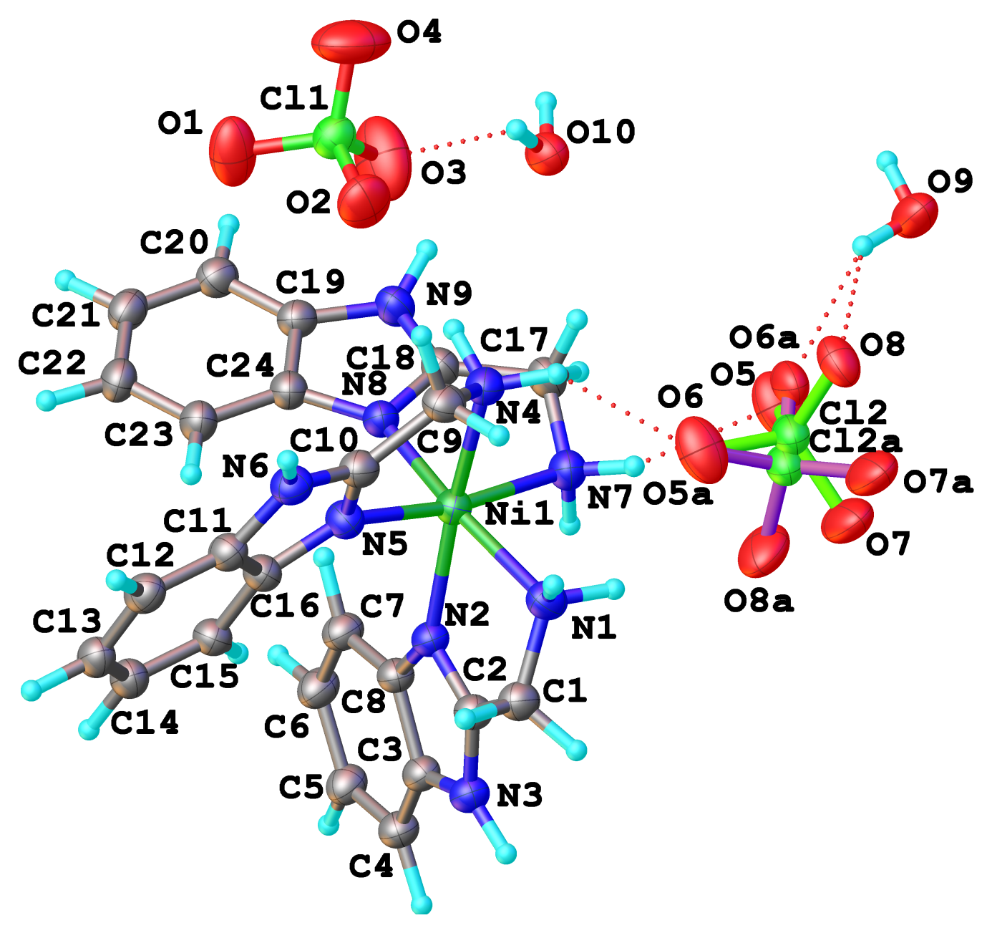
Figure S2. Ortep–like representations of the independent part of the crystal structure of complex 2
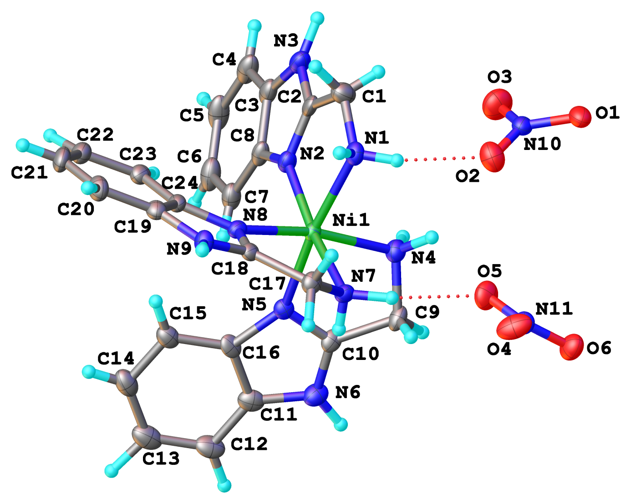
Figure S3. Ortep–like representations of the independent part of the crystal structure of complex 3
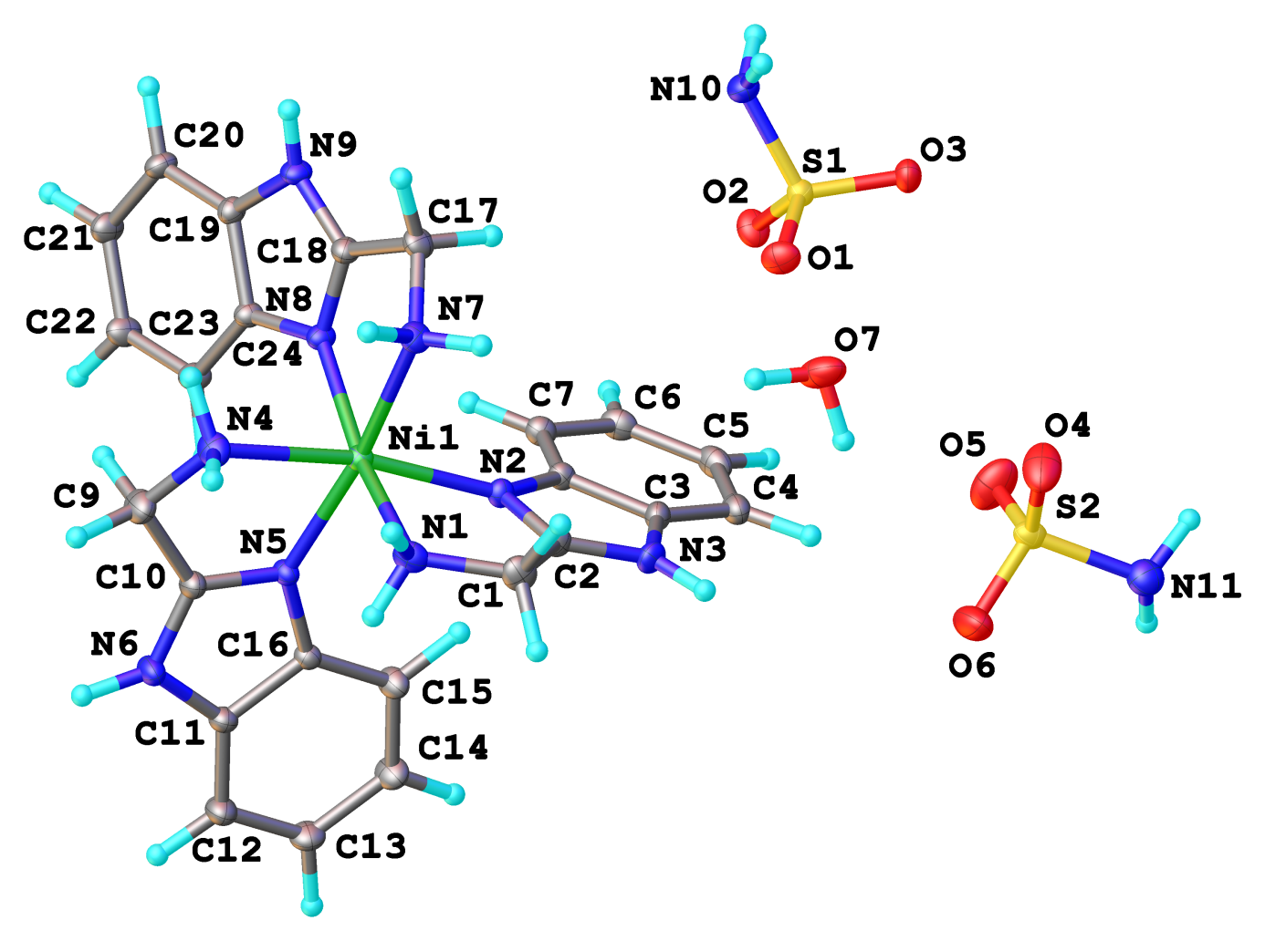
Figure S4. Ortep–like representations of the independent part of the crystal structure of complex 4
Table S1. Selected hydrogen bonds in complexes 1-4
D–H–A | d(D–H)/Å | d(H–A)/Å | d(D–A)/Å | D–H–A/°
1
O7–H7c–O2 | 0.94(4) | 1.91(4) | 2.796(3) | 157(3)
N4–H4a–O3¹ | 1.0090(10) | 2.42(2) | 3.126(2) | 126(2)
N4–H4a–O6² | 1.0090(10) | 2.29(2) | 3.002(4) | 127(2)
N4–H4b–O1¹ | 1.0090(10) | 2.353(19) | 3.130(2) | 133.0(19)
N9–H9–O4¹ | 1.0090(10) | 2.46(2) | 3.197(5) | 129.1(19)
N7–H7a–O3¹ | 0.98(3) | 2.06(3) | 3.028(2) | 169(2)
N7–H7b–O2² | 0.99(3) | 2.23(3) | 3.212(3) | 171(2)
N1–H1a–O6² | 1.0090(10) | 2.003(14) | 2.909(4) | 148(2)
N1–H1a–O6a² | 1.0090(10) | 2.056(13) | 3.023(9) | 160(2)
N1–H1b–O7³ | 1.0090(10) | 2.022(7) | 3.006(3) | 164(2)
N6–H6–O7 | 1.0090(10) | 1.827(4) | 2.831(2) | 173(2)
N3–H3–O5³ | 0.99(3) | 1.91(3) | 2.861(3) | 161(2)
N3–H3–O5a³ | 0.99(3) | 2.11(3) | 3.024(8) | 153(2)
2
N1–H1a–O6 | 1.0090(10) | 2.31(2) | 2.955(5) | 120.4(17)
N1–H1b–O7a¹ | 0.94(2) | 2.44(4) | 3.10(3) | 127.1(19)
N3–H3–O9² | 1.00(3) | 1.89(3) | 2.854(3) | 160(2)
N4–H4a–O4³ | 1.0090(10) | 2.63(2) | 3.263(3) | 120.9(17)
N4–H4a–O6 | 1.0090(10) | 2.259(16) | 3.110(5) | 141.1(19)
N4–H4a–O5a | 1.0090(10) | 2.29(6) | 3.15(5) | 142(3)
N4–H4b–O2 | 0.98(3) | 2.30(3) | 3.095(3) | 137.7(19)
N6–H6–O1⁴ | 0.95(2) | 1.90(2) | 2.837(2) | 167(2)
N7–H7a–O5 | 1.0090(10) | 2.220(10) | 3.175(3) | 157.2(19)
N7–H7a–O8a | 1.0090(10) | 2.34(2) | 3.23(2) | 146.7(19)
N7–H7b–O7–² | 1.0090(10) | 2.186(17) | 2.947(3) | 130.9(17)
N9–H9–O2⁵ | 1.0090(10) | 2.337(15) | 3.193(3) | 142.0(19)
N9–H9–O10 | 1.0090(10) | 2.313(19) | 3.0190(18) | 126.1(17)
O9–H9c–O5 | 0.99(5) | 2.63(5) | 3.255(3) | 122(3)
O9–H9c–O8 | 0.99(5) | 2.08(5) | 2.923(3) | 142(3)
O9–H9c–O6a | 0.99(5) | 2.22(5) | 2.91(2) | 125(3)
O10–H10a–O3 | 0.9600(10) | 2.24(9) | 3.026(2) | 139(11)
O10–H10b–O3⁶ | 0.9600(10) | 2.16(7) | 3.026(2) | 149(11)
3
N1–H1a–O6¹ | 0.83(5) | 2.28(5) | 3.017(5) | 148(4)
N1–H1b–O2 | 0.91(5) | 2.23(5) | 3.040(5) | 149(4)
N3–H3–O4² | 1.0089(10) | 2.09(2) | 2.952(5) | 142(3)
N3–H3–O6² | 1.0089(10) | 2.16(3) | 2.935(4) | 132(3)
N3–H3–N11² | 1.0089(10) | 2.43(3) | 3.284(4) | 142(3)
N4–H4a–O4³ | 1.0090(10) | 2.13(2) | 3.043(5) | 150(3)
N4–H4b–O2 | 1.0089(10) | 2.27(2) | 3.160(4) | 147(3)
N4–H4b–O5 | 1.0089(10) | 2.31(3) | 3.039(4) | 128(3)
N6–H6–O1³ | 0.94(5) | 2.18(5) | 3.033(5) | 151(4)
N6–H6–O2³ | 0.94(5) | 2.08(5) | 2.902(5) | 146(4)
N7–H7a–O1⁴ | 0.84(5) | 2.20(5) | 2.983(4) | 155(4)
N7–H7b–O5 | 1.0090(10) | 2.105(15) | 3.066(4) | 158(3)
N9–H9–O1¹ | 0.90(5) | 2.37(5) | 3.068(4) | 134(4)
4
N1–H1a–O2¹ | 0.99(2) | 2.16(2) | 3.098(2) | 157.2(19)
N1–H1b–O5¹ | 0.94(2) | 1.92(2) | 2.851(2) | 173(2)
N3–H3–O1² | 0.96(2) | 2.43(2) | 3.224(2) | 140.1(18)
N3–H3–O3² | 0.96(2) | 2.06(2) | 2.911(2) | 147.8(19)
N4–H4a–O3¹ | 0.95(2) | 2.31(2) | 3.106(2) | 140.4(19)
N4–H4b–O6³ | 1.009(2) | 2.031(14) | 2.927(2) | 146.6(19)
N6–H6–O1⁴ | 1.009(2) | 2.43(2) | 3.135(2) | 126.6(17)
N6–H6–O2⁴ | 1.009(2) | 2.033(11) | 2.966(2) | 152.7(19)
N7–H7a–O2¹ | 1.009(2) | 2.383(16) | 3.165(2) | 133.6(17)
N7–H7a–O6³ | 1.009(2) | 2.373(19) | 3.044(2) | 123.2(16)
N7–H7b–O4² | 0.96(2) | 2.07(2) | 3.036(2) | 178.3(19)
N9–H9–O7⁵ | 0.90(2) | 1.91(2) | 2.777(2) | 159(2)
N10–H10b–O5⁶ | 1.009(2) | 2.126(15) | 2.977(2) | 140.8(19)
N11–H11a–O2⁷ | 1.010(2) | 2.320(10) | 3.274(2) | 157(2)
N11–H11b–O3⁸ | 1.010(2) | 2.120(12) | 3.053(2) | 153(2)
O7–H7c–O4² | 0.984(5) | 1.995(9) | 2.963(2) | 167(3)
O7–H7d–O1² | 0.983(5) | 1.852(6) | 2.833(2) | 175(3)

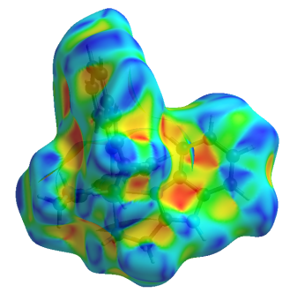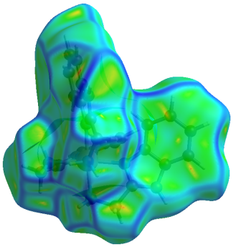
Figure S5. Hirshfeld surface of complex 1 mapped oved shape index (left) and curvedness (right)
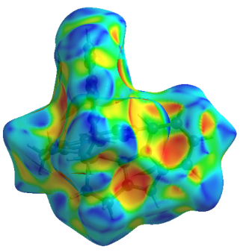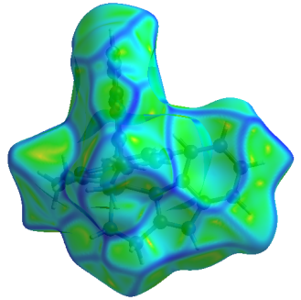
Figure S6. Hirshfeld surface of complex 2 mapped oved shape index (left) and curvedness (right)
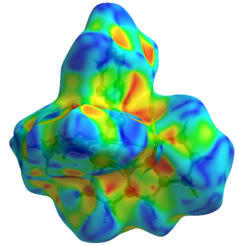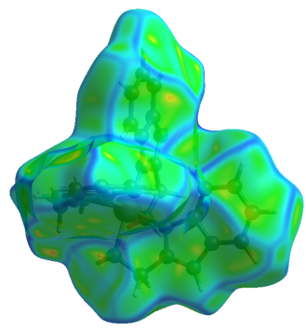
Figure S7. Hirshfeld surface of complex 3 mapped oved shape index (left) and curvedness (right)

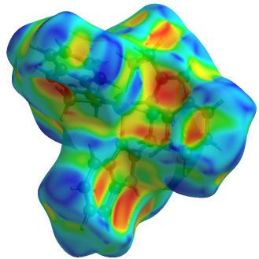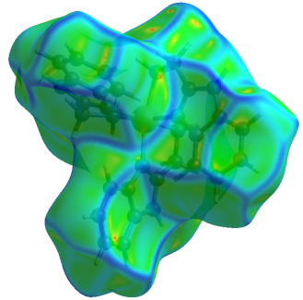
Figure S8. Hirshfeld surface of complex 4 mapped oved shape index (left) and curvedness (right)

a)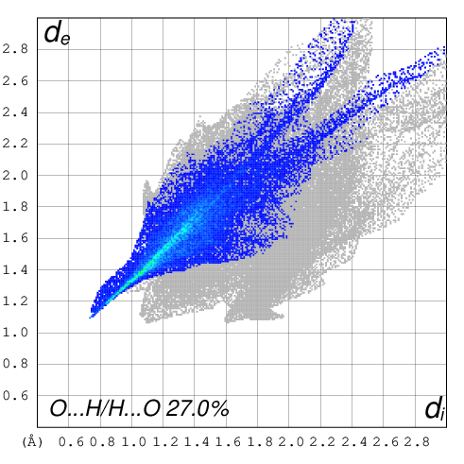 |  | b)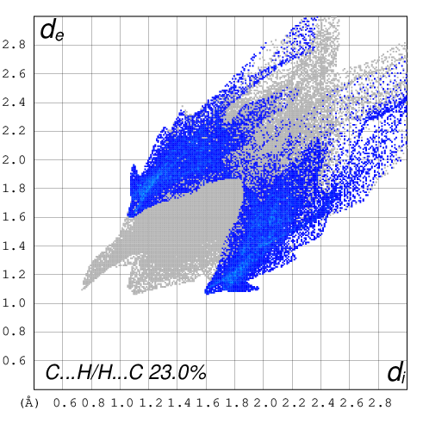
c)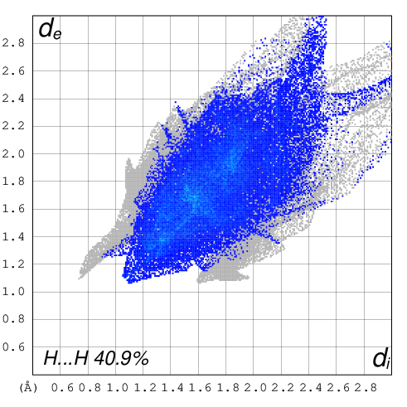 |  | d)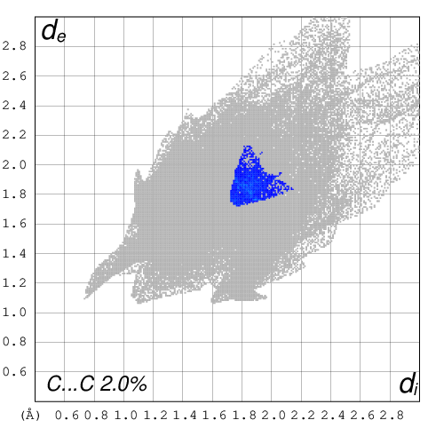
 | e)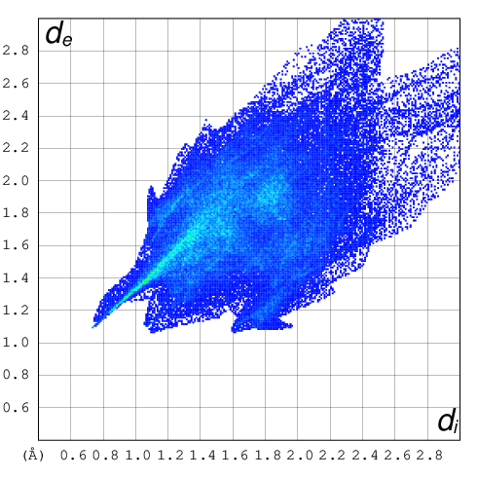
Figure S9. The full two-dimensional fingerprint plots of complex 1, showing a) O···H/H···O, b) C···H/H···C, c) H···H, d) C···C close contacts and e) all interactions

a)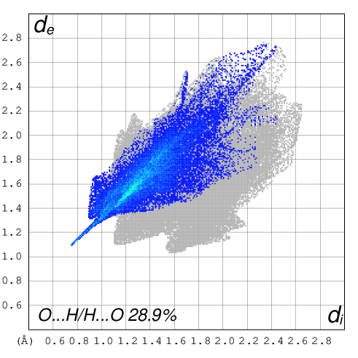 |  | b)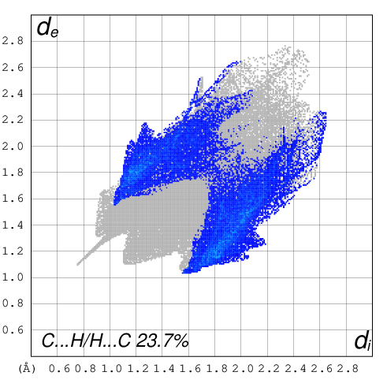
c)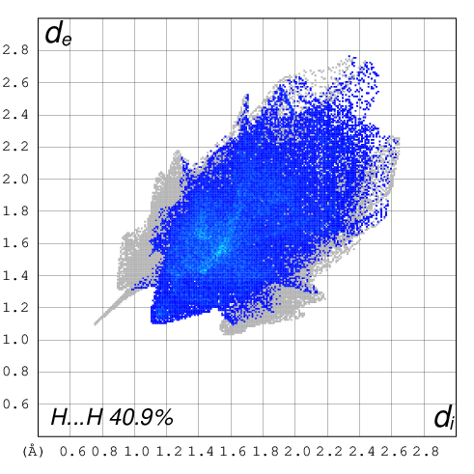 |  | d)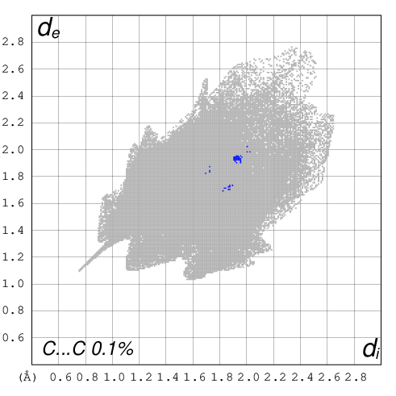
 | e)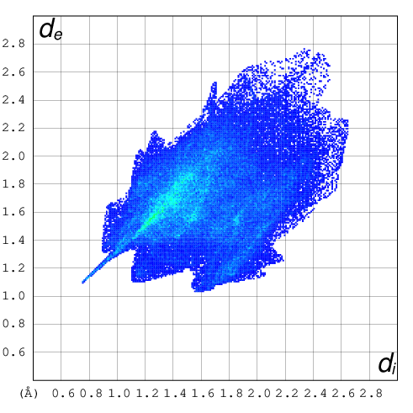
Figure S10. The full two-dimensional fingerprint plots of complex 2, showing a) O···H/H···O, b) C···H/H···C, c) H···H, d) C···C close contacts and e) all interactions
a)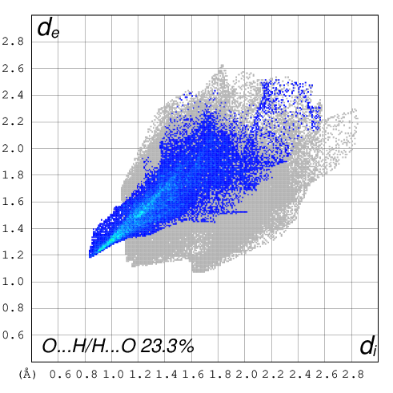 |  | b)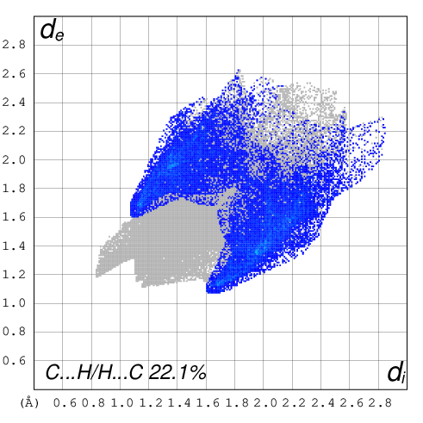
c)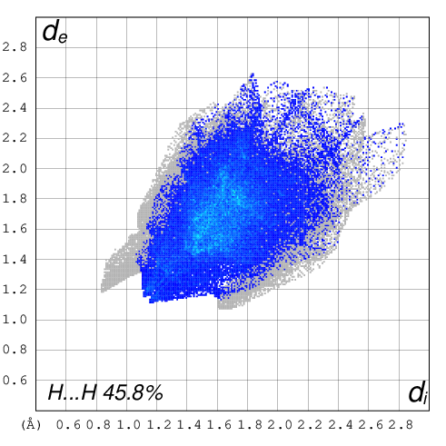 |  | d)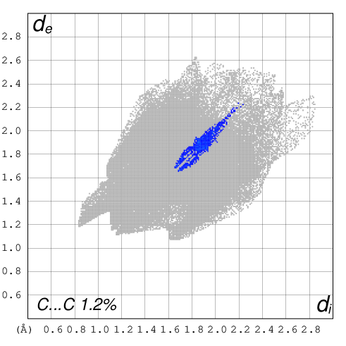
 | e)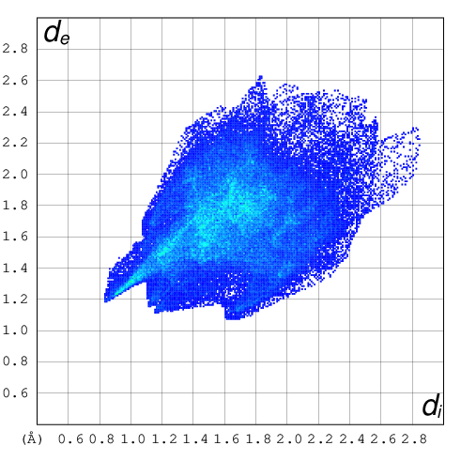
Figure S11. The full two-dimensional fingerprint plots of complex 3, showing a) O···H/H···O, b) C···H/H···C, c) H···H, d) C···C close contacts and e) all interactions
a)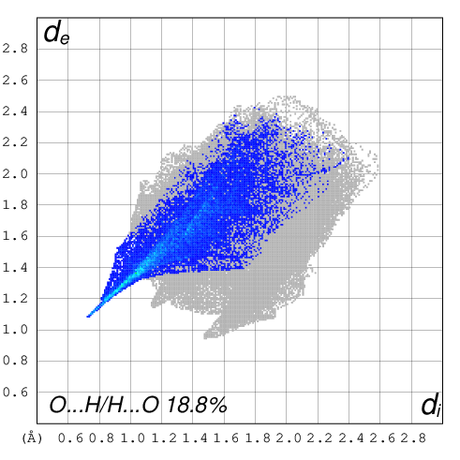 |  | b)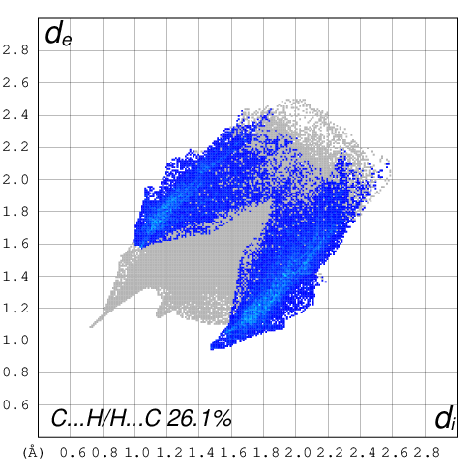
c)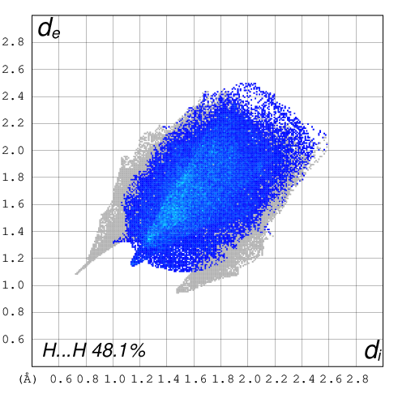 |  | d)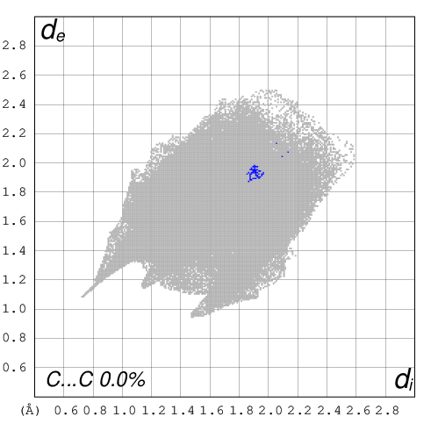
 | e)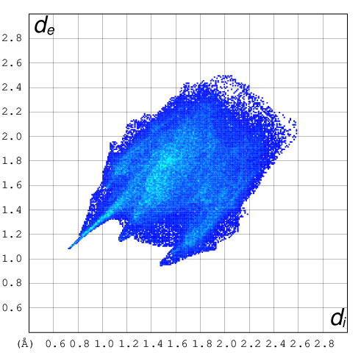
Figure S12. The full two-dimensional fingerprint plots of complex 4, showing a) O···H/H···O, b) C···H/H···C, c) H···H, d) C···C close contacts and e) all interactions
2. Spectral Characterisation of 1-4
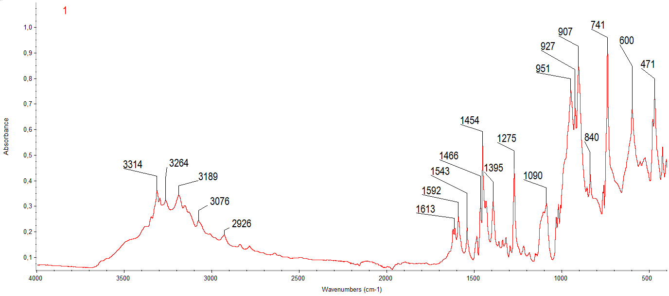
Figure S13. The FTIR spectrum of the complex 1
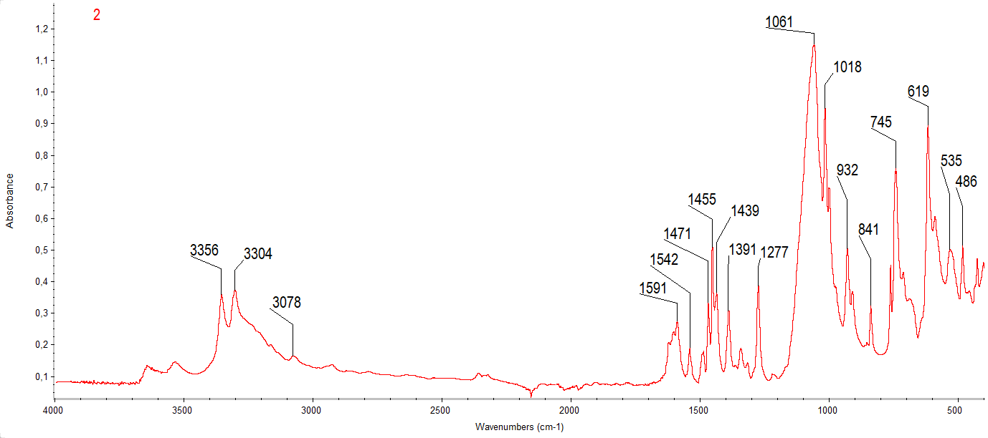
Figure S14. The FTIR spectrum of the complex 2
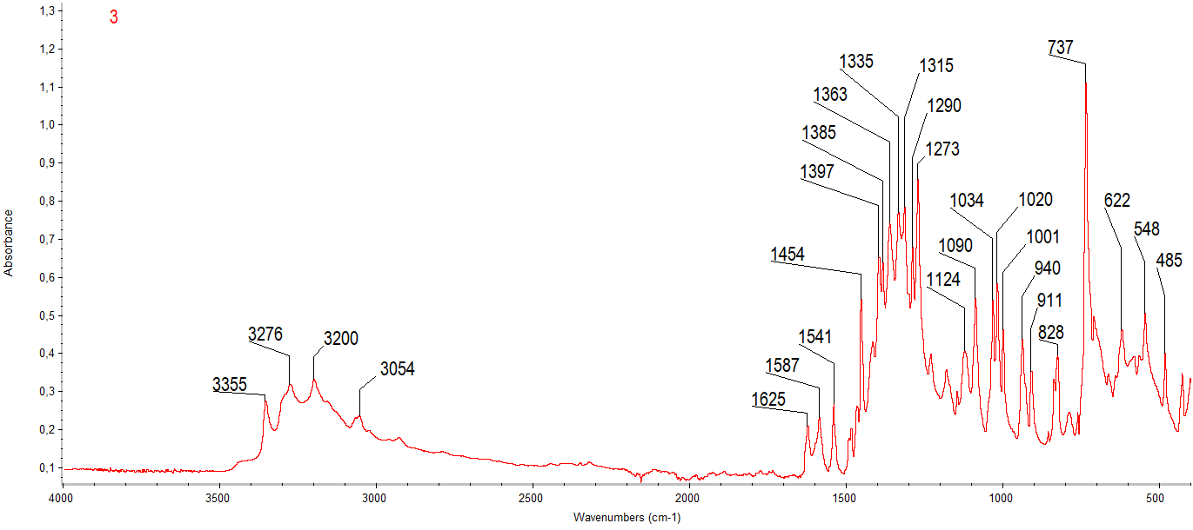
Figure S15. The FTIR spectrum of the complex 3
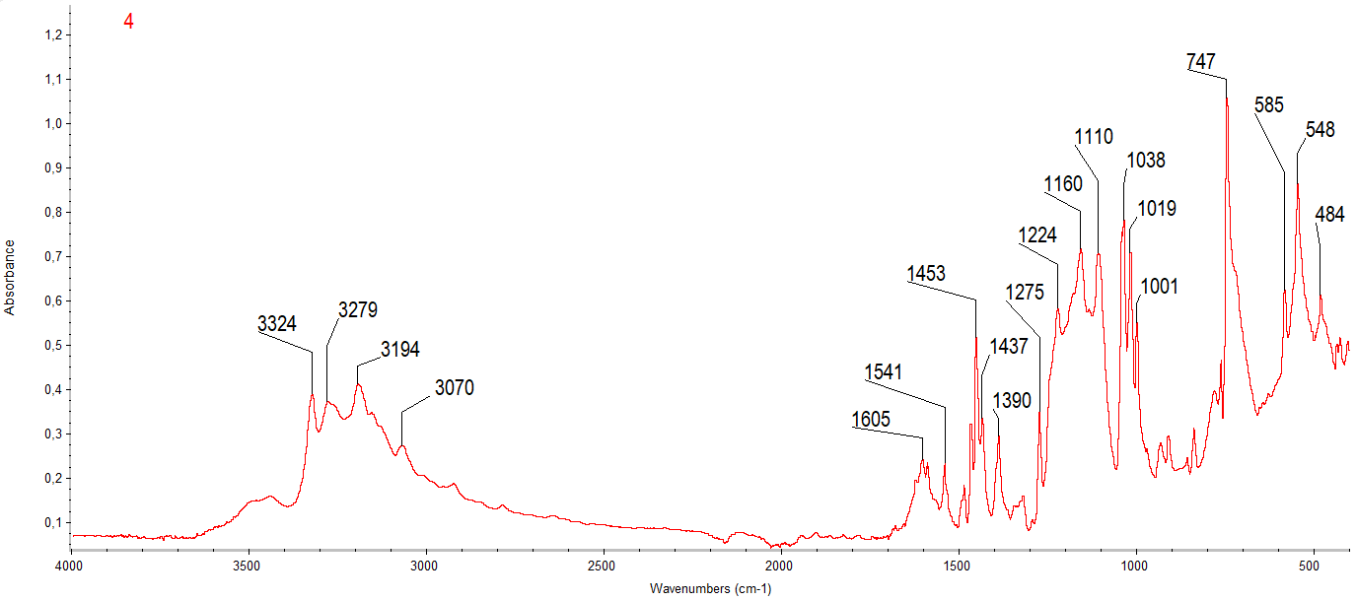
Figure S16. The FTIR spectrum of the complex 4
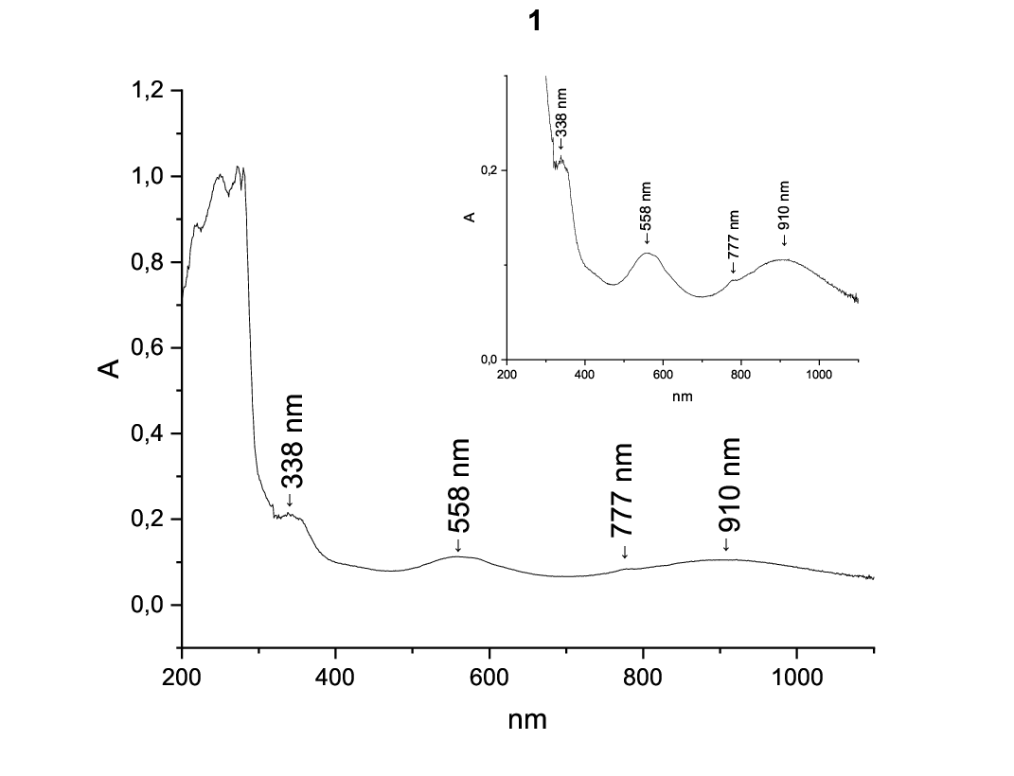
Figure S17. The Uv-Vis spectrum of complex 1
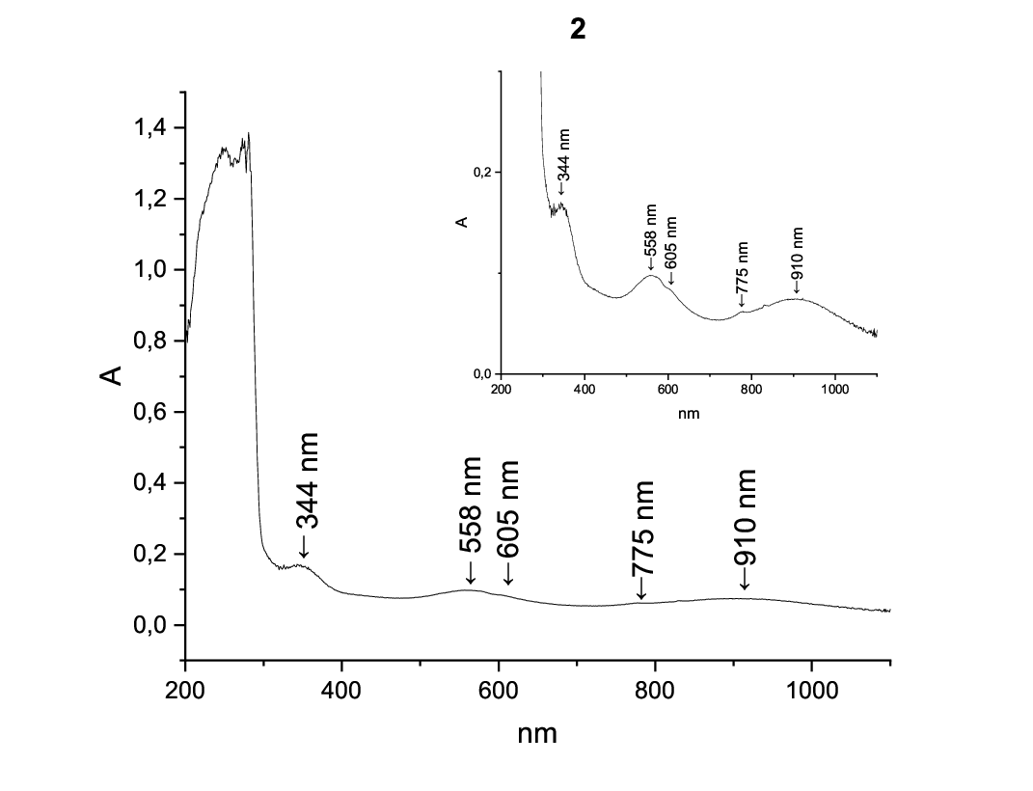
Figure S18. The Uv-Vis spectrum of complex 2
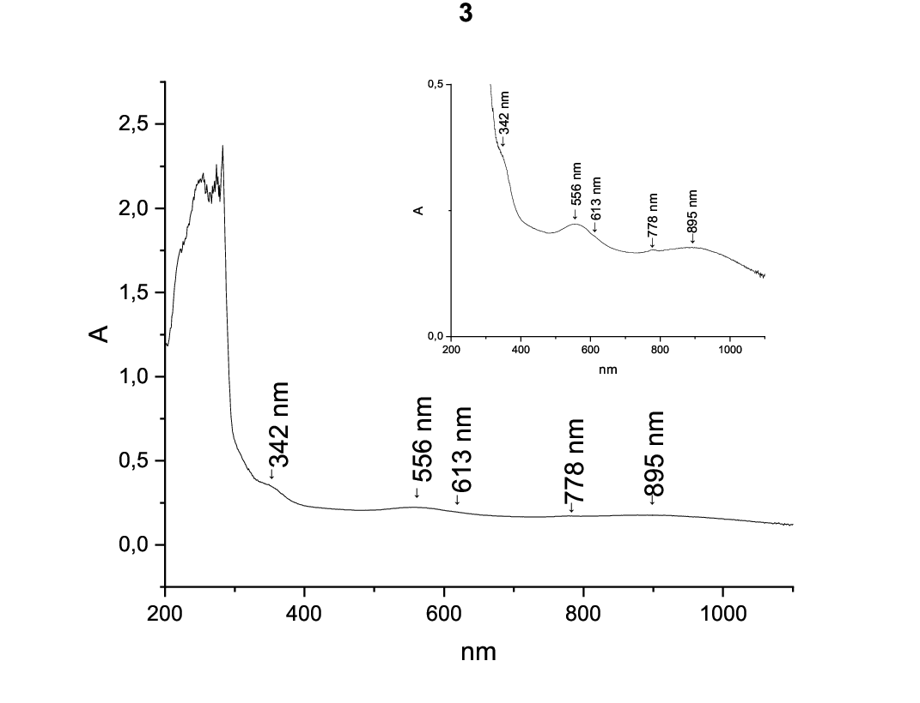
Figure S19. The Uv-Vis spectrum of complex 3
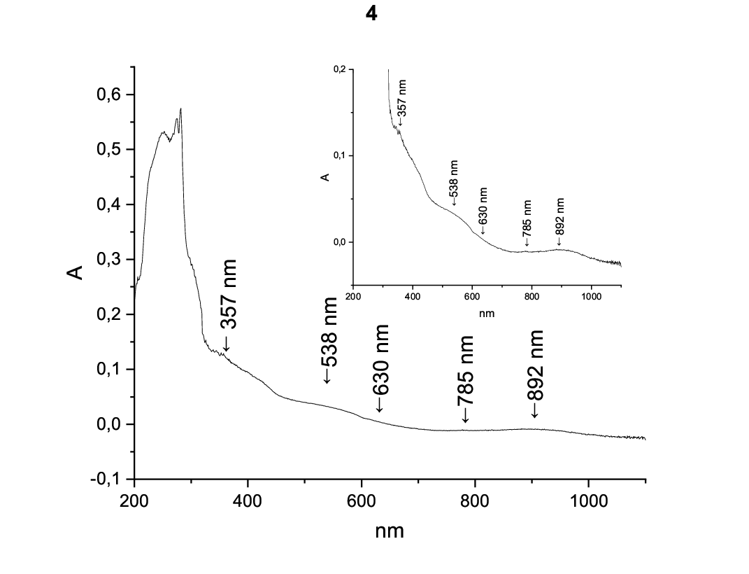
Figure S20. The Uv-Vis spectrum of complex 4

