Supporting Information

Correlation between Crystal Structure and Color Fading in the Solid-State Photochromism of Viologen Derivatives
Shota Hirai¹, Akiko Sekine*¹, Hidehiro Uekusa¹

Table of Contents
- Crystal Data and Structure Refinement Parameters
- Centroid-to-centroid distance distribution by CSD
- Frontier Orbital Analysis

1. Crystal Data and Structure Refinement Parameters
Table S1 Crystal data and structure refinement parameters for 1, 2, 3 and 4 crystals
Compound name 1 2 3 4
Empirical formula C₂₁ H₂₃ Br N₂ C₁₉ H₁₉ Br N₂ O₂ C₂₄ H₂₂ N₂ O₃ S C₂₈ H₃₀ N₂ O₃ S
Formula weight 383.32 387.27 418.49 474.60
Temperature 93(2) K 93(2) K 93(2) K 93(2) K
Wavelength 1.54184 Å 1.54184 Å 1.54184 Å 1.54184 Å
Crystal system Monoclinic Monoclinic Orthorhombic Monoclinic
Space group P2₁/c P2₁/c Pca2₁ P2₁
a / Å 15.5653(4) 12.0300(2) 13.7420(3)Å 19.4320(3)
a / Å 11.0878(3) 12.5706(3) 8.3103(2) Å 12.5401(2)
a / Å 10.5885(3) 11.5304(2) 17.9515(5) Å 10.0725(2)
α / ° 90 90 90 90
β / ° 91.787(2) 92.521(2) 90 103.864(2)
γ / ° 90 90 90 90
Volume 1826.53(9) 1741.99(6) 2050.06(9) 2382.95(7)
Z / Å³ 4 4 4 4
d_{calc} / g cm⁻³ 1.394 1.477 1.356 1.323
Absorption coefficient / mm⁻¹ 3.077 3.324 1.639 1.471
F(000) 792 792 880 1008
Crystal size / mm³ 0.172 × 0.115 × 0.083 0.215 × 0.161 × 0.111 0.076 × 0.040 × 0.036 0.090 × 0.070 × 0.030
θ range / ° 2.840 - 74.976 3.678 - 76.530 4.927- 76.463 4.233 - 76.162
Index ranges -19<=h<=19 -14<=h<=15 -16<=h<=11 - 23<=h<=24
-13<=k<=9 -12<=k<=15 -10<=k<=10 -15<=k<=15
-13<=l<=12 -14<=l<=12 -22<=l<=22 -11<=l<=12
Reflections collected 11414 12055 7430 15387
Independent reflections 3621 3519 3425 4753
R(int) 0.0261 0.0165 0.0248 0.0279
Completeness (%) 99.9 99.6 99.7 99.9
Data / restraints / parameters 3621 / 0 / 251 3519 / 0 / 220 3425 / 1 / 273 4753 / 0 / 311
Goodness-of-fit on F2 1.086 1.076 1.032 1.056
Final R indices [I>2sigma(I)] R₁ = 0.0277 R₁ = 0.0229 R₁ = 0.0327 R₁ = 0.0556
wR₂ = 0.0726 wR₂ = 0.0554 wR₂ = 0.0785 wR₂ = 0.1277
R indices (all data) R₁ = 0.0296 R₁ = 0.0233 R₁ = 0.0362 R₁ = 0.0615
wR₂ = 0.0736 wR₂ = 0.0556 wR₂ = 0.0802 wR₂ = 0.1309
Δρ_{max} / Δρ_{min} / e.Å⁻³ 0.308 / -0.472 0.352 / -0.267 0.205 / -0.299 0.652 / -0.418
CCDC 2505420 2505421 2505422 2505423

2. Centroid-to-centroid distance distribution by CSD

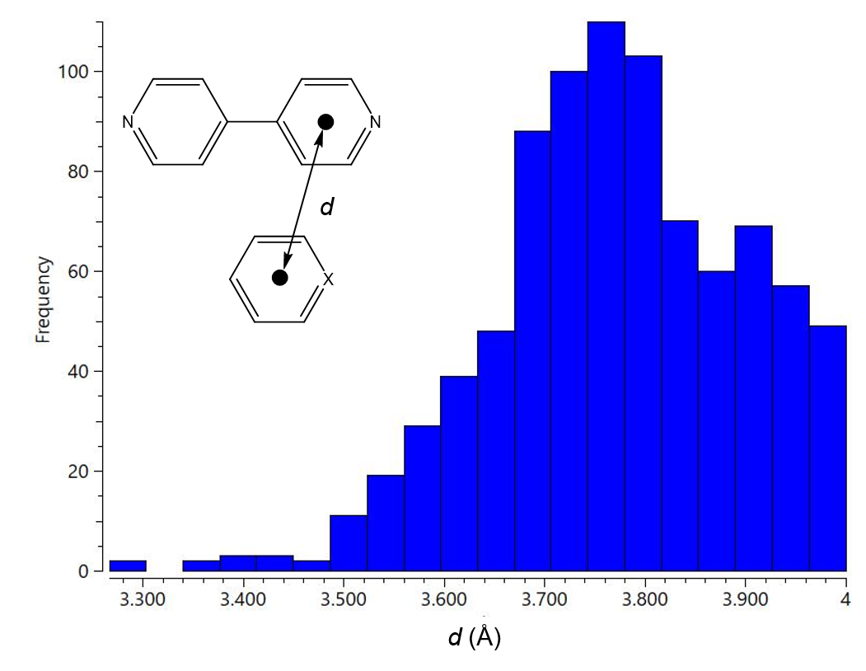
Fig. S1 Histogram of centroid-to-centroid distance distribution in stacked pyridyl pyridinium and pyridyl or phenyl rings (range: 3.26~4.0Å)

3. Frontier Orbital Analysis

Table S2 HOMO and LUMO energy levels for 1–4
Compound | HOMO / eV | LUMO / eV | HOMO−LUMO
1_major | −6.13 | −2.66 | 3.47
1_minor | −6.13 | −2.66 | 3.47
2 | −5.04 | −2.93 | 2.11
3 | −7.09 | −2.76 | 4.33
4 | −7.16 | −2.53 | 4.63

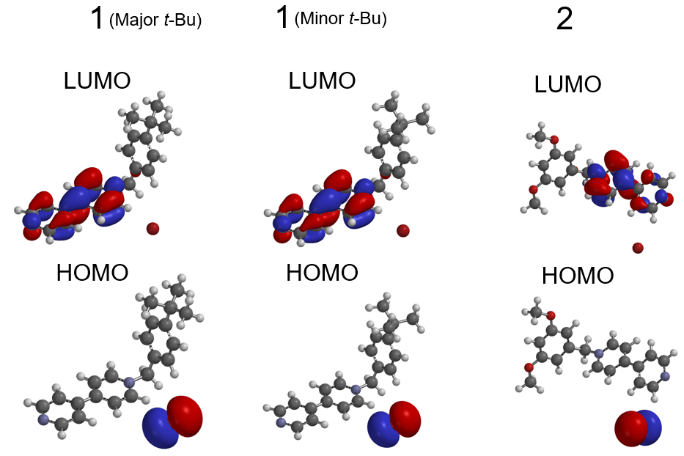

Fig. S2 HOMO and LUMO orbitals of 1 and 2

