Supporting Information

Computational Study: Antioxidant Activity of Aspulvinone E Toward Hydroperoxyl and Hydroxyl Radicals
Belma Gjergjizi Nallbani¹* and Isa Degirmenci²*

¹UBT – Higher Education Institution, Faculty of Pharmacy, Lagjia Kalabria 10000 Prishtina, Republic of Kosovo
E-mail: belma.nallbani@ubt-uni.net

²Chemical Engineering Department, Ondokuz Mayıs University, 55139 Samsun, Turkey
E-mail: isa.degirmenci@omu.edu.tr

The transition state theory (TST) was used in order to predict the RAF and formal HAT mechanisms rate coefficients. The following rate equation provides the reaction rate constants based on the TST approximation ¹.
$$k_{(T)}= κ \frac{k_{B}T}{h} {(\frac{p^{θ}}{RT})}^{1-m}e^{{-∆G}^{‡}∕RT}$$
In this equation, $k_{(T)}$ is the rate constant at temperature T, the Boltzmann constant (1,38 x 10⁻²³ J K⁻¹), T represents temperature in Kelvin, h is the Planck constant (6.63 × 10⁻³⁴ J·s), and ΔG‡ denotes the Gibbs free energy difference between the reactants and the geometry of the activated complex. R is the universal gas constant (8.314 J·K⁻¹·mol⁻¹), κ is the tunneling coefficient, which is assumed to be 1 except in hydrogen abstraction reactions where it is calculated using the Wigner approximation. pθ refers to the standard pressure (10⁵ Pa or 1 bar), and m indicates the molecularity of the reaction.
The tunneling correction factor, κ, was calculated according to the Wigner approximation, as expressed by the following equation ^{2,3}:
$$κ_{(T)}=1+\frac{1}{24}{\left|\frac{hω^{‡}}{k_{B}T}\right|}^{2}$$
In this context, ω‡ refers to the imaginary frequency associated with the bond that is forming or breaking within the transition state geometry during the transfer of a light atom or group from one species to another.

Table S1. Radical stabilization energy of butenolide radicals formed after hydrogen transfer reactions (M06-2X/6-31+G(d) level, 298.15 K, in water polarized implicit solvent medium).
Radical structures formed after transfer of H-atoms | RSE (kj mol⁻¹)
H1 | 97.84
H2 | 96.98
H3 | 137.68

Table S2. Computed AIP (adiabatic ionization potential), PDE (proton dissociation energy), BDE (homolytic O–H bond dissociation enthalpy), PA (proton affinity) and ETE (electron transfer enthalpy) parameters (kJ mol⁻¹) (M06-2X/6-31+G(d) level, 298.15 K, in water polarized implicit solvent medium).
 | AIP | PDE | BDE | PA | ETE*
Butenolide | 587.43
H‒1 |  | 800.11 | 327.88 | 987.90 | 270.34
H‒2 |  | 800.97 | 328.73 | 963.72 | 295.37
H‒3 |  | 760.27 | 288.03 | 897.49 | 320.90
*For ETE calculations, the reported enthalpy of the electron (ΔH_{hydr}(e–) = –129.3 kJ mol^{–1})⁴ was utilized.

Table S3. Computed AIP (adiabatic ionization potential), PDE (proton dissociation energy), BDE (homolytic O–H bond dissociation enthalpy), PA (proton affinity) and ETE (electron transfer enthalpy) parameters (kJ mol⁻¹) (M06-2X/6-311++G(d,p) level, 298.15 K, in water polarized implicit solvent medium).
 | AIP | PDE | BDE | PA | ETE*
Butenolide | 593.43
H‒1 |  | 839.98 | 390.71 | 1032.89 | 271.22
H‒2 |  | 840.27 | 391.00 | 1006.30 | 298.11
H‒3 |  | 798.44 | 349.17 | 937.65 | 324.92
*For ETE calculations, the reported enthalpy of the electron (ΔH_{hydr}(e–) = –129.3 kJ mol^{–1})⁴ was utilized.
Table S4. Energetics (kJ mol⁻¹) and kinetics (L mol⁻¹ s⁻¹) for hydrogen (H-1, H-2, and H-3) transfer reactions to HOO• and HO• (M06-2X/6-31+G(d) level, 298.15 K, in water polarized implicit solvent medium).
HOO• | $${ΔG}_{rxn}$$ | $${ΔG}^{‡}$$ | k_{water} | Wigner  Factor
H‒1 | 3.02 | 44.91 | 1.25E+07 | 5.99
H‒2 | -5.10 | 39.68 | 9.95E+07 | 5.78
H‒3 | -38.40 | 20.22 | 3.36E+11 | 7.61
HO•
H‒1 | -129.46 | 3.55 | 1.57E+14 | 4.28
H‒2 | -128.11 | 7.26 | 6.16E+13 | 7.48
H‒3 | -170.80 | 0.92 | 4.09E+14 | 3.85

Table S5. Energetics (kJ mol⁻¹) and kinetics (L mol⁻¹ s⁻¹) for HOO• and HO• addition reactions to C-1, C-2, and C-3 (M06-2X/6-31+G(d) level, 298.15 K, in water polarized implicit solvent medium).
HOO• | $${ΔG}_{rxn}$$ | $${ΔG}^{‡}$$ | k_{water}
C‒1 | -67.33 | 27.90 | 1.99E+09
C‒2 | -57.39 | 24.07 | 9.35E+09
C‒3 | -36.82 | 38.51 | 2.76E+07
HO•
C‒1 | -138.00 | 4.08 | 1.20E+12
C‒2 | -103.49 | 11.12 | 7.01E+10
C‒3 | -140.25 | 12.28 | 4.38E+10

Table S6. Parameters (eV) computed to determine and describe the mechanism involved in free radical scavenging compared with the data presented in the literature.
 | This Study  (M06-2X/6-31+G(d)) | Apigenin [15] | Aloe-emodin [30] | Quercetin [35]
ƞ | 1.74 | 3.30 | 1.74 | 3.23
S | 0.29 | 0.15 | 0.28 | 0.15
χ_{x} | 4.34 | 4.19 | 4.85 | 3.99
µ | -4.34 | -4.19 | -4.85 | -3.99
ω | 5.51 | 2.66 | 6.75 | 2.47
HOMO | -6.94 | -6.15 | -6.6 | -5.69
LUMO | -1.69 | -1.98 | -3.11 | -2.30
E_{gap} | 5.26 | 4.17 | 3.48 | 3.38

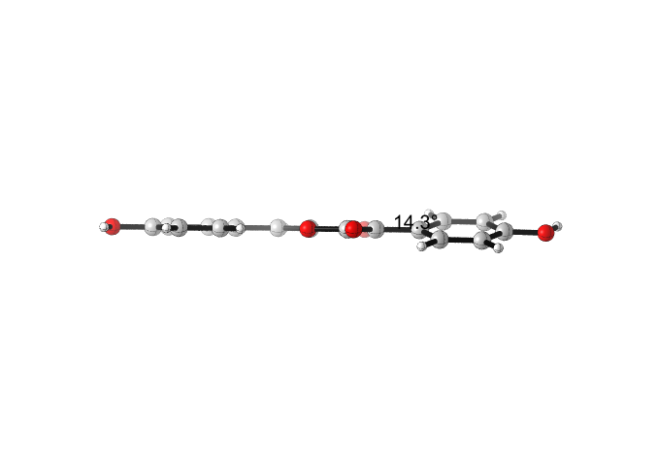
Figure S1. Illustrating the optimized structure (at m062x/6-31+g(d) level and in implicit water solvent medium) of Aspulvinone E and presentation of its carbon atoms labeled as C_{a}, C_{b}, C_{c}, C_{d}, C_{e}, and C_{f}, at which HO• addition reactions occur.

Figure S2. Energetics from pre-reactive complex (prc) for HO• radical hydrogen atom transfer reactions from the H-1, H-2, and H-3 atoms (the formal HAT mechanism) and for HO• radical addition reactions to C-1, C-2, and C-3 (the RAF mechanism) (M06-2X/6-311++G(d,p) level, 298.15 K, in water polarized implicit solvent medium).

Table S7. Gibbs free energy of activation (kJ mol⁻¹) and kinetics (L mol⁻¹ s⁻¹) for HO• addition reactions to C_{a}, C_{b}, C_{c}. C_{d}, C_{e}, C_{f}, C_{g} and C_{h} (M06-2X/6-311++G(d,p) level, 298.15 K, in water polarized implicit solvent medium).
 | HO• |  | HOO•
 | $${ΔG}^{‡}$$ | k_{water} | $${ΔG}^{‡}$$ | k_{water}
C_{a} | 28.87 | 5.44E+07 | 65.16 | 5.92E+02
C_{b} | 25.95 | 1.76E+08 | 51.62 | 1.39E+05
C_{c} | 22.70 | 6.54E+08 | 63.28 | 1.26E+03
C_{d} | 19.85 | 2.07E+09 | 57.38 | 1.36E+04
Average for ring B |  | 7.39E+08 |  | 3.86E+04
C_{e} | 25.83 | 1.85E+08 | 63.87 | 9.96E+02
C_{f} | 27.77 | 8.46E+07 | 51.32 | 1.57E+05
C_{g} | 27.91 | 8.02E+07 | 59.83 | 5.08E+03
C_{h} | 21.90 | 9.02E+08 | 56.72 | 1.78E+04
Average for ring A |  | 3.13E+08 |  | 4.52E+04

Figure S3. A schematic representation illustrating hydrogen atoms labeled as 1A, 2A, 3A, 4A, 1B, 2B, 3B and 4B, respectively, at which hydrogen transfer reactions to HO• occur.

Table S8. Gibbs free energy of activation (kJ mol⁻¹) and kinetics (L mol⁻¹ s⁻¹) for hydrogen transfer reactions to HO• and HOO• from H-1A, H-2A, H-3A, H-4A, H-1B, H-2B, H-3B and H-4B (Figure S4) at M06-2X/6-311++G(d,p) level, 298.15 K, in water polarized implicit solvent medium).
 | HO• |  | HOO•
 | $${ΔG}^{‡}$$ | k_{water} | $${ΔG}^{‡}$$ | k_{water}
H-1A | 21.97 | 5.91E+10 | 109.59 | 3.45E-05
H-2A | 29.40 | 3.14E+09 | 118.24 | 1.05E-06
H-3A | 30.67 | 2.15E+09 | 126.21 | 3.15E-08
H-4A | 23.32 | 4.06E+10 | 121.59 | 2.74E-07
Average for ring A |  | 2.62E+10 |  | 8.96E-06
H-1B | 33.35 | 7.54E+08 | 128.30 | 1.28E-08
H-2B | 30.53 | 1.86E+09 | 115.19 | 3.57E-06
H-3B
H-4B | 22.52 | 6.27E+10 | 114.88 | 1.15E-06
Average for ring B |  | 2.18E+10 |  | 1.58E-06

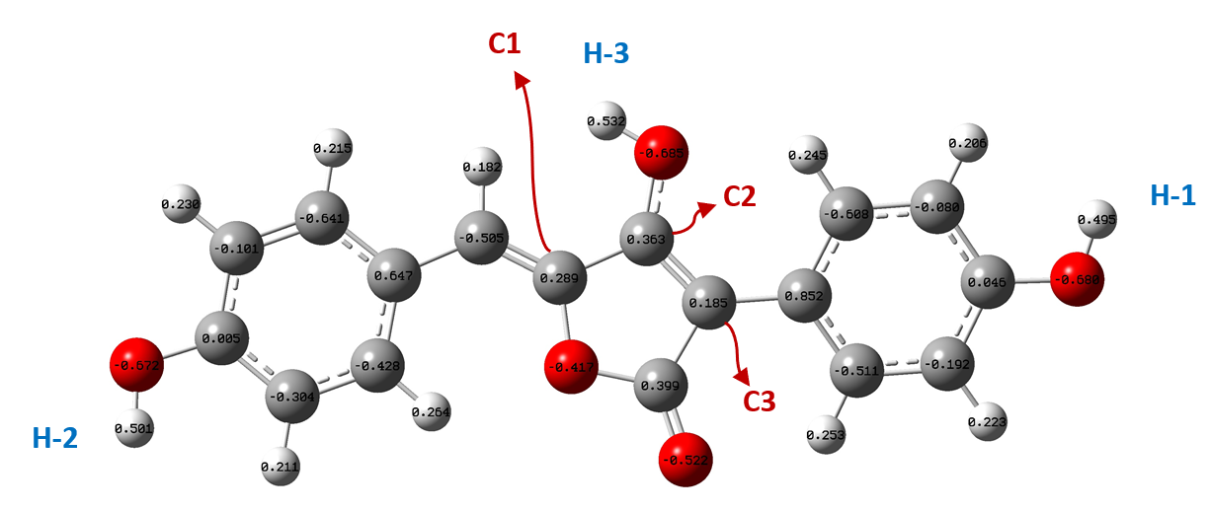
Figure S4. Mulliken charges on the natural antioxidant. Negative charge accumulation on the C4 carbon atom adjacent to the C1 carbon (-0.505) explains why radical addition on this carbon atom is not allowed.

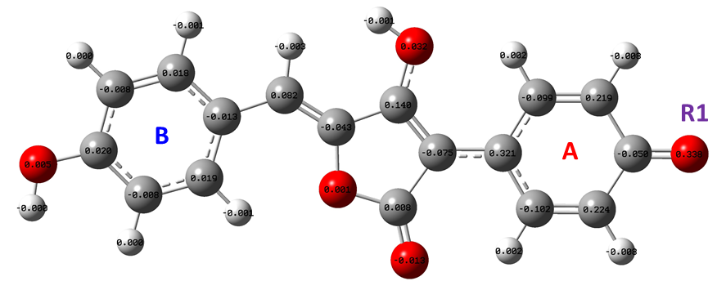
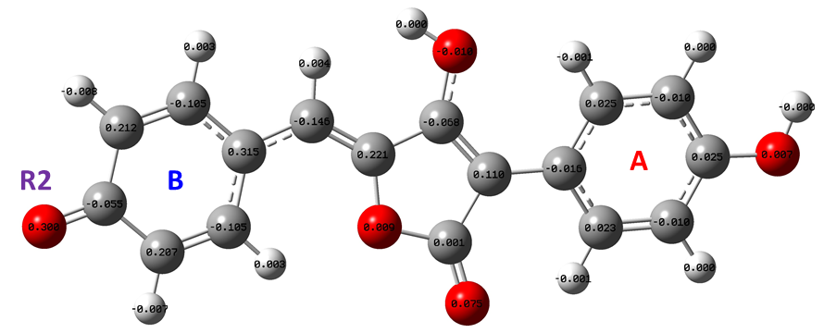
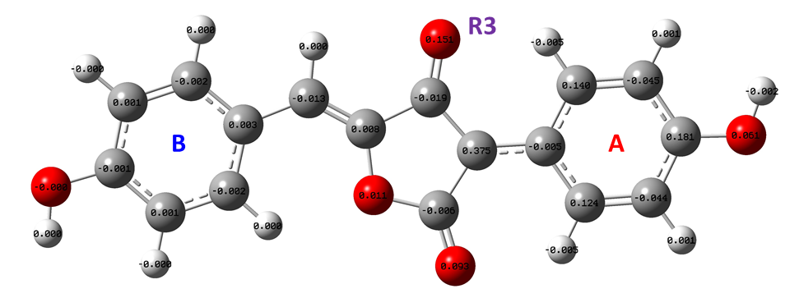
Figure S5. Natural Bond Orbital spin population analysis on the radical species formed from HAT mechanism. Spin densities on oxygen radicals R1, R2, and R3 are 0.338, 0.300, and 0.151 respectively. Spin on the oxygen radical center at R3 geometry more delocalized than the other radical species supports why it is more stable.

Table S9. Cartesian coordinates for transition states (TS) in the RAF mechanism with •OOH radical in M06-2X/6-311+G(d,p) level in water solvent media.
C1 addition pathway

C -1.87038 1.0471 0.22495
C 1.52489 -0.07675 -0.16129
C 0.73575 -1.27962 -0.45394
C 0.64542 0.8556 0.26671
C -0.70712 0.28855 0.26969
O 0.14969 -1.25909 2.27625
O -0.69977 -0.19156 2.17978
H -0.42136 -2.03062 2.10482
O -0.61731 -0.97225 -0.25346
O 0.83164 2.10001 0.71274
H 1.78122 2.25809 0.85045
O 1.06164 -2.37299 -0.82032
H -1.7312 2.08214 0.52676
C 2.98315 0.01833 -0.26835
C 3.80126 -1.06377 0.07804
C 3.59169 1.20355 -0.70935
C 5.18505 -0.95693 0.00543
H 3.34525 -1.99357 0.40307
C 4.97449 1.32094 -0.77694
H 2.97475 2.03164 -1.05401
C 5.77433 0.23764 -0.4135
H 5.80972 -1.80493 0.27796
H 5.44955 2.23225 -1.12538
O 7.12348 0.40215 -0.49846
H 7.57458 -0.41384 -0.23887
C -3.20901 0.61167 -0.04436
C -3.56049 -0.71455 -0.39599
C -4.24814 1.56266 0.04698
C -4.87661 -1.05965 -0.64011
H -2.78887 -1.47009 -0.47863
C -5.56776 1.22215 -0.19778
H -4.00422 2.58643 0.31868
C -5.88643 -0.0952 -0.54268
H -5.15093 -2.07443 -0.90938
H -6.35177 1.97201 -0.11971
O -7.15634 -0.49966 -0.79446
H -7.77152 0.24162 -0.69743

C2 addition pathway

C 0.91689 -0.34091 -0.00368
C -0.50964 1.39268 0.18303
C -1.3302 0.14059 0.25176
O -0.85991 2.53439 0.23791
O -2.18752 -1.22171 2.29558
O -1.50084 -0.02074 2.15477
H -3.12069 -0.96348 2.16955
C -0.40325 -0.88943 0.06515
C -2.75395 0.13077 -0.12814
C -3.25801 -0.84025 -0.99867
C -3.62943 1.10301 0.38341
C -4.60495 -0.8497 -1.3522
H -2.59176 -1.58751 -1.42144
C -4.97112 1.10046 0.03397
H -3.24183 1.85994 1.05797
C -5.46235 0.12117 -0.83513
H -4.98374 -1.6077 -2.03406
H -5.65594 1.84883 0.41931
O -6.78684 0.16906 -1.13768
H -7.01495 -0.53813 -1.758
O -0.63342 -2.20497 0.12382
H -1.39704 -2.33843 0.7235
O 0.81407 1.03842 0.04416
C 2.0829 -1.01688 -0.09183
H 1.96251 -2.09792 -0.10276
C 3.44067 -0.50947 -0.17277
C 3.7762 0.86092 -0.16399
C 4.48784 -1.44194 -0.26334
C 5.09703 1.26927 -0.2433
H 2.99451 1.60761 -0.09163
C 5.81388 -1.04029 -0.34325
H 4.25392 -2.50361 -0.27066
C 6.12104 0.32169 -0.333
H 5.36018 2.322 -0.23543
H 6.60776 -1.78064 -0.4125
O 7.39526 0.78791 -0.40759
H 8.01928 0.04981 -0.45987

C3 addition pathway

C 0.54504 -1.48503 0.10339
C 1.36401 -0.28934 -0.16367
C 0.46365 0.79618 -0.12985
O 1.89301 1.89659 1.77142
O 0.77211 1.09376 1.77804
H 2.62952 1.28859 1.97419
C -0.89025 0.24424 -0.09408
O 0.65034 2.05322 -0.55765
H 1.36378 2.44817 -0.01284
C 2.80232 -0.27487 -0.25588
C 3.48422 0.80165 -0.87074
C 3.57414 -1.33509 0.266
C 4.86547 0.82907 -0.94431
H 2.91652 1.60264 -1.33306
C 4.95889 -1.30657 0.19725
H 3.07262 -2.1804 0.7237
C 5.60997 -0.22519 -0.40433
H 5.38975 1.64813 -1.42551
H 5.53877 -2.12903 0.61027
O 0.86767 -2.63228 0.26429
O -0.78493 -1.1134 0.11446
C -2.0348 0.92704 -0.21736
H -1.89489 1.99555 -0.36434
C -3.40908 0.43936 -0.18535
C -4.44354 1.3689 -0.36648
C -3.76068 -0.90969 0.01605
C -5.77809 0.98329 -0.35078
H -4.19611 2.41603 -0.52224
C -5.08948 -1.30306 0.03285
H -2.98626 -1.65355 0.16189
C -6.10286 -0.35877 -0.15048
H -6.56374 1.72216 -0.49281
H -5.36537 -2.34102 0.18833
O 6.95947 -0.143 -0.50099
H 7.37385 -0.92861 -0.1151
O -7.38664 -0.80848 -0.12284
H -8.00017 -0.07258 -0.2597

Table S10. Cartesian coordinates for transition states (TS) in the RAF mechanism with •OH radical in M06-2X/6-311+G(d,p) level in water solvent media.
C1 addition pathway

C 1.85278 -1.01306 0.04391
C -1.55327 0.15919 -0.07429
C -0.76149 1.39245 -0.12163
C -0.66563 -0.84856 0.08939
C 0.69038 -0.30253 0.11947
O 0.76813 -0.44845 2.27195
O 0.59458 1.05119 -0.05626
O -0.84199 -2.16193 0.2503
H 0.02057 -2.60149 0.34038
O -1.09354 2.54262 -0.21071
H 1.71786 -2.0874 0.13583
C -3.01537 0.0953 -0.14029
C -3.78129 1.2561 -0.30322
C -3.68138 -1.13513 -0.02893
C -5.16898 1.19268 -0.33139
H -3.28344 2.21443 -0.41101
C -5.06799 -1.20627 -0.04892
H -3.10974 -2.05994 0.02151
C -5.81377 -0.03746 -0.19509
H -5.75191 2.10198 -0.45626
H -5.58542 -2.15644 0.03048
O -7.17551 -0.16216 -0.20935
H -7.42326 -1.09177 -0.10116
C 3.20778 -0.5242 -0.08169
C 3.55091 0.84225 -0.17593
C 4.2489 -1.47009 -0.10665
C 4.87332 1.23376 -0.28657
H 2.77395 1.59738 -0.16261
C 5.57501 -1.08505 -0.22107
H 4.00783 -2.52708 -0.03366
C 5.88898 0.27298 -0.31066
H 5.14442 2.28179 -0.35757
H 6.36376 -1.83256 -0.23941
O 7.16838 0.72552 -0.42235
H 7.179 1.6931 -0.46352
H 1.60141 0.05039 2.37592

C2 addition pathway

C 0.80949 -0.36404 0.0609
C -0.64819 1.34224 -0.21613
C -1.43913 0.13623 0.10941
O -0.99706 2.45814 -0.47641
O -1.39705 0.53655 2.21508
C -0.52648 -0.89025 0.20826
C -2.89353 0.0382 -0.04581
C -3.54765 -1.18001 0.16415
C -3.64756 1.15507 -0.43424
C -4.92751 -1.28525 0.01145
H -2.97677 -2.07311 0.40983
C -5.01931 1.05588 -0.59715
H -3.14055 2.10082 -0.59168
C -5.6619 -0.1639 -0.36813
H -5.42354 -2.23879 0.17309
H -5.6151 1.91237 -0.89492
O -7.01772 -0.1941 -0.53956
H -7.35521 -1.08243 -0.35434
O -0.73029 -2.17899 0.47629
H 0.12324 -2.64762 0.47484
O 0.70028 0.99455 -0.18351
C 1.96754 -1.04307 0.15401
H 1.84274 -2.1035 0.36264
C 3.33076 -0.563 0.00942
C 3.66823 0.77603 -0.2741
C 4.37497 -1.4904 0.15773
C 4.99175 1.16107 -0.40104
H 2.8866 1.51647 -0.39494
C 5.70369 -1.11259 0.03224
H 4.13851 -2.5285 0.37558
C 6.01302 0.21911 -0.24824
H 5.25842 2.18982 -0.61924
H 6.49621 -1.8469 0.15107
O 7.29448 0.6639 -0.38575
H 7.2995 1.61433 -0.57127
H -0.44026 0.58295 2.41067

C3 addition pathway

C -0.6614 1.40773 0.00109
C -1.46532 0.1681 -0.03851
C -0.54749 -0.86738 0.05685
O -1.09658 -0.84508 2.15385
C 0.79468 -0.31427 -0.0016
O -0.73386 -2.19671 -0.04681
H 0.14484 -2.60396 0.07646
C -2.90857 0.11745 -0.13214
C -3.57828 -1.12088 -0.19432
C -3.67382 1.29585 -0.16685
C -4.9583 -1.18126 -0.27769
H -3.00626 -2.043 -0.20915
C -5.05723 1.23922 -0.24478
H -3.17642 2.25811 -0.12804
C -5.70196 0.0014 -0.29738
H -5.47936 -2.13095 -0.33486
H -5.63922 2.15731 -0.26266
O -0.99858 2.56164 -0.00036
O 0.68178 1.06331 0.00836
C 1.9481 -0.99989 -0.0334
H 1.81463 -2.07947 -0.02309
C 3.31601 -0.50662 -0.08663
C 4.35489 -1.44948 -0.12669
C 3.66046 0.85943 -0.10041
C 5.68615 -1.06106 -0.17786
H 4.11299 -2.50894 -0.11754
C 4.98641 1.25581 -0.15072
H 2.88278 1.61342 -0.07044
C 6.00267 0.29763 -0.18937
H 6.47463 -1.80863 -0.20861
H 5.25802 2.30617 -0.1608
O -7.05726 -0.11806 -0.37476
H -7.30826 -1.05307 -0.4013
O 7.28775 0.75439 -0.23784
H 7.29788 1.72204 -0.20355
H -0.23271 -0.57887 2.52285

Table S11. Cartesian coordinates for PRC geometries in the RAF mechanism with •OH radical in M06-2X/6-311+G(d,p) level in water solvent media.
C1 addition pathway

C 1.82662 -1.03139 -0.12895
C -1.57096 0.14466 -0.20462
C -0.77701 1.37325 -0.31172
C -0.67764 -0.87137 -0.12191
C 0.674 -0.34 -0.20311
O 1.01176 -0.34456 2.38321
O 0.57447 1.02402 -0.34023
O -0.85901 -2.18702 0.04681
H -1.79523 -2.36748 0.23673
O -1.11146 2.52577 -0.37817
H 1.69512 -2.10457 -0.01395
C -3.03338 0.08975 -0.15542
C -3.77058 1.08241 0.50218
C -3.72896 -0.96859 -0.76098
C -5.15616 1.00866 0.57208
H -3.25156 1.91919 0.95861
C -5.11306 -1.05313 -0.69003
H -3.18749 -1.71171 -1.34334
C -5.82803 -0.06401 -0.01594
H -5.71631 1.78492 1.08775
H -5.65372 -1.86609 -1.16294
O -7.18874 -0.1936 0.02459
H -7.57702 0.54897 0.50947
C 3.19612 -0.53562 -0.15313
C 3.5393 0.82714 -0.26453
C 4.23767 -1.47035 -0.0384
C 4.86588 1.22719 -0.26095
H 2.76094 1.57529 -0.36038
C 5.56828 -1.07765 -0.03588
H 3.99704 -2.52629 0.05117
C 5.88368 0.2772 -0.147
H 5.13554 2.27455 -0.34716
H 6.35793 -1.81928 0.05326
O 7.16809 0.73705 -0.1499
H 7.78711 -0.00281 -0.0657
H 1.8721 0.093 2.21596

C2 addition pathway

C 0.8042 -0.37991 -0.16517
C -0.64014 1.33904 -0.03534
C -1.44817 0.11552 -0.17464
O -0.96151 2.49285 0.06718
O -0.9946 -0.35169 2.35048
C -0.55067 -0.9092 -0.24123
C -2.91199 0.08183 -0.18295
C -3.60371 -1.11231 0.0778
C -3.66169 1.24478 -0.43329
C -4.99331 -1.14684 0.08128
H -3.05354 -2.02531 0.27886
C -5.048 1.21235 -0.43441
H -3.14835 2.18023 -0.6243
C -5.71774 0.01601 -0.17726
H -5.51184 -2.08016 0.28674
H -5.62902 2.10723 -0.63168
O -7.08492 0.0465 -0.19042
H -7.43614 -0.83587 -0.00235
O -0.85518 -2.20424 -0.37801
H -0.05904 -2.75643 -0.35085
O 0.70487 0.98541 -0.03877
C 1.96588 -1.05095 -0.21611
H 1.88883 -2.13169 -0.32514
C 3.33033 -0.54342 -0.15406
C 3.65683 0.81405 0.00831
C 4.38484 -1.46798 -0.2604
C 4.98246 1.2226 0.0587
H 2.87187 1.55505 0.09642
C 5.70982 -1.06866 -0.21059
H 4.15649 -2.52346 -0.38501
C 6.01086 0.28447 -0.05033
H 5.21936 2.27625 0.18455
H 6.52048 -1.78463 -0.29315
O 7.33047 0.63072 -0.00681
H 7.41839 1.58817 0.10795
H -1.96926 -0.27405 2.28694

C3 addition pathway
C -0.64042 1.33894 -0.03596
C -1.44838 0.11531 -0.17494
C -0.55073 -0.90932 -0.24109
O -0.99204 -0.34832 2.35014
C 0.8041 -0.37988 -0.16497
O -0.85508 -2.20449 -0.3772
H -0.05878 -2.75649 -0.35064
C -2.91219 0.08162 -0.18308
C -3.60383 -1.11279 0.07662
C -3.66205 1.24475 -0.43216
C -4.99342 -1.14742 0.08034
H -3.05366 -2.026 0.27664
C -5.04834 1.21222 -0.43298
H -3.14887 2.18043 -0.62244
C -5.71804 0.01562 -0.17684
H -5.51183 -2.08099 0.28494
H -5.62944 2.10728 -0.62923
O -0.9618 2.49283 0.06582
O 0.70464 0.98542 -0.03906
C 1.96573 -1.05101 -0.21584
H 1.88867 -2.13177 -0.32449
C 3.3302 -0.54349 -0.15394
C 4.3847 -1.46824 -0.2589
C 3.65681 0.81413 0.00687
C 5.70968 -1.06896 -0.20915
H 4.15635 -2.52385 -0.38234
C 4.98245 1.22263 0.05717
H 2.87195 1.55536 0.09385
C 6.01085 0.28433 -0.05041
H 6.52027 -1.78515 -0.29063
H 5.21941 2.27642 0.18181
O -7.08516 0.04607 -0.18975
H -7.43636 -0.83631 -0.00164
O 7.33044 0.63048 -0.0069
H 7.41845 1.58806 0.10673
H -1.96701 -0.27336 2.28867

Table S12. Cartesian coordinates for PRC geometries in the HAT mechanism with •OH radical in M06-2X/6-311+G(d,p) level in water solvent media.
H-1 atom transfer
O 6.71005 0.40762 -0.04002
C 4.70312 -0.78185 -0.54262
C 4.65222 1.55331 0.1655
C 2.57928 0.31251 -0.14397
C 5.39343 0.39439 -0.14389
C 3.31452 -0.81746 -0.50559
C 3.2823 1.50988 0.16964
H 2.80486 -1.72127 -0.80848
H 2.71914 2.39555 0.43045
H 6.90002 -0.43765 0.20852
O 6.59456 -1.91604 0.7616
H 5.26404 -1.6053 -0.96274
H 5.19055 2.45053 0.44261
H 6.20087 -1.89102 1.64395
C 1.12487 0.28574 -0.11372
C 0.26084 1.47662 -0.06597
C -1.09555 -0.31692 -0.05561
O 0.51832 2.64332 -0.06074
C 0.2802 -0.78228 -0.10259
O 0.64589 -2.06536 -0.12558
H -0.11555 -2.64817 -0.03599
O -1.06488 1.05588 -0.02699
C -2.22015 -1.04792 -0.04416
H -2.08683 -2.12567 -0.08268
C -3.60514 -0.60869 0.00584
C -3.99755 0.738 0.05609
C -4.60956 -1.59038 0.00264
C -5.33818 1.08078 0.10112
H -3.25226 1.52034 0.0598
C -5.94892 -1.25553 0.0475
H -4.32921 -2.63726 -0.03601
C -6.31651 0.08748 0.097
H -5.62842 2.12531 0.13975
H -6.72179 -2.01308 0.04501
O -7.64737 0.36976 0.13987
H -7.78065 1.32156 0.17165

H-2 atom transfer
O 6.78324 0.90456 -0.14905
C 5.27614 -0.93969 -0.29018
C 4.46834 1.36493 -0.18177
C 2.89494 -0.48832 -0.13901
C 5.54711 0.45252 -0.21151
C 3.96472 -1.38363 -0.22219
C 3.17872 0.90759 -0.13789
H 3.76506 -2.44772 -0.27567
H 2.36394 1.61553 -0.08771
H 7.23946 0.22871 0.29607
O 7.40163 -1.09092 1.20544
H 6.08839 -1.62778 -0.48067
H 4.69438 2.42296 -0.14908
H 6.9991 -0.99349 2.07923
C 1.55217 -1.02954 -0.09274
H 1.49876 -2.11414 -0.09841
C 0.3746 -0.38183 -0.04923
C -0.96243 -0.95643 0.01245
O 0.24103 0.9788 -0.06133
C -1.8869 0.03548 0.01209
C -1.12129 1.29203 -0.03633
O -1.46705 2.43319 -0.05709
O -1.2188 -2.27034 0.05539
H -0.41093 -2.77965 0.17528
C -3.34563 -0.0423 0.06349
C -4.11716 1.07382 0.42192
C -4.00935 -1.23862 -0.23846
C -5.49728 0.99462 0.48355
H -3.62894 2.01091 0.65196
C -5.39186 -1.32062 -0.18029
H -3.44317 -2.11434 -0.52508
C -6.13891 -0.20339 0.18232
H -6.09493 1.85284 0.76325
H -5.89025 -2.25392 -0.42006
O -7.50205 -0.22339 0.25811
H -7.82755 -1.09748 0.02535

H-3 atom transfer
O 6.78324 0.90456 -0.14905
C 5.27614 -0.93969 -0.29018
C 4.46834 1.36493 -0.18177
C 2.89494 -0.48832 -0.13901
C 5.54711 0.45252 -0.21151
C 3.96472 -1.38363 -0.22219
C 3.17872 0.90759 -0.13789
H 3.76506 -2.44772 -0.27567
H 2.36394 1.61553 -0.08771
H 7.23946 0.22871 0.29607
O 7.40163 -1.09092 1.20544
H 6.08839 -1.62778 -0.48067
H 4.69438 2.42296 -0.14908
H 6.9991 -0.99349 2.07923
C 1.55217 -1.02954 -0.09274
H 1.49876 -2.11414 -0.09841
C 0.3746 -0.38183 -0.04923
C -0.96243 -0.95643 0.01245
O 0.24103 0.9788 -0.06133
C -1.8869 0.03548 0.01209
C -1.12129 1.29203 -0.03633
O -1.46705 2.43319 -0.05709
O -1.2188 -2.27034 0.05539
H -0.41093 -2.77965 0.17528
C -3.34563 -0.0423 0.06349
C -4.11716 1.07382 0.42192
C -4.00935 -1.23862 -0.23846
C -5.49728 0.99462 0.48355
H -3.62894 2.01091 0.65196
C -5.39186 -1.32062 -0.18029
H -3.44317 -2.11434 -0.52508
C -6.13891 -0.20339 0.18232
H -6.09493 1.85284 0.76325
H -5.89025 -2.25392 -0.42006
O -7.50205 -0.22339 0.25811
H -7.82755 -1.09748 0.02535

Table S13. Cartesian coordinates for transition (TS) geometries in the HAT mechanism with •OOH radical in M06-2X/6-311+G(d,p) level in water solvent media.
H-1 atom transfer
O 6.35386 0.14261 -0.8344
C 4.33274 -1.02544 -0.32941
C 4.31139 1.35673 -0.86292
C 2.22953 0.18518 -0.40417
C 5.03025 0.15839 -0.66806
C 2.95778 -1.00886 -0.20078
C 2.93843 1.36688 -0.73545
H 2.4383 -1.91951 0.07424
H 2.3944 2.28973 -0.89898
H 6.80918 -0.26377 0.06489
H 6.18962 0.17475 2.58772
O 7.32544 -0.48736 1.25305
O 6.17981 -0.60586 1.99938
C 0.78333 0.2038 -0.2798
C -0.01678 1.39324 0.00048
C -1.46156 -0.3203 -0.1922
H 4.89996 -1.93852 -0.17142
H 4.85741 2.25842 -1.12305
O 0.29945 2.54684 0.20385
C -0.11491 -0.83125 -0.38524
O -1.34889 1.03887 0.04661
O 0.2073 -2.09129 -0.64357
H -0.56922 -2.67716 -0.69853
C -2.62817 -0.99026 -0.23068
H -2.53786 -2.05495 -0.43863
C -3.99574 -0.52917 -0.04178
C -4.37627 0.80657 0.20582
C -5.01085 -1.50271 -0.10311
C -5.70848 1.1438 0.38459
H -3.63137 1.58941 0.26276
C -6.34728 -1.17443 0.07256
H -4.74045 -2.53846 -0.29155
C -6.69586 0.15515 0.32049
H -5.99995 2.17179 0.57742
H -7.11986 -1.937 0.02296
O -7.98811 0.54837 0.51025
H -8.58637 -0.21616 0.44881

H-2 atom transfer
O -6.52146 -0.04619 0.83174
C -4.85798 -1.57226 0.09777
C -4.25082 0.68316 0.81585
C -2.52547 -0.87909 0.14383
C -5.24547 -0.30021 0.57972
C -3.52428 -1.8516 -0.09915
C -2.91914 0.39953 0.60012
H -3.22259 -2.83253 -0.45445
H -2.17549 1.16416 0.78496
H -6.87807 0.72396 0.10084
H -5.25529 1.89638 -1.31906
O -7.03039 1.45305 -0.93259
O -5.87945 1.20302 -1.61612
H -5.62735 -2.31387 -0.0898
H -4.56639 1.65945 1.17275
C -1.15005 -1.26713 -0.09632
H -0.99018 -2.28174 -0.45196
C -0.02509 -0.54753 0.06342
C 1.3404 -0.98383 -0.19586
O 0.03243 0.7549 0.50285
C 2.19924 0.03257 0.0841
C 1.36646 1.14748 0.5276
O 1.54967 -2.21622 -0.65629
H 2.49078 -2.3403 -0.87853
O 1.65521 2.26334 0.88755
C 3.66142 0.08434 0.00032
C 4.44282 -1.03073 0.33934
C 4.31015 1.25294 -0.42156
C 5.82701 -0.98943 0.244
H 3.96793 -1.93346 0.7154
C 5.69441 1.30531 -0.51282
H 3.72483 2.1269 -0.68861
C 6.45464 0.1815 -0.18361
H 6.43208 -1.84974 0.51064
H 6.19397 2.21228 -0.84244
O 7.81807 0.17894 -0.25752
H 8.12354 1.05168 -0.55721

H-3 atom transfer
O -0.6682 1.94461 -0.52744
H -1.49468 2.2318 0.18282
H -2.24103 0.79144 2.34499
O -2.32098 2.25108 1.18869
O -1.59685 1.46267 2.04088
C -0.41057 0.68359 -0.35303
C -1.299 -0.37874 -0.18941
C -0.47137 -1.56505 0.0446
C 0.94298 0.16469 -0.23705
O 0.8595 -1.20125 -0.01469
O -0.77039 -2.72126 0.23727
C -2.73513 -0.36114 -0.24592
C -3.50549 -1.3614 0.39477
C -3.41614 0.67208 -0.9333
C -4.88202 -1.32382 0.35692
H -3.00453 -2.15777 0.9328
C -4.79806 0.7049 -0.98495
H -2.84804 1.42862 -1.4633
C -5.53602 -0.28807 -0.33448
H -5.47979 -2.07905 0.85625
H -5.31521 1.49211 -1.5256
C 2.0831 0.86877 -0.31725
C 3.46234 0.42505 -0.20478
C 3.84799 -0.90861 0.03431
C 4.4728 1.39148 -0.3462
C 5.18546 -1.2545 0.12541
H 3.09685 -1.6807 0.14967
C 5.8144 1.05474 -0.25666
H 4.19343 2.42504 -0.53051
C 6.17298 -0.27418 -0.0207
H 5.48575 -2.28095 0.30884
H 6.58786 1.80945 -0.36829
H 1.93142 1.93112 -0.49696
O -6.88755 -0.30859 -0.3378
H -7.22982 0.45028 -0.84179
O 7.47119 -0.67181 0.07598
H 8.05457 0.09629 -0.04569

Table S14. Cartesian coordinates for transition (TS) geometries in the HAT mechanism with •OH radical in M06-2X/6-311+G(d,p) level in water solvent media.
H-1 atom transfer
O 6.71937 0.42152 -0.05422
C 4.71091 -0.79965 -0.50506
C 4.65498 1.56473 0.12102
C 2.58025 0.30808 -0.14462
C 5.3999 0.3948 -0.14998
C 3.32021 -0.83515 -0.46724
C 3.28252 1.51903 0.12902
H 2.81198 -1.75258 -0.73822
H 2.71625 2.41355 0.36072
H 6.95439 -0.54455 0.24571
O 6.63805 -1.89857 0.79456
H 5.27382 -1.64128 -0.89029
H 5.19291 2.47418 0.36652
H 6.28261 -1.83057 1.69797
C 1.12555 0.28001 -0.11345
C 0.25868 1.46943 -0.05099
C -1.09904 -0.32534 -0.06721
O 0.51641 2.64348 -0.02668
C 0.27735 -0.7897 -0.12114
O 0.64455 -2.07483 -0.16373
H -0.12371 -2.66461 -0.11971
O -1.06736 1.04955 -0.02393
C -2.22926 -1.05361 -0.05741
H -2.1013 -2.13426 -0.1004
C -3.61336 -0.60977 -0.00003
C -4.0039 0.74033 0.05082
C -4.62195 -1.59108 0.00283
C -5.34612 1.08692 0.10319
H -3.25619 1.52377 0.04966
C -5.96305 -1.25328 0.05479
H -4.34339 -2.64104 -0.0364
C -6.32796 0.09338 0.10479
H -5.63329 2.1347 0.14228
H -6.73866 -2.01144 0.05716
O -7.66019 0.37689 0.15436
H -7.79628 1.3352 0.18604

H-2 atom transfer
O 6.7372 0.99459 -0.19451
C 5.23397 -0.86176 -0.32698
C 4.41884 1.44743 -0.22839
C 2.8457 -0.41183 -0.18808
C 5.50159 0.53462 -0.25294
C 3.92076 -1.30708 -0.26319
C 3.12719 0.98724 -0.18847
H 3.7226 -2.3741 -0.31466
H 2.30978 1.69602 -0.1433
H 7.26406 0.23437 0.28544
O 7.43432 -0.98843 1.09983
H 6.05003 -1.55171 -0.50606
H 4.64328 2.50821 -0.19772
H 7.06289 -0.8668 1.99156
C 1.50424 -0.95796 -0.14844
H 1.45667 -2.04517 -0.15555
C 0.32107 -0.31336 -0.10541
C -1.01728 -0.88687 -0.05161
O 0.1879 1.04973 -0.10376
C -1.94407 0.10729 -0.03347
C -1.17396 1.36281 -0.06688
O -1.51855 2.51231 -0.06935
O -1.27718 -2.20367 -0.02917
H -0.46226 -2.72435 0.03088
C -3.40377 0.03149 0.01746
C -4.17868 1.16469 0.32303
C -4.06867 -1.17937 -0.23418
C -5.56185 1.08855 0.38085
H -3.69022 2.11292 0.51466
C -5.45422 -1.25859 -0.17891
H -3.50166 -2.06994 -0.479
C -6.20389 -0.12383 0.12953
H -6.16112 1.96095 0.61968
H -5.95153 -2.20452 -0.37916
O -7.56927 -0.13816 0.19975
H -7.89977 -1.0276 0.00738
H-3 atom transfer
O -0.79769 -2.16255 -0.24994
H -0.85655 -2.39726 0.91306
O -0.81836 -1.58807 1.89658
C -0.57847 -0.92427 0.15762
C 0.77169 -0.32654 0.13914
C -0.67474 1.40559 0.30582
H 0.02684 -1.61092 2.37613
C -1.49392 0.20596 0.08546
C -2.89673 0.18425 -0.08022
C -3.66626 1.38547 -0.09117
C -3.58627 -1.0512 -0.24581
C -5.03166 1.34847 -0.24758
H -3.16116 2.33583 0.03199
C -4.95451 -1.08373 -0.40004
H -3.01659 -1.97244 -0.26149
C -5.68562 0.11461 -0.4008
H -5.62554 2.25609 -0.25465
H -5.46904 -2.03296 -0.52478
C 1.91323 -0.9874 -0.0865
H 1.76919 -2.05159 -0.26444
O 0.66054 1.03342 0.36275
O -0.98198 2.56389 0.43217
O -7.02748 0.14685 -0.54849
H -7.38295 -0.7497 -0.64729
C 3.28033 -0.48385 -0.13923
C 4.30926 -1.38767 -0.45665
C 3.63042 0.85372 0.111
C 5.63305 -0.98581 -0.52731
H 4.0598 -2.42741 -0.65194
C 4.95476 1.26544 0.04266
H 2.86413 1.57763 0.36196
C 5.95744 0.34812 -0.2769
H 6.4253 -1.68497 -0.77282
H 5.21061 2.3037 0.23967
O 7.27545 0.69729 -0.35778
H 7.38021 1.64028 -0.16467

References
1. Zgrzeba, A.; Andrzejewska, E.; Marcinkowska, A. Ionic liquid – containing ionogels by thiol–ene photopolymerization. Kinetics and solvent effect. RSC Adv 2015, 5:100354–100361. https://doi.org/10.1039/C5RA21254E
2. Furuncuoğlu, T.; Uğur, İ.; Değirmenci, İ.; Aviyente, V. Role of Chain Transfer Agents in Free Radical Polymerization Kinetics. Macromolecules 2010, 43 (4), 1823–1835. https://doi.org/10.1021/ma902803p.
3. Truong, T. N.; Truhlar, D. G. Ab Initio Transition State Theory Calculations of the Reaction Rate for OH+CH4→H2O+CH3. J Chem Phys 1990, 93 (3), 1761–1769. https://doi.org/10.1063/1.459103.
4. William A. Donald, Maria Demireva, Ryan D. Leib, M. Jeannette Aiken, and Evan R. Williams Journal of the American Chemical Society 2010 132 (13), 4633-4640 DOI: 10.1021/ja9079385

