Supplementary Material
Synthesis of 1 and 3
The synthesis of 1,3-bis(carboxymethyl)calix[4]arene (1) was achieved via hydrolysis of the corresponding methyl ester precursor (Scheme 1). This intermediate, in turn, was prepared from the parent calix[4]arene, as described in the experimental procedures below.

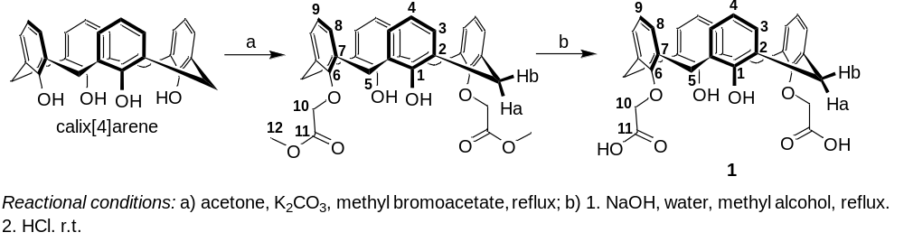
Scheme 1. Synthesis route for obtaining 1,3-bis(carboxymethyl)calix[4]arene (1).

Preparation of 1,3-bis(carboxymethyl)calix[4]arene methyl ester: To a two-necked round-bottom flask equipped with a reflux condenser, calix[4]arene (1.00 g, 2.36 mmol) and K₂CO₃ (1.43 g, 10.36 mmol) were added. The system was purged with argon, followed by the addition of anhydrous acetone (50 mL). The resulting suspension was stirred at room temperature for 20 min. Subsequently, a solution of methyl bromoacetate (0.49 mL, 5.18 mmol) in anhydrous acetone (10 mL) was added dropwise over 5 min. The reaction mixture was then heated to reflux and maintained under these conditions for 24 h. After completion of the reaction, the solvent was removed under reduced pressure, and the residue was treated with distilled water (50 mL). The mixture was extracted with dichloromethane (3 x 25 mL), and the combined organic layers were dried over anhydrous Na₂SO₄. After filtration, the solution was concentrated under reduced pressure to approximately 20 mL, and 5 mL of cold diethyl ether was added to induce precipitation. The solid was collected by filtration and dried under vacuum to afford the title compound as a white solid (0.93 g, 70% yield). ¹H NMR (400 MHz, CDCl₃): δ 3.40 (d, 4H, J = 13.2 Hz, H_{5b}), 3.88 (s, 6H, H₁₂), 4.47 (d, 4H, 13.2 Hz, H_{5a}), 4.75 (s, 4H, H₁₀), 6.66 (t, 2H, J = 7.5 Hz, H₄), 6.75 (t, 2H, J = 7.5 Hz, H₉), 6.90 (d, 4H, J = 7.5 Hz, H₃), 7.05 (d, 4H, J = 7.5 Hz, H₈), 7.54 (s, 2H, OH).

Preparation of 1,3-bis(carboxymethyl)calix[4]arene (1): To a 125 mL round-bottom flask, 1,3-bis(carboxymethyl)calix[4]arene methyl ester (1.00 g, 1.76 mmol) was suspended in methanol (20 mL) under magnetic stirring. An aqueous NaOH solution (20 mL, 0.50 mol L⁻¹) was then added dropwise over 20 min, and the reaction mixture was heated to reflux and maintained under these conditions for 24 h. After cooling to room temperature, the solution was acidified by the dropwise addition of concentrated HCl (37% w/w) over 5 min until pH ≤ 1 was reached, resulting in the formation of a precipitate. The resulting solid was collected by vacuum filtration, washed thoroughly with distilled water, and dried under reduced pressure to afford compound 1 as a white solid (0.87 g, 91% yield). IR (ATR): 3409, 2925, 1739, 1591, 1462, 1430, 1328, 1185, 1158, 1084, 1052, 904, 761cm⁻¹. ¹H NMR (400 MHz, DMSO-d₆): δ 3.41(d, 4H, J = 12.9 Hz, H_{5b}), 4.39 (d, 4H, J = 12.9 Hz, H_{5a}), 4.70 (s, 4H, H₁₀), 6.57 (t, 2H, J = 7.4 Hz, H₄), 6.76 (t, 2H, J = 7.4 Hz, H₉), 7.00 (d, 4H, J = 7.4 Hz, H₃), 7.11 (d, 4H, J = 7.4 Hz, H₈), 7.90 (br, 1H, OH), 13.05 (br, 1H, COOH). ¹³C NMR (100 MHz, DMSO-d₆): δ 30.7 (C₅), 72.3 (C₁₀), 119.0 (C₄), 125.1 (C₉), 127.8, 128.6, 129.0, 133.5 (C₈, C₇, C₃, C₂), 152.4, 152.8 (C₆, C₁), 170.4 (C₁₁).

The synthesis of hexakis(carboxymethyl)calix[6]arene methyl ester (3) is illustrated in Scheme 2. Its preparation was achieved in a single step via the functionalization of the parent calix[6]arene.
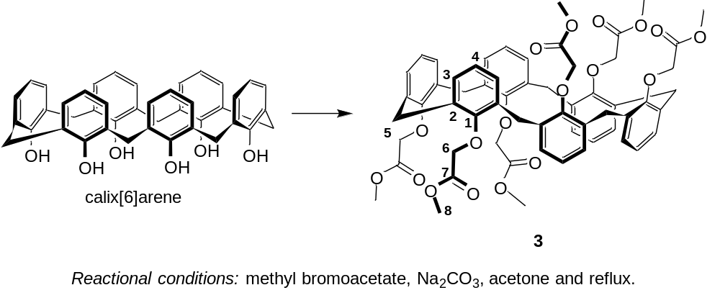
Scheme 2. Synthesis of hexakis(carboxymethyl)calix[6]arene methyl ester (3).

Preparation of hexakis(carboxymethyl)calix[6]arene methyl ester (3): To a 125 mL two-necked round-bottom flask equipped with a reflux condenser, calix[6]arene (1.00 g, 1.57 mmol) and Na₂CO₃ (1.00 g, 9.43 mmol) were added. The system was purged with argon and maintained under an inert atmosphere throughout the reaction. Anhydrous acetone (40 mL) was then added, and the suspension was heated to reflux (56 °C) under magnetic stirring. Methyl bromoacetate (2.7 mL, 28.59 mmol) was added dropwise over 5 min, and the reaction mixture was refluxed for 24 h. After completion of the reaction, the solvent was removed under reduced pressure. The resulting residue was taken up in distilled water (50 mL) and extracted with dichloromethane (3 x 25 mL). The combined organic extracts were dried over anhydrous MgSO₄, filtered, and concentrated under reduced pressure to afford a yellow oil. The residue was treated with a methanol/diethyl ether mixture (20 mL, 25:75 v/v), resulting in the formation of a white precipitate. The solid was collected by filtration and dried under vacuum to afford the title compound (1.03 g, 62% yield). IR (ATR): 2952, 1747, 1586, 1436, 1381, 1285, 1174, 1086, 1056, 813, 771, 700, 584, 557cm⁻¹. ¹H NMR (400 MHz, CDCl₃): δ 3.55 (s, 18H, H₈), 3.98 (s, 12H, H₅ or H₆), 4.08 (s, 12H, H₅ or H₆), 6.80 (t, 6H, J = 7.6 Hz, H₄), 6.97 (d, 12H, J = 7.6 Hz, H₃). ¹³C NMR (100 MHz, CDCl₃): δ 31.0 (C₅), 51.9 (C₈), 69.7 (C₆), 124.6 (C₄), 129.5 (C₂), 133.7(C₃), 154.7 (C₁), 169.5 (C₇).

Spectra of calix[n]arene derivatives
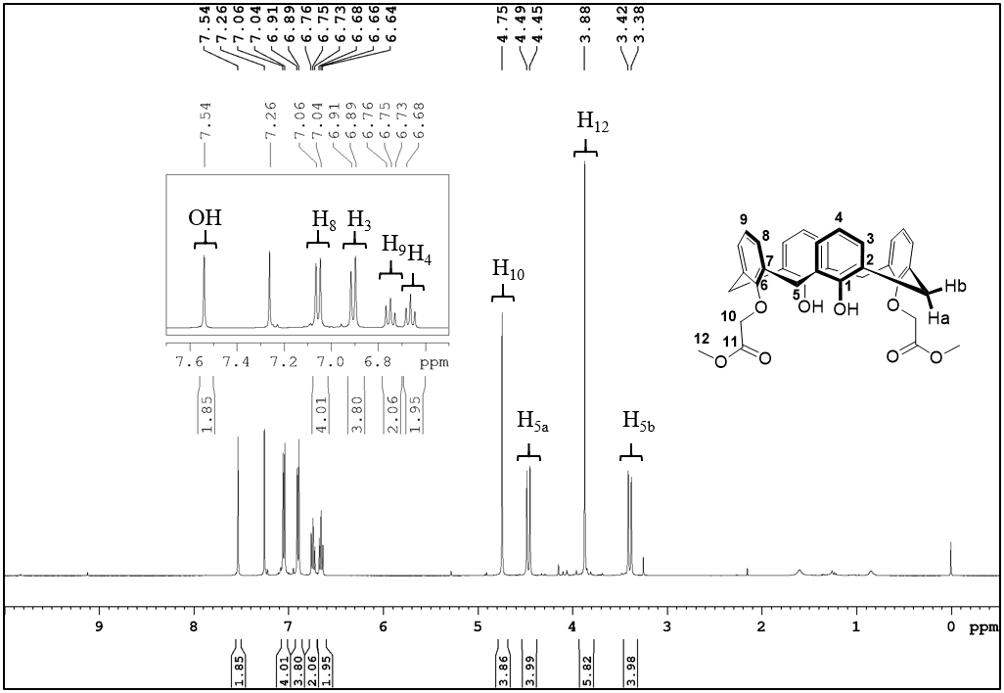Figure 1. ¹H NMR spectrum of 1,3-bis(carboxymethyl)calix[4]arene methyl ester (CDCl₃, 400 MHz).

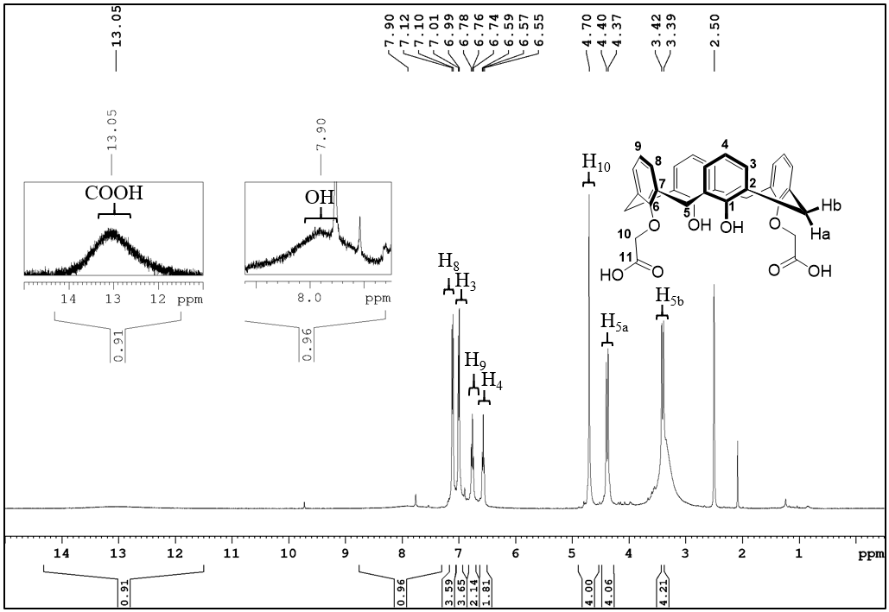Figure 2. ¹H NMR spectrum of 1,3-bis(carboxymethyl)calix[4]arene (1) (DMSO-d₆, 400 MHz).
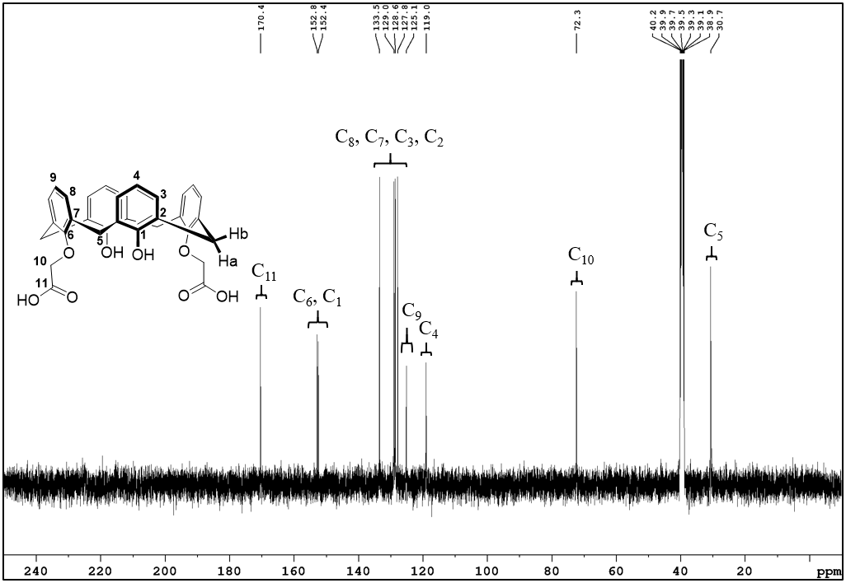Figure 3. ¹³C NMR spectrum of 1,3-bis(carboxymethyl)calix[4]arene (1) (DMSO-d₆, 100 MHz).

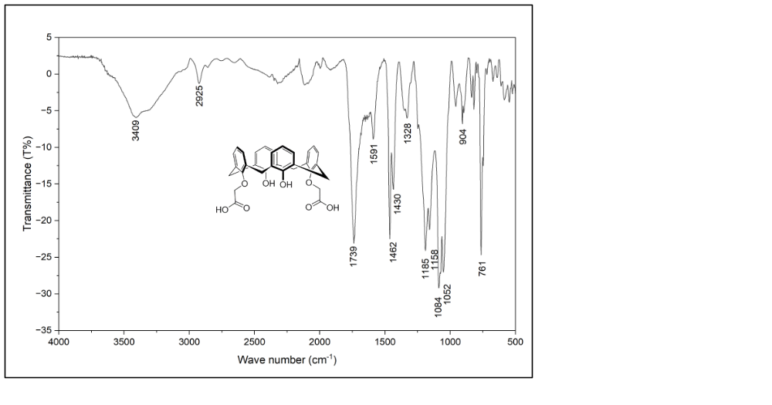
O-H
C=O
C=C
C_{sp3}-H
Figure 4. Infrared spectrum of 1,3-bis(carboxymethyl)calix[4]arene (1) (ATR).

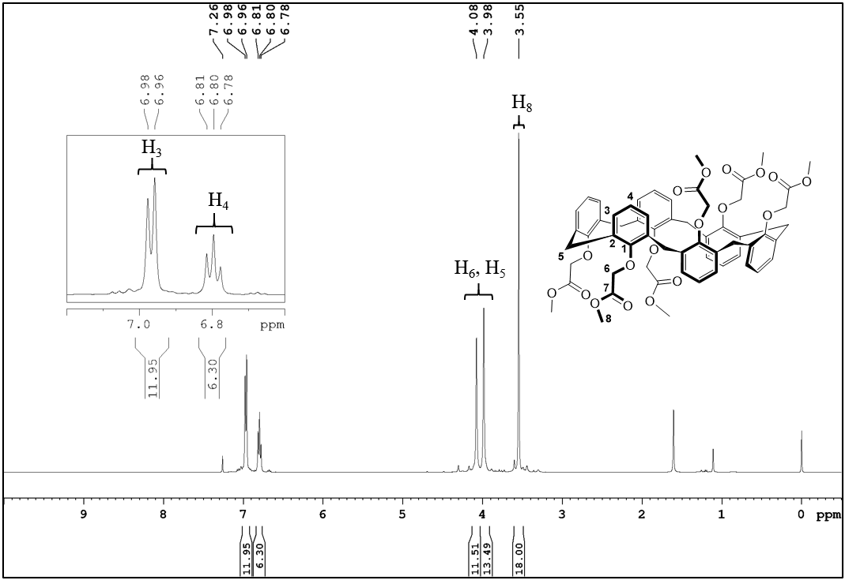Figure 5. ¹H NMR spectrum of hexakis(carboxymethyl)calix[6]arene methyl ester (3) (CDCl₃, 400 MHz).

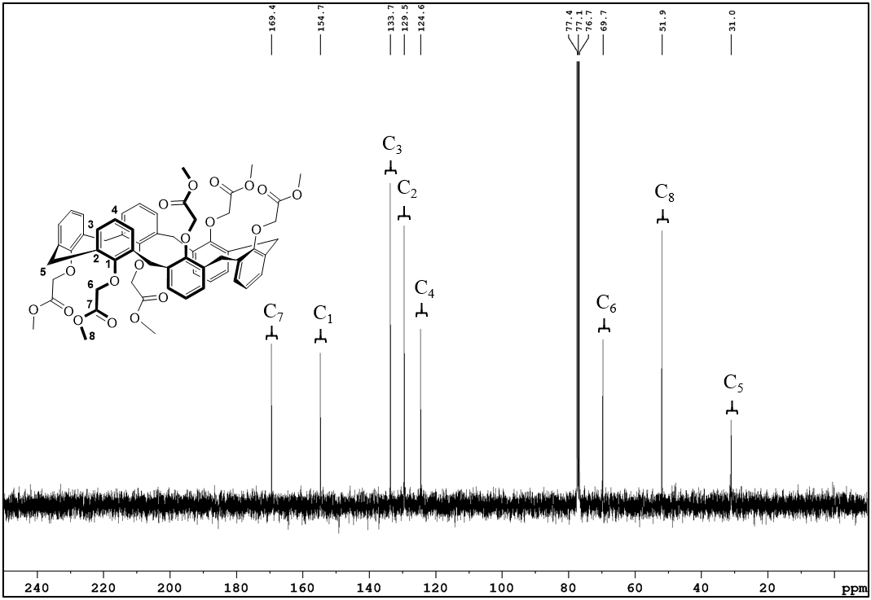Figure 6. ¹³C NMR spectrum of hexakis(carboxymethyl)calix[6]arene methyl ester (3) (CDCl₃, 100 MHz).

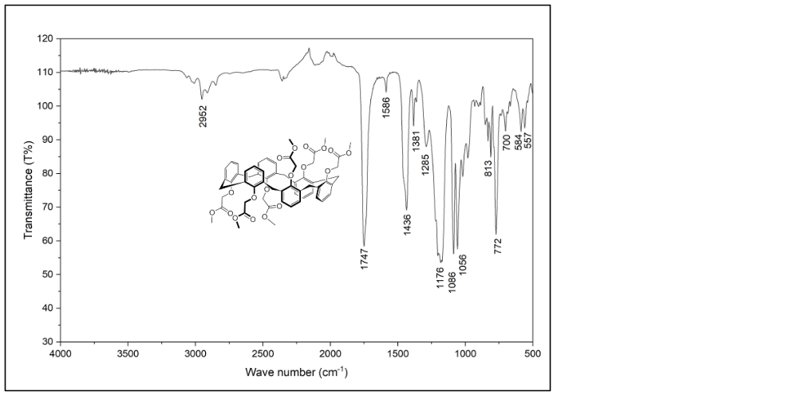
C=C
C_{sp3}-H
C=O
C-O
Figure 7. Infrared spectrum of hexakis(carboxymethyl)calix[6]arene methyl ester (3) (ATR).

