Online Resource 2
Rotating diamond diagrams

Title: Scientific modelling with diagrams
Journal name: Synthese
Author: Ulrich Stegmann
Affiliation: University of Aberdeen
Email: u.stegmann@abdn.ac.uk

This resource explains how diamonds can be mentally rotated around their axes.

Diamonds (♢-shapes) can be rotated bottom-up, thus swapping the labels of the top and bottom corners (first and third rotation in fig. 6). Diamonds can also be rotated sideways like a revolving door. This will swap the labels of the horizontal corners (second rotation in fig. 6). Together, the rotations can generate four structurally distinct permutations. As it happened, twelve of Gamow’s (1954) diamonds could occur in four structurally distinct permutations each. He marked these diamonds with a * star in his table (fig. 2, main text). 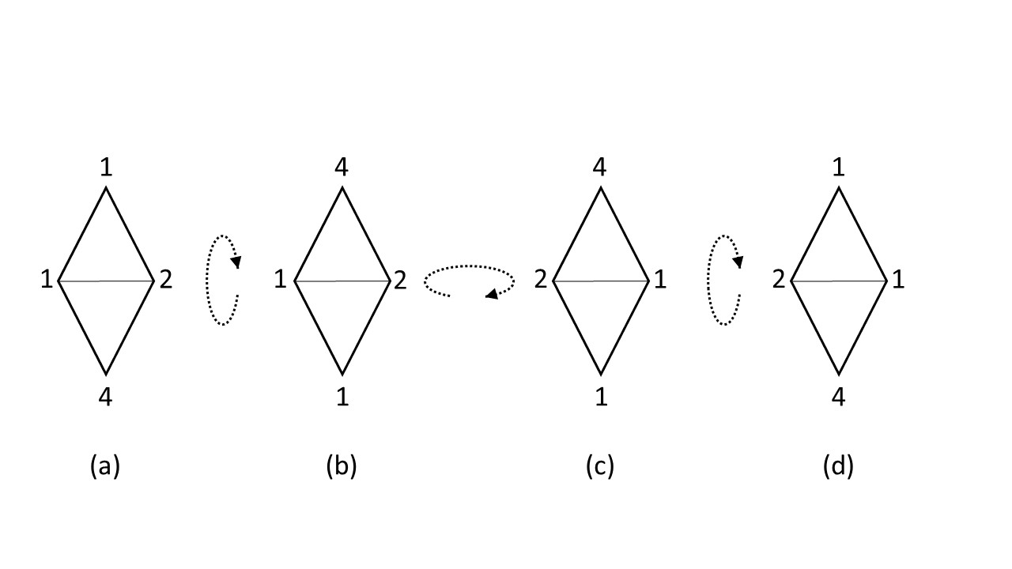
Fig. 6 Rotating the A-diamond bottom-up and sideways
The remaining eight, non-starred diamonds had only two structurally distinct permutations. For instance, rotating the F-diamond bottom-up made no difference to the configuration of labels (fig. 7): configuration (a) is identical with (b), and (c) is identical with (d). Only rotating the F-diamond sideways generates a new configuration, e.g. from (b) to (c).
Historical evidence suggests that George Gamow and Francis Crick performed the mental rotations described here (Stegmann online first).
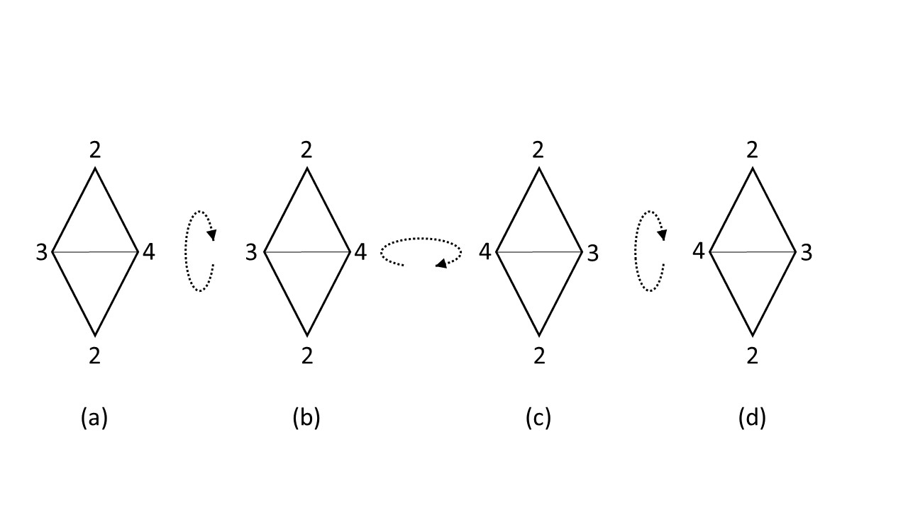
Fig. 7 Rotating the F-diamond sideways and bottom-up

Reference

Gamow, G. (1954). Possible relation between deoxyribonucleic acid and protein structures. Nature, 173, 318-318.
Stegmann, U. (online first). Physical models and embodied cognition. Synthese. DOI: https://doi.org/10.1007/s11229-018-01927-7

