Supplementary Materials

Appendix A – Corpus studies
We conducted three corpus studies to assess the relative occurrence frequencies of different senses or uses of ‘see’ and ‘aware of’ in ordinary discourse, academic philosophical discourse, and specialist discourse in a sub-field of philosophy, respectively.
Methods
Materials: We used three corpora which we regarded as representative of the three types of discourse of interest:
- The British National Corpus contains a written component (texts from books, periodicals, letters, reports, etc.) and a spoken component (from transcribed recordings), making it better suited than other corpora to model ordinary discourse. Its focus on British English is appropriate in the light of the participant samples of our main study. The corpus contains 100 million words, including 172,643 instances of the verb ‘see’ and 6,920 instances of ‘is aware of’, across all tenses.
- The SEP/IEP corpus is a topically generic philosophy corpus built from a snapshot of two philosophical encyclopedias (Stanford Encyclopedia of Philosophy and Internet Encyclopedia of Philosophy), taken in February 2018 (Sytsma et al. 2019, p.227). It contains 29 million words, including 46,384 instances of ‘see’ and 2,389 instances of ‘aware of’.
- The PHILO-P corpus is a philosophy of perception corpus built for this study, made up of ten monographs that shaped philosophical debates about sense-data, (challenges to) naïve and direct realism about perception, and the ‘problem of perception’ (Austin 1962; Ayer 1940; Ayer 1956; Brewer 2011; Broad 1923; Jackson 1977; Price 1932; Robinson 1994; Russell 1912; Smith 2002). It contains 1 million words, including 2,048 instances of ‘see’ and 375 instances of ‘aware of’.
We manually annotated occurrences of ‘see’ and ‘aware of’ in their context sentences. We did so for randomly selected subsets of 1000 occurrences of each verb from the BNC, and 1500 occurrences from SEP-IEP. We annotated all occurrences of these verbs, in PHILO-P.
Procedure: To annotate instances of ‘see’, three judges (the first author and two PhD students ignorant of the research questions) were given a list of 12 senses of ‘see’, recognized by the Macmillan English Dictionary for Advanced Leaners (MEDAL) or Oxford English Dictionary (OED), with dictionary explanations and examples (from MEDAL, except for the phenomenal sense, Sense 12 below, which is only given in the OED). We regarded it as an open question whether any of these dictionary explanations would individually capture a perceptual sense, because different dictionary senses can be devised to characterize uses referring to situations of different degrees of specificity and complexity (so that, e.g., WordNet 3.1 recognizes 24 senses of ‘see’, to MEDAL’s 11). More complex schemas or scripts (e.g., for doctor-visits) will then often include or adapt the basic schema associated with the visual sense (e.g., when you ‘see the doctor’, you typically look at and notice them, with your eyes). Judges were therefore asked to assess independently (1) which of the given dictionary-senses the sentence used, and (2) whether this use was ‘perceptual’ or ‘non-perceptual’. This second classification was intended to capture uses which activate the basic schema without subsequent suppression (though possible complementation by a richer schema). For this classification, judges were instructed to ask themselves:
Does the subject most probably see with their eyes whatever it is s/he is said to ‘see’, in the situation talked about? Alternatively, where ‘see’ can be replaced by ‘notice’, ask: Does the subject use her eyes in order to notice whatever it is she is said to ‘see’?
Since ‘be aware of’ has only one dictionary-attested sense (‘knowing about a situation or fact’, MEDAL) annotators merely classified its instances as ‘perceptual’ or ‘non-perceptual’. They did so by asking themselves:
Is the protagonist, in the situation talked about, seeing, hearing, tasting, smelling, or feeling whatever s/he is said to be aware of? (‘Feeling’ in a wide sense, including proprioception, introspection, sensing of features in the environment not straightforwardly reducible to any one of the five senses, etc.)
In each sentence, only the first occurrence of the verb of interest was considered. Final classifications were jointly determined after discussion of previous independent annotations. Instances that remained unclassifiable due to partial transcription, inherent ambiguity, persistent disagreement between judges, or because they employed phrasal verbs (like ‘see through’), were discarded.
Results
Occurrence frequencies for each sense of ‘see’ in our three corpora are shown in Table A-1.

Table A-1. Distribution of ‘see’ by sense across samples from three corpora.
Sense | BNC |  |  | SEP-IEP |  | PHILO-P
(MEDAL 1-11, OED 12) | No. Uses | (percep-tual) | % of classi-fiable uses | No. Uses | % of classi-fiable uses | No. uses | % of classi-fiable uses
Classifiable total | 946 |  | 100 | 1449 | 100 | 2099 | 100
01 notice with eyes/look at | 402 | (402) | 42.49 | 82 | 5.66 | 1233 | 58.74
02 meet/visit someone | 98 | (98) | 10.36 | 2 | 0.00 | 0 | 0.00
03 for more information | 144 | (143) | 15.22 | 785 | 54.18 | 9 | 0.43
04 understand/know something | 85 | (0) | 8.99 | 133 | 9.18 | 294 | 14.01
05 consider particular way | 78 | (0) | 8.23 | 218 | 15.04 | 52 | 2.48
06 imagine someone /something | 14 | (0) | 1.48 | 0 | 0.00 | 1 | 0.00
07 find something out | 32 | (6) | 3.38 | 203 | 14.01 | 472 | 22.49
08 experience/witness something | 45 | (10) | 4.76 | 8 | 0.55 | 1 | 0.00
09 happen somewhere | 34 | (0) | 3.59 | 17 | 1.17 | 0 | 0.00
10 go with someone somewhere | 4 | (1) | 0.42 | 0 | 0.00 | 0 | 0.00
11 bet same amount | 0 | (0) | 0.0 | 0 | 0.00 | 0 | 0.00
12 have an experience similar to that of seeing | 10 | (2) | 1.06 | 1 | 0.00 | 37 | 1.76

We noted that, in the BNC sample, virtually all occurrences of senses 1, 2, and 3 were classified as perceptual, by all judges. By contrast, occurrences of other senses were deemed ‘perceptual’ only 19% of the time for sense (7), 20% for sense (12), and 22% for sense (8). We therefore regarded senses 1, 2, and 3, as providing a good approximation at a ‘visual sense’. For further analysis, we grouped together these visual senses as well as the epistemic senses 4 and 7 (used to state that S possesses or acquires particular knowledge or understanding) and the doxastic senses 5 and 6 (as in ‘Fanon sees paranoia as symptomatic of racism’ and ‘She saw Messingham’s hand in this somewhere’). Occurrence frequencies for these sense-clusters and the philosophically important phenomenal sense 12 (‘Hallucinating, Macbeth saw a dagger’) varied across our three corpora (Figure A-1).
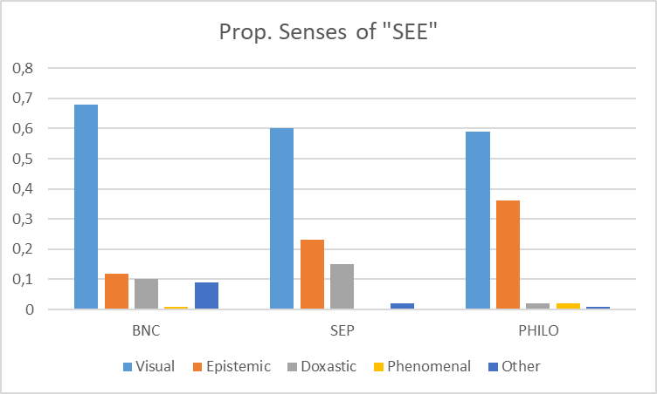
Fig. A-1. Distribution of ‘see’ by sense cluster across different corpora.

We found yet more marked differences in proportions of perceptual vs non-perceptual uses, across the samples from our three corpora (see Table A-2).

Table A-2. Perceptual uses as percentage of classifiable uses across corpora.
See |  |  | Aware
BNC | SEP/IEP | PHILO-P | BNC | SEP-IEP | PHILO-P
71 | 59 | 60 | 21 | 40 | 91

Appendix B - Distributional Semantics study
We constructed distributional semantics (DS) representations of each occurrence of ‘see’ and ‘aware’ of’ in our annotated samples, and used them to train a classifier to label all occurrences of these verbs in our three corpora as either perceptual or non-perceptual. To obtain such representations, we constructed neural embeddings that ‘contextualize’ representations of words as a function of the particular utterance they occur in, corresponding to the speaker meaning of the term (Peters et al., 2018; Devlin et al., 2019).
Data processing
Using the annotated sentences from Appendix A, we computed the contextualized vectors of ‘see’ and ’aware of’ in each sentence, as obtained through Bidirectional Encoder Representations from Transformers (BERT; Devlin et al., 2019), in its pretrained, ‘Base’ version. BERT Base representations each take the form of a 768-dimensional vector which encapsulates the lexical meaning of the word in the given context (e.g., sentence) in which it is encountered. The model is made of 110 million parameters trained on 3.3 billion words from an English Wikipedia snapshot and the BooksCorpus (Zhu et al., 2015).
For reference, we provide below a visual representation of the BERT vector space for ‘see’ and ‘aware’ in each one of our annotated corpora, flattened from 768 to 2 dimensions using Principal Component Analysis. Each point in a space corresponds to one particular use of ‘see’/‘aware’ in a given sentence. We expect perceptual and non-perceptual usages to form separate clusters. The plots for the BNC, and for the SEP and PHILO-P ‘see’-sentences, show strongly separated clusters of perceptual instances (on the right of the BNC figures and the left of SEP and PHILO-P). This indicates that at least some usages have very specific and recognizable patterns of use in our corpora (e.g., sense 3 above). The plot for PHILO-P ‘aware’ instances also illustrates the strong class imbalance in that corpus, with the figure consisting of mostly red (perceptual) points. Overlapping clusters indicate more similar sets of usages. However, clusters that show overlap in two dimensions may be separable in three or more dimensions. Our classifiers’ accuracies – all above 90% (see Tables 3A and 3B of the paper) demonstrate that this is indeed the case in 768 dimensions.
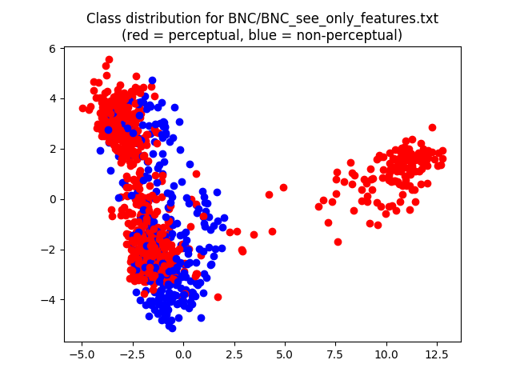 | 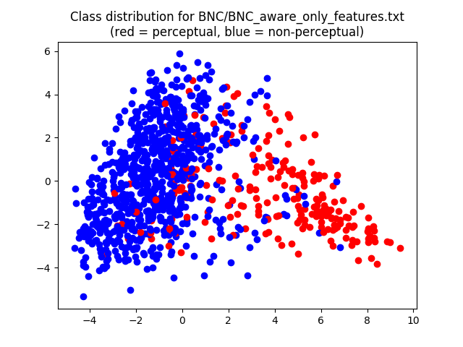
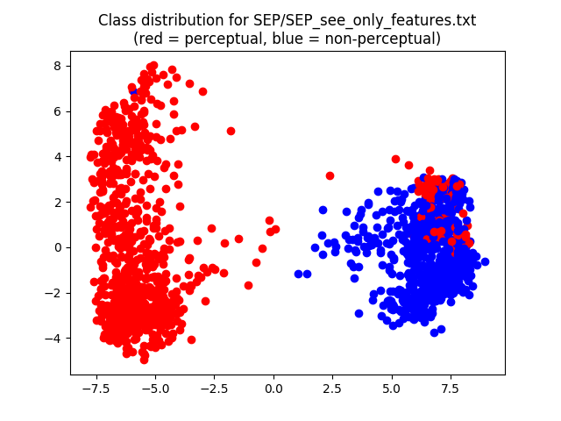 | 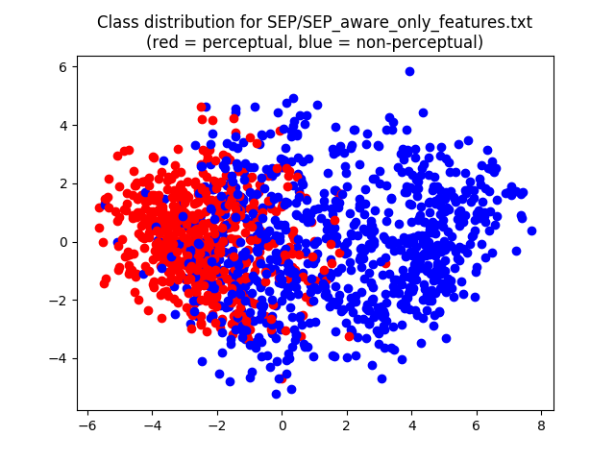
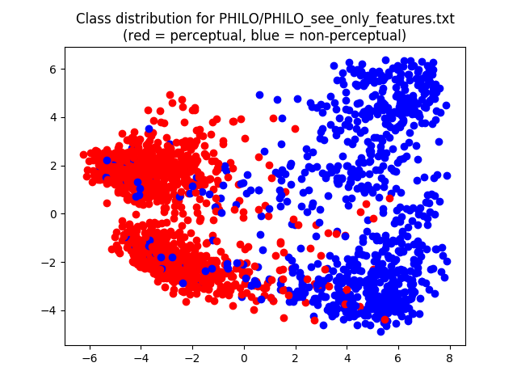 | 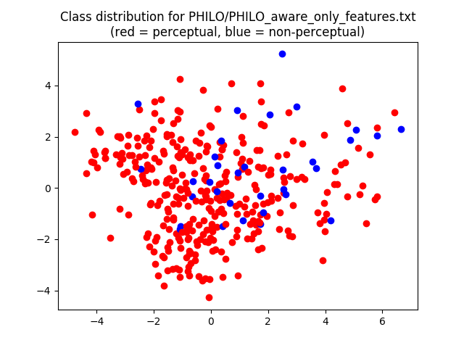
Classifier
To validate the representations, we trained a perceptual vs non-perceptual classifier, using as input the vectors extracted from the data, and as output the consensus label given to an instance by our annotators. The classifier was a simple Multilayer Perceptron consisting of two hidden layers with ReLU activation, and an output layer with softmax activation. We performed hyperparameter tuning using Bayesian optimization on a reserved portion of the data totaling 200 data points. We then performed 5-fold cross-validation on the rest of the sentences, averaging accuracies over the five folds. Results are shown in Tables 3A and 3B of the paper.
Automatic deployment
We used our trained classifiers to automatically annotate all instances of ‘see’ and ‘aware’ in our two large corpora (BNC and SEP-IEP). However, non-curated data may contain phenomena unseen by our classifier, creating problems for its automatic deployment. Manual annotation of the BNC illustrated that it differs from our philosophical corpora in containing instances of ‘see’ that relate to phrasal verbs (e.g., ‘to see something through’) and other unclassifiable usages (cf. Appendix A). When trained over decidable instances only, the classifier is then forced to decide between the perceptual and non-perceptual classes and may wrongly assign a label to an unclassifiable instance.
To address this issue, we retrained our BNC classifier, including a third class corresponding to undecidable instances. As training sample, we used all instances of ‘see’ that obtained full agreement amongst the three annotators, including those where the label was marked as undecidable. This resulted in 887 training instances, including 624 perceptual, 246 non-perceptual, and 16 undecidable. When training a classifier over such a skewed distribution, the minority class is usually ignored at training time. We therefore applied memory replay to the minority class. Memory replay is used in machine learning to prevent forgetting of rare but potentially useful experiences (Schaul et al., 2016). In our implementation, we repeated each instance of the undecidable class 5 times in the training data. We retrained using the set of hyperparameters used for the two-class training. The classifier obtained an average of 94% accuracy over 5 folds. The addition of a third class thus increased the classifier’s overall accuracy.
The BNC contains 150,305 instances of see in its non-academic section, and 20,914 in the academic portion (ACPROSE). We ran the three-class classifier separately on those two subsets, obtaining the results reported in Table 2 of the paper. For the non-academic portion of the corpus, we obtained 96,240 perceptual instances, 51,388 non-perceptual and 2,677 undecidable. The proportion of perceptual instances is thus 96240 / (96240 + 51388) = 0.65. For ACPROSE, we obtained 8,814 perceptual instances, 12,079 non-perceptual and 21 undecidable. The proportion is thus 8814 / (8814 + 12079) = 0.42.
Cross-domain annotation
We report results from a cross-domain classification in Tables 4A and 4B of the paper. This exercise examined whether the latent features used to capture the perceptual / non-perceptual distinction in one data source are the same as the ones modelling the distinction in another data source. If so, we can infer that the distinction is fundamentally the same in both corpora.
Results from cross-domain classification indicate that for ‘see’, the BNC and SEP model each other very well: a classifier trained on the BNC achieves 96% accuracy on SEP (just two points below the in-domain classifier); a classifier trained on the SEP achieves 87% accuracy on the BNC (3 points below in-domain classification). Similarly, SEP and PHILO-P model each other well, with minimal losses compared to in-domain classification. Although results are less convincing when comparing the BNC and PHILO-P, accuracies remain well above baseline. For ‘aware’, both the BNC and SEP model PHILO-P accurately, and the SEP classifier also performs well on the BNC. There is a larger loss in performance when applying the BNC classifier to SEP-IEP, possibly because the BNC encounters only relatively few perceptual uses of ‘aware’ (21%) in the course of training. However, accuracy remains well above baseline. The PHILO-P classifier struggles in modelling the BNC and SEP data, but this is expected given the extreme class imbalance of the data it was trained on, and the small size of this data set. Barring mathematical issues due to class imbalance, we conclude that our trained classifiers are very robust in cross-domain settings.

Appendix C – Experiment: Methods
This appendix contains further information about participant recruitment, instructions, and experimental materials for our main study.
Participant recruitment
To recruit academic philosophers as participants for the main study, invitations with links to the questionnaire were circulated through the Philos-L mailing list and the Daily Nous blog, and emailed to 306 analytic philosophers listed as faculty members of philosophy departments at the Universities of Birmingham, Durham, Edinburgh, Glasgow, Leeds, Manchester, Oxford, Sheffield, Southampton, Sussex, York, UCL, KCL, and the LSE (in May 2020). We further invited (in May-June 2020) 41 philosophers of perception with topical expertise aligned with the content of our PHILO-P corpus: authors who were either listed with post-2016 publications in the PhilPapers database under ‘Nature of Perception’, subcategories ‘Naïve and Direct Realism’ or ‘Sense-datum Theories’, or had made topically relevant contributions to the Oxford Handbook of Philosophy of Perception (Matthen, 2015), and had a topical research focus (as per perusal of online publication lists). Participants could enter a prize draw for Amazon vouchers. We excluded participants who self-identified as non-native speakers of English or did not meet the assignment criteria for our two philosophy groups (see main text, Sect. 5.2).
Instructions
Participants were instructed: ‘For each trial, you will be asked to read a short text of one or two sentences and then rate the plausibility of the text. As how plausible does the text strike you? By “plausible” we mean ‘likely to be true or accurate’. Please assess how likely each text is to be true or accurate, in the light of the information it gives you. Your plausibility rating will be on a 5-point scale from ‘very implausible’ (1) to ‘very plausible’ (5). There are four practice trials at the start to show you how the task works.’ Practice trials were followed by explanations of intended responses and the reminder: ‘Again, your plausibility judgments should be based on the information you can get from each text and how likely this is to be true or accurate.’
Critical items
We used two versions of the questionnaire. Where Version 1 employed ‘see’, Version 2 used ‘aware of’.
Item | Version 1
1 | Joe sees the problems facing him.
2 | Matt sees the spot on the wall facing him.
3 | Jack is aware of the problems that lie behind him.
4 | Chuck is aware of the spot on the wall behind him.
5 | Nelly is aware of the hardship that lies ahead of her.
6 | Carol is aware of the pictures on the wall facing her.
7 | Claire sees the hardship that lies behind her.
8 | Sheryl sees the pictures on the wall behind her.
9 | John sees the opportunities that lie ahead of him.
10 | Max sees the sign on the door facing him.
11 | Jim is aware of the opportunities he turned from.
12 | Tim is aware of the sign on the door behind him.
13 | Bob is aware of the commitments that lie ahead of him.
14 | Mona is aware of the vehicle on the road facing her.
15 | Bill sees the commitments that lie behind him.
16 | Laura sees the vehicle on the road behind her.
17 | Emma sees the challenges she is facing.
18 | Alan sees the customers waiting in front of him.
19 | Ellie is aware of the challenges that lie behind her.
20 | Alex is aware of the customers waiting behind him.
21 | Josh is aware of the issues he is facing.
22 | The hiker is aware of the friends walking in front of him.
23 | Jeb sees the issues he has turned from.
24 | The rambler sees the friends walking behind him.
25 | George sees the adversity that lies ahead of him.
26 | Nora sees the colleague seated in front of her.
27 | Greg is aware of the adversity that lies behind him.
28 | Ellie is aware of the colleague seated behind her.
29 | Liz is aware of the prejudices she is facing.
30 | Larry is aware of the child playing in front of him.
31 | Jess sees the prejudices that lie behind her.
32 | Jerry sees the child playing behind him.
33 | Mary sees the possibilities that she has before her.
34 | Harry sees the scene unfolding before his eyes.
35 | Kelly is aware of the possibilities that she has turned from.
36 | Sam is aware of the scene unfolding behind his back.
37 | Carl is aware of the risks that he has before him.
38 | Fay is aware of the accident happening before her eyes.
39 | Kurt sees the risks that he has turned from.
40 | Dawn sees the accident happening behind her back.
41 | Clara sees the solution that she has before her.
42 | Fred sees the fight breaking out before his eyes.
43 | Chloe is aware of the solution that she has turned from.
44 | Mark is aware of the fight breaking out behind his back.
45 | Jeff is aware of the options that he has before him.
46 | Amy is aware of the performance staged before her eyes.
47 | Jeff sees the options that he has turned from.
48 | Ann sees the performance staged behind her back.

These items included no outliers (attracting mean ratings >3 SDs from the mean in any condition).

Appendix D – Experiment: Further analyses
Further analyses examined (1) demographic factors and (2) the linguistic salience bias hypothesis.
Demographic factors
Our sample of psychology undergraduates was predominantly female and young. Our two samples of academic philosophers were predominantly male, and (inevitably) older. These imbalances within and across participant samples motivated correlational analyses of gender and age.
Gender
We first included gender as a covariate in the 2x2x2x3 mixed-model ANOVA. This did not produce a main effect of gender, and gender did not interact with any of the other variables. We then conducted bivariate correlations between gender and ratings in the eight within-subject conditions for the entire sample of participants (N=186). We found only one significant correlation, in the inconsistent-aware-visual condition r(186)=-.27, p<.001, where males gave higher plausibility ratings (3.83 vs 3.40). For all other conditions, correlations were not significant (all p’s >.27).
These findings suggest that gender did not influence responses. The lone correlation observed in the inconsistent-aware-visual condition may reflect the fact that most female participants (75%) were psychology undergraduates, whereas most male participants (85%) were academic philosophers: it may be an artefact of other, cognitive, differences between students and philosophers. This suggestion is supported by the fact that the inconsistent-aware-visual condition is the condition with the most pronounced difference in mean ratings between students and philosophers. To examine the suggestion, we considered correlations between gender and ratings in this condition separately, for undergraduates, PoPs, and Other Philosophers. The correlation observed in the whole sample disappeared (all p’s >.16).
Age
While all participants reported their gender, 4 (of 92) undergraduates, 6 (of 22) philosophers of perception, and 22 (of 72) other philosophers did not report their age, placing a caveat on our analyses.
We included age as a covariate in the 2x2x2x3 mixed-model ANOVA. We found age variously interacted with the within-subjects variables but did not produce a main effect (p=.20). We then conducted bivariate correlations between age and the eight within-subject conditions for the entire sample (N=186). As was the case for gender, we found only one significant correlation, again in the inconsistent-aware-visual condition r(154)=.30, p<.001, where older participants gave higher plausibility ratings. All remaining correlations were p>.05. Following up on the interactions, we finally ran the correlations for the three participant groups separately. There were two significant correlations, both in the Other Philosophers group: inconsistent-visual-aware condition r(50)=-.30, p=.038 and inconsistent-aware-epistemic condition r(50)=-.33, p=.020. The older these philosophers are, the less plausible they find items in these conditions. Arguably, the paucity of relevant data points from philosophers of perception (only 14 reported their age) and the restricted age range of the undergraduate sample prevented significant correlations in these groups.
Age thus correlates differently with ratings in the key inconsistent-visual-aware condition, in the whole sample (with a positive correlation) and the Other Philosophers group (negative correlation). This suggests that the positive correlation observed in the whole sample reflects another difference than age, between undergraduates and philosophers. It arguably reflects the same difference between these groups as the correlation between gender and ratings we previously found in only that condition. We suggested a relevant difference: Due to training or selection effects, philosophers will be better than undergraduates at suppressing contextually irrelevant default inferences (Sect. 3.1). This suppression ability influences ratings without interference from linguistic salience bias precisely in the two inconsistent aware conditions (Sect. 5.1), where Other Philosopher’s ratings are negatively correlated with their age. Suppression ability is influenced by lexical and world knowledge, and by inhibition (Sect. 3.2). Our items described familiar situations with high-frequency words, so that any differences in such knowledge will be less relevant than differences in inhibition. Unlike such knowledge, fluid intelligence including inhibition declines in advanced age (Wang & Kaufmann, 1993; DeLuca et al., 2003). We submit this explains the observed correlations: Philosophers have higher suppression ability than undergraduates, but the presently most relevant component of this ability declines with age, while even older philosophers’ suppression ability continues to exceed that of psychology undergraduates. In the condition in which this cognitive difference leads to the biggest difference in mean ratings between undergraduates, who are mostly young and female, and philosophers, who are mostly older and male, this cognitive difference due to selection and training leads to correlations of ratings with age and gender.
Linguistic salience bias
To assess whether the plausibility differences predicted by the linguistic salience bias hypothesis SBH translate into categorical differences between conditions, we conducted t-tests with a test value of ‘3’ for mean ratings of each condition. Mean ratings significantly above this mid-value indicate that items were deemed distinctly plausible, mean ratings significantly below ‘3’ indicate items were deemed distinctly implausible, and ratings not significantly different from ‘3’ indicate items were deemed neither plausible nor implausible, but neutral.

Table D-1. One sample t-tests with a test value of 3. Holm significance threshold in square brackets.

Visual Objects Epistemic Objects

Psychology Students
Aware Consistent t(91)=25.02, p<.001 [.002] t(91)=17.15, p<.001[.002]
See Consistent t(91)=28.76, p<.001 [.002] t(91)=15.71, p<.001[.002]
Aware Inconsistent t(91)=3.06, p=.003 [.008] t(91)=4.14, p<.001[.002]
See Inconsistent t(91)=-7.25, p<.001 [.002] t(91)=.834, p=.41 [.017]

Other Philosophers
Aware Consistent t(71)=24.23, p<.001[.002] t(71)=16.01, p<.001[.002]
See Consistent t(71)=26.21, p<.001[.002] t(71)=15.30, p<.001[.002]
Aware Inconsistent t(71)=11.96, p<.001[.002] t(71)=5.31, p<.001[.002]
See Inconsistent t(71)=-4.27, p<.001[.002] t(71)=.371, p=.712[.05]

Philosophers of Perception
Aware Consistent t(21)=16.18, p<.001[.002] t(21) =10.43, p<.001[.002]
See Consistent t(21)=16.42, p<.001[.002] t(21) =10.37, p<.001[.002]
Aware Inconsistent t(21)=5.04, p<.001[.002] t(21) =2.76, p=.012 [.01]
See Inconsistent t(21)=-2.82, p=.01 [.01] t(21) =-.507, p=.62 [.025]

Findings displayed the same pattern across our three groups (psychology undergraduates, expert philosophers of perception, and other philosophers) (Table D-1): S-inconsistent ‘see’-sentences with visual objects were deemed distinctly implausible. S-inconsistent ‘see’-sentences with epistemic objects were deemed neutral. Items in all other conditions struck participants as distinctly plausible (with the one caveat below). For all groups, the key plausibility difference predicted by SBH was categorical: Whereas s-inconsistent ‘see’-sentences with epistemic objects were deemed neutral, s-inconsistent ‘aware’ sentences with epistemic objects were deemed distinctly plausible (with one caveat: philosophers of perception gave these ‘aware’-sentences numerically higher mean ratings than psychology undergraduates, but the difference to mid-point remained just shy of significance, upon correction for multiple comparisons, due to the small size of the sample).
Next, we examined whether the specific formulation of the cancellation phrase used for sentences with epistemic objects affected plausibility ratings. We used the phrases ‘that lie(s) behind him/her’ and ‘[that] s/he has turned from’, in equal number. The latter supports an epistemic interpretation: The phrase implies the agent previously ‘looked at’ the patient (problem, etc.), that is (unpacking the familiar vision cognition metaphor), previously thought about the problem, etc. Thus interpreted, ‘turned from’ implies that the agent knows there is, e.g., a problem. This implication will promote an epistemic interpretation of relevant items. It will also increase their plausibility over otherwise similar items with ‘behind’ (which imply nothing of the sort) – if the verb is given an epistemic reading. We therefore considered separately the mean ratings for items using these different cancellation phrases, per group. Indeed, all groups deemed both ‘see’- and ‘aware’-items with ‘turn from’ more plausible than items with ‘behind’ (Figure D-1). This difference was significant for all groups in case of ‘aware’ (UGs: t(91)=-6.64, p<.001[.002], d=.69, Other Philosophers: t(71)=-3.72, p<.001[.002], d=.43, PoPs: t(21)=-2.21, p=.039[.05], d=.47) and ‘see’ (UGs: t(91)=-3.39, p=.001[.017], d=.35, Other Philosophers: t(71)=-4.09, p<.001[.002], d=.49, PoPs: t(21)=-4.07, p=.001[.017], d=.88).
Figure D-1. Mean plausibility ratings for s-inconsistent epistemic items with cancellation phrases ‘behind…’ and ‘turned from…’. Error bars show the standard error of the mean.

We next considered whether SBH’s key prediction about the s-inconsistent epistemic condition was borne out also at the level of individual cancellation phrases: whether ‘see’ items were rated less plausible than ‘aware’ items, regardless of the cancellation phrase used (Table D-2). Where items used ‘turned from’, all groups deemed ‘aware’ items distinctly plausible and ‘see’ items neutral. Where items used ‘behind’, this was true only of Other Philosophers, while Undergraduates and Philosophers of Perception deemed both kinds of items neutral (Table D-2). Three of the six relevant comparisons (Table D-2, see vs aware) were significant: Undergraduates judged ‘aware’ items more plausible than ‘see’ items, when they used ‘turned from’. Other Philosophers judged them more plausible, regardless of the cancellation phrase used. For Philosophers of Perception (PoPs), the comparisons remained shy of significance upon correction for multiple comparisons. This is arguably due to the small size of the sample which compounds the fact that present comparisons are based on just half the number of items. For further discussion, we therefore set aside these PoP results.
Table D-2. One sample t-tests with a test value of 3 and for ‘see’-‘aware’ differences. Holm significance thresholds in square brackets.

Behind Turned

Psychology Students
Aware Inconsistent t(91)=.08, p=.94 [.05] t(91)=7.86, p<.001 [.008]
See Inconsistent t(91)=-.91, p=.37 [.025] t(91)=2.55, p=.013 [.006]
See-vs aware t(91)=1.18, p=.24 [.017] t(91)=4.23, p<.001 [.004]

Other Philosophers
Aware Inconsistent t(71)=3.03, p=.003 [.017] t(71)=6.69, p<.001 [.008]
See Inconsistent t(71)=-1.28, p=.20 [.013] t(71)=2.31, p=.024 [.007]
See vs aware t(71)=5.51, p <.001 [.004] t(71)=4.31, p < .001 [.004]

Philosophers of Perception
Aware Inconsistent t(21)=.67, p=.51 [.025] t(21)=4.06, p=.001 [.013]
See Inconsistent t(21)=-1.43, p=.17 [.01 ] t(21)=.92, p=.37 [.025]
See vs aware t(21)=2.81, p=.011 [.006] t(21)=2.33, p=.03 [.008]

One of these data points is inconsistent with the SBH: Psychology undergraduates failed to rate ‘aware’-items more highly than ‘see’-items, where these used ‘behind’. In two earlier studies with undergraduates, however, ‘aware’-items with epistemic objects and ‘behind’ elicited even lower ratings that were, even so, still significantly higher than ratings for ‘see’-counterparts (Fischer & Engelhardt, 2019, pp.86-88; 2020, pp.429-30). It remains unclear why this difference failed to replicate in the present study. The only substantial difference between the studies is the delivery format: Previous studies were laboratory-based and simultaneously involved eye tracking. The present online questionnaire format may have led undergraduate participants to dispense less effort and go along with default perceptual readings of ‘aware of’ (see Sect. 5.1), in the absence of further contextual support (beyond the abstract patient-noun) for an epistemic reading (offered by ‘turned from’, but not ‘behind’). By contrast, Other Philosophers’ ratings preserved the difference between ‘see’- and ‘aware’-items with both ‘turned from’ and ‘behind’ and are fully consistent with the key prediction from the SBH.
Finally, we examined whether the suppression difficulties we observed can indeed be attributed to the effect of linguistic salience bias on the processing of subordinate uses of polysemous words or whether suppression difficulties of the same magnitude can be observed also where the verb is applied in its dominant sense to stereotype-incongruent situations, as in our s-inconsistent visual see condition, where spatial inferences from visual uses of ‘see’ are cancelled by s-inconsistent sequels (‘Chuck sees the spot on the wall behind him’). We therefore examined whether participants would make a higher number of incorrect judgments potentially resulting from suppression difficulties, in the epistemic than the visual inconsistent see condition.
In both conditions, participants will attempt to come up with interpretations that render items true (e.g., Chuck sees the spot in a mirror) and assess how likely the resulting scenario is to obtain under circumstances inferable from the sentence context. In the visual condition, these scenarios are not very implausible but certainly less than plausible – on a ‘truth-making’ interpretation, these items should attract ratings of ‘2’ or ‘3’. But these interpretations require suppression of the spatial inference. Hence lower ratings, of ‘1’, provide evidence of suppression difficulties that prevent a consistent and ‘truth-making’ interpretation of these s-inconsistent items.
For ‘see’-items with epistemic objects, complete suppression of the spatial inference should yield a purely epistemic interpretation (e.g., Jack knows what problems he had in the past). Fischer and Engelhardt (2020, Appendix A) elicited ratings for paraphrases of epistemic items that make explicit this interpretation. Such paraphrases of s-inconsistent epistemic items attracted a mean rating of 4.03 (SD=.37, on a 5-point Likert scale). We can use this mean rating as a norm of correctness: Ratings below ‘4’ (i.e., ‘1’-‘3’) provide evidence of suppression difficulties that prevented the intended interpretation.
To assess whether participants face suppression difficulties of the same magnitude in both cases, we therefore compared the proportions of ‘too low’ responses to s-inconsistent ‘see’-items in the visual and the epistemic conditions. To control for the different number of relevant response options (1 vs 3), we multiplied the number of ‘1’ responses to visual items by 3. Since our hypotheses predict no differences in the ratings of philosophers of perception and other philosophers for ‘see’-items, we combined these two groups for the present analysis. Controlling for the difference in response options yielded, for our 92 undergraduates, a proportion .35 of ‘too low’ (‘1’) responses to visual inconsistent ‘see’-items vs .54 of ‘too low’ (‘1’-‘3’) responses to epistemic counterparts. Considering proportions permits t-tests. A paired samples t-test showed this difference was significant t(91) = 2.77, p=.007 [.025]. For our 94 philosophers, controlling for the difference in response options yielded a proportion of .59 of ‘too low’ responses to visual inconsistent ‘see’-items, vs .63 to epistemic counterparts – a not significant difference t(93) = .44, p=.66 [.05].
The asymmetry found in undergraduate judgments provides evidence that the processing of epistemic uses of ‘see’ involves extra suppression difficulty in addition to those involved in processing utterances applying the dominant sense to stereotype-deviant situations. The absence of this asymmetry in philosophers is mainly due to a larger proportion of ‘1’ ratings for inconsistent ‘see’-items with visual objects, in philosophers’ judgments. Since higher ratings for inconsistent visual ‘aware’-items (as per H₁) suggest that philosophers benefit from higher suppression ability than undergraduates, the larger proportion of ‘1’ ratings for ‘see’-items is arguably not due to suppression difficulties but may be a task artefact: The critical items make the contrast between ‘see’ and ‘aware of’ contextually salient, so that participants with higher verbal IQ may have concluded that, for the purposes of the experiment, ‘aware’ items provide a ‘correct’ description of stereotype-deviant cases of seeing, and that ‘see’ items are to be deemed ‘incorrect’ descriptions of such cases. We therefore infer from our undergraduate participants’ ratings that the suppression difficulties we observed can indeed be attributed to the effect of linguistic salience bias on the processing of subordinate uses of polysemous words.

References cited in appendices but not the main paper
Austin, J.L. (1962). Sense and Sensibilia. Oxford: OUP.
Ayer, A.J. (1940). Foundations of Empirical Knowledge. London: Macmillan.
Ayer, A.J. (1956). The Problem of Knowledge. London: Penguin.
Boleda, G. (2020). Distributional semantics and linguistic theory. Annual Review of Linguistics, 6, 213-234
Brewer, B. (2011). Perception and its Objects. Oxford: OUP.
Broad, C. D. (1923). Scientific Thought. Repr. 2000. London: Routledge.
DeLuca, C.R., Wood, S.J., Anderson, V., Buchanan, J., Proffitt, T.M., Mahony, K., & Pantelis, C. (2003). Normative data from the Cantbab. I: Development of executive function over the lifespan. Journal of Clinical and Experimental Neuropsychology, 25, 242-254
Devlin, J., Chang, M.W., Lee, K., & Toutanova, K. (2019). BERT: Pre-training of Deep Bidirectional Transformers for Language Understanding. In Proceedings of 17th Annual Conference of the North American Chapter of the Association for Computational Linguistics: Human Language Technologies, Minneapolis, MN.
Erk, K. (2012). Vector space models of word meaning and phrase meaning: A survey. Language and Linguistics Compass, 6, 635-653.
Jackson, F. (1977). Perception. A Representative Theory. Cambridge: CUP.
Lenci, A. (2008). Distributional semantics in linguistic and cognitive research. Italian Journal of Linguistics, 20(1), 1-31.
Matthen M, (ed.) (2015). The Oxford Handbook of Philosophy of Perception. Oxford: OUP
Peters, M.E., Neumann, M., Iyyer, M., Gardner, M., Clark, C., ,Lee, K., & Zettlemoyer, L. (2018). Deep contextualized word representations. In Proceedings of the 16th Annual Conference of the North American Chapter of the Association for Computational Linguistics: Human Language Technologies, New Orleans, Louisiana (pp. 2227-2237).
Price, H.H. (1932). Perception. 2nd ed., repr. 1961, London: Methuen.
Robinson, H. (1994). Perception. London: Routledge.
Russell, B. (1912). The Problems of Philosophy. Repr. 1980. Oxford: OUP.
Schaul, T., Quan, J., Antonoglou, I., & Silver, D. (2016). Prioritized experience replay. The Fourth International conference on Learning Representations, San Juan, Puerto Rico.
Smith, A.D. (2002). The Problem of Perception. Cambridge, Mass: Harvard UP.
Sytsma, J., Bluhm, R., Willemsen, P. & Reuter, K. (2019). Causal attributions and corpus analysis. In E. Fischer & M. Curtis (Eds.), Methodological Advances in Experimental Philosophy (pp. 209-238). London: Bloomsbury.
Wang, J.J., & Kaufman, A.S. (1993). Changes in fluid and crystallized intelligence across the 20- to 90-year age range. Journal of Psychoeducational Assessment, 11, 29-37.
Zhu, Y. et al. (2015). Aligning books and movies: Towards story-like visual explanations by watching movies and reading books. In Proceedings of the IEEE international Conference on Computer Vision (pp.19–27).

https://www.macmillandictionary.com/dictionary/british/see_1 and https://www.oed.com/view/Entry/174749, both last accessed in February 2018.
For key ideas of distributional semantics, see Erk (2012), Lenci (2008), and Boleda (2020).
We used the BayesianOptimization package: https://github.com/fmfn/BayesianOptimization. Last accessed January 28, 2020.
A few hundred of these 172,643 instances were lost, as BERT cannot process very long sentences.

