Supplementary material A – Range of payoffs
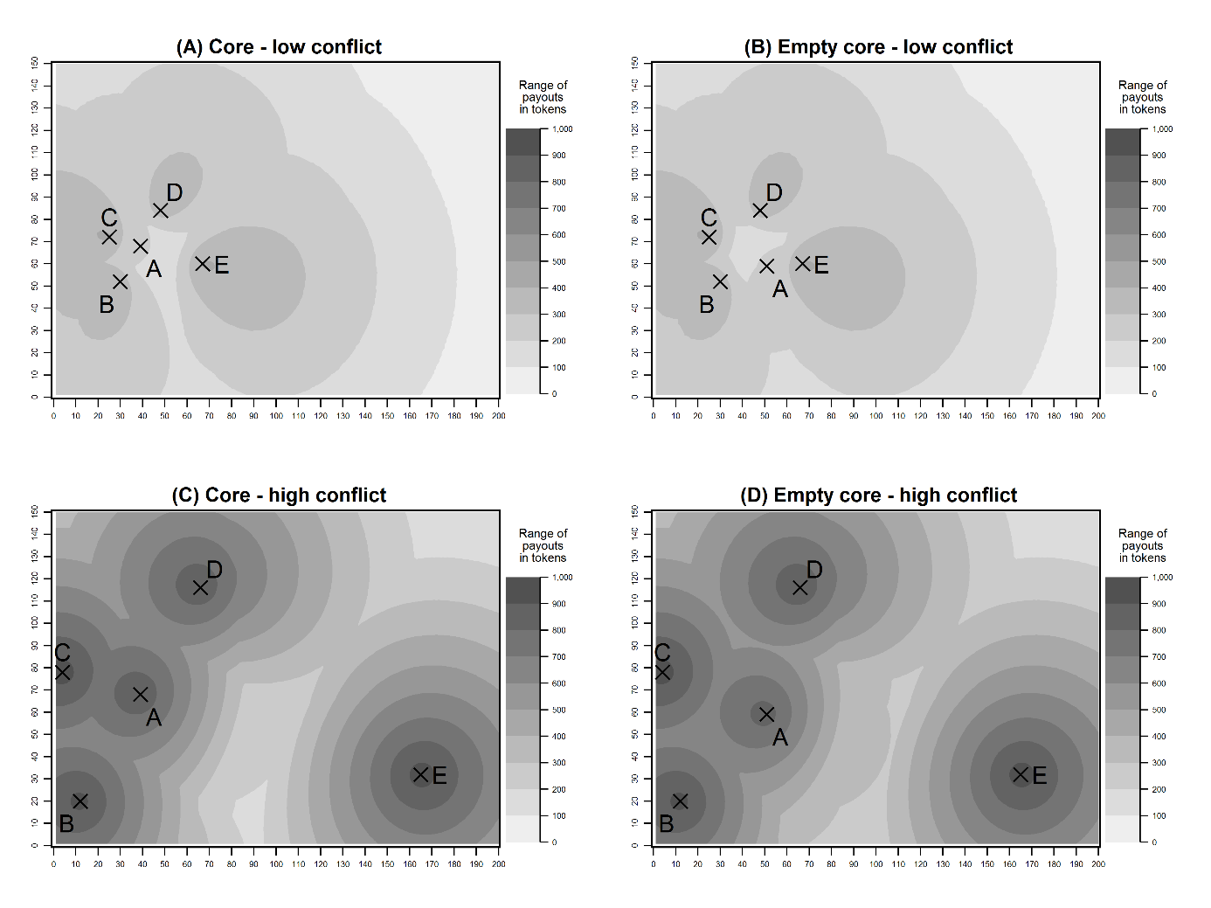
Fig. A1 Range of payoffs

Supplementary material B – Instructions to the experiment
Instructions
Welcome to today’s experiment. In the course of the experiment, you have the opportunity to earn money. How much you earn depends on your decisions during the experiment. Your decisions remain anonymous to the other participants in the experiment.
In any case, every participant will receive a lump sum payment (referred to as „Show-up-fee“ from here on) amounting to € 2.50. Moreover, you can earn tokens in the individual decision periods of the experiment. At the end of the experiment, all tokens during the experiment are added up. These tokens are then converted into EURO at a ratio of 1000:1. For instance, if you earn 3500 tokens, you will receive € 3.50 in addition to the Show-up-fee of € 2.50. The money will be handed out in cash at the end of the experiment. Participants only get to know their own payment.
Communication between participants is not allowed during the experiment. Please do not ask questions aloud! If something is unclear, please raise your hand. We will attend to your questions in private in that case.

The experiment in detail
During the experiment you will be part in a group of 5 participants. The members of your group will be called Participant A, Participant B, Participant C, Participant D and Participant E. You will not get to know the identity of the other participants in your group. The experiment takes 20 periods. All periods follow the same procedure. We will specify how an individual period proceeds below. During the experiment, the composition of the groups will not change. You will be in one group with the same 4 participants for all 20 periods of the experiment.

The Task
In each of the 20 periods your group will have to pick one point of a decision space by voting. You will find a picture of the decision field on the following page. The field is 200 units wide (x-axis) and 150 units high (y-axis). Each participant in your group has an ideal point in the decision field. The amount of tokens you earn in one period depends on point chosen by your group. The closer the chosen point is to your ideal point, the more tokens you earn. Thus, you earn the highest amount of tokens if the group chooses exactly your ideal point. In that case, you earn 1,000 tokens. All points inside the decision field earn you a positive amount of tokens. Therefore, you cannot incur any losses in a period.
Please have a look at the decision field below on this page and assume you were participant B. Your ideal point is point B with the coordinates 45 units on the x-axis and 63 units on the y-axis. The ideal points of the other 4 members of your group are A, C, D and E. Your own ideal point is blue in the experiment, those of the other 4 group members are black. In the situation shown below you receive more tokens if the group chooses P2 than if it chooses P1, because P2 is closer to your ideal point, B, than P1. Conversely, participant D receives more tokens if the group chooses P1 instead of P2 because P1 is closer to D’s ideal point than P2.
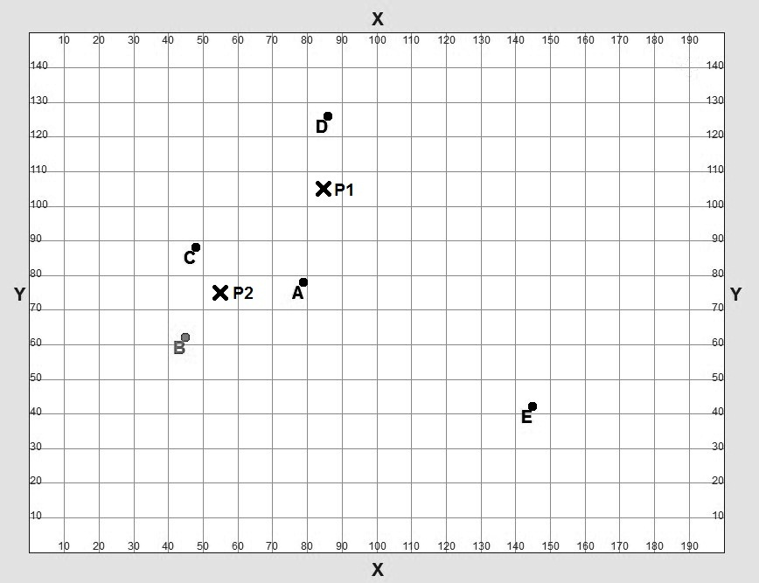
Over the course of the experiment’s 20 periods the position of your ideal point in the decision space does not change. The ideal points of the other participants in your group remain the same as well.

The course of decision making in your group
Below we will explain to you the details of how a decision is made by your group. Your group must choose one point in the decision space by majority rule. The decision-making process has two phases:
Phase 1: A randomly chosen member of the group is allowed to choose a point and submit is to a vote.
Phase 2: The group members vote on the proposal.

Details of Phase 1
At the beginning of each period the computer assigns the right to make a proposal randomly to one of the 5 members of your group. That member who has been assigned the right to make a proposal will then see the screen shown below. The other members of the group are asked to wait until the proposing participant has made a decision.
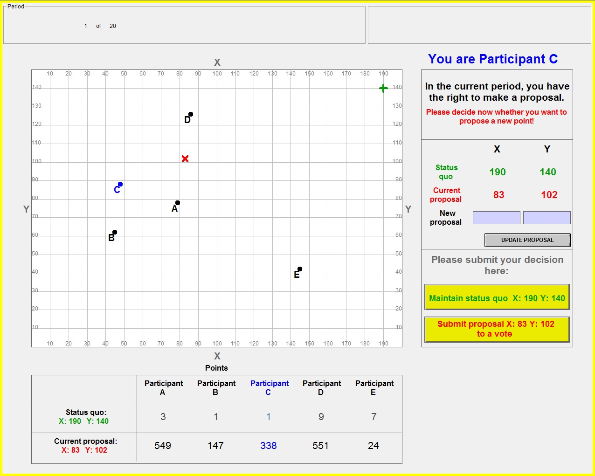
The decision space just explained is placed in the top left area of the screen. On the top right you see which participant you are. In this example you are Participant C. Below you are informed that you have been assigned the right to make a proposal in the current period.

In every period there is status quo point. In the first period of the experiment, the status quo is situated in the upper left area of the decision space and has the coordinates 190 units on the x-axis and 140 units on the y-axis. The status quo is represented in the decision space with a green ‚$+$‘. You can also see the exact coordinates of the status quo on the right in the line tagged „Status quo“, written in green. In later periods the status quo of the current period is the point chosen by your group in the previous period. Thus, if your group chooses the point x-axis: 63 and y-axis: 12 in Period 1, x: 63 ; y: 12 becomes the status quo in Period 2 of the experiment.
The participant with the right to make a proposal has two options:
- The participant can maintain the status quo. In that case, the status quo of that period becomes the result of the period.
- The participant can propose an alternative point. In that case the members of the group decide by majority rule whether they want to keep the status quo or whether they want to accept the proposal of the proposing participant.
The number of tokens that you and the other members gain in one period depends on the point of the decision space chosen by your group. You can see how many tokens you and the other members of the group gain in the table beneath the decision space. In the second row, you see how many tokens you and the other participants in your group earn if the status quo of that period is maintained (in the example shown above: 3 tokens for participant A, 1 token for participant B, etc.). In the third row, you see how many tokens you and the other participants in your group earn if your group accepts the current proposal (in the example shown above: 549 tokens for participant A, 147 tokens for participant B, etc.). The column that shows your own number of tokens is written in blue.
On the decision space, the current proposal is marked with a red ‚X‘. You can also read the exact coordinates of the current proposal in the box on the right in the line „Current proposal“, written in red, as well as in the last row of the tokens table beneath the decision space. At the beginning of each period the current proposal has the same coordinates as the status quo. If the computer assigned the right to make a proposal to you in the current period, you may change the current proposal. You have two options to do that:
You can click on points in the decision space with the computer mouse. The red ‚X‘ will move to the point you clicked, and you can see how many tokens you and the other participants of your group earn if the group decides in favor of the new proposal in the third row of the table beneath the decision space.
As another option of changing the current proposal, you can type coordinates into the field on the right of the decision space in the line „New proposal“. The first field is for the x-axis, the second is for the y-axis. Only integers (0, 1, 2, 3, 4, …) are permitted. For instance, it is not possible to type in 134.7. When you click „UPDATE PROPOSAL“, the red ‚X‘ will move to the coordinates you typed in. In the table beneath the decision space, you see again how many tokens you and the other members of your group gain if your group chooses the current proposal.
If you have the right to make a proposal in the current period, you can change the current proposal as often as you like to experiment with different points on the decision space before submitting it to a vote if you wish so. You can see how many tokens you and the other members of your group gain if the group chooses the current proposal in the last line of the table beneath the decision space at any time.
When you have decided whether to maintain the status quo of the current period or to propose an alternative point to the members of your group, you have to submit this decision. To do that, there are two yellow buttons on the right of the decision space. If you want to maintain the status quo, click the button that reads „Maintain status quo X: Y: “. If you want to submit your current proposal to a vote to the members of your group, click the button that reads „submit proposal X: Y: to a vote“. In any case you will be asked whether you want to transmit your decision to the other members of your group. If you want to transmit it, please click “YES”. If you want to reconsider your decision, please click “BACK”.
When the proposing participant has made a decision, Phase 1 of the current period ends:
- If the participant with the right to propose decides to maintain the status quo, the current period ends. In that case, the status quo is the chosen point of the period and all group members gain the amount of tokens assigned to them in the line „Status quo“ of the table beneath the decision space (In the example above: 3 tokens for participant A, 1 token for participant B, etc.).
- If the proposing participant decides to propose an alternative point, Phase 2 of the current period begins: The members of the group vote on the proposal.

Phase 2 in detail
If the proposing participant proposes an alternative point, the group members decide between the status quo and the proposal by majority rule. You will then see this screen:
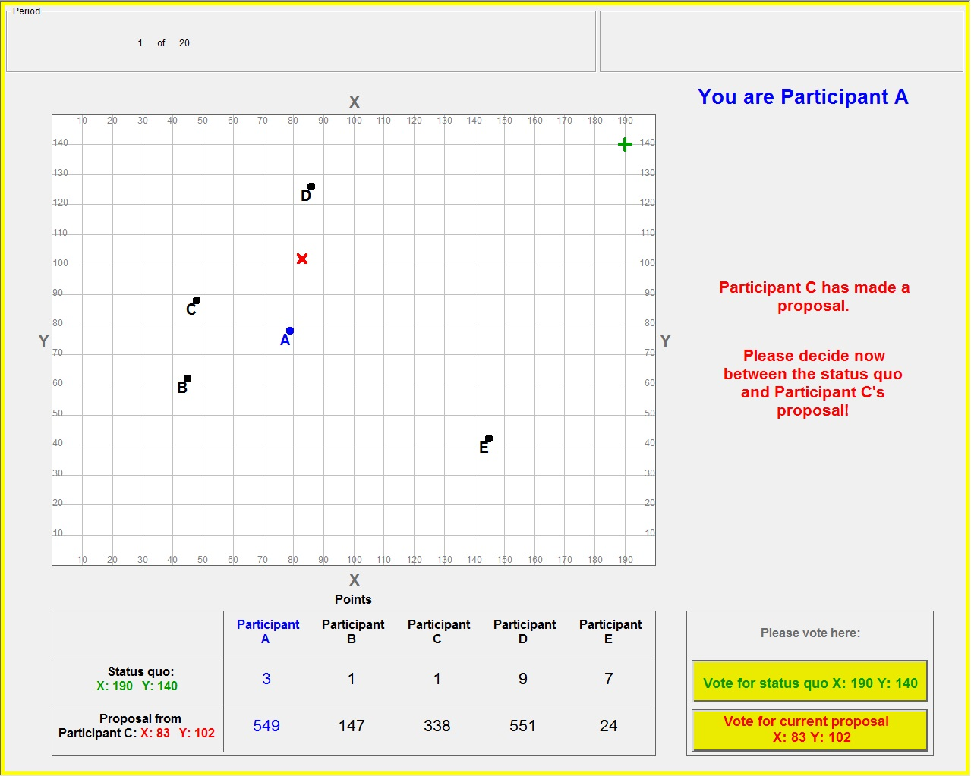
In the upper right corner you can see which participant you are (In the example above you are Participant A). You are informed that the proposing participant (in the example Participant C) has transmitted a proposal, and asked to choose between the proposal and the status quo. On the left you see the decision space with the ideal points of all group members. The status quo is marked with a green ‚$+$‘. The proposal is marked with a red ‚X‘. In the table beneath the decision space you can see the exact coordinates of the status quo (190 units on the x-axis and 140 units on the y-axis in the example) and the proposal (83 units on the x-axis and 102 units on the y-axis in the example) in the first column. In the second row, the table shows you how many tokens you and the other members of your group gain if your group chooses the status quo (In the example above: 3 tokens for Participant A, 1 token for Participant B, etc.). In the third row you see the numbers of tokens if your group chooses the proposal of the proposing participant (In the example above: 549 tokens for Participant A, 147 tokens for Participant B, etc.). Your own numbers are written in blue. Those of the other participants are written in black.
Voting proceeds as follows: Each group member has one vote. Only those 4 group members who do not have the right to propose actually vote in Phase 2. The vote of the proposing group member is automatically counted in favor of his/her own proposal. You cast your vote on the right of the table. There are two yellow buttons.
- If you want your group to maintain the status quo, please click the button „Vote for status quo X: Y: “ and confirm your choice by clicking „OK“.
- If you want your group to choose the current proposal as the result of the period, please click the button „Vote for current proposal X: Y: “ and confirm your choice by clicking „OK“.
All group members cast their votes at the same time. As long as you have not made your decision, you do not get to know the decision of the other members of your group in the current vote.
Your group decides by majority rule: That alternative which gets 3 or more votes from the 5 members of the group is the result of the current period. The vote of the participant with the right to propose is automatically counted in favor of the proposal. Therefore, if 2 more members of the group vote in favor of the proposal, the proposed point is the result of the current period. You and the other members of your group receive the number of tokens shown in the third row of the table beneath the decision space. If 3 or all 4 of the other members decide to keep the status quo, the status quo is the result of the period. You and the other 4 members of your group receive the number of tokens shown in the second row of the table.
When all group members have cast their votes, Phase 2 ends and the current period is over.

The end of a period
When all groups in the experiment have completed the voting, you see another screen. You may have to wait for a short time until the other groups in the experiment have made their decision.
If your group voted on a proposal, this screen will show you the distribution of votes in your group. This means you can see which members of your group voted for the status quo and which voted for the proposal.
In any case, you see how many tokens you and the other participants in your group earned in the period. You also learn how many tokens you and the other members of your group each gained in the experiment up to that point.
Subsequently, a new period begins. Again, the computer assigns the right to make a proposal to one group member at random. The result of the preceding period is the status quo of the new period. The proposing participant decides again whether to maintain the status quo or to submit a proposal to a vote. If an alternative point is proposed, the group members again decide by majority rule whether to maintain the status quo or adopt the proposed point.

After the 20th period of the experiment, all tokens you have earned in the course of the 20 periods are added up. Your total payment consists of the payment resulting from your tokens plus the „show-up-fee“ of € 2.50.

Included in the experiment is a questionnaire which will start after the 20th period of the experiment. We assure you that any information you enter there is treated anonymously and that your data will not be passed on to third parties.

In case you have questions, please raise your hand. We will come over to answer your question then.

