Supplemental Appendix
Associations between model-predicted rivaroxaban exposure and patient characteristics and efficacy and safety outcomes in patients with non-valvular atrial fibrillation
Journal of Thrombosis and Thrombolysis
Liping Zhang¹ • Xiaoyu Yan¹ • Keith A. A. Fox² • Stefan Willmann³ • Partha Nandy¹ • Scott D. Berkowitz⁴ • Anne Hermanowski-Vosatka¹ • Jeffrey I. Weitz⁵ • Alexander Solms⁶ • Stephan Schmidt⁷ • Manesh Patel⁸ • Gary Peters¹
¹ Janssen Research & Development, LLC, Raritan, NJ, USA
² Centre for Cardiovascular Science, The University of Edinburgh, Edinburgh, UK
³ Clinical Pharmacometrics, Bayer AG, Wuppertal, Germany
⁴ Bayer U.S., LLC, Research & Development, Pharmaceuticals, Whippany, NJ, USA
⁵ Department of Medicine, McMaster University, and the Thrombosis & Atherosclerosis Research Institute, Hamilton, ON, Canada
⁶ Clinical Pharmacometrics, Bayer AG, Berlin, Germany
⁷ Center for Pharmacometrics and Systems Pharmacology, Department of Pharmaceutics, College of Pharmacy, University of Florida, Orlando, FL, USA
⁸ Duke Clinical Research Institute, Durham, NC, USA
Address for correspondence Liping Zhang, Senior Scientific Director, Clinical Pharmacology and Pharmacometrics, Janssen Research & Development, LLC, 920 Route 202, Raritan, NJ 08869, USA
Tel.: +1 609 619 2430
E-mail: LZhang11@ITS.JNJ.com

Methods
Regression analyses
Relationships between rivaroxaban exposure metrics, patient characteristics and the efficacy and safety outcomes were quantified first by performing univariate Cox proportional hazard regression analysis using area under the plasma concentration–time curve from time 0 to 24 hours (AUC_{0–24}), maximum plasma concentration (C_{max}) and trough plasma concentration (C_{trough}) as independent variables, assuming a linear relationship with the log-hazard of outcome events. The exposure metric showing the strongest association with the likelihood of an event (lowest Akaike information criterion [AIC] value [1]) was then combined with the selected patient characteristics, as independent variables for predicting the probability of the outcome events, in a multivariate Cox proportional regression analysis. The statistical significance of each independent variable was determined by fitting the full model. Statistically non-significant variables (p > 0.01, according to the likelihood ratio test) were removed from the model, with the exception of the selected exposure metric, age and creatinine clearance (calculated using the Cockcroft–Gault formula); these were expected to influence the outcome events and were therefore retained as forced input variables, regardless of their associated p values. The derived model, containing the forced input variables and statistically significant variables, was considered the final model for the evaluated response outcome.
Results
Selection of exposure metric for investigation in exposure–response models
In the univariate regression analysis, the AIC values estimated from fitting the exposure metrics (AUC_{0–24}, C_{max} and C_{trough}) differed only marginally owing to the high correlation between predicted AUC_{0–24}, C_{max} and C_{trough}. However, C_{trough} was associated with the lowest AIC value and was selected for further investigation in the exposure–efficacy and exposure–safety models.
Reference
1. Olofsen E, Dahan A (2013) Using Akaike's information theoretic criterion in mixed-effects modeling of pharmacokinetic data: a simulation study. F1000Res 2:71. doi:10.12688/f1000research.2-71.v2

Supplemental Table 1 Definition and counts of patient characteristics for inclusion in exposure–response models
Covariate | Categoriesª | Exposure–efficacy models |  | Exposure–safety models
 |  | Number of patients (n = 7061) | Percent^{b} | Number of patients (n = 7111) | Percent^{b}
Patient characteristics included in the exposure–response models regardless of significance level
Age | 65–75 years | 2767 | 39.2 | 2777 | 39.1
Age | > 75 years | 2652 | 37.6 | 2688 | 37.8
Age | < 65 years | 1642 | 23.3 | 1646 | 23.1
Baseline renal function (CrCl) | 50–80 mL/min | 3297 | 46.7 | 3320 | 46.7
Baseline renal function (CrCl) | > 80 mL/min | 2279 | 32.3 | 2289 | 32.2
Baseline renal function (CrCl) | < 50 mL/min | 1485 | 21.0 | 1502 | 21.1
Patient characteristics for potential inclusion in exposure–response models
Baseline antiplatelet use  (including aspirin, thienopyridine, aspirin/dipyridamole, etc.^{c}) | No | 4226 | 59.8 | 4263 | 59.9
 | Yes | 2835 | 40.2 | 2848 | 40.1
Baseline NSAID use | No | 6780 | 96.0 | 6830 | 96.0
Baseline NSAID use | Yes | 281 | 4.0 | 281 | 4.0
Baseline chronic aspirin use | No | 4494 | 63.6 | 4533 | 63.7
Baseline chronic aspirin use | Yes | 2567 | 36.4 | 2578 | 36.3
Prior VKA use | Yes | 4401 | 62.3 | 4431 | 62.3
Prior VKA use | No | 2660 | 37.7 | 2680 | 37.7
History of stroke | No | 4632 | 65.6 | 4670 | 65.7
History of stroke | Yes | 2429 | 34.4 | 2441 | 34.3
History of TIA | No | 5501 | 77.9 | 5541 | 77.9
History of TIA | Yes | 1560 | 22.1 | 1570 | 22.1
History of systemic embolism | No | 6788 | 96.1 | 6835 | 96.1
History of systemic embolism | Yes | 273 | 3.9 | 276 | 3.9
Geographic region | Eastern Europe | 2696 | 38.2 | 2746 | 38.6
Geographic region | North America | 1334 | 18.9 | 1334 | 18.8
Geographic region | Asia Pacific | 1052 | 14.9 | 1052 | 14.8
Geographic region | Western Europe | 1040 | 14.7 | 1040 | 14.6
Geographic region | Latin America | 939 | 13.3 | 939 | 13.2
Weight | ≥ 60 and < 90 kg | 4201 | 59.5 | 4238 | 59.6
Weight | ≥ 90 kg | 2185 | 30.9 | 2197 | 30.9
Weight | < 60 kg | 675 | 9.6 | 676 | 9.5
Sex | Male | 4270 | 60.5 | 4292 | 60.4
Sex | Female | 2791 | 39.5 | 2819 | 39.6
Baseline diastolic blood pressure | < 90 mmHg | 5647 | 80.0 | 5680 | 79.9
Baseline diastolic blood pressure | ≥ 90 mmHg | 1414 | 20.0 | 1431 | 20.1
History of COPD | No | 6317 | 89.5 | 6360 | 89.4
History of COPD | Yes | 744 | 10.5 | 751 | 10.6
History of GI bleeding | No | 6836 | 96.8 | 6883 | 96.8
History of GI bleeding | Yes | 225 | 3.2 | 228 | 3.2
History of ICH | No | 7054 | 99.9 | 7104 | 99.9
History of ICH | Yes | 7 | 0.1 | 7 | 0.1
Atrial fibrillation | Persistent | 5739 | 81.3 | 5771 | 81.2
Atrial fibrillation | Paroxysmal | 1228 | 17.4 | 1242 | 17.5
Atrial fibrillation | New | 94 | 1.3 | 98 | 1.4
History of MI | No | 5892 | 83.4 | 5933 | 83.4
History of MI | Yes | 1169 | 16.6 | 1178 | 16.6
History of vascular disease  (CAD, PAD or COD) | No | 5133 | 72.7 | 5164 | 72.6
History of vascular disease  (CAD, PAD or COD) | Yes | 1928 | 27.3 | 1947 | 27.4
Heart rate from baseline ECG | ≥ 60 and < 100 BPM | 5400 | 76.5 | 5436 | 76.4
Heart rate from baseline ECG | ≥ 100 BPM | 957 | 13.6 | 969 | 13.6
Heart rate from baseline ECG | < 60 BPM | 704 | 10.0 | 706 | 9.9
History of diabetes mellitus | No | 4219 | 59.8 | 4242 | 59.7
History of diabetes mellitus | Yes | 2842 | 40.2 | 2869 | 40.3
History of heart failure | Yes | 4485 | 63.5 | 4515 | 63.5
History of heart failure | No | 2576 | 36.5 | 2596 | 36.5
History of hypertension | Yes | 6372 | 90.2 | 6419 | 90.3
History of hypertension | No | 689 | 9.8 | 692 | 9.7
Alcohol use | Abstinent | 4548 | 64.4 | 4576 | 64.4
Alcohol use | Light | 2152 | 30.5 | 2173 | 30.6
Alcohol use | Moderate | 306 | 4.3 | 307 | 4.3
Alcohol use | Heavy | 55 | 0.8 | 55 | 0.8
Smoking status | No | 6659 | 94.3 | 6706 | 94.3
Smoking status | Yes | 402 | 5.7 | 405 | 5.7
Low baseline hemoglobin  (< 13 g/dL for men;  < 12 g/dL for women) | No | 6090 | 86.2 | 6132 | 86.2
 | Yes | 971 | 13.8 | 979 | 13.8
CHADS₂ score | 3 | 3025 | 42.8 | 3047 | 42.8
CHADS₂ score | 4 | 2073 | 29.4 | 2087 | 29.3
CHADS₂ score | 2 | 922 | 13.1 | 923 | 13.0
CHADS₂ score | 5 | 918 | 13.0 | 930 | 13.1
CHADS₂ score | 6 | 122 | 1.7 | 123 | 1.7
CHADS₂ score | 1 | 1 | < 0.1 | 1 | < 0.1
BPM beats per minute, CAD coronary artery disease, CHADS₂ congestive heart failure, hypertension, age ≥ 75 years, diabetes mellitus, stroke (double weight), COD carotid occlusive disease, COPD chronic obstructive pulmonary disease, CrCl creatinine clearance, ECG electrocardiogram, GI gastrointestinal, ICH intracranial hemorrhage, MI myocardial infarction, NSAID non-steroidal anti-inflammatory drug, PAD peripheral artery disease, TIA transient ischemic attack, VKA vitamin K antagonist
ªFor each covariate, the reference category is highlighted in bold font
^{b}Percentages are rounded to the nearest 0.1%
^{c}Baseline antiplatelet medications were abciximab, acetylsalicylate lysine, acetylsalicylic acid (including acetylsalicylic acid with glycerol, magnesium oxide or magnesium hydroxide), acidum acetylsalicylicum, albyl-enterosoluble, anagrelide hydrochloride, acetylsalicylic acid or aspirin with dipyridamole, aspirin with magnesium oxide, aspirin, beraprost sodium, carbasalate calcium, cilostazol, clopidogrel (including clopidogrel sulfate or bisulfate), dipyridamole, eicosapentaenoic acid, epoprostenol, eptifibatide, iloprost, iloprost trometamol, indobufen, mesoglycan, ozagrel sodium, platelet aggregation inhibitors, sarpogrelate, sarpogrelate hydrochloride, ticlopidine, ticlopidine hydrochloride, tirofiban hydrochloride or triflusal

Supplemental Table 2 Summary of predicted rivaroxaban exposure in the efficacy and safety populations of the ROCKET AF study
Population | Exposure measure | n | P05 | Median | P95 | Mean | CV (%)
Efficacy population | AUC_{0–24} (µg/L×h) | 7061 | 2445.30 | 3377.20 | 5328.20 | 3554.06 | 26.01
Efficacy population | C_{max} (µg/L) | 7061 | 205.70 | 255.40 | 347.40 | 262.63 | 17.14
Efficacy population | C_{trough} (µg/L) | 7061 | 25.26 | 52.51 | 124.14 | 60.32 | 54.11
Safety population | AUC_{0–24} (µg/L×h) | 7111 | 2448.75 | 3379.40 | 5328.95 | 3555.45 | 25.99
Safety population | C_{max} (µg/L) | 7111 | 205.70 | 255.50 | 347.60 | 262.69 | 17.13
Safety population | C_{trough} (µg/L) | 7111 | 25.27 | 52.55 | 124.13 | 60.36 | 54.04
AUC_{0–24} area under the concentration–time curve from 0 to 24 hours, C_{max} maximum plasma concentration, C_{trough} trough plasma concentration, CV coefficient of variation,
P05 5th percentile, P95 95th percentile

Supplemental Table 3 Results of the likelihood ratio test for the final models
Variable | Degree of freedom | AIC | p value (likelihood ratio test)

Ischemic stroke or non-CNS SE
Age | 2 | 2584.175 | 0.47197
CrCl | 2 | 2593.361 | 0.00478
Stroke | 1 | 2605.695 | < 0.0001
Ischemic stroke, non-CNS SE or all-cause death
Age | 2 | 5976.166 | 0.87636
CrCl | 2 | 5995.540 | 0.00005
Geographic region | 4 | 5987.587 | 0.00347
Stroke | 1 | 5987.344 | < 0.0001
History of MI | 1 | 5999.435 | < 0.00001
History of heart failure | 1 | 5993.883 | 0.00006
Major bleeding
Age | 2 | 6505.709 | 0.0012
CrCl | 2 | 6492.577 | 0.85049
NSAID use at baseline | 1 | 6501.146 | 0.00865
Aspirin use at baseline | 1 | 6514.128 | 0.00001
Geographic region | 4 | 6533.364 | < 0.00001
GI bleeding | 1 | 6516.957 | < 0.00001
Baseline hemoglobin | 1 | 6525.122 | < 0.00001
Major or NMCR bleeding
C_{trough} | 1 | 24,633.74 | 0.00003
Age | 2 | 24,661.05 | < 0.00001
CrCl | 2 | 24,615.84 | 0.46286
Antiplatelet use at baseline | 1 | 24,636.13 | 0.00001
Geographic region | 4 | 24,733.12 | < 0.00001
GI bleeding | 1 | 24,626.22 | 0.00163
History of vascular disease | 1 | 24,639.66 | < 0.00001
Baseline hemoglobin | 1 | 24,627.54 | 0.0008
AIC Akaike information criterion, CNS central nervous system, CrCl creatinine clearance, C_{trough} trough concentration, GI gastrointestinal, MI myocardial infarction, NMCR non-major clinically relevant, NSAID non-steroidal anti-inflammatory drug, SE systemic embolism

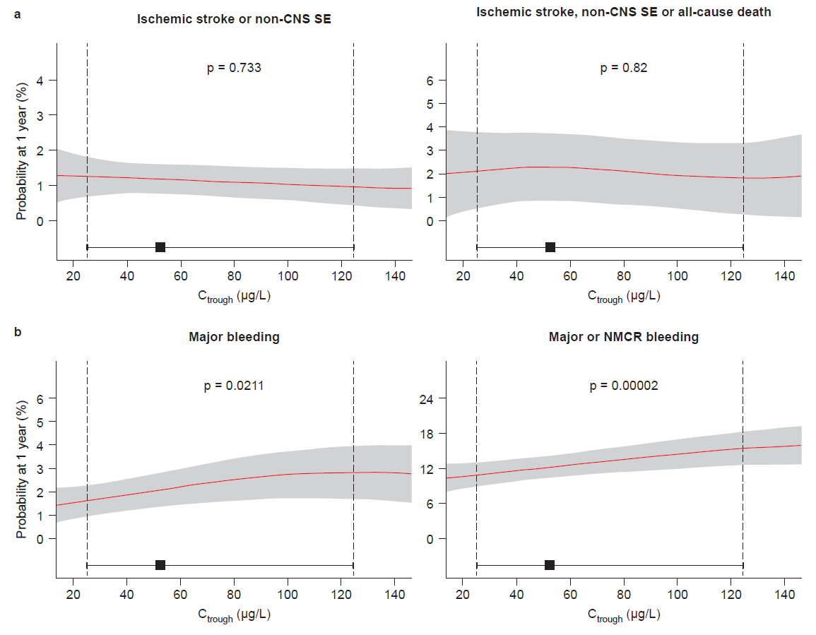Supplemental Fig. 1 Expected probability of (a) efficacy and (b) safety events at 1 year of treatment with rivaroxaban in a typical patient plotted against the range of increasing C_{trough} values. Red lines represent means and shaded areas represent 95% confidence intervals. Black squares represent median C_{trough} and horizontal error bars represent the range between the 5th and 95th percentiles of C_{trough}. Vertical dashed lines label the 5th and 95th percentiles of C_{trough}. p values presented are for the comparison of the 95th percentile of C_{trough} with the median. CNS central nervous system, C_{trough} trough concentration, NMCR non-major clinically relevant, SE systemic embolism

