Supplementary Table S3

Distribution of the resident population aged 80 years and older by region, according to the latest revision of the 2011 Population - Housing Census in Greece as completed by Hellenic Statistical Authority and respective number of patients enrolled in the study.

Region | Population aged ≥ 80 years (2011 Census) | Percentage share per region | Number of patients enrolled (population size 1018 patients)
- East Macedonia and Thrace | 38731 | 7% | 71
- Central Macedonia | 74099 | 13,4% | 137
- West Macedonia | 24395 | 4,4% | 45
- Epirus | 31076 | 5,6% | 57
- Thessaly | 48177 | 8,7% | 89
- Central Greece | 46816 | 8,5% | 86
- Ionian islands | 20422 | 3,7% | 38
- West Greece | 51536 | 9,3% | 95
- Peloponnese | 63632 | 11,5% | 117
- Attica | 71241 | 12,9% | 131
- North Aegean islands | 22916 | 4,1% | 42
- South Aegean islands | 21001 | 3,8% | 39
- Crete | 38891 | 7% | 71

Supplementary Table S4.

Distribution of dosing regimens among patients receiving NOACsª and classification in dosing groups: (a) recommended dosing, (b) underdosed, (c) overdosed based on European label recommendations.

Apixaban (n=304)
Recommended dosing |  |  | Underdosed |  |  | Overdosed
Dosing schema | N | % | Dosing schema | N | % | Dosing schema | N | %
2.5mg bid, CrCl:15–29 ml/min | 42 | 13.8 | 2.5 mg bid, in the absence of both Cr ≥ 1.5 mg/dL and weight ≤ 60 kg | 116 | 38.2 | 5 mg bid, Cr ≥ 1.5 mg/dL | 2 | 0.7
2.5 mg bid, Cr ≥ 1.5 mg/dL | 19 | 6.3 |  | 116 | 38.2 | 5 mg bid, weight ≤ 60 kg | 2 | 0.7
2.5 mg bid, weight ≤ 60 kg | 41 | 13.5 | 2.5 mg o.d. | 1 | 0.3
5 mg bid, in all other patients | 81 | 26.6
Dabigatran (n=83)
Recommended dosing |  |  | Underdosed |  |  | Overdosed
Dosing schema | N | % | Dosing schema | N | % | Dosing schema | N | %
110 mg bid | 63 | 75.9 | 75mg bid | 4 | 4.8 | 150mg bid | 9 | 10.8
 |  |  | 110mg od | 1 | 1.2 | Any dose if CrCl<30 ml/min | 5 | 6.0
 |  |  | 150mg od | 1 | 1.2
Rivaroxaban (n=198)
Recommended dosing |  |  | Underdosed |  |  | Overdosed
Dosing schema | N | % | Dosing schema | N | % | Dosing schema | N | %
15 mg od, CrCl:15-49 ml/min | 74 | 37.4 | 15 mg od, CrCl≥50 ml/min | 50 | 25.3 | 20 mg od, CrCl:15-49 ml/min | 22 | 11.1
20 mg od, CrCl ≥ 50 ml/min | 50 | 25.3 | 10mg od | 1 | 0.5 | Any dose if CrCl < 15 ml/min | 1 | 0.5

ªnon-vitamin K oral anticoagulants

Supplementary Figure 3

Μap of Greece with all regions reporting the percentage share and number
of patients enrolled in the study.

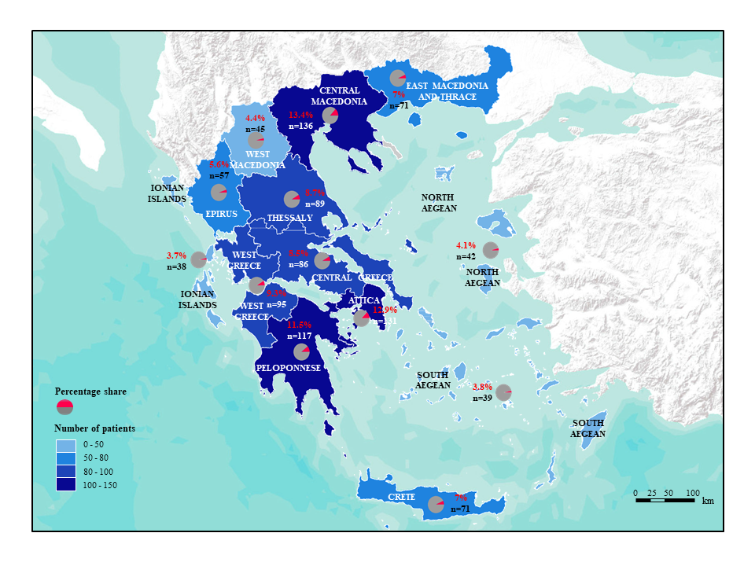

Supplementary Figure 4

Type of anticoagulant treatment administered in different atrial fibrillation type groups.

