Supplementary Material

Effects of Non-Vitamin K Antagonist Oral Anticoagulants versus Vitamin K Antagonist Therapy on Dementia Risk in Patients with Atrial Fibrillation: Systematic Review with Meta-Analysis

Authors: Diogo R Branco, Mariana Alves, Catarina Severiano Sousa,
João Costa, Joaquim J Ferreira, Daniel Caldeira

Corresponding author
Professor Joaquim Ferreira
Laboratory of Clinical Pharmacology and Therapeutics, Faculdade de Medicina, Universidade de Lisboa, Portugal. Av. Prof. Egas Moniz, Lisboa 1649-028, Portugal; joaquimjferreira@gmail.com
Contents
Supplementary table 1: Search strategy 3
Supplementary table 2: Primary outcomes and respective HRs 4
Supplementary table 3: Risk of bias 5
Supplementary table 4: PICOS 5
Supplementary table 5: Dementia criteria 5
ICD-10 codes 6
Conversion table: ICD-9 / ICD-10 10
Conversion table: ICD-8 / ICD-10 12
Supplementary figure 1: Hazard ratio for risk of bias subgroup analysis (moderate vs serious risk) 14
Supplementary figure 2: Hazard ratio for follow-up period subgroup analysis (short vs long follow-up) 14
Supplementary figure 3: Hazard ratio for outcome subgroup analysis (single vs composite outcome) 15
Supplementary figure 4: Egger Test 15

Supplementary table 1: Search strategy
# | Searches
1 | atrial fibrillation.af.
2 | (Atrial adj1 Fibrillat*).af.
3 | (Auricular adj1 Fibrillat*).af.
4 | atrial flutter.af.
5 | auricular flutter.af.
6 | Afib*.af.
7 | a-fib*.af.
8 | 1 or 2 or 3 or 4 or 5 or 6 or 7
9 | direct oral anticoagulant*.af.
10 | Direct Oral Anti-coagulant*.af.
11 | DTI*.af.
12 | Factor Xa Inhibitor*.af.
13 | Fxa inhibitor*.af.
14 | ((new or novel or newer or non-vitamin K or nonvitamin K or target-specific or target specific) adj3 anticoagulant*).af.
15 | rivaroxaban.af.
16 | dabigatran.af.
17 | edoxaban.af.
18 | apixaban.af.
19 | xarelto.af.
20 | savaysa.af.
21 | lixiana.af.
22 | pradaxa.af.
23 | eliquis.af.
24 | anticoagulant*.ti,ab.
25 | (Delirium or deliri*).af.
26 | (Dementia or dement*).af.
27 | (Cogniti* adj2 disorder*).af.
28 | Memory disorder*.af.
29 | Amnestic disorder* {Including Related Terms}
30 | Alzheimer Disease {Including Related Terms}
31 | (Dementia adj1 (senile or presenile)).af.
32 | exp Dementia, vascular/
33 | exp dementia/
34 | Frontotemporal lobar degeneration.af.
35 | Lewy body disease.af.
36 | (Cognitive adj1 impairment*).af.
37 | (Cognitive adj1 decline).af.
38 | (Cognitive adj1 loss).af.
39 | (Cognitive adj1 disorder).af.
40 | (Cognitive adj1 dysfunction).af.
41 | Neurocognitive disorder*.af.
42 | Mild cognitive impairment.af.
43 | exp Frontotemporal Dementia/
44 | exp Dementia, Multi-Infarct/
45 | exp Cognitive Dysfunction/
46 | Mini Mental State Examination.af.
47 | mmse.af.
48 | Montreal Cognitive Assessment {Including Related Terms}
49 | moca.af.
50 | COGNISTAT.af.
51 | Mini-Cog.af.
52 | "dementia rating".af.
53 | microcog.af.
54 | Cognitive Assessment Screening Instrument.af.
55 | 25 or 26 or 27 or 28 or 29 or 30 or 31 or 32 or 33 or 34 or 35 or 36 or 37 or 38 or 39 or 40 or 41 or 42 or 43 or 44 or 45 or 46 or 47 or 48 or 49 or 50 or 51 or 52 or 53 or 54
56 | 9 or 10 or 11 or 12 or 13 or 14 or 15 or 16 or 17 or 18 or 19 or 20 or 21 or 22 or 23 OR 24
57 | 8 and 55 and 56
58 | remove duplicates from 58

Supplementary table 2: Primary outcomes and respective HRs
Study year |  | Primary Outcome | HR
Chen et al. 2018 |  | Dementia | HR 0.85, 95%CI (0.71; 1.01)
Friberg et al. 2019 |  | Dementia | HR 0.97, 95%CI (0.67; 1.40)
Jacobs et al. 2016 |  | Composite outcome of dementia, stroke, and TIA | HR 0.42, 95%CI (0.18; 0.96)
Kim et al. 2020 |  | Dementia | HR 0.78, 95%CI (0.68; 0.90)
Mongkhon et al. 2020 |  | Composite of new-onset dementia/cognitive impairment | HR 0.89, 95%CI (0.69; 1.14)
Sogaard et al. 2019 | 60 – 69 years old | Dementia | HR 0.92, 95%CI (0.48; 1.76)
Sogaard et al. 2019 | 70 – 79 years old | Dementia | HR 0.86, 95%CI (0.68; 1.09)
Sogaard et al. 2019 | 80 or more years old | Dementia | HR 1.31, 95%CI (1.07; 1.59)
Hsu et al. 2021 |  | Dementia | HR 0.82, 95%CI (0.73; 0.92)
Kundnani et al. 2021 |  | Dementia | HR 0.38, 95%CI (0.09; 1.63)
Lee et al. 2021 |  | Dementia | HR 0.929, 95%CI (0.858; 1.007)

Supplementary table 3: Risk of bias
Author | Bias due to confounding | Bias in the selection of participants into the study | Bias in classification of interventions | Bias due to deviations from intended interventions | Bias due to missing data | Bias in the measurements of outcome | Bias in the selection of reported result | Overall risk of Bias
Chen et al. 2018 | Moderate | Moderate | Moderate | Low | Low | Moderate | Low | Moderate
Friberg et al. 2019 | Moderate | Low | Moderate | Low | Low | Serious | Low | Serious
Jacobs et al. 2016 | Moderate | Moderate | Moderate | Low | Low | Moderate | Low | Moderate
Kim et al. 2020 | Moderate | Low | Moderate | Low | Low | Moderate | Low | Moderate
Mongkhon et al. 2020 | Moderate | Low | Moderate | Low | Low | Serious | Low | Serious
Søgaard et al. 2019 | Moderate | Low | Moderate | Low | Low | Moderate | Low | Moderate
Hsu et al. 2021 | Moderate | Low | Moderate | Low | Low | Moderate | Low | Moderate
Kundnani et al. 2021 | Moderate | Low | Moderate | Low | Low | Moderate | Low | Moderate
Lee et al. 2021 | Moderate | Low | Moderate | Low | Low | Serious | Low | Serious

Supplementary table 4: PICOS
Parameter | Inclusion criteria
Participants | Patients with atrial fibrillation who had no previous diagnosis of neurocognitive impairment or dementia.
Interventions | Oral anticoagulation defined as non-vitamin K antagonists / direct oral anticoagulants (apixaban, dabigatran, edoxaban, rivaroxaban).
Comparators | Oral anticoagulation defined as vitamin K antagonists (warfarin, phenprocoumon, acenocoumarol).
Outcomes | Incidence of dementia.
Study designs | Randomized controlled trials or observational studies.

Supplementary table 5: Dementia criteria
Study | MMSE (Mini Mental State Examination) | ICD-8 | ICD-9 | ICD-10
 |  |  |  | Chapter V  Mental and behavioral disorders  (F00-F99) | Chapter VI  Diseases of the nervous system  (G00-G99)
Friberg et al. 2019 (Ref 23) | NA | NA | NA | F00- Dementia in Alzheimer disease  F01- Vascular dementia  F02- Dementia in other diseases classified elsewhere  F03- Unspecified dementia | G051- Encephalitis, myelitis and encephalomyelitis in viral diseases classified elsewhere  G300- Alzheimer disease with early onset  G301- Alzheimer disease with late onset  G308- Other Alzheimer disease  G309- Alzheimer disease, unspecified  G310- Other degenerative diseases of nervous system, not elsewhere classified- Circumscribed brain atrophy (Frontotemporal dementia, Pick disease, Progressive isolated aphasia)  G311- Other degenerative diseases of nervous system, not elsewhere classified- Senile degeneration of brain, not elsewhere classified (Alzheimer disease, Senility NOS)  G312- Other degenerative diseases of nervous system, not elsewhere classified- Degeneration of nervous system due to alcohol (Alcoholic cerebellar ataxia, alcoholic cerebellar degeneration, cerebral degeneration, encephalopathy, dysfunction of autonomic nervous system due to alcohol)  G318- Other degenerative diseases of nervous system, not elsewhere classified- Other specified degenerative diseases of nervous system (Grey-matter degeneration, Lewy body dementia/disease, subacute necrotizing encephalopathy)
Jacobs et al. 2016 (Ref 24) | NA | NA | 290-294 (organic psychotic conditions)  331 (other cerebral degenerations)  (See ICD-9 code table) | NA | NA
Chen et al. 2018 (Ref 27) | NA | NA | 290 (dementia)  294 (persistent mental disorders attributable to conditions classified elsewhere)  331 (Alzheimer disease)  (See ICD-9 code table) | NA | NA
Kim et al. 2020 (Ref 28) | NA | NA | NA | F00- Dementia in Alzheimer disease  F01- Vascular dementia  F02- Dementia in other diseases classified elsewhere  F03- Unspecified dementia, combined with use of one or more of dementia drugs (rivastigmine, galantamine, memantine, donepezil) | G30- Alzheimer disease (ver lista de códigos)  G31- Other degenerative diseases of nervous system, not elsewhere classified (See ICD-10 code table)
Mongkhon et al. 2020 (Ref 29) | NR* | NR* | NR* | NR* | NR*
Sogaard et al. 2019 (Ref 30) | NA | Alzheimer dementia:  290.10  290.09  Vascular dementia:  293.09  293.19  Other dementia:  094.19  290.11-290.19 | NA | Alzheimer dementia:  F00  Vascular dementia:  F01  Other dementia:  F02-F03  F10.73-F19.73 | Alzheimer dementia:  G30  Other dementia:  G23.1  G31.0A  G31.0B  G31.1  G31.8B  G31.8E  G31.85
Hsu et al. 2021 (Ref 31) | NA | NA | 290.0-290.4- Ver lista  331.0- Alzheimer disease | F01- Vascular dementia  F03- Unspecified dementia | G30- Alzheimer disease
Lee et al. 2021 | NR* | NR* | NR* | NR* | NR*
Kundnani 2021 | NR**

NA: Not applicable
NR: Not reported
* Supplement data not available.
** The authors state that they used MMSE and SCL-90 for neuropsychiatric evaluations. They do not mention the exact criteria used.

ICD-10 codes
F00 Dementia in Alzheimer's disease
F00.0*Dementia in Alzheimer disease with early onset
F00.1*Dementia in Alzheimer disease with late onset
F00.2*Dementia in Alzheimer disease, atypical or mixed type
F00.9*Dementia in Alzheimer disease, unspecified
F01 Vascular dementia
F01.0 Vascular dementia of acute onset
F01.1 Multi-infarct dementia
F01.2 Subcortical vascular dementia
F01.3 Mixed cortical and subcortical vascular dementia
F01.8 Other vascular dementia
F01.9 Vascular dementia, unspecified
F02 Dementia in other diseases classified elsewhere
F02.0 Dementia in Pick's disease
F02.1 Dementia in Creutzfeldt-Jakob disease
F02.2 Dementia in Huntington's disease
F02.3 Dementia in Parkinson's disease
F02.4 Dementia in human immunodeficiency virus [HIV] disease
F02.8 Dementia in other specified diseases classified elsewhere
F03 Unspecified dementia
F10 Mental and behavioral disorders due to use of alcohol
F10.0 Acute intoxication
F10.1 Harmful use
F10.2 Dependence syndrome
F10.3 Withdrawal state
F10.4 Withdrawal state with delirium
F10.5 Psychotic disorder
F10.6 Amnesic syndrome
F10.7 Residual and late-onset psychotic disorder
F10.8 Other mental and behavioral disorders
F10.9 Unspecified mental and behavioral disorder
F11 Mental and behavioral disorders due to use of opioids
F11.0 Acute intoxication
F11.1 Harmful use
F11.2 Dependence syndrome
F11.3 Withdrawal state
F11.4 Withdrawal state with delirium
F11.5 Psychotic disorder
F11.6 Amnesic syndrome
F11.7 Residual and late-onset psychotic disorder
F11.8 Other mental and behavioral disorders
F11.9 Unspecified mental and behavioral disorder
F12 Mental and behavioral disorders due to use of cannabinoids
F12.0 Acute intoxication
F12.1 Harmful use
F12.2 Dependence syndrome
F12.3 Withdrawal state
F12.4 Withdrawal state with delirium
F12.5 Psychotic disorder
F12.6 Amnesic syndrome
F12.7 Residual and late-onset psychotic disorder
F12.8 Other mental and behavioral disorders
F12.9 Unspecified mental and behavioral disorder
F13 Mental and behavioral disorders due to use of sedatives or hypnotics
F13.0 Acute intoxication
F13.1 Harmful use
F13.2 Dependence syndrome
F13.3 Withdrawal state
F13.4 Withdrawal state with delirium
F13.5 Psychotic disorder
F13.6 Amnesic syndrome
F13.7 Residual and late-onset psychotic disorder
F13.8 Other mental and behavioral disorders
F13.9 Unspecified mental and behavioral disorder
F14 Mental and behavioral disorders due to use of cocaine
F14.0 Acute intoxication
F14.1 Harmful use
F14.2 Dependence syndrome
F14.3 Withdrawal state
F14.4 Withdrawal state with delirium
F14.5 Psychotic disorder
F14.6 Amnesic syndrome
F14.7 Residual and late-onset psychotic disorder
F14.8 Other mental and behavioral disorders
F14.9 Unspecified mental and behavioral disorder
F15 Mental and behavioral disorders due to use of other stimulants, including caffeine
F15.0 Acute intoxication
F15.1 Harmful use
F15.2 Dependence syndrome
F15.3 Withdrawal state
F15.4 Withdrawal state with delirium
F15.5 Psychotic disorder
F15.6 Amnesic syndrome
F15.7 Residual and late-onset psychotic disorder
F15.8 Other mental and behavioral disorders
F15.9 Unspecified mental and behavioral disorder
F16 Mental and behavioral disorders due to use of hallucinogens
F16.0 Acute intoxication
F16.1 Harmful use
F16.2 Dependence syndrome
F16.3 Withdrawal state
F16.4 Withdrawal state with delirium
F16.5 Psychotic disorder
F16.6 Amnesic syndrome
F16.7 Residual and late-onset psychotic disorder
F16.8 Other mental and behavioral disorders
F16.9 Unspecified mental and behavioral disorder
F17 Mental and behavioral disorders due to use of tobacco
F17.0 Acute intoxication
F17.1 Harmful use
F17.2 Dependence syndrome
F17.3 Withdrawal state
F17.4 Withdrawal state with delirium
F17.5 Psychotic disorder
F17.6 Amnesic syndrome
F17.7 Residual and late-onset psychotic disorder
F17.8 Other mental and behavioral disorders
F17.9 Unspecified mental and behavioural disorder
F18 Mental and behavioral disorders due to use of volatile solvents
F18.0 Acute intoxication
F18.1 Harmful use
F18.2 Dependence syndrome
F18.3 Withdrawal state
F18.4 Withdrawal state with delirium
F18.5 Psychotic disorder
F18.6 Amnesic syndrome
F18.7 Residual and late-onset psychotic disorder
F18.8 Other mental and behavioral disorders
F18.9 Unspecified mental and behavioral disorder
F19 Mental and behavioral disorders due to multiple drug use and use of other psychoactive substances
F19.0 Acute intoxication
F19.1 Harmful use
F19.2 Dependence syndrome
F19.3 Withdrawal state
F19.4 Withdrawal state with delirium
F19.5 Psychotic disorder
F19.6 Amnesic syndrome
F19.7 Residual and late-onset psychotic disorder
F19.8 Other mental and behavioral disorders
F19.9 Unspecified mental and behavioral disorder
G05 Encephalitis, myelitis and encephalomyelitis in diseases classified elsewhere
G05.0 Encephalitis, myelitis and encephalomyelitis in bacterial diseases classified elsewhere
G05.1 Encephalitis, myelitis and encephalomyelitis in viral diseases classified elsewhere
G05.2 Encephalitis, myelitis and encephalomyelitis in other infectious and parasitic diseases classified elsewhere
G05.8 Encephalitis, myelitis and encephalomyelitis in other diseases classified elsewhere
G23 Other degenerative diseases of basal ganglia
G23.0 Hallervorden-Spatz disease
G23.1 Progressive supranuclear ophthalmoplegia [Steele-Richardson-Olszewski]
G23.2 Multiple system atrophy, parkinsonian type
G23.3Multiple system atrophy, cerebellar type
G23.8Other specified degenerative diseases of basal ganglia
G23.9Degenerative disease of basal ganglia, unspecified
G30 Alzheimer's disease
G30.0 Alzheimer's disease with early onset
G30.1 Alzheimer's disease with late onset
G30.8 Other Alzheimer's disease
G30.9 Alzheimer's disease, unspecified
G31 Other degenerative diseases of nervous system, not elsewhere classified
G31.0 Circumscribed brain atrophy (Frontotemporal dementia, Pick disease, Progressive isolated aphasia)
G31.1 Senile degeneration of brain, not elsewhere classified
G31.2 Degeneration of nervous system due to alcohol
G31.8 Other specified degenerative diseases of nervous system (Grey-matter degeneration, Lewy-body dementia/disease, Subacute necrotizing encephalopathy)
G31.9 Degenerative disease of nervous system, unspecified

Conversion table: ICD-9 / ICD-10
ICD-9 | ICD-10
290 Senile and presenile organic psychotic conditions | No direct conversion
290.0 Senile dementia, uncomplicated | F03.90 Unspecified dementia without behavioral disturbance
290.1 Presenile dementia | No direct conversion
290.10 Presenile dementia, uncomplicated | F03.90 Unspecified dementia without behavioral disturbance
290.11 Presenile dementia with delirium | F03.90 Unspecified dementia without behavioral disturbance
290.12 Presenile dementia with delusional | F03.90 Unspecified dementia without behavioral disturbance
290.13 Presenile dementia with depressive | F03.90 Unspecified dementia without behavioral disturbance
290.2 Senile dementia with delusional or depressive features | No direct conversion
290.20 Senile dementia with delusional features | F03.90 Unspecified dementia without behavioral disturbance
290.21 Senile dementia with depressive features | F03.90 Unspecified dementia without behavioral disturbance
290.3 Senile dementia with delirium | F03.90 Unspecified dementia without behavioral disturbance
290.4 Arteriosclerotic dementia | No direct conversion
290.40 Arteriosclerotic dementia, uncomplicated | F01.50 Vascular dementia without behavioral disturbance
290.41 Arteriosclerotic dementia with delirium | F01.51 Vascular dementia with behavioral disturbance
290.42 Arteriosclerotic dementia with delusional features | F01.51 Vascular dementia with behavioral disturbance
290.43 Arteriosclerotic dementia with depressive features | F01.51 Vascular dementia with behavioral disturbance
290.8 Other specified senile psychotic conditions | F03.90 Unspecified dementia without behavioral disturbance
290.9 Unspecified senile psychotic condition | F03.90 Unspecified dementia without behavioral disturbance
291 Alcoholic psychoses | No direct conversion
291.0 Alcohol withdrawal delirium | F10.231 Alcohol dependence with withdrawal delirium
291.1 Alcohol amnestic syndrome | F10.96 Alcohol use, unspecified with alcohol-induced persisting amnestic disorder
291.2 Other alcoholic dementia | F10.27 Alcohol dependence with alcohol-induced persisting dementia
291.3 Alcohol withdrawal hallucinosis | F10.951 Alcohol use, unspecified with alcohol-induced psychotic disorder with hallucinations
291.4 Idiosyncratic alcohol intoxication | F10.929 Alcohol use, unspecified with intoxication, unspecified
291.5 Alcoholic jealousy | F10.950 Alcohol use, unspecified with alcohol-induced psychotic disorder with delusions
291.8 Other specified alcoholic psychosis | No direct conversion
291.9 Unspecified alcoholic psychosis | F10.99 Alcohol use, unspecified with unspecified alcohol-induced disorder
292 Drug psychoses | No direct conversion
292.0 Drug withdrawal syndrome | F19.939 Other psychoactive substance use, unspecified with withdrawal, unspecified
292.1 Paranoid and/or hallucinatory states induced by drugs | No direct conversion
292.11 Drug-induced organic delusional syndrome | F19.950 Other psychoactive substance use, unspecified with psychoactive substance-induced psychotic disorder with delusions
292.12 Drug-induced hallucinosis | F19.951 Other psychoactive substance use, unspecified with psychoactive substance-induced psychotic disorder with hallucinations
292.2 Pathological drug intoxication | F15.920 Other stimulant use, unspecified with intoxication, uncomplicated
292.8 Other specified drug-induced mental disorders | No direct conversion
292.81 Drug-induced delirium | F19.921 Other psychoactive substance use, unspecified with intoxication with delirium
292.82 Drug-induced dementia | F19.97 Other psychoactive substance use, unspecified with psychoactive substance-induced persisting dementia
292.83 Drug-induced amnestic syndrome | F19.96 Other psychoactive substance use, unspecified with psychoactive substance-induced persisting amnestic disorder
292.84 Drug-induced organic affective syndrome | F19.94 Other psychoactive substance use, unspecified with psychoactive substance-induced mood disorder
292.89 Other | F11-F19 (105 codes)
292.9 Unspecified drug-induced mental disorder | F19.99 Other psychoactive substance use, unspecified with unspecified psychoactive substance-induced disorder
293 Transient organic psychotic conditions | No direct conversion
293.0 Acute delirium | F05 Delirium due to known physiological condition
293.1 Subacute delirium | F05 Delirium due to known physiological condition
293.8 Other specified transient organic mental disorders | No direct conversion
293.81 Organic delusional syndrome | F06.2 Psychotic disorder with delusions due to known physiological condition
293.82 Organic hallucinosis syndrome | F06.0 Psychotic disorder with hallucinations due to known physiological condition
293.83 Organic affective syndrome | F06.30 Mood disorder due to known physiological condition, unspecified
293.89 Other | F06.1 Catatonic disorder due to known physiological condition  F53 Puerperal psychosis
293.9 Unspecified transient organic mental disorder | F06.8 Other specified mental disorders due to known physiological condition
294 Other organic psychotic conditions (chronic) | No direct conversion
294.0 Amnestic syndrome | F04 Amnestic disorder due to known physiological condition
294.1 Dementia in conditions classified elsewhere | No direct conversion
294.8 Other specified organic brain syndromes (chronic) | F06.0 Psychotic disorder with hallucinations due to known physiological condition  F06.8 Other specified mental disorders due to known physiological condition
294.9 Unspecified organic brain syndrome (chronic) | F06.8 Other specified mental disorders due to known physiological condition
331 Other cerebral degenerations | No direct conversion
331.0 Alzheimer's disease | G30.9 Alzheimer disease, unspecified
331.1 Pick's disease | No direct conversion
331.2 Senile degeneration of brain | G31.1 Senile degeneration of brain, not elsewhere classified
331.3 Communicating hydrocephalus | G91.0 Communicating hydrocephalus
331.4 Obstructive hydrocephalus | G91.1 Obstructive hydrocephalus
331.5 Jakob-Creutzfeldt disease | G91.2 (Idiopathic) normal pressure hydrocephalus
331.6 Progressive multifocal leukoencephalopathy | G31.85 Corticobasal degeneration
331.7 Cerebral degeneration in other diseases classified elsewhere | G94 Other disorders of brain in diseases classified elsewhere
331.8 Other cerebral degeneration | No direct conversion
331.81 Reye's syndrome | G93.7 Reye's syndrome
331.89 Other | G31.89 Other specified degenerative diseases of nervous system
331.9 Cerebral degeneration, unspecified | G31.9 Degenerative disease of nervous system, unspecified

Conversion table: ICD-8 / ICD-10
ICD-8 | ICD-10
094 Syphilis of central nervous system | No direct conversion
094.0 Tabes dorsalis | A52.11 Tabes dorsalis
094.1 General paresis | A52.17 General paresis
094.9 Other syphilis of central nervous system | A52.3 Neurosyphilis, unspecified
290 Senile and presenile dementia | No direct conversion
290.0 Senile dementia | F00.1* Dementia in Alzheimer disease, late onset  F00.2* Dementia in Alzheimer’s disease, atypical or mixed type
290.1 Presenile dementia | F00.0* Dementia in Alzheimer’s disease, early onset  F02.1* Dementia in Creutzfeldt-Jakob disease  F02.0* Dementia in Pick disease
293 Psychosis associated with other cerebral condition | No direct conversion
293.0 Cerebral arteriosclerosis | F01.1 Multi-infarct dementia  F01.3 Mixed cortical and subcortical vascular dementia
293.1 Other cerebrovascular disturbances | F01.0 Vascular dementia of acute onset  F01.2 Subcortical vascular dementia  F01.8 Other vascular dementia
293.2 Epilepsy | Use 2 codes: one from the list of disorders mentioned for 292, plus an additional code to specify the associated condition:  G40 Epilepsy
293.3 Intercranial neoplasm | Use 2 codes: one from the list of disorders mentioned for 292, plus one of the following codes to specify the associated condition:  C70.—Malignant neoplasm of meninges  C71.—Malignant neoplasm of brain  D32.0 Benign neoplasm of cerebral meninges  D33.—Benign neoplasm of brain and other parts of central nervous system
293.4 Degenerative diseases of central nervous system | Use 2 codes: one from the list of disorders mentioned for 292, plus an additional code to specify the associated condition:  F02.2* Dementia in Huntington disease
293.5 Brain trauma | Use 2 codes: one from the list of disorders mentioned for 292, plus an additional code to specify the associated brain trauma, such as:  S06.—Intracranial injury  S02.—Fracture of skull and facial bones  S07.—Crushing injury of head  P10.—Intracranial laceration and hemorrhage due to birth injury  P20.—Intrauterine hypoxia  P21.—Birth asphyxia
293.9 Other and unspecified cerebral condition | F02.8 Dementia in other diseases classified elsewhere  F03 Unspecified dementia  F04 Organic amnesic syndrome, not induced by alcohol or other psychoactive substances.  F05.9 Unspecified delirium  F06.9 Unspecified mental disorder, due to brain damage and dysfunction and to physical disease  F09 Unspecified organic or symptomatic mental disorder

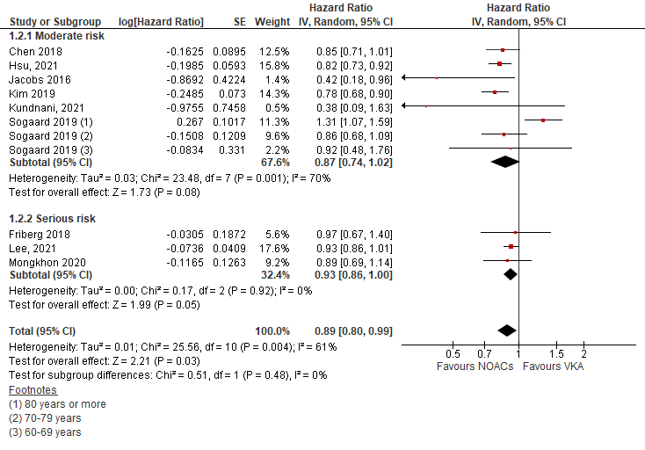

Supplementary figure 1: Hazard ratio for risk of bias subgroup analysis (moderate vs serious risk)

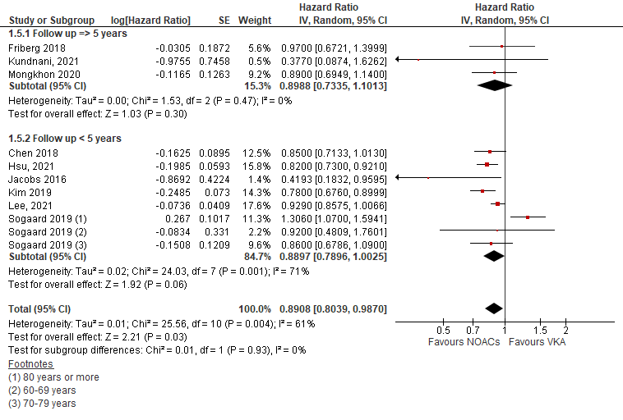

Supplementary figure 2: Hazard ratio for follow-up period subgroup analysis (short vs long follow-up)

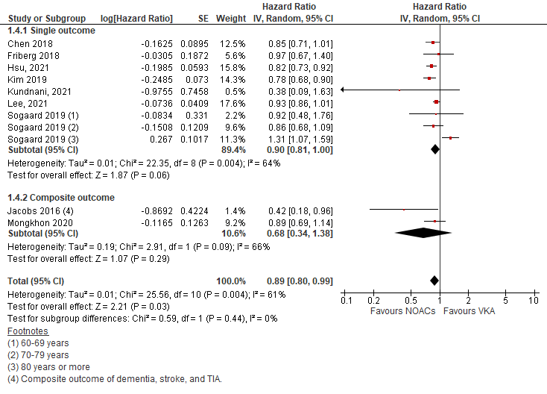

Supplementary figure 3: Hazard ratio for outcome subgroup analysis (single vs composite outcome)

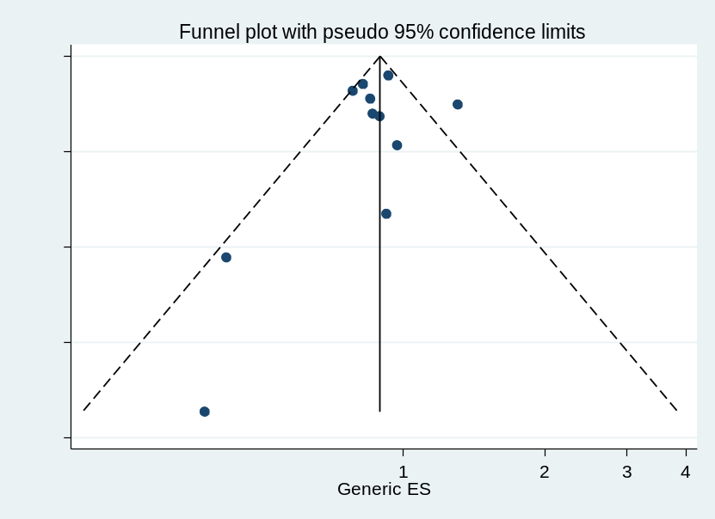

Supplementary figure 4: Egger Test
No small-study effects / publication bias was detected (P = 0.586).

