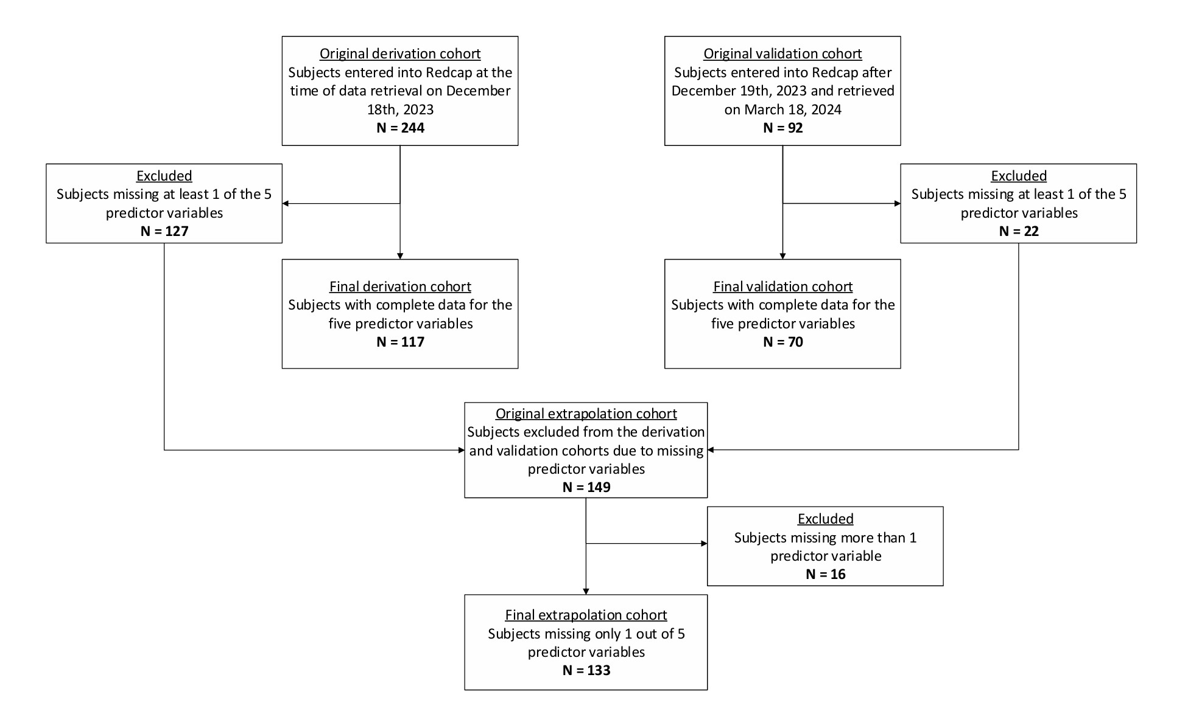
e-Figure 1: STROBE diagram of the inclusion and exclusion of subjects in the derivation, validation, and extrapolation cohorts.
The final derivation cohort was used to develop the PEP score. The validation cohort was used to test the PEP score on an independent sample. The extrapolation cohort was used to test the PEP score on subjects missing 1 of the 5 predictor variables, referred to as the modified PEP score.

 | Clinical Deterioration within 72 hours
Clinical/Historical Variables, N (%) | No (N=192) | Yes (N=52) | P-value
HR > 110 bpm | 69 (35.9) | 31 (59.6) | 0.002
Supplemental O2 > 4L/min (above baseline)¹ | 18 (9.4) | 28 (53.9) | <0.001
Dyspnea | 150 (78.1) | 47 (90.4) | 0.05
Altered mental status | 15 (7.8) | 11 (21.2) | 0.005
Syncope | 21 (10.9) | 10 (19.2) | 0.11
Presence of DVT | 122 (63.5) | 40 (76.9) | 0.07
Active/past malignancy | 42 (23.5) | 13 (25.5) | 0.76
Prior PE or DVT | 39 (20.3) | 7 (13.5) | 0.26
Pre-existing heart failure | 25 (13.0) | 8 (15.4) | 0.66
Chronic lung disease | 50 (26.0) | 12 (23.1) | 0.66
Recent systemic infection | 24 (12.5) | 14 (26.9) | 0.01
Echocardiogram Findings, N (%)
RV dilation | 77 (40.1) | 42 (80.8) | <0.001
Septal flattening² | 49 (25.5) | 39 (75) | <0.001
Clot in transit | 5 (2.6) | 8 (15.4) | <0.001
McConnell sign | 27 (14.1) | 21 (40.4) | <0.001
RVSP > 40 mm Hg | 72 (48.0) | 32 (72.7) | <0.001
TAPSE ≤ 13 mm | 20 (11.3) | 22 (43.1) | <0.001
CTPA Findings, N (%)
RV:LV ratio > 1.0 | 98 (53.0) | 42 (84.0) | <0.001
Saddle thrombus | 35 (18.23) | 25 (48.1) | <0.001
Left main artery thrombus | 87 (45.3) | 35 (67.3) | 0.004
Right main artery thrombus | 98 (51.0) | 41 (78.9) | <0.001
Left lobar artery thrombus | 91 (47.4) | 34 (65.4) | 0.02
Right lobar artery thrombus | 104 (54.2) | 39 (75.0) | 0.007
Left segmental artery thrombus | 78 (40.6) | 29 (55.8) | 0.05
Right segmental artery thrombus | 92 (48.0) | 30 (57.7) | 0.21
Left subsegmental artery thrombus | 32 (16.7) | 18 (34.7) | 0.004
Right subsegmental artery thrombus | 35 (18.2) | 20 (38.5) | 0.002
Right and/or left subsegmental artery thrombus | 42 (21.9) | 22 (42.3) | <0.01
Central (saddle or main or lobar artery) thrombus | 147 (76.6) | 47 (90.4) | 0.03
Central and subsegmental artery thrombus³ | 27 (14.1) | 20 (38.5) | <0.001
Laboratory Results, N (%)
Hs-cTnT T > 40 ng/L | 89 (47.9) | 39 (76.5) | <0.001
Lactate > 2 mmol/L | 25 (32.1) | 35 (76.1) | <0.001
NT-proBNP > 300 pg/mL | 102 (53.1) | 39 (75.0) | 0.06

e-Table 1: Univariate analysis of the original derivation cohort.
Chi-Square test was used to compare variables between those who had clinical deterioration and those who did not. The original derivation cohort included 244 subjects before excluding those with missing predictor variables.
DVT = Deep Vein Thrombosis; HR = Heart Rate, Hs-cTnT = High-sensitivity Cardiac Troponin T; NT-proBNP: N-Terminal pro-B-type Natriuretic Peptide; PE = pulmonary embolism; RVSP = Right Ventricular Systolic Pressure; TAPSE = Tricuspid Annular Plane Systolic Excursion

- Supplemental oxygen requirements, rather than SpO2, was used as a marker of hypoxemia because many patients brought to the emergency department by ambulance were already on supplemental O2.
- Septal flattening was in the initial mode, but it was replaced with TAPSE < 13 mm to improve clinical objectivity.
- Central thrombus, defined as clot at the pulmonary trunk bifurcation (“saddle”) and/or in the main or lobar pulmonary arteries, was combined with subsegmental thrombus to serve as a surrogate for clot burden.

