Supplementary material Plant Cell, Tissue and Organ Culture
Title Inheritance patterns of the response to in vitro doubled haploid induction in perennial ryegrass (Lolium perenne L.)
Authors Rachel F. Begheyn¹, Niels Roulund², Kirsten Vangsgaard², David Kopecký³ and Bruno Studer¹
Corresponding author Bruno Studer (bruno.studer@usys.ethz.ch)
Affiliations
- Molecular Plant Breeding, Institute of Agricultural Sciences, ETH Zurich, Universitätsstrasse 2, 8092 Zurich, Switzerland
- DLF Research Center, Højerupvej 31, 4460 Store Heddinge, Denmark
- Centre of the Region Haná for Biotechnological and Agricultural Research, Institute of Experimental Botany, Šlechtitelů 31, CZ-78371, Olomouc-Holice, Czech Republic
Table of contents
Supplementary Table S1 – page 1.
Supplementary Table S2 – page 2.
Supplementary Fig. S1 – page 3.
Supplementary Table S1 Response of the paircross parents of the populations evaluated in this study to in vitro doubled haploid (DH) induction and their androgenic classification. This data has been generated approximately two decades ago at the research and breeding station of DLF A/S in Store Heddinge, Denmark
Paircross parent | ELS per 100 AC | Plants per 100 AC | Plants per 100 EC | GP per  100 AC (%) |  | GP per  100 EC | Androgenic  characteristics
Androgenic
P2 | 283 | 168 | 59 | 98 | (58) | 35 | Many GP
P102 | 913 | 357 | 39 | 183 | (51) | 20 | Many GP
P169 | 906 | 592 | 65 | 506 | (86) | 56 | Many GP
Non-androgenic
P10 | 510 | 171 | 33 | 0 |  | 0 | Many albinos, no GP
P48 | 527 | 137 | 26 | 0 |  | 0 | Many albinos, no GP
P133 | 833 | 188 | 23 | 0 |  | 0 | Many albinos, no GP
P144 | 556 | 103 | 19 | 0 |  | 0 | Many ELS, no plants
P175 | 0 | 0 |  | 0 |  |  | No ELS, no plants
AC – anthers cultured; ELS – embryo-like structures; EC – ELS cultured; GP – green plants

Supplementary Table S2 Differences between the responses of the genotypes grouped by common non-androgenic paircross parent (top) or common androgenic paircross parent (bottom). The combination with a significantly higher or lower response is indicated
Non-androgenic parent | Androgenic parent | Embryogenic anthers (%) | ELS/100AC | P/100AC | P/100EC | GP/100AC | GP/100EC | A/100AC | A/100EC
P10 | P2 | ns | ns | ns | ns | ns | ns | ns | ns
 | P169 | ns | ns | ns | ns | ns | ns | ns | ns
P48 | P2 | ns | ns | ns | ns | ns |  | ns | ns
 | P102 | ns | ns | ns | ns | ns | higher* | ns | ns
P133 | P2 | lowest* | ns | ns | ns | ns | ns | ns | ns
 | P102 |  | ns | ns | ns | ns | ns | ns | ns
 | P169 |  | ns | ns | ns | ns | ns | ns | ns
Androgenic parent | Non-androgenic parent | Embryogenic anthers (%) | ELS/100AC | P/100AC | P/100EC | GP/100AC | GP/100EC | A/100AC | A/100EC
P2 | P10 2
 | P48 3
 | P133 1 |  | higher than P48, P144* |  |  |  | ns | higher than P48, P144* | higher than P144*
 | P144 10 |  |  |  | ns |  | ns |  | ns
 | P175 11 | lowest*** | lowest** | lowest** | lowest* | lowest* | lower* | lowest** | lowest*
P102 | P48 6 | ns | ns | ns | higher* | ns | higher** | ns | ns
 | P133 4 | ns | ns | ns |  | ns |  | ns | ns
P169 | P10 8 |  | ns |  | ns | ns | ns |  | ns
 | P133 7 | higher** | ns | higher* | ns | ns | ns | higher* | ns

A – albinos; AC – anthers cultured; ELS – embryo-like structures; EC – ELS cultured; GP – green plants; P – plants. *** P ≤ 0.001; ** P ≤ 0.01; * P ≤ 0.05; ns – not significant
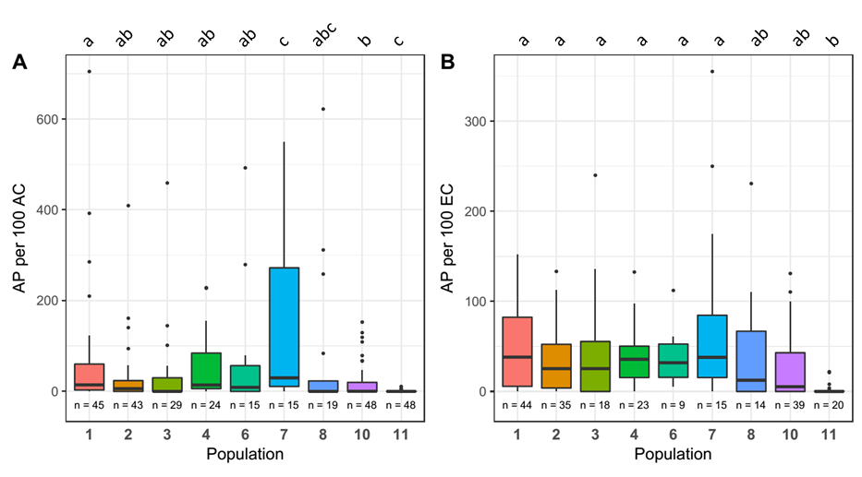
Supplementary Fig. S1 Boxplots of the responses of the evaluated populations to anther culture. The letters above each plot denote significant differences between populations (P ≤ 0.05). a number of albino plants (AP) regenerated per 100 anthers cultured (AC); b number of AP regenerated per 100 embryo-like structures cultured (EC). For graphical reasons, observation 800 from population 11 has been omitted from graph b

