Supplementary Material 1
Information on biochar production
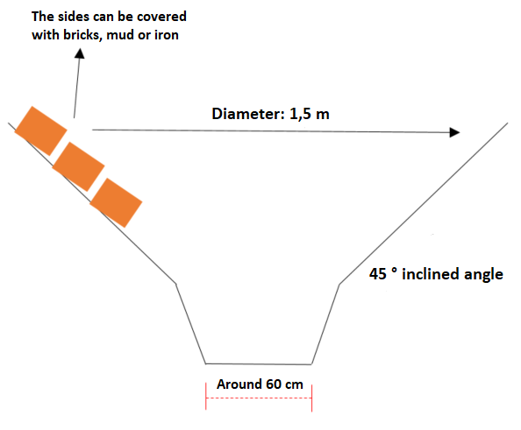

Figure 1a -Design of the floor kiln used for the production of biochar derived from Gliricidia sepium (biochar II and its activated variants)
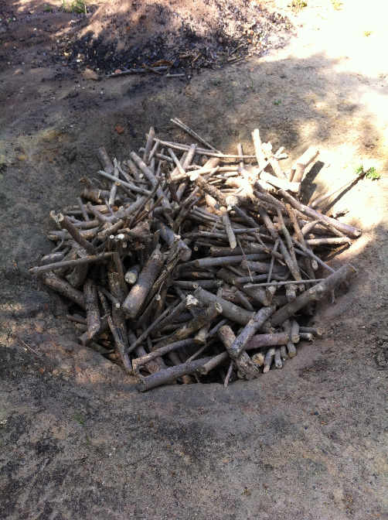

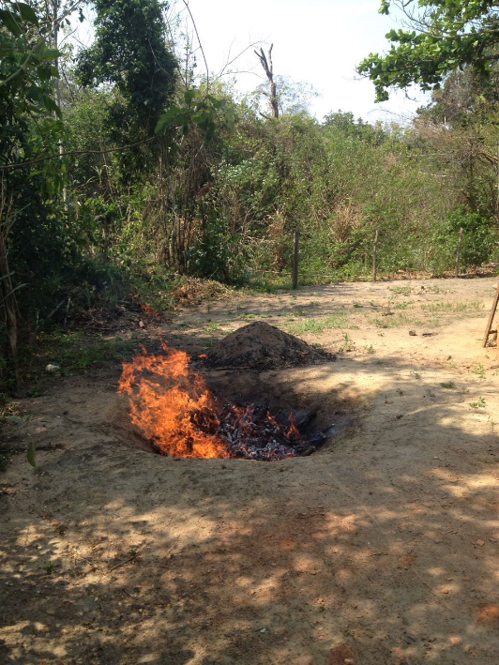
Figure 1b – Floor kiln and Gliricidia sepium biomass
Figure 1c – Process of biochar II production from Gliricidia sepium in the floor kiln

