Supplementary table S1: List of Amino acid substitutions observed in herbicide resistant weed biotypes (www.weedscience.com) or site-mutants or transgenic gene-edited plants conferring herbicide resistance.
Domains | Amino acid substitutions in ALS (numbering based on AtALS) | Total number of highly resistant species | Number of highly resistant weed biotypes |  |  |  |  | Site-mutants or gene-editing conferring resistance to ALS inhibiting herbicides
Domains | Amino acid substitutions in ALS (numbering based on AtALS) | Total number of highly resistant species | TP** | SU** | PTB** | IMI** | SCT** | Dicots | Monocots
1 | A122T | 6 | 1 |  |  | 6 |  | tobacco¹, sunflower², sugarbeet³ | maize¹⁴, wheat¹⁶
1 | A122V | 2 |  | 1 |  | 1 |  | tobacco⁴, sunflower⁵
1 | A122N | 1 | 1 | 1 | 1 | 1
1 | A122Y* | 1 | 1 | 1 |  | 1
2 | P197A | 11 | 3 | 11 | 1 |  |  | tomato⁶ | wheat¹⁸
2 | P197R | 5 |  | 5 |  |  | 1
2 | P197N | 1 |  | 1
2 | P197Q | 7 | 1 | 7 |  |  |  | tobacco⁷
2 | P197E | 1 | 1 | 1 | 1 | 1
2 | P197H | 9 | 3 | 8 | 1 | 1
2 | P197I | 1 | 1 | 1
2 | P197L | 13 | 1 | 13 | 1 | 2 |  | Sunflower⁸
2 | P197S*† | 26 | 4 | 24 | 2 |  | 2 | potato⁶, tomato⁶, tobacco⁴, soybean^{9, 10}, watermelon¹¹, grapevine (confirmed in this study) | maize¹⁵, wheat¹⁸
2 | P197T | 14 | 2 | 13 | 1 |  | 1 | tomato⁶, potato⁶, grapevine (confirmed in this study)
2 | P197Y | 1 |  | 1
3 | A205F | 1 | 1 | 1 | 1 | 1 | 1
3 | A205V* | 6 |  | 1 | 1 | 4 |  | sunflower⁵
4 | D376E* | 13 | 6 | 9 | 4 | 3 | 3
4 | R377H* | 1 | 1 | 1 |  |  | 1

Supplementary table S1 (continued from preceding page)
Domains | Amino acid substitutions in ALS (numbering based on AtALS) | Total number of highly resistant species | Number of highly resistant weed biotypes |  |  |  |  | Site-mutants or gene-editing conferring resistance to ALS inhibiting herbicides
Domains | Amino acid substitutions in ALS (numbering based on AtALS) | Total number of highly resistant species | TP** | SU** | PTB** | IMI** | SCT** | Dicots | Monocots
5 | W574R | 1 | 1 | 1 |  | 1
5 | W574G | 1 |  | 1
5 | W574L*† | 37 | 23 | 35 | 15 | 28 | 6 | potato¹², oilseed rape (Brassica napus)¹³, grapevine (confirmed in this study) | maize¹⁴, rice¹⁹
5 | W574M | 1 |  | 1
6 | S653N* | 6 |  |  | 2 | 6 | 1 | tobacco¹, oilseed rape (Brassica napus)¹⁴ | maize¹⁴, wheat¹⁷ & rice¹⁴
6 | S653I | 1 |  |  | 1 | 1 |  |  | rice¹⁷
6 | S653T | 6 |  |  |  | 6 |  | potato¹²
6 | G654D* | 1 |  |  |  | 1 |  |  | wheat
6 | G654E | 1 |  |  |  | 1 |  |  | Rice¹⁴
* VvALS1 mutations explored by the University of Florida (UF) group where only the combination of all 6 types resulted in resistant phenotypes (20).
**Herbicide family abbreviations: Triazolopyrimidines (TP), Sulfonylureas (SU), Pyrimidinylthiobenzoates (PTB), Imidazolinones (IMI), Sulfonylaminocarbonyltriazolinone (SCT)
†VvALS mutation by UF group was unable to produce resistance not only in grape but also in tobacco (20).
References:
1. Chong CK, Choi JD (2000) Amino acid residues conferring herbicide tolerance in tobacco acetolactate synthase. Biochem Biophys Res Commun 279:462-467. https://doi.org/10.1006/bbrc.2000.3958
2. Sala C, Bulos M, Echarte M, Whitt S, Ascenzi R (2008) Molecular and biochemical characterization of an induced mutation conferring imidazolinone resistance in sunflower. Theor Appl Genet 118:105-112. https://doi.org/10.1007/s00122-008-0880-6
3.Wright TR, Bascomb NF, Sturner SF, Penner D (1998) Biochemical mechanism and molecular basis for ALS-inhibiting herbicide resistance in sugarbeet (Beta vulgaris) somatic cell selections. Weed Sci 46:13-23. https://doi.org/10.1017/S0043174500090111
4. Shimizu M, Goto M, Hanai M, Shimizu T, Izawa N, Kanamoto H, Tomizawa K, Yokota A, Kobayashi H (2008) Selectable tolerance to herbicides by mutated acetolactate synthase genes integrated into the chloroplast genome of tobacco. Plant Physiol 147:1976-1983. https://doi.org/10.1104/pp.108.120519
5. White AD, Graham MA, Owen MDK (2003) Isolation of acetolactate synthase homologs in common sunflower. Weed Sci 51:845-853. https://doi.org/10.1614/P2002-136
6. Veillet F, Perrot L, Chauvin L, Kermarrec MP, Guyon-Debast A, Chauvin JE, Nogue F, Mazier M (2019) Transgene-free genome editing in tomato and potato plants using Agrobacterium-mediated delivery of a CRISPR/Cas9 cytidine base editor. Int J Mol Sci 20:402. https://doi.org/10.3390/ijms20020402
7. Lee KY, Townsend J, Tepperman J, Black M, Chui CF, Mazur B, Dunsmuir P, Bedbrook J (1988) The molecular basis of sulfonylurea herbicide resistance in tobacco. EMBO J 7:1241-1248. https://doi.org/10.1002/j.1460-2075.1988.tb02937.x
8. Kolkman JM, Slabaugh MB, Bruniard JM, Berry S, Bushman BS, Olungu C, Maes N, Abratti G, Zambelli A, Miller JF, Leon A, Knapp SJ (2004) Acetohydroxyacid synthase mutations conferring resistance to imidazolinone or sulfonylurea herbicides in sunflower. Theor Appl Genet 109:1147-1159. https://doi.org/10.1007/s00122-004-1716-7
9. Green JM (2007) Review of glyphosate and ALS-inhibiting herbicide crop resistance and resistant weed management. Weed Technol 21:547-558. https:://doi.org/10.1614/WT-06-004.1
10. Li Z, Liu ZB, Xing A, Moon BP, Koellhoffer JP, Huang L, Ward RT, Clifton E, Falco SC, Cigan AM (2015) Cas9-guide RNA directed genome editing in soybean. Plant Physiol 169:960-970. https://doi.org/10.1104/pp.15.00783
11. Tian SW, Jiang LJ, Cui XX, Zhang J, Guo SG, Li MY, Zhang HY, Ren Y, Gong GY, Zong M, Liu F, Chen QJ, Xu Y (2018) Engineering herbicide-resistant watermelon variety through CRISPR/Cas9-mediated base-editing. Plant Cell Rep 37:1353-1356. https://doi.org/10.1007/s00299-018-2299-0.
12. Butler NM, Baltes NJ, Voytas DF, Douches DS (2016) Geminivirus-mediated genome editing in potato (Solanum tuberosum L.) using sequence-specific nucleases. Front Plant Sci 7:1045. https://doi.org/10.3389/fpls.2016.01045
13. Hattori J, Brown D, Mourad G, Labbe H, Ouellet T, Sunohara G, Rutledge R, King J, Miki B (1995) An acetohydroxy acid synthase mutant reveals a single-site involved in multiple herbicide resistance. Mol Gen Genet 246:419-425. https://doi.org/10.1007/BF00290445
14. Tan S, Evans RR, Dahmer ML, Singh BK, Shaner DL (2005) Imidazolinone-tolerant crops: history, current status and future. Pest Manag Sci 61:246-257. https://doi.org/10.1002/ps.993
15. Svitashev S, Young JK, Schwartz C, Gao H, Falco SC, Cigan AM (2015) Targeted mutagenesis, precise gene editing, and site-specific gene insertion in maize using Cas9 and guide RNA. Plant Physiol 169:931-945. https://doi.org/10.1104/pp.15.00793
16. Li D, Barclay I, Jose K, Stefanova K, Appels R (2008) A mutation at the Ala122 position of acetohydroxyacid synthase (AHAS) located on chromosome 6D of wheat: improved resistance to imidazolinone and a faster assay for marker assisted selection. Mol Breed 22:217-225. https://doi.org/10.1007/s11032-008-9168-4
17. Pozniak CJ, Birk IT, O'Donoughue LS, Menard C, Hucl PJ, Singh BK (2004) Physiological and molecular characterization of mutation-derived imidazolinone resistance in spring wheat. Crop Sci 44:1434-1443. https://doi.org/10.2135/cropsci2004.1434
18. Zhang R, Liu J, Chai Z, Chen S, Bai Y, Zong Y, Chen K, Li J, Jiang L, Gao C (2019) Generation of herbicide tolerance traits and a new selectable marker in wheat using base editing. Nat Plants 5:480-485. https://doi.org/10.1038/s41477-019-0405-0
19. Sun Y, Zhang X, Wu C, He Y, Ma Y, Hou H, Guo X, Du W, Zhao Y, Xia L (2016) Engineering herbicide-resistant rice plants through CRISPR/Cas9-mediated homologous recombination of acetolactate synthase. Mol Plant 9:628-631. https://doi.org/10.1016/j.molp.2016.01.001
20. Li Z, Nguyen C, Dean D, Grant T, Creech M, Das B, Gray D (2015) Mutagenesis Analysis of Acetolactate Synthase (ALS) Genes from Vitis vinifera for Use as a Selectable Marker to Facilitate Precision Breeding of Grapevine. In HORTSCIENCE 2015 Sep 1 (Vol. 50, No. 9, pp. S146-S146). 113 S WEST ST, STE 200, ALEXANDRIA, VA 22314-2851 USA: AMER SOC HORTICULTURAL SCIENCE

Supplementary table S2: List of ALS-Inhibiting herbicides used in the United States (Source: https://herbicidesymptoms.ipm.ucanr.edu/MOA/ALS_or_AHAS_inhibitors/) and confirmed mutations providing resistance to the listed herbicides.
Chemistry group | Common Name (Trade name) | Previously tested in plant tissue culture (plant species involved) | Confirmed mutations in ALS genes providing resistance to the herbicides in the family (numbering based on VvALS)
Imidazolinones | Imazamethabenz-methyl |  | A116T, P191H, P191L, P191S, W568L, S647N, S647T
Imidazolinones | Imazamox | rice, potato | A116T, P191H, P191L, P191S, W568L, S647N, S647T
Imidazolinones | Imazapic (Panoramic 2SL) | wheat | A116T, P191H, P191L, P191S, W568L, S647N, S647T
Imidazolinones | Imazapyr (Polaris)* | grape, tobacco | A116T, P191H, P191L, P191S, W568L, S647N, S647T
Imidazolinones | Imazaquin (Image)* | grape, tobacco | A116T, P191H, P191L, P191S, W568L, S647N, S647T
Imidazolinones | Imazethapyr |  | A116T, P191H, P191L, P191S, W568L, S647N, S647T
Pyrimidinylthiobenzoates | Bispyribac-sodium | rice | P191A, P191H, P191L, P191S, P191T, W568L, S647N
Pyrimidinylthiobenzoates | Pyrithiobac-sodium |  | P191A, P191H, P191L, P191S, P191T, W568L, S647N
Sulfonylaminocarbonyl  triazolinone | Flucarbazone-sodium |  | P191A, P191H, P191L, P191S, P191T, W568L, S647N
Sulfonylaminocarbonyl  triazolinone | Propoxycarbazone-sodium |  | P191A, P191H, P191L, P191S, P191T, W568L, S647N
Sulfonylureas | Bensulfuron-methyl |  | P191A, P191H, P191L, P191R, P191S, P191T, W568L
Sulfonylureas | Chlorimuron-ethyl |  | P191A, P191H, P191L, P191R, P191S, P191T, W568L
Sulfonylureas | Chlorsulfuron | Soybean, maize | P191A, P191H, P191L, P191R, P191S, P191T, W568L
Sulfonylureas | Foramsulfuron |  | P191A, P191H, P191L, P191R, P191S, P191T, W568L
Sulfonylureas | Halosulfuron-methyl |  | P191A, P191H, P191L, P191R, P191S, P191T, W568L
Sulfonylureas | Mesosulfuron-methyl | wheat | P191A, P191H, P191L, P191R, P191S, P191T, W568L
Sulfonylureas | Metsulfuron-methyl |  | P191A, P191H, P191L, P191R, P191S, P191T, W568L
Sulfonylureas | Nicosulfuron | wheat | P191A, P191H, P191L, P191R, P191S, P191T, W568L
Sulfonylureas | Primisulfuron-methyl |  | P191A, P191H, P191L, P191R, P191S, P191T, W568L
Sulfonylureas | Prosulfuron |  | P191A, P191H, P191L, P191R, P191S, P191T, W568L
Sulfonylureas | Rimsulfuron |  | P191A, P191H, P191L, P191R, P191S, P191T, W568L
Sulfonylureas | Sulfometuron-methyl |  | P191A, P191H, P191L, P191R, P191S, P191T, W568L
Sulfonylureas | Sulfosulfuron (Certainty)* | grape | P191A, P191H, P191L, P191R, P191S, P191T, W568L
Sulfonylureas | Thifensulfuron-methyl |  | P191A, P191H, P191L, P191R, P191S, P191T, W568L
Sulfonylureas | Triasulfuron |  | P191A, P191H, P191L, P191R, P191S, P191T, W568L
Sulfonylureas | Tribenuron-methyl | watermelon | P191A, P191H, P191L, P191R, P191S, P191T, W568L
Sulfonylureas | Trifloxysulfuron-sodium (Monument) | tobacco | P191A, P191H, P191L, P191R, P191S, P191T, W568L
Sulfonylureas | Triflusulfuron-methyl |  | P191A, P191H, P191L, P191R, P191S, P191T, W568L
Triazolopyridines | Cloransulam-methyl |  | A116T, P191A, P191H, P191L, P191S, P191T, W568L
Triazolopyridines | Diclosulam |  | A116T, P191A, P191H, P191L, P191S, P191T, W568L
Triazolopyridines | Florasulam |  | A116T, P191A, P191H, P191L, P191S, P191T, W568L
Triazolopyridines | Flumetsulam |  | A116T, P191A, P191H, P191L, P191S, P191T, W568L
Triazolopyridines | Penoxsulam |  | A116T, P191A, P191H, P191L, P191S, P191T, W568L
Triazolopyridines | pyroxsulam |  | A116T, P191A, P191H, P191L, P191S, P191T, W568L
* Herbicides tested by the UF group (Li et al., 2015)

Figure S1. Sequence alignment of the functionally characterized Arabidopsis thalaiana (AtALS) and nine grapevine ALS homologs VvALS1-9. The conserved domains harboring resistance substitutions were indicated in red rectangles. Positions of amino acids whose substitutions may endow resistance to ALS-inhibiting herbicides in VvALS1 (Ala116, Pro191, Ala199, Asp370, Arg371, Trp568, Ser647 and Gly648) are indicated by an asterisk. Genebank accession numbers and/or locus names of grapevine candidate ALS proteins and functionally characterized ortholog in Arabidopsis, AtALS were listed in Fig. 1.
Figure S2. Herbicide sensitivity response in Chardonnay embryogenic calli. The treatment was done in 3 replications and images of the plates were collected 4 weeks after transfer to the herbicide containing medium.
Figure S3. Pictures of non-transgenic (NT) and representative transgenic plants of the 3 amino acid substitution ALS mutants (P191S, P191T and W568L). The picture was taken one month planting in soil.

Fig S1.
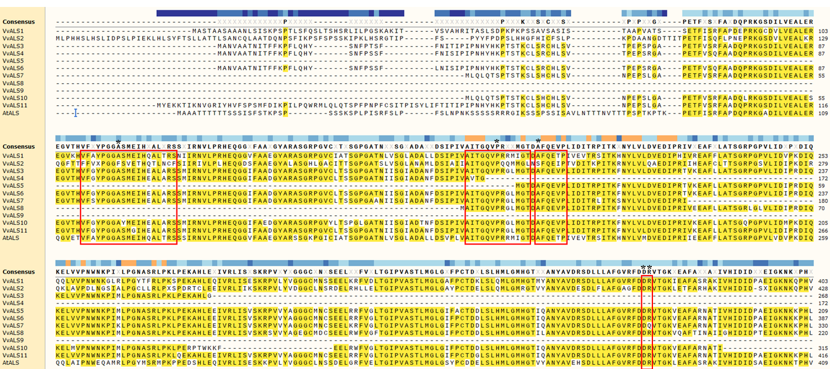

Fig S1 (continued)
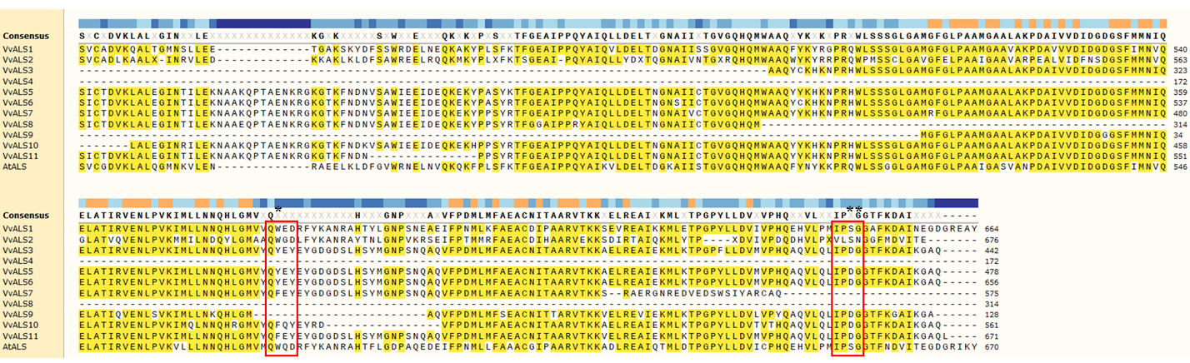

Fig S2.
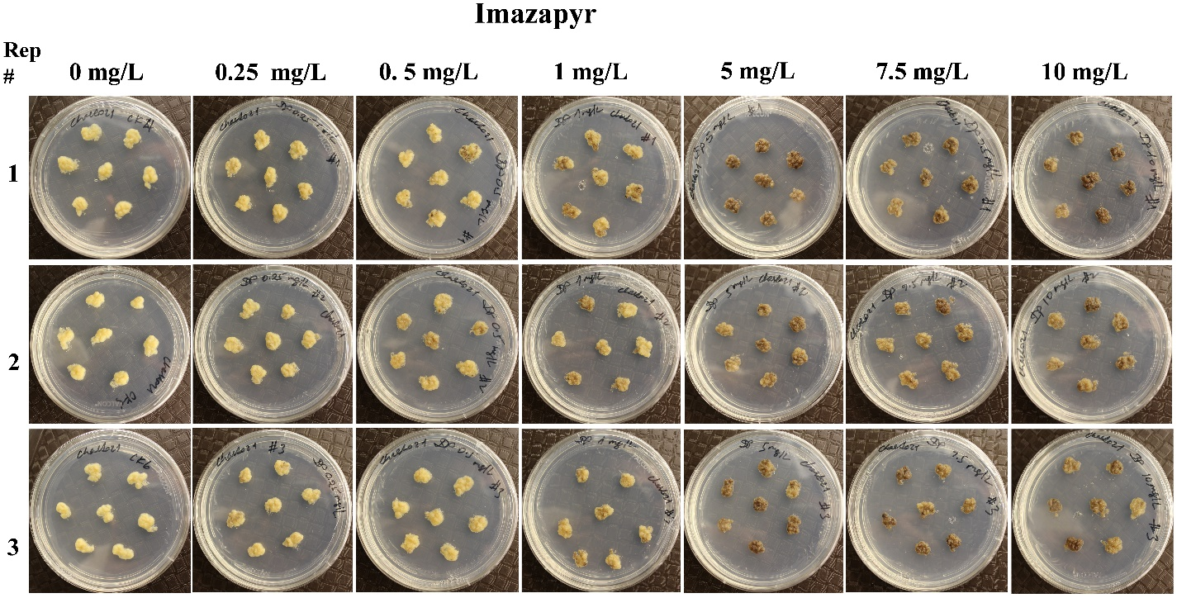
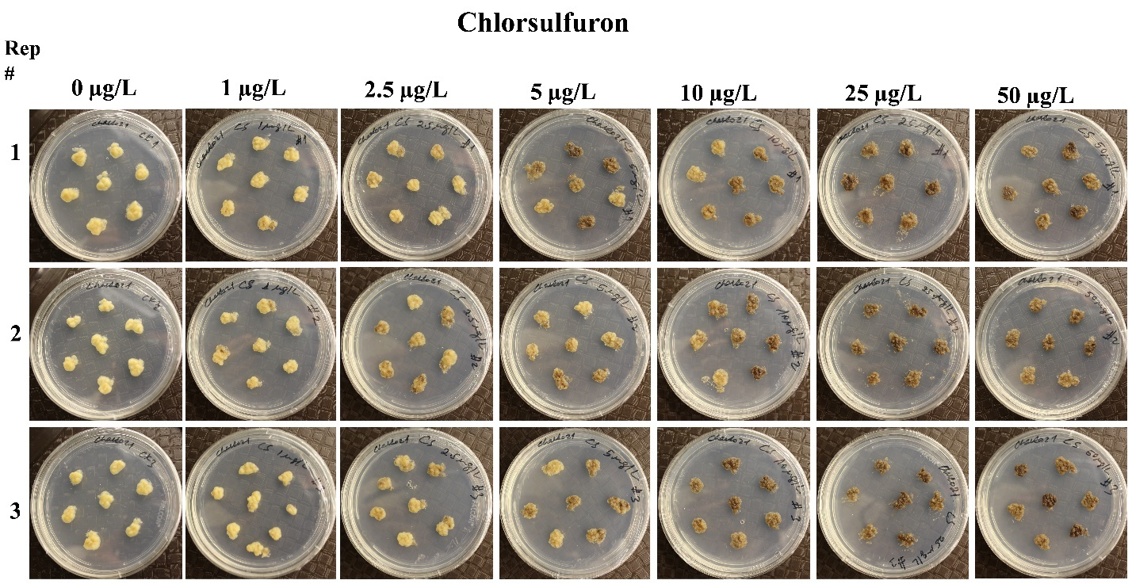

Fig S2 (continued from preceding page).
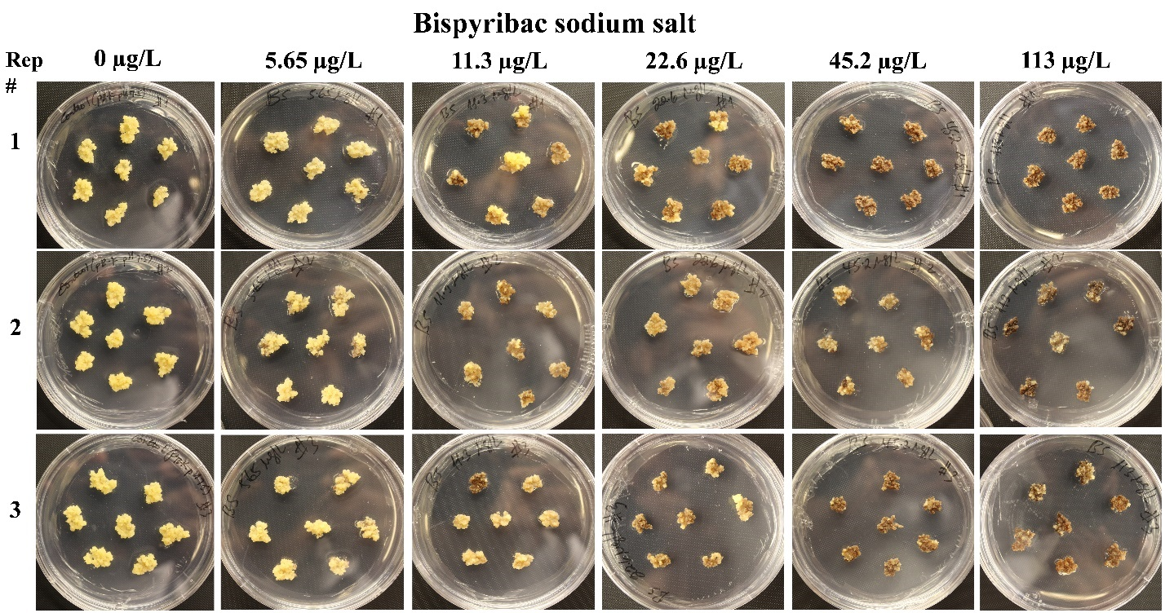
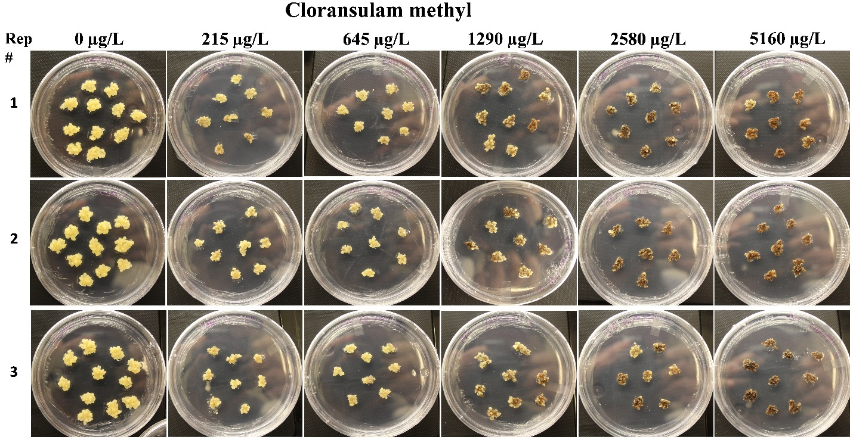

Fig S2 (continued from preceding page).
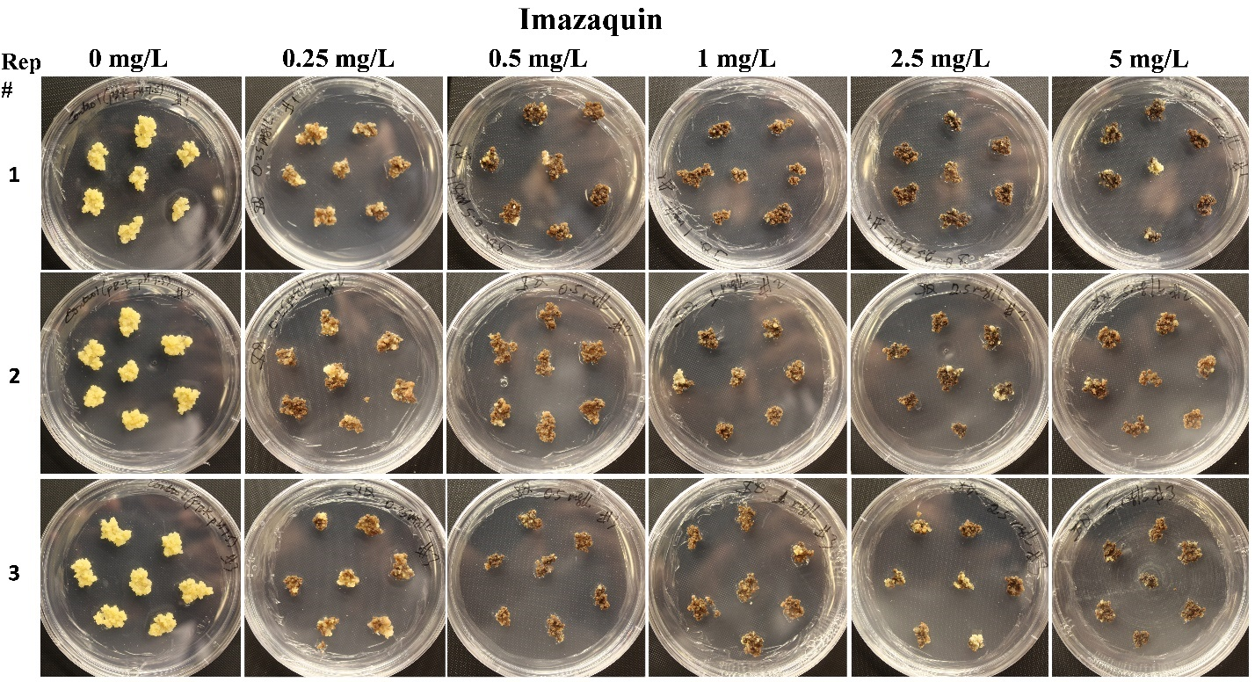
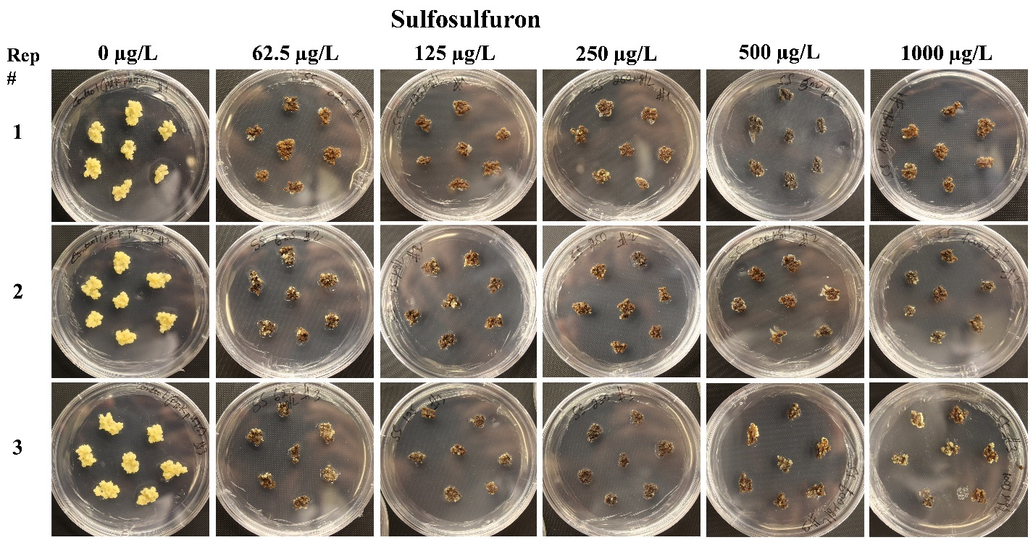

Fig S3.
