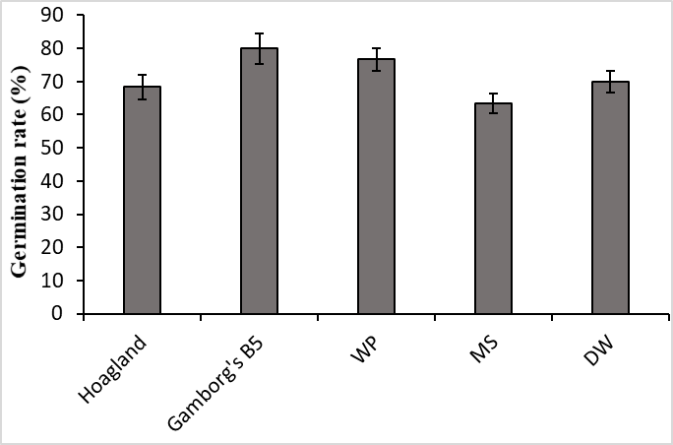

Figure S1. Germination of pomegranate seeds using various plant growth media, including ¼-strength Hoagland, Gamborg’s B5, WP (Woody plant) and MS (Murashige and Skoog), as well as DW (distilled water). Data represent mean ± SD of 60 seeds across three separate plates.

Figure S2. The effect of exposure duration to cold temperatures (4°C) on the germination of pomegranate seeds of the PG116-17 accession. The seeds were transferred from 4°C to 25°C after four days (blue line) or 13 days (green line). One hundred and twenty seeds were placed on ¼-strength Hoagland (Hog) agar medium and monitored for 35 days in each treatment. Data represent the average ± SD of three plates for each treatment.

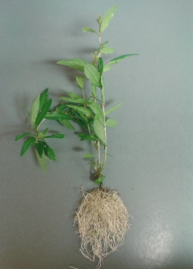
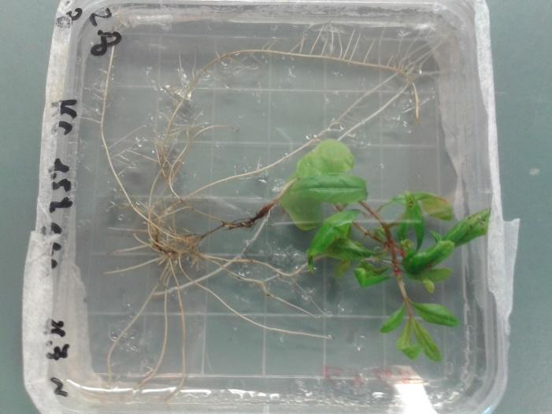
(a)
(b)
(c)

Figure S3. A representative image of transgenic pomegranate hairy roots. (a) A representative plant two months after being transferred to the soil and four months after the initial sowing of seeds; (b) green fluorescent protein (GFP)-positive hairy roots taken from this plant; (c) a representative image of hairy roots with shoots attached that were kept growing on a Hoagland agar plate for four months after the initial sowing of seeds.

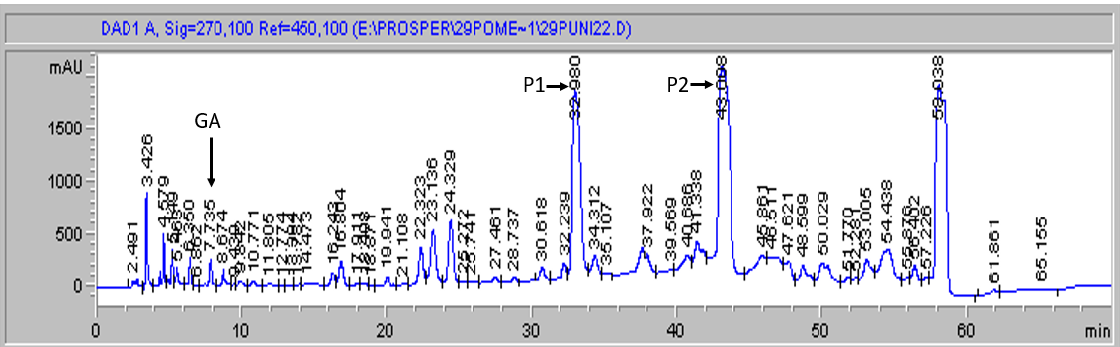

Figure S4. The chromatogram obtained from HPLC for line PGC-13. About 70 peaks were identified as having a high signal-to-noise ratio. The peaks of gallic acid (GA) and the two isomers of punicalagin (P1, P2) are marked with arrows.

Supplementary Text S1

Protocol for the production of pomegranate hairy roots
- Choose the most appropriate accession that has a high germination rate, a high ability to produce, a high level of biomass of hairy roots, and a high level of the desired bioactive compounds.
- Take at least 100 dry seeds after removing all the aril debris by rubbing them well under water. Dry the seeds at 30 °C for several days until they are dry.
- Rub the seeds with sandpaper on all sides.
- Soak the seeds in 10 mL of concentrated sulfuric acid (96% H₂SO₄) for 45 min.
- Wash with distilled water 4-5 times to remove residual H₂SO₄.
- Add 30 mL of 3% Economica (house bleach) for 15-min exposure.
- Rinse with sterile distilled water 8-9 times in a laminar hood. Remove the water.
- Keep at 4ºC for four days.
- Place the seeds on ¼-strength Hoagland agar with 3% sucrose and 0.8% agar.
- Place the plates in a chamber room at 25°C under a 16-h/8-h light/dark cycle for about 2-3 weeks.
- After the radicle has reached a length of about 5-10 mm, cut the tip with a sterile scalpel and remove about 1-2 mm.
- Grow the A. rhizogenes strain MSU440 carrying the binary vector pK7WG2D (Invitrogen, Carlsbad, CA) on MGL media (5 g mannitol, 1.125 g L-glutamic acid, 0.625 g K₂HPO₄, 0.1g NaCl, 0.1 g MgSO₄-7H₂O, 5g tryptone & 2.5 g yeast extract) for 36 h.
- Drag the wounded roots through the creamy A. rhizogenes culture and then co-cultivate on antibiotic-free ¼-strength Hoagland agar plates. Keep the plates at 25ºC under the dark condition for two days.
- Transfer the seedlings to a medium supplemented with cefotaxime at 200 mg L⁻¹ to eliminate any remaining A. rhizogenes. Place the plates at 25ºC under a 16-h light and 8-h dark cycle for four weeks.
- Search for the presence of GFP in transgenic hairy roots using a Leica fluorescence stereomicroscope (Leica Microsystems, Deerfield, IL, USA) equipped with a filter for green fluorescence.
- Remove the non-GFP-expressing roots.
- Transfer the seedlings to fresh ¼-strength Hoagland agar plates with cefotaxime every three weeks.
- After about two months, transfer the seedlings from the agar plate to soil and continue to grow in a growth room (25 ± 3°C; 16-h light /8-h dark) for an additional two months.
- Harvest the roots and carefully wash the roots with distilled water. Then, flash-freeze using liquid nitrogen, lyophilize and grind to a fine powder using mortar and pestle. Keep at -80°C for further analyses.
- Examine the roots for their bioactive compounds and other analyses as required.

