Supplementary data

Tables

Table 1. The effect of 2 cold stratification temperatures (T1: 7 °C; T2: -20 °C), and different stratification durations (D: 2, 4, 6, and 8 weeks) on the mean germination percentage of in vitro cultured C. sinaica seeds on MSB5.
Stratification temperature (°C) |  | Duration (weeks) |  |  |  | Mean (x̄)
 |  | 2 | 4 | 6 | 8
Control (non-stratified seeds) |  | 10.8 ± 1.7 c |  |  |  | 10.8 ± 1.7 ab
7 °C |  | 17.0 ± 4.0 bc | 29.3 ± 4.3 a | 13.0 ± 0.0 bc | 10.8 ± 2.2 c | 17.6 ± 1.6 a
-20 °C |  | 15.0 ± 2.0 bc | 21.0 ± 4.0 ab | 13.0 ± 0.0 bc | 8.7 ± 4.3 c | 14.4 ± 1.5 ab
Mean (x̄) of Duration |  | 16.0 ± 1.7 b | 25.2 ± 3.6 a | 13.0 ± 0.0 b | 9.8 ± 3.3 b
LSD |  | 9.1 | 9.1 | 12.2 | 15.4 | 6.3
Different lowercase letters indicate significant differences among different durations for each stratification temperature (in the same row) and significant differences between pooled means for each storage temperature (in the last column). Different letters indicate significant differences at P = 0.05

Table 2-a: Effect of 2 types of cytokinins BA and mTp at concentrations of 0.5, 1.0, and 2.0 mg/L on the mean germination percentage of C. sinaica seeds stratified for 4 weeks at 7 °C. Seeds were cultured on MSB5.
BA (mg/L) | mTp (mg/L) | G%
0 | 0 | 7.0 ± 0 d
 | 0.5 | 36 ± 4 a
0.5 | 1 | 14 ± 0 cd
 | 2 | 14.7 ± 0.3 cd
 | 0.5 | 14 ± 0 cd
1 | 1 | 29 ± 0 ab
 | 2 | 21.7 ± 4.3 bc
 | 0.5 | 28.7 ± 8.4 ab
2 | 1 | 14 ± 0 cd
 | 2 | 14 ± 0 cd
Mean (x̄) |  | 19.30 ± 1.8
P < 0.05 |  | 0.000
LSD |  | 14.3
Different letters indicate significant differences at P = 0.05
Table 2-b: Effect of 2 types of cytokinin, BA and mTp at concentrations of 0.5, 1.0, and 2.0 mg/L on the pooled mean germination percentage of C. sinaica seeds that were stratified for 4 weeks at 7 °C. Seeds cultured on MSB5.
Cytokinin conc. (mg/L) | BA Mean (x̄) | mTp Mean (x̄) | Mean (x̄) of BA and mTp
0 | 7± 0.0 c | 7± 0.0 c | 7± 0.0 d
0.5 | 23.3 ± 3.2 a | 27.9± 2.8 a | 17.07 ± 0.29 a
1 | 19.7 ± 1.1 ab | 19 ± 0.0 b | 12.9 ± 0.35 b
2 | 15.9 ± 2.1 b | 18.4± 0.7 b | 11.4 ± 0.75 c
Mean (x̄) | 16.5 ± 2.1 | 18.1 ± 2.3 | 12.1 ± 1.1
P < 0.05 | 0.002 | 0.000 | 0.000
LSD | 7.4 | 7.4 | 1.5
Means with the same letter(s) are not significantly different at P = 0.05
Table 3: Mean germination percentage of C. sinaica stratified seeds as affected by sinapic acid (SA) concentrations (0, 1, 2, 3 mg/L), the media strength (full-strength MSB5 and ½ MSB5), and their interaction. Different letters show significant variation at 0.05 P.
Media strength  SA (mg/L) | Full strength MSB5 | 1/2MSB5 | Mean | LSD
0 | 50±0.0 bB | 17±0.3 bCD | 34±0.2 b | 22
1 | 50±0.0 bB | 50±10 aB | 50±5 a | 28
2 | 75±14 aA | 25±0.0 bC | 50±7 a | 24
3 | 17±0.3 abCD | 0.0±0.0 cD | 9±0.2 c | 28
Mean of media | 48±7 | 23±6 | 36±5
LSD for media strength | 25 | 17 | 16
Different lowercase letters indicate significant differences among different SA concentrations on the same medium. Different uppercase letters indicate significant differences in the interaction of different SA concentrations with different media strength.

Table 4: Mean germination percentage of C. sinaica seeds cultured in sterile dd.H₂O supplemented with different growth regulators (Control: dd.H₂O with no growth regulator; GA: dd.H₂O supplemented with 200 mg/L gibberellic acid (GA); SA: dd.H₂O supplemented with 1 mg/L sinapic acid (SA); GA x SA x mTp: medium supplemented with 200 mg/L GA, 1 mg/L SA, and 0.5 mg/L mTp).
Growth regulator | Control | GA | SA | GA x SA x mTp
Total mean | 40 ± 0.33 b | 26 ± 2.0 c | 15 ± 1.2 d | 46 ± 2.3 a
LSD | 6.7

Table 5: Changes in the concentration of total soluble sugars, total carbohydrates, and total soluble proteins, expressed as mg/g dry weight (DW) in seeds of C. sinaica as affected by collection time/date (August, Aug; September, Sep; and October, Oct; stratified seeds from October, Str) and the collection site (Abohamman, L1; Mosa Mountain, L2; and Algragania, L3).
Source | Primary metabolites (mg/g DW seed)
Source | Soluble sugars |  |  |  |  | Total carbohydrates |  |  |  |  | Total soluble proteins
 | Aug | Sep | Oct | Total | Str | Aug | Sep | Oct | Total | Str | Aug | Sep | Oct | Total | Str
L1 | 41.01  ± 4.10  abA | 39.19  ± 2.85  bA | 44.02 ±6.30  abA | 41.41  ± 2.42  A | 54.83  ± 1.48  aB | 58.44 ± 4.60  aB | 37.56  ± 0.95  bB | 56.46  ± 1.17  aA | 50.82 ± 3.61  B | 56.68  ± 1.12  aA | 26.65 ± 2.04  bB | 32.95  ± 0.37  aA | 19.16  ± 0.77  cA | 26.25  ± 2.09  A | 8.18  ± 0.33  dB
L2 | 35.81  ± 2.01  aA | 38.58 ± 0.83  aA | 40.70  ± 6.39  aA | 38.37 ± 2.07  A | 47.79 ± 2.56  aC | 65.24 ± 5.08  aB | 63.85  ± 7.41  aA | 41.16  ± 0.86  bB | 56.75  ± 4.69  B | 49.11 ± 0.40  bB | 21.76  ± 0.20  aC | 23.47  ± 0.61  aB | 9.73 ± 1.27  bB | 18.32  ± 2.20  C | 9.05  ± 0.44  bB
L3 | 37.31  ± 0.90  cA | 20.17  ± 2.59  dB | 45.16 ± 2.80  bA | 40.57  ± 1.46  A | 63.96  ± 1.87  aA | 87.70 ± 3.24  aA | 52.22  ± 2.55  bAB | 54.61  ± 0.64  bA | 64.84  ± 5.85  A | 57.81 ± 1.34  bA | 31.03  ± 0.75  aA | 16.59  ± 1.07  bC | 12.79  ± 1.21  cB | 20.14  ± 2.82  B | 11.52  ± 0.71  cA
Mean (x̄) | 38.05  ± 1.55  bc | 32.65  ± 3.32  c | 43.29  ± 2.79  b |  | 55.53  ± 2.55  a | 70.46  ± 4.93  a | 51.21  ± 4.43  b | 50.74 ± 2.45  b |  | 54.54  ± 1.46  b | 26.48  ± 1.48  a | 24.34  ± 2.40  b | 13.89  ± 1.49  c |  | 9.58  ± 0.56  d
LSD at 0.05 P | 17.48 | 10.64 | 10.64 |  | 12.23 | 13.18 | 10.71 | 10.71 |  | 13.18 | 2.14 | 2.14 | 4.31 |  | 4.31
Lowercase letters indicate significant differences in the same row, and uppercase letters indicate significant differences in the same column at P < 0.05

Table 6: Endogenous hormone concentration GA3 and ABA (µg/100 g FW seed) in seeds of Crataegus sinaica as affected by the time/date of seed collection (August, September, October, Stratification for October collected seeds) and locality (L1=Abohamman, L2=Mosa Mountain and L3=Algargania).

Source | Endogenous Phytohormones concentration (µg/100 g FW)
Source | GA3 |  |  |  |  | IAA |  |  |  |  | ABA
 | Aug | Sep | Oct | Total | Str | Aug | Sep | Oct | Total | Str | Aug | Sep | Oct | Total | Str
L1 | 651.1 ±  137.95  Aa | 508.2 ±  32.35  Aa | 449.9 ±  24.50  Ba | 536.4 ±  51.15 A | 700.2 ±  46.16 Aa | 19.6 ±  2.01 Bc | 29.4 ±  3.63 ABbc | 60.5 ±  7.89 Aa | 36.5 ±  6.67 A | 43.6 ±  0.89  Ab | 168.7 ±  2.05 Ab | 193.3 ±  11.01 Ab | 299.3 ±  24.77 Aa | 220.4 ±  21.53 A | 178.0 ±  3.71  Ab
L2 | 629.8 ± 120.43 Aa | 610.1 ±  111.49 Aa | 596.6 ±  50.52 Aa | 612.2 ±  49.80 A | 743.6 ± 29.73 Aa | 28.7 ± 2.47 Ab | 15.2 ± 0.66 Bd | 23.2 ± 1.10 Bc | 22.4 ±  2.12  B | 35.7 ± 1.66  Ba | 180.6 ± 32.53 Aa | 315.3 ±  92.38 Aa | 213.8 ± 19.73 Ba | 236.6 ± 35.25 A | 210.5 ±  1.73  Aa
L3 | 585.21 ±  157.56 Aa | 628.27 ± 59.55  Aa | 473.2 ± 38.15 ABa | 562.2 ±  54.95 A | 634.2 ± 64.22 Aa | 19.1 ± 0.31 Bb | 45.2 ± 10.42 Aa | 38.4 ± 6.45 Bab | 34.3 ± 5.27 AB | 27.7 ± 1.95 Cab | 161.3 ± 30.09 Ab | 163.8 ± 10.05 Ab | 336.7 ± 27.50 Aa | 220.6 ±  31.46  A | 278.5 ± 56.05 Aab
Mean (x̄) | 622.03 ± 70.41 ab | 582.2 ± 42.05 ab | 506.6 ± 30.04 b |  | 692.7 ± 29.12 a | 22.5 ± 1.81 c | 30.0 ± 5.38 bc | 40.7 ± 6.17 a |  | 38.0 ± 2.38 ab | 170.2 ± 13.11 b | 224.1 ± 5.61 ab | 283.3 ± 21.85 a |  | 222.3 ± 21.96 ab
LSD at 0.05 P | NS | NS | 186.11 |  | 186.11 | 13.17 | 10.71 | 10.71 |  | 13.17 | 113.09 | NS | 113.09 |  | 60.96
IAA=Indole-acetic acid, GA₃=Gibberelic acid, ABA=Abscisic acid, Str=stratified seed
Lowercase letters indicate significant differences in the same row, and uppercase letters indicate significant differences in the same column at P < 0.05

Figures

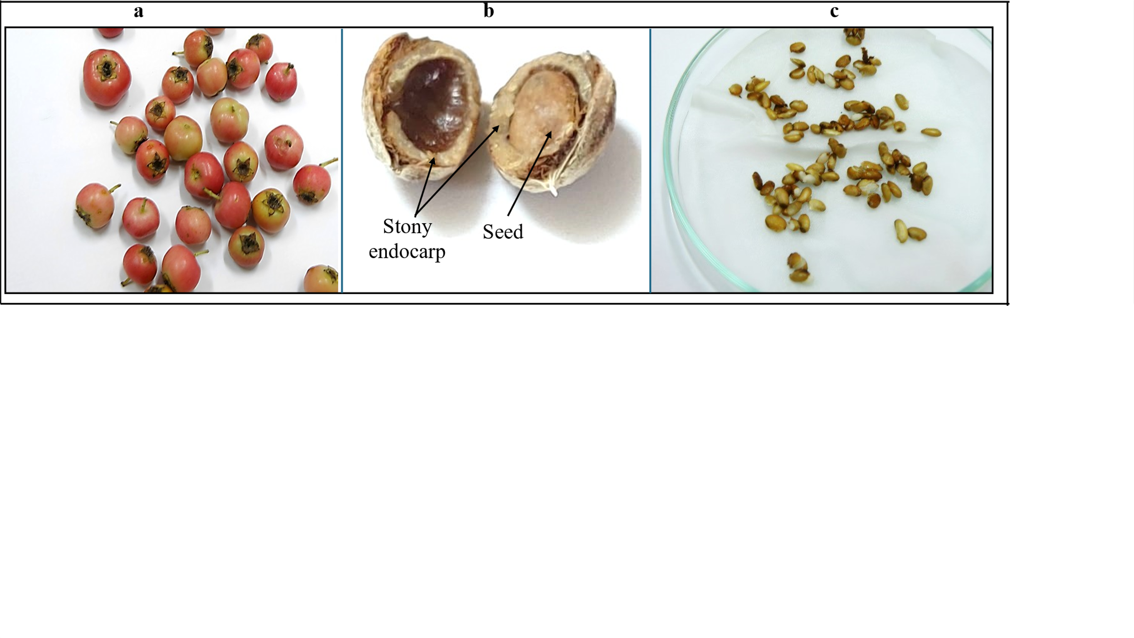
Fig. 1 Crataegus sinaica, mature fruits with fleshy pericarp, (b) stony endocarp, and (c) sterile seeds for in vitro culture.

